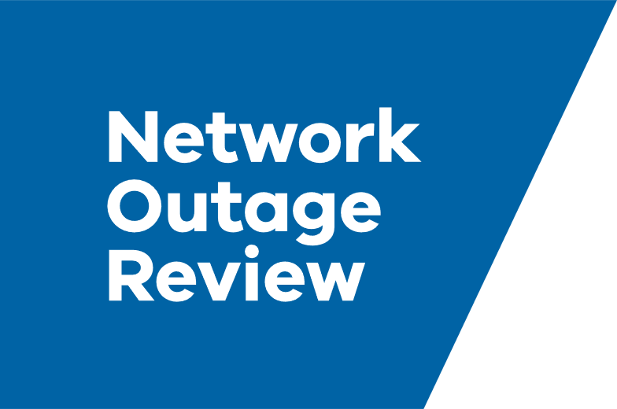
Review into the transmission and distribution businesses operational response to the 13 February 2024 Storms
  - Interim Report
www.energy.vic.gov.au/safety/network-outage-review

Acknowledgements
We would like to acknowledge the engagement with affected communities, distribution businesses, regulators, emergency services, peak bodies, social and community organisations that has supported us to deliver this report.
Author
This document has been prepared by the Network Outage Review Expert Panel and supporting Secretariat.
Network.outagereview@deeca.vic.gov.au
Photo credit
Cover picture was provided by Powercor.

The Network Outage Review Panel and Secretariat acknowledge and respect Victorian Traditional Owners as the original custodians of Victoria’s land and waters, their unique ability to care for Country and deep spiritual connection to it.
We honour Elders past and present whose knowledge and wisdom has ensured the continuation of culture and traditional practices.
The Network Outage Review Panel and Secretariat is committed to genuinely partnering with Victorian Traditional Owners and Victoria’s Aboriginal community to progress their aspirations.
© The State of Victoria June 2024.
Creative Commons
This work is licensed under a Creative Commons Attribution 4.0 International licence, visit the Creative Commons website (http://creativecommons.org/licenses/by/4.0/).
You are free to re-use the work under that licence, on the condition that you credit the State of Victoria as author. The licence does not apply to any images, photographs or branding, including the Victorian Coat of Arms, and the Victorian Government and Department logos.
ISBN 978-1-76136-817-2 (pdf/online/MS word)
Disclaimer
This publication may be of assistance to you, but the State of Victoria and its employees do not guarantee that the publication is without flaw of any kind or is wholly appropriate for your particular purposes and therefore disclaims all liability for any error, loss or other consequence which may arise from you relying on any information in this publication.
Accessibility
To receive this document in an alternative format, phone the Customer Service Centre on 136 186, email customer.service@delwp.vic.gov.au, or contact National Relay Service on 133 677. Available at www.energy.vic.gov.au/safety/network-outage-review.

Table of Contents
1 Executive Summary 3
1.1 Background 3
1.2 Terms of Reference 7
1.3 The Interim Report 8
1.4 A summary of what we heard 8
1.5 A summary of what we are thinking 11
2 Transmission network response to 13 February 2024 storm event 16
3 Distribution network response to 13 February 2024 storm event 20
3.1 Before the 13 February 2024 storm event 20
3.1.1 Planning and Coordination 20
3.1.2 Planning for life support customers 24
3.1.3 Telecommunications continuity planning 30
3.1.4 Business continuity planning for other essential service providers 36
3.1.5 Incentives and compensation 41
3.1.6 Worst performing areas of the network 50
3.2 During the 13 February 2024 storm event 58
3.2.1 Communication with customers and community 58
3.2.2 Impact assessment and make-safe actions 66
3.2.3 Restoration planning, prioritisation and operations 71
3.2.4 Mutual aid between distribution businesses and other organisations 78
3.2.5 Temporary generation for key community assets 81
3.3 After the 13 February 2024 storm event 85
3.3.1 Recovery after the emergency 85
4 Appendices 88
4.1 Appendix 1: Terms of Reference 88
4.2 Appendix 2: Analysis of Terms of Reference to Interim Report 90
4.3 Appendix 3: Glossary of Terms 93
4.4 Appendix 4: Glossary of Acronyms 96

Table of Figures
Figure 1: Restoration of customers from the 2021 and 2024 storm events. 4
Figure 2: Main features of the national electricity market 5
Figure 3: Map of Victorian Distribution Businesses. 6
Figure 4: Map of impacts of the towers down at Anakie on 13 February 2024. 16
Figure 5: Map of impacts of 2020 Cressey towers failure. 18
Figure 6: Dependency assessment - Electricity Sector. 37
Figure 7: Chart of restoration during major power outages in 2021 and 2024. 39
Figure 8: Chart of worst performing feeders (SAIDI) across all distribution businesses. 52
Figure 9: Worst performing feeders - AusNet 52
Figure 10: Worst performing feeders - Jemena 53
Figure 11: Worst performing feeders - Citipower 53
Figure 12: Worst performing feeders - Powercor 54
Figure 13: Worst performing feeders - United Energy 54
Figure 14: Example of an outage tracker. 59
Figure 15: AusNet communication channels. 60
Figure 16: Powercor's Mobile Emergency Response Vehicle in the field. 63
Figure 17: Diagram of identified constraints in managing AusNet's response. 74
Figure 18: Diagram of opportunities to improve AusNet's response. 77
Figure 19: Temporary generation for main streets. 82
Figure 20: Picture of large generator deployed to support main street. 83
Figure 21: Picure showing large generator and temporary connection to local electricity grid. 84

Executive Summary

Background

The 13 February 2024 Storm Event
On the afternoon of 13 February 2024, a significant thunderstorm crossed Victoria causing heavy rainfall and damaging winds. During this storm, Victoria experienced wind gusts of more than 110 kilometres per hour (km/hr) and as high as 150km/hr. The event caused significant damage to trees, buildings and infrastructure including the electricity network.
Damaging microbursts of wind associated with the storm caused six high voltage transmission towers near Anakie (Geelong) to collapse. As a result, 2,210 megawatts of generation disconnected in Victoria (Loy Yang A and wind farms), and 90,000 customers had their supply switched off (load shedding) following directions from the Australian Energy Market Operator (AEMO) during the afternoon to keep the grid secure.
The storm event caused significant damage to Victoria’s electricity distribution network, affecting about 12,000 kilometres of distribution lines, and 1,100 powerlines down. Over 1 million customers lost power across the event with over 531,000 customers off power at the peak of the event.
Around 400,000 customers were restored within a day (24 hours), and after three days (72 hours), around 30,000 customers remained without power. Around 3,000 customers were without power for more than a week with the last five properties reconnected on 24 February 2024, 11 days after the initial event.
Power outages also affected many essential services throughout Victoria - including telecommunications, water treatment plants, health facilities, schools, supermarkets, dairies, and food manufacturing facilities. The loss of essential services intensified the impact of the event for the communities with telecommunication loss specifically impacting the response of emergency services and electricity distribution impact assessment and restoration.
Victoria’s five distribution businesses had varied experiences on the 13 February 2024 event, with AusNet and United Energy customers experiencing the most significant outages.
AusNet
AusNet’s network was significantly impacted by the storm event, with 360,000 customers losing supply – the highest number of customer outages in a single day in the history of AusNet’s network. 94 per cent of AusNet affected customers had their power restored within 72 hours; but 20,000 customers were off supply for three days, and more than 4,000 customers were off supply for at least seven days. The last five properties were reconnected on 24 February 2024, 11 days after the initial event.
During the event, AusNet deployed large generators to Mirboo North, Emerald and Cockatoo communities, which temporarily restored some customer supply until fault repairs were completed.
During the event, AusNet’s online Outage Tracker failed due to high customer demand. This, along with other technological and system issues, meant that impacted communities could not access timely and reliable information about their power outage, and make informed decisions about what to do. In some areas of the AusNet network, telecommunications services failed, further isolating affected communities.
United Energy
United Energy’s network was impacted by the storm event with 249,180 customers losing supply. Around 42,000 of these customers were restored in under a minute, around 180,000 customers were restored within 19 hours, with all customers restored by 4:00 pm on 18 February 2024.
CitiPower and Powercor
CitiPower and Powercor networks were impacted by the storm event with around 257,000 customers losing supply. Around 72,000 customers were restored within three minutes of the 185,000 who experienced a sustained outage, 96 per cent were restored by 8:00am on 14 February (16 hours from outage peak).
During the event, Powercor deployed large generators to the Donald and Lara communities, which temporarily restored customer supply until fault repairs were completed.
Jemena
Around 54,250 of Jemena customers lost supply during the afternoon of 13 February 2024. 1,250 customers lost supply due to a direct fault from the storm, while around 53,000 customers lost supply due to load shedding to keep the electricity grid secure. The 53,000 customers were restored at around 5:00 pm (AEDT) that evening, while the 1,250 customers were restored between 5:00 pm and 5:00 pm (AEDT).

The environment our network businesses operate in is changing
For many years, Victorian electricity distribution businesses have operated in a ‘steady state’ environment with events that cause impacts at scale an infrequent occurrence. The regulatory frameworks were designed around a ‘steady state’ environment and incentivise distribution businesses to design, build, maintain, and operate their networks through incremental performance improvement and financial efficiency.
Events that cause impacts at scale are now occurring in Victoria nearly every year.
In addition to the 13 February 2024 storm event, other events that caused impacts at scale to the electricity network include:
- The October 2021 storm which impacted more than 526,000 customers at its peak including customers across the whole of the coastal fringe from Warrnambool to Mallacoota. Communities impacted with prolonged outages were in the United Energy Mornington Peninsula area, and in the AusNet Dandenong Ranges and Gippsland areas.
- The June 2021 storms which impacted more than 297,000 customers at its peak including customers in the Powercor Central Highlands area and AusNet Yarra Ranges, Dandenong Ranges and Gippsland areas.
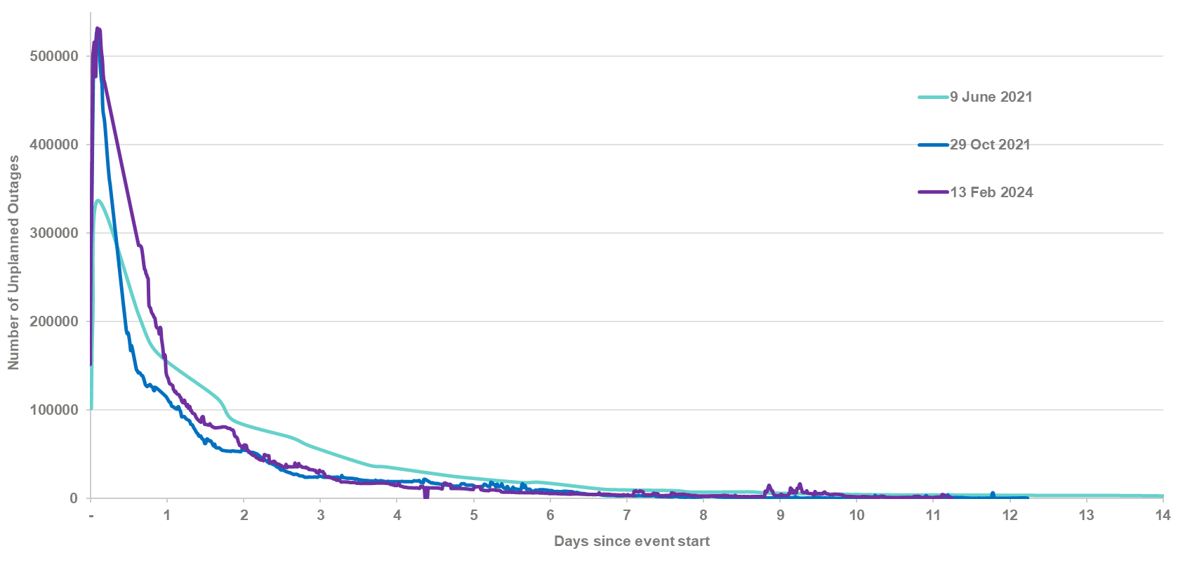
Figure 1: Restoration of customers from the 2021 and 2024 storm events.
Additionally, events like the October 2022 floods, 2019-20 Eastern Victorian Bushfires and 2018 St Patricks Day fires required sustained response by Powercor and AusNet to mitigate risks and impacts to the electricity network and restore damaged areas of the network.
These events highlight that distribution businesses no longer operate in an environment which is ‘steady state’, the potential for weather and security events that cause impacts at scale is real. This necessitates a step change in distribution businesses preparedness, response, and recovery from these events to protect the reliability of power Victorians value and to protect the ecosystem of essential services that electricity distribution networks sustain.

How we get our electricity
Victoria is a part of the National Electricity Market - a large, interconnected power system where electricity is generated, transmitted, distributed, and consumed by customers.
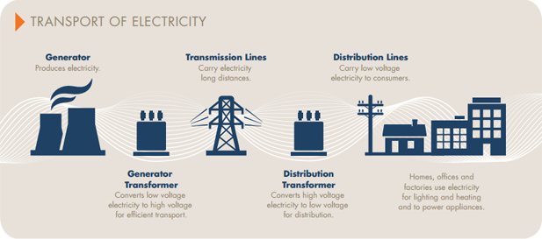
Figure 2: Main features of the national electricity market
The National Electricity Market is one of the largest interconnected electricity systems in the world. It allows electricity to be traded between Victoria, New South Wales (including the Australian Capital Territory), Queensland, South Australia, and Tasmania. The focus of this report is the Victorian region of the National Electricity Market.
Generation: Generators produce electricity from fossil fuels, including coal and gas, and renewable energy sources, including water (for hydroelectricity), wind (for wind power) and sunlight (for solar photovoltaics panels).
Transmission: Once electricity is generated at a power station, it is transported to load centres in metropolitan and regional areas by a network of high voltage transmission lines – like an electricity highway. AusNet Services owns, operates and maintains Victoria’s high-voltage electricity transmission system. It consists of around 6,620km of transmission lines across 13,399 transmission towers. The transmission system is subject to the operational control of the Australian Energy Market Operator (AEMO), the national market and system operator – responsible for system integrity.
Once electricity nears customers, it needs to step down (like getting off the highway and reducing your speed in built up areas). Low voltage distribution networks transport electricity from the transmission lines to customers. In Victoria, five electricity distribution businesses own and manage the low voltage power poles, wires and meters which deliver power to homes and businesses across the state.
Distributors have a responsibility to:
- deliver reliable electricity supply to customers
- connect homes to the grid
- maintain infrastructure
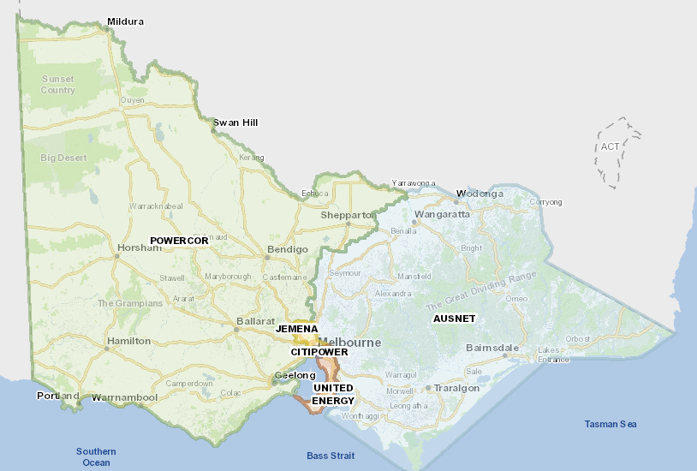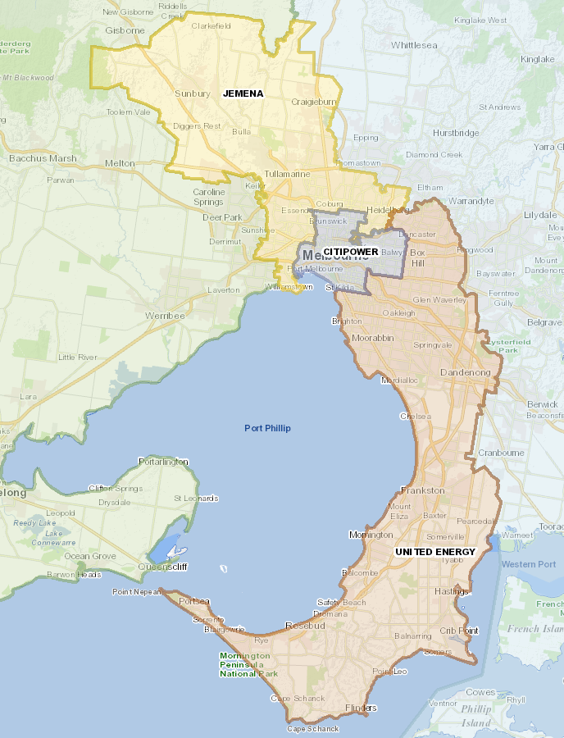
Figure 3: Map of Victorian Distribution Businesses.
Jemena provides distribution network services to around 370,000 customers across north-west greater Melbourne, across around 6,800 km of poles and wires.
CitiPower – provides distribution network services to around 332,000 customers in Melbourne's central business district and inner suburbs. Powercor provides distribution network services to around 844,000 customers across 64 per cent of Victoria, spanning from the western suburbs of Melbourne through central and western Victoria, to the South Australian and New South Wales borders. Together, these networks consist of around 100,000 km of powerlines.
United Energy provides distribution network services to around 700,000 customers from the east and southeast suburbs of Melbourne, and along the Mornington Peninsula. Its network consists of around 13,500 km of powerlines and cables, and 215,000 power poles.
AusNet provides distribution network services to around 802,000 customers across eastern and north-eastern Victoria, including Melbourne’s north and east. AusNet’s network covers around 80,000 square kilometres, with about 93 per cent of its network in regional and rural areas. Its network consists of 45,985 km of distribution lines, and 417,145 power poles.
Electricity retailers sell electricity to household and business customers. Retailers are businesses that pay the different costs involved in supplying electricity and then sell electricity to customers as a packaged offer. Retailers are responsible for billing, customer service and helping arrange network services.
Energy businesses must hold a licence or be exempt from holding a licence to generate, transmit, supply or sell energy in Victoria. The Essential Services Commission (ESC) is Victoria’s independent regulator for the electricity and gas sectors. It is responsible for granting licences.
The ESC has the power to investigate energy businesses and determine whether they are complying with the rules. If a business is not compliant, the ESC has enforcement powers. These include the ability to:
- issue penalty notices (fines)
- issue enforceable orders and undertakings
- revoke business licences.
Electricity supply is also regulated through complex series of national and state legislation, regulators, and market bodies. We will discuss any of these throughout the Interim Report where they are relevant to our review.

Terms of Reference
The Victorian Minister for Energy and Resources established the Network Outage Review in response to the 13 February 2024 storms which caused prolonged power outages. We are tasked to inquire into and make recommendations in respect to the operational response of transmission and distribution businesses, including contingency planning, timely and effective management of the incident, and restoration of supply.
The full terms of reference can be found in appendix 1 of this report.

The Panel
The panel comprises:
- Rosemary Sinclair AM - CEO of auDA, the administrator and self-regulatory policy body for Australia’s country code Top Level Domain, the .au domain. Prior to joining auDA, Rosemary was CEO of Energy Consumers Australia, responsible for enhancing consumer advocacy in the national energy market on issues including price, quality and security of supply.
- Gerard Brody – former CEO of the Consumer Action Law Centre, a leading consumer advocacy organisation that provides legal assistance and financial counselling, for ten years until February 2023. Gerard is a board director of both the Australian Financial Complaints Authority and the Telecommunications Industry Ombudsman and was a board director of the Energy & Water Ombudsman Victoria from 2014 to 2023.
- Kevin Kehl - Non-Executive Director of TasNetworks, Marinus Link Pty Ltd, and Energy Queensland. Kevin was previously an executive leader at Powerlink Queensland and Energex and has more than 40 years’ experience in the energy industry across the distribution and transmission networks sector.

Our approach to the Network Outage Review – electricity as part of a wider ecosystem
Victoria’s electricity network is one part of a broader ecosystem focused on providing the essential service needs of our community.
Electricity is of itself an essential service; however, it is also critical to supporting the provision of other essential services including water, communications, transport, health, banking and finance, food and grocery, agriculture and government.
Failure of the electricity network impacts the broader essential services ecosystem. When the provision of multiple essential services are affected, the impact on the community including its safety and quality of life is compounded.
We can no longer consider the electricity network in isolation of other essential services that meet community needs.
We have approached the Network Outage Review by placing the needs of the community at the centre. We have examined the operational response of the transmission and distribution businesses to the 13 February storms to identify practical opportunities that will create better outcomes for the Victorian community during and after future events that cause impacts at scale.
Key considerations of the review include community safety and wellbeing, reliability of electricity supply and affordability.

The Interim Report
Our Interim Report identifies that there are improvements throughout this ecosystem which will result in better outcomes for the community in an environment of more frequent and intense weather events that challenge our networks. This includes quick response on the ground relief, compensation and adjustments to regulatory frameworks, which were made for a time when our distribution businesses operated in a ‘steady state’.

Structure of the Report
The Interim Report examines the transmission response and the distribution response to the 13 February storm event separately. Our review of the distribution networks’ response is structured temporally – according to the activities that enable a response, the response, and after the response.
Before an event – includes activities such as planning, preparedness, business continuity planning, and coordination. These activities enable the distribution businesses, or other organisations to response effectively during events, and play their part in the ecosystem. It also includes regulatory incentives and compensation frameworks – which influence everything a distribution business does from planning, preparing, mitigating, building, maintaining, operating their networks, and responding to events.
During the 13 February storm event – includes the key activities undertaken by distribution businesses throughout an event. These activities are roughly assigned based on the time these activities occur, but many occur on an ongoing basis throughout an event. These activities include customer and community communication and engagement, inspecting the damage and making it safe, planning, prioritising and undertaking restoration, use of mutual aid, and installation of temporary generation within communities.
After the 13 February storm event – includes recovery activities related to restoring electricity supply to customers.

A summary of what we heard
In undertaking the Network Outage Review, we have engaged deeply with affected communities, distribution businesses, regulators, emergency services, peak bodies, social and community organisations. Communities that were impacted by the 13 February 2024 event include Cockatoo, Emerald, Gembrook, Monbulk, and Mirboo North areas.
We explore in detail throughout the Interim Report what we have heard where it relates to each relevant section or topic explored.
A summary of what we heard includes:
Preparedness and coordination
- There were opportunities for closer coordination between AusNet, emergency services and local councils that could have improved restoration of power supply and provided better information and support to customers.
- Communities want better coordination between all responding organisations including community groups. Improved planning and preparedness outside of emergency events and between essential services and responder organisations will support more effective coordination during events and improved restoration of electricity to customers.
Life support customers
- Many life support customers did not feel adequately supported during the 13 February event. This feedback is consistent with the findings of the 2022 Distribution Network Resilience Review which identified the need for an improved life support register.
- Limitations with the accuracy of contact information in life support registers including robust registration and deregistration processes, and the inability to triage individuals that have critical health needs were key issues identified through this review. These issues are experienced by all Australian jurisdictions. The Energy Charter is working with the energy and health sectors and across jurisdictions to drive national reform to address these issues.
Telecommunications loss
- The loss of telecommunications isolated individuals, restricted information access, prevented purchase of essential supplies, and undermined their safety. It also impacted on the capacity of the community, emergency services and AusNet to respond effectively and safely.
- Communication with the community in the event was undertaken via electronic platforms, which is not effective when there are telecommunications and power outages.
- The community want better resilience of telecommunications.
Essential Services
- The loss of multiple essential services (power, telecommunications, banking, food and grocery, liquid fuel supply, wastewater) made the event significantly worse for communities.
- Ineffective business continuity arrangements for other essential services diverted AusNet restoration resources from systematic restoration of the network.
Incentives that drive the behaviour of distribution businesses, and customer compensation
- The current regulatory mechanisms do not incentivise distribution businesses to achieve timely restoration of the tail of customers without power. Customers pay the costs of distribution businesses response to prolonged power outages.
- The community identified that the help they need during major events is accurate and timely information, immediate local support, and financial support that is automatic, timely and reflects costs.
- Larger Guaranteed Service Level Payments are needed on Major Event Days, and the distribution businesses should have to pay them into bank accounts rather than on future bill reductions.
- Customers were grateful for the Prolonged Power Outage Program, but they want earlier and more flexible support and found accessibility of the program challenging.
Communication with customers and the community
- Effective communication of accurate information during an event is essential for keeping community members safe and connected, and for supporting individuals to make informed decisions that best suit their circumstances.
- In some locations, the safety of community was put at risk as they could not make Triple Zero emergency calls. Emergency responding organisations including AusNet experienced telecommunication limitations between their dispatch and field crews. The community want improved telecommunications resilience, and compensation for communication outages.
- Failure or limitations in AusNet customer communication technology systems, and lack of backup planning for these failures meant customers did not receive timely, accurate, tailored, and accessible information about their power outage. However, AusNet’s physical presence in impacted townships was well received by communities.
- The community identified that networks should prioritise being present during power outage events to support the community, particularly when telecommunications services fail.
- Customers had difficulty accessing AusNet to resolve complex matters such as Prolonged Power Outage Payment applications, wanted proactive engagement about the program, and better communication on the progress of applications, more responsive communication generally.
Impact assessment and making the network safe
- The community want faster identification and rectification of network damage.
- A faster impact assessment by AusNet would have provided improved operational intelligence of the event, enabled it to communicate estimated returns of service more effectively to customers and enabled strategic resourcing, planning and restoration decisions that would have resulted in a timelier restoration of customers.
- There are opportunities for closer coordination and integration between emergency services and distribution businesses during the early impact assessment and make-safe phase of a response – both in the field and in incident control centres. This integration would enable emergency services to prioritise their efforts (where appropriate) to support access issues for distribution businesses to undertake impact assessment.
- The community expect that downed powerlines presenting an actual or perceived threat to their safety must be addressed as a priority. In this event, downed powerlines prevented the mobility of people.
Restoration Planning, prioritisation, and operations
- AusNet’s restoration of customers was lengthy. Although AusNet’s network is more susceptible to storm damage (elevation and vegetation), and more difficult to repair (access), than other networks in Victoria, there were significant opportunities for AusNet to improve its timely restoration of customers.
- AusNet’s systems, planning, technology for monitoring, planning and restoring outages did not have the capacity, functionality and integration for the event of this scale. This created inefficiencies and organisational constraints, impacting restoration planning, prioritisation, control, effective use of field crews, and reduced the ability to absorb mutual aid resources.
- Many communities impacted by the 13 February event and previous events experience unreliable power supply outside of emergencies.
Temporary Generation
- Temporary generation installed at key community locations during power outage events makes the event more manageable, as businesses can stay open and communities can access local goods and services.
- During events, the community want their ‘main street’ quickly set up with fast deployment of temporary generation to keep key community facilities including the supermarket, fuel station, banking, and community centres operational.
Recovery after the emergency – private damage to electrical systems
- Storms and other extreme events can damage private electrical infrastructure which prevents supply from being restored to a customer. Many customers do not understand where their responsibility starts for private electricity infrastructure and the role of the distribution business in restoring supply to the ‘point of supply’. There are also barriers to customers organising and funding a licensed electrician to undertake repairs, further delaying restoration of power to their property.

We have not finished listening. This Interim Report is an opportunity to provide further feedback on how we have addressed what community and stakeholders have told us and our proposed approach to achieving better outcomes for the Victorian community when it next experiences an event that causes impacts at scale.

A summary of what we are thinking
While this Interim Report focuses on AusNet and its response to the 13 February storm and power outage event, there are lessons that can and must be learned from this event that apply to all of Victoria’s distribution businesses – with a view to achieving best practice, preparing better for future events, and improving outcomes for customers.
For other Victorian distribution businesses, the lessons from this event provide an opportunity to review whether their systems, technologies, processes and resources are capable of effectively responding to an event that causes impacts at scale, regardless of the cause (storm, fire, flood, cyber-attack).
For this reason, lessons identified in this Review will apply to all distribution businesses. Similarly, where there are other parts of the ecosystem that are connected in some way to an electricity network response to this event, we provide lessons on these matters.
In developing our thinking, we have sought to provide guidance and direction to distribution businesses, regulators, or other organisations, to optimise, make best use of, or enhance existing regulatory arrangements and responsibilities. We have focused on efficient implementation of lessons learnt, setting distribution businesses up to provide better outcomes for the Victorian community in the next event that causes impact at scale.
When we recommend a new requirement on distribution businesses, we also recommend that to the extent possible, a monitoring mechanism is identified to create accountability for the distribution businesses to implement this in a satisfactory manner. Throughout the Interim Report we explore the use of Essential Services Commission codes of practice and electricity network and retail licences as a few ways to implement recommendations quickly and create accountability. We also explore energy critical infrastructure obligations under Part 7A of the Emergency Management Act (2013) as another way to implement many of the recommendations and enable continued monitoring and review of progress. This in our view, ensures that the recommendations are enduring and will provide the expected and customer informed benefits.
While the language associated with our lessons in the Interim Report may not be definitive in some areas, this is because we are exploring the best way to achieve outcomes we have identified as necessary to get better outcomes for the community. We are open to feedback on the best way to achieve these outcomes, and our Final Report with its recommendations will be more definitive.

Chapter | We’re thinking
Transmission network response | - AusNet upgrade its asset integrity register and its contingency planning for events that affect its transmission towers. The upgrade is to include transmission tower design, location, maintenance history, and labour and equipment resource availability.  - AusNet support its compliance with Emergency Management Act 2013 attestation and audit requirements with evidence of its identification of transmission tower and line risks, risk controls and maturity level in organisational risk management.
Planning and Coordination | - Distribution businesses should work with Municipal Emergency Management Planning Committees to ensure Municipal Emergency Management Plans and Community Emergency Risk Assessments include prolonged power outages.  - The Department of Energy, Environment and Climate Action (DEECA) work with Emergency Management Victoria (EMV) and distribution businesses to update the State Emergency Management Plan to make explicit the role of transmission and distribution businesses as responder / support agencies for electricity emergencies.  - Distribution businesses in conjunction with other Victorian critical infrastructure providers plan for how they will support community-led recovery groups in their response, relief centres and support to vulnerable community members.  - Distribution businesses in collaboration with emergency services, local councils, and community groups to support community members to create a household plan for prolonged power outages in line with bushfire plans.  - Enhance existing critical infrastructure forums to support Regional Emergency Management Planning of distribution businesses and critical infrastructure providers.  - Distribution businesses exercise network-wide, multi-sector emergencies with cascading impacts with other responder organisations to identify and remove barriers to effective coordination and response.  - Distribution businesses demonstrate compliance with the Emergency Management Act 2013 attestation and audit requirements through the provision of evidence of:  - collaboration with Municipal Emergency Management Planning Committees on their Community Emergency Risk Assessments  - the update of risks and risk controls following the exercise of network-wide, multi-sector emergencies
Planning for life support customers | - Victorian Government work with local councils, community organisations, and distribution businesses to create or improve vulnerable customer registers that address vulnerability to power outages and other emergencies more generally.  - The Victorian Government and energy sector work with The Energy Charter #BetterTogether Life Support Customer Initiative to support a national approach to achieve better outcomes for life support customers.  - The Essential Services Commission review its Energy Retail Code of Practice to enhance accountability and compliance of energy retailers in collecting, validating, and updating life support customer data, referring this to distribution businesses, and undertaking their role in de-registering life support customers who are not medically confirmed or no longer eligible.
Telecommunications continuity planning | - The Victorian Government advocate for stronger telecommunications service reliability outcomes from the Australian Government, and associated telecommunications reviews.  - Government and industry responsible for telecommunications services ensure that there are appropriate arrangements for continued provision of services for 72 hours without network power supply.  - Telecommunication network providers to share - and keep current - information about their sites to enable more effective planning with distribution businesses and a faster emergency response.  - Enhance existing critical infrastructure forums to support coordinated emergency management planning and exercising by distribution businesses and critical infrastructure providers.
Business continuity planning for other essential service providers | - The Victorian Government and critical infrastructure providers ensure that there are appropriate business continuity planning and arrangements for continued provision of essential services for 72 hours without network power supply.  - Critical infrastructure providers record and keep current, information about their sites, to enable more effective planning with distribution businesses, and a timely and effective emergency response.  - Enhance existing critical infrastructure forums to support coordinated emergency management planning and exercising of distribution businesses and critical infrastructure providers.
Incentives and compensation | - Review distribution business regulatory and incentive schemes that drive network behaviour in building, maintaining the network, and preparing, mitigating, and responding to events.  - Make Victorian distribution businesses accountable for providing financial support to customers during events, replacing the Major Event Day GSL reduced payment and Prolonged Power Outage Payment.
Worst performing areas of the network | - Victorian distribution businesses improve the performance of their worst performing feeders and report through their annual Emergency Management Act 2013 statement of attestation on actions planned, underway, and undertaken to improve reliability of their 10 worst performing feeders.  - The Essential Service Commission review the Electricity Distribution Code of Practice to consider whether changes are made to improve distribution business incentives for an effective response to prolonged power outages.  - The regulatory framework is changed to support actions to improve worst performing feeders
Communication with customers and community | - Distribution businesses to report to the Minster for Energy and Resources on the feasibility of a single-entry point for outage trackers for all Victorians.  - Distribution businesses proactively and regularly test the operability of their customer service systems to manage surge demand and identify contingencies in their back-up continuity plans if these services fail.  - Distribution businesses should apply inclusive design standards (ISO22458:2020) to the design of customer service systems such as outage trackers and interactive voice response (IVR) systems. This includes regular monitoring, evaluation, and feedback from customers with lived experience of vulnerability.  - As part of its review of the Energy Retail Code of Practice, the Essential Service Commission (ESC) consider requirements for energy retailers to collect the phone and email contact details of customers and others in the household for the purpose of sharing with distributors to facilitate information about power outages. Retailers should be required to check data quality and share with distribution businesses regularly.  - Distribution businesses identify and share best practice community communication approaches during prolonged power outages, and these become minimum standards in the ESC Electricity Distribution Code of Practice.  - Distribution businesses develop and maintain the capability to provide on-the-ground support to communities during emergencies using trained staff with pre-developed relationships with these communities and local authorities.  - Distribution businesses undertake strategic and risk planning for communicating with the community before, during and after events. This should include planning for dedicated event communication roles within their emergency management plans.  - When reviewing the Electricity Distribution Code of Practice and the Energy Retail Code of Practice, the ESC considers introduction of a principle-based regulatory model including an overarching consumer duty.
Impact assessment and make-safe actions | - ESC reviews the Distribution Code of Practice to require distribution businesses to report powerlines down/infrastructure damage and repair/works status on their outage trackers.  - Distribution businesses embed the State Emergency Management Priorities in fault and restoration strategies, including formally embedding ‘make safe’ as a priority.  - Distribution businesses demonstrate impact assessment and make-safe capacity and capability to the Minister for Energy and Resources through provision of evidence of their operational ability to effectively:  - undertake rapid impact assessment of faults and damaged infrastructure at a network-wide scale during an event  - integrate reports of damaged network infrastructure by emergency services and the community into restoration prioritisation  - develop procedures and practices with state and regional emergency response teams to support rapid impact assessment  - integrate internal surge resources, emergency services personnel and mutual aid resources into distribution business teams to support rapid impact assessment, and vice versa  - communicate confirmed ‘safe’ infrastructure to emergency services and communities, including via local signage, outage trackers with repair/works status and locations of downed infrastructure  - prioritise making safe of downed infrastructure.  - Distribution businesses develop appropriate systems to enable impact assessment information to flow in a consistent way through to the incident response and restoration planning teams from inhouse, outsourced and mutual aid resources.  - Distribution businesses develop a consistent approach for emergency services and the community to report wires down/network damage.
Restoration planning, prioritisation and operations | - Distribution businesses incorporate a requirement to achieve best practice outcomes for customers into any commercial arrangements with third party providers.  - The Minister for Energy and Resources considers an audit of network maintenance and fault response services between distribution businesses and third party providers to ensure that distribution businesses are fulfilling their licence obligations and have effective control over their network.  - Distribution businesses and third party contractors must improve the way they integrate and work with each other during major events to facilitate better outcomes for customers.  - Distribution business should align their emergency management arrangements with the Victorian Preparedness Framework.  - Distribution businesses, and AusNet in particular, must address limitations identified in this event that prevented more rapid restoration through improving processes, systems, enabling technology and resourcing constraints. Report back to the Minister under Part 7A of the Emergency Management Act with exercised emergency management and restoration procedures to demonstrate how faster customer restoration and more effective communication with customers is achieved for network-wide and prolonged power outages.  - Distribution businesses enhance their Emergency Management Liaison Officer programs so there is capacity and capability for activation in State, Regional and Incident management tiers during an emergency.
Mutual aid between distribution businesses and other organisations | - Victorian distribution businesses formalise mutual aid service level agreements and memorandums of understanding across Victorian businesses.  - Mutual aid should always be considered when an event is expected to last more than 48 hours.  - Distribution businesses remove barriers to rapid deployment, absorption and effective use of mutual aid through:  - Review of organisational processes, systems, enabling technologies and resourcing  - Exercising network-wide events with incorporation of mutual aid, with outage scenarios to stress test control room and restoration planning operations and capacity  - Formalisation of the provision of mutual aid for events expected to last more than 48 hours, through establishment of guidelines and service level agreements.  - In considering the above with respect to emergency response, this should include:  - Cross walk analysis of role to role (role familiarisation between businesses)  - Work system analysis  - Crew make up including supervisory support for crews assisting other networks  - Near real-time training  - Expansion to include non-energy specific personnel resources, such as emergency services, other volunteer or manpower services organisations  - Include physical as well as personnel resources.
Temporary generation for key community assets | - Victorian distribution businesses work with local government and their communities to identify key township locations that are important for priority restoration in a prolonged power outage and install ‘quick-connect’ points and other necessary upgrades to enable temporary generation to be installed within 12 hours of future prolonged events.  - Distribution businesses provide information about sites with ‘quick-connect’ points to the Municipal Emergency Management Planning Committee for each local plan to be updated.
Recovery after the emergency | - Distribution businesses, Energy Safe Victoria and other relevant organisations develop and proactively communicate consistent statewide messaging about safety and repair of private electrical infrastructure, including what to do when a defect notice is issued.  - Distribution businesses provide details of properties issued with defect notices in an emergency event to emergency recovery agencies to enable emergency recovery agencies to monitor and coordinate access to licensed electricians if a capacity constraint emerges.

Transmission network response to 13 February 2024 storm event

Introduction
On 13 February 2024 at 2:08pm, six AusNet transmission towers near Anakie collapsed due to a microburst of wind associated with a surrounding storm weather event.

This collapse tripped the Moorabool and Sydenham transmission lines No. 1 and 2, causing a significant disturbance in the Victorian electricity system. As a result, all four Loy Yang A generating units, the Dundonnell Wind Farm and the Yaloak South Wind Farm disconnected from the National Electricity Market (NEM).

Approximately 2,690 megawatts (MW) of generation were lost and 1,000 MW of load was shaken off (disconnection of load due to unusual network conditions) in Victoria. To manage the impact of the event, the Australian Energy Market Operator (AEMO) instructed AusNet to shed 300 MW of load at 2.20pm, with instructions to restore this load progressively at 3:50pm and 4:10pm.

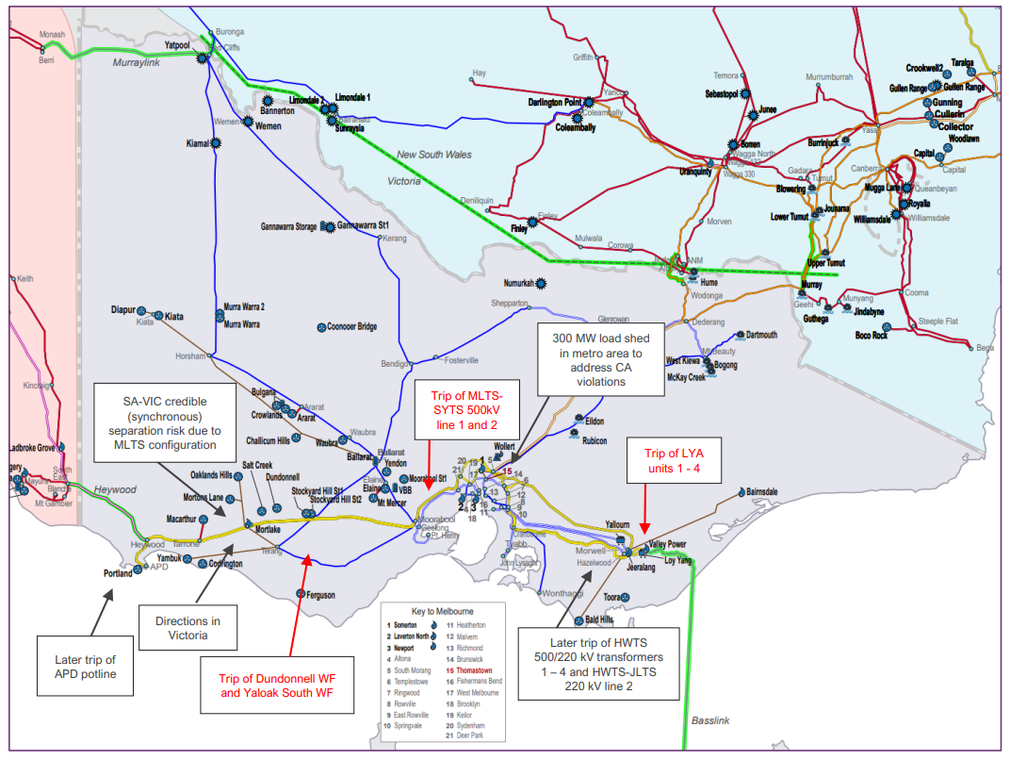
Figure 4: Map of impacts of the towers down at Anakie on 13 February 2024.

This load shedding event impacted approximately 90,000 customers in the west of Metropolitan Melbourne, with over half of these customers in the Jemena network area. While this event was significant, the action taken by AEMO and AusNet was able to stabilise the network.

The Network Outage Review is tasked with examining the operational response of AusNet to this incident. This includes matters such as contingency planning, the timely and effective management of the incident, and restoration of supply.

We heard
We met with stakeholders to discuss AusNet’s response to the transmission tower collapse near Anakie on 13 February 2024. This includes AusNet, AEMO and Energy Safe Victoria.

AusNet has a contract with a third-party provider to provide transmission operations and maintenance services, including for fault response to the transmission infrastructure, across Victoria. To deliver these services, AusNet’s transmission services contractor has approximately 105 direct field operators located at multiple Victorian depot sites, including 14 licensed transmission line workers.

AusNet became aware of the incident on 13 February via a fault identification at its control centre. It dispatched responders, while also receiving external reports of transmission tower damage from Powercor.

AusNet enacted its emergency response procedures, setting up a transmission network incident control team to manage the event. Its first priority was to ensure the site was safe. AusNet then began its process of restoring the damaged transmission line with temporary transmission towers.

AusNet and its transmission services contractor advised that in the response:
- Temporary transmission structures were onsite by 7pm on the evening of 13 February.

- The initial assessment phase of identifying damage and developing a plan to construct and restore service to the impacted line was completed in the first few days. This included a completed engineering/technical design for temporary transmission tower structures within the first 24 hours.

- Constructing temporary transmission towers would take two to three weeks. AusNet contracted additional transmission line workers from other projects across the State to assist in the repair of the transmission service. These additional resources commenced on 14 and 15 February.

- At the peak of the response, there were approximately 85 licensed transmission line workers and other construction specialists constructing the temporary towers and repairing the transmission service.

- Line 1 was restored by 25 February with line 2 restored by 6 March.

- The AusNet and its transmission services contractor’s transmission response did not impact the emergency response of AusNet in its distribution network, as transmission line workers require a different licence to distribution line workers. Both categories are licensed by Energy Safe Victoria.

- The response to the transmission event was delayed due to short periods of windy weather, which made it unsafe to continue works.

- AusNet had a previous transmission tower collapse in Cressy near Colac in January 2020 and had incorporated lessons from that event into its emergency planning practices. This meant that AusNet had ready access to temporary transmission tower structures and had existing engineering/technical designs of the towers, supporting a more timely response.

- AusNet has indicated it will incorporate lessons from this event for future events. Key lessons include:

2020 Cressy AusNet transmission tower collapse
On 31 January 2020 at 1.24pm, six AusNet transmission towers at Cressy, near Geelong, were damaged due to a severe convective downburst (severe winds) during a thunderstorm, tripping the Moorabool to Mortlake and the Moorabool to Haunted Gully 500 kilovolt (kV) transmission lines.

This resulted in a separation event, where the South Australia region and Victoria’s Portland Alcoa Aluminium Smelter (which also tripped), Mortlake Power Station, Macarthur Wind Farm, and Portland Wind Farm separated from the rest of the Victorian region. This event caused Lack of Reserve (LOR) Level 2 conditions, requiring AEMO to activate reserves to manage Victorian electricity demand.

AusNet restored service to the impacted transmission lines by constructing temporary transmission towers. The first line was restored on 17 February 2020 (17 days), and the second on 3 March 2020 (32 days).

Energy Safe Victoria investigated the 2020 incident, and concluded that:
- The cause of the incident was a severe weather event (severe conductive downburst)
- The damaged towers had been inspected and maintained in accordance with ESV requirements – but were constructed in the early 1980’s in accordance with design standards that did not account for high intensity winds generated by severe thunderstorms (convective downdraft wind gusts).
- AusNet’s response to the event was appropriate
- New replacement towers would be constructed to the most recent design standards, which consider high intensity winds (from severe thunderstorms) in their design.
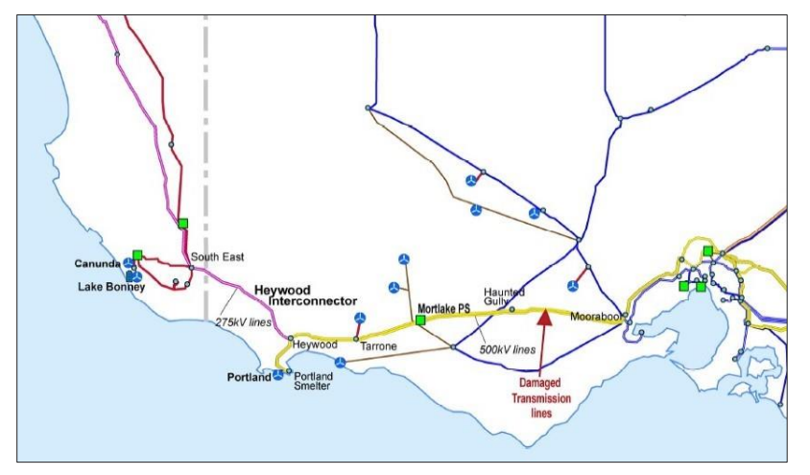
Figure 5: Map of impacts of 2020 Cressey towers failure.
As an outcome of AEMO’s investigation into the event, it was recommended AusNet conduct a risk assessment into the potential for similar extreme weather events to impact its assets.

  - Refining temporary transmission tower designs for more specific situations across its different transmission tower designs, and parts of the network.

  - Procurement of necessary materials based on the refined scenarios, including adequate concrete blocks for anchoring temporary structures.

  - While there are always opportunities for improvement, the response to the transmission tower collapse was considered to be managed in a timely and effective manner.

Stakeholders engaged have indicated that AusNet’s response to the transmission tower collapse was effective, with construction of temporary towers and full restoration of the transmission line service by 6 March after the 13 February event.

As a result of this event, Energy Safe Victoria is investigating the factors that contributed to the collapse of the six transmission towers, including AusNet’s compliance with its safety obligations, which incorporates its inspection and maintenance responsibilities.

Due to the consequence of this event on power system security, AEMO is also required under the National Electricity Rules to assess the response and appropriateness of actions taken to restore power system security.

Both investigations are separate to the Network Outage Review.

We’re thinking
Based on the evidence, the response to the transmission tower collapse and restoration of transmission lines by AusNet and its transmission services contractor were completed in a timely and effective manner.

AusNet’s systems identified a fault on its network, and staff were dispatched to inspect. Once inspection of the fault was completed and relevant information available, AusNet enacted emergency procedures and worked to make the site safe. It then worked to deploy reserve temporary transmission tower structures, developed designs to construct these towers and restore service to the line, procuring the additional resources it required to respond to the event.

AusNet had incorporated lessons from the previous event on its transmission network and, on the whole, had the necessary materials and pre-works completed to enable a more timely response. There are opportunities for AusNet to incorporate further lessons from this event to undertake more targeted planning and preparedness based on the different transmission towers it has across its network, and the different environments in which these towers are based.

We’re thinking:
- AusNet upgrade its asset integrity register and its contingency planning for events that affect its transmission towers. The upgrade is to include transmission tower design, location, maintenance history, and labour and equipment resource availability.
- AusNet support its compliance with Emergency Management Act 2013 attestation and audit requirements with evidence of its identification of transmission tower and line risks, risk controls and maturity level in organisational risk management.

Distribution network response to 13 February 2024 storm event

Before the 13 February 2024 storm event
Distribution businesses undertake a series of activities outside of emergency events so that they are prepared and ready to respond during events.

For essential services including telecommunications, it is about working with distribution businesses to understand the electricity supply risk to their assets on the network, and developing continuity plans so that they can continue to deliver essential services to the community when the power goes out.

For distribution businesses, everything from planning and preparedness, through to network design, build, maintenance, organisational resource, event mitigation, and response are incentivised through a series of regulatory incentives and compensation measures. These are designed so that distribution businesses provide reliable and effective services to their customers across everything that they do – by allowing increased revenue for excellent performance and decreased revenue (or increased costs) for poor performance.

These measures, if designed and implemented well, should position distribution business to mitigate the impact of events, improve their response, and provide reliable electricity services to their customers.

The focus of the following sections is on the core planning and coordination activities of distribution businesses, critical infrastructure, local councils, and emergency services, and how the experiences of this event highlight improvements that are necessary to get better outcomes for the community.
It also focuses the underlying incentives and compensation measures that drive the behaviour of distribution businesses and how they could be optimised to respond to a changing environment, increase accountability on distribution businesses and provide community with the right support needed in events that cause impacts at scale.

Planning and Coordination

Introduction
In examining the planning and operational response of Victoria’s distribution businesses to the 13 February event, we are tasked with examining the operational response of the distribution businesses to the event, and how their coordination with other agencies influenced their operational response. The ability to coordinate and respond effectively to an event stems not only from appropriate planning and preparation within a distribution business, but also with key organisations it is likely to need to respond alongside. This section examines coordination, preparedness, and planning, noting these themes continue in some form in most parts of this report.

Planning and preparing for events within an organisation, and with other responder organisations, is essential to an effective and well-coordinated response. Planning and preparedness for emergencies can include activities that prevent impacts, prepare organisations to better respond when impacts do occur, provide relief and support longer term recovery. Preparedness for emergencies involves making arrangements, creating and testing plans and processes, training, exercising and other activities that will improve response effectiveness, and reduce the negative effects of emergencies on organisations and the community.

Ineffective coordination increases effort without gaining the desired outcomes.

Communities and stakeholders told us
We have engaged deeply with affected communities, distribution businesses, regulators, emergency services, peak bodies, social and community organisations. Communities that were impacted by the 13 February 2024 event include Cockatoo, Emerald, Gembrook, Monbulk, and Mirboo North areas. We heard that:

There were opportunities for closer cross sector coordination between distribution businesses, emergency services and local councils that could have improved restoration of power supply and provided better information and support to customers. Communities want better coordination between all responding organisations including community groups.

- The community want a more coordinated response from distribution businesses, local councils, emergency services and the community. Many in the community found it difficult to know each organisation’s role and responsibilities during the event.

- The community appreciated the initial response from local volunteers, but later involvement of local councils and authorities created additional complexities.

- AusNet and local councils did not have well established relationships, which impacted their ability to disseminate information through established community groups and physical message boards in community centres where outages were prolonged. Existing systems and structures such as the Municipal Emergency Management Planning Committees are an opportunity to better integrate distribution businesses with emergency services and local councils.

- Ensuring that roles and responsibilities are captured in state, regional and local emergency management planning has been identified as an opportunity to further enhance the coordination between responding agencies and the community.

Municipal Emergency Management
Municipal Emergency Management Plans (MEMPs) are developed by the relevant Municipal Emergency Management Planning Committee to:

- Foster sustainable and efficient emergency management systems that mitigate the risk and consequences of emergencies.
- Establish governance arrangements that clarify the roles and responsibilities of agencies while facilitating cooperation between agencies.
- Promote community resilience through implementing an ‘all communities – all emergencies’ approach to emergency management.

MEMPs outline the mitigation, response and recovery strategies for emergencies that may occur within a specific municipality. Where appropriate, MEMPs may also outline intention and guidelines for inter-operability arrangements with neighbouring municipal districts.

Community Emergency Risk Assessments (CERAs) are a hazard risk assessment process that identifies risks specific to a community within a municipality. The CERA process is incorporated within MEMPs, enabling the identification of vulnerable and critical community assets, and is used to inform community emergency management planning.

The CERA process is conducted with the engagement of municipalities, emergency agencies and community members ensuring a tailored and relevant approach to emergency preparedness is utilised.

- Distribution businesses did not readily know where and what community events its presence would be valuable at nor which community hub locations to provide information and support to, or where to support communication when power-dependent communication modes had been lost.

- The community identified that better communication and coordination of relief measures is needed in events, and that could be achieved through cross promotion of relief services across organisations.

- There are opportunities to improve how distribution businesses work together, and how they in turn work with emergency services to deliver more effective coordination during emergencies to achieve more effective restoration of services. This will require removal of barriers between different organisations’ processes, systems and resources.

Improved planning and preparedness outside of emergency events and between critical infrastructure and responder organisations will support more effective coordination during events and improved restoration of customers.

- Many in the community, including businesses and industry, were not prepared for a prolonged power outage and storm event. Some have developed plans because they believe emergency services cannot support them during prolonged storm events.

- Some communities have strong preparedness at the local community level, with both formal and informal groups active in supporting planning and response. These groups can be more effectively leveraged in preparing for and responding to events. Opportunities have been identified in a range of supporting materials to support household and community planning such as the Energy Ready Toolkit.

Energy Ready Toolkit
The Energy Ready Toolkit is a free resource produced in consultation with communities for communities to help them prepare a plan for a power outage and ensure they remain energy resilient.

Communities in Queensland, Victoria and New South Wales have shared their lived experience of disasters and extended power outages during in-person workshops, and their lessons learned on what to do or not to do in crisis situations. A common theme from these events was social isolation and general disconnection between community members.

The Energy Ready Toolkit addresses energy resilience from a practical perspective, helping communities to first come together, then prepare, cope with, and finally recover from extreme events in ways that meet their collective needs, deliver benefits across sectors, and drive systemic change.

A resilient community is socially connected, has reliable infrastructure to withstand disaster and foster community recovery, and takes the necessary steps to adapt and transform.
The Energy Ready Toolkit is the result of a Collaboration Grant from Energy Consumers Australia in partnership with UTS Institute for Sustainable Futures (ISF), the Community Power Agency and Parallel Lines.

You can access and download the Toolkit (for free) here.
For more information, visit Energy Ready: empowering energy-resilient communities.

- Some critical infrastructure and essential services did not have suitable business continuity arrangements for a prolonged power outage. Even fewer had suitable plans for loss of both power and telecommunications. Planning and coordination between distribution businesses and essential services could support better continuity planning.

- Many organisations had not exercised concurrent telecommunications and power loss in as part of their emergency management planning.

- There are opportunities for distribution businesses to work with local councils and communities, critical infrastructure and emergency services outside of an emergency to develop relationships and co-design plans, systems and protocols to enable effective coordination and a more effective response.

We’re thinking
The 13 February storm event significantly impacted AusNet’s network, and our engagement identified that better coordination is required before, during, and after events to improve the operational response and achieve better outcomes for community.

Notwithstanding the lessons learned by AusNet in this event, we consider that effective response to an event of this scale requires robust planning by all distribution businesses. Additionally, the complexities of large-scale power outage events (and their causes) require the concurrent response of distribution businesses, emergency services, local councils and volunteers. Responding in isolation is rarely effective, and strong coordination of responder organisations is needed to achieve better outcomes for the community and customers.

Better planning before events will improve response during events. In improved planning across the ecosystem, we consider that:

- Distribution businesses should work with Municipal Emergency Management Planning Committees to ensure Municipal Emergency Management Plans and Community Emergency Risk Assessments include prolonged power outages.

We have identified that the State Emergency Management Plan does not specify roles and responsibilities to distribution businesses beyond generic groupings of ‘energy industry’. Improving the roles and responsibilities under the SEMP will ensure that distribution businesses have clarity on expectations during energy emergencies.

- The Department of Energy, Environment and Climate Action (DEECA) work with Emergency Management Victoria (EMV) and distribution businesses to update the State Emergency Management Plan to make explicit the role of transmission and distribution businesses as responder / support agencies for electricity emergencies.

Many in the community were not well prepared for a prolonged power outage, which would have reduced reliance on communications. Improved planning and preparedness by all distribution businesses with local councils and community organisations outside of an event will support better responses to future events across Victoria.

- Distribution businesses in conjunction with other Victorian critical infrastructure providers plan for how they will support community-led recovery groups in their response, relief centres and support to vulnerable community members.

- Distribution businesses in collaboration with emergency services, local councils and community groups to support community members to create a household plan for prolonged power outages in line with bushfire plans.

AusNet’s restoration was diverted by priority restoration requests of critical infrastructure like telecommunications and wastewater sites, which had insufficient business continuity arrangements for prolonged power outages. Critical infrastructure should put business continuity arrangements in place for prolonged power outages, and work with distribution businesses to understand where their sites are located on the network, as this will support their business continuity planning. We consider that this could be achieved through existing cross-sector forums.

- Enhance existing critical infrastructure forums to support Regional Emergency Management Planning of distribution businesses and critical infrastructure providers
  - Forums that enable planning between the distribution businesses and critical infrastructure providers will help the distribution businesses understand critical infrastructure in the context of their network. It also informs business continuity planning for critical infrastructure providers about their location on the network, and associated risk profile in events. These in turn, will inform REMP, and support more coordinated response during emergency events.
  - The Utilities Consultative Committee is a planning and coordination forum co-chaired by AusNet and Southeast Water, consisting of regional essential services. This forum could be expanded, or equivalent regional forums developed, to support more coordinated planning between distribution businesses and telecommunications providers.

We have heard that better coordination is required across sectors to plan, coordinate, and respond more effectively with customers at the centre. As a part of any planning and preparedness, this must be practised to identify whether the planning was effective and incorporate any lessons and improvements into future practice. We have also heard that many organisations had not exercised the loss of both telecommunications and power are a part of their preparedness activities. In achieving better coordination, exercising across sectors to understand these impacts would benefit coordination and planning for future events. We consider that:

- Distribution businesses exercise network-wide, multi-sector emergencies with cascading impacts with other responder organisations to identify and remove barriers to effective coordination and response.

Accountability in delivering on these outcomes is important. In ensuring that distribution businesses deliver on the above outcomes, we consider that:

- Distribution businesses demonstrate compliance with the Emergency Management Act 2013 attestation and audit requirements through the provision of evidence of:
  - collaboration with Municipal Emergency Management Planning Committees on their Community Emergency Risk Assessments
  - the update of risks and risk controls following the exercise of network-wide, multi-sector emergencies

Planning for life support customers

Introduction
Life support customers are electricity customers who require electricity to power devices to maintain their health and wellbeing. During prolonged power outages, the consequences for these customers can be significant. Life support customers are a subset of people experiencing vulnerability. People experiencing vulnerability are those who may be unable to take care of themselves or are unable to protect themselves against harm.

In Victoria, life support customers are identified on registers held and maintained by distribution businesses using data provided by a customer’s retailer (see case study below). Life support customer registers are important tools that identify customers who are vulnerable to power supply loss due to medical reasons. In an emergency, health and emergency services organisations check on the welfare of these customers and provide them with support if it is needed.

In examining how timely and effective the operational response of Victoria’s distribution businesses to the 13 February event was, the Network Outage Review is tasked with examining their preparedness to administer relief and customer support; and the tools and systems to communicate proactively with customers.

We have heard significant feedback from the community regarding life support customers and considers effective support to life support customers merits examining in the Network Outage Review to build on the work undertaken as part of the Electricity Distribution Network Resilience Review in 2022.

Life Support Customers – an explanation
Life support customers require medical equipment in their homes for their health and wellbeing. This medical equipment requires a reliable power supply to function. Their health and wellbeing can be more significantly impacted during power outages.
A life support customer is anyone who relies on medical equipment, with a broad list of equipment set out in the Essential Services Commission Energy Retail Code of Practice 2022.
When a customer notifies either a retailer or a distributor that they have life support equipment, the businesses are required to register this customer, and notify the other business. Each distribution business maintains a life support customer register, with information provided primarily from retailers. Medical confirmation of the customer’s medical status is required to remain on this register, and customers should be removed if they do not provide this.
These requirements are set out in the Electricity Distribution Code of Practice, and the Energy Retail Code of Practice.

Once a life support customer is registered, they receive additional notification and support before planned outages, prioritisation of their welfare and support during unplanned outages, and access to an emergency number to access support.
Life support customer details are also provided to health and emergency services during prolonged power outages and other emergency events, enabling health and emergency services to check the welfare of customers and support them if needed.
Contrary to community expectation or belief, being a life support customer does not prevent their home from losing power or guarantee a faster restoration. Life Support Customers will experience power outages of the same duration as their neighbours and local communities during events. It instead allows the distribution businesses and emergency services to know who these customers are, make sure they are safe during an event, and provide support to these customers if needed.
Distribution businesses are also required to provide information to assist life support customers in preparing for unplanned outages under the Electricity Distribution Code of Practice. This can include encouraging these customers to have a back-up plan in place in the event of a power outage. Back-up plans vary for each life support customer depending on their needs. Some back-up plans identify what steps to take in a power outage, where to go and how to get there, who to contact and how, and the need to keep medical equipment fully charged. Customers with more significant medical needs may require back-up power supply (generators or batteries) in their homes or may need to seek alternate accommodation.
Medical confirmation of life support customer status is required within 50 business days of registering to remain on the life support customer register. Retail or distribution businesses may deregister customers who do not provide this confirmation, subject to taking reasonable steps to contact the customer about the registration and notifying them of their de-registration. In practice however, de-registration is not occurring.

Customers and Stakeholders told us
We have engaged deeply with affected communities, distribution businesses, regulators, emergency services, peak bodies, social and community organisations. Communities that were impacted by the 13 February 2024 event include Cockatoo, Emerald, Gembrook, Monbulk, and Mirboo North areas. We heard that:

Life support customers did not feel adequately supported during the event.

- Life support customers and their support persons want improved communication during prolonged outages and physical welfare check-ins.

- Due to the failure of local telecommunications during this event, life support customers did not have the ability to contact support persons or other support services.

- Clear and consistent life support customer messaging is important in preparing life support customers and their support persons for power outages. This includes support for customers to have a sufficient back-up plan for emergencies, including emergencies with no communications. It also includes increasing awareness that life support customers will not receive priority restoration within two hours of the power going out – which stakeholders identified was a belief held by many life support customers.

- Generally, distribution businesses have processes in place and are proactive in their communications with life support customers before planned outages and during unplanned outages, with many having a priority line available for life support customers. The distribution businesses notify life support customers of risks to their power supply disruption before high-risk weather periods.

- AusNet call centre staff provided welfare checks on life support customers during the event, but limitations with the accuracy of the register, and telecommunication failures meant that this work was hampered.

- There are a number of different registers at different tiers of government for vulnerable persons, with varying levels of information. This makes effective management and utilisation of registers during emergencies difficult. The Life Support Customer Register is just one of these lists.

- Members of the community can become vulnerable during a prolonged outage (particularly if communications services are not available) and may not be listed on the local council vulnerable persons register, or as a Life Support Customer. Despite not having a qualifiable medical condition, a prolonged power outage has a significant impact on their health, wellbeing and safety.

  - An older person who had lost both power and communication had resorted to eating mouldy food because access to their street was blocked by a fallen tree, and the food delivery organisation could not access the property to provide food and did not refer this individual’s circumstances to an emergency response organisation to resolve.

The number of customers on life support customer registers has grown significantly over recent years - the information is not accurate or adequately updated and does not identify those with critical health needs. This reduces the efficiency and effectiveness of distribution businesses, health, and emergency services capacity in providing welfare checks and other support to life support customers.

- The Distribution Network Resilience Review identified that the life support customer list had doubled from 2016 to 2022, with over 25,000 registered life support customers. The distribution businesses have advised that the size of the list continues to grow. Given its size, it is extremely difficult for the distribution businesses, health, and emergency services to use this register meaningfully to prioritise support to customers.

- There is not enough information available in the list about the medical needs of the customer to effectively prioritise support activities to the most critical customers within the registers. The type of medical device the customer requires, and whether the registration is medically confirmed, would assist in triaging support during an event.

- Accuracy and currency of information on the register is poor. There are obligations on retailers to maintain accurate Life Support Customer information and de-register customers in Part 8 of the Energy Retail Code, but provisions to remove customers do not compel retailers to do so. These provisions result in retailers not removing people from the register, as doing so creates a risk for them if an inaccurate deregistration occurs.

- Retailers are the primary customer contact point for energy customers. They are best placed to register and de-register life support customers as they have the closest relationship to the customer. The Energy Retail Code, however, does not compel them do so, as it says they ‘may’ de-register a customer. While distribution businesses maintain the register for their distribution area, they are also hesitant to de-register customers that do not seek medical confirmation.

- There are opportunities to refine the list of registered life support customers by removing customers for whom information is confirmed to be out-of-date. This will benefit the remaining life support customers during an event as we will be able to contact them sooner. This assessment is most appropriately carried out by retailer as the party that registered the life support information in the majority of cases.

There is work underway in Victoria and nationally, to improve the life support customer registers through the Essential Services Commission review, and the Energy Charter #BetterTogether Initiative

- The Distribution Network Resilience Review (DNRR) recommended that the ESC, with support from government agencies, should carry out a review of the life support register arrangements in the Electricity Distribution Code of Practice to:
  - Improving the customer registration process to support customers to obtain medical confirmation without delay
  - Require that the register identify the ‘critical few’ who have a complex, severe or critical need
  - Embed regular reviews of the register to ensure it remains relevant (this could require businesses to confirm that customer added registration is appropriate every 2 years, for example)
  - Improve business to business arrangements to ensure retailers are required to provide up-to-date information to Distribution businesses for use in emergencies
  - Drive regular audits of the life support registration and register maintenance processes of Distribution businesses and retailers.

- The Energy Charter and its members are working to improve outcomes for life support customers by:
  - Creating a ‘Critical Needs Life Support Customer’ category – so that customers who would be critically impacted by power loss are clearly identified in the register, and support can be provided quickly
  - Co-developing a national medical registration process – establishing a robust process of identification so to keep the list accurate and targeted
  - Co-developing a national outage back-up plan template – developing a template back-up plan that is integrated with GP’s IT systems. This would provide GPs with the necessary information to support their patients to develop a suitable back-up plan for their medical condition during a power outage
  - Co-developing a national information and awareness campaign – on power outage back-up planning, keeping their life support customer information current, and any eligible concessions.

The Energy Charter #BetterTogether initiative working together to better protect Life Support Customers
Better Protections for Life Support Customers is the Energy Charter’s #BetterTogether initiative, which is committed to identify life support customers with critical continuous energy supply needs on life support customer registers. This will allow energy distribution businesses to better support them.
The Australian Energy Foundation Report Better outcomes for energy consumers using life support equipment at home, funded by Energy Consumers Australia in 2022, outlined key findings from over 4,000 life support customers surveyed. The research found that:
- 59% of life support customers use their Life Support Equipment to sustain their life
- 54% of life support customers do not have a plan in place for back-up power
- 68% of life support customers mistakenly expected priority power restoration within 2 hours
- 7% of life support customers have access to back-up power
Energy Charter signatories, collaborators and supporters have engaged with customer and patient representatives, the medical profession and the energy sector to consider how to better protect life support customers. The Energy Charter established the Life Support Medical Advisory Group in 2022, to support energy businesses and medical professionals collectively exploring meaningful support programs for life support customers. This resulted in key recommendations that underpin the initiative’s Rule Change Proposal.
Since October 2023, the Energy Charter have extended collaboration with energy and health consumer representatives to ensure life support customers, under the existing definition, are appropriately protected. In counsel with the Public Interest Advocacy Centre and in partnership with Consumer Health Forum of Australia, the initiative works to prioritise life support customers who face life threatening circumstances if their life support equipment loses power.
In 2024, the Energy Charter, in partnership with Consumers Health Forum of Australia, established a consumer panel of health consumers with lived and living experience of life support equipment in the home. Panel members will work to co-develop the initiative’s opportunities over the next 12 months until December 2024.
The opportunities include:
- Re-define life support customers and include in proposed rule change – introduce a critical needs life support customers definition and incorporate the definition and associated customer protections for considerations to Australian Energy Market Commission (AEMC).
- Co-development of a national Medical Registration Process - ensure safety steps are taken as part of the Medical Registration Process and build capacity of health and wellbeing services to implement better protections for all life support customers.
- Co-development of national outage back-up plan template - most people on the Life Support Equipment Register don’t have adequate back-up plans. There is an opportunity to work with representatives of life support customers, their carers and professionals from health services alongside Energy Charter #BetterTogether Collaborators, to develop a national outage back-up plan template.
- Co-development of national information and awareness campaign - working with those with lived experience as life support customers, their carers and professionals from health and services alongside #BetterTogther Collaborators to co-develop a national information and awareness campaign that ensures diversity and equity, underpins communication approaches and provides life support customers with regular updated information and support. This includes, but is not limited to:
- in the preparation of natural disasters
- if they move house
- if their medical situation changes.
The proposed Rule Change (opportunity 1) is expected to be submitted to the AEMC at the end of July, supported by an 18 to 24-month change management process. However, to protect life support customers now, the Energy Charter will coordinate and deliver co-development opportunities 2 to 4 from April to December 2024, making sure life support customers are more prepared to stay out of danger when the power goes out.

We are thinking
In responding to events, there are multiple vulnerable customers lists maintained by different agencies and organisations, at different levels of government and industry. Using these lists in a meaningful way quickly during an emergency is becoming difficult. Enhancing how prolonged power outages are considered in the broader context of at-risk communities would also ensure that those experiencing vulnerability more broadly, are captured on a register and can be supported during an emergency.

- Victorian Government work with local councils, community organisations, and distribution businesses to create or improve vulnerable customer registers that address vulnerability to power outages and other emergencies more generally.
  - We heard of vulnerable persons within impacted communities who required support during the 13 February event and in some cases did not receive it. There is a gap between the Life Support Customer Register, which is a medical health dependence on power supply, and those who are at risk of becoming vulnerable in a prolonged power outage.
  - We consider that an existing list could be utilised for this purpose, and seeks stakeholder views on the most appropriate list, and best placed authority to maintain this list.

Life support customers are vulnerable to the impacts of a power outage, as the medical equipment they rely on for their health, wellbeing and safety requires power supply. During this event, community felt that life support customers were not adequately supported during the event and want better support in future events.

Concerningly, some life support customers did not have suitable back-up plans, and there is an incorrect assumption among many life support customers that they will be restored significantly faster than other properties in a power outage event. The dispersal of life support customers across the network, and the physical limitations in how the network is restored, mean that this is not a correct expectation. Improved understanding of the potential impact of power outages for life support customers, and better back-up planning, are needed.

AusNet, and the other distribution businesses, provided pre-emptive messaging to life support customers about the risk of a power supply disruption before the 13 February event. Compared to other networks, AusNet had the most significant impacts to its network. AusNet and emergency and health services’ ability to provide support to life support customers during the 13 February event was made more difficult, because the Life Support Customer Register is large, contains inaccurate contact details, and customers with critical health needs (who may need priority support) are not well identified. Energy retailers collect most life support customer information but aren’t accountable or incentivised to register customers, see the registration process through to confirmation, de-register customers if they do not provide medical confirmation, or ensure life support customer details are current. The dynamic nature of Victoria’s retail market, with customers moving from retailer to retailer, may compound this issue.

The Essential Services Commission is currently reviewing the Energy Retail Code of Practice. The Energy Charter and its member organisations, through its #BetterTogether Life Support Customer Initiative, are progressing a national rule change to address many of the issues being experienced by distribution businesses across the National Electricity Market. There is an opportunity to leverage this work and apply it to Victoria to get better outcomes for Victorian customers – and support those in need during emergencies.

We consider that life support customer registers need to be accurate, current, and effectively identify customers with critical life support needs. The below measures would address the accuracy, size, currency and ability to identify life support customers with critical needs in the event of an emergency. It would enable more effective utilisation of life support customer registers in Victoria by the distribution businesses, emergency and health services to support customers in prolonged power outage events or other emergencies – resulting in better outcomes for these customers.

- The Victorian Government and energy sector work with The Energy Charter #BetterTogether Life Support Customer Initiative to support a national approach to achieve better outcomes for life support customers.
  - The intent of The Energy Charter initiative should be adopted in Victoria to enable identification of critical life support customers, and support better backup planning, taking into account the national rule change process and amendments to Victorian legislation and regulation.

- The Essential Services Commission review its Energy Retail Code of Practice to enhance accountability and compliance of energy retailers in collecting, validating, and updating life support customer data, referring this to distribution businesses, and undertaking their role in de-registering life support customers who are not medically confirmed or no longer eligible.
  - The review should identify and remove barriers to achieving a high level of accuracy and currency of the register, including amendment and de-registration of life support customer information.
  - The review should have regard to the #BetterTogether Life Support Customer Initiative, including the addition of a ‘support person’ category into the register.

Telecommunications continuity planning

Introduction
In reviewing the operational response of Victoria’s distribution businesses to the 13 February event, the Network Outage Review is tasked with examining how timely and effectively the incident was managed, including the operational response of the distribution businesses, and their ability to communicate with customers.

We consider that in getting better outcomes for customers and the community, the distribution businesses’ capacity to respond and communicate was impacted by telecommunications outages, and that this matter merits examination in the Network Outage Review.

Telecommunications is a responsibility of the Australian Government, governed primarily through the Telecommunications Act 1997. The Victorian Government works with the telecommunications sector in planning and preparedness to improve resilience, and in response to emergency events, under the State Emergency Management Plan and Critical Infrastructure Resilience Strategy.

It is important for the community to be prepared for power outages. This means understanding how to best manage a power outage in their individual circumstance. It is even more important for organisations that provide essential services to have appropriate business continuity planning arrangements in place, so they can continue to provide the essential services that the community relies upon.

The capacity for the community, the distribution businesses and emergency services to communicate with each other during power outage events is critical to achieving an effective response, but also so that community members can get the information they need to make the right decisions for them, support each other and let family know what’s happening.

It is important that telecommunications services are robust and that appropriate planning is in place so that telecommunication services are available to the community, distribution businesses and other essential services during a prolonged power outage.

Given that telecommunications in any location may involve multiple types of services (e.g. mobile services or broadband to the premises, community Wi-Fi, satellite broadband) and multiple commercial providers, it may be that a cooperative multi-carrier approach to maintaining connectivity can provide the most efficient and effective solution. For example, current arrangements for mobile Triple Zero calls enable a single carrier to provide this service to customers of other carriers.

Business continuity planning of essential services, in the context of electricity supply, is understanding how a power outage would impact the delivery of an organisation’s essential service to the community (the consequences of a power disruption). It then involves putting into place steps to eliminate or reduce the risk that a power outage can have in disrupting an organisation’s ability to provide its essential service to the community.

Customers and stakeholders told us
Telecommunications outages – 13 February event
The 13 February storm event resulted in significant outages of Victoria’s telecommunications infrastructure, which did not have back-up arrangements for a power outage capable of managing an event of this duration and scale.

At the peak of the event:
- 1,100 mobile and broadband carrier network sites were without power
- 250,000 customers were without NBN broadband services
- 60 communities were potentially unable to contact Triple Zero (000)

While back-up arrangements (diesel or battery back-up) were installed or deployed to continue providing telecommunication services, these back-up arrangements proved insufficient and local communities lost mobile and internet services after a few hours of network power loss.

We have engaged deeply with affected communities, distribution businesses, regulators, emergency services, peak bodies, social and community organisations. Communities that were impacted by the 13 February 2024 event include Cockatoo, Emerald, Gembrook, Monbulk, and Mirboo North areas. We heard that:

The loss of communications intensified the experience of the event as it isolated individuals, restricted information access, prevented purchase of essential supplies and undermined their safety. The community want better resilience of telecommunications.

Resilience for telecommunications
The Commonwealth Government has recently opened funding rounds for both the Telecommunications Disaster Resilience and Innovation (TDRI) program and Disaster Ready Fund (DRF).

Victoria has worked with carriers to support applications for several projects aimed at bringing new technology and innovation to telecommunications infrastructure and substantially uplifting its reliability. Examples of these technologies include:

- Automatic Transfer Units (ATUs) allow temporary generation to automatically detect power loss and transfer to back-up power. ATUs also facilitate easy installation of temporary generation to mobile towers, enabling local responders to deploy generation in an emergency event.
- Long Duration Battery Energy Storage Solutions that deliver more reliable power supply to key telecommunications infrastructure by deploying solar generation that can support power loads for 24 hours.
- Emergency response push to talk communication capability that is enabled by the Starlink network for responders in the field.
- Better data sharing, trialling more real time information sharing between a carrier and government.

- Accurate and timely information is required so that communities can make the best decisions for themselves in emergency events.

- The community need functional communications during an event to receive and provide information, let other people know they are safe, as well as keep people connected and mentally well. Telecommunications loss in addition to the power outage made the experience of the event much worse for the community.

- Loss of phone and internet communications was a key issue for the community, emergency services, and AusNet, and in some locations.

- Telecommunications loss impacted Triple Zero (000) services in communities during the event, significantly undermining public safety.

- Implementation of emergency roaming by the Commonwealth will support better outcomes for the community.

- The community want improved telecommunications resilience, and compensation for mobile communication outages.

- Some in the community identified the telecommunications outage impacted them far worse than the power outage during the 13 February event.

- Like power supply, communications services underpins the communities’ access to banking and financial services, which is essential to purchase products and services during an event.

- The community want better pre-warning of a potential or actual telecommunications outage before it happens – so they can plan accordingly. A notification that a local mobile tower was impacted and running on back-up power would give the community an opportunity to plan accordingly.

- The community expects a very high level of reliability from telecommunications - higher than its the expectation on power reliability.

- The community wants compensation for communications outages because of financial, social and personal impacts an outage has on them.

- Where support for communications infrastructure has been made such as the STAND program (see below), community were pleased that these initiatives kept people connected during the emergency. However, there were concerns about the sustainability of this into the future once initial funding concludes. There was also sentiment within the community that these installations should be further rolled out and supported.

Telecommunications loss impacted the capacity for the community, response agencies and AusNet to communicate among themselves and each other to respond effectively and safely. Most communication with the community is undertaken via electronic platforms during emergencies, which is not effective when telecommunications and power outages occur simultaneously.

- Functional telecommunications are required for an effective response and multiple telecommunications channels (mobile services, SMS access, internet access) failed during the event. Maintaining telecommunications is a higher critical infrastructure priority than power for communities.

- Most organisations communicated with each other, and the community through electronic platforms during the event which was ineffective due to telecommunications and power outages. When telecommunications are out, the community needs alternate communication modes such as on the ground presence by distribution businesses, notice boards and community meetings.

Strengthening Telecommunications Against Natural Disasters (STAND) - Temporary Telecommunications Infrastructure Deployment
The Victorian and Australian Governments funded the installation of NBN Sky Muster satellite connections to evacuation, relief and recovery centres across Victoria that could be switched on during an emergency event to provide essential internet access. It also provides redundancy for when land-based communications are temporarily impacted due to power loss or damage to communications infrastructure.

- Loss of telecommunications impacted AusNet’s ability to communicate with its customers during the event. It also impacted the capacity for its control room and planners to coordinate and control an effective response, and the safety of field crews restoring the network. This challenge was also felt across other responder and emergency service organisations.

- Lack of business continuity for power outages by critical infrastructure and essential services providers meant that AusNet diverted resources to restore these services, impacting the broader restoration process.

- Loss of telecommunications impacted the emergency services response and its ability to support information flow, coordinate with different responders and effectively respond. It also impacted the safety of responders in the field.

Satellite Internet Services
Satellite internet services are increasing connectivity around the world, particularly in locations where internet is unreliable, unavailable, or expensive.

Compared to traditional forms of telecommunications that require towers and cables to transmit information, satellite internet services utilise radio signals sent from ground stations to satellites in orbit and then back to earth. To operate this service, satellite receivers can be installed where there is open access to the sky. Starlink and SkyMuster NBN are two satellite internet services operating in Australia.

Powercor, one of Victoria’s distribution businesses, provides access to Starlink satellite internet to impacted communities during power outages and other emergencies through its emergency response vehicles.

Satellite internet services were available in Victorian locations affected by the February 2024 storm event, but back-up power was not available to all sites.

- Maintaining telecommunications for emergency services is a critical infrastructure priority. The loss of multiple pieces of critical infrastructure made the experience worse for the community, other critical infrastructure providers and emergency responders.

- Some organisations had satellite internet services such as SkyMuster or Starlink during the event. These customers were able to continue accessing internet telecommunications services (if they had back-up power arrangements).

We are thinking
The outage of telecommunications infrastructure in certain communities made their experience of the 13 February event significantly worse. It isolated individuals, restricted their ability to access information about the event, and prevented them from purchasing the goods and services they need when the power goes out. Some in the community identified that losing their phone services was worse than being without power. The community want better reliability of telecommunications services.

Telecommunications outages also impacted the ability to respond to the 13 February event and provide relief to affected communities.

AusNet was limited in its capacity to provide information to customers, and operationally coordinate and communicate efficiently with field crews. Local councils, emergency services and other responders had a similar experience.

Most of the established communication methods used by responding organisations with communities relied on access to telecommunications and power. We discuss elsewhere in this report how this should be addressed.

While mobile and internet services were once novel luxuries, they are now an essential service in our lives, and underpin functioning communities, economies, and society. Community resilience is significantly undermined when essential services fall over like dominos as soon as a power outage occurs, and events that challenge our electricity systems are becoming more frequent and severe.

Telecommunication network providers need better planning and industry coordination to prevent their services from failing during power outages, and to support more effective response and restoration of telecommunications services when they do fail. This will deliver better outcomes for Victorian communities.

The implementation of the Optus Outage Review Recommendations (Bean Review), outlined in the case study below, will improve accountability of telecommunication network providers to ensure Triple Zero calls are delivered, regardless of the network. Better information sharing would also help facilitate better coordination and response during emergency events.

Optus Outage Review – Functioning of Triple Zero
The ‘Review into the Optus Outage of 8 November 2023 Final Report’ (March 2024) established a series of recommendations regarding the functionality of Triple Zero during emergencies – specifically in instances where the telecommunications network experienced mass outages.

The review identified:
- That clarification of telecommunication network providers’ responsibilities for Triple Zero call delivery is necessary.
- The importance of telecommunication network providers enabling Triple Zero calls to be carried out on any network, regardless of the customer.
Other key recommendations included:
- Establishing a Triple Zero custodian responsible for monitoring the end-to-end performance of the ecosystem.
- The compulsory conduct of 6-monthly end-to-end testing of all aspects of the Triple Zero ecosystem by carriers.
- Reviewing legislation and regulation relating to the delivery of Triple Zero.
- Requiring carriers to share real time network information detailing outages with relevant emergency services organisations and other appropriate entities.
When a customer’s carrier network is unavailable due to an outage, they can still access another available network to make Triple Zero emergency calls. However, the presence of ‘live’ Optus 3G towers and their failure to ‘wilt’ (disconnect) prevented consumers from accessing other networks to make emergency calls.
When applied to the 13 February event in Victoria, it is evident that adoption of the Bean Review’s recommendations and learnings would support preparedness, risk mitigation, planning and response effectiveness.

We consider that the following measures would reduce the likelihood of telecommunications services failing during prolonged power outages:
- The Victorian Government advocate for stronger telecommunications service reliability outcomes from the Australian Government, and associated telecommunications reviews.
  - Telecommunications services are the responsibility of the Australian Government, and improving telecommunications reliability can only be effectively delivered through national reform.
  - The Australian Government is currently undertaking a:
    - Regional Telecommunications Review – examining existing and future telecommunication needs in regional, rural and remote communities across Australia.
    - Universal Service Obligation (USO) Review. The USO is a requirement to provide standard telephone services so that all Australians have universal access to telecommunications services.

The Victorian Government should advocate for stronger reliability requirements of telecommunications infrastructure providers, including mobile roaming during emergencies, in these reviews. Stronger controls could include requirements for telecommunication providers to develop appropriate business continuity arrangements that are sufficient to provide telecommunications services to customers during a prolonged power outage.

- Government and industry responsible for telecommunications services ensure that there are appropriate arrangements for continued provision of services for 72 hours without network power supply.
  - Recent events have demonstrated that around 90 per cent of customers from a large-scale power outage are restored within 72 hours.
  - We consider that stronger business continuity arrangements would address how to prepare for, mitigate and respond to loss of power supply to prevent telecommunication disruptions to communities. Business continuity planning should include preparedness planning across the sector to better coordinate during events and develop response arrangements that are timely and effective.
  - In examining business continuity and responding to outages, the telecommunication network providers should explore the deployment of temporary mobile satellite telecommunications facilities within communities to provide access to telecommunications services during events.

- Telecommunication network providers to share - and keep current - information about their sites to enable more effective planning with distribution businesses and a faster emergency response.
  - This includes maintaining telecommunications infrastructure site names, National Metering Identifiers (NMI) and site addresses.
  - We consider that this will help telecommunication network providers work with distribution businesses to respond to an event. It will also help telecommunication network providers to understand their infrastructure risk profile considering the business continuity objective at each site. This would enable more effective mitigation of, and response to, power outages by telecommunication network providers.

- Enhance existing critical infrastructure forums to support coordinated emergency management planning and exercising by distribution businesses and critical infrastructure providers.
  - Forums that enable planning between the distribution businesses and other critical infrastructure providers will help the distribution businesses understand critical infrastructure in their electricity network footprint. It also informs business continuity planning for critical infrastructure providers, such as telecommunications, about their location on the energy network, and associated risk profile in events.
  - The Utilities Consultative Committee is a planning and coordination forum co-chaired by AusNet and Southeast Water consisting of regional essential services. This forum could be expanded, or equivalent regional forums developed, to support more coordinated planning between distribution networks and telecommunications providers.
  - The Energy Networks Australia (networks peak body) and the Communications Alliance (communications industry body) have an existing Memorandum of Understanding (MoU) to target effective collaboration and coordination between telecommunications and electricity networks in preparing for and responding to emergencies at local, regional and state level. These arrangements could be leveraged to enhance better coordination.

Business continuity planning for other essential service providers

Introduction
In reviewing the operational response of Victoria’s distribution businesses to the 13 February event, the Network Outage Review is tasked with examining how timely and effectively the incident was managed, including the operational response of the networks.

We consider that in getting better outcomes for customers, the timeliness of the distribution networks’ restoration was compromised because many essential services providers did not have appropriate business continuity plans in place to manage a power outage. This merits examination in the Network Outage Review.

Electricity supply underpins the operations of all essential services. It is critical for organisations that provide essential services, such as water, waste water and government services including health, to have appropriate business continuity planning arrangements in place so they can continue to provide the essential services that the community relies upon in emergency events such as prolonged power outages.

Business continuity planning for essential services, in the context of electricity supply, starts with understanding how a power outage would impact the delivery of an organisation’s essential service to the community (the consequences of a power disruption); and then involves putting into place steps to eliminate or reduce the risk that a power supply disruption will impact the organisation’s ability to provide its essential service to the community.

Essential Services and electricity supply dependency
Energy is itself an essential service. But all other essential services require electricity to provide their services to the community. Failure of one, or multiple essential services significantly impacts the health, wellbeing and safety of the community, or the environment. The diagram below explains these interdependencies.

The dependencies between energy and the water, banking and finance, transport, health, government, communications sectors are significant. While the consequences are wide ranging, energy supply loss to:
- Water Sector – impacts the treatment and distribution (pumping) of water, wastewater treatment, and the electronic systems that underpin these activities. Water supply loss would likely impact the health and wellbeing of the community, while failure of wastewater systems causes damage to the environment.
- Banking and finance – disrupts electronic payments systems to purchase goods and services, and access to cash; causing significant impacts.
- Transport – impacts electronic transport (trams, trains, electric vehicles), electronic systems (traffic lights, bridges). Loss of power supply severely restricts the mobility of people in the community.
- Health – impacts function of medical equipment and hospital communication, and limits access to patient information. May lead to increased risk of morbidity and mortality, and increased vulnerability of persons.
- Food and grocery – impacts food refrigeration, production and processing of goods. Loss of power would impact the communities access to food.
- Government – impacts provision of emergency services, programs and services provided by government. Loss would impact health, wellbeing and safety of the community.
- Communications – impact mobile, landline, and internet telecommunication services. Loss of supply impacts ability of society to communicate effectively, and may increase risks to health and wellbeing of community (e.g. Triple Zero 000)

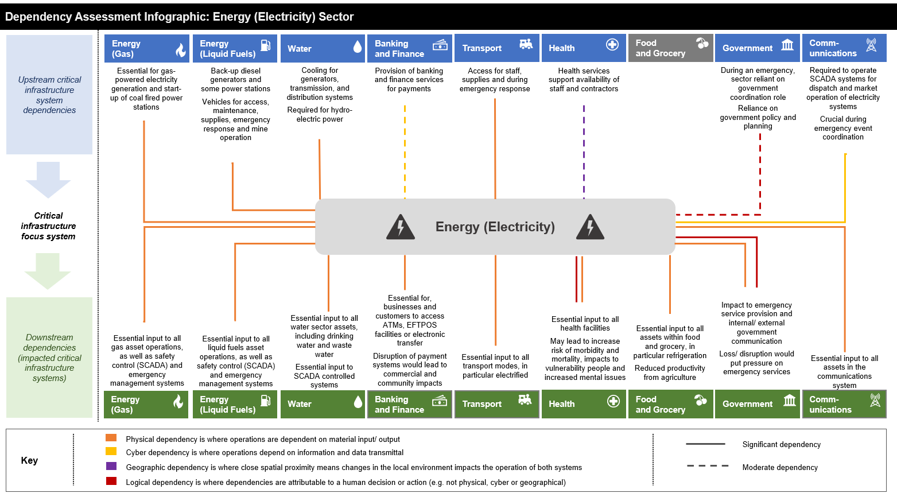
Figure 6: Dependency assessment - Electricity Sector.

Given this high dependency, essential services must have robust arrangements in place to continue providing their services when there are power outages.

Community and stakeholders told us
We have engaged deeply with affected communities, distribution businesses, regulators, emergency services, peak bodies, social and community organisations. Communities that were impacted by the 13 February 2024 event include Cockatoo, Emerald, Gembrook, Monbulk, and Mirboo North areas. We heard that:

The loss of multiple essential services (power, telecommunications, banking, food and grocery, fuel supply, wastewater and water supply service disruptions) made the event significantly worse for communities.
- Some essential services did not have suitable business continuity arrangements for a prolonged power outage. Even fewer had suitable plans for loss of both power and telecommunications.

- The impact and trauma to the community of the event was compounded by the loss of multiple essential services.

- Many in the community, including businesses and industry, were not prepared for a prolonged power outage and storm event.

Ineffective essential services’ business continuity arrangements meant that AusNet diverted resources to restore these services, impacting the broader restoration process.

- Telecommunications services failed because there were not suitable backup arrangements in place. Telecommunication loss intensified the experience of the event as it isolated individuals, and restricted information access, prevented purchase of essential supplies, and undermined community safety. The community want better resilience of telecommunications services. This issue has been dealt with separately in the previous section.

- Telecommunications loss impacted the capacity for the community, response agencies, other essential services, and AusNet to communicate amongst themselves, each other, and the community to respond effectively and safely. Doorknocking was used by a water authority to communicate with communities experiencing water pressure reductions.

- Water authorities had relatively effective back-up arrangements deployed backup generation to key sites in preparation for the storm and set up arrangements to respond to outages of its infrastructure. Despite these arrangements, there was insufficient backup generation at some sites, and some sites were without backup generation. This resulted in water supply, and wastewater treatment impacts to communities.

13 February storm event and power outage impacts – water sector
The water sector enacted its business continuity arrangements in preparation for, and during the 13 February event. Insufficient backup generation resulted in water supply, and wastewater treatment impacts.

In Southeast Water’s service area, the event impacted around 62 sewer pumpstations, 37 water sites and 1,636 pressure sewer customers. Two sewer pump stations spilled in the Lang Lang catchment with a major spill on Modella Road and a minor spill on Jefferson Road.

Melbourne Water experienced power loss at its Cardinia Water Treatment Plant Berwick Feeder, impacting supply to 1 million water customers. It also experienced low quality drainage water entering its reservoir due to the storm event.

Multiple Yarra Valley Water sites experienced raw sewerage discharge and potential loss of treatment processes, and sewer spills. Some sites did not have backup generation.

- The Department of Education deployed backup generation to schools during the event. However, community members also described extended school closures as disruptive, and in some cases required parents to be away from work to provide care.

- Hospitals switched on their back-up generators.

- Extreme weather events, and associated impacts on the electricity system are becoming increasingly frequent and severe. Better business continuity planning is important for essential services to continue delivering these services during events that impact the power system. This is important for the health, wellbeing and safety of the community and environment.

- 72 hours of backup energy supply to support business continuity arrangement for essential services is necessary in Statewide events.

Restoration of supply during large power outages – why 72 hours?
The past three large-scale power outage events in Victoria highlight that supply is restored to around 90% of customers within 72 hours of an event – but this depends on where you are in the network.
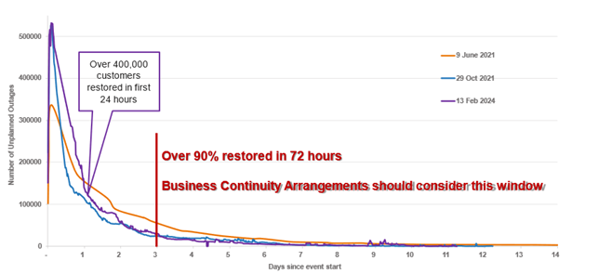
Figure 7: Chart of restoration during major power outages in 2021 and 2024.
When responding to a large-scale event, distribution businesses can take up to 48 hours to fully access and inspect their network following a large-scale event to identify the cause of faults and the damage caused and plan the best way to restore the network safely and quickly.

In the last three large-scale power outage events in Victoria, around 90 per cent of customers were restored within 72 hours. The remaining customers restored over subsequent days are usually customers on a part of the network that has sustained significant damage or are located on the outer edges of the network.

As a reasonable guide, essential services need at least 72 hours of backup energy supply so they can continue providing their service to the community. By this time, the network response may be able to prioritise restoration of essential services’ facilities.

However, the location of the essential service on the network has a significant impact on restoration. Networks typically restore the network from the inside out – repairing the foundational core before working their way out. If the service operates on the extremities of the network, it is more likely power supply would be impacted for longer than 72 hours during a large-scale event.

We’re thinking
The failure of some essential services in certain communities made their experience of the 13 February event significantly worse. Community resilience, health, wellbeing and safety is significantly undermined when essential services fail when a power outage occurs; and events that challenge our electricity systems are becoming more frequent and severe.

The subsequent loss of each essential service also compounds the difficulty for other essential services to continue providing their services. Loss of power supply impacted all other essential services, and some sectors were better prepared to manage without network power supply in the event. Subsequent telecommunications outages impacted the ability for AusNet, emergency services, and local councils to respond to the 13 February event and provide relief to affected communities.

Disaster Resilience for Businesses – Business Victoria
Business Victoria (BV) helps prepare business during emergencies by promoting resilience and business continuity planning to reduce risk.
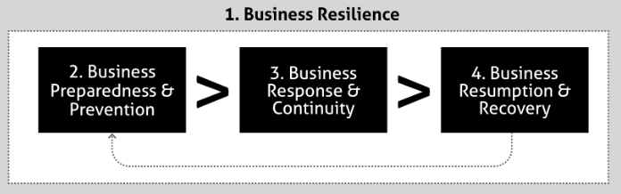
Business Victoria provides business owners with both a business response checklist and disaster resilience toolkit designed to assist owners in establishing tailored resilience plans.
Business Victoria has online resources providing guidance and examples of how businesses can protect themselves, local economies and communities from the impact of emergency events.

https://business.vic.gov.au/business-information/disaster-resilience/business-resilience

Essential services that were not prepared, requested priority restoration of their power from AusNet. This meant AusNet diverted resources from restoring customers, to restore these services, impacting the broader restoration process. Essential services are as the name suggests – essential. That means communities need these services continuously, or their health, wellbeing and safety is at risk. Better power-outage business continuity planning is required from essential services to support timely and effective restoration of energy supply services after large-scale events.

We consider that the following measures would reduce the likelihood of essential services failing during prolonged power outages:

- The Victorian Government and critical infrastructure providers ensure that there are appropriate business continuity planning and arrangements for continued provision of essential services for 72 hours without network power supply.
  - Recent events have demonstrated that around 90 percent of customers from a large-scale power outage are restored by 72 hours.
  - We consider that business continuity arrangements should address how to prepare, mitigate, and respond to loss of power supply to prevent essential service disruption to communities. This should include preparedness planning across sectors to better coordinate during events and to develop response arrangements that are timely and effective.

- Critical infrastructure providers record and keep current, information about their sites, to enable more effective planning with distribution businesses, and a timely and effective emergency response.
  - This includes maintaining telecommunications infrastructure site names, National Metering Identifiers (NMI), and site addresses.
  - We consider that this will support the distribution networks to understand critical infrastructure in their network footprint and help critical infrastructure providers to understand their risk profile (for business continuity objective set for each site). This would enable more effective mitigation of, and response to power outages across sectors.

- Enhance existing critical infrastructure forums to support coordinated emergency management planning and exercising of distribution businesses and critical infrastructure providers.
  - Forums that enable planning between the distribution businesses and critical infrastructure service providers will help the distribution businesses to understand critical infrastructure facilities in their network footprint. This understanding will inform business continuity planning for critical infrastructure providers about their location on the network, and their associated risk profile in extreme events.
  - The Utilities Consultative Committee as previously discussed.

Incentives and compensation

Introduction
In reviewing the operational response of Victoria’s distribution businesses to the 13 February event, the Network Outage Review is tasked with examining how timely and effectively the incident was managed. This includes their preparedness to administer the Prolonged Power Outage Payment program and other forms of relief and customer support.

We consider that an operational response of the businesses is underpinned by their planning, preparedness, and mitigation activities. The regulatory frameworks which incentivise the behaviour and actions of distribution businesses deeply influence how they undertake their activities.

Regulatory context
The way Victoria’s distribution businesses operate and earn revenue is guided by a series of laws and rules, including the National Electricity Objective (NEO) set out in the National Electricity Law. The National Electricity Objective is to promote efficient investment in, and efficient operation and use of, electricity services for the long-term interests of consumers of electricity with respect to:
- price, quality, safety, reliability and security of supply of electricity
- the reliability, safety, and security of the national electricity system
- achieving targets to reduce Australia’s greenhouse gas emissions

Distribution businesses are incentivised to deliver outcomes for customers according to this objective. This section focusses on economic regulatory incentives that apply to distribution businesses, customer compensation and support during power outages, and the relationship between these.

The Australian Energy Regulator is the economic regulator for distribution businesses. It regulates the revenue distribution businesses can earn to provide reliable and secure energy to customers and ensures that customers pay no more than necessary for energy supply services to their homes and businesses. The AER does this by setting the maximum amount of revenue that monopoly electricity distribution businesses can earn from consumers. Every five years, the AER makes a determination (decision) on this amount.

Service Incentives

As a part of this decision, it also determines the performance targets for each distribution business, under the Service Target Performance Incentive Scheme (STPIS). STPIS uses average historical five-year performance data of a distribution businesses’ different feeder categories, excluding extreme events that impact the network to establish a performance baseline. The maximum revenue a distribution business can collect from customers is then subject to STPIS– as a part of their revenue can increase or decrease (revenue at risk) depending on their performance. Distribution businesses receive higher revenue if they exceed their historical performance but get less revenue if their performance is below their historical baseline.

The STPIS provides distribution businesses incentives for maintaining and improving network performance, to the extent that consumers are willing to pay for improvements. The STPIS is intended to ensure that distribution businesses’ service levels do not reduce as result of efforts to achieve efficiency gains.

In providing incentives, STPIS provides financial rewards if service standards improve, and financial penalties when service standards deteriorate. The scheme provides incentives to:
- reduce the number and duration of outages (the service component of the STPIS)
- plan outages for when they have the least impact on wholesale energy market prices
- undertake low-cost projects which improve the capability of existing networks

The Essential Services Commission (ESC) also regulates the Victorian distribution businesses. It incentivises Victorian distribution business service levels through its regulated Guaranteed Service Level (GSL) payment scheme. This scheme requires electricity distribution businesses to meet service levels (in this case, delivering power), and to pay their customers (through their retailer) if that services does not meet the required levels. Supply service levels are set out in the Electricity Distribution Code of Practice, and financial payments relate to the total hours or number of unplanned interruptions per year. The ESC considers that the GSL scheme recognises and provides a financial gesture to customers who experience the worst service from their distributor compared to other customers.

Together, the AER and ESC frameworks incentivise distribution businesses to design, build, maintain, upgrade their networks, and respond quickly to outages so they meet or exceed their expected performance standards. Failure to do so may undermine the financial profitability of the business as reduced revenue (AER) or increase expenses (GSL payments).

Compensation and Support for Customers

Separately, there are other hardship and compensation programs such as the emergency relief payments (Personal Hardship Assistance Program), the Prolonged Power Outage Payment Program (PPOP), and AusNet’s $12 million Energy Resilience Community Fund (part of its enforceable undertaking with the ESC for failure to maintain its outage tracker during the February 2024 storm event).

These measures are designed to support impacted customers and to assist them to manage through and recover from the event.

Guaranteed Service Level (GSL) Payment Scheme
The GSL Payment scheme requires distribution businesses to meet minimum service levels for customers and pay customers if they do not meet these service levels. This requires Victorian distribution businesses to provide appropriate service levels to their customers, maintain their networks, and respond in a timely and effective manner to outages.
A guaranteed service level payment is money an electricity distributor pays to their customers (via their retailer), if the service (delivering power) they provide is worse than a specific benchmark or level. The ESC considers this to be a recognition of the inconvenience a customer experiences from long or frequent power outages, or poor service.
Minimum service levels are set out in the Electricity Distribution Code of Practice, for:
- appointments that distributors make with you to provide services
- delay or failure to connect a new supply of electricity
- delayed supply restoration
- low energy supply reliability
- major event days like storms and severe weather.
Payments range from $40 to $380 depending on a range of factors and are usually a bill reduction from the retailer at the next billing period. The cost of GSL payments (including those for Major Event Days) are paid for by the affected distribution businesses’ entire customer base rather than the business itself, which the AER authorises.
The below table from the Essential Services Commission Victorian Energy Market Report provides a summary of GSL payments made by Victoria’s distribution businesses for the 2021-22 and 2022-23 financial years.

Table 1: Total Number of Guaranteed Service Level Payment Made to Customers in 2021-22 and 2022-23.
Guaranteed Service Level payment category | Financial year | Ausnet Services | Jemena | CitiPower | Powercor Australia | United Energy Distribution
Late or missed appointments | 2021-22 | 178 | 7 | 170 | 310 | 21
 | 2022-23 | 234 | 2 | 82 | 179 | 323
Delay to new connections | 2021 -22 | 2,116 | 165 | 20 | 301 | 25
 | 2022-23 | 2,263 | 13 | 19 | 306 | 931
Multiple outages of 18 hours or more per year | 2021 -22 | 19,135 | 162 | 266 | 4,961 | 454
 | 2022-23 | 24,955 | 204 | 109 | 6,994 | 631
Multiple (over 8 long outages or over 24 brief outages) per year | 2021 -22 | 2,962 | Nil | 1 | 17,232 | 25
 | 2022-23 | 20,863 | Nil | Nil | 14,738 | Nil
Major event day payments for outages over 12 hours, for events like storms | 2021 -22 | 100,133 | 6,321 | 402 | 27,479 | 34,482
 | 2022-23 | 13755 | Nil | 15 | 5579 | Nil
Total |  | 186,594 | 6,874 | 1,084 | 78,079 | 36,892

Customers and stakeholders told us
We have engaged deeply with affected communities, distribution businesses, regulators, emergency services, peak bodies, social and community organisations. Communities that were impacted by the 13 February 2024 event include Cockatoo, Emerald, Gembrook, Monbulk, and Mirboo North areas. We heard that:

There is not enough accountability on the distribution businesses to respond to major events and support better outcomes for the community. Exclusion of Major Event Days in measuring network performance and passing through GSL payment costs to customers reduces this accountability.

- There was concern that the cost of AusNet’s response will be worn by consumers, as distribution businesses can apply to the Australian Energy Regulator to recoup costs of extensive damage to infrastructure caused by a natural disaster, including Major Event Days, through customers.

- The distribution businesses should be required to fund storm related compensation and relief costs to customers. They are currently not accountable or incentivised during large, prolonged outages. Major Event Days are excluded from their service performance measures and, GSL payment costs are recovered from all of the distribution businesses’ customers.

- GSL payments reduce during Major Event Days which is not appropriate, as this is when the businesses should be incentivised to restore supply quickly, and when customers require increased support to manage the event.
Prolonged Power Outage Payment Program and other support
Prolonged Power Outage Payment Program
The Prolonged Power Outage Payment Program (PPOP) is a relief payment that assisted Victorian residential customers affected by the prolonged power outages following the 13 February storm event. It is funded by the Victorian Government.
AusNet and Powercor customers who were without power for a total of 7 days cumulatively due to the 13 February, and 22 February severe storm weather events in Victoria were eligible for the payment of $1,920.
AusNet Services and Powercor administered the relief payment on behalf of the Victorian Government to their residential customers impacted by the prolonged power outage. To be eligible, customers needed to be an electricity Account Holder of a property that was without power for 7 days cumulatively within the 14-day period from Tuesday 13 to Tuesday 27 February 2024.
The Program supported 3,740 customers, through $7.5 million funding.
The PPOP program has also been available to impacted customers in previous storm events.
This payment is different from the Personal Hardship Assistance Program (PHAP), which provides a one-off emergency relief payment during the first seven days following a natural emergency.
This section relates to experiences by AusNet customers during the 13 February extreme weather event because AusNet customers were subject to a Prolonged Power Outage, in some cases up to 12 days.
The community identified that the help they need during major events is accurate and timely information, immediate local support, and financial support that is easy to access and better reflects loss.

Customer complaints received
Between January and March 2024, EWOV received at least 253 complaints directly related to the storm event, and overall unplanned outage complaints that were 445% higher than the same period in 2023.
The primary causes of complaints relating to the storm event were issues with consumers accessing compensation and provider communication relating to the storm event.
217 of 253 (86%) of complaints received by the ombudsman related in part to consumers facing difficulties accessing compensation. Of these:
- 158 cases related to difficulties with PPOP,
- 67 cases related to other issues with compensation (such as GSL)
31 cases related at least in part with communication from their energy providers in relation to the storm event.
Customers do not think they are appropriately compensated for the loss of power supply. They found it hard to find out what different compensation programs were available, understand if the programs were right for them, make the application, and get support quickly. They said:

- Customers impacted by extreme weather event outages are inadequately compensated for their losses and should be compensated.

- Confusion is associated with the different compensations available, and how to apply.

- Some customers had difficulty, or could not make an application, if they did not have access to technology. AusNet supported customers at community hubs and relief centres to process PPOP payments and troubleshoot issues.

- Many customers were dissatisfied with the timeliness on the program, as customers needed access to financial support within the first few days of the event when costs began to accrue.

- Support and relief programs did not use simple language, which made it difficult for some to understand their eligibility.

- Payments could be made automatic to mitigate these barriers in the future.

The community want more timely compensation that is reflective of their loss at that point in time - made available early due to costs incurred after 48 hours. They said:

- Customers want more tiered and timely compensation, more closely aligned to costs encountered because of power outages. Many were denied a GSL payment or other compensation when they had incurred loss because of the power outage.

- Costs begin to accrue after around 48 hours because food begins to spoil and needs replacing, and essential goods and services are required.

  - Most insurance companies cover up to $500 for food spoilage, but it is likely people won’t claim this due to insurance excess payments.

  - Other costs include loss of employment and income, purchasing and running a generator, alternative accommodation, and transport costs associated with driving out of area to access goods and services like telecommunications.

Customers were exceptionally grateful to receive support from the (Prolonged Power Outage Program). But the Program and its administration was problematic for many customers. They want earlier and more flexible support and found accessibility of the program challenging. They said:

- Many customers had a good experience with the PPOP program and were exceptionally grateful for the financial support.

- The community want more flexibility with PPOP eligibility criteria. They want support to be made available earlier, and in a smaller amount, to provide financial support when customers start incurring costs. They also want more flexibility around eligibility for shared account holders, or properties that have a business operating from a residential address.

- Many in the community found accessibility of the program difficult. There was confusion about how to apply and obtain PPOP support, and they want better communication about this. The community were confused about three main eligibility criteria:

  - Whether the period off supply was measured in hours (168) or days (7), and whether this was cumulative, or consecutive.
  - Eligibility for the small business payment – confusion as to whether small businesses could access the small business PPOP when they operated from a residential address (small business operating from a residential property)
  - Whether customers with multiple National Meter Identifiers (NMI’s) could get multiple PPOP payments.

- Customers wanted more leniency in accessing support. The strict eligibility criteria for PPOP payments meant some customers were not eligible even though they missed out by a few hours. The large gap between the GSL next bill reduction ($90 – the reduced level for a Major Event Day), and the full PPOP payment ($1,920) made missing out much more significant, particularly as the GSL bill reduction is not available during the event but in next bill.

Some customers experienced poor service from AusNet in its administration of PPOP. Customers cited conflicting advice around PPOP, inaccuracy of information in determining eligibility, claims rejected without a reason, barriers to applying, payment delays due to administrative errors, and difficulty communicating with AusNet to resolve matters.

- Some customers reported that they received conflicting advice regarding their eligibility for PPOP payments meaning that many were rejected despite receiving notifications and information from their provider, community representatives, and media coverage that they would be eligible. Eligibility criteria for PPOP were altered by the Victorian Government midway through the event because customers were impacted again by a second, smaller storm on 22 February.

- Some customers disputed AusNet’s calculation of how long they were off supply, and daylight savings influenced the recorded times customers outages and restoration.

- Customers wanted proactive engagement from AusNet about their eligibility for PPOP, as it has the systems which can determine eligibility.

- Some customers had extended delays in their PPOP application process and had to complete applications multiple times.

- Internet issues as a result of the power outage meant there were barriers for customers in completing PPOP applications and receiving support. Customers had difficulty getting access into AusNet to resolve application issues, and AusNet did not provide timely resolution of issues for some customers.

- Customers had claims for PPOP rejected without being provided with a reason.

- For some customers, their information was not recorded accurately in AusNet’s system, and payments were made to the wrong accounts – delaying their access to support.

- PPOP is very costly, and this comes at a cost to government. Some questioned why government should have to pay, and that the distribution business should be responsible. Distribution Businesses should work with communities to improve their resilience, and reduce the impact of an event on them, and lessen their need for support during events and reduce the need for the payments.

Larger Guaranteed Service Level Payments are needed on Major Event Days, and the distribution businesses should have to pay them. GSL payments need to be made available immediately to cover costs incurred, not as a future bill reduction.

- Communities are not satisfied that GSL payments reduce during a Major Event Days, as this is when customers require support the most, and think that the businesses should be incentivised to restore supply quickly.

- GSL payments as a reduction on retail bills does not provide support for the immediate costs the customers incur. This occurs because it is administratively simpler to do and does not meet customer needs in major events.

- The ESC affirms that the GSL is not intended to compensate consumers but create an incentive for distribution businesses to meet minimum services levels for their customers, and provide a financial gesture to customers who experience the worst service. In its view, increasing the GSL and changing its purpose to a compensation scheme would result in a cross subsidy from some customers to others.

AusNet’s Energy Resilience Community Fund provided valuable support to impacted communities, but there is a gap between payments in the Fund, and PPOP.

- Customers with a concession card who were not eligible for PPOP (less than 7 days off supply) could access AusNet’s Energy Resilience Payment. While customers were grateful for any support, many acknowledged that they incurred much higher costs than the payment provided as a result of the event.

- AusNet established the Fund shortly after the event. The Essential Services Commission Undertaking in regard to AusNet’s communication failure with customers in the event (outage tracker) requires AusNet to distribute the full $12 million Energy Resilience Community Fund by 31 December 2026. Some in the community have suggested that allocation of fund to charities for example, could be better allocated to disrupted customers.

We’re thinking

We are entering an environment where severe weather events are becoming more frequent and severe – and the new ‘normal’. Accountability for the distribution businesses to build, maintain, mitigate, prepare their networks, and respond quickly and effectively during these events is important. The Victorian Government provides financial support at significant cost to taxpayers during each event, when the impact of these events could be reduced. This was less problematic when these events occurred once every ten or twenty years, but they are now happening much more frequently.

Incentives and compensation – and how they drive the behaviour of distribution businesses

We consider that customers should be better supported in prolonged power outage events such as the 13 February storm event. The existing regulatory settings do not provide enough accountability on the distribution businesses to respond in a timely and effectively way to extreme events, and to provide support for the community. There is an opportunity to improve the response of the distribution businesses by making them more accountable to prepare, mitigate, and respond during major event days driven by severe weather events or other extreme events causing widespread outages.

There are multiple programs that seek to support or compensate customers during emergencies and prolonged power outages. There are also regulatory incentives that are supposed to incentivise the distribution businesses to effectively build, maintain, mitigate, prepare their networks, and respond quickly and effectively to outages. Incentives in the STPIS framework do not apply during Major Event Days, and GSLs are reduced, and paid for by the distribution businesses’ customer base during Major Event Days. In both cases, this dulls any incentive effect. In addition, the Victorian Government funds PPOP, which does not incentivise the distribution businesses in any way, as they have no accountability to provide support.

There are a range of different government and industry programs that provide support to customers during prolonged power outages. Community has identified that the best help they can receive during events is accurate and timely information, immediate local support, and financial support that is easy to access and better reflects for loss. They start encountering financial pressures from about 48 hours after an event, and that is when they start needing support – particularly those customers who don’t have cash reserves. Our review indicates that PPOP and GSL do not effectively support communities during events because support is not immediate, easy to access, or reflective of loss – particularly after 48 hours.

Administration of Prolonged Power Outage Payments
During the event, PPOP provided important support to impacted customers at the end of the event, but the program design and its administration was problematic for many customers. Customers experienced accessibility issues with the program, and there were delays in AusNet administering the program. Customers also had issues with how AusNet calculated their eligibility, rejected claims without providing a reason, and administrative errors resulting in payment delays.

The requirement for customers to apply for PPOP seems counter-intuitive to them, when the distribution business has all the information available to see who is eligible – any applying should only be required on exception rather than the rule. Customers also found it difficult to communicate with AusNet or resolve issues with their PPOP application in a timely way. Community confusion about the program occurred due to Victorian Government changes to PPOP eligibility criteria midway through the event; although this was to accommodate customers impacted by a second, smaller storm event on 22 February.

There were technological barriers in applying for PPOP where internet and device access capability was not available, or customers were not confident to use devices. Many customers required physical AusNet support to lodge a PPOP application, and AusNet engagement could have been enhanced if it had better planned for physical engagement, provided direction to staff, worked with councils and communities in preparedness, and trained and resourced its staff appropriately. The community identified that AusNet should prioritise being present during power outage events to support the community.

AusNet was not well prepared to administer the Prolonged Power Outage Program, which resulted in delays in providing support to customers, and the various issues encountered by customers in accessing this support.

AusNet has provided further support through its Energy Resilience Community Fund, which does go some way to provide better support for some customers who did not receive a PPOP Payment. It will also provide funding for community resilience initiatives such as resilient facilities to charge devices, shower, make phone calls and access support in future power outages.

Leveraging regulatory incentives with appropriate compensation to provide better outcomes for the community
There is an opportunity to consolidate and optimise GSL Major Event Day payments, and PPOP into compensation and relief measure, that meets the needs of the community, and also create accountability to the distribution businesses to respond to events effectively.

Ofgem’s approach to compensating customers in storm events
In late November 2021, Storm Arwen brought widespread disruption to the UK and resulted in over one million customers losing power. Approximately 40,000 customers were without supply for more than three days, and nearly 4,000 customers were off supply for over a week. In light of the severity of the event and the long duration that many customers endured without power, the UK Office of Gas and Electricity Markets (Ofgem) conducted a review of the Distribution Network Operators (DNOs) response to the storm.
The Ofgem Storm Arwen report recommended a further review of severe weather compensation for electricity customers, which resulted in a range of changes including:
- Ofgem increased the maximum amount of compensation consumers can access as a result of severe weather events from £700 to £2,000 ($1,330 to $2,281).
- Ofgem made it simpler for consumers to access compensation payments by making bank transfers available.
- Compensation amounts are linked to how long consumers are off supply for. For example, during certain storm events, consumers can access £80 ($152) if their power has been cut-off for 48 hours and an extra £40 ($76) for every 6 hours afterwards.
Further changes are being considered to enable more consumers to more efficiently receive compensation payments, including bank transfer via secure link. Up to the cap, network companies are responsible for the compensation, thereby managing their financial exposure.

We consider that the following measures would strengthen the accountability for Victoria’s distribution businesses to build and maintain their networks, and prepare, mitigate, and respond effectively to events. It would also reduce the burden of the Victorian Government to provide support to communities, by making the distribution businesses more accountable to the consequences of their network outages.

- Review distribution business regulatory and incentive schemes that drive network behaviour in building, maintaining the network, and preparing, mitigating, and responding to events.
  - We consider that this includes the national AER STPIS framework, and Victoria’s ESC GSL Payment Framework.
  - Incentives should drive operational behaviours that deliver improved outcomes for the community. This could include gradated increases in accountability during a major event to incentivise a timely response.
  - Incentives should account for the reality that State Emergency Management Restoration priorities may extend the response.

- Make Victorian distribution businesses accountable for providing financial support to customers during events, replacing the Major Event Day GSL reduced payment and Prolonged Power Outage Payment.
  - Victorian distribution businesses to agree on an appropriate compensation scheme and rate for communities. If no agreement is reached, government is to determine the rate of compensation. This requirement is to be implemented through the ESC Electricity Distribution Code of Practice or licence conditions.
  - Compensation to customers should be gradated and relate to the time off power, received quickly by customers, and target customers incurred costs related to loss of power. This compensation should be automatic, and customers should not need to apply for support as a default, as the distribution businesses’ network already has information about customer outage durations.

Worst performing areas of the network

Introduction
As a part of its regulation of Victoria’s distribution businesses, the Australian Energy Regulator (AER) publishes annual network performance reports for electricity networks. These reports provide transparency around network performance under the regulatory regime, comparing actual network performance against forecasts.

Service performance under this regulatory regime is, however, largely incentive driven. Although AER’s network performance reports provide some transparency about outcomes, there are no specific regulatory requirements for accountability on delivering service commitments and reliability. Further, performance targets are based on the distributor's average performance over the past five-year regulatory period, which may serve to mask underlying problems and make the scheme less responsive to new challenges like increased weather events or other extreme events.

Examining the performance of network feeders shows parts of the network continue to experience longer outages, which can be influenced by:
- the geographical features of that region of the network
- the susceptibility of the region to severe weather conditions
- how well that region of the network is designed and maintained
- how well a distribution business resources outages in that region of its network

Improving worst performing feeders across the Victorian distribution networks will reduce the number and impact of outages, and will support faster restoration of customers after severe weather events.

How network performance is measured
The Australian Energy Regulator (AER) measures the network performance of distribution businesses through SAIFI, SAIDI, MAIFIe and MAIFI. They measure the average number and time customers experience outages over three minutes (SAIFI/SAIDI), and the number of outages customers experience under three minutes (MAIFIe or MAIFI). These performance measures are independently applied to the performance of distribution networks. If performance is above the historical average baseline, a business can charge customers the maximum (or close to) ceiling amount it was authorised by the AER. If it underperforms, it collects a smaller amount.

System Average Interruption Frequency Index (SAIFI) is the average frequency of power outages for a customer. This is measured by the total number of interruptions to supply (over three minutes), divided by the number of customers on the distribution network.

System Average Interruption Duration Index (SAIDI) – is the average duration of power outages for a customer. This is measured by the total minutes of all interruptions to supply (over 3 minutes), divided by the number of customers on the distribution network.

Momentary Average Interruption Frequency Index (MAIFI) – is the average number of brief interruptions for a customer. This is measured by the number of interruptions under three minutes, divided by the number of customers in the distribution network.

Momentary Average Interruption Frequency Index event (MAIFIe) - is the same as MAIFI, except it measures multiple interruptions to supply in under three minutes as one ‘event’, divided by the number of customers in the distribution network. This is the AER’s preferred measure to MAIFI as it more suitably recognises performance levels, but some distribution businesses are unable to measure their performance with this method.

These measures are set against different feeder categories within a distribution network:
- CBD feeder – located in the CBD area of a state or territory which supplies electricity predominantly commercial and high-rise buildings. Electricity is supplied by mostly underground distribution network that is highly reliable (interconnected with multiple redundancy).
- Urban feeder – located in urban areas, where there is high demand per km of line
- Short rural feeder a part of the network where the total feeder route is less than 200km, but not a part of the urban network because demand per km of line is lower
- Long rural feeder – a part of the network where the total feeder route is more 200km or more (and does not meet the demand levels to be an urban feeder)

These feeder categories are specified because customers will more likely have better network service in more densely populated areas, compared with more rural locations. This is because there is usually more interconnection, or pathways for electricity to flow, which means more redundancy in the network if one part experiences an outage

Customers and stakeholders told us
- Customers in the Cockatoo, Emerald, Gembrook, Monbulk and Mirboo North have experienced prolonged periods without power during two storm events in 2021, and the 13 February storm event.

- These customers also told us that they do not have reliable power supply, and experienced power outages frequently.

- The resilience of customers impacted by frequent and/or prolonged power outages erodes with each event, as the economic, social, and personal impacts cumulate with each event.

- Poor feeder performance occurs due to a range of geographical factors including the surrounding vegetation types (i.e. very tall trees) and the susceptibility of the area to severe weather patterns. Poor feeder performance is also a result of network design, maintenance regime and resourcing.

- Some consider AusNet’s infrastructure is not well maintained, and that technologies that can reduce outage areas such as high voltage switches do not operate well, or there are too few.

- Some also consider that the AusNet network does not have adequate field staff managing its lines, as when comparing field staff per kilometres of line with other distribution businesses, AusNet has less resources.

We undertook analysis of AER network performance data, including SAIDI (average minutes off supply per customer) from 2018-2023, the analysis indicates that numerous AusNet and some United Energy feeders consistently rank as some of the worst performing feeders in Victoria as shown in Figure 8.

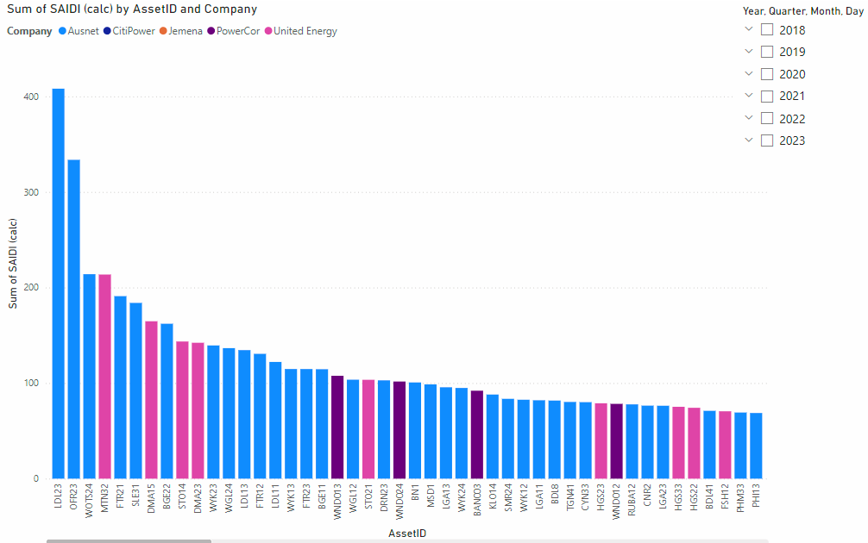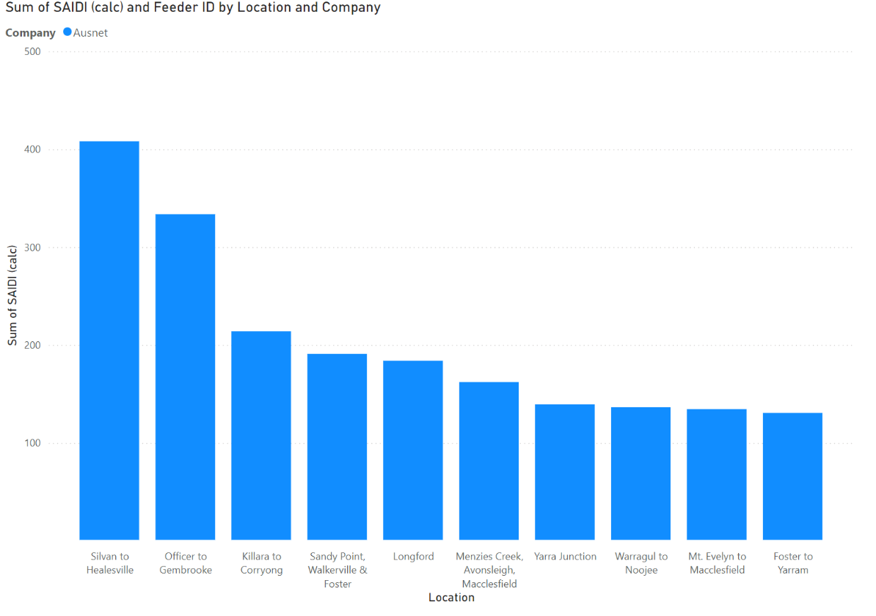
Figure 8: Chart of worst performing feeders (SAIDI) across all distribution businesses.
Figure 9: Worst performing feeders - AusNet
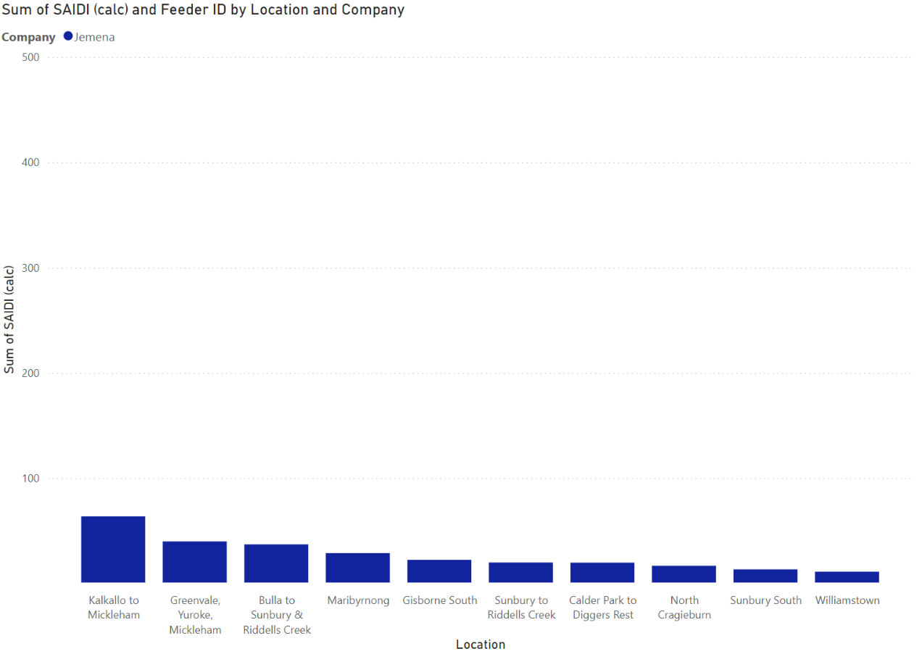
Figure 10: Worst performing feeders - Jemena
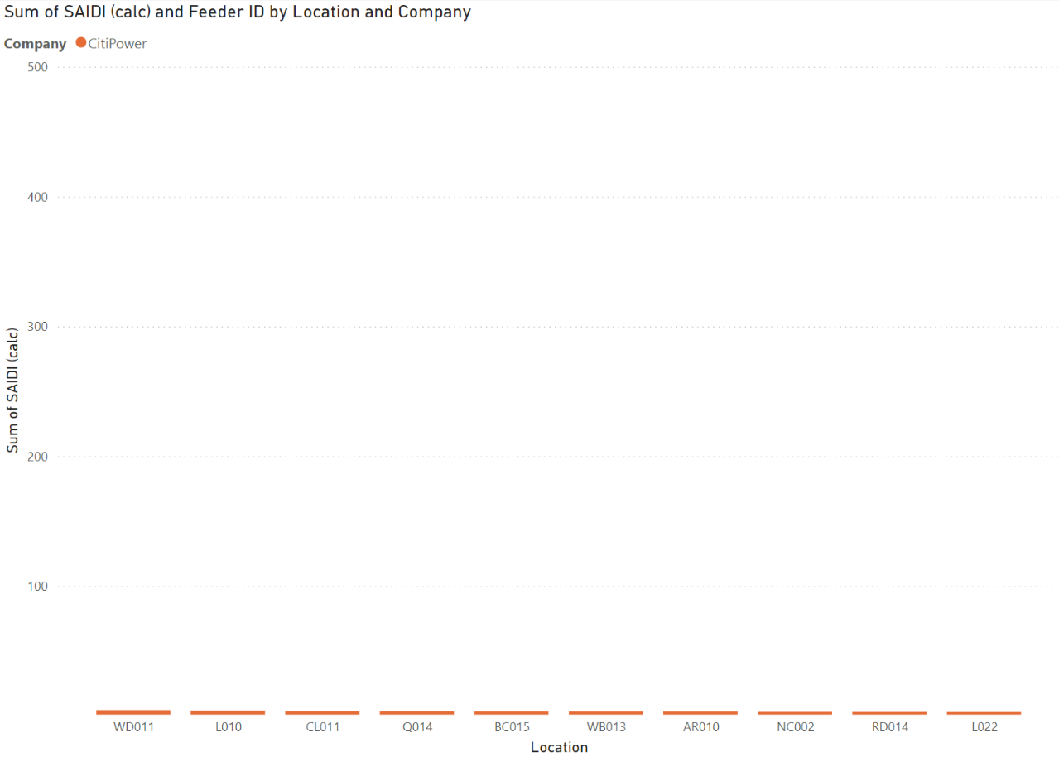
Figure 11: Worst performing feeders - Citipower
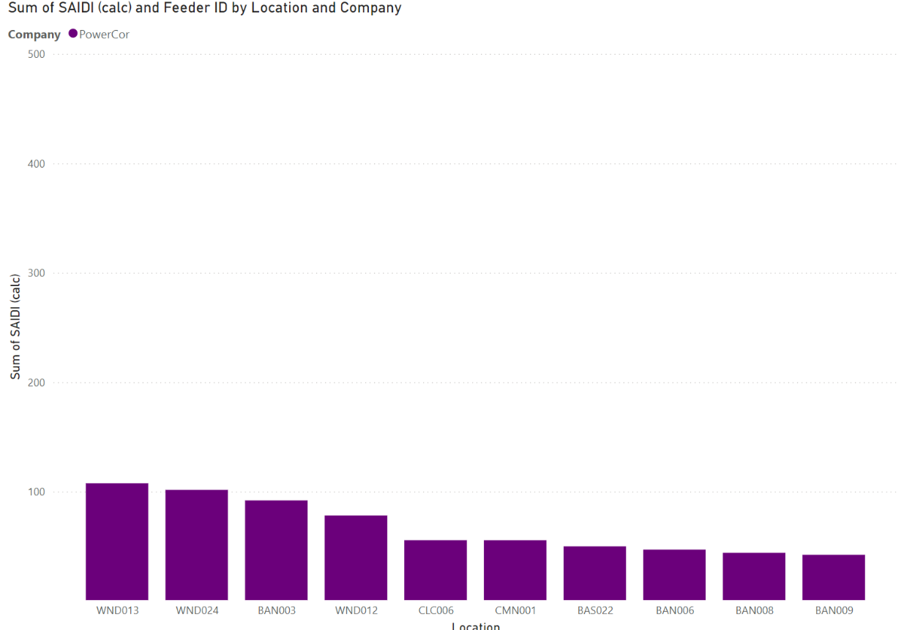
Figure 12: Worst performing feeders - Powercor
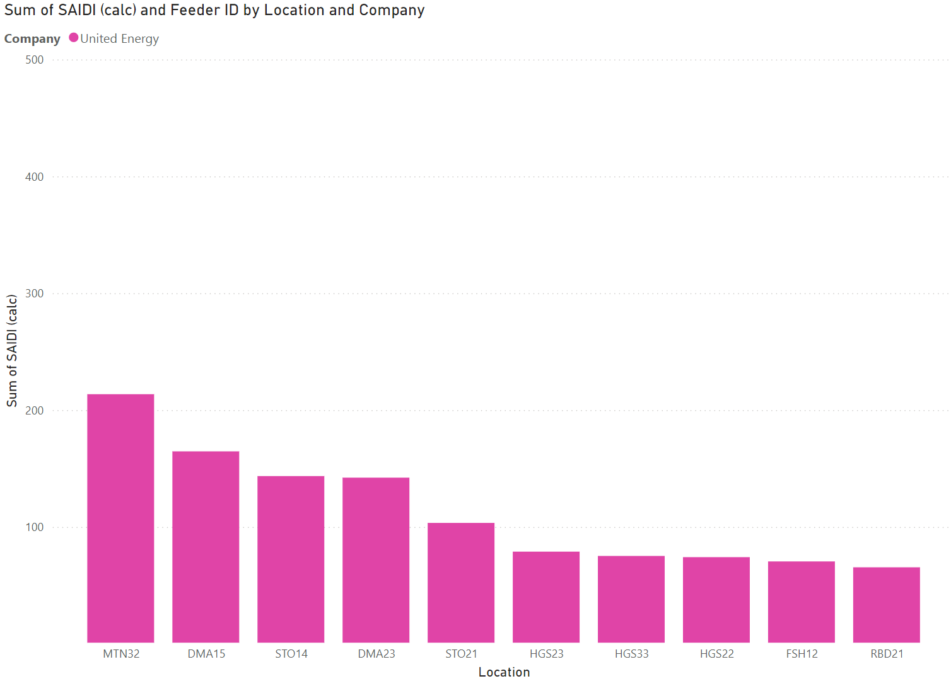
Figure 13: Worst performing feeders - United Energy

Improving worst performing feeders – what can be done?
Ergon Energy is the distribution business in regional Queensland, responsible for building, operating, and maintaining the regional network. It has submitted a public business case to the Australian Energy Regulator seeking approval for the 2025 to 2030 regulatory period to collect additional money from customers to continue improving the performance of its worst performing feeders through network investments. This includes through:

- Protection setting changes
- Installation of Line Fault Indicators (LFIs) with communication and Fuse Savers
- New Automatic Circuit Reclosers (ACRs)
- Sectionalisers
- Remote Controlled Gas Switches (RCGS)
- Relocation and/or replacement of switching devices

- The Australian Energy Regulator requires distribution businesses to report on their performance standards each year, including on inadequately served customers through Regulatory Information Notices (RIN). An inadequately served customer is a customer who has an average outage duration that is more than four times the network average.

- In AusNet’s last annual report, it noted it is:
  - focusing on improving the distribution network’s reliability performance by systematically reviewing poorly performing segments and investing in technology that automatically reconfigures the affected network to minimise the number of customers affected by outages.
  - continuing to monitor the reliability performance and take appropriate actions to outperform the targets. These include installing additional switches, fuses, automatic circuit reclosers, vegetation management, animal proofing and protection coordination improvements.

- As a part of upcoming AER Revenue Determinations:
  - Powercor is exploring investment in feeder tie lines at the end of long rural lines to support its worst served customers. Customers on long rural lines are often at the ends of the network, where there are long stringy single lines, that when damaged, have are no other supply routes to provide customers with power. Feeder tie lines potentially improve this by linking one branch of the network to another, so if the original line experiences an outage, there is an alternative pathway for electricity to flow, and continue supplying customers.
  - AusNet is exploring investment in its 10 worst feeders.

We’re Thinking
We heard that worst performing feeders provides a strong indication of the distribution businesses performance in network design, maintenance, risk mitigation, network resourcing, and response to events.
Customers and communities in regions prone to unreliable power supply are broadly consistent with the areas also experiencing prolonged power outages during severe weather events. These customers and communities want more reliable power, and their ongoing experience of frequent power outages throughout the year, and prolonged power outages during more frequent storm events do not meet community expectations.

Recurrent power outages cumulatively erode the resilience of customers to manage through each significant outage. The amount of time, effort, and dedication that communities have put into organising themselves to improve their power supply and manage through events is commendable.

While there are costs associated with the provision of reliable power supply, there are also benefits to communities and government in having a more reliable power supply. Supporting the improvement of reliability on poor performing feeders is also likely to translate into faster restoration in major outage events and therefore a reduction in time customers have their power out.

As discussed in the Incentives and compensation section, we consider that the distribution networks are not appropriately incentivised to improve their worst performing feeders:
- STPIS sets service targets based on average historical performance, and these are measured by the average performance of different feeder types. This works well in a steady state environment and delivers incremental change and efficiency in the service of feeders; but when feeder services are poor, faster change is needed. Forward looking service targets for example, would address what an appropriate service level to the community should be.
- GSL does not include Major Event Days in the assessment of service performance, Major Event Day reductions on bills for customers are less than other GSL bill reductions and the cost of GSL bill reductions can be passed through to all customers softening the accountability effect of the regulatory scheme.

In addition, there is currently no requirement for distribution businesses to invest in poorly performing areas of their network even if they have received approval for expenditure from the AER – as the AER framework does not hold distribution businesses to account for the revenue they authorise. They rely on STPIS to achieve this outcome.

Greater accountability for network performance, particularly for the worst served customers, would improve outcomes for communities affected by prolonged power outages. For example, investing in smart control devices on the network would enable networks to identify and sectionalise faults faster – reducing the number of customers off supply, and enabling faster restoration.

The increasing severity and frequency of severe storm events of recent years is not something the ‘steady state’ regulatory framework that provides incremental and progressive efficiencies and improvement was designed to address. Faster and more targeted change is required to improve outcomes for customers, and a greater focus on network performance will contribute to the networks better preparing for, mitigating, and responding to extreme events.
We consider that the below measures will help achieve targeted improvement of poorly performing feeders across Victoria’s distribution businesses and provide accountability for this improvement to occur.
- Victorian distribution businesses improve the performance of their worst performing feeders and report through their annual Emergency Management Act 2013 statement of attestation on actions planned, underway, and undertaken to improve reliability of their 10 worst performing feeders.
  - We consider the distribution business upcoming AER revenue determination period an important opportunity to propose funding to improve feeder performance and network reliability in conjunction with community support.
  - We seek stakeholder views on how to determine a threshold for improvement.

- The Essential Service Commission review the Electricity Distribution Code of Practice to consider whether changes are made to improve distribution business incentives for an effective response to prolonged power outages (see recommendation 20 from regulatory incentives and compensation).

- The regulatory framework is changed to support actions to improve worst performing feeders. This should include:
  - Incentives that provide recognition of the performance of these feeders
  - Consideration of how SAIDI and SAIFI, and other relevant measures, are customer informed and forward looking rather than based on past performance.
  - Changes could be made to the AER or ESC frameworks to achieve this intent. We consider that the ESC framework would enable more rapid change. Alternatively, distribution business licence conditions could be amended to drive this outcome.

As an outcome, these measures would heighten accountability and better incentivise the networks to improve the service of their worst performing feeders through application of revenue from their network revenue determinations.

During the 13 February 2024 storm event
There are two key phases of activity during an emergency: response and the provision of relief.
- Responding to an emergency typically refers to taking action to address and mitigate a situation that poses a serious threat to life, health, property, or the environment. It involves quickly assessing the situation, determining the appropriate course of action based on established protocols or training, and initiating necessary measures to minimise harm and provide support to affected communities. This could include actions taken by emergency responders, or trained individuals in the community. Response activities take place during an emergency and are usually measured in hour, days, or weeks.
- Emergency relief refers to immediate assistance provided to individuals and communities affected by a disaster, crisis, or other shock. It aims to address the basic humanitarian needs of those affected, such as food, water, shelter, medical care, and protection from harm. Emergency relief efforts are typically coordinated by governmental agencies, humanitarian organizations, or non-governmental organizations (NGOs) and are crucial in providing timely support to help people cope with and recover from the impacts of emergencies. It can include the provision of financial assistance.

Communication with customers and community

Introduction
The capability for distribution businesses to communicate timely and accurate information about outages, and the expected time that it will take for power to be restored is essential for customers and the community and responding organisations. Effectively communicating this information allows affected customers and communities to plan accordingly and make the best decision to manage the impacts of a power outage for them. It is also important that distribution businesses have robust ways for customers and communities to reach into distribution businesses to get or provide information or receive necessary support.

The Essential Services Commission (ESC) requires Victorian distribution businesses to provide information about outages on their networks – through an Estimated Time to Restore (ETR) power supply, or an Estimated Time to Assess (ETA) – or when further information about at ETR will be available. The distribution businesses do this through online outage trackers.

In examining the operational response of Victoria’s distribution businesses to the 13 February event, the Network Outage Review is examining how timely and effectively the incident was managed. This includes:
- The tools and systems to communicate proactively with customers and external authorities, including SMS, call centres and effective information platforms and services, such as outage trackers.
- The capacity to provide support and resources to offer in-field communication and support to heavily impacted communities (via mobile community response vehicles or community centres).

Outage trackers
Victorian distribution businesses provide most information to customers on network outages through live outage tracker information, available on their websites.

These electronic tools allow customers to look for outages via an interactive map, a list of current outages, and also through search functions. They allow customers to view the general location of the fault, the status of the outage, the location of customers impacted by the outage, and the expected time the power will be restored. They also allow customers a pathway to contact the distribution business to report their fault if it isn’t listed on the tracker.

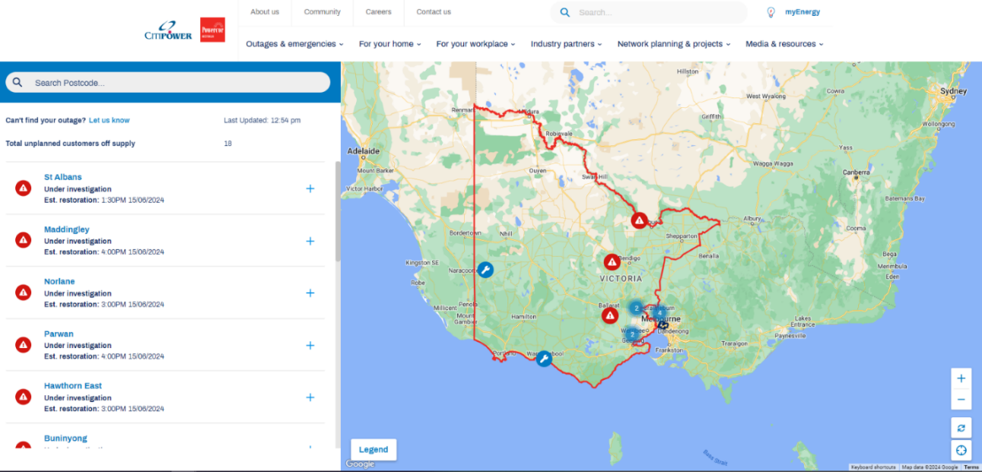
Figure 14: Example of an outage tracker.

Community and Stakeholders told us
Most organisations communicated through electronic platforms during the event. Because of the telecommunication failures, these were not available in the regions affected by storm and power outages.

We heard that:
- Effective communication of information during an event is essential for keeping community members safe, connected and mentally well – and allows them to make the best decision for them. It was difficult for customers to access accurate information about the storm event due to the unavailability of communications services and lack of access to accurate and timely information.

- Customers were unable to access information at some community hubs as they were without power.

- There was not enough communication regarding available support payments.

Failure or limitations in AusNet customer communication technology systems, and lack of backup planning for these failures meant customers did not receive timely, accurate, tailored, and accessible information about their power outage.

- AusNet’s outage tracker failed due to high demand, and its SMS systems and call centre had limitations. These factors resulted in inconsistent delivery of timely, accurate, and accessible customer information. There was no backup plan for the outage tracker failure, and the rapid solution deployed did not provide accessible information to customers.

- This increased demand on the AusNet call centre, which caused service delays and customer frustration. The call centre received 43,000 inbound calls on 13 February. An interactive voice response service was implemented which enabled around 62 per cent of customers to self-serve; but many customers did not know their National Meter Identifier (NMI) and so could not use this service.

  - The AusNet customer team expanded the capacity of its call centre from 25 agents (day 1) to 54 agents (day 3) to service unprecedented customer demand.
  - Many calls made by customers were abandoned due to long call waiting times. Customers waited for 22 minutes on average to contact an operator over the first two days, and there was no way the initial level of demand could be feasibly serviced.

How distribution businesses communicate with customers – when the communications network is available
Victorian distribution businesses communicate with customers and the broader community through multiple channels.
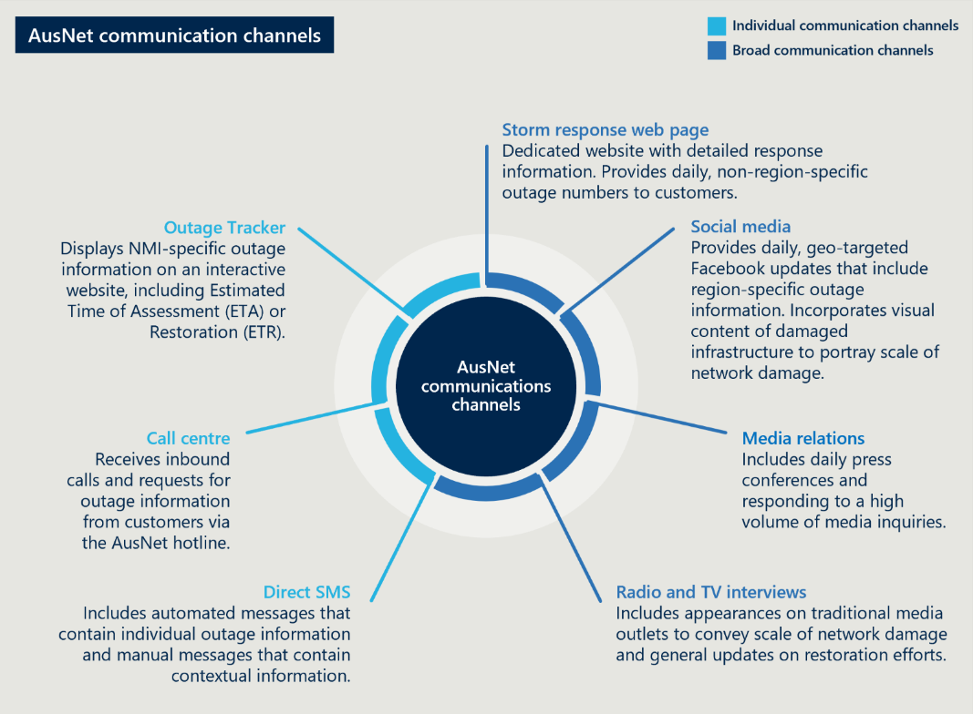
Figure 15: AusNet communication channels.

Individual customer channels:
Distribution businesses communicate information to individual customers through an electronic outage tracker (see outage tracker case study), and by automated text messages to individuals, which contain automated messaging information, or more targeted contextual information sent manually. Distribution businesses can communicate information to customers, and customers communicate information to the business through the businesses’ call centre.

Broader communication channels
A distribution business can communicate broadly to its customers through dedicated webpage information on events, social media, and through the media (press conferences, radio, TV, and print and online media). While these communications channels can reach a large audience, they may not provide local or contextual information that customers or communities require.
During an event, the distribution businesses can also physically respond to heavily impacted communities – usually at community hubs – to provide information and to customers and the communities.

- AusNet’s automated systems and processes to update customers on their outage were defective and were switched off to prevent the communication of incorrect information to customers. AusNet reverted to manual messaging, which was not as regular or tailored to customers.

- AusNet communicated overly optimistic and definitive restoration information to customers in uncertain circumstances, which was slowly revised as inspection of the network occurred. Customers were unable to make good decisions about how to manage their own situation when provided with inaccurate and unreliable information.

- AusNet used social media alternatives to provide information to customers, but these were no substitute for a functioning Outage Tracker. The scale of the event initially overwhelmed the capacity of AusNet to monitor, develop timely briefings, and respond to the volume of customer engagement through social media.

- AusNet maintained a 24/7 priority phone line to support life support customers throughout the event.

- Energy retailers are the primary link to customers. Limitations in the way energy retailers collect, validate, and update customer contact information and provide this to distribution businesses reduces the effectiveness of communication with customers during events. AusNet estimated that outbound messages to customers reached around 60 percent of AusNet customers during the event because of data quality issues with customer contact details.

AusNet’s communication with customers assumes the availability of power and telecommunications services. The failure of both these services in many areas meant customers had much less information on the nature of their outage and expected duration.

- Loss of telecommunications also impacted AusNet’s response capability. AusNet did not have backup systems to communicate between the field and control centre. This resulted in slower information flow and lost field crew productivity.

AusNet’s community engagement was improvised and inconsistent across communities and could have provided better communication and support. The community want alternate ways to communicate with their distribution business in events when telecommunications services fail.

- AusNet engaged with heavily impacted communities and stationed staff at relief centres, pop ups, and community meetings to provide information and support to communities. This included Mirboo North, Belgrave, Cockatoo, Emerald, Grantville, Gembrook, and Yarra Junction.

- AusNet’s physical presence in communities during the event was well received, but there was minimal direction provided to staff, and varied staff preparedness to do these roles. The improvised approach taken by regional support personnel meant that some communities felt AusNet’s presence was limited. The community identified that AusNet should prioritise being present during power outage events to support the community.

- AusNet regional support personnel were not equipped in a systematic way with resources to enhance their engagement, such as refrigeration and electronic device charging.
As a part of the upcoming Australian Energy Regulator Revenue Determinations, we understand that Powercor United Energy, and AusNet are exploring additional emergency mobile response vehicles, and additional officers to engage with community groups and local government to support improved resilience planning during extreme weather events.

- AusNet and local governments did not have well established relationships, which impacted their ability to disseminate information through established community groups and physical message boards in community centres where outages were the longest. Local governments did not consistently or readily notify AusNet of community events where its presence would be valuable or identify suitable community hub locations to provide information and support, or support communication to communities through non-power dependent channels.

- AusNet’s website, the call centre, and local council websites could be better utilised as centre points for information during the event, and in the post-event recovery.

- Many customers were not well prepared for, or understood who was responsible for what, in a prolonged power.

- Event media protocols between the Australian Energy Market Operator and the energy industry slowed AusNet’s communication with impacted communities.

Customers had difficulty communicating with AusNet to resolve complex matters such as Prolonged Power Outage Payment applications and progress on their applications. They wanted proactive engagement about the program and more responsive communication generally.

- Many customers had difficulty in receiving email responses and other forms of communication from AusNet for extended periods throughout the event.

Jemena communicates with customers in a variety of ways in the lead up to a potential high risk event as well as during outage events:
- Short Message Service (SMS) and email notifications are used to alert customers to heatwaves or potential bad weather.
- Warnings may also be published to the general Jemena website and outage pages, and social media channels.
- SMS and email notifications automatically sent when there is an outage.
- Outage information is automatically posted to Jemena’s website and social media channels (Facebook and Twitter/X).
- Customers calling the Jemena contact centre are provided with outage information, obtained by ‘polling’ outage systems so that real-time information specific to the property address can be played. This reduces the need to speak to someone and provides confidence to the customer that Jemena are aware that they are impacted.
- Situational messages are played to all callers to the contact centre during extraordinary events to provide more contextual information, e.g. widespread in nature, why restoration may take longer, etc.
- Situational/contextual information published to the Jemena website and outage webpage.
- Life support customers who report an outage to the Jemena contact centre are offered call backs every hour until supply is restored.
- During prolonged or widespread events, Jemena can send targeted SMS and email notifications to its entire customer community, smaller customer segments, e.g. life support, or to individuals using our communications platforms.

Powercor/CitiPower and United Energy ensure there is a wide reach to customers by applying multi-faceted and multi-channel communications to keep customers informed before, during and after major events:
- Text messages remain a primary mode of communication
- Use two 24/7 contact centres in Bendigo and Melbourne
- Kept customers informed regularly through social media
- Leveraged local media companies to communicate preparation, during and after the event
- Deployed emergency response vehicles to provide support and keep customers informed where they also shared other collateral (information flyers) to educate customers of electricity safety.

Mobile response vehicles – MERV and VERA and how they can help
Powercor has developed two mobile response vehicles to support local communities during emergencies and prolonged power outages.

These vehicles are deployed into heavily impacted areas during power outages and other emergencies and allow communities to get first-hand information from Powercor about what is happening in their area. The Mobile Engagement and Response Vehicle (MERV) was the first of these vehicles developed in Victoria, and has on board a:
- Generator
- Large monitor to display information about an event
- Flood lighting
- Charging facilities for 20 small electronic devices, in lockable lockers, for residents to charge their mobile phones and tablet devices
- Small facilities to make hot drinks

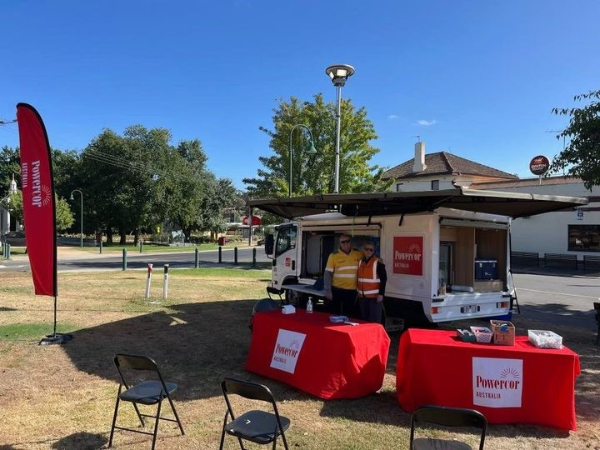
Figure 16: Powercor's Mobile Emergency Response Vehicle in the field.

Powercor’s new model, VERA, is also equipped with Starlink satellite internet, enabling customers to use their devices when at VERA if there are telecommunications outages (mobile towers, NBN).

We’re thinking
Customers and the community need accurate, timely and accessible information from their distribution businesses during power outage events. This allows them to understand the circumstances they are facing and act accordingly. Providing inaccurate, untimely, and inaccessible information negatively impacts the capacity for customers to manage their way through an event.

Community members may not know who their distribution business is and broader community contact networks such as remote family members may not know which distribution business to go to for information about their loved ones. A single-entry point to outage tracker information may provide a pathway to more detailed information held at each distribution business’ online resources.

We consider that the following measures would improve the timeliness, accuracy, and accessibility of information customers and community receive in events. It would also improve the redundancy of communications, through multiple communication methods, stress testing of communication systems, and plans for if primary communication methods fail.

- Distribution businesses to report to the Minster for Energy and Resources on the feasibility of a single-entry point for outage trackers for all Victorians.

The 13 February storm event had a significant impact on AusNet’s distribution network. Despite previous efforts to improve AusNet’s outage tracker, it had not been stress-tested sufficiently to handle the customer demand created by an event impacting most of AusNet’s network, nor had there been any contingency planning to develop a way to communicate outage information to customers if the outage tracker failed. The temporary solution to replace the outage tracker had to be designed during the event and was not an accessible or effective tool for customers to get information about their particular outage. AusNet’s recently launched automated messaging system was also insufficient, and had to be switched off, and manual messaging relied upon.

The failure of the outage tracker and automated messaging had a cascading effect, significantly increasing demand in the AusNet call centre to get information about the event, which could have been provided automatically to customers if these systems had not failed. Customers experienced long wait times to talk to the call centre, and the ability to ‘self-serve’ with IVR required customer information that was not familiar to many in need of support, which created a barrier for many to access information quickly.

- Distribution businesses proactively and regularly test the operability of their customer service systems to manage surge demand and identify contingencies in their back-up continuity plans if these services fail.

- Distribution businesses should apply inclusive design standards (ISO22458:2020) to the design of customer service systems such as outage trackers and interactive voice response (IVR) systems. This includes regular monitoring, evaluation, and feedback from customers with lived experience of vulnerability.

We heard that not everyone in the community is digitally enabled or confident to be able to access information such as outage trackers online. The experience was that many people could also not access the AusNet customer call centre. There needs to be consideration of community communication methods beyond online and phone. However, existing regulatory requirements about distribution company communications during unplanned outages are limited to having information available online and via phone. We consider it essential that communications services are designed to meet the needs of as many customers as possible, including those that experience barriers to accessing information.

- As part of its review of the Energy Retail Code of Practice, the Essential Service Commission (ESC) consider requirements for energy retailers to collect the phone and email contact details of customers and others in the household for the purpose of sharing with distributors to facilitate information about power outages. Retailers should be required to check data quality and share with distribution businesses regularly.

- Distribution businesses identify and share best practice community communication approaches during prolonged power outages and these become minimum standards in the ESC Electricity Distribution Code of Practice.

  - We consider that this should go beyond technologies reliant on power supply and telecommunication services and include local sharing of information. It should include local media, noticeboards, and provision of information physically in the community (community hubs, response vehicles).
  - This should be incorporated into best practice guidance or minimum standards and be required by the ESC Electricity Distribution Code of Practice.
  - Best practice approaches should be identified and shared between Australian networks and across different sectors.

AusNet communicated overly optimistic, authoritative customer restoration times at a time when the extent of network damage and repair was not known. The information provided to customers changed multiple times as new information became available, undermining customer and the community’s confidence and ability to make good decisions about how best to manage their circumstances.

While AusNet adapted and used social media to compensate for the loss of its outage tracker and SMS systems, the information provided was more general, and less customer specific, and was not an effective substitute. Like many organisations involved in the event, the majority of AusNet’s customer communication methods rely on power and telecommunication service availability. The failure of both these services in many areas of the network significantly undermined its communication with customers. Further, poor customer data provided to AusNet from retailers meant that the effectiveness of its communication was further undermined.

Community Hubs – essential services in extreme conditions
During prolonged power outages, community hubs provide a way for the community to visit and access facilities and services that are essential to managing their way through the event.

Community hubs can be different for each community, but are sites or multiple sites identified and established before emergencies within communities where they can:

- Receive reliable information
- Charge electronic devices
- Access cooking and shower facilities.

These hubs may also consist of a strip of shops that provide essential services to the community, such as food and groceries, medications, fuel, ice and money.

These hubs are important places for the community during prolonged power outages, particularly when telecommunications and internet services are also unavailable. The distribution business can staff these facilities to provide communities with information about the event and provide support, while emergency services assist people impacted by the event.

As an outcome of the major storm event in 2021, the Victorian Government provided funding for back-up power systems in 26 community hub sites across Victoria to provide support and safety during power outages. This includes solar panels, batteries and back-up generators, with the majority of systems now installed.

During the 13 February event, AusNet staffed community hubs in Mirboo North and the Dandenong Ranges to provide information to impacted customers and help customers to apply for the Prolonged Power Outage Payment (PPOP) and other financial assistance.

When AusNet was physically present in communities, this was well received. However, this engagement was reactive, not pre-planned, and staff were not appropriately equipped, trained, or provided with suitable direction to undertake these roles – leading to inconsistent community engagement outcomes. The community want more physical engagement by distribution businesses, and other alternate forms of communication with customers and community in future events.

These factors meant that customers and the community did not receive timely, accurate, tailored and accessible information about their power outage, which impacted their ability to make the best decisions for them.

- Distribution businesses develop and maintain the capability to provide on-the-ground support to communities during emergencies using trained staff with pre-developed relationships with these communities and local authorities.

All of these factors meant that customers and the community did not receive timely, accurate, tailored and accessible information about their power outage, which impacted their ability to make the best decisions for them.

We consider that the 13 February event requires distribution companies to significantly uplift in their approach to customer communication and service. Electricity distribution companies have not historically had a customer-facing role, and this has been the responsibility of retailers. However, as the distribution network evolves and there are greater community expectations following more frequent, more severe disruptions and extreme weather events, there is a need for change.

- Distribution businesses undertake strategic and risk planning for communicating with the community before, during and after events. This should include planning for dedicated event communication roles within their emergency management plans.

Community sentiment was that improvements can be made through a duty of care to ensure that distribution businesses put customers first in their decision making. This would enhance a distribution businesses’ customer communications and service by fostering a customer-centric mindset. Such a duty supports prioritising clear, empathetic, and reliable interactions, ultimately building trust and satisfaction. Focused on outcomes, a principles-based approach has been applied in other settings creating expectations for providers to act in the interests of consumers and ensure good consumer outcomes. This approach ensures transparency, responsiveness, and personalisation, ultimately leading to enhanced customer outcomes during events like the 13 February storm.

- When reviewing the Electricity Distribution Code of Practice and the Energy Retail Code of Practice, the ESC consider introduction of a principle-based regulatory model including an overarching consumer duty.

Impact assessment and make-safe actions

Introduction
When faults occur on the distribution network, the control room investigates the fault information and packages work for field crews to investigate the fault, make any damaged electricity infrastructure safe and work to repair and restore the network to service. In making any network damage safe, field crews work with the control room to de-energise active lines, clear powerlines from footpaths and roads, remove vegetation and clear damaged infrastructure.

In large-scale events like the 13 February storms, there are too many faults for control rooms to investigate and field crews to physically respond to at the same time – so the networks need to undertake an overall impact assessment by inspecting the network to identify the cause of faults and network damage and feed this intelligence to the control room to enable prioritisation and planning of repair and restoration work.

The control room and planners consider all sources of information, and agreed restoration priorities, to determine the most effective way to use resources to make the network safe in the first instance and then restore supply to the largest numbers of customers possible. Impact assessment intelligence is essential to an effective and timely response, as it gives planners the information required to plan, prioritise and implement restoration, make strategic decisions regarding deployment of field crews and provide customers with accurate and timely information.

Following initial impact assessment by field crews, actions can be undertaken to make the network safe where it poses a risk to public safety.

In examining the operational response of Victoria’s distribution businesses to the 13 February event, the Network Outage Review is tasked with examining how timely and effectively the incident was managed, including the restoration of supply. This includes the process for enacting State emergency management restoration priorities in accordance with the Emergency Management Act 2013.

State Emergency Management Priorities
The State Emergency Management Priorities underpin and guide all decisions
during a response to any emergency.

The priorities are:
- Protection and preservation of life and relief of suffering is paramount. This includes:
  - Safety of emergency response personnel; and
  - Safety of community members including those most at-risk in emergencies, residents and visitors/tourists
- Issuing of community information and community warnings detailing incident information that is timely, relevant and tailored to assist community members make informed decisions about their safety
- Protection of critical infrastructure and community assets that support community resilience
- Protection of residential property as a place of primary residence
- Protection of assets supporting individual livelihoods and economic production that supports individual and community financial sustainability
- Protection of environmental and conservation assets that considers the cultural, biodiversity, and social values of the environment.

Assessing the impact on the network is important in shaping operational intelligence that informs restoration planning, while making the network safe is a key emergency management priority.

Stakeholders told us
Victoria’s five distribution businesses had varied impacts to their networks and customers from the 13 February 2024 storm event, with AusNet experiencing network-wide impacts and compounding communications services failures.

Distribution businesses emergency response structures are similar across all businesses. In the case of AusNet, two areas of interest for the review are:

- Customer and energy operations team (CEOT) – This team operates from the AusNet control room, plans and prioritises fieldwork according to AusNet processes, and prepares the necessary information required and directs field teams to do network repairs, restoration, and reconnection work. CEOT also does network switching – it turns parts of the network on and off, so that field staff can do work safely. It also manages priority escalations, like deployment of temporary generation. The restoration process involves multiple contact points with CEOT. CEOT identifies and dispatches the initial job to delivery crews; isolates the relevant section of the network; arranges vegetation crews if required; issues work permit; reenergise the section of line; and closes out the permit.

- Field operations teams (Field operations leads and field resources) – These teams are responsible for carrying out repairs and restoration work and installing temporary generation. Field operations lead assessment of the operational impacts of the incident, determine the need for additional field crews and are responsible for safe field operations. AusNet outsources these functions to a third party integrated service provider – Downer . When not in an emergency, AusNet’s third-party provider undertakes restoration planning, but, in the event, it received instruction from CEOT on the work to prioritise and undertook more granular planning as needed.

While this section strongly focuses on AusNet and its response to the 13 February storm and power outage event, there are lessons that can and must be learned from this event that apply to all of Victoria’s distribution businesses – with a view of achieving best practice, preparing better for future events, and improving outcomes for customers.

Simply because some networks did not experience prolonged outages during the event, does not mean that their systems, technologies, processes and resources would not encounter similar challenges in a similar event that cause impacts at scale whatever the cause (storm, fire, flood, cyber-attack).

Impact assessment

AusNet did not have the systems, processes or technologies to efficiently utilise surge capacity for impact assessment tasks nor for the integration and analysis of impact assessment information to support restoration planning.

- Assessment of network damage and planning repairs was limited by scalability and capacity of AusNet and its third-party specialist field crews and helicopters, and the capacity of AusNet to process incoming data from the field.

- Field crews were largely used to undertake damage assessment and diverted resources from restoration. Patrol work could be undertaken by less specialist staff so that assessment work does not reduce the capacity of restoration crews.

- AusNet’s systems, process, and technologies constrained the CEOT team in assessing insights and information from field crews undertaking impact assessment. Impact assessment information was received by AusNet’s third party through integrated systems, but by phone from internal AusNet surge resources and other third-party contractors.

- Emergency services and community had valuable information about impacted electricity infrastructure and powerlines down but could not effectively feed this information back to AusNet to improve its intelligence picture and inform restoration priorities.

Earlier deployment of vegetation crews, and stronger coordination with emergency services could have enabled faster damage identification, and earlier access for field crews undertake impact assessment
- There are opportunities for closer coordination and integration between emergency services and the distribution businesses during the early impact assessment and make-safe phase of a response – both in the field and in incident control centres. This integration would enable emergency services to prioritise efforts, such as resolving access issues for distribution businesses to undertake impact assessment.

- Emergency services responding within a region could also play a role in identifying damaged electricity infrastructure and feed this information back to distribution businesses to improve their intelligence and inform restoration priorities.

- Access to impacted areas was initially hampered by the fallen vegetation on the afternoon and evening of 13 February.

- Our engagement with AusNet identified it deployed some vegetation crews on 14 February, a day after the event, but most vegetation crew deployments occurred from 15 February. Earlier deployment of vegetation crews for vegetation and debris clearing and assisting in network damage identification could have enabled earlier intelligence to AusNet planners and informed more efficient restoration planning. Earlier information could have allowed specialist field work crews earlier access to areas of the network impacted by fallen trees.
There are opportunities for closer coordination and integration between emergency services and the networks during the early impact assessment and make-safe phase of a response – both in the field and in incident control centres. This integration would enable emergency services to prioritise their efforts (where appropriate) to support access issues for networks to undertake more rapid impact assessment.

- The presence of a Powercor emergency management liaison officer within an incident control centre in the West of the state supported its access to information from an aerial inspection of network infrastructure when emergency services were inspecting impacted regions. This opportunity is available to all networks and is best facilitated by an emergency management liaison officer integrated within an incident control centre.

Making the network safe
Engagement with impacted communities highlighted that downed powerlines (wires) caused significant concern for the community, and they want faster assessment, communication, and rectification of damaged powerlines during events

“It was anxiety inducing driving over downed powerlines.” “Is there a way AusNet could have notified emergency responders and the community that wires were not live?” “There were powerlines laying on roads for days” (Mirboo North).

- The community is aware that downed powerlines are dangerous and can put the public at risk of serious harm.

“Lines down all over street but didn’t see AusNet for a week – people in street cleared the lines. Rang AusNet three days later and told six times not to go near the lines due to safety but that was impossible” (Cockatoo, Emerald, Gembrook, Monbulk engagement).

- The community wants a faster response to assess, signpost and rectify downed powerlines and better communication and information about the status of downed powerlines to address this concern and enable a more effective response from other responder agencies.

- Community engagement also identified that downed powerlines in Mirboo North and the Dandenong Ranges required emergency service resources to attend the downed powerlines and remain on site until they were made safe.

“The usual response practice was irrelevant due to the scale of how many lines were down. We opted to just shut down roads to manage the risks of fallen powerlines and trees to take out the guesswork” (Mirboo North).

- Engagement with distribution businesses identified that downed powerlines, whether live or isolated on public roads, are addressed as a priority when encountered by field crews. But wires down creating obstructions and safety hazards that are not seen and assessed by field crews are not incorporated into prioritisation and are not addressed immediately.

- AusNet’s Fault and Restoration Strategy does not provide clarity on how or when to prioritise community safety incidents ahead of restoration works, which led to occurrences where downed powerlines remained across driveways, near homes or on roads for extended periods.

We’re thinking
The community have an expectation that downed powerlines presenting an actual or perceived threat to their safety must be addressed as a priority. Downed powerlines may also prevent the mobility of people during an event. The State Emergency Management Priorities underpin and guide all decisions during a response to any emergency.

There are opportunities for the public, emergency services and AusNet staff to identify network damage, or undertake and enable impact assessment work to take place and minimise the requirement for field crews to spend precious time on initial inspections when they could be restoring the network, but there were technological and system barriers that prevented this from occurring effectively during the event.

Community also expressed frustration that they could not clearly identify which damaged and downed powerlines had been made safe or were being attended to. Community would like a way to confirm safety of damaged powerlines to support their mobility and decision making.

We consider that the following measures would support improve making safe of downed powerlines, and more rapid and effective impact assessment of network damage in events. This would improve identification of network damage, community safety (perceived or actual), and a more efficient and effective restoration process; both of which result in better outcomes for customers and the community.

- ESC reviews the Distribution Code of Practice to require distribution businesses to report powerlines down/infrastructure damage and repair/works status on their outage trackers.

While the loss of electricity supply may impact the safety of community members, so do public hazards caused by downed energy infrastructure. This event highlighted that AusNet’s Fault and Restoration Strategy does not clearly articulate how it should respond to prioritise community safety incidents against restoration works and how other resources could have been utilised.

- Distribution businesses embed the State Emergency Management Priorities in fault and restoration strategies, including formally embedding ‘make safe’ as a priority.

- Distribution businesses demonstrate impact assessment and make-safe capacity and capability to the Minister for Energy and Resources through provision of evidence of their operational ability to effectively:
  - undertake rapid impact assessment of faults and damaged infrastructure at a network-wide scale during an event
  - integrate reports of damaged network infrastructure by emergency services and the community into restoration prioritisation
  - develop procedures and practices with state and regional emergency response teams to support rapid impact assessment
  - integrate internal surge resources, emergency services personnel and mutual aid resources into distribution business teams to support rapid impact assessment, and vice versa
  - communicate confirmed ‘safe’ infrastructure to emergency services and communities, including via local signage, outage trackers with repair/works status and locations of downed infrastructure
  - prioritise making safe of downed infrastructure.

There are also opportunities to enable people who encounter network damage to report this to distribution businesses in a meaningful way so they can:
- Enhance impact assessment and operational intelligence of the event
- Enable identification of unsafe network infrastructure to be acted on as a priority.

The Victorian State Emergency Service (SES) identified that it uses the “Snap, Send, Solve” system to assist it to gather rapid impact assessment information from the community.

We consider that the impact assessment phase of a distribution network’s response is critical to it developing operational intelligence of an event to inform its actions. A faster impact assessment by AusNet would have provided improved operational intelligence of the event, enabled it to communicate estimated return of service more effectively for customers and make strategic resourcing, planning and restoration decisions that would have resulted in a timelier restoration of customers.
.
Snap, Send, Solve
Empowering individuals to be the eyes and ears of their community - helping councils, utilities, and businesses to improve public spaces.

What is it?
Snap, Send, and Solve is a mobile application (app) that enables anyone with a smart mobile device to identify and report incidents and damage to public infrastructure that requires a relevant authority’s attention and rectification. The app allows users to report by uploading photographs, descriptions and the location.

Who uses it?
The app is widely used by Victorian local councils, with community members utilising it to support councils in facilitating a prompt and efficient identification and response to issues like potholes and broken equipment.
The Victorian State Emergency Service (SES) also uses the app for its field responders to capture incidents and damage during emergencies and efficiently report these to incident command. The SES reports that this results in accurate and timely information flow and improved operational intelligence of incidents, which helps the planning and prioritisation of its emergency response, getting better outcomes for Victorian communities.

Opportunity for the Victorian energy sector?
Snap, Send Solve is one of many technology platforms that enable community identification and reporting of incidents or damage to public infrastructure. This type of technology could enable the public and emergency services to provide timely and accurate information to Victoria’s distribution businesses about damage of their assets, enabling more efficient restoration planning and prioritisation and an effective response.

- Distribution businesses develop appropriate systems to enable impact assessment information to flow in a consistent way through to the incident response and restoration planning teams from inhouse, outsourced and mutual aid resources.

- Distribution businesses develop a consistent approach for emergency services and the community to report wires down/network damage.

Restoration planning, prioritisation and operations

Introduction
When outages occur on the distribution network, they are detected at the control room or reported through the call centre. The control room operator identifies the necessary information and dispatches field crews to investigate, make the site safe and undertake restoration repairs. Distribution networks have field crews deployed across their networks who respond to outages on a 24/7 basis.

In large-scale outage events, damage occurs across multiple parts of the network and there are too many faults for a distribution business to respond to at once. In responding effectively, the control room must dispatch field crews to assess the areas of the network that are impacted and gather operational intelligence for restoration planners to understand what has happened, plan the best way to repair the network and then implement the plan to restore supply to customers. This includes the prioritisation of what work should be completed and what work happens later in the response to an event.

How a network is repaired after a significant event depends on many variables, including the location and damage sustained to the network, resources available and any physical barriers to accessing parts of the network to investigate and repair.

Networks are designed with high voltage ‘backbones’, which span from zone substations (transmission to distribution) and supply larger sub-transmission customers, similar to a highway or the trunk of a tree. Lower voltage feeders connect from the trunk and supply electricity to households and communities, like the branches, twigs and leaves of a tree.

The general approach to planning and prioritisation of networks is to restore the integrity of network backbone, or the trunk of the tree, before working outwards to the branches, twigs, and leaves – the individual feeders and households – usually prioritising best ‘value for effort’ by prioritising large customer numbers. Remote customers, or the leaves, are on the ends of the network, so restoration of these customers often takes some time in large-scale outage events – as the foundation of the network requires stabilisation before working outwards.

Restoration is more difficult when there is critical infrastructure providing essential services to the community that is impacted. When critical infrastructure loses power, the Victorian Government feeds intelligence via emergency management liaison officers to restoration planners about critical infrastructure, such as telecommunications towers, wastewater treatment sites, and hospitals, that are impacted by the event, and the network incorporates this into its restoration planning.

For areas of the network facing a longer time off supply, networks can provide temporary generation and other forms of relief to support impacted communities until power is restored. These activities require resourcing and may impact the overall restoration time.

In examining the operational response of Victoria’s distribution businesses to the 13 February event, the Network Outage Review is tasked with examining:

- The operational response - How timely and effective the incident was managed, including the restoration of supply. This includes activities such as:
  - Planning and prioritisation - The process for enacting State emergency management restoration priorities in accordance with the Emergency Management Act (primacy of life, communications, etc)
  - Planning and prioritisation - The efficacy of control room operations and escalation model to manage and direct the business-wide response to the event
  - Resourcing - The availability and number of field crews and technical expertise, fleet and equipment, operating depot size and locations and comparative benefits in the operating model of energy network companies, including through insourced, outsourced or shared service provider models, and consequent speed of deployment.

This section of the Interim Report explores these matters.

Restoration response during the 13 February storm event
Victoria’s five distribution businesses had varied experiences of the 13 February storm event.
AusNet
AusNet prepared for 13 February by enacting its Incident and Crisis Management Plan, which details the processes of prevention, preparation and response and recovery. This included cancelling planned outages, continuously monitoring weather patterns and forecasts, increasing and preparing available resources and optimising locations to respond to. On 13 February, AusNet’s response escalated to a Level 3 crisis management team response as outlined in its Strategic Plan for Integrated Response and Contingency System (SPIRACS) due to the rapid impact of the weather on a very large number of customers.

AusNet scaled up fault field resources from an average of 60 to 456 resources at peak on 15 February, with the majority of the surge resources provided by its third-party provider (323 during the peak) and the remainder provided through surge resourcing and mutual aid from other contractors.

Prioritisation of restoration included a combination of prioritisation of critical infrastructure, priorities from state departments and getting as many customers back on supply as quickly as possible. AusNet was able to restore 94% of impacted customers within 72 hours, with approximately 20,000 offline for longer due to severe damage. During the event, AusNet’s online outage tracker failed due to a high volume of traffic, which contributed to AusNet’s call centre receiving 43,000 calls on 13 February. As a result of the high call volume, AusNet’s call centres were unable to effectively meet demand for the first two days, with 89% of calls abandoned. A key driver of high abandonment was long call waiting times, with customers waiting approximately 22 minutes on average over the first two days before connecting with a call centre agent.

United Energy
United Energy (UE) prepared for 13 February by enacting its emergency management processes and having its network emergency team undertake detailed planning 14 days prior to the event. This included the cancellation of planned works, securing additional resources for its call centres, adding, and positioning additional organisational and field resources in strategic locations to respond to potential outages, and enacting Total Fire Ban procedures.

During the event, UE prioritised network stability and restored approximately 42,000 customers in under one minute using automated network switching technology called FLISR (Fault, Location, Isolation and Service Restoration). UE assign priority based on its “call out procedure”, which determines priority based on customer type, asset type, SCADA (Supervisory Control and Data Acquisition) telemetry and customer call details.

UE deployed 240 staff from its third-party provider, and 45 field staff from Citipower/Powercor through mutual aid and saw a sustained outage (outage over three minutes) for 84% of its customers before restoring 90% of these customers within 19 hours of the storm front. The mutual aid received from Citipower/Powercor supported the close out of 589 jobs and shortened the event for UE by 2-3 days.

Citipower/Powercor
Citipower/Powercor prepared for 13 February by enacting its emergency management process and undertaking detailed readiness planning prior to the event. This included the cancellation of planned works, adding additional organisational and field resourcing to respond to potential outages on the day and overnight, notifying life support customers, and enacting Total Fire Ban procedures.

Citipower/Powercor coordinated with the local incident management teams for early access to fire grounds so that they could attend sites and restore customers. Citipower/Powercor saw a combined total of 4,610km of line damaged or off supply and made effective use of network switching automation or self-healing network technology (FDIR) which expedited recovery work to one minute for some outages.

Citipower/Powercor deployed large generators to Donald and Lara, which temporarily restored the network prior to fault damage repair completion. Citipower/Powercor utilised a system which allows customers to send photos of damaged assets, expediting assessment and dispatch works.

Citipower and Powercor saw full deployment of their field crews including contractors in response to the event, which saw a sustained outage (outage over three minutes) for 76% of their customers and were able to restore 96% of these customers within 16 hours of the peak. Citipower/Powercor adjusted restoration times in real-time as they received information throughout the event from both their crews and customers, allowing faster assessment and prioritisation.

Jemena
Jemena prepared for 13 February in accordance with its crisis and emergency management systems and processes, which identified hot weather from the network. This included the cancellation of planned works, additional organisational and field resourcing to respond to potential outages for the day and overnight and enacting its Total Fire Ban procedure.

At 15:22, a 22-kilovolt feeder fault occurred out of the Coolaroo zone substation, which impacted approximately 1,250 customers. While responding to this outage using staff from its third party provider, approximately ~53,000 Jemena customers lost electricity supply from the Broadmeadows, Broadmeadows South, Coolaroo and Thomastown zone substations. This was identified as load shedding directed by AEMO to protect the grid due to the AusNet transmission tower collapse and associated generator disconnections. In response, Jemena immediately activated an emergency management team. Later that evening, AEMO instructed this shed load to be restored and approximately 53,000 of Jemena’s customers were restored at around 5 pm (AEDT).

Jemena’s restoration of the Coolaroo zone substation was delayed as it was part of the Jemena network area that experienced load shedding. Restoration of the line occurred in accordance with Total Fire Ban procedures for the Rapid Earth Fault Current Limiter (REFCL) line, which involved sectionalising and progressively restoring supply. Jemena restored 602 customers of this affected line by 5:06 pm (AEDT), with the remaining 604 customers restored by 5:51 pm (AEDT). Jemena then returned to business-as-usual activity, but with its emergency management team remaining in place overnight, with a small number of customers still offline, who were restored that night.

We heard from stakeholders and the community

The experiences of the distribution businesses during the event were varied. CitiPower and Jemena experienced relatively lower outage numbers (excluding Jemena’s requirement to load shed). Powercor had a higher volume of outages, which were responded to within the first 24 hours. United Energy experienced longer outages in pockets of its network, while AusNet experienced significant outage numbers, with some customers not restored until 12 days after the event. Although this section uses detailed examples from AusNet’s experience in this event, we consider that many of the identified areas apply to all distribution businesses and thus have applied their thinking across all businesses.

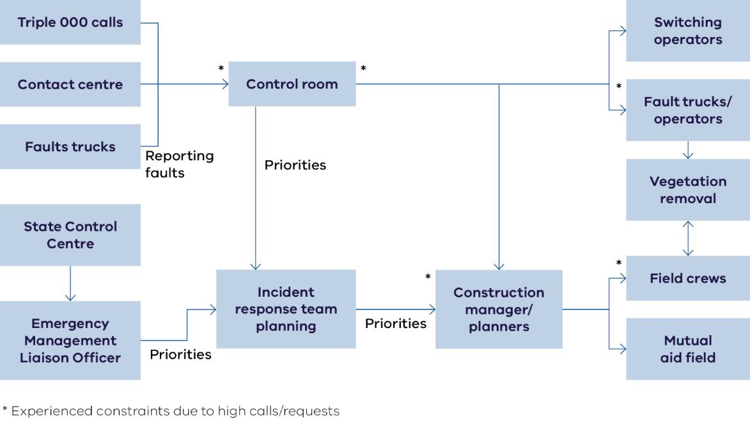
Figure 17: Diagram of identified constraints in managing AusNet's response.
AusNet’s systems and processes did not respond effectively to a large-scale, widespread outage impacting its network. Its approach to plan, manage and deliver its response centrally through its customer energy operations team (CEOT) increased burden on specialist roles and impacted information flow, and effective restoration. AusNet’s Restoration Plan does not identify how to manage requests for priority restoration or community safety concerns. Some of this may be the result of AusNet’s business-as-usual processes, under which AusNet’s third-party provider undertakes field planning and prioritisation, with this function elevated to AusNet in CEOT during the event.

Figure 17 shows where constraints were found during AusNet’s review of its response. These constraints limited its response capacity and influenced restoration times for customers. These are reported in more detail and necessarily focus on AusNet. However, we note that any distribution business would potentially be similarly constrained by similar issues when responding to a large-scale and prolonged power outage event.

AusNet’s systems and planning were not designed for an event of this scale, impacting restoration planning, prioritisation, control, and effective use of field crews.

- AusNet’s response was planned, managed and delivered centrally, without governance structures at the regional level for field resources. This slowed information flow and decision making between CEOT and field crews.
- AusNet’s Fault Response and Restoration Strategy does not document how requests for priority restoration from the SCC, or how downed lines, are integrated and dealt with during an event. There was not a formal process to integrate damage assessments undertaken by internal AusNet corporate resources who were deployed to undertake damage assessment.
- AusNet established different reporting lines and governance for its third-party provider, mutual aid surge capacity, and AusNet vegetation management. This impacted visibility and control of faults, priorities and the workforce – and efficient use of resources.

AusNet and its third-party provider’s enabling technology for monitoring, planning and restoring outages did not have the capacity, functionality and integration for the event. This created inefficiencies and constrained CEOT, resulted in poor information flow, sub-optimal planning of sequencing and repairs and inefficient use of field resources.

- CEOT could not view all necessary information to plan and dispatch work on a centralised platform (such as faults, asset information, job status, resource allocation, location, photos and dependencies), which slowed down controllers in their roles.
- The technology systems used by field crews were inconsistent in capability and did not provide full visibility of job status, location and priority to CEOT - limiting its visibility of restoration activation and optimal planning.
- Mutual aid and CEOT did not have an integrated and automated way to operate with each other to update and receive jobs – as mutual aid could not integrate with AusNet and its third-party provider’s automated systems. Mutual aid crews had to call or email the AusNet CEOT to be issued jobs, provide updates, and otherwise interact with Ausnet. This constrained CEOT and, at times, field crews had to wait hours to progress work because they could not contact CEOT.
- AusNet had no backup technology to communicate with field teams when telecommunications failed. Field crews were required to drive from the fault to where they could get phone reception to contact CEOT at each step of the restoration process. Manual processes (spreadsheets) were implemented during the event to prioritise restoration work, resulting in job re-visits due to incorrect information.
- Early in the event, surge field crews waited several hours before being provided direction from CEOT on where to start their assessment and restoration work.

AusNet operational resourcing
- AusNet scaled its response from 60 resources to 450 in the field delivery team (cancelled works and mutual aid).
- The planning and scheduling team within AusNet’s third-party provider faced constraints to process the volume of work issued.
- AusNet and its third party provider did not have the necessary planning, systems, technology and resourcing to make best use of its resources, mutual aid, or accept additional mutual aid, impacting efficient issuing of work to mutual aid resources.
  - Capacity and capability of resources involved in the response were not always sufficient, and the ramping up of specialist dispatchers and controllers in AusNet’s CEOT for a campaign event meant rostering less experienced and effective resources. The planning and scheduling team in AusNet’s third party provider faced constraints to process the volume of work issued.
  - AusNet engaged mutual aid early in the event to support its response. AusNet declined further field crew resources from third parties, as it could not accommodate additional field crews without increasing capacity of its CEOT to plan, dispatch and control crews.
- Handover processes were either not in place, or robustly followed for certain roles during the event, which resulted in lost time and inefficiencies.
- outsourced field services require greater integration, visibility and control to effectively traverse organisational boundaries.

We’re thinking
AusNet’s restoration of customers was lengthy. Although AusNet’s network is more susceptible to storm damage (elevation and vegetation), and more difficult to repair (access), we consider that based on the evidence it has received, there were significant opportunities for AusNet to improve its restoration of customers by addressing its processes, systems, enabling technology and resourcing constraints in its response. This would improve the efficiency and utilisation of its resources, better capacity to make informed, considered decisions in relation to planning and authorising works, and improve outcomes for customers in a timelier response that addresses key restoration priorities of AusNet, the State and communities.

We note that outsourced field services require greater integration, visibility and control to effectively traverse organisational boundaries. It is apparent from this event that AusNet does not have effective systems, processes, visibility, oversight and technological integration with its third-party service provider, to facilitate an effective and timely response to large scale events. AusNet and their third-party provider must improve the way they integrate and work with each other, and their ability to accept external mutual aid, to facilitate better outcomes for customers.

- Distribution businesses incorporate a requirement to achieve best practice outcomes for customers into any commercial arrangements with third party providers.
- The Minister for Energy and Resources considers an audit of network maintenance and fault response services between distribution businesses and third-party providers to ensure that distribution businesses are fulfilling their licence obligations and have effective control over their network.
- Distribution businesses and third-party contractors must improve the way they integrate and work with each other during major events to facilitate better outcomes for customers.

AusNet’s systems and processes and technologies were not effective in responding to a large-scale, widespread outage impacting its network. Various constraints prevented information flow or increased workload for the Customer Energy Operations Team, which impacted information flow, operational intelligence, and effective restoration.

Figure 18 highlights some of the areas that have been identified to improve AusNet’s response. However, we consider that these should be explored by all distribution businesses when considering how to develop escalation models for scale and prolonged power outage events:
- Increased capacity to report faults including technology options to allow emergency services and community to identify faults and damage to the network.
- Increased damage assessment capability including developing new roles to support field scouting and verification of damage.
- Technology improvements to support improved response planning and prioritisation.
- Increased planning support and resourcing including exploring regional planning and delivery models for scale events.

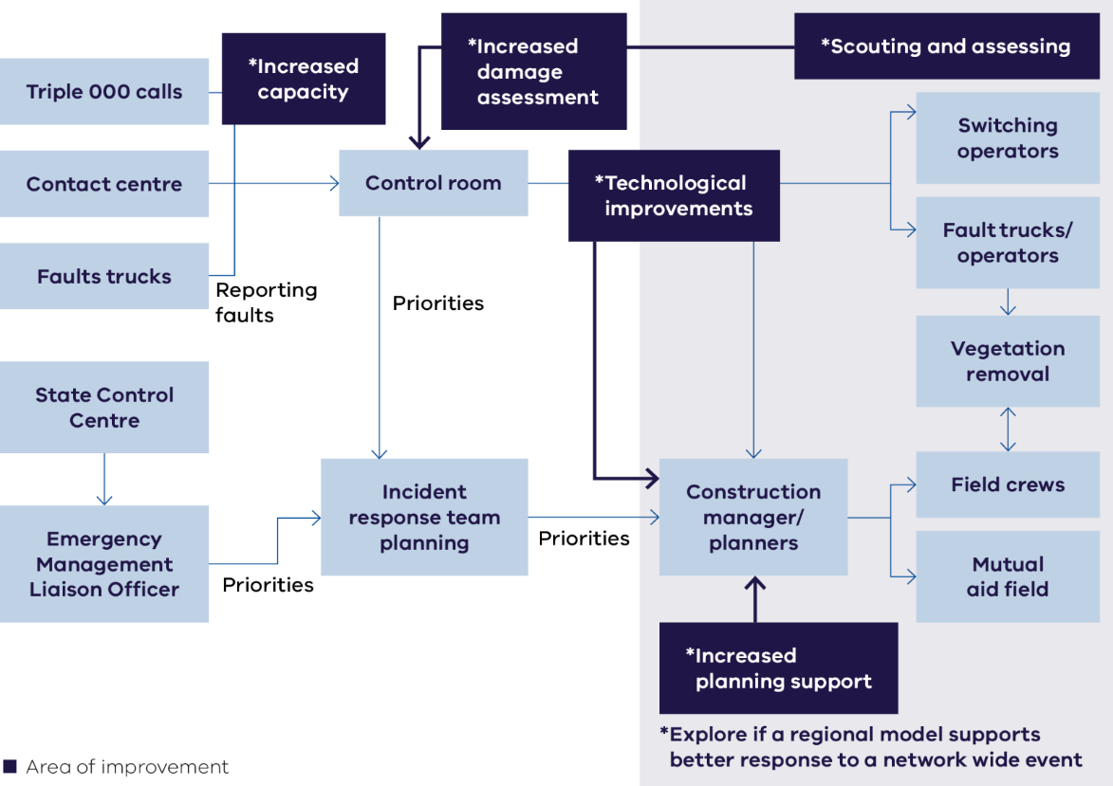
Figure 18: Diagram of opportunities to improve AusNet's response.
Distribution business should align their emergency management arrangements with the Victorian Preparedness Framework. This will include enhancements to existing capability and escalation models such as:
  - When a sustained scale event occurs, emergency response plans, such as AusNet’s SPIRACS, should be an appropriate tool that sets out the strategic resourcing, systems, processes and technologies to respond to a 2–4-week prolonged event, and addresses the barriers and constraints identified in this and previous events.
  - Extended resource planning including mutual aid should be triggered when an event is expected to last greater than 48 hours.
  - Workforce succession planning, particularly when workforce is outsourced through commercial arrangements.
There is evidence of multiple constraints across AusNet’s response that impacted its capacity to restore supply to customers in a timely manner. But we know about these constraints because AusNet was seriously tested in during the event. Victoria’s other distribution businesses must learn from AusNet’s experience to ensure that if they share similar constraints, these are addressed so they can respond effectively to events causing large-scale outages on their networks.
- Distribution businesses, and AusNet in particular, must address limitations identified in this event that prevented more rapid restoration through improving processes, systems, enabling technology and resourcing constraints. Report back to the Minister under Part 7A of the Emergency Management Act with exercised emergency management and restoration procedures to demonstrate how faster customer restoration and more effective communication with customers is achieved for network-wide and prolonged power outages.

Electricity Emergency Management Liaison Officer's (E-EMLO) are employees from the distribution businesses that are integrated into the state emergency management response to provide a key contact point between the distribution business and emergency response, enabling more effective information flow, intelligence sharing, and coordination of activities during events. Greater E-EMLO’s representation by AusNet at local and regional emergency management tiers early in the event could have also enabled emergency services agencies to support AusNet in all response phases.

Through their Electricity Emergency Management Liaison Officers, distribution businesses worked closely with the State Control Centre throughout the event. Our engagement has identified that there were opportunities where closer coordination and collaboration with other organisations responding during the event could have contributed to a timelier restoration. Emergency services have identified that liaison at all three tiers of response (state, region, and incident) would improve local interaction, planning and coordination between distribution business response and emergency services and provide better outcomes for community overall. In improving collaboration between organisation, we consider that:

- Distribution businesses enhance their Emergency Management Liaison Officer programs so there is capacity and capability for activation in State, Regional and Incident management tiers during an emergency.

Mutual aid between distribution businesses and other organisations

Introduction
Repairing and restoring the network requires significant resourcing during events that cause impacts at scale such as storms. Field crews undertake inspections of the network to assess the cause of faults and the actions required to rectify faults, make the site safe, repair any damage and restore the line back to service.

During large scale events, distribution businesses do not have the necessary resources on standby to restore customers in a timely manner, and they share resources amongst each other, including from third party providers, so that the impacted business can restore customers sooner. This is known as ‘mutual aid’. Mutual aid can be for both people and physical resources, such as temporary generators or other limited equipment.

To make use of additional resources, a distribution business requires the necessary systems, processes and technologies to accommodate and absorb external field crews and other resources into its response effectively.

In examining the operational response of Victoria’s distribution businesses to the 13 February event, the Network Outage Review is tasked with examining how timely and effectively the incident was managed, including the restoration of supply. This includes activities such as:
- The efficacy of control room operations and escalation model to manage and direct the business-wide response to the event.
- The availability and number of field crews and technical expertise, fleet and equipment, operating depot size and locations and comparative benefits in the operating model of energy distribution business companies, including through insourced, outsourced, or shared service provider models, and consequent speed of deployment.
- Whether there were material opportunities to enable more rapid restoration of supply to customers using mutual aid and resource sharing within Victoria, or from interstate resources, and the extent to which there was adequate contingency planning for mutual aid, including the ability to incorporate surge capacity into the response.

Stakeholders and community told us
- The 13 February storm event most heavily impacted the AusNet network, where 360,000 customers were left without power across 1,864 different faults. This is the highest number of outages AusNet has ever experienced. While 94 per cent of AusNet customers had their power restored within 72 hours, this still left 20,000 customers off supply for three days, with more than 4,000 customers off supply for at least seven days and final customers restored on 24 February - 12 days after the event.

- Mutual aid was used in the 13 February event by United Energy and AusNet.
  - Jemena provided mutual aid to AusNet using its third-party resources.
  - Powercor provided mutual aid to United Energy using its inhouse resources.
  - AusNet scaled its response from 60 resources to 450 in the field delivery team through cancelled works and mutual aid received from Jemena and UE resources.
  - United Energy provided its third-party resources as mutual aid to the AusNet network.

Mutual aid and resource sharing is an integral part of emergency management, but without adequate planning, resourcing, well maintained infrastructure and appropriate communication between the distribution business and its third-party providers, the ability to maximise the use of additional resources fails to support faster restoration for Victorian customers.

- Mutual aid resources need to be effectively deployed in order to accelerate restoration. This is impacted by a receiving distribution business’ ability to assess, triage and package work parcels for the incoming crews.
- There is not an up-to-date Victorian wide process for distribution businesses to request and provide mutual aid. The process needs to provide clarity on which party requests should be directed to, i.e. the distribution business, directly to a third-party provider contracted to the distribution business, or under a separate arrangement with third party providers.
- Interstate field delivery resources under a mutual aid agreement would be a useful solution in future events but this is not presently feasible due to licensing restrictions and the lack of an established process. Licensing of field crew roles is not a barrier to the use of field workers from other businesses in Victoria as all field workers are licensed by Energy Safe Victoria.

AusNet’s systems, planning and governance were not designed for an event of this scale and the emergency response systems put in place to manage mutual aid limited an effective field response. This resulted in sub-optimal planning of sequencing and repairs, and less efficient restoration and use of mutual aid.
- AusNet’s response was planned, managed and delivered centrally, without governance structures at the regional level for field resources. This slowed information flow and decision making between planning and control, and field crews.
- AusNet and its third-party provider did not have the necessary planning, systems, technology and resourcing to make best use of mutual aid or accept additional mutual aid. Key limitations included:

  - The lack of integrated technology for monitoring, planning and restoring outages. This meant that AusNet’s controllers and dispatchers did not have the ability to view all necessary information to plan and dispatch work (such as faults, asset information, job status, resource allocation, location, photos, dependencies). This impacted AusNet controllers' ability to direct field crews in the most efficient way, resulting in mutual aid crews waiting several hours before being provided direction on where to start their assessment and restoration work.
  - The lack of an integrated and automated way for AusNet and mutual aid crews to operate with each other to update and receive jobs. Mutual aid crews had to call or email AusNet to be issued jobs, provide updates and otherwise interact with Ausnet.
  - Insufficient capacity and capability of AusNet specialist dispatchers and controller for effective resourcing of a prolonged event (5-30 days).
  - The ability of Ausnet’s third-party provider’s planning and scheduling team to process the volume of work issued.

- AusNet engaged mutual aid early in the event to support its response but declined further field crew resources from third parties as it could not accommodate additional field crews because it could not increase the capacity of its customer energy operations team to plan, dispatch and control the additional crews.
- Field resources deployed as mutual aid to AusNet experienced significant delays in engagement with AusNet’s customer energy operations team to obtain approval to start and finish jobs.
- The outsourcing model employed by AusNet creates additional complexity and opportunity for things to go wrong in an event that requires the use of mutual aid to get the best outcome for Victorian customers.

We’re thinking
Mutual aid was provided by Powercor to United Energy during the event, and by Jemena, United Energy and other third parties to AusNet during the event.

AusNet’s systems and processes are not designed to respond effectively to a large scale, widespread outage impacting its network. Its approach to centrally plan, manage and deliver its response through its customer energy operations team (CEOT) increases the burden on specialist roles and impacts information flow and effective restoration.

CEOT was the central planner and authoriser of restoration works, and AusNet’s systems and processes increased workload and impacted information flow for CEOT, making it a bottleneck preventing the efficient planning and restoration of customers. The absence of a formal system for AusNet to accommodate campaign resources (mutual aid) further compounded demands on CEOT, as manual communication was required at each stage of the restoration process. This reduced the efficiency of field work crews.

The structure of AusNet’s response meant there were separate chains of command for its third party provider, mutual aid field surge capacity and AusNet vegetation contractors. This reduced visibility and control, negatively impacting an effective field response.

The capacity of CEOT and field staff to effectively and efficiently undertake their roles was undermined by the functionality and integration of AusNet and its third-party provider’s technology systems for monitoring, planning and restoring outages. This reduced the efficiency and productivity of planning and restoration.

AusNet declined further field crew resources from third parties in the event. Sourcing further surge capacity would not have significantly increased the productivity of AusNet’s response, because it did not have the planning resources in CEOT to effectively control and direct additional crews. To frame this in line with the Terms of Reference, further mutual aid was an opportunity to enable a timelier and more effective response, but this opportunity was not available to AusNet because of the systems, processes, technologies and capacity of its organisation to absorb this additional support.

AusNet’s speed of restoration of customers was too long. Although AusNet’s network is more susceptible to storm damage (elevation and vegetation), and more difficult to repair (access), we consider that based on the evidence received, there are significant opportunities for AusNet to improve its restoration speed for customers by addressing its processes, systems, enabling technology and resourcing constraints in its response. This would improve:
- The efficiency and utilisation of its resources and mutual aid resources.
- Its capacity to absorb additional mutual aid resources from other organisations to support its response.

This would have improved outcomes for customers with a timelier response that addresses key restoration priorities of AusNet, the State and communities.

It is critical that Victoria’s distribution businesses can accept and provide as much mutual aid as is practical to support a timely and effective response to events which cause impacts at scale. This event demonstrates that there are technology, process and resourcing constraints within AusNet and its third party provider impacting the effective utilisation of mutual aid. It is unclear whether Victoria’s other distribution businesses would also face constraints to the utilisation of mutual aid if faced with similar outage scenario.

We consider that the below measures would better prepare Victoria’s distribution business to effectively integrate mutual aid into their organisational response during large-scale events, which would result in a faster restoration, better outcomes for Victorian customers.

- Victorian distribution businesses formalise mutual aid service level agreements and memorandums of understanding across Victorian businesses.

- Mutual aid should always be considered when an event is expected to last more than 48 hours.

- Distribution businesses remove barriers to rapid deployment, absorption and effective use of mutual aid through:

  - Review of organisational processes, systems, enabling technologies and resourcing
  - Exercising network-wide events with incorporation of mutual aid, with outage scenarios to stress test control room and restoration planning operations and capacity
  - Formalisation of the provision of mutual aid for events expected to last more than 48 hours, through establishment of guidelines and service level agreements.

- In considering the above with respect to emergency response, this should include:

  - Cross walk analysis of role to role (role familiarisation between businesses)
  - Work system analysis
  - Crew make up including supervisory support for crews assisting other networks
  - Near real-time training
  - Expansion to include non-energy specific personnel resources, such as emergency services, other volunteer or manpower services organisations
  - Include physical as well as personnel resources.

Temporary generation for key community assets

Introduction
When large-scale power outage events occur, it takes time for the distribution business to assess the impact, make any damage safe, put a plan in place to restore the network, and then restore the network and power supply to customers.

There are some parts of the network where achieving restoration can be completed quite quickly - usually areas close to the ‘trunk’ of the network or areas that are well connected to other parts of the network. Parts of the network that are less interconnected, or more remote, need to have the central damaged parts of the network repaired before power can reach them.

Once a distribution business has assessed its network, the time customers will be off supply is better known and temporary generation can be deployed to provide power to impacted communities that cannot be restored to the main network in a reasonable time (e.g. 12-24 hours). This generation can effectively make a mini-islanded grid or stand-alone power system within communities to support them during an event. This can include powering main streets, petrol stations, ATMs, supermarkets, community centres or other important community locations.

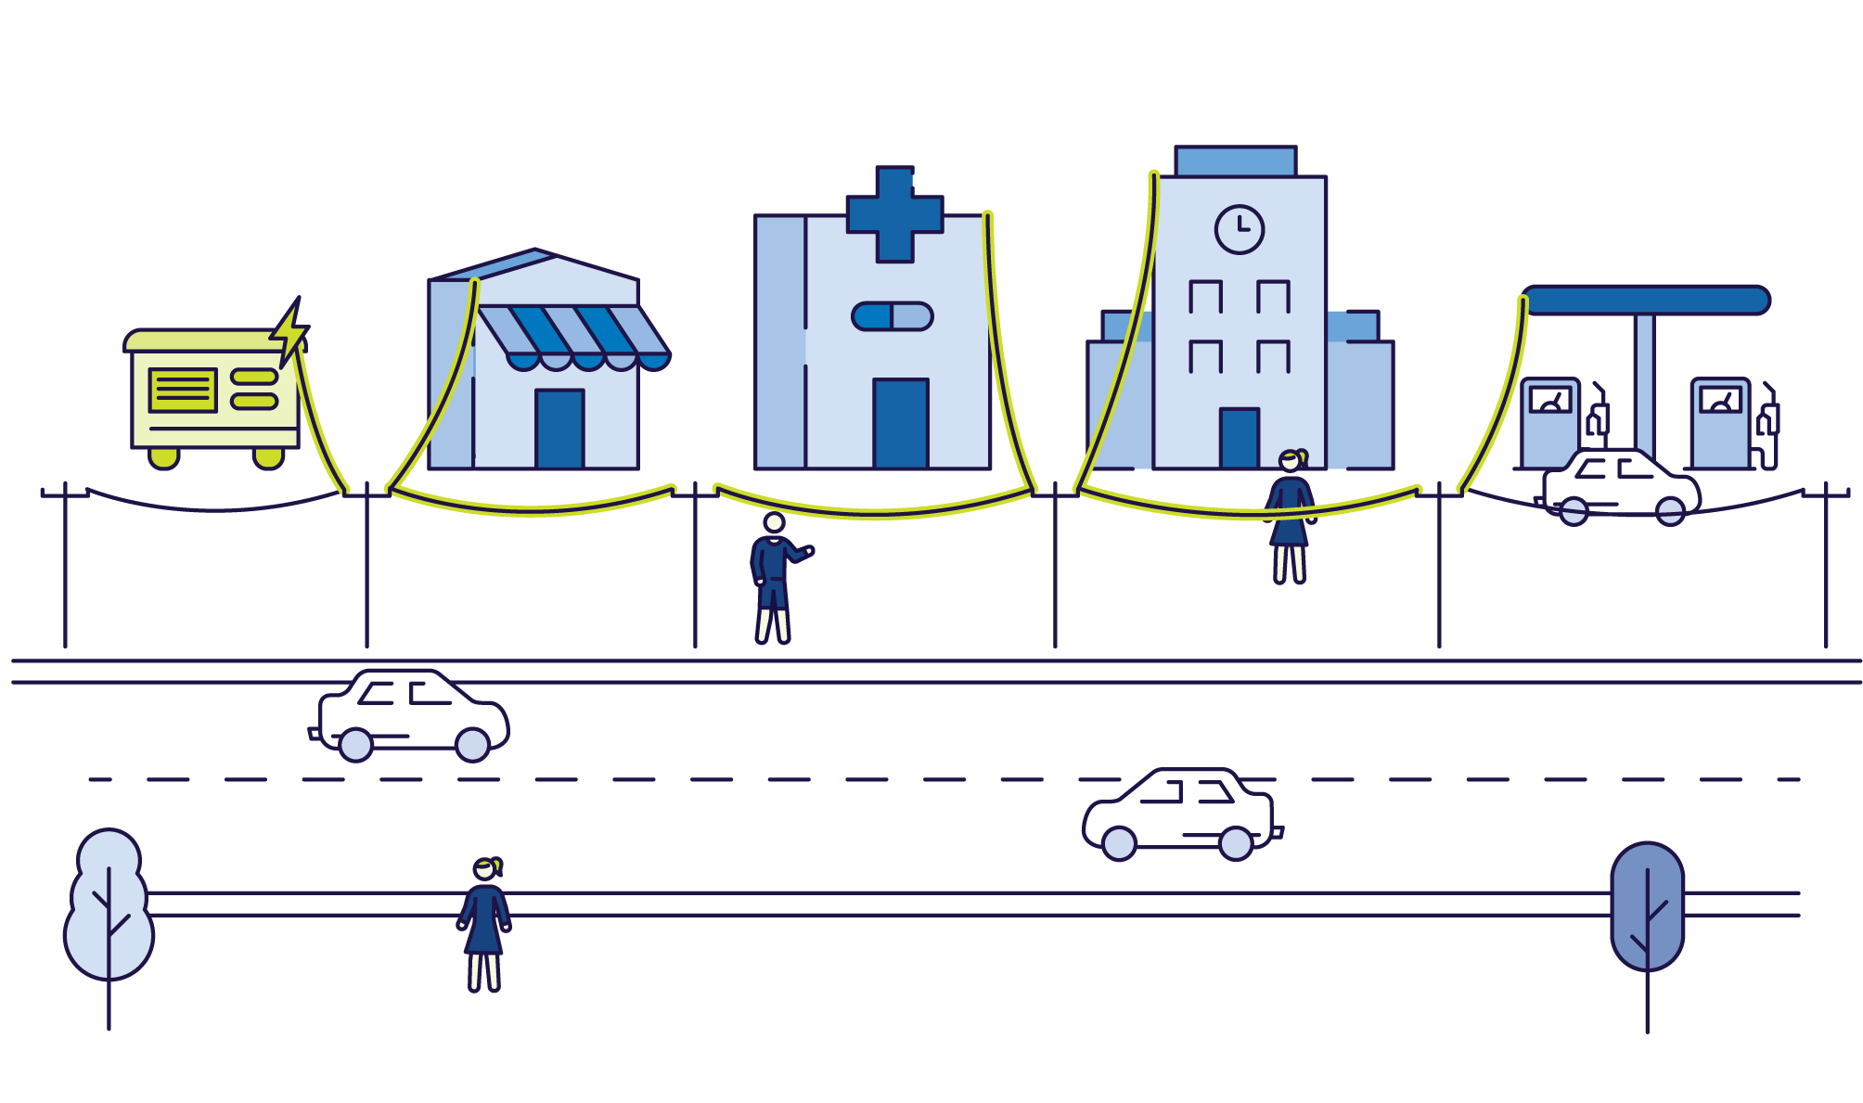
Figure 19: Temporary generation for main streets.
This is important for communities without power for prolonged periods, to ensure they can:
- purchase ready-to-eat food or medication due to spoilage (refrigeration)
- access hot water and hygiene facilities
- purchase fuel for driving or to sustain a home back-up generator
- access banking facilities.

Without power to these critical services, the impact and trauma to the community from prolonged power outages is amplified.

With support from the communication sector, temporary communication systems can also be installed once there is power available to a central location.

In examining the operational response of Victoria’s distribution businesses to the 13 February event, we are tasked with examining how timely and effectively the incident was managed. This includes the capacity to provide support and resources to offer in-field communication and support to heavily impacted communities; and best practice systems, resources and technologies for managing extended outages.

Customers and stakeholders told us
Temporary generation installed at key community locations during power outage events makes the event more manageable, as businesses can stay open, communities can access goods and services essential to them locally and stock doesn’t go to waste.

- While communities were grateful for temporary generation, they want AusNet to prioritise earlier deployment of temporary generators to restore priority township areas in an event.

- While installing temporary generation at key community locations is important for the community’s capacity to manage the event, it can divert key field services crews from restoring supply to customers.

- The Monbulk, Emerald, Cockatoo, Gembrook and Upper Beaconsfield communities have identified key infrastructure in their main streets, like the supermarket, butcher, banking, pharmacy, doctors and fuel station as important services to their communities that should be supported with temporary generation during events.

Temporary generation – Cockatoo, Emerald and Mirboo North
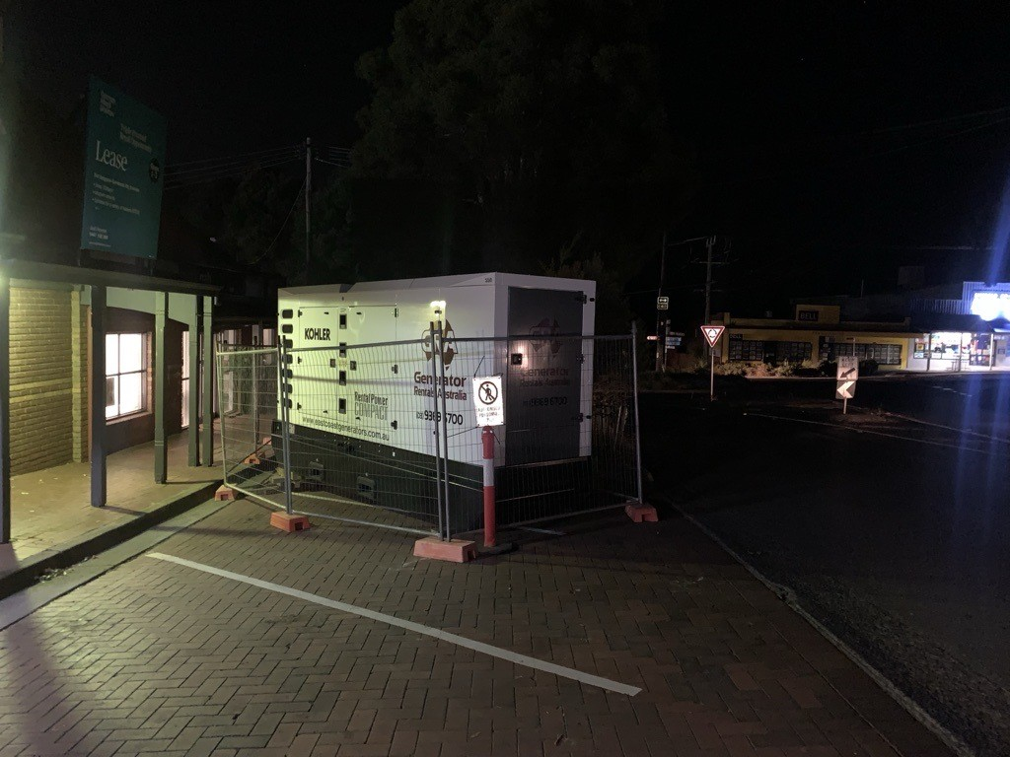
Figure 20: Picture of large generator deployed to support main street.
During the 13 February storm event, AusNet deployed temporary generation to Cockatoo, Emerald and Mirboo North, as these communities were expected to be off supply for a prolonged period.

These diesel generators were deployed on the main streets of these townships, allowing electricity supply to key community assets including supermarkets and fuel stations. Generators are transported into the affected area and specialist field crews undertake work to isolate the small area to be restored from the rest of the network, connect the generator into the isolated network and deploy the generation. The generator is then refuelled to continue to provide power to key community locations and services until the main network is restored.

- The Monbulk community has identified key emergency relief centres required during power outages and would like more support to enable them to provide adequate services and facilities.

Improved preparation and consistent planning between distribution businesses, local councils and communities is required to support communities with temporary generation for events and make best use of the town’s main street to support them.

- During the 13 February event, local councils were not consistently or readily able to notify AusNet of a list of priority buildings and assets suitable for temporary generation.

- AusNet is working on ‘quick connect’ points to facilitate a ‘plug and play’ deployment of temporary generation in future events, reducing the time required for specialist field crews to install this generation.

We’re thinking
We have heard clearly from communities that AusNet’s deployment of temporary generation to key community assets during the 13 February storm event was extremely beneficial and made the event more manageable through local access to essential supplies and services.

Community have identified that getting this temporary generation sooner, and better planned and considered deployment, would enhance its value to community during events. While AusNet identified that installing temporary generation during events diverted its resources from repairing the network and restoring supply, it is now working to develop ‘quick connect’ points so that temporary generation can be 'plugged in’ quickly in future events.

There are opportunities for the distribution businesses to work with local councils and communities in areas that are more susceptible to prolonged power outages and identify important community locations that could be supported with temporary generation during large-scale events. Doing this work outside of an emergency will enable more considered and effective deployment of temporary generation, which would better support impacted communities during events.

We consider that the below measures would enable rapid deployment of temporary generation to support communities in an event.

- Victorian distribution businesses work with local government and their communities to identify key township locations that are important for priority restoration in a prolonged power outage and install ‘quick-connect’ points and other necessary upgrades to enable temporary generation to be installed within 12 hours of future prolonged events.

- Distribution businesses provide information about sites with ‘quick-connect’ points to the Municipal Emergency Management Planning Committee for each local plan to be updated.

AusNet Quick Connect Initiative
AusNet provided temporary generation for communities during the 13 February storm event, but it took time to modify the network so that temporary generation could be installed and deployed.

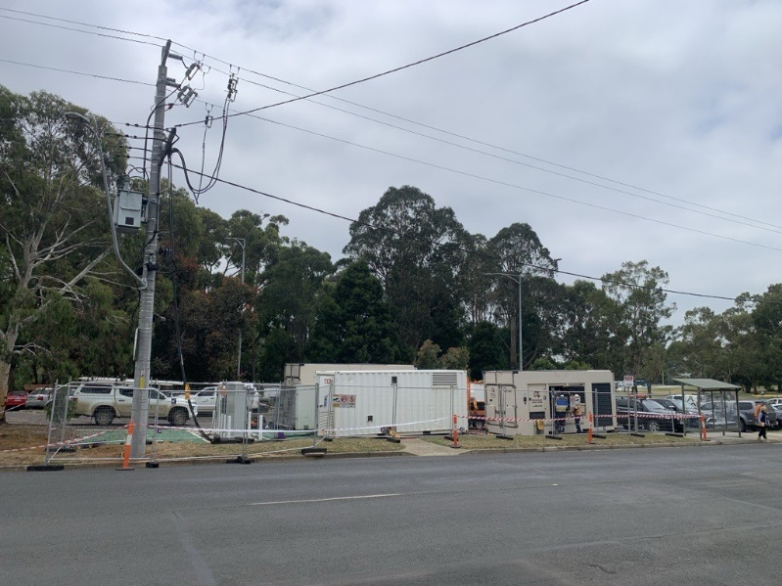
Figure 21: Picture showing large generator and temporary connection to local electricity grid.
AusNet plans to develop ‘quick connect’ points in some towns in preparedness for future events, so that temporary generation can be installed faster in the future.

After the 13 February 2024 storm event
Key actions that take place after emergencies are recovery activities and review processes to allow for lessons to be identified that can be improved upon prior to the next emergency.
Recovery activities take place after an emergency and are usually measured in month and/or years. Recovery is a coordinated process of supporting emergency-affected communities in reconstruction of physical infrastructure and restoration of emotional, social, economic and physical wellbeing. Recovery includes actions taken to return to a normal or even safer situation following an emergency as well as potentially receiving financial assistance to help pay for the repairs.
This section expands on areas that our conversation brought to the fore for attention and were associated with activities that occur after an emergency.

Recovery after the emergency

Introduction
When a distribution business responds to a power outage event, restoration of supply is completed when it is restored to the point of supply on the customer’s premises.

Sometimes the distribution business cannot connect individual customers’ premises as the connection doesn’t meet safety standards due to damage to the switchboard, point of attachment issues such as unsecured cables, or trees contacting private lines.

In these cases, the distribution business issues the customer with a defect notice, which requires the customer to engage a licensed electrician to undertake repairs, complete a safety and compliance inspection, issue a certificate of electrical safety and arrange for the distribution business to send a truck to reconnect the power to the customer’s property.

Some customers received defect notices following the 13 February storm event. There was some confusion as to why these customers’ power had not been restored, when neighbouring properties had been. There was also confusion about how far the responsibilities of the distribution business extended and why distribution businesses were not undertaking repairs to private electrical infrastructure to enable customers’ reconnection to power supply.

Distribution businesses are responsible for restoration of power supply to the point of supply, which is generally the connection to the premises. Property owners are responsible for repairing private electrical infrastructure on the private side of the point of supply.

Some rural properties have a private electric line, which is a low-voltage electric line used to take electricity from the point of supply to the premises. In these instances, the point of supply is usually the first pole that is carrying the line onto the land. The Electrical Safety Act 1998 Section 84A identifies the person responsible for maintaining private electric lines as the occupier of land on which there is a private electricity line.

Some customers encountered barriers to rectifying the damage to their private electrical infrastructure following 13 February storm event. This was due to factors including availability of information, personal and financial circumstances, ownership and access to licensed electricians.

We consider that delays to customer restoration due to private electricity infrastructure damage merits examination to identify how customers can be supported to achieve faster restoration.

Customers and stakeholders told us
We have engaged deeply with affected communities, distribution businesses, regulators, emergency services, peak bodies, social and community organisations. Communities that were impacted by the 13 February 2024 event include Cockatoo, Emerald, Gembrook, Monbulk, and Mirboo North areas. We heard that:

Some customers had outages extend beyond the time the distribution business took to restore supply to their area because of damage to private electricity infrastructure requiring the property owner to take action.

- Many customers do not understand where their responsibility starts for private electricity infrastructure and the role of the distribution business in restoring supply to the ‘point of supply’.

- In some cases, damage to private electricity infrastructure was only identified when mains power was restored, and a defect notice was issued to the customer.

There are barriers to customers organising and funding a licensed electrician to undertake repairs, delaying restoration of power to their property.

- Customers in impacted communities simultaneously experienced a severe storm event, a prolonged power outage and loss of telecommunications. Some customers faced barriers in resolving private electricity infrastructure repairs including:

- Information – many customers did not understand private electricity infrastructure repair was their responsibility, or what to do to resolve it.
- Financial – many customers were engaging with insurance companies and needing to wait for assessors before contracting licensed electricians to undertake repairs. Other customers were not insured and do not have the necessary funds to pay for repairs.
- Personal – vulnerable customers, including those experiencing trauma and recovering from the event, had limited capacity to manage additional issues.
- Ownership – renters require the property owner to undertake repairs. The process of notification to the owner and owner rectification may cause delays.
- Access to services – while not something we have heard during this event, other events have resulted in local shortages of electricians to undertake private repairs.
Customers also identified that when claiming for damage to their electrical equipment from their distribution business, they were required to have it assessed by an electrician before a claim could be made. This added an extra cost burden that proved a barrier and challenge for some customers to be able to claim compensation.
Overall restoration for customers could be achieved sooner if they had better information and support
- There is a knowledge gap within communities about responsibility for repairing private electricity infrastructure and what to do to resolve this.
- Distribution businesses assisted customers with information.
- There are gaps in summer preparedness campaigns that mean many customers were not well prepared for a prolonged power outage.
- Customers need support during emergencies to easily and quickly access suitable and licensed electrical services to repair private electricity infrastructure damage.

We’re thinking
This review is focused on getting better outcomes for customers during significant prolonged power outage events.

There is opportunity for consistent information to Victorian customers, including property owners and property managers, about what constitutes private electrical infrastructure and what customers need to do when their infrastructure is damaged and/or they are issued with a defect notice.

The below measures would better prepare and support customers to ensure their safety and guide managing repair of private electrical infrastructure following damage.

- Distribution businesses, Energy Safe Victoria and other relevant organisations develop and proactively communicate consistent statewide messaging about safety and repair of private electrical infrastructure, including what to do when a defect notice is issued.

In significant events, there is an opportunity for emergency services to facilitate access to licenced electricians, removing the complexity for customers in accessing these services. Recovery agencies can also connect affected community members to other support, such as financial assistance.

- Distribution businesses provide details of properties issued with defect notices in an emergency event to emergency recovery agencies to enable emergency recovery agencies to monitor and coordinate access to licensed electricians if a capacity constraint emerges.

In the 13 February event, distribution businesses supported customers with information and in some cases went above and beyond their responsibilities to help customers get their power back.

Appendices

Appendix 1: Terms of Reference
Introduction
- An extreme weather event in Victoria on Tuesday 13 February 2024 resulted in storm damage to distribution networks causing widespread outages. At its peak, over 530,000 electricity customers were offline, and some customers were offline for more than week.

- The Network Outage Review – System response has been established to inquire into and make recommendations in respect to the operational response of transmission and distribution businesses, including contingency planning, timely and effective management of the incident, and restoration of supply.
Definitions
- In these Terms of Reference-
Review means the Network Outage Review-System Response to 13 February storms advisory Review, established by the Minister by these Terms of Reference
Code of Conduct means the Directors’ Code of Conduct and Guidance Notes issued by the Victorian Public Sector Commission;
Department means the Department of Energy, Environment and Climate Action or its successor.
Appointment and Remuneration Guidelines means the Government’s Appointment and Remuneration Guidelines, as updated from time to time.
Member means a member of the Review and includes a reference to the Chairperson unless the contrary intention is expressed.
Minister means the Minister for Energy and Resources;
PAA means the Public Administration Act 2004;
Public sector employee has the meaning given in section 4(1) of the PAA.
Secretary means the Secretary to the Department.
Establishment of Review
- The Minister establishes the Network Outage Review-System Response to 13 February storms from the date of these Terms of Reference.

- The Review is classified as a Group D Band 3 non-departmental entity under the Appointment and Remuneration Guidelines.
Functions
- The functions of the Review are to provide recommendations that address –
  - The operational response of transmission and distribution businesses, including contingency planning, their timely and effective management of the incident, and restoration of supply (including temporary supply via generators).
  - For Distribution businesses:
    - The process for enacting State emergency management restoration priorities in accordance with the Emergency Management Act (primacy of life, communications, etc).
    - The efficacy of control room operations and escalation model to manage and direct the business wide response to the event.
    - The availability and number of field crews and technical expertise, fleet and equipment, operating depot size and locations and comparative benefits in the operating model of energy network companies, including through insourced, outsourced or shared service provider models, and consequent speed of deployment.
    - Whether there were material opportunities to enable more rapid restoration of supply to customers through the use of mutual aid and resource sharing within Victoria, or from interstate resources, and the extent to which there was adequate contingency planning for mutual aid, including the ability to incorporate surge capacity into the response.
    - The tools and systems to communicate proactively with customers and external authorities, including SMS, call centres and effective information platforms and services, such as outage trackers
    - The capacity to provide support and resources to offer in-field communication and support to heavily impacted communities (via mobile community response vehicles or community centres).
    - Preparedness to administer the Prolonged Power Outage Payment program and other forms of Relief and Customer Support.
    - The extent to which customers who were affected by the 13th February storms should be and were adequately prioritised in subsequent outages.
    - In light of the above, the identification of best practice systems, resources and technologies for managing extended outages, and the need for industry wide adoption.
  - Matters that supplement and avoid duplication with Network Resilience Review undertaken after the 2021 events.
- The Review should have regard to the need for timely completion and so, if required, may recommend a limited number of significant areas for further detailed investigation.
- The Review should facilitate direct input from the community and stakeholders, including through Public Panel meetings and accepting written contributions to inquire into the matters identified at clause 6 above. The location of the public meetings will be determined in consultation with the Department of Energy, Environment and Climate Action.
- The Review should facilitate input from the Australian Energy Market Operator, Australian Energy Regulator, Energy Safe Victoria, the Essential Services Commission, and other regulators as appropriate.
- The Review should provide an interim report to the Minister by June 2024 and a final Report by August 2024.
- Both the interim and final reports should be provided to the Department for review and consideration before they are provided to the Minister.

Appendix 2: Analysis of Terms of Reference to Interim Report
# | Terms of Reference | Transmission Response | Planning and Coordination | Planning for life support customers | Telecommunications continuity planning | Business continuity planning (other essential services) | Incentives and compensation | Worst performing areas of the network | Communications with customers/community | Impact assessment and make safe actions | Restoration planning and prioritisation | Mutual aid | Temporary generation for key community assets | Recovery after the emergency
6.a. | The operational response of transmission and distribution businesses, including contingency planning, their timely and effective management of the incident, and restoration of supply (including temporary supply via generators). | X
6.b.i. | The process for enacting State emergency management restoration priorities in accordance with the Emergency Management Act (primacy of life, communications, etc). |  | X | X | X | X |  |  | X | X | X |  | X
6.b.ii. | The efficacy of control room operations and escalation model to manage and direct the business wide response to the event |  | X |  |  |  | X | X |  | X | X | X | X
6.b.iii. | The availability and number of field crews and technical expertise, fleet and equipment, operating depot size and locations and comparative benefits in the operating model of energy network companies, including through insourced, outsourced or shared service provider models, and consequent speed of deployment. |  | X | X |  |  | X |  |  | X | X | X | X
6.b.iv. | Whether there were material opportunities to enable more rapid restoration of supply to customers through the use of mutual aid and resource sharing within Victoria, or from interstate resources, and the extent to which there was adequate contingency planning for mutual aid, including the ability to incorporate surge capacity into the response. |  | X | X | X | X | X | X | X | X | X | X | X
6.b.v. | The tools and systems to communicate proactively with customers and external authorities, including SMS, call centres and effective information platforms and services, such as outage trackers |  | X | X |  |  |  |  | X | X | X | X | X | X
6.b.vi. | The capacity to provide support and resources to offer in-field communication and support to heavily impacted communities (via mobile community response vehicles or community centres). |  | X | X |  |  |  |  | X |  |  |  | X | X
6.b.vii. | Preparedness to administer the Prolonged Power Outage Payment program and other forms of Relief and Customer Support. |  | X |  |  |  | X |  | X
6.b.viii. | The extent to which customers who were affected by the 13th February storms should be and were adequately prioritised in subsequent outages. |  | X |  | X | X |  | X |  | X | X | X | X | X
6.b.ix. | In light of the above, the identification of best practice systems, resources and technologies for managing extended outages, and the need for industry wide adoption | X | X | X | X | X | X | X | X | X | X | X | X | X

Appendix 3: Glossary of Terms
Term | Definition
AusNet Outage Tracker | AusNet’s outage tracker is a live website that is regularly updated to reflect the outages – both planned and unplanned, and their respective status.
Australian Energy Market Operator (AEMO) | The Australian Energy Market Operator (AEMO) operates the systems that allow energy to be generated, transmitted, and distributed, and the financial markets that allow energy to be sold and bought in the National Electricity Market (NEM).
Australian Energy Regulator (AER) | The regulator of Australian wholesale electricity and gas markets in Australia.
Automatic Transfer Unit (ATU) | A device that automatically transfers power supply from a primary supply to a secondary supply in the instance of an outage
Business continuity | Refers to the capability of an organisation to continue delivering its products or services at pre-defined acceptable levels in the wake of an emergency or disruptive event
Consumer Affairs Victoria | Provides advice to residents on what they should consider during repairs and rebuilding their property.
Convective downdraft wind gusts | Convective storms produce downdrafts that descend to the surface and spread out.
Department of Energy, Environment and Climate Action (DEECA) | Provides public information about staying safe during an outage.
Distribution business (DB) | A business that owns, operates, or control an electricity distribution network that distributes electricity to households and businesses
Emergency Management Victoria (EMV) | Emergency Management Victoria is responsible for facilitating the cooperation of emergency management services, external stakeholders, communities, and government by assisting in preparation, response, and recovery required because of an emergency.
Energy Charter | A collaboration between organisations from the energy sector regarding collective resilience
Energy Distribution Code of Practice | A set of rules regulating the distributing of electricity by a distributer to customers ensuring that it’s conducted in a safe way. It additionally regulates planned and unplanned interruptions of supply, as well as implanting protections life support customers.
Energy Retail Code of Practice | A set of rules electricity and gas retailers must follow when selling energy to Victoria Customers.
Energy Safe Victoria | Energy Safe Victoria regulates Victoria’s energy industries ensuring that they are meeting safety standards and community expectations. Responsible for issuing various licenses and auditing certificates of electrical safety as well as overseeing bushfire mitigation programs.
Essential Services Commission (ESC) | The economic regulator responsible for essential utility services supplied by the Victorian Government
Feeders (Feeder Lines) | A type of electrical line that carries power from a main distribution point to end users
Generator | A device that converts motion-based power or fuel-based power into electric power for use in an external circuit
Lack of reserve (LOR) conditions | A notification indicating a reduction in pre-determined electricity reserve levels. Indicates that load shedding is about to commence or has already begun.
Life support customer register | The life support register is a record of life support customers that help distributors and retails uphold the responsibilities they have to customers using these systems.
Line workers | A worker that constructs and maintains the electric transmission and distribution facilities that deliver electricity
Load shedding | Deliberate and temporary shutdown of electricity supply in specific areas or regions to prevent a complete system collapse during times of high demand or insufficient power generation
Major event days | Days where the system operational and/or design limits are exceeded
National Electricity Market (NEM) | The national electricity market involves both the wholesale electricity market and physical power system that operates in New South Wales, Australian Capital Territory, Queensland, South Australia, Victoria, and Tasmania.
National Electricity Rules | Govern the operation of the National Electricity Market. These rules govern the operation of the wholesale electricity markets, the way in which AEMO manages power system security and economic regulation.
Rapid Earth Fault Current Limiters (REFCLs) | A technology that detects and limits the amount of energy released when an earth fault occurs on a power line. This technology acts as a safety switch reducing the possibility of a fire being started. e
Service Target Performance Incentive Scheme (STPIS) | Provide networks with incentives for maintaining and improving network performance to the extent that customers are willing to pay for such improvements
Severe conductive downburst | A weather phenomenon by which powerful winds are produced by a storm with strong downward moving air hitting the group radiating the wind outward at high speeds.
Total Fire Ban | A declaration made on days with heightened fire danger that restrict and prohibits many activities that can cause a fire
Transmission business | A business that owns and operates transmission infrastructure used to transport electricity to distribution infrastructure.
Voltage | The amount of potential energy between two points in a circuit. Refers to the work needed per unit of charge to move a positive test charge from one point to another.

Appendix 4: Glossary of Acronyms
Acronym | Stands for:
ACRs | Automatic Circuit Reclosers
AEMC | Australian Energy Market Commission
AEMO | Australian Energy Market Operator
AER | Australian Energy Regulator
AMI | Advanced Metering Infrastructure
ATU | Automatic Transfer Units
BOM | Bureau of Meteorology
CAIDI | Customer Average Interruption Duration Index
CEOT | Customer and Energy Operations Team
CERAs | Community Emergency Risk Assessments
CFA | County Fire Authority
CSG | Customer Service Guarantee
DB | Distribution business
DEECA | Department of Energy, Environment and Climate Action
DNOs | Distribution Network Operators
DNRR | Distribution Network Resilience Review
EMLO | Emergency Management Liaison Officer
EMV | Emergency Management Victoria
ESC | Essential Services Commission
ESV | Energy Safe Victoria
ETA | Estimated Time to Assess
ETR | Estimated Time to Restore
FLISR | Fault, Location, Isolation, and Service Restoration
GSL | Guaranteed Service Level
ISF | Institute of Sustainable of Futures
IVR | Interactive Voice Response
kWh | Kilowatt hour
LFI | Installation of Line Fault Indicators
LOR | Lack of reserve
LSC | Life support customers
LSC | Life Support Customer
MAIFI | Momentary Average Interruption Frequency
MED | Major Event Days
MEMPs | Municipal Emergency Management Plans
MoU | Memorandum of Understanding
MW | Megawatts
NEM | National Electricity Market
NEO | National Electricity Objective
NMI | National Metering Identifiers
Ofgem | Office of Gas and Electricity Markets
PPOP | Prolonged Power Outage Payment
PREMO | Performance, Risk, Engagement, Management and Outcomes
RCGS | Remote Controlled Gas Switches
REFCL | Rapid Earth Fault Current Limiters
REMP | Regional Emergency Management
RIN | Regulatory Information Notices
SAIDI | System Average Interruption Duration Index
SAIFI | System Average Interruption Frequency Index
SPIRACS | Strategic Plan for Integrated Response and Contingency System
STAND | Strengthening Telecommunications Against Natural Disasters
STPIS | Service Target Performance Incentive Scheme
TDRI | Telecommunications Disaster Resilience and Innovation
TFB | Total Fire Ban
UE | United Energy
USO | Universal Service Obligation

Appendix 5: Stakeholder engagement
Stakeholder engagement | Public submissions received
Ambulance Victoria  Electrical Trade Union  Minister for Energy and Resources  Emergency Management Commissioner  AusNet  Jemena  CitiPower & Powercor  United Energy  Mirboo North Public Engagement  Australian Energy Regulator  Electricity Distribution Network Resilience Review (2022 Chair)  CEO Energy Safe Victoria  Essential Services Commission  DGS – Telecommunications  Monbulk Public Engagement  Cockatoo Public Engagement  Emerald Public Engagement  Gembrook Public Engagement  Australian Energy Market Operator  Downer (AusNet’s third party service provider)  Zinfra – Transmission Services  Zinfra – Distribution Services  VCOSS – Vic Utilities Group  Energy and Water Ombudsman Victoria  State Emergency Service  Energy Charter  Energy Consumers Australia  Emergency Management Victoria | Consumer Action Law Centre (CALC)  ETU – Electrical Trade Union  Emerald Village Association  Madcow – Monbulk and District Community Opportunities Working Group  Janet Granger-Wilcox (Personal Submission)  George Trojan (Personal Submission)  John Mumford (Personal Submission)  Energy and Water Ombudsman Victoria

www.energy.vic.gov.au/safety/network-outage-review

https://aemo.com.au/energy-systems/electricity/national-electricity-market-nem/about-the-national-electricity-market-nem
https://mapshare.vic.gov.au/webmap/energy/
AEMO Preliminary Report – Trip of Moorabool – Sydenham 500 kV No. 1 and No. 2 lines on 13 February 2024
https://www.energysafe.vic.gov.au/sites/default/files/2022-12/Cressy_500kV_Tower_Incident_31Jan2020_report.pdf
AEMO Preliminary Report – Victoria and South Australia Separation Event – 31 January 2020
https://www.esv.vic.gov.au/media-centre/news/energy-safe-investigates-transmission-towers-collapse
https://aemo.com.au/-/media/files/electricity/nem/market_notices_and_events/power_system_incident_reports/2024/preliminary-report---loss-of-moorabool---sydenham-500-kv-lines-on-13-feb-2024.pdf
This diagram has been developed in 2022 as a part of a Sector wide risk assessment process.
From DEECA outages data.
https://www.esc.vic.gov.au/electricity-and-gas/market-performance-and-reporting/victorian-energy-market-report
https://www.ofgem.gov.uk/sites/default/files/2022-06/Final%20report%20on%20the%20review%20into%20the%20networks%27%20response%20to%20Storm%20Arwen.pdf
https://www.aer.gov.au/system/files/2024-02/Ergon%20-%205.5.11%20-%20Business%20Case%20Worst%20Performing%20Feeder%20Program%20-%20January%202024%20-%20public.pdf
published at: http://vpsc.vic.gov.au/resources/directors-code-of-conduct-and-guidance-notes/
available at: http://www.dpc.vic.gov.au/index.php/policies/governance/appointment-and-remuneration-guidelines

