Victoria’s Investment Prospectus: Onshore Wind

**Victoria, one of the world’s most exciting energy markets**

Table of Contents

Acknowledgements 3

Why invest in Victoria’s onshore wind sector? 6

Our legislated targets are driving investment 7

Victoria’s world-leading wind resource 9

VicGrid – shaping Victoria’s future grid 11

Flagship investments enabling new project connections 12

Powering Victoria’s renewable energy future 13

Government policy accelerating demand 15

Fast-tracking planning approvals 17

Investing in a Future Made in Australia 19

Capacity Investment Scheme 21

Offshore Wind 22

Access to Victoria’s world-class renewable energy talent 24

In-demand critical mineral deposits 26

Celebrating success in our wind sector 28

Co-locate with energy storage to maximise output 30

A world class supply chain to support a thriving wind industry 32

Key Victorian Government entities 35

For international investors 38

# Acknowledgements

**Acknowledgement of Country**

We acknowledge and respect Victorian Traditional Owners as the original custodians of Victoria’s land and waters, their unique ability to care for Country and deep spiritual connection to it.

We honour Elders past and present whose knowledge and wisdom have ensured the continuation of culture and traditional practices.

We are committed to genuinely partner, and meaningfully engage, with Victoria’s Traditional Owners and Aboriginal communities to support the protection of Country, the maintenance of spiritual and cultural practices and their broader aspirations in the 21st century and beyond.

© The State of Victoria Department of Energy, Environment and Climate Action, September 2024

**Creative Commons**

This work is licensed under a Creative Commons Attribution 4.0 International licence, visit the [Creative Commons website](http://creativecommons.org/licenses/by/4.0) (<http://creativecommons.org/licenses/by/4.0/>).

You are free to re-use the work under that licence, on the condition that you credit the State of Victoria as author. The licence does not apply to any images, photographs or branding, including the Victorian Coat of Arms, and the Victorian Government and Department logos.

ISBN 978-1-76136-595-9 (pdf/online/MS word)

**Disclaimer**

This publication may be of assistance to you but the State of Victoria and its employees do not guarantee that the publication is without flaw of any kind or is wholly appropriate for your particular purposes and therefore disclaims all liability for any error, loss or other consequence which may arise from you relying on any information in this publication.

**Accessibility**

To receive this document in an alternative format, phone the Customer Service Centre on 136 186, email customer.service@delwp.vic.gov.au, or contact [National Relay Service](http://www.accesshub.gov.au/) ([www.accesshub.gov.au](http://www.accesshub.gov.au/)) on 133 677. Available at [DEECA website](https://www.deeca.vic.gov.au/) ([www.deeca.vic.gov.au](https://www.deeca.vic.gov.au/)).

#### Traditional Owners at the centre of decision-making processes

Strong and mutually beneficial partnerships with Traditional Owners and First Peoples are imperative to the electricity transition’s success and integral to ensuring the goals and objectives of self-determination set out in the Victorian Government’s Self Determination Reform Framework and the Department of Energy, Environment and Climate Action’s (DEECA) Pupangarli Marnmarnepu ‘Owning Our Future’ Aboriginal Self-Determination Reform Strategy 2020–2025.

We will be continually guided by Traditional Owner and First Peoples’ communities – now and in the future – who have expressed a strong interest in investing in renewable energy to deliver their interests and their desire to own and manage renewable energy generation and storage technology and infrastructure to meet their communities’ cultural, spiritual and economic needs.

As part of a once-in-a-generation renewable electricity transition and transformation, there is an obligation for industry and government to create genuine partnerships with Traditional Owners and First Peoples, to ensure that their self-determining rights and interests are upheld. This will be the catalyst for historical change and reform that will see immediate and future flow-on effects. It will have a positive impact on the environment and advance the social and economic outcomes for Traditional Owners and First Peoples and all Victorians.

# Why invest in Victoria’s onshore wind sector?

#### Targets fuelling investment

Victoria is estimated to need an additional 5.4 GW of onshore wind generation to meet the Victorian Renewable Electricity Target of 95% by 2035.

#### Planning reforms to derisk your investments

The Victorian Government recently expanded the Development Facilitation Program to fast-track planning approvals for large renewable energy facilities such as wind farms.

#### Attractive market for generators

Victoria has a fully competitive, transparent and privatised energy market, positioned at the heart of Australia’s National Electricity Market.

#### Network upgrades unlock access to resources

Planned near-term transmission network upgrades to Victoria’s Renewable Energy Zones will unlock even more of Victoria’s wind resources.

#### One of the best wind resource regions in the world

Victoria has excellent wind resources by global standards, with a top average wind speed of 8.4 m/s in the state’s west.

#### Advanced manufacturing and supply chain capabilities

Our experienced manufacturing sector and local suppliers are well-positioned to support project development.

# Our legislated targets are driving investment

#### Victoria's changing energy market is creating investment opportunities

Victoria’s energy market is in transition, shifting from its historic fuel source of brown coal to a more diversified, renewable mix. The Victorian Government has entered into structured transition agreements with owners of 2 of the largest coal-fired generators, that will see these assets close in 2028 and 2035 respectively.

This creates unprecedented opportunities for investment, as the state will need an estimated **$35 billion** of additional investment to provide 25 GW of new renewable energy and storage capacity by 2035.

Our transition to renewable energy is supported by strong targets set by the Victorian Government, creating significant opportunities for investors.

#### Victoria’s Electricity Future

The Victorian Government has released its vision for Victoria’s future electricity system.

The Victoria Electricity Future is a four pillared plan that will enable the renewables big build, empower households and businesses to lower energy bills, manage the transition away from fossil fuels, create jobs, skills and supply chains.

#### Legislated renewable energy targets

The Victorian Government has legislated renewable energy targets of:

* 40% by 2025
* 65% by 2030
* 95% by 2035
* Net-Zero Emissions by 2045

##### Energy storage capacity targets of at least:

* 2.6 GW by 2030
* 6.3 GW by 2035

##### Offshore Wind Energy Targets:

* At least 2 GW by 2032
* 4 GW by 2035
* 9 GW by 2040

#### Further information

For more information, visit: [energy.vic.gov.au/renewable-energy/victorias-electricity-future](http://energy.vic.gov.au/renewable-energy/victorias-electricity-future)

# Victoria’s world-leading wind resource

Victoria boasts excellent wind resources, with an average wind speed of 8.4 m/s in Western Victoria and 7.2 m/s in the southwest.

Victoria has been a location of choice for wind developers since the early 2000s. Our state’s wind resource is among the best in the world.

Victoria’s southern coastline, which lies in the path of the strong westerly wind belt between 35˚ and 60˚ latitudes, boasts high average wind speeds exceeding 8 m/s in many areas.

Table 3: Snapshot of the sector (as of October 2024)

|  |  |
| --- | --- |
| Number of wind farms | Combined capacity |
| **42** operating | **4,734 MW** |
| **2** under construction | **1,333 MW** |
| **7** granted development approval | **759 MW** |
| **Total** | **6,826 MW** |

(**Note:** Internal register figures from the Department of Energy, Environment and Climate Action, October 2024)

Figure 1: Victoria’s average yearly wind speed (Source: GeoVic, Resources Victoria)

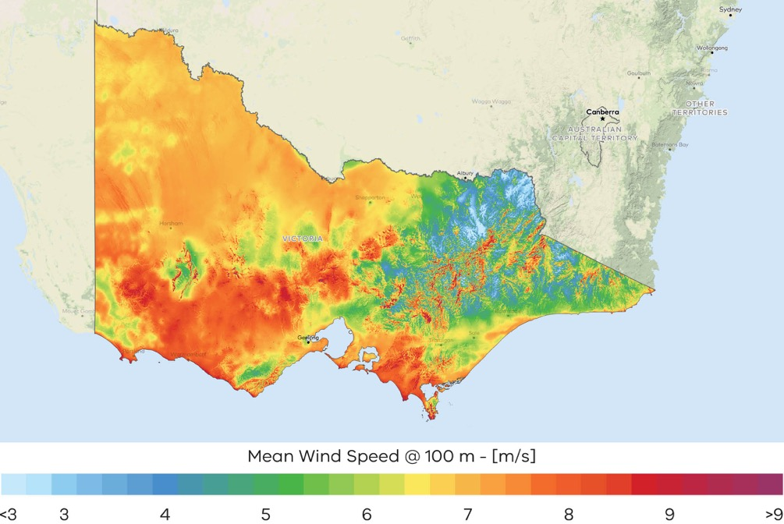

# VicGrid – shaping Victoria’s future grid

VicGrid is changing the way Renewable Energy Zones are planned and developed and delivering the infrastructure Victoria needs to connect renewable energy sources to the grid.

#### As part of its role, VicGrid is:

* Introducing a strategic and proactive process to ensure timely coordination of investment in transmission, generation and storage infrastructure across our Renewable Energy Zones.
* Delivering the Victorian Transmission Plan which will give industry a clear picture of the state’s long term strategic plan and identify priority areas for investment to be released in 2025.
* Implementing the Victorian Access Regime to give industry certainty of access to the network and reduce the risk of curtailment.
* Designing and procuring major projects like the transmission to support offshore wind.
* Managing the $480 million already committed across 12 projects to address known capacity constraints to maximise Victoria’s renewable energy potential.

# Flagship investments enabling new project connections

VicGrid is working in partnership to deliver flagship projects that will not only unlock significant new generation and storage, but present strong investment opportunities in their own right.

#### Victoria to New South Wales Interconnector West (VNI West)

A proposed high-capacity 500 kV double-circuit overhead transmission line between Victoria and New South Wales, VNI West will allow up to 2.7 gigawatts of new generation across both states. It will also connect Victorian electricity generation and storage to load centres across the border, enabling increased export opportunities to other states.

#### Marinus Link

A proposed high voltage direct current interconnector comprising 250km of undersea and 90km of underground cables, which will enable the neighbouring state of Tasmania to import excess supply of solar and wind produced in Victoria.

#### Gippsland Offshore Wind

VicGrid is leading a coordinated approach to transmission infrastructure development for offshore wind generation in Gippsland. The proposed transmission technology will be either a double circuit 330 kV or a 500 kV overhead transmission line, with next steps being to refine this area to a corridor (and then a route).

To register interest in these investment opportunities or to find out more, please email:   
[market.engagement.vicgrid@deeca.vic.gov.au](mailto:market.engagement.vicgrid@deeca.vic.gov.au)

# Powering Victoria’s renewable energy future

#### What is the SEC?

The SEC is a government-owned renewable energy company that:

* invests in renewable energy and storage projects that accelerate the energy transition and deliver sustainable returns
* supports households to go all-electric to reduce their energy bills and emissions
* builds the renewable energy workforce our energy transition requires.

#### How the SEC invests:

By 2035, Victoria will need 25 GW of new renewable energy and storage capacity. The SEC will contribute to this by investing an initial $1 billion towards delivering 4.5 GW of new renewable energy generation and storage. Its work will ensure Victorian households and businesses continue to have the power they need as we transition to renewable energy.

The SEC’s investments include opportunities in renewable generation and storage. Utility-scale storage can address critical system gaps and help catalyse investment in large wind and solar generation to replace ageing coal assets. The organisation will also continue to explore emerging technologies, including long duration energy storage opportunities, that accelerate the sector's maturity and global competitiveness.

The SEC’s investments focus is on achieving sustainable returns while delivering broader benefits to the Victorian public and enabling the market.

Find more information, visit: [secvictoria.com.au](http://secvictoria.com.au/)

#### The Melbourne Renewable Energy Hub

The SEC is accelerating the renewable energy transition by investing in one of the world’s biggest battery projects – the Melbourne Renewable Energy Hub.

The hub will comprise 3 battery components totalling 600 MW in size and is being developed in partnership with renewable energy investor Equis Australia.

The SEC’s $245 million investment in the hub enabled construction to begin immediately and supported one of the project's battery components to double in size.

Once complete in late 2025, the hub will deliver 1.6 GW hours of energy storage, with potential to expand. That’s enough to power around 200,000 homes during peak evening consumption.

# Government policy accelerating demand

In 2017, Victoria launched its flagship initiative, the first Victorian Renewable Energy Target Auction – a competitive reverse auction scheme. After the success of the first auction, in 2021 a second auction was announced to contribute to our 2025 renewable energy target of 40%.

Figure 2: Locations of VRET projects in Victoria

* Kiamal Solar Farm Stage 2 – 150 MW with 150 MW/300 MWh storage
* Derby Solar Project – 95 MW with 85 MW/100 MWh storage
* Cohuna Solar Farm – 34 MW
* Glenrowan Solar Farm – 102 MW
* Horsham Solar Farm – 118.8 MW with 50 MW/100 MWh storage
* Mortlake South Wind Farm – 157.5 MW
* Dundonell Wind Farm – 336 MW
* Berrybank Wind Farm – 180 MW
* Fulham Solar Farm – 88 MW with 80 MW/ 100MWh storage
* Frasers Solar Farm – 77 MW
* Winton Solar Farm – 98.8 MW

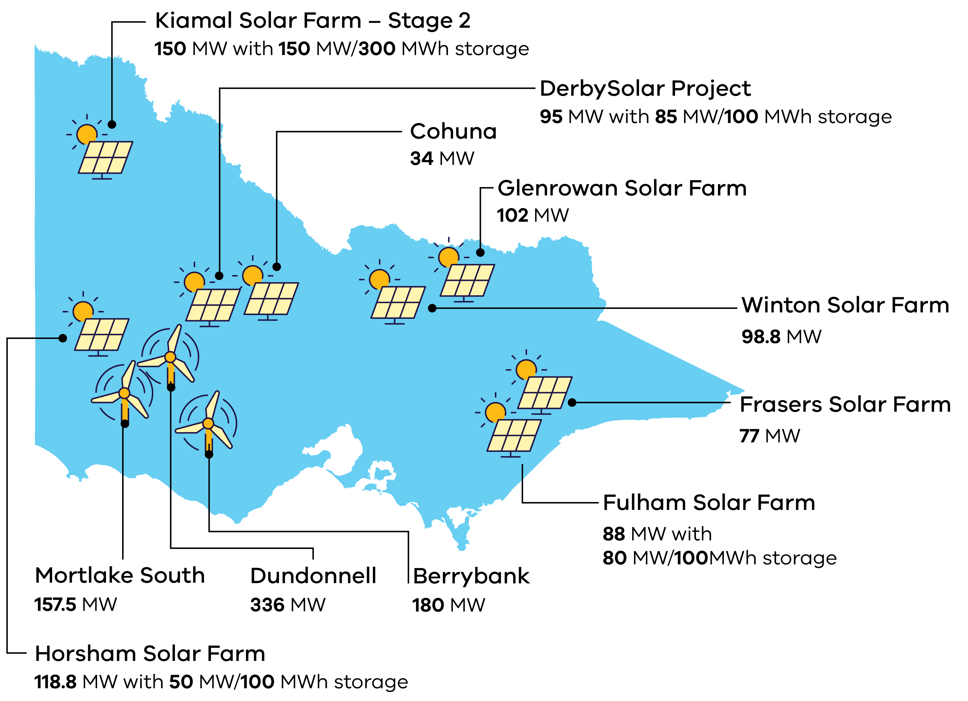

The Victorian Renewable Energy Target auctions – VRET1 and VRET2 – provide long-term contracts that create investment certainty to build new energy generation projects.

The first auction round, VRET1, supported over 800 MW of new renewable generation capacity across 5 projects.

The second auction round, VRET2 will bring 623 MW of new renewable energy generation capacity online and up to 600 MWh of new battery energy storage once projects are operational.

For more information visit: [energy.vic.gov.au/renewable- energy/victorian-renewable-energy-and-storage-targets/victorian-renewable-energy-target-auction-vret2](http://energy.vic.gov.au/renewable-%20energy/victorian-renewable-energy-and-storage-targets/victorian-renewable-energy-target-auction-vret2)

# Fast-tracking planning approvals

Both the Victorian Government and the Australian Government are committed to getting your project through planning approvals as quickly as possible.

#### Fast-tracked planning approvals

The Victorian Government Development Facilitation Program fast-tracks the planning permit approval process for large renewable energy facilities and utility installations. This provides certainty to investors by removing the risk of delay by third-party appeals.

For more information, visit: [planning.vic.gov.au/planning-approvals/planning-enquiries-and-requests/development-facilitation-program](http://planning.vic.gov.au/planning-approvals/planning-enquiries-and-requests/development-facilitation-program)

Furthermore, the Australian Government is providing $168 million to better prioritise approval decisions for renewable energy projects of national significance, and support faster decisions on environment, cultural heritage and planning approvals.

#### Clearer biodiversity planning guidelines

The Victorian Government is developing interactive spatial tools and guidance materials to improve upfront planning for renewable energy projects and provide clearer requirements for managing biodiversity impacts.

In 2024 two new maps have been developed: Habitat Value and the Marine Biodiversity Values (MBV). The maps combine information on thousands of species habitats to show the relative biodiversity value of habitats in Victoria.

Biodiversity values mapping provides decision-makers with an objective and comprehensive view of the relative biodiversity importance of all parts of Victoria’s land and state waters, to help prioritise areas for protection or avoid areas of high biodiversity value in development footprints. The values mapping does not highlight areas that are “no-go” zones for development. Instead, they can be used to consider the relative value of biodiversity to help design infrastructure that minimises impacts.

#### Further information

For more information, visit: [energy.vic.gov.au/about-energy/news/news-stories/better-managing-biodiversity-impacts-of-energy-projects](http://energy.vic.gov.au/about-energy/news/news-stories/better-managing-biodiversity-impacts-of-energy-projects)

For more information or to download the map datasets visit:

* Habitat Value: [environment.vic.gov.au/biodiversity/habitat_value](http://environment.vic.gov.au/biodiversity/habitat_value)
* MBV: [marineandcoasts.vic.gov.au/marine-and-coastal-knowledge/MBV](http://marineandcoasts.vic.gov.au/marine-and-coastal-knowledge/MBV)

# Investing in a Future Made in Australia

The Australian Government is investing $22.7 billion to transform the nation into a renewable energy superpower. As the country’s leading manufacturing state, Victoria can be central to these ambitions.

Future Made in Australia has been designed to maximise the economic and industrial benefits of the net zero transition. It is focused on facilitating private sector investment and building a stronger, more diversified and more resilient economy powered by renewable energy.

The Victorian Government can connect you with the Australian Government’s specialist investment vehicles, including the:

* **Clean Energy Finance Corporation:** Australia’s ‘Green Bank’, with access to $30.5 billion in investment capital from the Australian Government
* **Australian Renewable Energy Agency:** Provides financial assistance for research, development, demonstration, commercialisation and deployment of renewable energy technologies.
* **National Reconstruction Fund:** A $15 billion national investment fund designed to diversify and transform Australia's industry and economy.
* **Net Zero Economy Authority:** $399 million to establish the Net Zero Economy Authority and support the economy wide net zero transformation.

#### Key initiatives include:

* **$7 billion** production tax incentive for the processing and refining of critical minerals
* **$6.7 billion** production tax incentive for renewable hydrogen
* **$2 billion** for early-mover renewable hydrogen projects as part of the Hydrogen Headstart program (bringing total investment to $4 billion)
* **$1.7 billion** to promote net zero innovation, including for green metals and low-carbon fuels
* **$1.5 billion** to strengthen battery and solar panel supply chains through production incentives
* **$134 million** to fast-track approval processes for renewable energy projects.

#### Further information

For more information, visit: [treasury.gov.au/publication/p2024-526942](https://treasury.gov.au/publication/p2024-526942)

# Capacity Investment Scheme

The Capacity Investment Scheme (CIS) provides a national framework to underwrite 23 GW of renewable capacity and 9 GW of clean dispatchable capacity by 2030.

The Australian Government will provide revenue underwriting for successful CIS tender projects, with an agreed revenue ‘floor’ and ‘ceiling.’ This will offer a long-term revenue safety-net that decreases financial risks for investors and encourages more investment when and where it is needed.

Competitive tenders for renewable energy and storage will be held approximately every 6 months. The first was held in May 2024 where Victoria secured a minimum allocation of 1.4 GW of renewable energy capacity. This is in addition to the 600 MW storage tender held in early-2024 for projects in Victoria or South Australia.

Through the CIS, the Australian Government is committed to bring jobs and investment to regional communities, strengthen industries that create our sustainable future and support First Nations people to preserve their unique culture and heritage and remain on Country.

The Victorian Government is engaging with the Australian Government to finalise the bilateral Renewable Energy Transformation Agreement (RETA). The RETA will set out Victorian allocations for future tender rounds of the CIS, securing support for investments in renewable energy and storage projects in Victoria.

#### Further information

For more information, visit: [dcceew.gov.au/energy/renewable/capacity-investment-scheme](http://dcceew.gov.au/energy/renewable/capacity-investment-scheme)

# Offshore Wind

Offshore wind (OSW) a key pillar in Victoria’s renewable energy future.

Victoria is perfectly positioned to lead the nation in establishing a thriving new OSW industry, with:

* a world class offshore wind resource close to our transmission backbone
* a skilled regional workforce
* a track record of delivering renewable energy projects, and
* the largest declared offshore wind energy area in Australia.

The Australian Government has declared an area of the Bass Strait off Gippsland, Victoria, as Australia’s ﬁrst and largest offshore wind zone, spanning an area of approximately 15,000 square kilometers.

Feasibility licenses have been awarded to 12 projects in the Gippsland offshore wind declared area with planning and investigations now underway.

The Australian Government has also declared an offshore wind zone in the Southern Ocean off the coast of South-west Victoria. Offshore wind farms can only be built in Commonwealth waters, in areas approved by the Australian Government.

The Victorian Government established Offshore Wind Energy Victoria (OWEV) to coordinate and drive the development of Victoria’s offshore wind sector.

#### Investment Opportunity

The market provides significant opportunities for investment in the offshore wind industry:

* Offshore wind is a key pillar in Victoria’s renewable energy future with legislated targets of 2GW by 2032, 4GW by 2035 and 9GW by 2040.
* The strength and consistency of wind speeds are high by Australian and international standards.
* Victoria’s first mover advantage in Australia presents opportunities for manufacturing that may extend to other jurisdictions over time.

#### Manufacturing Opportunity

Victoria is estimated to need up to 222 offshore wind turbines by 2035. Initial Victorian demand for turbines creates a foundation for providing OEMs with long‑term pipeline certainty.

# Access to Victoria’s world-class renewable energy talent

Our growing, highly-skilled workforce drives project delivery and fosters industry growth. To meet the needs of the sector, the Victorian Government has committed to significant new energy skills and workforce initiatives.

#### World-class education and training

Victoria has a globally renowned education and training system, including:

* 2 global ‘Top 50’ universities (Source: QS World University Rankings 2024 [topuniversities.com/world-university-rankings?page=2](http://topuniversities.com/world-university-rankings?page=2))
* 4 dual-sector universities (offering both tertiary and vocational education).
* 12 independent technical and further education (TAFE) locations under a single TAFE network.
* a diverse talent pool with strong growth across the broad range of occupations relevant to the renewable energy sector.
* the highest number of engineering managers of any Australian state or territory.

#### Government investment in skills and workforce

The Victorian Government is investing in the skills and workforce requirements needed for Victoria’s transition to a renewable energy future. Major initiatives include:

* The Victorian Energy Jobs Plan, which will set out actions to develop the workforce required to deliver our nation-leading target of 95 per cent renewable electricity generation by 2035 and drive investment confidence. The plan is due to be released in early 2025.
* Establishing the SEC Centre of Training Excellence to attract and train a skilled renewable energy workforce, working with industry to ensure Victoria has the workers required to support the energy transition.
* The Wind Worker Training Centre and Renewable Hydrogen Worker Training Centres are funded initiatives to ensure Victoria has a pipeline of skilled workers to meet workforce needs and deliver the wind and renewable hydrogen projects now and in the future.

# In-demand critical mineral deposits

The global energy transition presents significant opportunities to invest in Victoria’s critical minerals sector – from mining to manufacturing.

#### Valuable resources

Regional Victoria has significant mineral sand deposits containing titanium, zirconium, and rare earth elements, as well as other resources like antimony, copper, high-purity alumina, and silica.

Heavy mineral sand deposits in the Murray Basin, in the northwest of the state, have some of the largest resources of ilmenite, rutile and zircon, with:

* 22% of Australia’s ilmenite (~7% of global economically demonstrated resource)
* 51% of Australia’s rutile (~32% of global economically demonstrated resource)
* 39% of Australia’s zircon (~27% of global economically demonstrated resource).

These deposits could support downstream processing and metallisation of titanium and/or rare earth metals.

* REEs or Rare earth elements are found in monazite and xenotime in Victoria’s mineral sand deposits
* Titanium is found in ilmenite and rutile
* Zirconium is found in zircon.

#### Victoria’s potential mining-to-manufacturing opportunities

* **Permanent magnet manufacture**REEs or Rare earth elements
* **Wind turbines from the Wimmera**REEs and copper
* **Modern battery components**Lithium and antimony
* **Solar panel components**Silicon, titanium and antimony
* **Hydrogen electrolysers**Zircon and titanium

#### Case study: Melbourne Renewable Energy Project

In 2017, a 14-member buying group led by the City of Melbourne signed one of Australia’s first renewable energy corporate Power Purchase Agreements (PPA). The Melbourne Renewable Energy Project (MREP1) marked the first time in Australia that a group of local governments, cultural institutions, universities and corporations collectively purchased renewable energy from a newly built facility. The MREP Group’s procurement of 88 GWh per year catalysed the construction of a $200 million, 39 turbine, 80 MW wind farm at Crowlands near Ararat; avoiding 96,800 tonnes of greenhouse pollution annually and enabling member organisations to secure long-term electricity price certainty.

Building on the success and insights of MREP1, the City of Melbourne brought together a second renewable energy buying group (MREP2) with 7 large energy users from across the city and facilitated them through the process of procuring a renewable PPA. In June 2020, the MREP2 group successfully transacted a 10-year, multi-million dollar, 110 GWh per annum PPA backed by a portfolio of Victorian wind assets. The MREP2 deal powers 14 shopping centres, 9 office buildings, 7 educational campuses and 4 manufacturing facilities, avoiding 123,000 tonnes of greenhouse pollution annually.

# Celebrating success in our wind sector

*“Victoria is blessed with a world class wind resource and the Golden Plains Wind Farm site is traversed by a double circuit 500 kV transmission line, giving it one of the strongest and most reliable connection points into the national electricity network in the country” –***Westwind Energy**

#### Case study: Golden Plains Wind Farm

Golden Plains Wind Farm is located 60km west of Geelong and 45km south of Ballarat in Western Victoria. Upon completion, it is expected that the project will boast 1,333 MW of installed generation capacity from 215 wind turbines. Golden Plains Wind Farm will generate more than 4 TWh of electricity in an average year, which is equivalent to over 9% of Victoria’s current electricity grid demand. Once completed, the Golden Plains Wind Farm will be Australia’s largest wind farm with a total investment volume well above $4 billion.

The project has been developed in two stages – East & West. Golden Plains Wind Farm - East (756 MW) reached its final investment decision in November 2022, with TagEnergy holding 85% ownership of the first stage of the project, and Inka Group having the remaining 15%. Golden Plains Wind Farm – West (574 MW), the second stage of the project, reached its financial investment decision in June 2024. This stage of the project is owned solely by TagEnergy. TagEnergy has structured the financing of this mammoth project on a purely market-based electricity offtake model, which is testament to the project’s competitiveness in the energy market and strong technical and financial fundamentals.

Golden Plains Wind Farm has been developed by Westwind Energy, Victoria’s largest wind energy developer.

For more information, visit: [goldenplainswindfarm.com.au](http://goldenplainswindfarm.com.au/)

#### Case study: Iberdrola

Iberdrola is a global electricity utility company that operates 1.5 GW of nameplate capacity in Australia, making it one of the largest renewable energy businesses in the country.

Within Victoria, Iberdrola Australia provides commercial and industrial customers with green energy solutions, including retail green energy supply and behind-the-meter technologies. To service this customer base, Iberdrola Australia has entered into Power Purchase Agreements with Cherry Tree Wind Farm, a 57.6 MW generator located near Seymour in Victoria.

For more information, visit: [www.iberdrola.com.au](http://www.iberdrola.com.au/)

# Co-locate with energy storage to maximise output

Pairing renewable generation with storage assets can boost revenue, reduce costs and provide the potential to leverage existing development sites.

#### Victoria’s energy storage targets

Victoria has set energy storage targets of:

* at least 2.6 GW of energy storage capacity by 2030
* at least 6.3 GW by 2035.

These energy storage targets will include short, medium and long-duration energy storage systems.

For more information, visit: [energy.vic.gov.au/renewable-energy/victorian-renewable-energy-and-storage-targets](http://energy.vic.gov.au/renewable-energy/victorian-renewable-energy-and-storage-targets)

For more information on Victoria's energy storage sector visit:  
[energy.vic.gov.au/for-industry/investment-opportunities](http://energy.vic.gov.au/for-industry/investment-opportunities)

#### Case study: Dundonnell Wind Farm

The 336 MW Dundonnell Wind Farm is located near Mortlake, in Western Victoria. The $560 million project was successful under VRET1 and was awarded a support agreement with the State of Victoria in late 2018. In March 2020, it was the first of the VRET1 projects to generate electricity.

The project includes 80 wind turbines, each one 4.2 MW with a diameter of 150 metres – the largest installed in Australia at the time.

The Dundonnell Wind Farm can produce enough clean energy each year to power about 245,000 homes.

Project owner Tilt Renewables was the recipient of the Clean Energy Council’s 2020 Community Engagement Award for its extensive and tailored engagement and benefit sharing programs which address key social, economic and environmental needs of the local community and surrounding region.

For more information, visit: [tiltrenewables.com/assets-and-projects/Dundonnell-Wind-Farm](http://tiltrenewables.com/assets-and-projects/Dundonnell-Wind-Farm)

#### Case study: Bulgana Green Power Hub

In December 2017, the Victorian Government signed a 15-year support agreement with Neoen Australia to deliver the Bulgana Green Power Hub. The hub is in the Wimmera region of central-western Victoria, about 200km north-west of Melbourne and 11km north-east of Stawell. It consists of a 56 turbine, 194 MW wind farm and a 20 MW/34 MWh Tesla lithium-ion battery – supplying around 750,000MWh of renewable electricity each year.

For more information, visit: [bulganagreenpowerhub.com.au](http://bulganagreenpowerhub.com.au/)

# A world class supply chain to support a thriving wind industry

Victoria’s wind farm manufacturing and supply chain capabilities have been growing progressively since the early 2000s, meaning that local businesses are well-equipped to contribute to project development across the entire supply chain.

Victoria is also home to a wide range of specialist manufacturing, research and development facilities keeping the state at the cutting edge of Australian manufacturing innovation.

#### Manufacturing Opportunity

Victoria is estimated to need up to an additional 900 onshore wind turbines by 2035. (Note:   
Indicative estimates are based on internal forecasts and modelling conducted by Accenture (2023) for the Department of Energy, Environment and Climate Action and are subject to change.)

Initial Victorian demand for turbines creates a foundation for providing original equipment manufacturers (OEMs) with long-term pipeline certainty.

#### Case study: ACCIONA Energía

Since its establishment in Australia in 2002, ACCIONA Energía has built 3 wind farms across the state, publicly announced the development of an additional two wind farm projects and has multiple other projects under development.

ACCIONA Energía has a unique model to build, own and operate all of its projects across their lifetimes. As a long-term neighbour within the community, the company is focused on giving back and ensuring the benefits of its projects generate significant and positive local impact.

*“Victoria’s plentiful renewable resources, highly skilled and trained workforce and accessible port and transportation network have made the state a centre for renewable energy.”* – **Brett Wickham, Managing Director, ACCIONA Energía Australia**

#### Full or partial supply chain capability

##### Tower components

* Nacelle housing
* Generator
* Gearbox metal
* Drive train
* Belts
* Yaw motor
* Yaw ring and gears
* Blade adaptor
* Rotor hub
* Spinner
* Clutch
* Hydraulic pitch control
* Brake assembly
* Wind tower sections
* Powder coating
* Wind tower flanges
* Wind tower bolts
* Structural steel
* Tie-down bolts
* Footings
* Steel reinforcement/ anchor cage
* Anemometers
* Safety railings
* Meteorological masts
* General hydraulics and oils.

##### Electrical balance of plant

* Tower lighting
* Control cabinets
* Metal cabinets
* Copper busbar and chassis
* Conduit
* LV and HV cable
* Fibre optic cable
* Switchboards
* Transformers
* Substation
* UPS
* Transmission cables
* Transmission towers
* Insulators
* MV and MV switchgear
* Ring main unit
* Capacitor banks
* Synchronous condensers
* Isolation units
* Tower earthing systems
* SCADA system.

#### Full supply chain capability

##### Civil/site works

* Building contractor
* Civil construction
* Electrical wholesalers
* Crane hire
* HVAC
* Commissioning and safety tests
* PCV tests and energisation.

##### Project management services

* Regulatory/planning
* Electrical contractor
* Civil contractor
* Mechanical installer
* Surveyor
* Environmental monitoring
* Geotechnical testing
* Electricity grid support
* Communications
* Noise testing
* EPC contractor
* Supply chain consulting
* Engineering
* Site analysis
* Stakeholder engagement
* Technical Due diligence/auditing
* Project management.

# Key Victorian Government entities

We can help facilitate connections with key Victorian Government entities and industry members across our renewable energy sector.

#### Department of Energy, Environment and Climate Action (DEECA)

DEECA works with industry and the community to develop Victoria's secure and sustainable energy future.

For information on Victoria’s energy policy landscape and facilitated connections across the Victorian Government and renewable energy sector, contact the Business and Industry Engagement team at: [BIE@deeca.vic.gov.au](mailto:BIE@deeca.vic.gov.au)

[energy.vic.gov.au](http://energy.vic.gov.au/)  
[energy.vic.gov.au/ forindustry/investment-opportunities](http://energy.vic.gov.au/%20forindustry/investment-opportunities)

#### Breakthrough Victoria

Breakthrough Victoria is an independent investment management company established in 2021 to manage the Victorian Government’s landmark $2 billion Breakthrough Victoria Fund.

Visit the website of Breakthrough Victoria at: [breakthroughvictoria.com](http://breakthroughvictoria.com/)

#### Invest Victoria

Invest Victoria is the Victorian Government’s investment attraction agency. Services include:

* market regulatory information
* statutory approvals coordination
* site location services
* identification of infrastructure and utility requirements
* advocacy within government.

Visit the website of Invest Victoria at: [invest.vic.gov.au](http://invest.vic.gov.au/)

#### Offshore Wind Energy Victoria

Offshore Wind Energy Victoria (OWEV) was established as the single point of entry for industry and community engagement on offshore wind.

Visit the website of Offshore Wind Energy Victoria at:   
[energy.vic.gov.au/renewable-energy/offshore- wind-energy](http://energy.vic.gov.au/renewable-energy/offshore-%20wind-energy)

#### SEC

The SEC is a Victorian Government-owned renewable energy company. It is partnering with the private sector to deliver 4.5 GW of new renewable energy and storage projects with an initial investment of $1 billion.

Visit the SEC website at: [vic.gov.au/state-electricity-commission-Victoria](http://vic.gov.au/state-electricity-commission-Victoria)

#### Solar Victoria

Solar Victoria is responsible for the delivery of the Victorian Government’s $1.3 billion Solar Homes Program – one of the most ambitious and transformative renewable energy programs in Australia.

Visit the Solar Victoria website at: [solar.vic.gov.au](http://solar.vic.gov.au/)

#### Sustainability Victoria

Sustainability Victoria empowers Victorians to live sustainably by taking action on climate change and using our precious resources wisely – to deliver a sustainable future for us all.

Visit the Sustainability Victoria website at: [sustainability.vic.gov.au](http://sustainability.vic.gov.au/)

#### VicGrid

VicGrid coordinates the planning and development of Victorian Renewable Energy Zones (REZs). It also oversees the $540 million REZ fund that will be used to strengthen the grid and develop each REZ.

Visit the VicGrid website at: [energy.vic.gov.au/renewable- energy/renewable-energy-zones](http://energy.vic.gov.au/renewable-%20energy/renewable-energy-zones)

# For international investors

Contact a local Victorian Government Trade and Investment Office to help you:

* navigate investment opportunities in Victoria’s new energy technology sector
* set up a briefing with energy specialists
* arrange inbound market visits
* introduce you to the Victorian Government’s Energy Business and Industry Engagement team and Invest Victoria.

For more information, visit: [global.vic.gov.au/meet-our-global-team/all-office-locations](http://global.vic.gov.au/meet-our-global-team/all-office-locations)

Figure 3: Victorian Government Trade and Investment office locations

* Melbourne, Australia
* Kuala Lumpur
* Jakarta
* Singapore
* Vietnam
* Tokyo
* Seoul
* Bengaluru
* Mumbai
* Shanghai
* Nanjing
* Chengdu
* Beijing
* Hong Kong
* London
* Paris
* Frankfurt
* Dubai
* Tel Aviv
* New York
* Washington DC
* Boston
* San Francisco
* Santiago

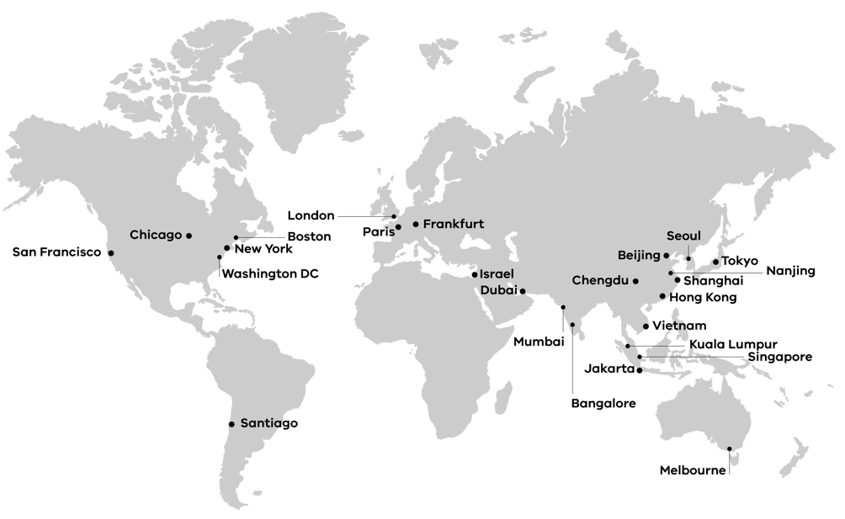

**End of document.**