Victoria’s Renewable Energy  
Investment Prospectus

## Victoria, one of the world’s most exciting energy markets

Table of Contents

Acknowledgements 3

Minister’s Foreword 6

Our legislated targets are driving investment 8

Fast-tracking planning approvals 10

Pathway to deliver the future electricity system 12

Victorian Government initiatives drive sector growth 17

Powering Victoria’s renewable energy future 19

A trusted location for your next energy investment 21

Investing in a Future Made in Australia 24

Capacity Investment Scheme 26

VicGrid – shaping Victoria’s future grid 27

Flagship investments enabling new project connections 28

Access to Victoria’s world-class renewable energy talent 29

In-demand critical mineral deposits 31

The heart of Australia’s National Electricity Market 33

Dive into Victoria’s renewable energy subsectors 36

Solar 37

Onshore Wind 39

Offshore Wind 41

Energy storage 44

Bioenergy 47

Renewable hydrogen 50

Digital energy and innovation 52

Zero emissions vehicles 54

Subsector packs 56

Key Victorian Government entities 56

For international investors 59

# Acknowledgements

**Acknowledgement of Country**

We acknowledge and respect Victorian Traditional Owners as the original custodians of Victoria’s land and waters, their unique ability to care for Country and deep spiritual connection to it.

We honour Elders past and present whose knowledge and wisdom have ensured the continuation of culture and traditional practices.

We are committed to genuinely partner, and meaningfully engage, with Victoria’s Traditional Owners and Aboriginal communities to support the protection of Country, the maintenance of spiritual and cultural practices and their broader aspirations in the 21st century and beyond.

© The State of Victoria Department of Energy, Environment and Climate Action, September 2024

**Creative Commons**

This work is licensed under a Creative Commons Attribution 4.0 International licence, visit the [Creative Commons website](http://creativecommons.org/licenses/by/4.0) (<http://creativecommons.org/licenses/by/4.0/>).

You are free to re-use the work under that licence, on the condition that you credit the State of Victoria as author. The licence does not apply to any images, photographs or branding, including the Victorian Coat of Arms, and the Victorian Government and Department logos.

ISBN 978-1-76136-595-9 (pdf/online/MS word)

**Disclaimer**

This publication may be of assistance to you but the State of Victoria and its employees do not guarantee that the publication is without flaw of any kind or is wholly appropriate for your particular purposes and therefore disclaims all liability for any error, loss or other consequence which may arise from you relying on any information in this publication.

**Accessibility**

To receive this document in an alternative format, phone the Customer Service Centre on 136 186, email customer.service@delwp.vic.gov.au, or contact [National Relay Service](http://www.accesshub.gov.au/) ([www.accesshub.gov.au](http://www.accesshub.gov.au/)) on 133 677. Available at [DEECA website](https://www.deeca.vic.gov.au/) ([www.deeca.vic.gov.au](https://www.deeca.vic.gov.au/)).

#### Traditional Owners at the centre of decision-making processes

Strong and mutually beneficial partnerships with Traditional Owners and First Peoples are imperative to the electricity transition’s success and integral to ensuring the goals and objectives of self-determination set out in the Victorian Government’s Self Determination Reform Framework and the Department of Energy, Environment and Climate Action’s (DEECA) Pupangarli Marnmarnepu ‘Owning Our Future’ Aboriginal Self-Determination Reform Strategy 2020–2025.

We will be continually guided by Traditional Owner and First Peoples’ communities – now and in the future – who have expressed a strong interest in investing in renewable energy to deliver their interests and their desire to own and manage renewable energy generation and storage technology and infrastructure to meet their communities’ cultural, spiritual and economic needs.

As part of a once-in-a-generation renewable electricity transition and transformation, there is an obligation for industry and government to create genuine partnerships with Traditional Owners and First Peoples, to ensure that their self-determining rights and interests are upheld. This will be the catalyst for historical change and reform that will see immediate and future flow-on effects. It will have a positive impact on the environment and advance the social and economic outcomes for Traditional Owners and First Peoples and all Victorians.

**The Victorian Government has committed to a target of Net-zero greenhouse gas emissions by 2045**

# Minister’s Foreword

**On behalf of the Victorian Government, I am pleased to present to you Victoria’s Renewable Energy Investment Prospectus.**

With abundant renewable resources to harness, sophisticated supply chain capabilities and strong economic credentials, Victoria is developing into one of the fastest-growing destinations for renewable energy investment in the Southern Hemisphere.

We’ve legislated our targets of 95 per cent renewable energy by 2035 and net-zero emissions by 2045, placing us at the forefront of the global energy transition and giving the private sector the confidence to invest.

We’re delivering a balanced combination of renewable generation and storage, including projects such as the 600-megawatt Melbourne Renewable Energy Hub – the first investment to be made by the SEC.

Victoria is leading development of offshore wind in Australia, backed by our legislated offshore wind energy targets, with the announcement of the first six recipients of feasibility licenses for offshore wind projects off the Gippsland coast.

Through VicGrid, we are modernising our state’s transmission infrastructure, guided by the Victorian Transmission Investment Framework. We are also coordinating the development of our Renewable Energy Zones, the areas with the greatest potential for renewable energy development, providing further opportunities for investment.

To build the workforce our energy transition requires and enable rapid deployment of new projects, we’re strengthening local renewable electricity supply chains, developing the Victorian Energy Jobs Plan and establishing greater energy focused training, including the Wind Worker and Renewable Hydrogen Worker Training Centres.

The scale of change in the energy market over the next decade will be significant, but so too are the opportunities. For companies and investors looking to operate in a dynamic and innovative energy marketplace, Victoria welcomes you.

**The Hon. Lily D’Ambrosio MP**  
Minister for Energy, Environment and Climate Change  
Minister for Solar Homes

# Our legislated targets are driving investment

#### Victoria's changing energy market is creating investment opportunities

Victoria’s energy market is in transition, shifting from its historic fuel source of brown coal to a more diversified, renewable mix. The Victorian Government has entered into structured transition agreements with owners of 2 of the largest coal-fired generators, that will see these assets close in 2028 and 2035 respectively.

This creates unprecedented opportunities for investment, as the state will need an estimated **$35 billion** of additional investment to provide 25 GW of new renewable energy and storage capacity by 2035.

Our transition to renewable energy is supported by strong targets set by the Victorian Government, creating significant opportunities for investors.

#### Victoria’s Electricity Future

The Victorian Government has released its vision for Victoria’s future electricity system.

The Victoria Electricity Future is a four pillared plan that will enable the renewables big build, empower households and businesses to lower energy bills, manage the transition away from fossil fuels, create jobs, skills and supply chains.

#### Legislated renewable energy targets

The Victorian Government has legislated renewable energy targets of:

* 40% by 2025
* 65% by 2030
* 95% by 2035
* Net-Zero Emissions by 2045

##### Energy storage capacity targets of at least:

* 2.6 GW by 2030
* 6.3 GW by 2035

##### Offshore Wind Energy Targets:

* At least 2 GW by 2032
* 4 GW by 2035
* 9 GW by 2040

#### Further information

For more information, visit: [energy.vic.gov.au/renewable-energy/victorias-electricity-future](http://energy.vic.gov.au/renewable-energy/victorias-electricity-future)

# Fast-tracking planning approvals

Both the Victorian Government and the Australian Government are committed to getting your project through planning approvals as quickly as possible.

#### Fast-tracked planning approvals

The Victorian Government Development Facilitation Program fast-tracks the planning permit approval process for large renewable energy facilities and utility installations. This provides certainty to investors by removing the risk of delay by third-party appeals.

For more information, visit: [planning.vic.gov.au/planning-approvals/planning-enquiries-and-requests/development-facilitation-program](http://planning.vic.gov.au/planning-approvals/planning-enquiries-and-requests/development-facilitation-program)

Furthermore, the Australian Government is providing $168 million to better prioritise approval decisions for renewable energy projects of national significance, and support faster decisions on environment, cultural heritage and planning approvals.

#### Clearer biodiversity planning guidelines

The Victorian Government is developing interactive spatial tools and guidance materials to improve upfront planning for renewable energy projects and provide clearer requirements for managing biodiversity impacts.

In 2024 two new maps have been developed: Habitat Value and the Marine Biodiversity Values (MBV). The maps combine information on thousands of species habitats to show the relative biodiversity value of habitats in Victoria.

Biodiversity values mapping provides decision-makers with an objective and comprehensive view of the relative biodiversity importance of all parts of Victoria’s land and state waters, to help prioritise areas for protection or avoid areas of high biodiversity value in development footprints. The values mapping does not highlight areas that are “no-go” zones for development. Instead, they can be used to consider the relative value of biodiversity to help design infrastructure that minimises impacts.

#### Further information

For more information, visit: [energy.vic.gov.au/about-energy/news/news-stories/better-managing-biodiversity-impacts-of-energy-projects](http://energy.vic.gov.au/about-energy/news/news-stories/better-managing-biodiversity-impacts-of-energy-projects)

For more information or to download the map datasets visit:

* Habitat Value: [environment.vic.gov.au/biodiversity/habitat_value](http://environment.vic.gov.au/biodiversity/habitat_value)
* MBV: [marineandcoasts.vic.gov.au/marine-and-coastal-knowledge/MBV](http://marineandcoasts.vic.gov.au/marine-and-coastal-knowledge/MBV)

# Pathway to deliver the future electricity system

Table 1: Pathway to deliver the future electricity system

| Progress to date | 2025 onwards → | 2030 onwards → | 2035 onwards → | 2024-35 |  |
| --- | --- | --- | --- | --- | --- |
| **Pillar 1:** Enabling the renewables big build | | | | | |
| Generation   * 38% renewable energy use * SEC strategy released | 2025: 0.6GW comes online from VRET2 auction |  | 2035: 12.7GW onshore grid-scale renewables: onshore wind (9.7GW) and utility solar (3GW) online | **+7.4GW** |  |
| Storage   * ~0.5GW of storage currently operating * Legislated storage targets |  | 2030: 2.6GW total storage online | 2035: At least 6.3GW total storage online | **+6.3GW** |  |
| Offshore wind   * Legislated offshore wind targets * Offshore wind implementation statements released |  | 2032: 2GW offshore wind | 2035: A further 2GW offshore wind | **+4GW** | +25GW  (Total of Generation (7.4GW) + Storage (6.3GW) + Offshore wind (4GW) + Solar PV (7.6GW) |
| Transmission   * 6,000km network * Invested in priority renewable energy zone stage 1 projects to strengthen the grid * Community and stakeholder engagement on the first Victorian Transmission Plan | 2027: Western Renewables Link online  2029: 1.7GW VNI West (Delivery as close as possible to 2028.) | 2030: 750MW Marinus Link stage 1 (Development of Marinus Link Stage 2 subject to further business case assessment. This would provide a  further 750MW of interconnector transfer capacity.​) | 2030-40: Completion of other high priority renewable energy zone transmission projects | **+2.4GW** (Interconnector flows only from VNI West and MarinusLink. Additional renewable energy zone transmission projects will be identified in the  Victorian Transmission Plan, a long-term strategic plan for transmission development in Victoria.) |  |
| **Pillar 2: Empowering households and businesses to lower energy bills** | | | | |  |
| Solar PV   * ~28 % of Victorian homes have solar PV * Introduced emergency backstop for all new, upgrading and replacement solar systems | 2025: 100 Neighbourhood Batteries program Round 1 projects completed |  | 2035: 7.6GW additional solar PV (6.3GW rooftop PV, 1.2GW large distributed up to 30MW) | +7.6GW |  |
| Energy efficiency in buildings   * Introduced 7-star energy efficiency, all-electric new homes and minimum rental standards * Solar Victoria 's Residential Electrification Grants program launched * Energy Efficiency in Social Housing program launched | 2025-26: New energy efficiency standards for commercial buildings  2027: 45,000 social housing energy efficiency upgrades complete |  |  | 6GW  avoided |  |
| Lowest energy prices in NEM  VDO established | 2025: Consumer Protections Framework |  |  |  |  |
| **Pillar 3: Managing the transition away from fossil fuels** | | | | |  |
| Hazelwood closure (-1.6GW) | 2028: Yallourn closure (-1.45GW) |  | 2035: Loy Yang A closure (-2.21GW)  TBC: Loy Yang B closure (-1.16GW) | - 4.8GW |  |
| **Pillar 4: Creating jobs, skills and supply chains** | | | | |  |
| New Energy Jobs Fund, ~1,800 jobs created through VRET, ~2,200 jobs supported through the VEU program, over 4,700 workers received training through Solar Victoria  SEC is building awareness of career opportunities in renewable energy through engagement with students at career days and events, with plans to scale up engagement from 2025 | 2025: Release of the Victorian Energy Jobs Plan and Women in Energy Strategy  2025: SEC Centre of Training Excellence commences implementation  2028: Full implementation of the TAFE Clean Energy Fund, including Clean Energy Centres established at TAFE Gippsland and South West TAFE; Stage 2 of the Asia Pacific Renewable Energy Training Centre at Federation TAFE |  | 2035: Enabled the creation of 6,000 apprenticeships and traineeships through the electricity transition | 59,000  jobs  created |  |

# Victorian Government initiatives drive sector growth

Over the past five years, the Victorian Government has committed over $3.7 billion to support the energy transition (Note: Includes funding announced in the 2020-21, 2021-22, 2022-23, 2023-24 and 2024-25 Victorian Budgets, all figures are in AUD). This government support makes it easier for investors to join the state’s growing renewable energy sector.

#### Network stability

**$480 million** to establish 6 Renewable Energy Zones (REZ) across Victoria that will unlock new renewable energy investment, supporting regional economic growth and jobs.

#### SEC

**$1 billion** towards delivering 4.5 GW of power through renewable energy and storage projects over the next 10 years, delivered by the SEC, a government-owned energy company.

#### Solar and batteries

**$1.3 billion** funded through the Solar Homes Program, providing rebates and loans that are accelerating uptake of rooftop solar PV, batteries, heat pumps and solar hot water systems for eligible homes.

#### Victorian Renewable Energy Target Auctions

**$2.5 billion** of investment leveraged by the Victorian Renewable Energy Target auctions (VRET1 and VRET2), by awarding long-term Support Agreements that provide investment certainty.

#### Innovation

**$108 million** to support the commercialisation of innovative, emerging renewable energy technologies in Victoria, including offshore wind, renewable hydrogen, bioenergy and battery energy storage systems.

#### Energy efficiency

**$600 million** in energy efficiency and electrification upgrades unlocked through the Victorian energy upgrades (VEU) program in 2024.

# Powering Victoria’s renewable energy future

#### What is the SEC?

The SEC is a government-owned renewable energy company that:

* invests in renewable energy and storage projects that accelerate the energy transition and deliver sustainable returns
* supports households to go all-electric to reduce their energy bills and emissions
* builds the renewable energy workforce our energy transition requires.

#### How the SEC invests:

By 2035, Victoria will need 25 GW of new renewable energy and storage capacity. The SEC will contribute to this by investing an initial $1 billion towards delivering 4.5 GW of new renewable energy generation and storage. Its work will ensure Victorian households and businesses continue to have the power they need as we transition to renewable energy.

The SEC’s investments include opportunities in renewable generation and storage. Utility-scale storage can address critical system gaps and help catalyse investment in large wind and solar generation to replace ageing coal assets. The organisation will also continue to explore emerging technologies, including long duration energy storage opportunities, that accelerate the sector's maturity and global competitiveness.

The SEC’s investments focus is on achieving sustainable returns while delivering broader benefits to the Victorian public and enabling the market.

Find more information, visit: [secvictoria.com.au/](http://secvictoria.com.au/)

#### The Melbourne Renewable Energy Hub

The SEC is accelerating the renewable energy transition by investing in one of the world’s biggest battery projects – the Melbourne Renewable Energy Hub.

The hub will comprise 3 battery components totalling 600 MW in size and is being developed in partnership with renewable energy investor Equis Australia.

The SEC’s $245 million investment in the hub enabled construction to begin immediately and supported one of the project's battery components to double in size.

Once complete in late 2025, the hub will deliver 1.6 GW hours of energy storage, with potential to expand. That’s enough to power around 200,000 homes during peak evening consumption.

# A trusted location for your next energy investment

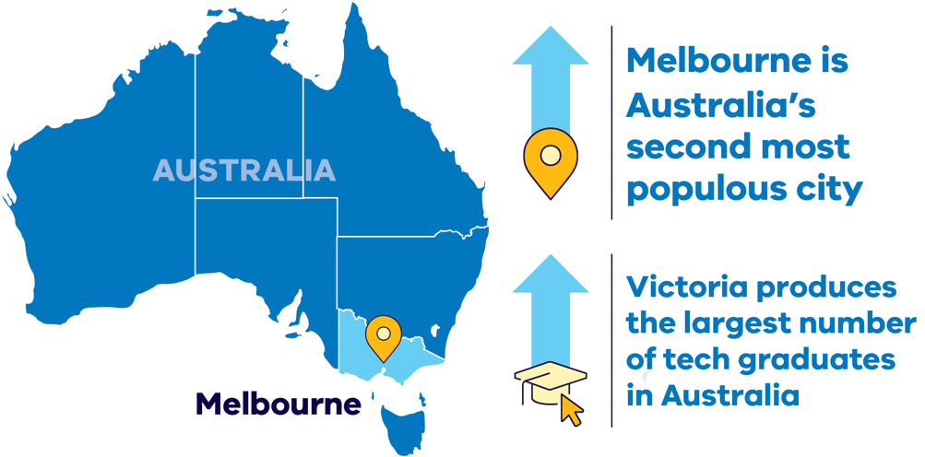

* **Melbourne is Australia’s second most populous city**

(Source: Australian Bureau of Statistics, March 2024, [abs.gov.au/media-centre/media-releases/capital-city-growth-highest-record)](http://abs.gov.au/media-centre/media-releases/capital-city-growth-highest-record)

* **Victoria produces the largest number of tech graduates in Australia**

(Source: LinkedIn Talent Insights (Talent Pool Report), 23 March 2023. Referenced figures refer to the total number of professionals by job titles on LinkedIn.)

#### Verifiable, ethical business practices

* Our transparent and auditable local supply chains ensure alignment
* with responsible sourcing principles
* Proximity to Australia’s critical minerals and an extensive local supply network reduces Victoria’s manufacturing carbon footprint.

#### Stable and trusted

* Australia has a stable political environment and is a global leader in the protection of property rights, including IP rights
* Victoria’s environmental, social and governance (ESG) benefits are underpinned by a fair legal system, strong governance and an agile public service with the ability to formulate and implement sound policies.

#### A strong economy

* The Australian economy is the world’s 13th largest economy, according to the International Monetary Fund
* Australia’s nominal Gross Domestic Product (GDP) was around $2.67 trillion in July 2024 (Source: International Monetary Fund, [https://www.imf.org/external/datamapper/  
  NGDPD@WEO/AUS?zoom=AUS&highlight=AUS](https://www.imf.org/external/datamapper/NGDPD@WEO/AUS?zoom=AUS&highlight=AUS))
* Victoria ’s economy has experienced strong growth over the last decade and is forecast to grow by 2.5% in 2023-24, outpacing all other Australian states and territories over the next 5 years (Source: Deloitte Access Economics Business Outlook, 23 April 2024, <https://www.deloitte.com/au/en/about/press-room/business-outlook.html>).

#### Leading the way to economy wide net‑zero

* The Victorian Government has set strong net zero objectives and targets of 95% renewable electricity generation by 2035 and net zero emissions by 2045
* The Victorian Government has supported renewable energy supply chain development to enable these goals.

#### World class skilled workforce

* Victoria has 2 universities ranked in the top 50 globally (Source: QS World University Rankings 2024 <http://topuniversities.com/world-university-rankings?page=2>)
* and several quality regional universities
* We have strong vocational education and training options to ensure workforce skills and future capacity align with evolving industry requirements.

#### Globally connected

Victoria provides access to domestic and international goods, services and markets via its:

* 4 major seaports
* 24-hour international airport
* extensive road and rail networks.

# Investing in a Future Made in Australia

The Australian Government is investing $22.7 billion to transform the nation into a renewable energy superpower. As the country’s leading manufacturing state, Victoria can be central to these ambitions.

Future Made in Australia has been designed to maximise the economic and industrial benefits of the net zero transition. It is focused on facilitating private sector investment and building a stronger, more diversified and more resilient economy powered by renewable energy.

The Victorian Government can connect you with the Australian Government’s specialist investment vehicles, including the:

* **Clean Energy Finance Corporation:** Australia’s ‘Green Bank’, with access to $30.5 billion in investment capital from the Australian Government
* **Australian Renewable Energy Agency:** Provides financial assistance for research, development, demonstration, commercialisation and deployment of renewable energy technologies.
* **National Reconstruction Fund:** A $15 billion national investment fund designed to diversify and transform Australia's industry and economy.
* **Net Zero Economy Authority:** $399 million to establish the Net Zero Economy Authority and support the economy wide net zero transformation.

#### Key initiatives include:

* **$7 billion** production tax incentive for the processing and refining of critical minerals
* **$6.7 billion** production tax incentive for renewable hydrogen
* **$2 billion** for early-mover renewable hydrogen projects as part of the Hydrogen Headstart program (bringing total investment to $4 billion)
* **$1.7 billion** to promote net zero innovation, including for green metals and low-carbon fuels
* **$1.5 billion** to strengthen battery and solar panel supply chains through production incentives
* **$134 million** to fast-track approval processes for renewable energy projects.

#### Further information

For more information, visit: [treasury.gov.au/publication/p2024-526942](https://treasury.gov.au/publication/p2024-526942)

# Capacity Investment Scheme

The Capacity Investment Scheme (CIS) provides a national framework to underwrite 23 GW of renewable capacity and 9 GW of clean dispatchable capacity by 2030.

The Australian Government will provide revenue underwriting for successful CIS tender projects, with an agreed revenue ‘floor’ and ‘ceiling.’ This will offer a long-term revenue safety-net that decreases financial risks for investors and encourages more investment when and where it is needed.

Competitive tenders for renewable energy and storage will be held approximately every 6 months. The first was held in May 2024 where Victoria secured a minimum allocation of 1.4 GW of renewable energy capacity. This is in addition to the 600 MW storage tender held in early-2024 for projects in Victoria or South Australia.

Through the CIS, the Australian Government is committed to bring jobs and investment to regional communities, strengthen industries that create our sustainable future and support First Nations people to preserve their unique culture and heritage and remain on Country.

The Victorian Government is engaging with the Australian Government to finalise the bilateral Renewable Energy Transformation Agreement (RETA). The RETA will set out Victorian allocations for future tender rounds of the CIS, securing support for investments in renewable energy and storage projects in Victoria.

#### Further information

For more information, visit: [dcceew.gov.au/energy/renewable/capacity-investment-scheme](http://dcceew.gov.au/energy/renewable/capacity-investment-scheme)

# VicGrid – shaping Victoria’s future grid

VicGrid is changing the way Renewable Energy Zones are planned and developed and delivering the infrastructure Victoria needs to connect renewable energy sources to the grid.

#### As part of its role, VicGrid is:

* Introducing a strategic and proactive process to ensure timely coordination of investment in transmission, generation and storage infrastructure across our Renewable Energy Zones.
* Delivering the Victorian Transmission Plan which will give industry a clear picture of the state’s long term strategic plan and identify priority areas for investment to be released in 2025.
* Implementing the Victorian Access Regime to give industry certainty of access to the network and reduce the risk of curtailment.
* Designing and procuring major projects like the transmission to support offshore wind.
* Managing the $480 million already committed across 12 projects to address known capacity constraints to maximise Victoria’s renewable energy potential.

# Flagship investments enabling new project connections

VicGrid is working in partnership to deliver flagship projects that will not only unlock significant new generation and storage, but present strong investment opportunities in their own right.

#### Victoria to New South Wales Interconnector West (VNI West)

A proposed high-capacity 500 kV double-circuit overhead transmission line between Victoria and New South Wales, VNI West will allow up to 2.7 gigawatts of new generation across both states. It will also connect Victorian electricity generation and storage to load centres across the border, enabling increased export opportunities to other states.

#### Marinus Link

A proposed high voltage direct current interconnector comprising 250km of undersea and 90km of underground cables, which will enable the neighbouring state of Tasmania to import excess supply of solar and wind produced in Victoria.

#### Gippsland Offshore Wind

VicGrid is leading a coordinated approach to transmission infrastructure development for offshore wind generation in Gippsland. The proposed transmission technology will be either a double circuit 330 kV or a 500 kV overhead transmission line, with next steps being to refine this area to a corridor (and then a route).

To register interest in these investment opportunities or to find out more, please email:   
[market.engagement.vicgrid@deeca.vic.gov.au](mailto:market.engagement.vicgrid@deeca.vic.gov.au)

# Access to Victoria’s world-class renewable energy talent

Our growing, highly-skilled workforce drives project delivery and fosters industry growth. To meet the needs of the sector, the Victorian Government has committed to significant new energy skills and workforce initiatives.

#### World-class education and training

Victoria has a globally renowned education and training system, including:

* 2 global ‘Top 50’ universities (Source: QS World University Rankings 2024 [topuniversities.com/world-university-rankings?page=2](http://topuniversities.com/world-university-rankings?page=2))
* 4 dual-sector universities (offering both tertiary and vocational education).
* 12 independent technical and further education (TAFE) locations under a single TAFE network.
* a diverse talent pool with strong growth across the broad range of occupations relevant to the renewable energy sector.
* the highest number of engineering managers of any Australian state or territory.

#### Government investment in skills and workforce

The Victorian Government is investing in the skills and workforce requirements needed for Victoria’s transition to a renewable energy future. Major initiatives include:

* The Victorian Energy Jobs Plan, which will set out actions to develop the workforce required to deliver our nation-leading target of 95 per cent renewable electricity generation by 2035 and drive investment confidence. The plan is due to be released in early 2025.
* Establishing the SEC Centre of Training Excellence to attract and train a skilled renewable energy workforce, working with industry to ensure Victoria has the workers required to support the energy transition.
* The Wind Worker Training Centre and Renewable Hydrogen Worker Training Centres are funded initiatives to ensure Victoria has a pipeline of skilled workers to meet workforce needs and deliver the wind and renewable hydrogen projects now and in the future.

# In-demand critical mineral deposits

The global energy transition presents significant opportunities to invest in Victoria’s critical minerals sector – from mining to manufacturing.

#### Valuable resources

Regional Victoria has significant mineral sand deposits containing titanium, zirconium, and rare earth elements, as well as other resources like antimony, copper, high-purity alumina, and silica.

Heavy mineral sand deposits in the Murray Basin, in the northwest of the state, have some of the largest resources of ilmenite, rutile and zircon, with:

* 22% of Australia’s ilmenite (~7% of global economically demonstrated resource)
* 51% of Australia’s rutile (~32% of global economically demonstrated resource)
* 39% of Australia’s zircon (~27% of global economically demonstrated resource).

These deposits could support downstream processing and metallisation of titanium and/or rare earth metals.

* REEs or Rare earth elements are found in monazite and xenotime in Victoria’s mineral sand deposits
* Titanium is found in ilmenite and rutile
* Zirconium is found in zircon.

#### Victoria’s potential mining-to-manufacturing opportunities

* **Permanent magnet manufacture**REEs or Rare earth elements
* **Wind turbines from the Wimmera**REEs and copper
* **Modern battery components**Lithium and antimony
* **Solar panel components**Silicon, titanium and antimony
* **Hydrogen electrolysers**Zircon and titanium

# The heart of Australia’s National Electricity Market

The National Electricity Market (NEM) is one of the world’s largest interconnected power systems, stretching 5,000 km along Australia’s eastern and southeastern seaboard with 40,000 km of transmission lines and cables. It services almost 90% of Australia’s population, generating over 200 TWh of electricity annually.

#### The National Energy Market

* A wholesale 5-minute spot market to trade electricity between generators and retailers
* Over 54,000 MW total system generation capacity
* Facilitated $25.5 billion in trade over the 2022-23 financial year
* 5 interconnected states that function as pricing regions
* $17,500 per MWh spot price market cap.

#### Investment Opportunities

Victoria’s fully competitive, privatised electricity market creates many opportunities for investors. This includes the spot and contract markets for companies that specialise in buying and selling electricity, with opportunities to leverage market fluctuations and participate in existing and emerging grid services markets.

For more information, visit: [energy.vic.gov.au/electricity/about-the-electricity-sector](http://energy.vic.gov.au/electricity/about-the-electricity-sector)

#### Australian Energy Market Operator

The Australian Energy Market Operator (AEMO) manages the electricity and gas systems and markets across Australia, ensuring Australians have access to affordable, secure and reliable energy.

AEMO produces trusted publications and reports relating to our energy systems, which can support investment decisions.

For more information, visit: [aemo.com.au/library](http://aemo.com.au/library)

##### Other regulating bodies included:

The Australian Energy Market Commission – [aemc.gov.au](http://aemc.gov.au/)

Australian Energy Regulator – [aer.gov.au](http://aer.gov.au/)

Figure 1: Victoria's (VIC) high voltage interconnections

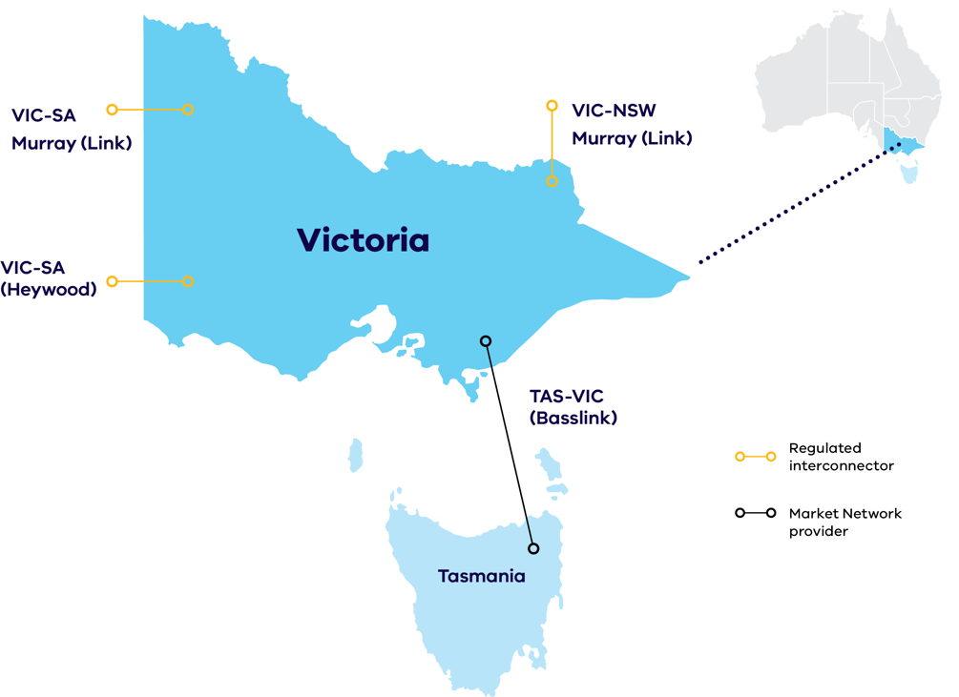

**Victoria's (VIC) high voltage interconnections with South Australia (SA), New South Wales (NSW) and Tasmania (TAS) create lucrative opportunities for generators to export electricity across price regions.**

# Dive into Victoria’s renewable energy subsectors

To achieve our ambitious renewable energy targets, including 95% renewable electricity generation by 2035, we will need to rapidly deploy a variety of technologies across eight key subsectors. Each of these subsectors has a targeted Investment Prospectus pack, summarised over coming pages. Read on to learn more about Victoria’s exciting opportunities in:

* Solar
* Wind
* Offshore wind
* Energy storage
* Bioenergy
* Renewable hydrogen
* Digital energy and innovation
* Zero emissions vehicles.

# Solar

Northwest Victoria receives especially high irradiation levels similar to Spain, with Southern Victoria boasting better solar resources than most of Western Europe.

Northwest Victoria receives an exceptional amount of solar energy, with irradiation levels exceeding 1,900 kWh/m2/y. Additionally, Victoria exhibits high solar irradiation levels between 1,500–1,900 kWh/m2/y in the Loddon Mallee, Grampians and Hume regions.

The corresponding Renewable Energy Zones of Murray River, Western Victoria, Central North and Ovens Murray capture this abundance of solar radiation, supported by the Victorian Government’s strong policy settings and transmission development plans.

Table 2: Snapshot of the sector (as of October 2024)

|  |  |
| --- | --- |
| Number of solar farms | Combined capacity |
| **45** operating | **1,304 MW** |
| **6** under construction | **469 MW** |
| **Total** | **1,773 MW** |

**Note:** Internal register figures from the Department of Energy, Environment and Climate Action, October 2024.

#### Investment Opportunity

To help meet the Victorian Renewable Electricity Targets of 95% by 2035 the state is estimated to need an additional 2 GW of utility-scale solar and 7.6 GW of rooftop solar installed by 2035 (Indicative estimates based on internal forecasts and modelling conducted by Accenture (2023) for the Department of Energy, Environment and Climate Action).

Figure 2: Solar Irradiation in Victoria

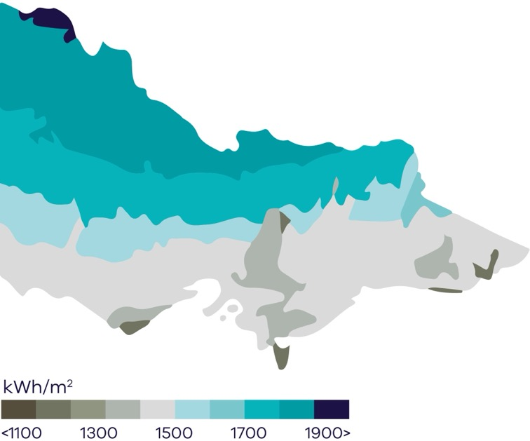

#### Further information

For more information on Victoria's Solar sector visit:   
[energy.vic.gov.au/for-industry/investment-opportunities](http://energy.vic.gov.au/for-industry/investment-opportunities)

# Onshore Wind

**Victoria boasts excellent wind resources, with an average wind speed of 8.4 m/s in Western Victoria and 7.2 m/s in the southwest.**

Victoria has been a location of choice for wind developers since the early 2000s. Our state’s wind resource is among the best in the world.

Victoria’s southern coastline, which lies in the path of the strong westerly wind belt between 35˚ and 60˚ latitudes, boasts high average wind speeds exceeding 8 m/s in many areas.

Table 3: Snapshot of the sector (as of October 2024)

|  |  |
| --- | --- |
| Number of wind farms | Combined capacity |
| **42** operating | **4,734 MW** |
| **2** under construction | **1,333 MW** |
| **7** granted development approval | **759 MW** |
| **Total** | **6,826 MW** |

(**Note:** Internal register figures from the Department of Energy, Environment and Climate Action, October 2024)

#### Investment Opportunity

To help meet the Victorian Renewable Electricity Target of 95% by 2035 the State is estimated to need an additional 5.4 GW of onshore wind generation installed by 2035 (**Note:** Indicative estimates based on modelling conducted by Accenture (2023) for the Department of Energy, Environment and Climate Action and are subject to change).

Figure 3: Victoria’s average yearly wind speed (Source: GeoVic, Resources Victoria)

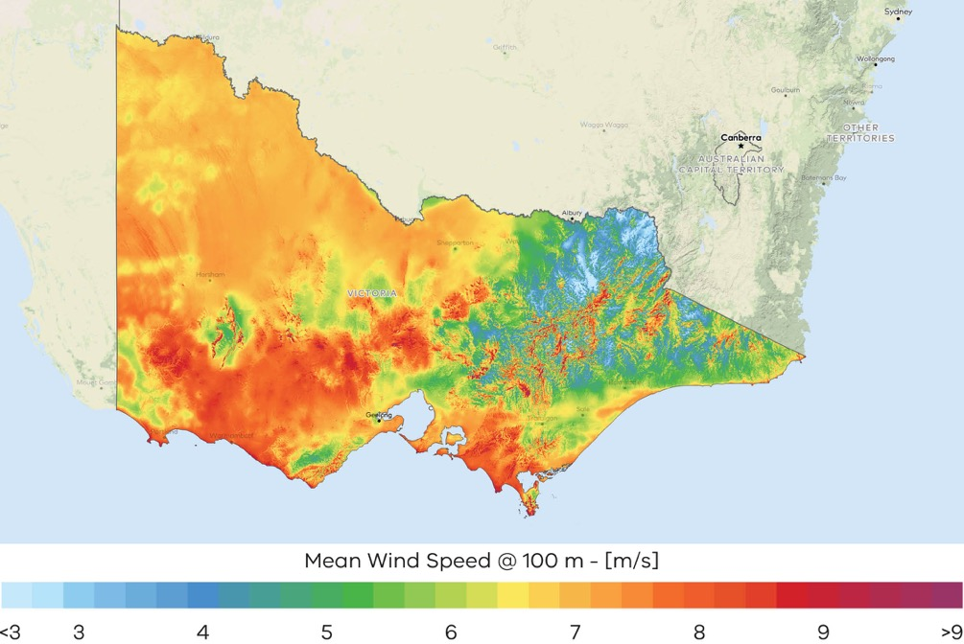

#### Further information

For more information on Victoria's Wind sector visit:   
[energy.vic.gov.au/for-industry/investment-opportunities](http://energy.vic.gov.au/for-industry/investment-opportunities)

# Offshore Wind

Offshore wind (OSW) a key pillar in Victoria’s renewable energy future.

Victoria is perfectly positioned to lead the nation in establishing a thriving new OSW industry, with:

* a world class offshore wind resource close to our transmission backbone
* a skilled regional workforce
* a track record of delivering renewable energy projects, and
* the largest declared offshore wind energy area in Australia.

The Australian Government has declared an area of the Bass Strait off Gippsland, Victoria, as Australia’s ﬁrst and largest offshore wind zone, spanning an area of approximately 15,000 square kilometers.

Feasibility licenses have been awarded to 12 projects in the Gippsland offshore wind declared area with planning and investigations now underway.

The Australian Government has also declared an offshore wind zone in the Southern Ocean off the coast of South-west Victoria. Offshore wind farms can only be built in Commonwealth waters, in areas approved by the Australian Government.

The Victorian Government established Offshore Wind Energy Victoria (OWEV) to coordinate and drive the development of Victoria’s offshore wind sector.

#### Investment Opportunity

The market provides significant opportunities for investment in the offshore wind industry:

* Offshore wind is a key pillar in Victoria’s renewable energy future with legislated targets of 2GW by 2032, 4GW by 2035 and 9GW by 2040.
* The strength and consistency of wind speeds are high by Australian and international standards.
* Victoria’s first mover advantage in Australia presents opportunities for manufacturing that may extend to other jurisdictions over time.

#### Manufacturing Opportunity

Victoria is estimated to need up to 222 offshore wind turbines by 2035. Initial Victorian demand for turbines creates a foundation for providing OEMs with long‑term pipeline certainty.

Offshore Wind Energy Victoria (OWEV) was established to coordinate and drive the development of Victoria’s offshore wind sector and is the gateway of industry, stakeholder and community engagement.

Offshore Wind Energy Implementation Statements provide industry and stakeholder guidance for how the Victorian Government is developing offshore wind energy.

#### Implementation Statement 3 was released in December 2023 and provided updates on:

* procurement process and support package design
* local content targets for offshore wind energy developers
* energy workforce development plan
* Traditional Owner partnerships
* legislation and regulatory reforms
* environmental protections
* ports
* transmission.

OWEV is a division within the Energy group of the Victorian Government’s Department of Energy, Environment and Climate Action (DEECA).

# Energy storage

We are Australia’s biggest developer of battery and energy storage projects. Both short and long duration energy storage are critical to the energy transition.

Energy storage will play a key role in Victoria’s renewable energy transition in providing reliable, affordable and zero-emissions energy as Victoria’s coal generators are replaced with new renewable capacity.

#### Victoria’s Energy Storage Targets

Victoria has legislated energy storage targets of:

* at least 2.6 GW of energy storage capacity by 2030
* at least 6.3 GW by 2035.

The energy storage targets will include short, medium and long duration energy storage systems.

For more information about the storage targets, visit: [energy.vic.gov.au/renewable-energy/victorian- renewable-energy-and-storage-targets](https://www.energy.vic.gov.au/renewable-energy/victorian-renewable-energy-and-storage-targets)

#### Victorian Big Battery

The Victorian Big Battery (VBB) is Australia’s largest lithium-ion battery located at Moorabool Terminal Station, just outside Geelong. Owned and operated by Neoen, it plays 2 important roles in Victoria’s electricity system.

Firstly, it allows for increased power flows through the Victoria-New South Wales Interconnector during peak demand summer months. This reduces the risk of unscheduled load shedding during summer.

Secondly, the VBB delivers a 250 MW network support service - System Integrity Protection Scheme (SIPS), which allows the battery to operate automatically and instantly in response to a network failure.

#### Neighbourhood batteries

The Victorian Government has committed more than $42 million to fund installation of 100 neighbourhood batteries across Victoria.

The 100 Neighbourhood Batteries Program provides grants to install neighbourhood batteries to improve energy reliability and provide energy storage capacity for locally generated solar power. This is expected to increase access to renewable energy and help lower energy bills.

#### Investment Opportunity

The Victorian market provides significant opportunities for investment across many aspects of the storage industry, including:

* Battery manufacturing and assembly utilising our existing manufacturing capability and skilled workforce
* Battery recycling and remanufacturing
* Deploying energy storage technologies to generate revenue though lucrative energy arbitrage and ancillary services markets.

#### Manufacturing Opportunity

Victoria is estimated to need up to:

* 3,600 utility-scale battery packs by 2035(Indicative estimates based on internal forecasts and modelling conducted by Accenture (2023) for the Department of Energy, Environment and Climate Action and are subject to change).
* 820,000 distributed battery packs by 2035 (Indicative estimates based on internal forecasts and modelling conducted by Accenture (2023) for the Department of Energy, Environment and Climate Action and are subject to change).

Initial Victorian demand for batteries creates a foundation for providing OEMs with long-term pipeline certainty.

#### Further information

For more information on energy storage opportunities in Victoria visit: [energy.vic.gov.au/for-industry/investment-opportunities](http://energy.vic.gov.au/for-industry/investment-opportunities)

# Bioenergy

Decarbonising the gas sector requires immediate investment in the existing technologies that are available now – energy efficiency and renewable electricity – and in the new technologies that can play an increasingly larger role in the future, such as biomethane and green methanol.

#### Victorian Gas Substitution Roadmap

The Gas Substitution Roadmap is helping our state navigate the path to net zero emissions while ensuring gas reliability. The Roadmap outlines how we will use energy efficiency, electrification, renewable hydrogen and biomethane to cut carbon emissions.

The Roadmap highlights the importance of developing Victoria’s renewable gas sector to meet the needs of ‘harder to electrify’ uses across the economy. Due to the scale of Victoria’s gas demand, there needs to be significant growth in the supply of biomethane and renewable hydrogen to meet Victoria’s emissions reduction targets. This will help empower Victorian households and businesses to embrace sustainable alternatives to fossil gas and enhance access to an affordable, secure, reliable and safe energy supply. It sets a clear path forward to help protect consumers from rising fossil gas prices or interrupted supply, and ensure that the appropriate planning and investment is made for a smooth and coordinated transition.

As the Victorian Government delivers the actions of the Gas Substitution Roadmap Update 2023 and progresses the next stage of the fossil gas sector transition, we will continue to engage with industry and Victorians to ensure milestones are met, including regular updates to the Roadmap with the next release planned for 2024.

For more information visit: [energy.vic.gov.au/renewable-energy/victorias-gas-substitution-roadmap](http://energy.vic.gov.au/renewable-energy/victorias-gas-substitution-roadmap)

#### Victorian Recycling Infrastructure Plan

In late 2024, Recycling Victoria is expected to release the Victorian Recycling Infrastructure Plan (VRIP). The VRIP provides Victorian circular economy investors with information and analysis to guide decision-making on waste, recycling and resource recovery infrastructure over the next 30 years.

The VRIP outlines infrastructure needs and gaps, driving innovation and investment where it is needed most.

For more information on the VRIP, please visit: [vic.gov.au/recycling-infrastructure-planning](http://vic.gov.au/recycling-infrastructure-planning)

The VRIP is supported by information an online waste and resource recovery map shows the current locations of Victoria’s waste, recycling and resource recovery infrastructure facilities.

The map is part of the Recycling Victoria Data Hub, which provides data, intelligence and insights for use by Victoria's waste, recycling and resource recovery sector, businesses, government and the community.

To access the Data Hub and infrastructure map please visit: [vic.gov.au/recycling-victoria-data-hub](http://vic.gov.au/recycling-victoria-data-hub)

#### Investment Opportunity

As legacy Gippsland gas supply starts to decline, replacing gas use in buildings where cost-effective electric alternatives exist (such as high efficiency heat pump hot water systems and reverse cycle air-conditioners) will help maintain reliable gas supply for essential industrial uses while renewable gas alternatives are being developed.

The Victorian Government is consulting with industry to develop policy measures and mechanisms that support new opportunities for renewable gases to transition hard to abate sectors.

#### Further information

For more information on bioenergy opportunities in Victoria visit:   
[energy.vic.gov.au/for-industry/investment-opportunities](http://energy.vic.gov.au/for-industry/investment-opportunities)

# Renewable hydrogen

The Victorian Government is investing in a range of opportunities relating to hydrogen. This prospectus focuses on hydrogen derived from renewable energy, which could support the transition to a low-carbon energy system.

#### The Victorian Renewable Hydrogen Industry Development Plan

Victoria’s renewable hydrogen developments are being guided by the Renewable Hydrogen Industry Development Plan (the Plan). The Plan outlines the Victorian Government’s focus areas and key actions that it will take to drive the development of a renewable hydrogen industry across the state. The Plan also launched two renewable hydrogen grants programs to support industry pilots, demonstrations and feasibility studies, and announced a state-wide regional hydrogen cluster network.

#### Initiatives driving demand

##### National Hydrogen Strategy

The Victorian Government has supported the Australian Government to refresh its National Hydrogen Strategy (NHS) in 2024, ensuring our state priorities are reflected at the national level. The NHS includes substantial new funding support (see below) to develop Australia's hydrogen sector and this support can be leveraged by Victorian projects.

##### Hydrogen Production Tax Incentive

In its 2024-25 budget, the Australian Government announced $6.7 billion for a hydrogen production tax incentive. This initiative will provide a tax credit of $2 per kilogram of renewable hydrogen produced for facilities that reach Final Investment Decision by 2030. The incentive will be available to projects from 2027-28 for up to 10 years.

##### Hydrogen Headstart Round 2

Building on the $2 billion Round 1 of the program, a further $2 billion was announced in the 2024-25 Australian Government budget to support early mover large-scale renewable hydrogen projects to bridge the green premium.

#### Investment Opportunity

The Victorian market provides significant opportunities for investment across many aspects of the hydrogen supply chain, including:

* Hydrogen for transport capitalising on the multiple trial projects underway and a thriving multimodal transport network
* Underground hydrogen storage which may support long duration energy storage
* Renewable hydrogen production located close to renewable generation in one of our Renewable Energy Zones
* Renewable hydrogen to decarbonise high heat industrial processes
* Green chemicals and fuels utilising Victoria’s plentiful renewable carbon sources.

#### Development Plan

Read the Victorian Renewable Hydrogen Industry Development Plan here: [energy.vic.gov.au/renewable-hydrogen/ industry-development-plan](http://energy.vic.gov.au/renewable-hydrogen/%20industry-development-plan)

#### Further information

For more information on hydrogen opportunities in Victoria visit:  
[energy.vic.gov.au/for-industry/investment-opportunities](http://energy.vic.gov.au/for-industry/investment-opportunities)

# Digital energy and innovation

Victoria has the most extensive penetration of smart meters in Australia (over 99%), making the state the ideal location to pilot new smart grid technologies, services and business models.

#### What makes Victoria's digital energy and innovation subsector different?

Victoria is the only state in Australia with a fully digitised energy system, thanks to the roll-out of over 2.5 million smart meters to residential and small business electricity customers (over 99% coverage).

This makes Victoria the ideal place to develop and test new digital energy innovations, with smart meters:

* enabling near real-time remote monitoring of customer electricity flows.
* allowing digital energy businesses to provide customers with new product offerings and greater insight into their energy use.

#### Smart meter coverage around Australia:

* In Victoria smart meter coverage is above 99%
* In the rest of Australia smart meter coverage is less than 30%

#### The increasing role of Distributed Energy Resources (DER)

The drive to integrate increasing DER creates opportunities to introduce technologies and services to the Victorian market, including:

* next generation smart inverter technologies
* advanced control and coordination of batteries
* smart household energy management systems and smart appliances
* smart solar electric hot water systems and heat pumps.

#### Investment Opportunity

Victoria’s growing digital and digital energy sectors are creating a wealth of investment opportunities. The following statistics show the pace and scale of growth:

* Australia's growing digital technologies sector is expanding at a rate 4 times faster than the rest of the economy, having grown 26% to $167 billion since 2020 and expected to reach $244 billion by 2031 (Source: [startupgenome.com/report/gser2023](http://startupgenome.com/report/gser2023)).
* Victoria's digital technology sector generated $34 million in revenue and $3 billion in exports annually. (Source: Scaling Up: Growing the Economic Opportunity for Victoria's start-up ecosystem).
* Melbourne is home to more than half of Australia’s top 20 technology companies (Source: [breakthroughvictoria.com/growth-sectors/digital-technologies](http://breakthroughvictoria.com/growth-sectors/digital-technologies)).

#### Further information

For more information on digital energy opportunities in Victoria visit:   
[energy.vic.gov.au/for-industry/investment-opportunities](http://energy.vic.gov.au/for-industry/investment-opportunities)

# Zero emissions vehicles

The Victorian Government has released a Zero Emissions Vehicle (ZEV) Roadmap that will support Victoria’s transport sector to become ZEV-ready, enabling a pathway to economy wide net zero greenhouse gas emissions by 2045. This includes a commitment for half of all light vehicle sales in Victoria to be ZEVs by 2030 – creating demand for around 3.4 million ZEVs by 2045.

#### Victoria’s ZEV Targets

* 50% of all light vehicles sold from 2030 must be ZEVs
* Replace 400 vehicles in the Victorian Government Fleet with new ZEVs by 2024
* All new public transport buses must be a ZEV after 2025.

The transition to ZEVs will play a critical role in achieving Victoria’s target of economy-wide net zero emissions by 2045. Key Victorian Government policies and initiatives to support this transition include:

* **$30 million** for Australia’s first public ZEV subsidy program (now closed)
* **$19 million** to accelerate the roll-out of electric vehicle (EV) charging infrastructure across regional Victoria and support the charging of EV fleets
* **$20 million** for a ZEV public transport bus trial – and a target for all public transport bus purchases to be ZEVs from 2025
* **$10 million** to replace 400 vehicles in the Victorian Government Fleet with ZEVs
* **$5 million** to establish a Commercial Sector Zero Emissions Vehicle Innovation Fund.

#### Investment Opportunity

The Victorian market provides significant opportunities for investment across many aspects of the ZEV supply chain, including:

* component manufacturing
* vehicle, truck and bus manufacturing
* battery supply chain and recycling
* charging infrastructure
* software engineering for managed demand
* vehicle to grid energy management systems.

#### Manufacturing Opportunity

There are 4,500 diesel buses in the Victorian fleet that will be replaced with a Zero Emission Vehicle from 2025.

#### Victoria’s Zero Emissions Vehicle Roadmap

Victoria’s Zero Emissions Vehicle Roadmap is focused on actions that will be taken in this decade to address key barriers to uptake of zero emissions vehicle technologies, while also leveraging the opportunities associated with this major technology transition.

For more information visit:[energy.vic.gov.au/renewable-energy/zero-emissions-vehicles](http://energy.vic.gov.au/renewable-energy/zero-emissions-vehicles)

#### Further information

For more information on ZEV opportunities in Victoria visit:   
[energy.vic.gov.au/for-industry/investment-opportunities](http://energy.vic.gov.au/for-industry/investment-opportunities)

# Subsector packs

To access the New Energy Technologies subsector packs, please visit: [energy.vic.gov.au/for-industry/investment-opportunities](http://energy.vic.gov.au/for-industry/investment-opportunities)

# Key Victorian Government entities

We can help facilitate connections with key Victorian Government entities and industry members across our renewable energy sector.

#### Department of Energy, Environment and Climate Action (DEECA)

DEECA works with industry and the community to develop Victoria's secure and sustainable energy future.

For information on Victoria’s energy policy landscape and facilitated connections across the Victorian Government and renewable energy sector, contact the Business and Industry Engagement team at: [BIE@deeca.vic.gov.au](mailto:BIE@deeca.vic.gov.au)

[energy.vic.gov.au](http://energy.vic.gov.au/)  
[energy.vic.gov.au/ forindustry/investment-opportunities](http://energy.vic.gov.au/%20forindustry/investment-opportunities)

#### Breakthrough Victoria

Breakthrough Victoria is an independent investment management company established in 2021 to manage the Victorian Government’s landmark $2 billion Breakthrough Victoria Fund.

Visit the website of Breakthrough Victoria at: [breakthroughvictoria.com](http://breakthroughvictoria.com/)

#### Invest Victoria

Invest Victoria is the Victorian Government’s investment attraction agency. Services include:

* market regulatory information
* statutory approvals coordination
* site location services
* identification of infrastructure and utility requirements
* advocacy within government.

Visit the website of Invest Victoria at: [invest.vic.gov.au](http://invest.vic.gov.au/)

#### Offshore Wind Energy Victoria

Offshore Wind Energy Victoria (OWEV) was established as the single point of entry for industry and community engagement on offshore wind.

Visit the website of Offshore Wind Energy Victoria at:   
[energy.vic.gov.au/renewable-energy/offshore- wind-energy](http://energy.vic.gov.au/renewable-energy/offshore-%20wind-energy)

#### SEC

The SEC is a Victorian Government-owned renewable energy company. It is partnering with the private sector to deliver 4.5 GW of new renewable energy and storage projects with an initial investment of $1 billion.

Visit the SEC website at: [vic.gov.au/state-electricity-commission-Victoria](http://vic.gov.au/state-electricity-commission-Victoria)

#### Solar Victoria

Solar Victoria is responsible for the delivery of the Victorian Government’s $1.3 billion Solar Homes Program – one of the most ambitious and transformative renewable energy programs in Australia.

Visit the Solar Victoria website at: [solar.vic.gov.au](http://solar.vic.gov.au/)

#### Sustainability Victoria

Sustainability Victoria empowers Victorians to live sustainably by taking action on climate change and using our precious resources wisely – to deliver a sustainable future for us all.

Visit the Sustainability Victoria website at: [sustainability.vic.gov.au](http://sustainability.vic.gov.au/)

#### VicGrid

VicGrid coordinates the planning and development of Victorian Renewable Energy Zones (REZs). It also oversees the $540 million REZ fund that will be used to strengthen the grid and develop each REZ.

Visit the VicGrid website at: [energy.vic.gov.au/renewable- energy/renewable-energy-zones](http://energy.vic.gov.au/renewable-%20energy/renewable-energy-zones)

# For international investors

Contact a local Victorian Government Trade and Investment Office to help you:

* navigate investment opportunities in Victoria’s new energy technology sector
* set up a briefing with energy specialists
* arrange inbound market visits
* introduce you to the Victorian Government’s Energy Business and Industry Engagement team and Invest Victoria.

For more information, visit: [global.vic.gov.au/meet-our-global-team/all-office-locations](http://global.vic.gov.au/meet-our-global-team/all-office-locations)

Figure 4: Victorian Government Trade and Investment office locations

* Melbourne, Australia
* Kuala Lumpur
* Jakarta
* Singapore
* Vietnam
* Tokyo
* Seoul
* Bengaluru
* Mumbai
* Shanghai
* Nanjing
* Chengdu
* Beijing
* Hong Kong
* London
* Paris
* Frankfurt
* Dubai
* Tel Aviv
* New York
* Washington DC
* Boston
* San Francisco
* Santiago

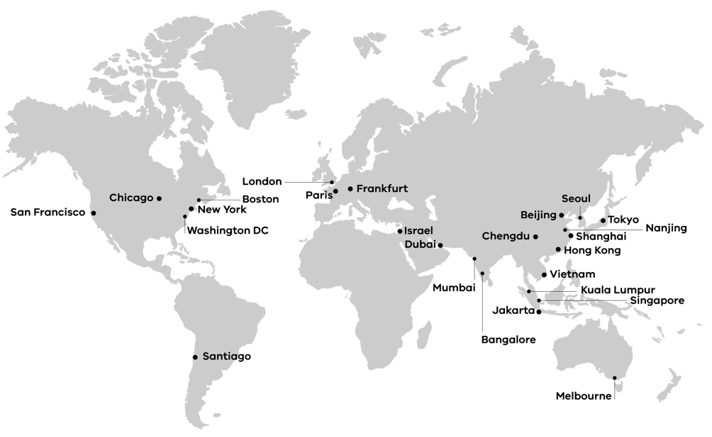

**End of document.**