Victoria’s Investment Prospectus: Renewable Hydrogen

## Victoria, one of the world’s most exciting energy markets

Table of Contents

Acknowledgements 3

Why invest in Victoria’s renewable hydrogen sector? 6

Victoria’s renewable hydrogen ecosystem 8

Our legislated targets are driving investment 9

Taking a strategic approach to hydrogen 11

Leading opportunities for Victoria's renewable hydrogen sector 13

Victoria’s flagship projects 15

Renewable hydrogen’s potential to decarbonise high heat industries 16

Victoria is a leader in hydrogen transport 18

Decarbonising the shipping industry 21

Renewable hydrogen opportunities across Victoria 23

South-west Victoria is primed for investment 24

Access to Victoria's world class renewable energy talent 26

Strong renewable hydrogen supply chain and manufacturing capabilities 28

Key Victorian Government entities 30

For international investors 33

# Acknowledgements

**Acknowledgement of Country**

We acknowledge and respect Victorian Traditional Owners as the original custodians of Victoria’s land and waters, their unique ability to care for Country and deep spiritual connection to it.

We honour Elders past and present whose knowledge and wisdom have ensured the continuation of culture and traditional practices.

We are committed to genuinely partner, and meaningfully engage, with Victoria’s Traditional Owners and Aboriginal communities to support the protection of Country, the maintenance of spiritual and cultural practices and their broader aspirations in the 21st century and beyond.

© The State of Victoria Department of Energy, Environment and Climate Action, September 2024

**Creative Commons**

This work is licensed under a Creative Commons Attribution 4.0 International licence, visit the [Creative Commons website](http://creativecommons.org/licenses/by/4.0) (<http://creativecommons.org/licenses/by/4.0/>).

You are free to re-use the work under that licence, on the condition that you credit the State of Victoria as author. The licence does not apply to any images, photographs or branding, including the Victorian Coat of Arms, and the Victorian Government and Department logos.

ISBN 978-1-76136-595-9 (pdf/online/MS word)

**Disclaimer**

This publication may be of assistance to you but the State of Victoria and its employees do not guarantee that the publication is without flaw of any kind or is wholly appropriate for your particular purposes and therefore disclaims all liability for any error, loss or other consequence which may arise from you relying on any information in this publication.

**Accessibility**

To receive this document in an alternative format, phone the Customer Service Centre on 136 186, email customer.service@delwp.vic.gov.au, or contact [National Relay Service](http://www.accesshub.gov.au/) ([www.accesshub.gov.au](http://www.accesshub.gov.au/)) on 133 677. Available at [DEECA website](https://www.deeca.vic.gov.au/) ([www.deeca.vic.gov.au](https://www.deeca.vic.gov.au/)).

#### Traditional Owners at the centre of decision-making processes

Strong and mutually beneficial partnerships with Traditional Owners and First Peoples are imperative to the electricity transition’s success and integral to ensuring the goals and objectives of self-determination set out in the Victorian Government’s Self Determination Reform Framework and the Department of Energy, Environment and Climate Action’s (DEECA) Pupangarli Marnmarnepu ‘Owning Our Future’ Aboriginal Self-Determination Reform Strategy 2020–2025.

We will be continually guided by Traditional Owner and First Peoples’ communities – now and in the future – who have expressed a strong interest in investing in renewable energy to deliver their interests and their desire to own and manage renewable energy generation and storage technology and infrastructure to meet their communities’ cultural, spiritual and economic needs.

As part of a once-in-a-generation renewable electricity transition and transformation, there is an obligation for industry and government to create genuine partnerships with Traditional Owners and First Peoples, to ensure that their self-determining rights and interests are upheld. This will be the catalyst for historical change and reform that will see immediate and future flow-on effects. It will have a positive impact on the environment and advance the social and economic outcomes for Traditional Owners and First Peoples and all Victorians.

# Why invest in Victoria’s renewable hydrogen sector?

#### New national funding support for renewable hydrogen

The Australian Government has recently announced a second $2 billion round of its Hydrogen Headstart program, bringing total program investment to $4 billion. The Australian Government has also committed $6.7 billion over 10 years to a hydrogen production tax incentive (HPTI), which will provide a $2 per kilogram tax credit for renewable hydrogen produced at facilities expected to reach Final Investment   
Decision by 2030.

#### Underground hydrogen storage potential

Victoria has significant potential for underground hydrogen storage, which can play an important role in providing long-duration energy storage and help firm hydrogen supply for green chemical manufacturing.

#### Government policy drives investment

Victoria has legislated renewable energy targets including 95% by 2035. The state is developing 6 Renewable Energy Zones (REZs) to unlock Victoria's excellent renewable energy resources.

#### Access to key resources

Victoria has access to suitable, sustainable sources of water and renewable carbon. For example, the Green Forestry Triangle region in Southwest Victoria provides access to renewable carbon sources to support green fuel projects.

#### Leadership in hydrogen for transport

Victoria leads in hydrogen transport potential – with 8 hydrogen refuelling stations built or in the pipeline and trials occurring across four different hydrogen vehicle types (trucks, waste trucks, buses and light vehicles). Heavy transport, shipping and aviation are part of this immense potential, with a large-scale green methanol production project under development to help decarbonise shipping.

#### Skilled workforce and world‑class education

Victoria is delivering a Renewable Hydrogen Worker Training Centre to ensure Victoria has a pipeline of skilled workers to meet workforce needs. Its establishment will be supported by up to $8 million in state funding and up to $10 million in Australian Government funding.

# Victoria’s renewable hydrogen ecosystem

Our competitive advantages, strategic investments and ambitious renewable energy targets create a unique opportunity for a renewable hydrogen market to thrive.

Figure 1: Map of Victoria’s renewable hydrogen ecosystem

There are multiple hydrogen projects and research facilities already operational in Victoria providing the opportunity for synergies and leveraging existing skills and infrastructure:

Melbourne

* Swinburne University of Technology
  + The Victorian Hydrogen Hub (VH2)
* Yarra Valley Water
  + A pilot scale electrolyser for mobility applications
* CSIRO Hydrogen Refueller
  + A demonstration hydrogen refuelling station at the Clayton campus
* Energys
  + A fuel cell power station manufacturer and 1 MW electrolyser project
* Transit Systems
  + Footscray Zero Emissions Bus Trial
* Toyota
  + Altona Hydrogen Demonstration Centre
* Boundary Power
  + Renewable Hydrogen Standalone Power System Demonstration

Geelong

* Viva Energy
  + A renewable hydrogen refuelling station, 2.5 MW electrolyser and 15 FCEV
* Austeng
  + Ashes to Ashes – Renewable Hydrogen Cremation

Portland

* HAMR Energy
  + >200 ktpa green methanol production feasibility project

Warrnambool

* Deakin University
  + Hycel Technology Hub

Port Campbell

* Underground storage potential in depleted gas fields

Green Forestry Triangle

* One of Australia's major forest regions

And multiple declared offshore wind areas as potential green power sources.

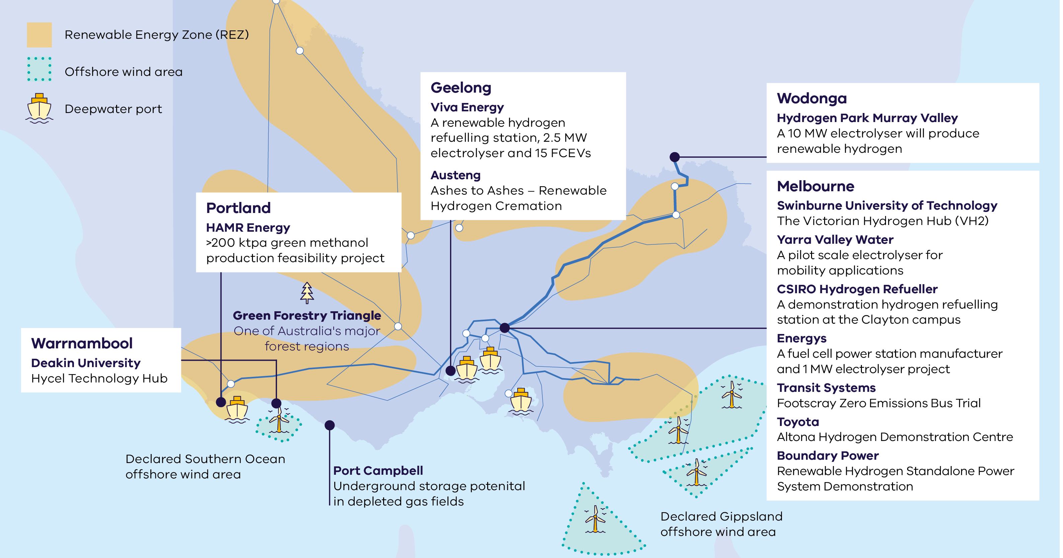

# Our legislated targets are driving investment

The following targets form the pillars of Victoria’s energy policy. These targets create the right investment framework to develop a renewable hydrogen economy. Renewable hydrogen has a critical role to help Victoria reach these targets.

#### Net zero emissions by 2045

Renewable hydrogen has an important role to help reach our economy-wide net zero emissions target by 2045. It will be critical in the decarbonisation of our hard-to-abate sectors such as heavy transport, shipping, aviation and industrial.

#### 95% Renewable electricity by 2035

As potentially flexible source of demand, electrolysers can help offset investment in network augmentation and improve the commercial prospects of renewable energy projects. They can become an important part of our future grid as Victoria progresses towards 95% renewable electricity.

#### 6.3 GW Energy storage by 2035

Renewable hydrogen can play a role in meeting Victoria’s energy storage targets by providing long- duration and seasonal storage. Victoria has strong potential for underground hydrogen storage and continues to explore this and other hydrogen storage opportunities.

#### 9 GW Offshore wind by 2040

Offshore wind has the potential to bring significant volumes of electricity into the state. This can help enable large-scale renewable hydrogen production in key regions and unlock further sector opportunities, such as green methanol production.

# Taking a strategic approach to hydrogen

The Victorian Government is creating a solid foundation to enable a thriving renewable hydrogen sector in alignment with the National Hydrogen Strategy.

#### Hydrogen Production Tax Incentive

In its 2024-25 budget, the Australian Government announced $6.7 billion for a hydrogen production tax incentive. This initiative will provide a tax credit of $2 per kilogram of renewable hydrogen produced for facilities that reach Final Investment Decision by 2030. The incentive will be available to projects from 2027-28 for up to 10 years.

#### Hydrogen Headstart Round 2

Building on the $2 billion Round 1 of the program, a further $2 billion was announced in the 2024-25 Australian Government budget to support early mover large-scale renewable hydrogen projects to bridge the commercialisation gap.

**Renewable Gas Policy Directions** **Paper**The Victorian Government is transparently developing a stable and clear policy environment to drive international investment needed to foster a thriving Victorian renewable gas sector. This was headlined by the Renewable Gas Consultation Paper released in 2023, and will be built on through the Renewable Gas Policy Directions Paper to be released in late 2024, which will outline the Victorian Government's preferred approach to scaling this important sector.

#### National Hydrogen Strategy

The Victorian Government has supported the Australian Government to refresh its National Hydrogen Strategy (NHS) in 2024, ensuring our state priorities are reflected at the national level. The NHS includes substantial new funding support (see below) to develop Australia's hydrogen sector and this support can be leveraged by Victorian projects.

#### Victoria’s Renewable Hydrogen Industry Development Plan

Victoria’s renewable hydrogen developments are guided by the Renewable Hydrogen Industry Development Plan (IDP). The IDP outlines the Victorian Government’s focus areas and key actions to drive the development of a renewable hydrogen industry across the state. Following the release of the IDP, Victoria launched 2 renewable hydrogen grants programs to support industry pilots, demonstrations and feasibility studies, and announced a state-wide regional hydrogen cluster network.

For more information, visit [energy.vic.gov.au/renewable-energy/renewable-hydrogen](https://www.energy.vic.gov.au/renewable-energy/renewable-hydrogen)

The Victorian Government is taking action to:

* build our skills and capacity in renewable hydrogen and renewable fuels like green methanol
* drive innovation to develop a thriving renewable hydrogen sector that can enable the future export of renewable energy
* create long-term jobs through new career pathways and clusters
* reduce greenhouse gas emissions across our hard-to-abate sectors, including industrial, energy and transport applications.

#### Sector activity since IDP release

* **50** projects announced or underway
* **8** hydrogen refuelling stations built or in the pipeline
* **9** key hydrogen manufacturing projects
* **3** renewable hydrogen grant programs delivered or underway
* **12** electrolysers (over 1 GW total) announced or in development

Victoria’s 2021 Renewable Hydrogen Industry Development Plan and our strategic approach is creating impact across the sector

# Leading opportunities for Victoria's renewable hydrogen sector

#### Enablers

Figure 2: Enablers in Victoria’s renewable hydrogen sector

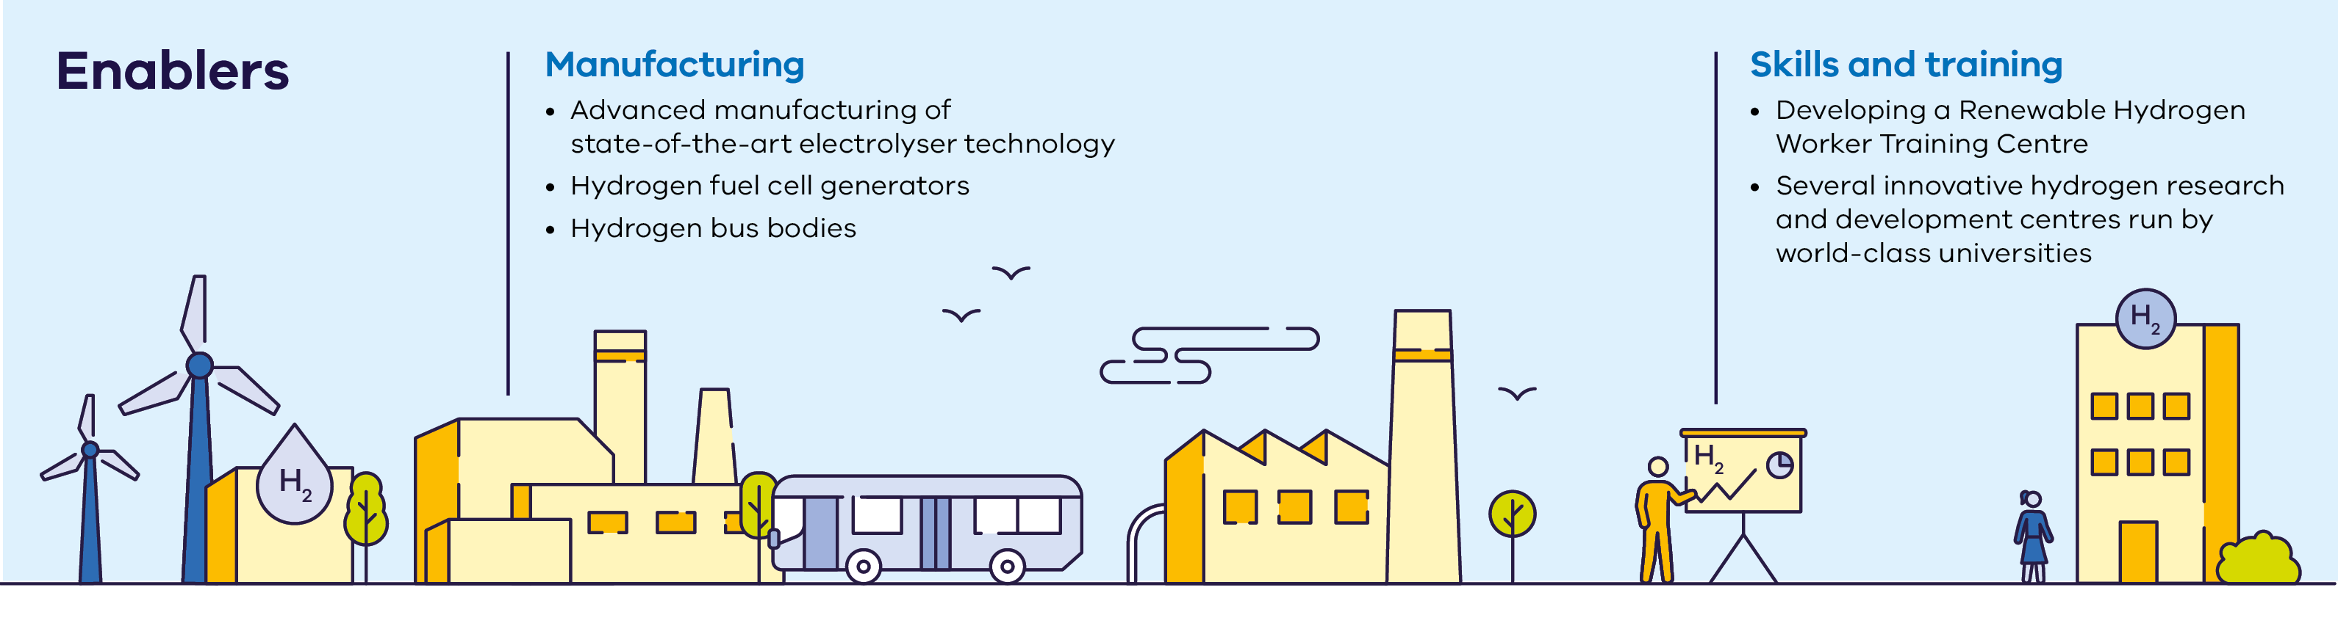

##### Manufacturing

* Advanced manufacturing of state-of-the-art electrolyser technology
* Hydrogen fuel cell generators
* Hydrogen bus bodies

##### Skills and training

* Developing a Renewable Hydrogen Worker Training Centre
* Several innovative hydrogen research and development centres run by world-class universities

#### End uses

Figure 3: End uses in Victoria’s renewable hydrogen sector

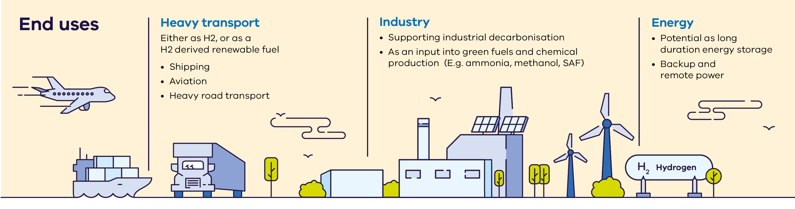

##### Heavy transport

Either as H2, or as a H2 derived renewable fuel

* Shipping
* Aviation
* Heavy road transport

##### Industry

* Supporting industrial decarbonisation
* As an input into green fuels and chemical production (E.g. ammonia, methanol, SAF)

##### Energy

* Potential as long duration energy storage
* Backup and remote power

# Victoria’s flagship projects

The Victorian Government has made several groundbreaking investments to support renewable hydrogen projects, including one of Australia’s biggest electrolysers and delivery of a renewable hydrogen worker training centre in partnership with the Australian Government.

#### Case study: Hydrogen Park Murray Valley

The Victorian Government is providing $12.3 million to the Hydrogen Park Murray Valley project led by Australian Gas Infrastructure Group (AGIG). The project is also supported by $36.1 million in ARENA funding and financing from the Clean Energy Finance Corporation.

AGIG will construct a 10 MW electrolyser co-located with North East Water’s wastewater treatment plant in Wodonga in Northern Victoria.

# Renewable hydrogen’s potential to decarbonise high heat industries

Renewable hydrogen has a long-term, supporting role in decarbonising Victoria’s gas sector, especially in hard-to-abate industries, and as a feedstock to produce green chemicals and fuels.

Renewable hydrogen and other renewable gases such as biomethane will play an important role in decarbonising Victoria’s hard-to-abate industrial sector, in particular high heat industries where electrification will be challenging. Renewable hydrogen will also be a critical feedstock for new industries such as green methanol, ammonia and sustainable aviation fuel.

#### Investment Opportunities

To support industrial gas users to transition away from fossil gas, approximately 40-60 PJ per annum of renewable gas will likely be required. This accounts for 30% of Victoria’s current total gas consumption. The government is investigating opportunities for scaling up renewable gas, which will be important for transitioning hard-to-abate industries.

#### Victoria’s Gas Substitution Roadmap

The Victorian Government released its Gas Substitution Roadmap in 2022. The roadmap states that alternative sources of gas, such as renewable hydrogen and biomethane, will be essential for the gas sector to reach net zero emissions. In late 2023, the roadmap was updated. The update outlines new commitments to maintain momentum towards a net zero emissions energy system that delivers lower energy bills for households and businesses. The latest roadmap update is set for release in late 2024.

Roadmap scenario modelling shows that whilst electrification is key to decarbonising residential and commercial sectors, for many users, particularly those with high-temperature process needs, alternative types of gas including biomethane and renewable hydrogen are a lower cost decarbonisation option. The Victorian Government is considering policy options to drive the uptake of and investment into renewable gases.

For more information visit: [energy.vic.gov.au/renewable-energy/victorias-gas-substitution-roadmap](http://energy.vic.gov.au/renewable-energy/victorias-gas-substitution-roadmap)

#### Case study: Austeng crematoria burner system

Austeng, an innovative engineering business, has successfully trialled and demonstrated how an existing crematorium burner system can run on a blend of hydrogen and natural gas without significant changes to the existing burner and gas train.

This enables the first step for the crematoria industry to transition to the use of renewable hydrogen. The Victorian Government provided $100,000 in funding support for this project through the Renewable Hydrogen Business Ready Fund.

This technology will be applicable to many other industrial processes that require high heat levels. Austeng Managing Director, Ross George spoke of the pride he felt that this innovative work was undertaken in Geelong – a city with a tradition of diverse manufacturing and a ‘can do’ attitude.

# Victoria is a leader in hydrogen transport

Heavy transport, including shipping and aviation, is one of the first sectors where renewable hydrogen and derivative fuels will become cost competitive. The sector also accounts for 25% of the state’s greenhouse gas emissions. The Victorian Government has supported several hydrogen transport and refuelling projects to position the state as a sector leader.

Hydrogen fuel cell electric vehicles are a zero-emission option to support the decarbonisation of Victoria’s transport sector. Renewable hydrogen, or renewable hydrogen derivatives can be used across the transport sector, including for heavy freight, trains, aircraft, specialty and passenger vehicles, and industrial vehicles.

In 2021, the Victorian Government launched its Zero Emissions Vehicle (ZEV) Roadmap. The ZEV Roadmap outlines actions the Victorian Government is taking to support economy-wide net zero emissions road transport by 2050.

The Victorian Government is also funding a 3-year trial of hydrogen passenger vehicles for use in government fleet operations.

#### Investment Opportunities

Victoria’s hydrogen transport network is set to grow significantly. The state already has hydrogen vehicle manufacturing, several announced renewable hydrogen refuelling stations and trials occurring across multiple vehicle modes including freight and waste trucks. This is in addition to the flagship Zero Emissions Bus Trial.

For more information, visit: [energy.vic.gov.au/for-industry/investment-opportunities](http://energy.vic.gov.au/for-industry/investment-opportunities)

#### Case study: CSIRO’s Hydrogen Refuelling Station

CSIRO, in collaboration with the Victorian Hydrogen Hub (VH2), has built Victoria’s second hydrogen refuelling station at its Clayton campus in Melbourne. The $2 million Hydrogen Refuelling Station was co-funded by VH2 through the Victorian Higher Education State Investment Fund. CSIRO chose to build the station in Melbourne, based on a partnership with VH2, an initiative of Swinburne University of Technology.

The Hydrogen Refuelling Station produces green hydrogen using electricity from renewable sources.

The refueller itself can generate up to 20 kilograms of green hydrogen a day, using an electrolyser to convert water into hydrogen, and has a storage capacity of 80 kilograms.

The refuelling station demonstrates hydrogen’s transport and urban mobility capabilities. It will be used by CSIRO, VH2 and other partners to showcase hydrogen’s real-world uses and capabilities.

#### Case study: Viva’s New Energies Service Station

The Victorian Government and ARENA are supporting construction of Viva Energy's New Energies Service Station which will be Australia's most ambitious hydrogen mobility project and the first public renewable hydrogen refuelling station.

The Geelong project, which has been awarded $22.8 million from ARENA and $1 million through the Victorian Government’s Renewable Hydrogen Commercialisation Pathways Fund, will feature a 2.5 MW electrolyser and be co-located alongside electric vehicle charging infrastructure.

The New Energies Service Station will promote the use of renewable hydrogen to decarbonise the heavy transport sector by demonstrating the capacity to embed fuel cell electric vehicles (FCEVs) into existing heavy transport operations. The station will initially service a fleet of 15 heavy FCEVs across a number of industry partners including Toll Group, ComfortDelGro Corporation Australia (CDC), Cleanaway and Barwon Water.

# Decarbonising the shipping industry

Victoria is home to Australasia’s largest container port – the Port of Melbourne – handling around 8,000 containers each day. (Source: Navigating our Port Futures: The Victorian Commercial Ports Strategy, The Victorian Government, 2022). Renewable hydrogen, as a critical feedstock of zero emissions fuel, may play a key role in decarbonising the shipping industry.

#### Victoria at the forefront of shipping industry decarbonisation

Victoria’s existing refining capabilities give it the potential to be a major player in the production of green methanol and other future fuels. The state is home to 4 deepwater, commercial ports, through which over 4000 ships are processed annually, providing significant opportunities for green energy carrier investment. Port of Melbourne is the largest container port in Australasia, and like the other 3 Victorian deepwater ports, will continue to be an important component of the supply chain.

#### Singapore-Australia Green and Digital Shipping Corridor

A Green and Digital Shipping Corridor is being established between Singapore and Australia, which will help decarbonise and digitalise shipping routes. Both countries formalised their cooperation by signing a Memorandum of Understanding in March 2024.

One of the focus areas will be supporting the development and uptake of zero or near-zero greenhouse gas emission technologies, fuels and/or energy sources, with the aim of accelerating maritime decarbonisation. Key actions include:

* exploring opportunities for a joint supply chain and logistics of zero or near-zero emission fuels
* developing training programs to safely handle zero or near-zero emission fuels
* conducting test pilots and demonstration projects for bunkering zero or near-zero emission fuels

Discussions with key stakeholders are underway to commence work on the action areas.

Agreements like this are helping to create favourable conditions for investment in green methanol in Victoria.

#### Investment Opportunities

Victoria’s 4 deepwater ports – Melbourne, Hastings, Geelong and Portland – have liquid fuel infrastructure that can support a renewable hydrogen industry.

Victoria is well positioned to export renewable hydrogen, either as a liquid or using a hydrogen carrier like green methanol or ammonia, to Asia-Pacific markets and beyond.

#### Case study: HAMR Energy’s Portland Renewable Fuels Project

The Victorian Government is supporting HAMR Energy’s Portland Renewable Fuels project which is a world-scale green methanol development. When completed, the project will produce over 200,000 tonnes of green methanol per annum.

The Portland region, located in southwest Victoria, is uniquely placed for such a development with one of the Australia’s best renewable wind resources, a significant sustainable forestry resource and existing infrastructure including a deepwater port.

HAMR Energy has established a leading position as a renewable fuels developer in Australia and recently entered into a memorandum of understanding with the Port of Melbourne and major global shipping lines to explore green methanol bunkering in Melbourne.

# Renewable hydrogen opportunities across Victoria

Each of Victoria’s regions offer different hydrogen-related infrastructure, resources and capabilities. Together they create a strong ecosystem for hydrogen project development and investment. This includes plentiful renewable energy for producing hydrogen.

Figure 4: Map of Renewable hydrogen opportunities across Victoria

In addition to access to renewable energy resources, regional educational institutions, supply chain networks and freight opportunities, the below regions also have the additional benefits to support the renewable hydrogen industry.

Greater Melbourne Port Phillip

* Clayton Hydrogen Technology Cluster
* Melbourne Deep Water Port
* Hastings Deep Water Port

Barwon South West

* Hycel Tech Hub
* Geelong Deep Water Port
* Portland Deep Water Port

Gippsland

* Gippsland Hydrogen Technology Cluster

Loddon Mallee

* Mallee Hydrogen Technology Cluster

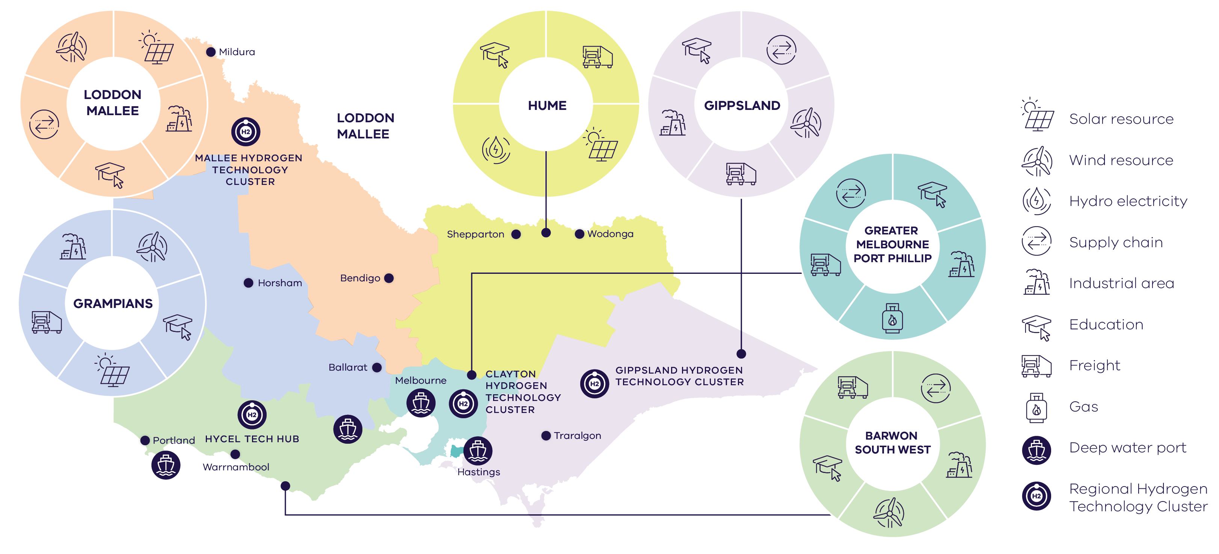

# South-west Victoria is primed for investment

The Barwon South West region, from Portland through to Geelong with connections into Melbourne, is an exciting area for renewable hydrogen project development and investment.

The region includes strong renewable energy resources with an offshore wind and renewable energy zone, large scale underground hydrogen storage potential, 2 deepwater ports, large industrial hubs, key freight and transport routes, and existing energy infrastructure such as transmission. The region is also home to several exciting renewable hydrogen projects.

Figure 5: Victoria’s South West Renewable Energy Zone

Green methanol production for marine fuel

* The region is ideal for green methanol production due to its proximity to Victoria's Green Forestry Triangle, transport links to the Port of Melbourne and opportunities for residual, renewable biomass as a feed stock for methanol production

R&D and skills and training

* The region is emerging as a skills and training hub for Victoria, led by Deakin Uni Hycel and a Deakin campus in Geelong, and South West TAFE

Hydrogen for mobility: freight and back to base

* The region hosts one of Australia's first and largest back to base hydrogen mobility projects, is home to the first public refuelling station and is ideally placed for further heavy transport opportunities

Underground hydrogen storage potential

* Underground depleted gas reservoirs at Port Campbell are a nationally significant asset with potential to be used for long duration storage

Viva Energy

* Renewable hydrogen refuelling station, 2.5 MW electrolyser and 15 FCEVs

Deakin University

* Hycel Technology Hub

Green Forestry Triangle

* One of Australia's major forest regions

Industrial base

* Portland smelter
* Keppel Prince Engineering

As well as:

* Port of Geelong
* Port of Portland
* Declared offshore southern wind area
* High voltage transmission line

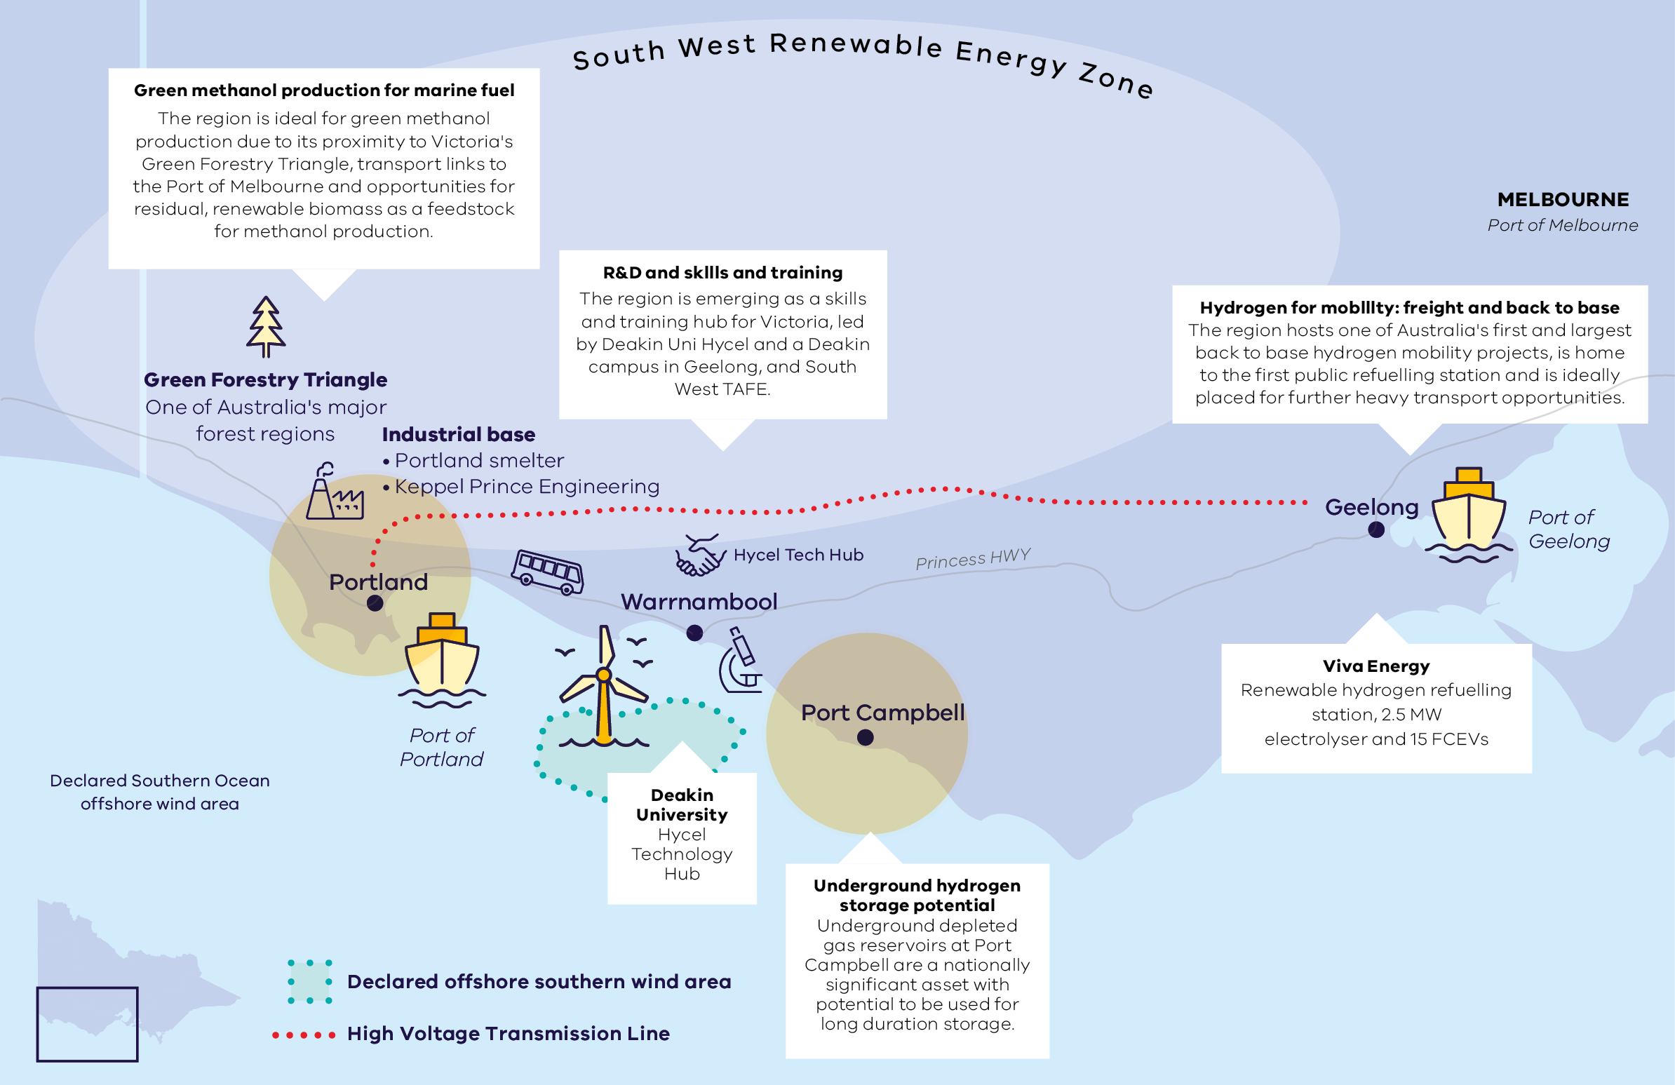

# Access to Victoria's world class renewable energy talent

Victoria is home to the highest number of globally-recognised universities in Australia and several innovative hydrogen research and development hubs.

Victoria is delivering a Renewable Hydrogen Worker Training Centre. Up to $8 million in Victorian Government funding, plus up to $10 million additional in Australian Government funding will be available to support its establishment.

Victoria has made significant investments to support its world-class universities to further their expertise in hydrogen innovation and R&D.

Victoria is also developing its Victorian Energy Jobs Plan to provide a pathway for Victoria’s workforce to meet the needs of the energy transition, including in renewable hydrogen. It will provide tangible actions to advance skills and workforce development in Victoria’s renewable energy sector.

#### Victorian Government investment into hydrogen R&D and skills

* **$10 million** Victorian Hydrogen Hub (Swinburne University, CSIRO and Germany’s ARENA 2036)
* **$9 million** Hycel Technology Hub at Deakin University Warrnambool
* **$4.7 million** Zero Emissions Energy (ZEE) Lab at University of Melbourne
* **$12 million** Aerostructures Innovation Research (AIR) Hub at Swinburne University
* **$18 million** Renewable Hydrogen Worker Training Centre (Note: Includes $10 million from the Australian government.)

#### Case study: Hycel Technology Hub

The Victorian Government has invested $9 million (alongside $9 million in Commonwealth Government funding) to establish the Hycel Technology Hub, Deakin University’s gateway to industry-led and sector-driven hydrogen research, education, and training. By developing technology, training, education, and social licence pathways, Hycel is readying the Australian workforce for the clean energy jobs of the future.

The Hycel Technology Hub, (pictured below) a 2200 m2 facility located in southwest Victoria, is Australia’s first purpose-built hydrogen fuel cell research, prototyping and fabrication facility.

For more information, visit: [www.deakin.edu.au/hycel](http://www.deakin.edu.au/hycel)

#### Case study: Victorian Hydrogen Hub (VH2)

Supported by $10 million funding from the Victorian Government, Swinburne University of Technology’s Victorian Hydrogen Hub (VH2), in partnership with CSIRO and Germany’s ARENA2036, brings together researchers, industry and business to drive implementation of the hydrogen economy.

Through collaboration with more than 14 industry partners, VH2 is completing research in key areas including port decarbonisation, aviation, heavy industries, digital applications, community acceptance, light and heavy vehicles, skills and training, and storage and pressure vehicles. A key initiative for VH2 has been the installation of a demonstration hydrogen refuelling station, in collaboration with CSIRO at its Clayton campus in Melbourne.

For more information, visit:   
[www.swinburne.edu.au/research/platforms-initiatives/victorian-hydrogen-hub](http://www.swinburne.edu.au/research/platforms-initiatives/victorian-hydrogen-hub)

# Strong renewable hydrogen supply chain and manufacturing capabilities

Victoria is building a well‑connected supply chain network and boosting advanced manufacturing capabilities to deliver hydrogen infrastructure, componentry, and products and services more efficiently and at a lower cost.

Victoria has a long manufacturing history and continues to build its advanced capabilities to support the renewable hydrogen sector. These capabilities and our thriving R&D sector make the state an attractive location for businesses looking to setup and be part of the renewable hydrogen supply chain.

#### Case study: Energys

The Victorian Government has committed $1 million funding to Energys Australia to develop its renewable hydrogen facility through the Renewable Hydrogen Commercialisation Pathways Fund. This project will provide a source of renewable hydrogen to support the adoption of fuel cell-based power systems for use in the transportation sector as well as an alternative for ways diesel is currently utilised.

The facility will comprise a 1MW electrolyser with compression and storage together with dispensing facilities for portable storage tanks.

Energys draws significantly on Victoria’s local supply chain and talent pool to support its rapidly growing operations.

#### Case study: SunGreenH2

Singapore start-up SunGreenH2, an advanced manufacturer of clean energy technology, has opened an R&D and manufacturing facility in Clayton with support from the Victorian Government.

SunGreenH2 build high performance electrolyser and fuel cell hardware and develop complementary technology that enables on-site green hydrogen production for industry, transport, energy

# Key Victorian Government entities

We can help facilitate connections with key Victorian Government entities and industry members across our renewable energy sector.

#### Department of Energy, Environment and Climate Action (DEECA)

DEECA works with industry and the community to develop Victoria's secure and sustainable energy future.

For information on Victoria’s energy policy landscape and facilitated connections across the Victorian Government and renewable energy sector, contact the Business and Industry Engagement team at: [BIE@deeca.vic.gov.au](mailto:BIE@deeca.vic.gov.au)

[energy.vic.gov.au](http://energy.vic.gov.au/)  
[energy.vic.gov.au/ forindustry/investment-opportunities](http://energy.vic.gov.au/%20forindustry/investment-opportunities)

#### Breakthrough Victoria

Breakthrough Victoria is an independent investment management company established in 2021 to manage the Victorian Government’s landmark $2 billion Breakthrough Victoria Fund.

Visit the website of Breakthrough Victoria at: [breakthroughvictoria.com](http://breakthroughvictoria.com/)

#### Invest Victoria

Invest Victoria is the Victorian Government’s investment attraction agency. Services include:

* market regulatory information
* statutory approvals coordination
* site location services
* identification of infrastructure and utility requirements
* advocacy within government.

Visit the website of Invest Victoria at: [invest.vic.gov.au](http://invest.vic.gov.au/)

#### Offshore Wind Energy Victoria

Offshore Wind Energy Victoria (OWEV) was established as the single point of entry for industry and community engagement on offshore wind.

Visit the website of Offshore Wind Energy Victoria at:   
[energy.vic.gov.au/renewable-energy/offshore- wind-energy](http://energy.vic.gov.au/renewable-energy/offshore-%20wind-energy)

#### SEC

The SEC is a Victorian Government-owned renewable energy company. It is partnering with the private sector to deliver 4.5 GW of new renewable energy and storage projects with an initial investment of $1 billion.

Visit the SEC website at: [vic.gov.au/state-electricity-commission-Victoria](http://vic.gov.au/state-electricity-commission-Victoria)

#### Solar Victoria

Solar Victoria is responsible for the delivery of the Victorian Government’s $1.3 billion Solar Homes Program – one of the most ambitious and transformative renewable energy programs in Australia.

Visit the Solar Victoria website at: [solar.vic.gov.au](http://solar.vic.gov.au/)

#### Sustainability Victoria

Sustainability Victoria empowers Victorians to live sustainably by taking action on climate change and using our precious resources wisely – to deliver a sustainable future for us all.

Visit the Sustainability Victoria website at: [sustainability.vic.gov.au](http://sustainability.vic.gov.au/)

#### VicGrid

VicGrid coordinates the planning and development of Victorian Renewable Energy Zones (REZs). It also oversees the $540 million REZ fund that will be used to strengthen the grid and develop each REZ.

Visit the VicGrid website at: [energy.vic.gov.au/renewable- energy/renewable-energy-zones](http://energy.vic.gov.au/renewable-%20energy/renewable-energy-zones)

# For international investors

Contact a local Victorian Government Trade and Investment Office to help you:

* navigate investment opportunities in Victoria’s new energy technology sector
* set up a briefing with energy specialists
* arrange inbound market visits
* introduce you to the Victorian Government’s Energy Business and Industry Engagement team and Invest Victoria.

For more information, visit: [global.vic.gov.au/meet-our-global-team/all-office-locations](http://global.vic.gov.au/meet-our-global-team/all-office-locations)

Figure 7: Victorian Government Trade and Investment office locations

* Melbourne, Australia
* Kuala Lumpur
* Jakarta
* Singapore
* Vietnam
* Tokyo
* Seoul
* Bengaluru
* Mumbai
* Shanghai
* Nanjing
* Chengdu
* Beijing
* Hong Kong
* London
* Paris
* Frankfurt
* Dubai
* Tel Aviv
* New York
* Washington DC
* Boston
* San Francisco

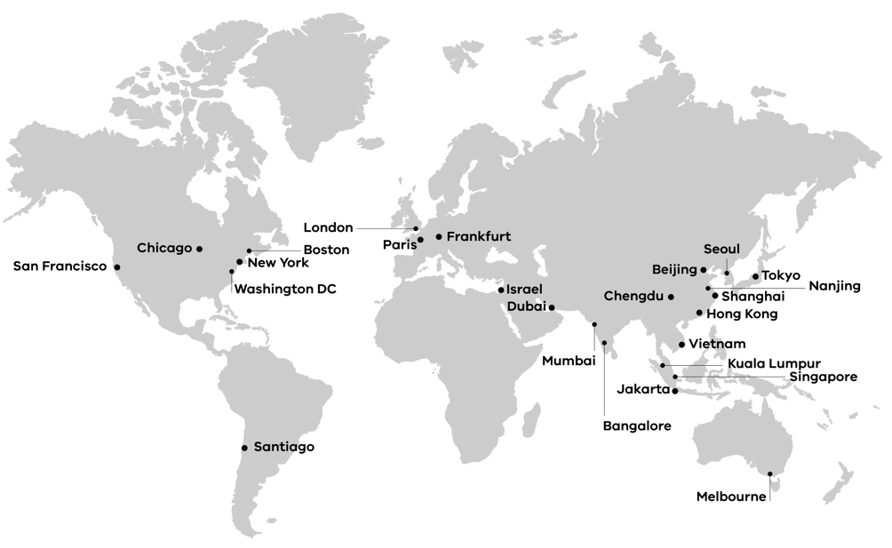

**End of document.**