Victoria’s Investment Prospectus: Zero Emissions Vehicles

## Victoria, one of the world’s most exciting energy markets

Table of Contents

Acknowledgements 2

Why invest in Victoria’s Zero Emissions Vehicle (ZEV) sector? 5

Government policy and funding is accelerating the uptake of ZEVs 7

Investing in a Future Made in Australia 9

An ideal location for your next Asia Pacific battery and ZEV manufacturing facility 11

Strong supply chain capability and skills for manufacturing ZEVs 14

Access to Victoria’s world-class renewable energy talent 17

A ZEV industry on the move 19

Key Victorian Government entities 21

For international investors 24

# Acknowledgements

**Acknowledgement of Country**

We acknowledge and respect Victorian Traditional Owners as the original custodians of Victoria’s land and waters, their unique ability to care for Country and deep spiritual connection to it.

We honour Elders past and present whose knowledge and wisdom have ensured the continuation of culture and traditional practices.

We are committed to genuinely partner, and meaningfully engage, with Victoria’s Traditional Owners and Aboriginal communities to support the protection of Country, the maintenance of spiritual and cultural practices and their broader aspirations in the 21st century and beyond.

© The State of Victoria Department of Energy, Environment and Climate Action, September 2024

**Creative Commons**

This work is licensed under a Creative Commons Attribution 4.0 International licence, visit the [Creative Commons website](http://creativecommons.org/licenses/by/4.0) (<http://creativecommons.org/licenses/by/4.0/>).

You are free to re-use the work under that licence, on the condition that you credit the State of Victoria as author. The licence does not apply to any images, photographs or branding, including the Victorian Coat of Arms, and the Victorian Government and Department logos.

ISBN 978-1-76136-595-9 (pdf/online/MS word)

**Disclaimer**

This publication may be of assistance to you but the State of Victoria and its employees do not guarantee that the publication is without flaw of any kind or is wholly appropriate for your particular purposes and therefore disclaims all liability for any error, loss or other consequence which may arise from you relying on any information in this publication.

**Accessibility**

To receive this document in an alternative format, phone the Customer Service Centre on 136 186, email customer.service@delwp.vic.gov.au, or contact [National Relay Service](http://www.accesshub.gov.au/) ([www.accesshub.gov.au](http://www.accesshub.gov.au/)) on 133 677. Available at [DEECA website](https://www.deeca.vic.gov.au/) ([www.deeca.vic.gov.au](https://www.deeca.vic.gov.au/)).

#### Traditional Owners at the centre of decision-making processes

Strong and mutually beneficial partnerships with Traditional Owners and First Peoples are imperative to the electricity transition’s success and integral to ensuring the goals and objectives of self-determination set out in the Victorian Government’s Self Determination Reform Framework and the Department of Energy, Environment and Climate Action’s (DEECA) Pupangarli Marnmarnepu ‘Owning Our Future’ Aboriginal Self-Determination Reform Strategy 2020–2025.

We will be continually guided by Traditional Owner and First Peoples’ communities – now and in the future – who have expressed a strong interest in investing in renewable energy to deliver their interests and their desire to own and manage renewable energy generation and storage technology and infrastructure to meet their communities’ cultural, spiritual and economic needs.

As part of a once-in-a-generation renewable electricity transition and transformation, there is an obligation for industry and government to create genuine partnerships with Traditional Owners and First Peoples, to ensure that their self-determining rights and interests are upheld. This will be the catalyst for historical change and reform that will see immediate and future flow-on effects. It will have a positive impact on the environment and advance the social and economic outcomes for Traditional Owners and First Peoples and all Victorians.

50% of all light vehicles sold in Victoria from 2030 to be Zero Emissions Vehicles.

# Why invest in Victoria’s Zero Emissions Vehicle (ZEV) sector?

#### Government initiatives driving demand

The Victorian Government has set strong ZEV targets – by 2030, we are aiming for half of all light vehicle sales in Victoria to be zero emissions vehicles.

#### Demand for zero emissions buses

There are 4,500 diesel buses in the Victorian fleet that are in the process of being replaced.

#### Leadership in hydrogen for transport

With several hydrogen refuelling stations built or in the pipeline and trials occurring across multiple vehicle types (e.g. buses, waste trucks and freight vehicles), there are significant opportunities for further investment in renewable hydrogen for heavy and long haul transport.

#### ZEV manufacturing

Access the skilled workforce, existing supply chains and critical minerals required to manufacture batteries and ZEVs at scale.

#### Integrating ZEVs into the grid

Strong demand exists for grid integration technologies, with up to 115,000 public electric vehicle chargers likely to be needed by 2035. (Indicative estimates based on internal forecasts and modelling conducted by Accenture (2023) for the Department of Energy, Environment and Climate Action and are subject to change.)

#### World-class research and development

Partner with Victorian universities that are pioneering world-leading research and development.

# Government policy and funding is accelerating the uptake of ZEVs

The Victorian Government released the Zero Emissions Vehicle Roadmap in 2021 to support Victoria’s transport sector to become   
ZEV-ready. We are working with the Australian Government and other jurisdictions to implement the National Electric Vehicle Strategy to further reduce barriers to electric vehicle uptake and improve charging infrastructure.

The transition to ZEVs will play a critical role in achieving Victoria’s target of economy-wide net zero emissions by 2045. Key Victorian Government policies and initiatives to support this transition include:

* $30 million for Australia’s first public ZEV subsidy program (now closed)
* $19 million to accelerate the roll-out of electric vehicle (EV) charging infrastructure across regional Victoria and support the charging of EV fleets
* $20 million for a ZEV public transport bus trial – and a target for all public transport bus purchases to be ZEVs from 2025
* $10 million to replace 400 vehicles in the Victorian Government Fleet with ZEVs
* $5 million to establish a Commercial Sector Zero Emissions Vehicle Innovation Fund.

#### Investment Opportunity

The Victorian market provides significant opportunities for investment across many aspects of the ZEV supply chain, including:

* component manufacturing
* vehicle, truck and bus manufacturing
* battery supply chain and recycling
* charging infrastructure.

#### Zero Emissions Vehicle Roadmap

Victoria’s first Zero Emissions Vehicle Roadmap was focused on actions that will be taken in this decade to address key barriers to the uptake of ZEV technologies while also leveraging the opportunities associated with this major technology transition.

For more information visit: [energy.vic.gov.au/renewable-energy/zero-emission-vehicles](http://energy.vic.gov.au/renewable-energy/zero-emission-vehicles)

In the first half of 2023, ZEVs made up 8.4% of all light vehicle sales, more than double the 2022 level of 4%.

# Investing in a Future Made in Australia

The Australian Government is investing $22.7 billion to transform the nation into a renewable energy superpower. As the country’s leading manufacturing state, Victoria can be central to these ambitions.

Future Made in Australia has been designed to maximise the economic and industrial benefits of the net zero transition. It is focused on facilitating private sector investment and building a stronger, more diversified and more resilient economy powered by renewable energy.

The Victorian Government can connect you with the Australian Government’s specialist investment vehicles, including the:

* **Clean Energy Finance Corporation:** Australia’s ‘Green Bank’, with access to $30.5 billion in investment capital from the Australian Government
* **Australian Renewable Energy Agency:** Provides financial assistance for research, development, demonstration, commercialisation and deployment of renewable energy technologies.
* **National Reconstruction Fund:** A $15 billion national investment fund designed to diversify and transform Australia's industry and economy.
* **Net Zero Economy Authority:** $399 million to establish the Net Zero Economy Authority and support the economy wide net zero transformation.

#### Key initiatives include:

* **$7 billion** production tax incentive for the processing and refining of critical minerals
* **$6.7 billion** production tax incentive for renewable hydrogen
* **$2 billion** for early-mover renewable hydrogen projects as part of the Hydrogen Headstart program (bringing total investment to $4 billion)
* **$1.7 billion** to promote net zero innovation, including for green metals and low-carbon fuels
* **$1.5 billion** to strengthen battery and solar panel supply chains through production incentives
* **$134 million** to fast-track approval processes for renewable energy projects.

#### Further information

For more information, visit: [treasury.gov.au/publication/p2024-526942](https://treasury.gov.au/publication/p2024-526942)

#### Case study: Zero Emissions Bus Trial

The $20 million Zero Emissions Bus (ZEB) Trial is currently underway across Victoria. There are 6 bus operators undertaking 7 trials, 6 using battery electric technology and one using hydrogen fuel cells.

The trial was launched in April 2022, with the first 50 buses on the road in August 2024.

From 2025, all new buses in Victoria need to be zero emissions. This is creating a steady demand for new ZEBs as operators transition their fleets. In total, there are 4,500 diesel buses that need to be replaced.

# An ideal location for your next Asia Pacific battery and ZEV manufacturing facility

Our advanced manufacturing capability, skilled workforce, world-leading battery research and access to Australia's rich source of critical minerals make Victoria the ideal place to establish your battery and ZEV manufacturing operations.

Figure 1: Forecast demand for energy storage and electric vehicles in Australia's National Electricity Market (GWh) (Source: AEMO ISP’s ‘Step Change’ scenario which is considered to be the most likely of the scenarios modelled by AEMO)

Australian demand for energy storage and electric vehicles is forecast to go from 73 GWh in 2025, to 1,473 GWh in 2040 and 2,562 GWh by 2050. This demand is predominantly driven by electric vehicles.

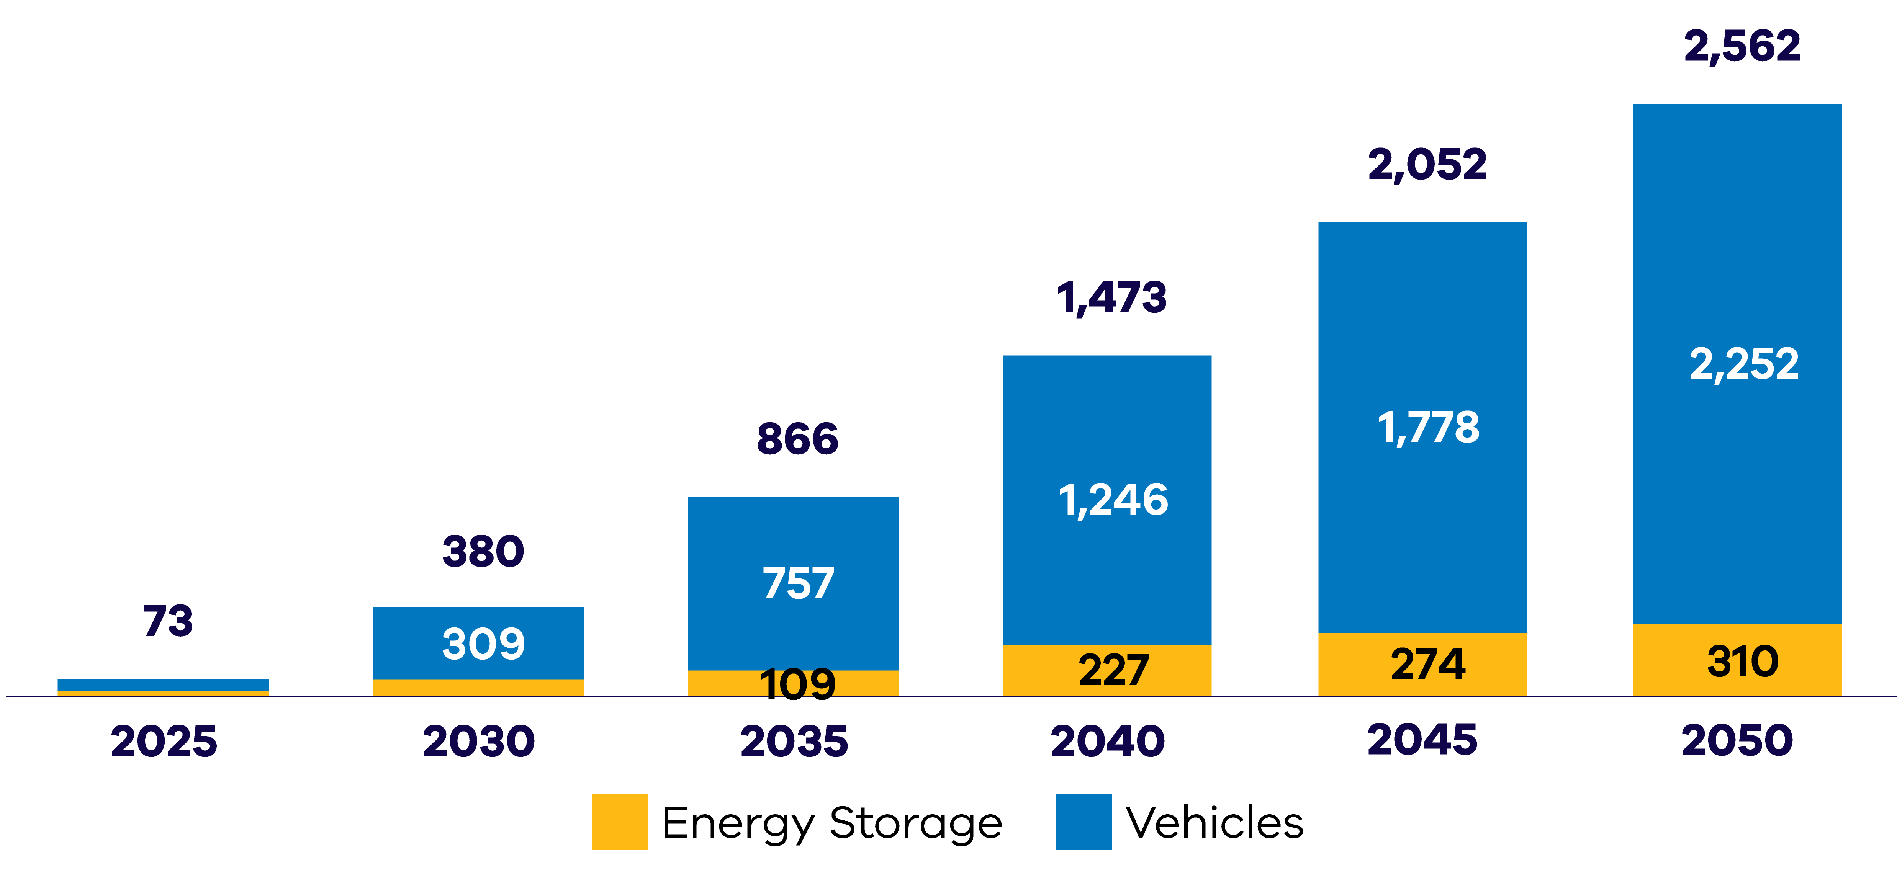

#### Security of mineral supply

* Australia is home to some of the largest recoverable critical mineral deposits on earth, including high-quality cobalt, lithium, manganese, rare-earth elements, tungsten and vanadium
* There is the option to refine critical minerals near their source or co-locate a refinery with manufacturing in Victoria
* The northwest region of Victoria hosts globally significant deposits of mineral sands, including rare-earth elements in high demand as inputs to the permanent magnets utilised in electric vehicles and wind turbines.

Victoria has:

* 22% of Australia’s ilmenite (~7% of global economically demonstrated resource)
* 51% of Australia’s rutile (~32% of global economically demonstrated resource)
* 39% of Australia’s zircon (~27% of global economically demonstrated resource).

#### Seamless logistics

* There is strong capacity to ship goods – including Australian minerals – into Victoria via the ports of Geelong or Portland
* Transfer products by train to a nearby manufacturing site
* Export products to local and international markets through the Port of Melbourne, Australia’s busiest and most connected port.

#### Existing supply chain capability and skills

* Building on a long tradition in automotive, aerospace, defence, metal, chemical and general manufacturing, Victoria continues to be the destination of choice for leading businesses
* Victoria has the highest number of manufacturing engineering skills relative to other states and can support large-scale production.

#### Renewable energy and environmental credentials

* Recycle batteries to strengthen critical mineral supply, leveraging Victoria’s existing battery recycling capability
* Decarbonise your operations with 95% renewable electricity through Victoria’s grid by 2035, Power Purchasing Agreements and the potential for green shipping using methanol.

#### Enabling speed to market

* Access specialist advice from Invest Victoria, including site location services, development, statutory approvals and intergovernmental coordination.

#### Manufacturing Opportunities

Preliminary estimates suggest Victoria could need up to:

* 3,600 utility-scale battery packs by 2035
* Around 820,000 distributed battery packs by 2035

(**Note:** Indicative estimates are based on internal forecasts and modelling conducted by Accenture (2023) for the Department of Energy, Environment and Climate Action and are subject to change.)

Initial Victorian demand for batteries creates a foundation for providing OEMs with long-term pipeline certainty.

# Strong supply chain capability and skills for manufacturing ZEVs

Companies looking to diversify or expand their ZEV manufacturing capabilities can leverage Victoria’s strong existing design, manufacturing, engineering and recycling capabilities.

#### Manufacturing opportunities

Victoria is estimated to need up to 115,000 public EV chargers by 2035. (Indicative estimates are based on internal forecasts and modelling conducted by Accenture (2023) for the Department of Energy, Environment and Climate Action and are subject to change.)

Initial Victorian demand for chargers creates a foundation for providing OEMs with long-term pipeline certainty.

##### Bosch

Bosch maintains a strong engineering presence in Australia through its research and manufacturing hub in Clayton and proving grounds in Anglesea.

###### Location

Clayton & Anglesea

###### Key Products

* Global Centre of Competence for Trailer Safety
* Automotive component engineering
* Automotive and motorsport parts
* Personalised, automated, connected, and electrified mobility solutions

##### Rectifier Technologies

Rectifier Technologies is a leading innovator in power electronics, dedicated to driving progress in electric mobility and emerging new energy solutions through high-efficiency power conversion technologies.

###### Location

Burwood

###### Key Products

* High Power Rectifier Modules
* EV Charger Modules
* Active Power Factor Correction (PFC) Rectifier Modules
* Powershelves
* Battery Chargers and Power Systems

##### Premcar

Premcar is a trusted partner of some of the world’s leading OEMs, covering the end-to-end automobile product development program from concept to production.

###### Location

Epping

###### Key Products

* Chassis system design and tuning
* Body/trim concept design and manufacturing

##### Infinitev

Infinitev is part of the IM Group, owned by GUD Holdings. It provides value-added engineering to reuse, repurpose or recycle hybrid and EV batteries to create a circular economy.

###### Location

Cranbourne West

###### Key Products

* Hybrid replacement batteries
* EV Lithium engineering services
* Stationary battery energy storage system (BESS)

##### Envirostream

Envirostream is Australia’s only EPA-permitted and licensed recycler of mixed batteries, including lithium-ion batteries. Its processes recover around 95% of the materials in a spent battery.

###### Location

Laverton North

###### Key Products

* Steel
* Copper
* Aluminium
* Mixed metal compound

# Access to Victoria’s world-class renewable energy talent

Our growing, highly-skilled workforce drives project delivery and fosters industry growth. To meet the needs of the sector, the Victorian Government has committed to significant new energy skills and workforce initiatives.

#### World-class education and training

Victoria has a globally renowned education and training system, including:

* 2 global ‘Top 50’ universities (Source: QS World University Rankings 2024 [topuniversities.com/world-university-rankings?page=2](http://topuniversities.com/world-university-rankings?page=2))
* 4 dual-sector universities (offering both tertiary and vocational education).
* 12 independent technical and further education (TAFE) locations under a single TAFE network.
* a diverse talent pool with strong growth across the broad range of occupations relevant to the renewable energy sector.
* the highest number of engineering managers of any Australian state or territory.

#### Government investment in skills and workforce

The Victorian Government is investing in the skills and workforce requirements needed for Victoria’s transition to a renewable energy future. Major initiatives include:

* The Victorian Energy Jobs Plan, which will set out actions to develop the workforce required to deliver our nation-leading target of 95 per cent renewable electricity generation by 2035 and drive investment confidence. The plan is due to be released in early 2025.
* Establishing the SEC Centre of Training Excellence to attract and train a skilled renewable energy workforce, working with industry to ensure Victoria has the workers required to support the energy transition.
* The Wind Worker Training Centre and Renewable Hydrogen Worker Training Centres are funded initiatives to ensure Victoria has a pipeline of skilled workers to meet workforce needs and deliver the wind and renewable hydrogen projects now and in the future.

# A ZEV industry on the move

#### Case study: Chargefox Network

The Victorian Government provided $3 million to Chargefox to support the rollout of 7 electric vehicle charging stations across the state. The charging stations include 4 ultra-rapid chargers (350 kW) and 2 fast chargers (50 kW). there are 6 regional sites that each have 2 ultra-rapid and 2 fast charging stations. These charging stations were some of the first in the Chargefox network which is now the largest in Australia and features 2512 public plugs across 1598 charging stations nationwide as of May 2024.

For more information visit: [chargefox.com](http://chargefox.com/)

#### Case study: JET Charge

##### Demonstrating the Power of Electric Vehicles to Support the Grid

In a first of its kind in the world, in February 2024, when major storms in Melbourne triggered the disconnection of Loy Yang coal power station and two wind farms, 16 electric vehicles, plugged in at properties, responded within seconds, rapidly discharging short bursts of electricity into the grid to stabilise it. Those 16 vehicles were part of a fleet of 51 installed with vehicle to grid (V2G) chargers as part of the Realising Electric Vehicle-to-grid Services (REVS) project.

Melbourne-based JET Charge, Australia’s leading EV charging infrastructure company and leaders in V2G technology, coordinated the market certification for the first and only V2G charger sold in the Australian market and developed in-house the proprietary control system technology that enabled the vehicles to discharge power from EVs into the grid.

In total, the 16 vehicles provided 107 kilowatts of support to the grid. With almost 100,000 EVs sold in Australia in 2023, and that number rapidly rising, the potential of EVs to support the grid during national emergencies serves as a beacon for the potential of electric vehicles to change the way that Victorians live and move.

#### Case study: Nissan HQ and electric car centre

Nissan Australia has established its national headquarters and technical training centre in Mulgrave, in Melbourne’s southeast. The facility was developed and equipped with Nissan’s new and emerging electrified technologies in mind, providing crucial training and support to Nissan service technicians nationwide.

This builds on Nissan’s Victorian electric vehicle presence, with its sister company, Nissan Casting Australia, producing electric vehicle components for Nissan products sold worldwide.

For more information visit: [nissan.com.au](http://nissan.com.au/)

# Key Victorian Government entities

We can help facilitate connections with key Victorian Government entities and industry members across our renewable energy sector.

#### Department of Energy, Environment and Climate Action (DEECA)

DEECA works with industry and the community to develop Victoria's secure and sustainable energy future.

For information on Victoria’s energy policy landscape and facilitated connections across the Victorian Government and renewable energy sector, contact the Business and Industry Engagement team at: [BIE@deeca.vic.gov.au](mailto:BIE@deeca.vic.gov.au)

[energy.vic.gov.au](http://energy.vic.gov.au/)  
[energy.vic.gov.au/ forindustry/investment-opportunities](http://energy.vic.gov.au/%20forindustry/investment-opportunities)

#### Breakthrough Victoria

Breakthrough Victoria is an independent investment management company established in 2021 to manage the Victorian Government’s landmark $2 billion Breakthrough Victoria Fund.

Visit the website of Breakthrough Victoria at: [breakthroughvictoria.com](http://breakthroughvictoria.com/)

#### Invest Victoria

Invest Victoria is the Victorian Government’s investment attraction agency. Services include:

* market regulatory information
* statutory approvals coordination
* site location services
* identification of infrastructure and utility requirements
* advocacy within government.

Visit the website of Invest Victoria at: [invest.vic.gov.au](http://invest.vic.gov.au/)

#### Offshore Wind Energy Victoria

Offshore Wind Energy Victoria (OWEV) was established as the single point of entry for industry and community engagement on offshore wind.

Visit the website of Offshore Wind Energy Victoria at:   
[energy.vic.gov.au/renewable-energy/offshore- wind-energy](http://energy.vic.gov.au/renewable-energy/offshore-%20wind-energy)

#### SEC

The SEC is a Victorian Government-owned renewable energy company. It is partnering with the private sector to deliver 4.5 GW of new renewable energy and storage projects with an initial investment of $1 billion.

Visit the SEC website at: [vic.gov.au/state-electricity-commission-Victoria](http://vic.gov.au/state-electricity-commission-Victoria)

#### Solar Victoria

Solar Victoria is responsible for the delivery of the Victorian Government’s $1.3 billion Solar Homes Program – one of the most ambitious and transformative renewable energy programs in Australia.

Visit the Solar Victoria website at: [solar.vic.gov.au](http://solar.vic.gov.au/)

#### Sustainability Victoria

Sustainability Victoria empowers Victorians to live sustainably by taking action on climate change and using our precious resources wisely – to deliver a sustainable future for us all.

Visit the Sustainability Victoria website at: [sustainability.vic.gov.au](http://sustainability.vic.gov.au/)

#### VicGrid

VicGrid coordinates the planning and development of Victorian Renewable Energy Zones (REZs). It also oversees the $540 million REZ fund that will be used to strengthen the grid and develop each REZ.

Visit the VicGrid website at: [energy.vic.gov.au/renewable- energy/renewable-energy-zones](http://energy.vic.gov.au/renewable-%20energy/renewable-energy-zones)

# For international investors

Contact a local Victorian Government Trade and Investment Office to help you:

* navigate investment opportunities in Victoria’s new energy technology sector
* set up a briefing with energy specialists
* arrange inbound market visits
* introduce you to the Victorian Government’s Energy Business and Industry Engagement team and Invest Victoria.

For more information, visit: [global.vic.gov.au/meet-our-global-team/all-office-locations](http://global.vic.gov.au/meet-our-global-team/all-office-locations)

Figure 3: Victorian Government Trade and Investment office locations

* Melbourne, Australia
* Kuala Lumpur
* Jakarta
* Singapore
* Vietnam
* Tokyo
* Seoul
* Bengaluru
* Mumbai
* Shanghai
* Nanjing
* Chengdu
* Beijing
* Hong Kong
* London
* Paris
* Frankfurt
* Dubai
* Tel Aviv
* New York
* Washington DC
* Boston
* San Francisco

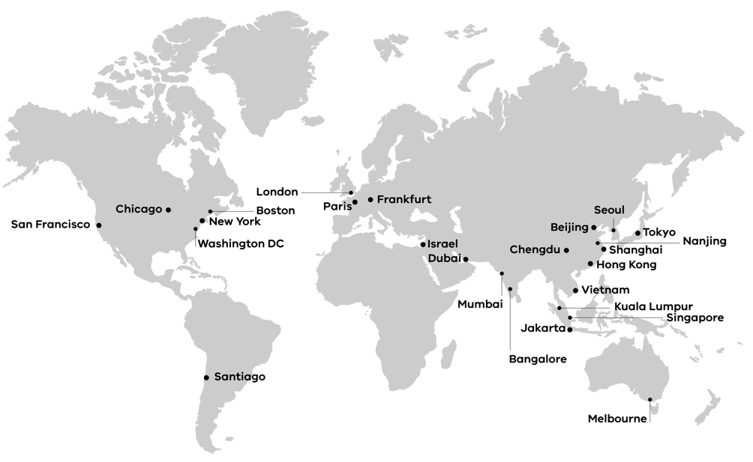

**End of document.**