# Save money and the environment with your new all electric home

New all-electric homes are cheaper to heat, cool and run – and can save households approximately $1,820 per year on their energy bills when combined with solar panels.

New all-electric homes don’t need two separate systems for heating and cooling – instead using one, efficient system.

New all-electric homes can use highly efficient heat pumps for their hot water, which are cheaper to run and can be timed to soak up solar power. And they can also use modern, induction cooktops – which are safer, faster and easier to clean than gas cooktops.

New all-electric homes don’t need to cost any more upfront than new homes connected to mains gas and mains electricity, and can often cost less.

This is why the Victorian Government, as part of its Gas Substitution Roadmap, has chosen to phase out gas connections to new homes – to ensure Victorians can benefit from low cost, healthy and comfortable new homes.

Building a new home is also the best time to consider higher energy efficiency for the building. Building to 7 Stars and above will further reduce heating and cooling energy use and save even more money on energy bills and emissions.

Victorian households are able to take advantage of rebates and interest free loans available through the Solar Homes Program to reduce the cost of installing solar on their new home. Victorians can start saving from the day they move in and can further increase their savings by consuming the energy generated by their system each day.

The Gas Substitution Roadmap is helping our State navigate the path to net zero emissions while cutting energy bills.

## Example: Costs of a new all-electric home (with multi-split heating/cooling) vs a new dual-fuel home

### All-electric:

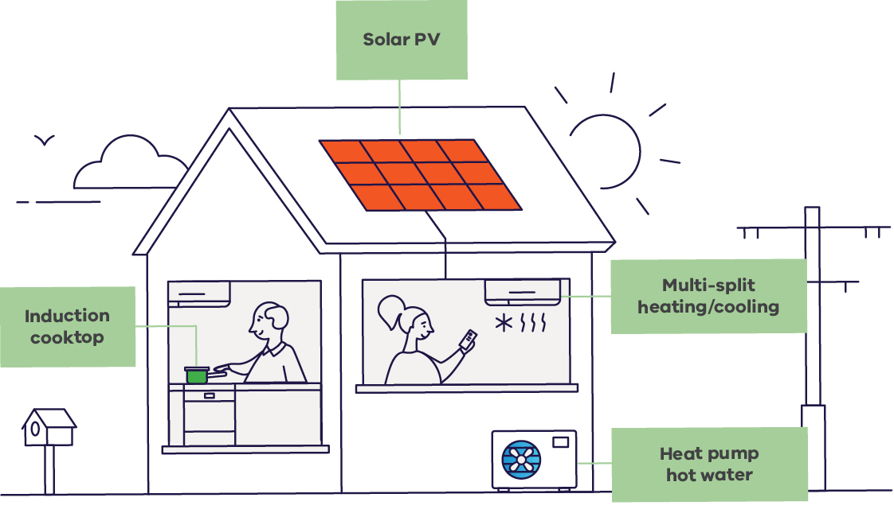

|  |  |
| --- | --- |
| **Appliance and install costs** | |
| Heating and cooling | $11.6k |
| Hot water | $4.2k |
| Cooktop | $2.3k |
| Additional wiring | $0.9k |
| **Total (appliance + installation)** | **$19k** |

|  |  |
| --- | --- |
| **Bill savings (Average annual savings, 2024 dollars)** | |
| Heating and cooling | $370 saving |
| Hot water | $160 saving |
| Cooktop (inc. fixed charge) | $350 saving |
| **Total savings** | **$880 saving** |
| **Annual energy bill** | **$2,070** |

|  |  |
| --- | --- |
| **Solar** | |
| Solar installation cost (6.6 kW) | $3,860**  **Solar installation cost includes small-scale technology certificates (STCs) and Solar Homes rebate |
| Solar saving | $940 saving |
| **Annual energy bill (with solar)** | **$1,130** |

### Dual-fuel:

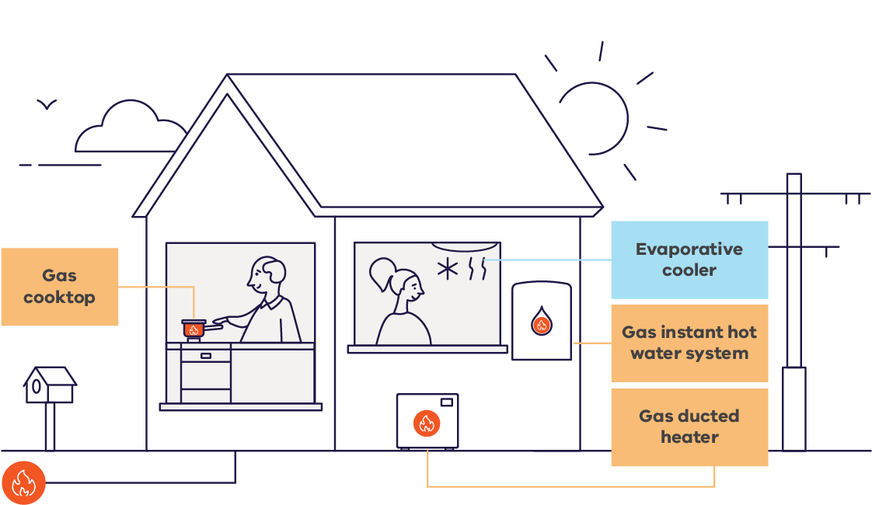

|  |  |
| --- | --- |
| **Appliance and install costs** | |
| Cooling / Heating | $11.4k |
| Hot water | $2.7k |
| Cooktop | $1.9k |
| Gas pipework installation cost | $1.3k to $5k |
| **Total (appliance + installation)** | **$17.3k to $21k** |

|  |  |
| --- | --- |
| **Bill costs** | |
| Electricity bill | $1,520 |
| Gas bill | $1,430 |
| **Annual energy bill** | **$2,950** |

For more information, visit the following: www.energy.vic.gov.au/renewable-energy/victorias-gas-substitution-roadmap

# Publication information

## Acknowledgement of Traditional Owners

We acknowledge Victorian Traditional Owners and their Elders past and present as the original custodians of Victoria’s land and waters and commit to genuinely partnering with them and Victoria’s Aboriginal community to progress their aspirations.

## Copyright

© The State of Victoria Department of Energy, Environment and Climate Action,   
December 2024.

**ISBN** 978-1-76176-036-5 **(pdf/online/MS word)**

**ISBN** 978-1-76176-037-2 **(Print)**

## Disclaimer

This publication may be of assistance to you but the State of Victoria and its employees do not guarantee that the publication is without flaw of any kind or is wholly appropriate for your particular purposes and therefore disclaims all liability for any error, loss or other consequence which may arise from you relying on any information in this publication.

## Accessibility

To receive this document in an alternative format, phone the Customer Service Centre on 136 186, email customer.service@delwp.vic.gov.au, or contact National Relay Service on 133 677. Available at DEECA website (www.deeca.vic.gov.au).

**End of document.**