Supporting Material: Neighbourhood Batteries Online Training Videos
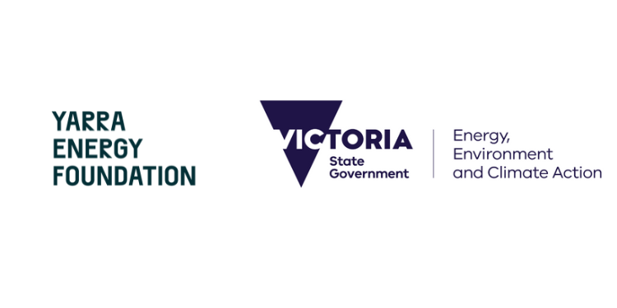
Welcome!

The Victorian Government's Department of Energy, Environment and Climate Action (DEECA) engaged the Yarra Energy Foundation (YEF) to develop training videos on neighbourhood batteries.
This supporting material has been designed to complement these videos and assist with your understanding of:
- Key concepts, such as the duck curve and the low voltage network,
- The context of energy storage in the NEM and in Victoria, with some case studies, and
- The electricity grid and its markets.
You can jump from one section to another by clicking on the bottom right icon of this page.

Some electricity fundamentals
What are current, voltage, power, and energy?
Both current and voltage are fundamental aspects of electricity. To explain, it can be helpful to imagine electricity as the flow of water through a pipe.
Current is the flow of electrical charge in the form of electrons, measured in Amperes (A) or Amps. The amount of current is the amount of electrical charge flowing, for instance, along a wire or into a battery. Think of this as the diameter of the pipe, defining how much water is flowing at a given time.
Voltage is a bit like pressure, and is measured in Volts (V). Just as water will follow the path of least resistance, so will electricity, generally flowing from high voltage to low voltage. More water will flow through a pipe at high pressure; similarly, the higher the voltage, the greater the flow of electricity.
Power is the product of current and voltage (i.e., current x voltage), defined as the rate at which energy moves from one place to another, measured in Watts (W). Low current flowing at high voltage would be equivalent in power to high current flowing at low voltage if it resulted in the same amount of energy being transferred. Power is like the flow rate of water - how much water is flowing out of a pipe in any particular instant - and defines how much 'work' can be done by the electricity in that instant.
Energy is a quantity. If electricity were to flow along a wire and into a battery for several minutes (like water flowing out of a pipe and into a tank), the battery would contain a certain amount of energy. Electrical energy is simply a particular form of energy, hence electricity can be converted to or stored as various other forms of energy - for example, heat energy (e.g., think of the heat produced by a computer), kinetic energy (e.g., the movement of a fan's blades), or electrochemical energy (as in batteries).
To put it all together, think of a kettle. A typical kettle has a power draw of about 2 kilowatts, or 2000 Watts. Households are supplied power at ~230-240 volts. The current would therefore be 2000/240 (power divided by voltage), which is just over 8 Amps.
Imagine it is a very large kettle, and it takes one hour to boil water. The energy consumed to boil the kettle can be calculated as power multiplied by time: 2kW x 1hr; or, 2 kilowatt-hours (kWh).
What is the difference between kW and kWh?
The kilo-watt (kW) is a unit of power describing the rate at which energy is being used or produced. Power is the speed at which energy is converted from one form to another or moved from one place to another. For instance, if a neighbourhood battery has a capacity of 100kW, it will be able to charge or discharge energy at up to 100kW.
The kilowatt-hour (kWh) is a unit of energy equivalent to one kilowatt of power expended for one hour of time. This unit is typically used to measure the amount of energy consumed.
For instance, if the 100kW neighbourhood battery has an energy capacity of 200kWh, it will be able to charge or discharge energy at a rate of 100kW for up to two hours. You might hear the battery being referred as a two-hour battery.
A 50kW/200kWh battery, for example, is a four-hour battery: it will charge/discharge at a power rating of 50kW for a duration of 4 hours to store energy of 200kWh. While it will store the same amount of energy as the 100kW/200kWh battery, it has a smaller power capacity, and will take longer to charge or discharge completely.
Generally, you will find components of the electricity grid discussed in kVA (kilovolts-amps). This is because these components, such as transformers and generators, handle both real power (kW) and reactive power (kVAR). The latter is essential in maintaining the voltage levels in the system and ensuring that devices, like motors, function correctly.
However, for batteries, the reactive power is generally not relevant, and for ease of communication, kW is typically used. This is why kW and kWh are used to discuss batteries.
AC vs DC: what is it about?
Alternating Current and Direct Current are different ways in which electric current flows.
Alternating Current (AC) is electric current that changes its direction and magnitude periodically and repeatedly. AC is the form of electric power generated by power plants that use spinning turbines such as coal and gas generators. It is suitable for the transmission and distribution throughout the electricity network as it can easily be transformed to higher or lower voltages.
Direct Current (DC) is the type of electric current that flows consistently in one direction. Unlike AC, the direction of power flow does not change. Examples of DC power sources include batteries, fuel cells, solar cells and wind turbines. DC is used in most consumer electronics such as computers, phones, and LED lights. It's also used for energy storage, fast electric vehicle charging, and any long-distance high-voltage direct current (HVDC) transmission lines because it has less power loss compared to AC when transmitted over long distances (such as submarine power cables).
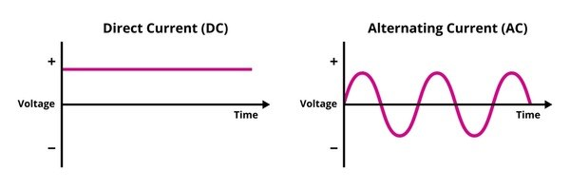
Frequency
In AC power systems, frequency refers to the number oscillations in the electrical waveform per second. In Australia, the nominal frequency of the grid is 50Hz, and the turbines in coal, gas and hydro power stations actually rotate 50 times per second.
Frequency shifts slightly according to the balance of supply and demand. This balance can change rapidly if a major generator or load (consumer) fails. A sudden change will causes a shift in frequency. If there is an oversupply of power, frequency rises and if there is undersupply, it will fall.
Frequency is a global property of the National Electricity Market (NEM) – it is essentially the same everywhere – and maintaining the frequency as close to 50Hz as possible is essential for the stability of the grid and the proper functioning of electrical hardware.
Australian Energy Market Operator (AEMO) manages frequency through a combination of regulated generator requirements, contracts for frequency services, and markets (such as the various Frequency Control Ancillary Services, or FCAS, markets). See AEMO’s explainer.
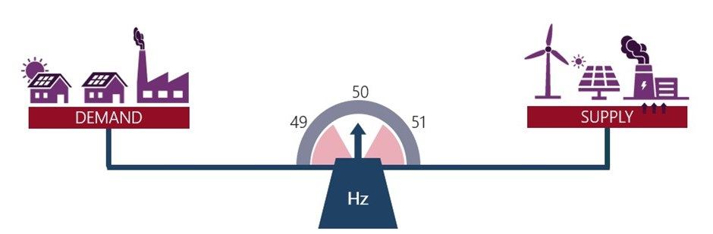
Grid inertia
Grid inertia refers to a grid's ability to maintain a consistent frequency (usually 50Hz), and it plays a key role in grid stability. Traditional power generation contributes to grid inertia through the kinetic energy of rotating turbines. These turbines provide the steady rotational inertia that helps to resist and slow down frequency changes in the event of disturbances.
Renewable energy sources, which use inverters to convert DC into AC power, do not contribute the same steady rotational inertia. While lacking in traditional inertia, inverter-based generators, such as battery energy storage systems (BESS), can provide a faster response to changes in system frequency.
As the energy landscape shifts towards renewable sources, batteries and inverters will play a key role in ensuring grid stability as fossil fuel generators shut off.

How does electricity reach you?
The Australian power network operates at various voltages, which are crucial to the efficient transmission and distribution of electricity. The key component facilitating these transitions between different voltage levels is the transformer.
Generators supply power which is transformed to high voltage (HV) for transmission at voltages between 500kV (500,000 Volts) down to 66kV. The transmission network carries electricity over long distances at high voltage to reduce losses, traveling from power plants to terminal stations.
The distribution network forms the next layer of the grid downstream of terminal stations. The distribution network encompasses several networks:
- the sub-transmission networks (66kV to 22kV to 11kV and 6.6kV),
- the high voltage distribution network (22kV to 6.6kV), and
- the low voltage (LV) distribution network (230V-240V on a single-phase, and 400V in three-phase).
Between each layer of the grid – from transmission through to the LV distribution network – transformers at terminal stations, zone substations, or distribution substations ‘step down’ the voltage, and in the case of the LV distribution network, for supply to households and most consumers. For example:
- Terminal stations 'step down' voltages from 220kV transmission lines to 66kV sub-transmission lines
- Zone substation transformers 'step down' 22kV sub-transmission to 6.6kV high voltage distribution lines; and
- Distribution substations 'step down' 6.6kV to 400V from high voltage to low voltage distribution.
The low-voltage (LV) distribution network is the final stage in the delivery of electricity. The broader LV network consists of a patchwork of small networks, each comprising a distribution transformer and usually several sets of wires that feed the surrounding neighbourhood. It is along these wires that electricity is carried over short distances to households and small businesses.
Due to the direct servicing of consumers, LV networks face fluctuating demand patterns, often intensified by distributed energy resources like solar panels.
Neighbourhood batteries can be connected directly to low-voltage networks providing services that depend on their proximity to end consumers such as households and local businesses. Neighbourhood batteries primarily serve the community members connected to that local voltage network (unless they are behind-the-meter, acting like a 'solar battery').
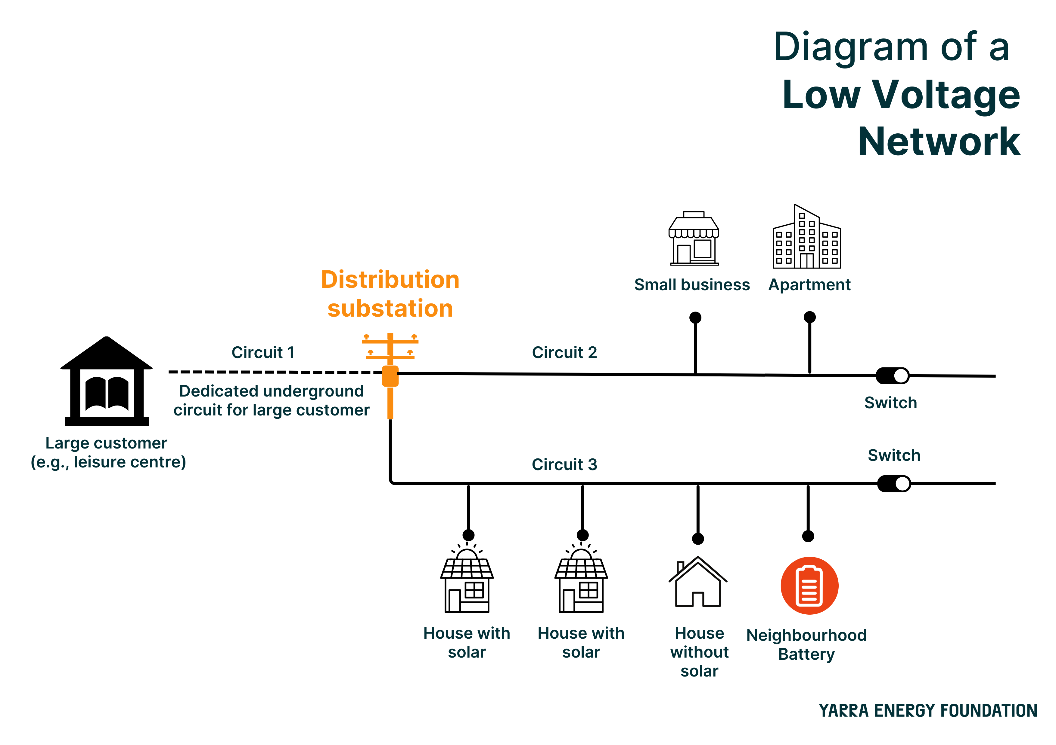
It is crucial to maintain voltage within an optimal range for the safe and efficient operation of electrical equipment. If voltage is too high, equipment can suffer damage, or even become 'fried'. Conversely, if voltage is too low, equipment may operate poorly or not at all.
Voltage levels within the electrical grid can vary throughout the day, depending on factors such as electricity demand or the amount of solar energy being fed back into the grid. It is not uncommon to see fluctuations of 10 volts over the course of a day. In Australia, the DNSP is responsible for keeping the voltage levels within 216 volts and 253 volts, the nominal voltage being 230V.
However, to manage dips in the voltage ('voltage drop’) that occurs at periods of high demand, such as the evening peak, or due to resistance over long circuits, LV network voltage settings are commonly 240V or above. This can be problematic where there is a lot of solar energy feeding back into the grid, as the voltage will rise above 240V.
This is one of the reasons why the DNSPs may implement limits or charges on solar energy exported back to the grid. These policies aim to ensure network voltages remain compliant with regulation, especially in low voltage networks where there may be numerous solar systems. This is particularly true during the off-peak times when electricity demand is at its lowest and solar energy exports are at their highest (more on this below).
Grid-connected neighbourhood batteries have the potential to regulate voltage levels in local electricity networks by lowering voltage when charging and raising it when discharging. This could help Distribution Network Service Providers (DNSPs) maintain a more stable, efficient grid close to the nominal 230V, reducing the need to curtail solar power generation.

Energy generation, transmission, and distribution
Australia has three main electricity markets:
- the National Electricity Market (NEM),
- the Northern Territory Electricity Market (NTEM) and
- the Wholesale Electricity Market (WEM) in Western Australia.
Victoria is covered by the NEM, which also includes Queensland, New South Wales, South Australia, Tasmania, and the Australian Capital Territory.
An electricity market consists of generators, transmission and distribution network service providers, retailers, and end-users. It's regulated by the Australian Energy Regulator (AER), which monitors the market, enforces regulations, and approves revenue for services. The AER’s goal is to allow access to energy at the lowest and most efficient cost.
The Australian Energy Market Operator (AEMO) is responsible for day-to-day management of the wholesale electricity and gas markets. It facilitates the buying and selling of electricity among the market participants (generators and retailers). The AEMO also ensures the stability of the electricity grid by managing the supply and demand of electricity. Rule-setting and advice to policy makers are provided by the Australian Energy Market Commission (AEMC).
Approximately 200 large and many smaller generators feed the NEM with power. These power plants use a variety of energy sources, ranging from traditional fossil fuels to renewable energies like wind and solar. The energy is then transmitted over long distances through a high-voltage transmission network managed by five state-based Transmission Network Service Providers (TNSPs). These TNSPs, using a series of transformers and interconnectors, link the power generators to the distribution networks. These distribution networks are built, maintained, and operated by Distribution network service providers (DNSPs).
The final step of energy provision involves electricity retailers. These entities purchase the wholesale electricity, manage its sale to end users, and handle customer service and billing.
Neighbourhood batteries are typically positioned within the DNSPs distribution networks. These networks operate at different voltages, which will in turn influence the selection of the battery capacity.
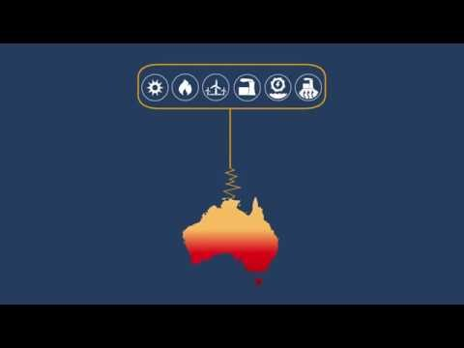
1 - AEMO and its markets

The "duck curve": what is it, and how is it impacting energy generation and supply?
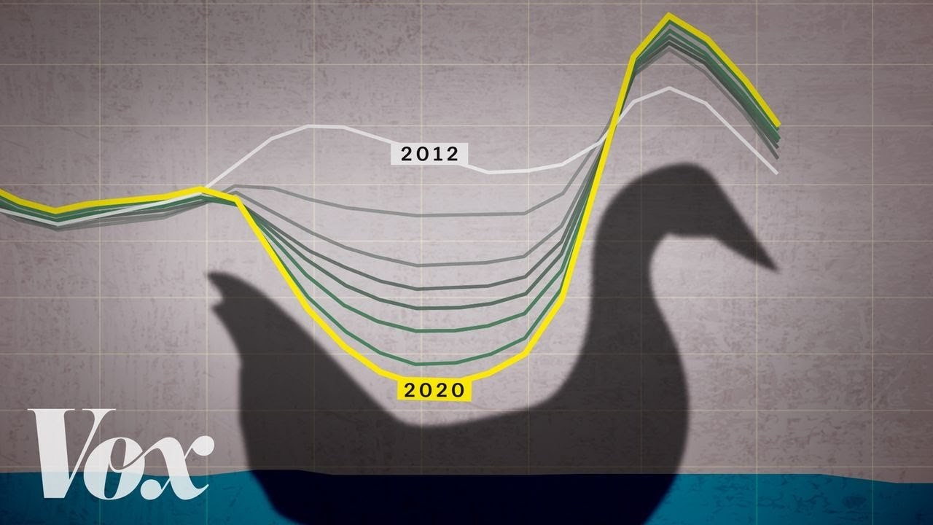
2 - The 'duck curve' is solar energy's greatest challenge - short video explainer
The duck curve shows the average demand for electricity from the grid across a day, and highlights the difference between minimum and peak demand. It is so named because the graphical representation of average demand across the day resembles the silhouette of a duck. The belly of the 'duck' dips during the day when solar production is high and demand is low, typically in the mid-afternoon. Conversely, the curve peaks in the morning and evening when demand is high and solar production is low or non-existent, as represented by the above image.
The duck curve represents a challenge for the energy system in several ways:
- To maintain system stability and safety, the energy system requires a certain level of demand at all times. The duck curve shows that minimum demand may approach unsafe levels at the system scale.
- Network infrastructure, such as distribution transformers, must be built to accommodate peak demand. However, given that peak demand is increasingly a fleeting 'spike' in otherwise low or moderate demand, network upgrades may be an inefficient investment.
- The wide disparity in demand across the day may be problematic for the energy market, potentially leading to high power prices and a slower energy transition. For example, to manage peak demand periods, we require dispatchable generation that can quickly ramp up and down to meet demand. Typically, this is provided by hydro and gas, but these are expensive and/or contribute significant greenhouse gas emissions.
By charging during the day and discharging during peak demand periods, neighbourhood batteries help to address each of these challenges. This approach not only balances supply and demand, but also helps to reduce solar curtailment, whereby rooftop solar systems are de-rated ('spilling' potential solar energy) to limit voltage rise or to ensure sufficient demand for system stability.
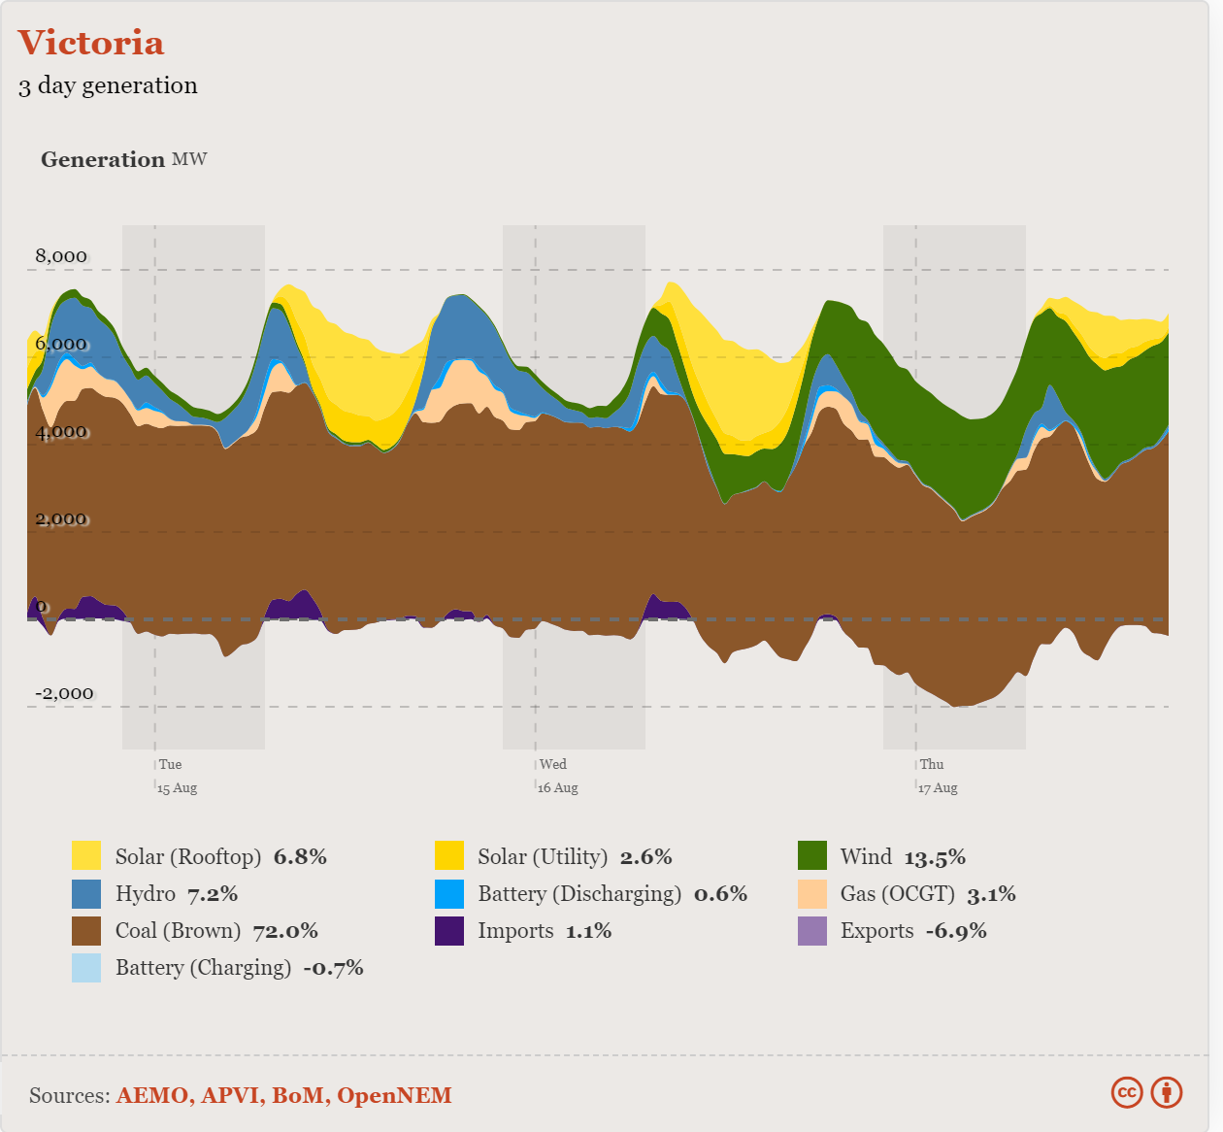
The Australian Energy Market hit two records in 2020-21:
- The total electricity generation in Australia was nearly steady at around 266 TWh (956 PJ), the highest total generation on record for Australia.
- Businesses and households generated about 17% of Australia's electricity with their on-site solar systems. This type of generation is coined 'embedded generation', or 'distributed energy resources'.
This article Rooftop solar switch-off: Why and where it's being used - and where it's headed published by Sophie Vorrath in Renew Economy (17 October 2023) provides a summary of these trends.
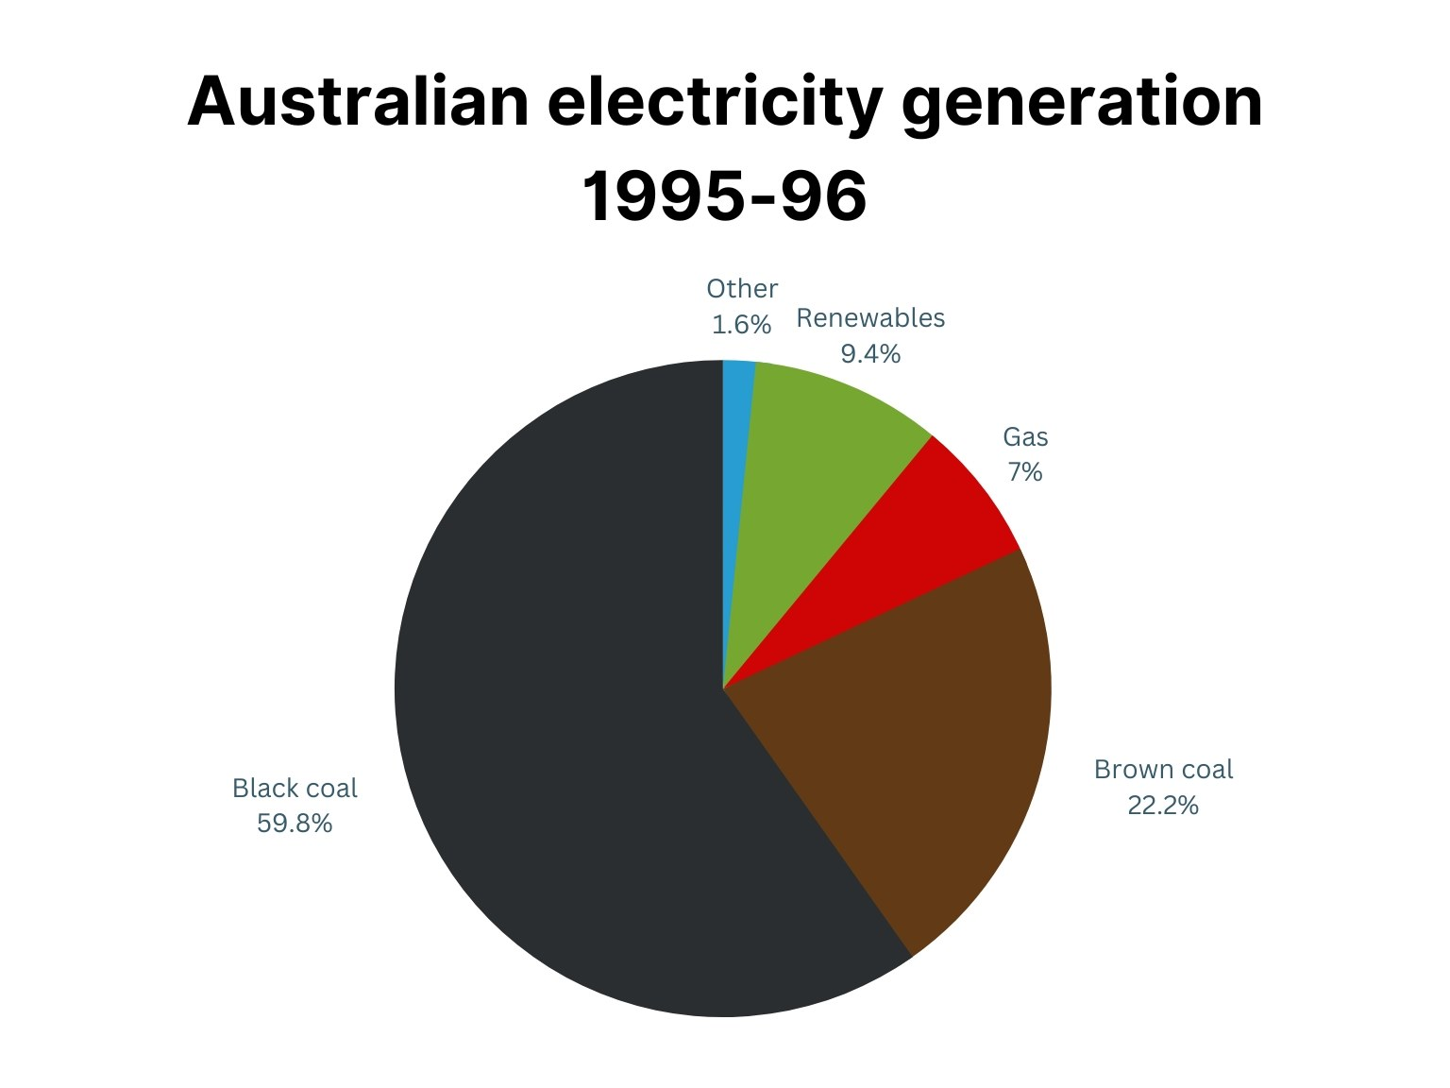
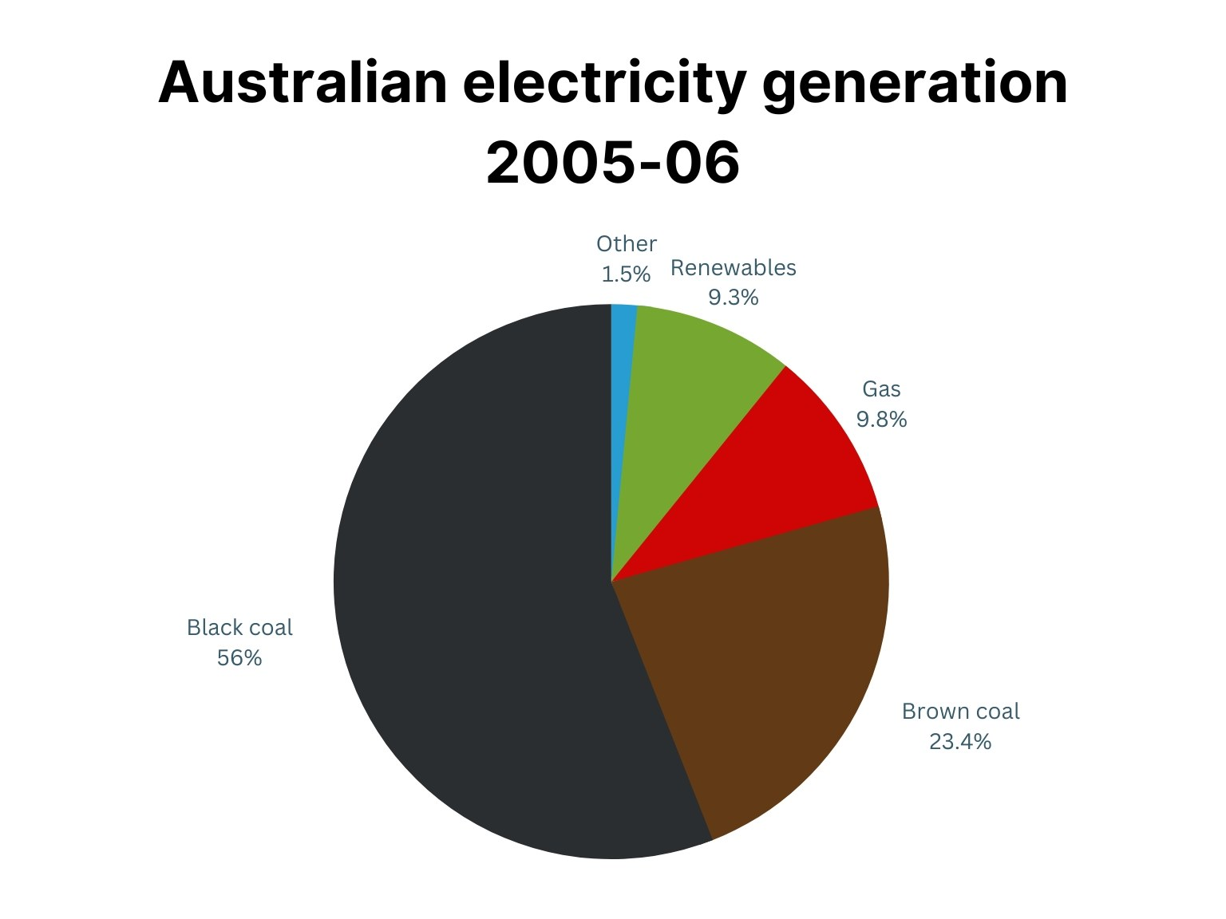
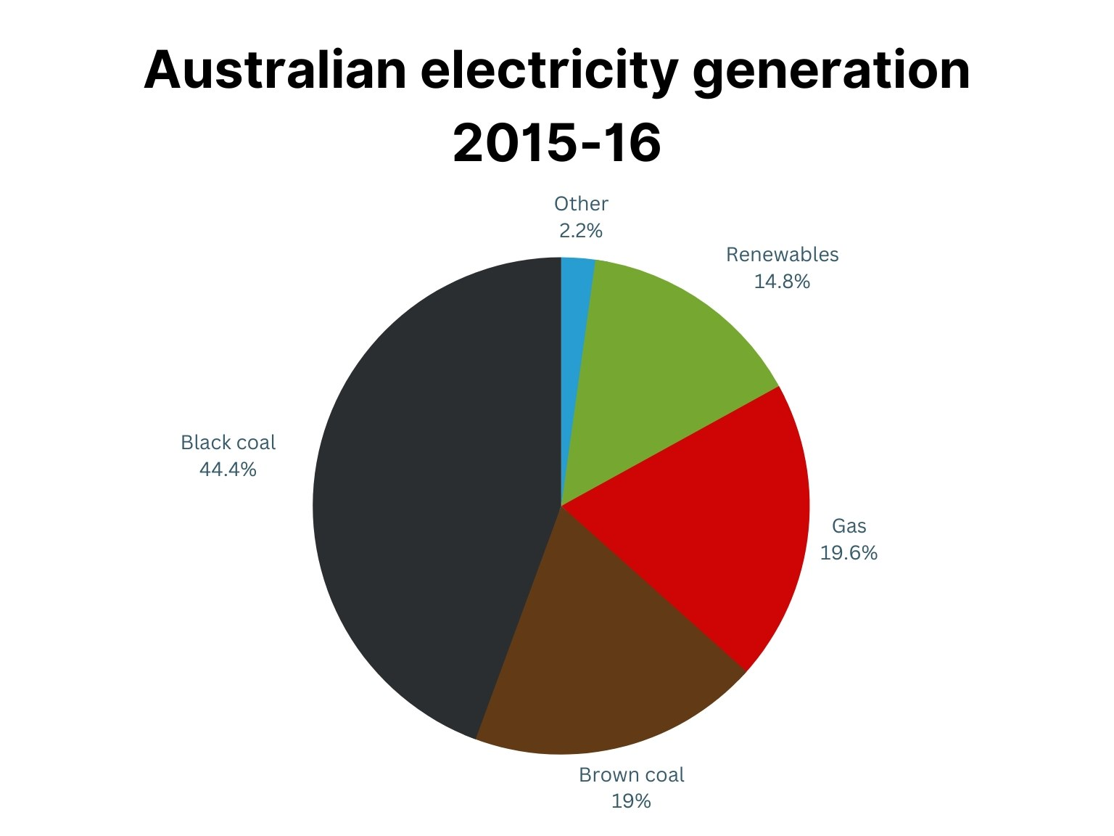
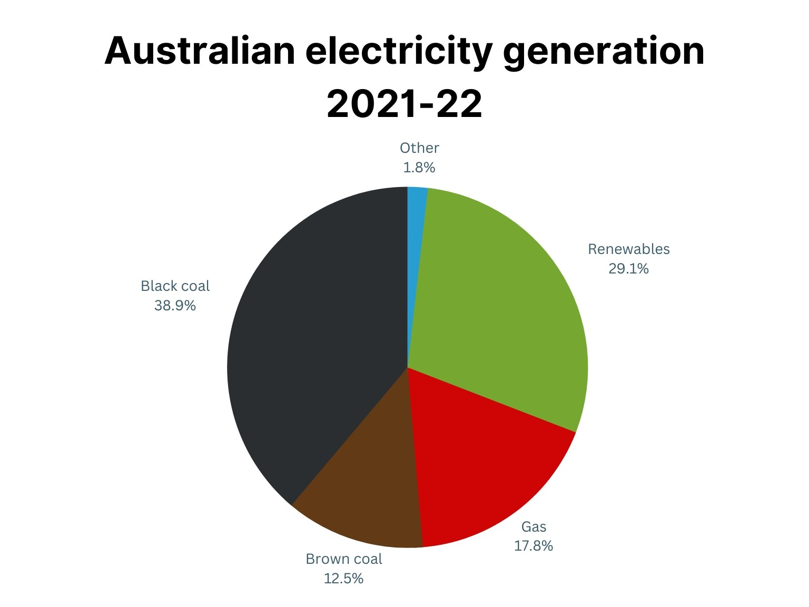

Energy storage targets and case studies
With national attention on the need for more storage, the Australian Government launched a program to roll out 400 community batteries, in line with the AEMO's forecast that 57-61GW of storage across the NEM will be required to reach net zero emissions by 2050.
In August 2021, the Department of Energy, Environment and Climate Action (DEECA) initiated a series of Victorian Neighbourhood Batteries Initiative grants aimed at exploring the role of neighbourhood batteries in the transitioning electricity system.
The first round funded feasibility studies for 16 communities and the trial implementations of two front-of-meter batteries in the suburbs of Tarneit and Fitzroy North. In late 2022, a second round funded two additional implementation projects led by the City of Melbourne and the Yarra Energy Foundation.
This development coincided with an announcement from the Victorian Government setting a target of 2.6GW of energy storage capacity by 2030.
August 2023 marked the launch of the Victorian Government’s 100NB program, which supports the installation of 100 neighbourhood batteries to enhance energy reliability and provide storage capacity for locally generated solar power.
The images below show a range of neighbourhood batteries. Click the link the text to read about them in more detail.
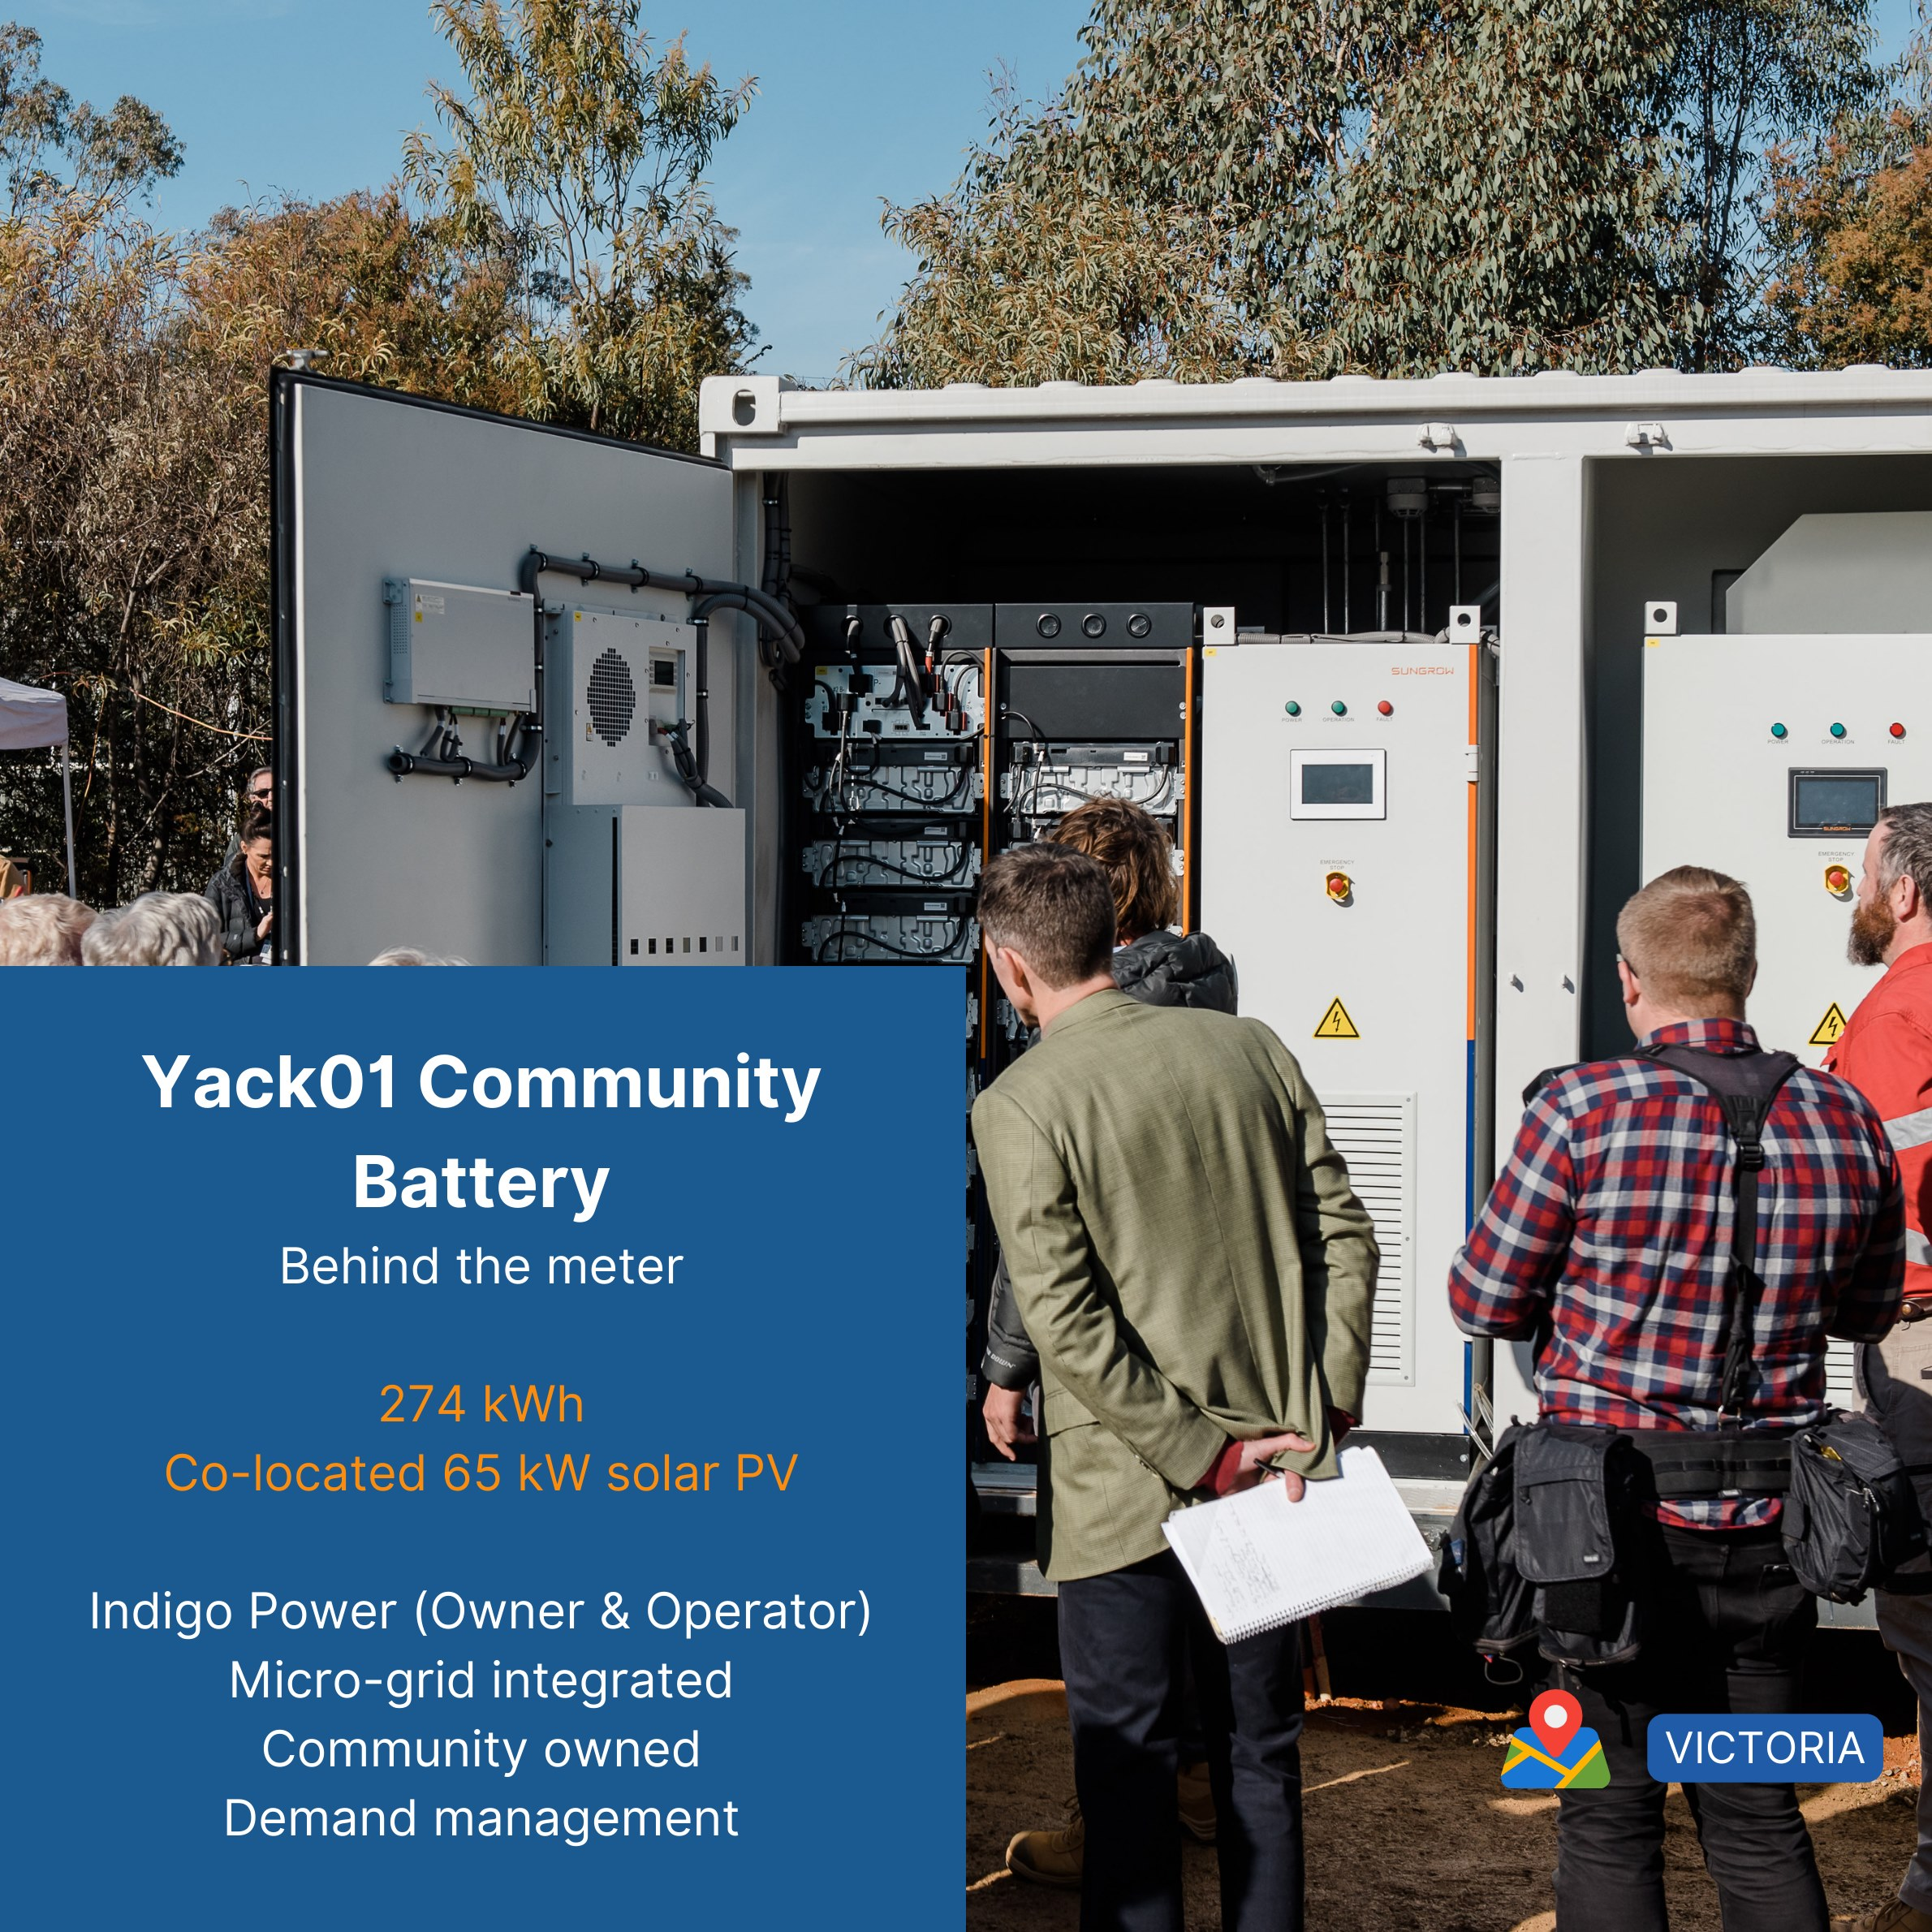
3 - Learn more
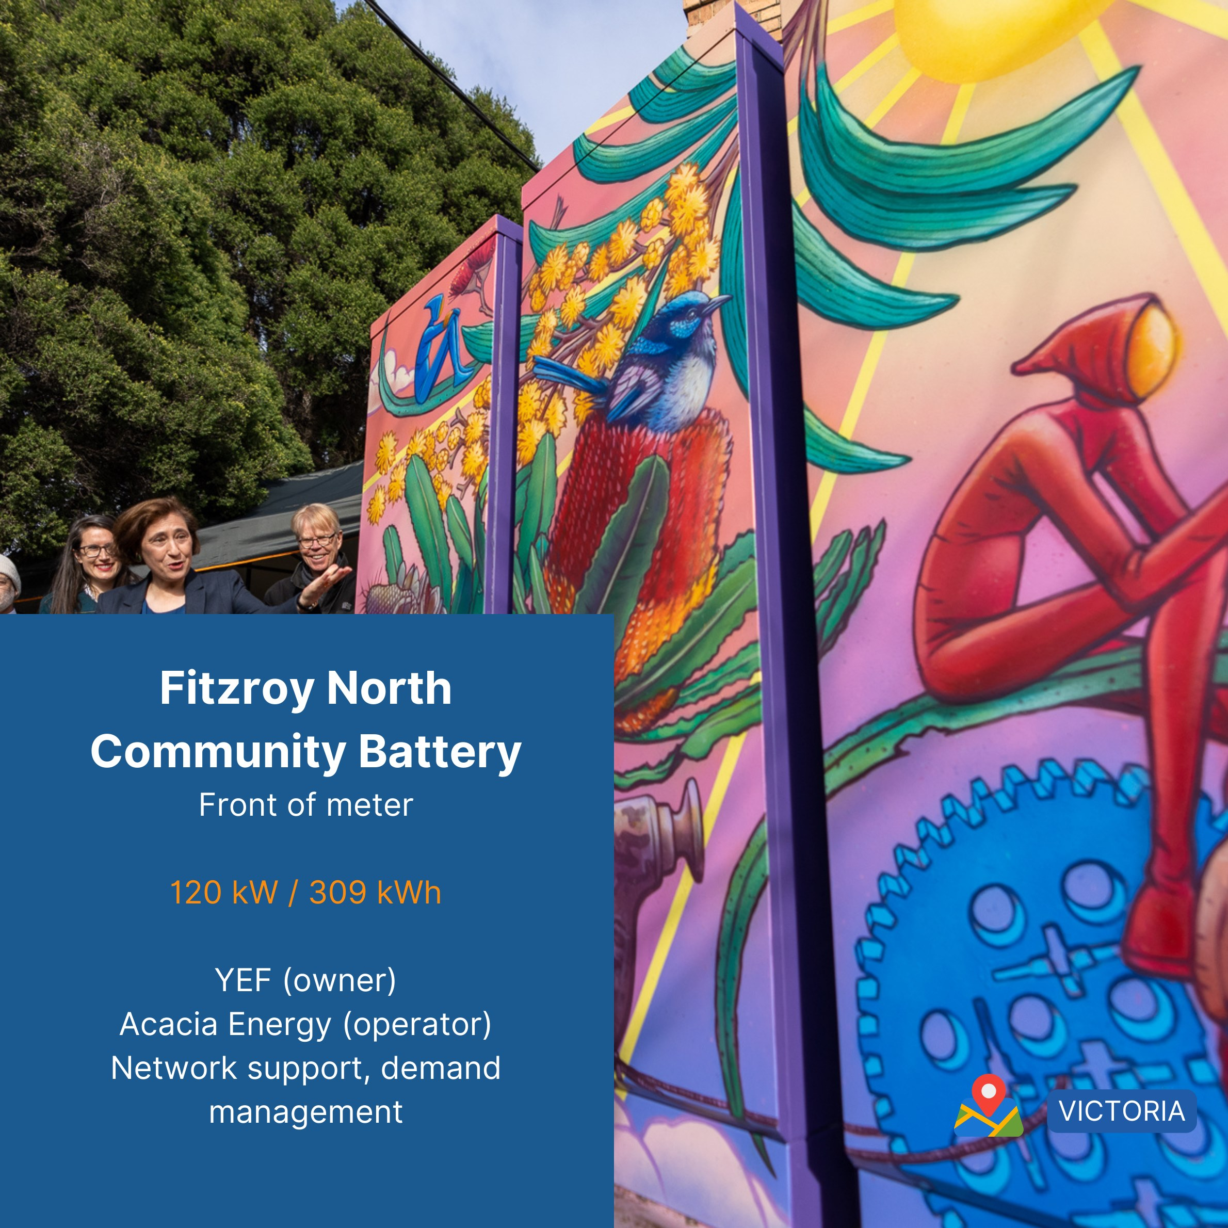
4 - Learn more
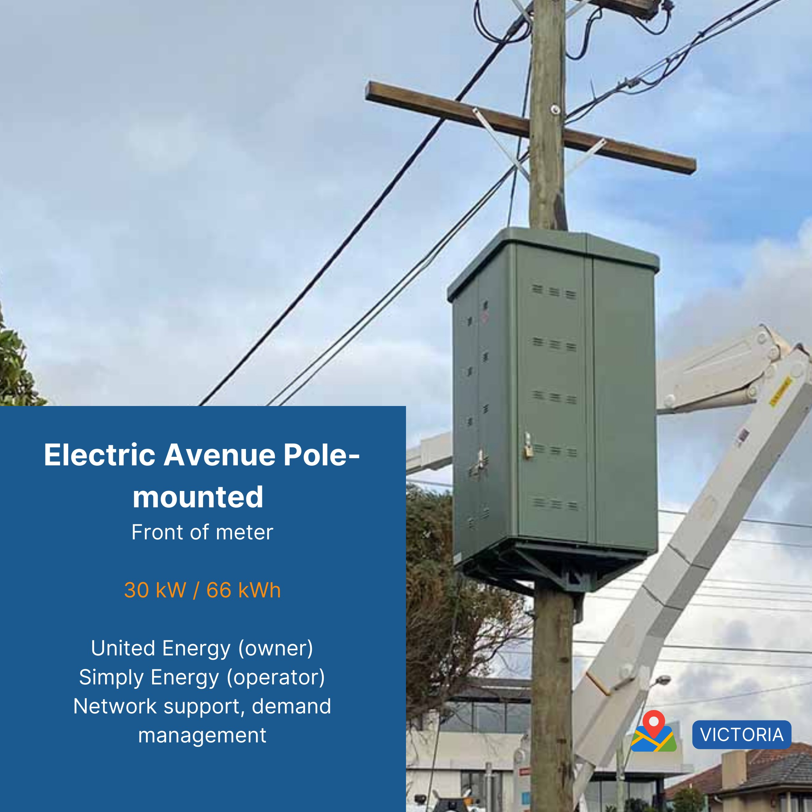
5 - Learn more
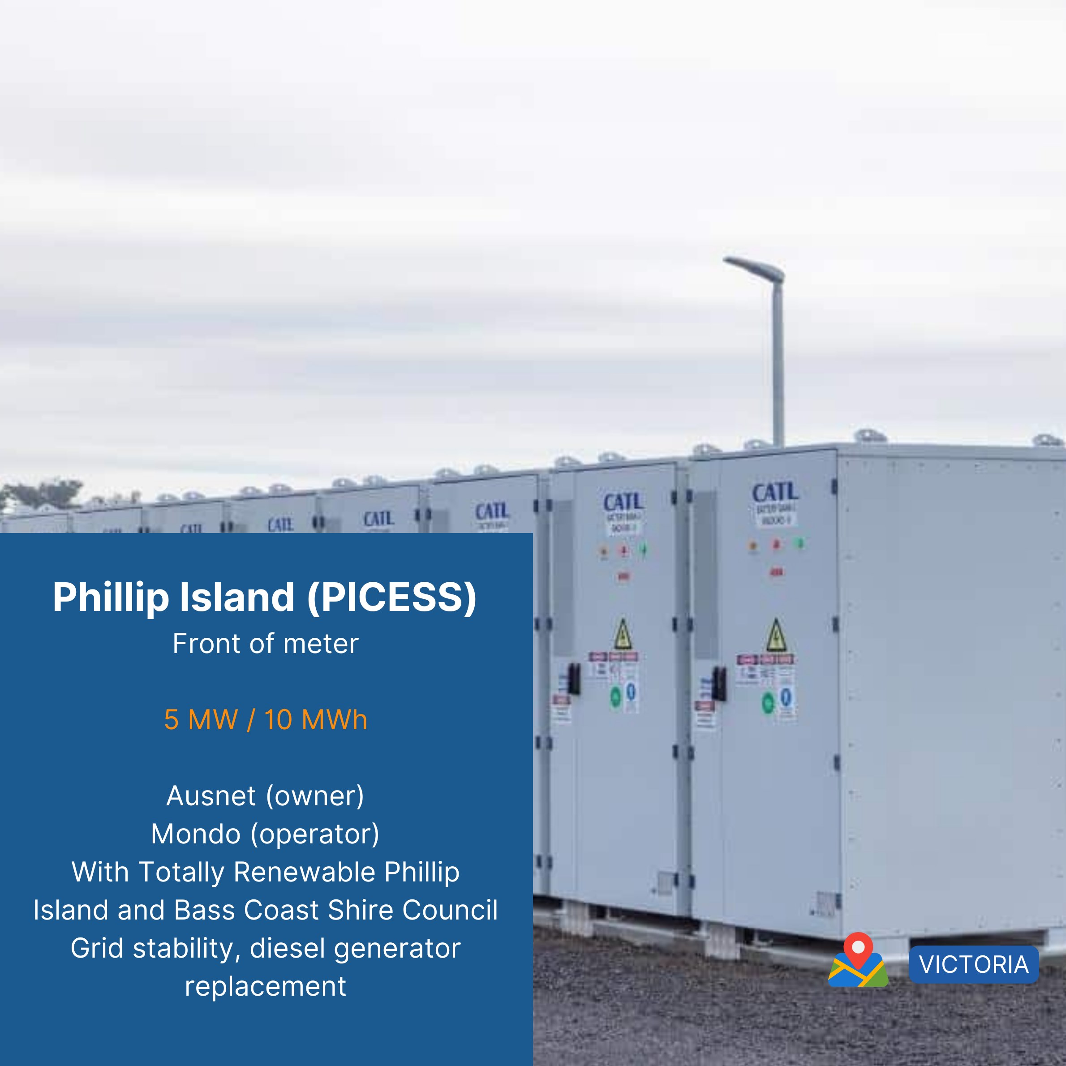
6 - Learn more
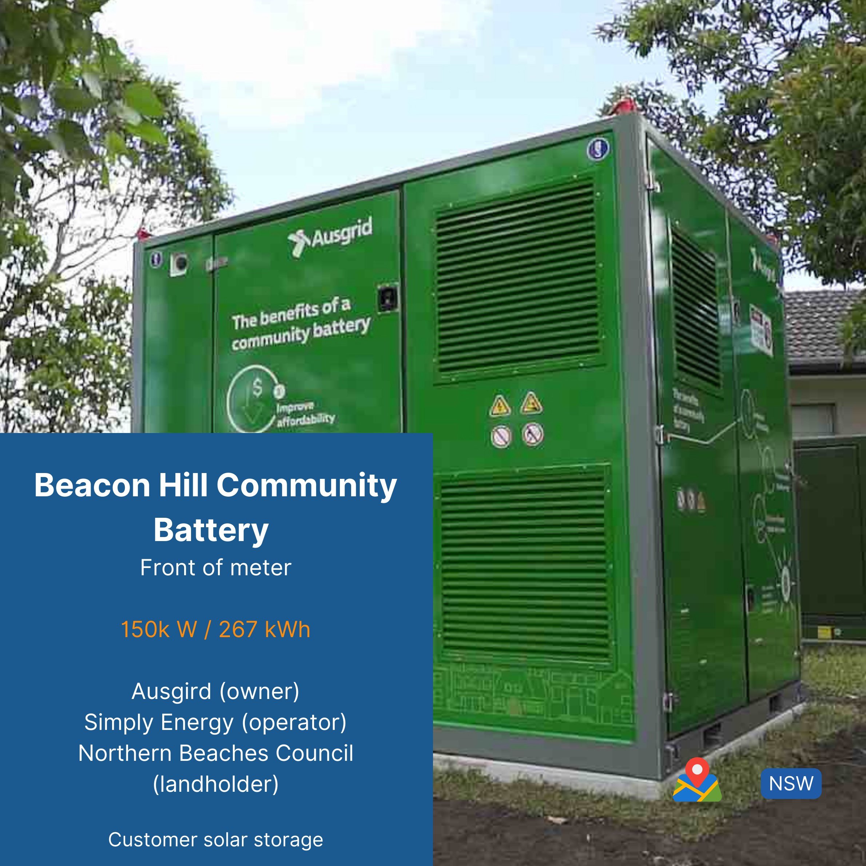
7 - Learn more
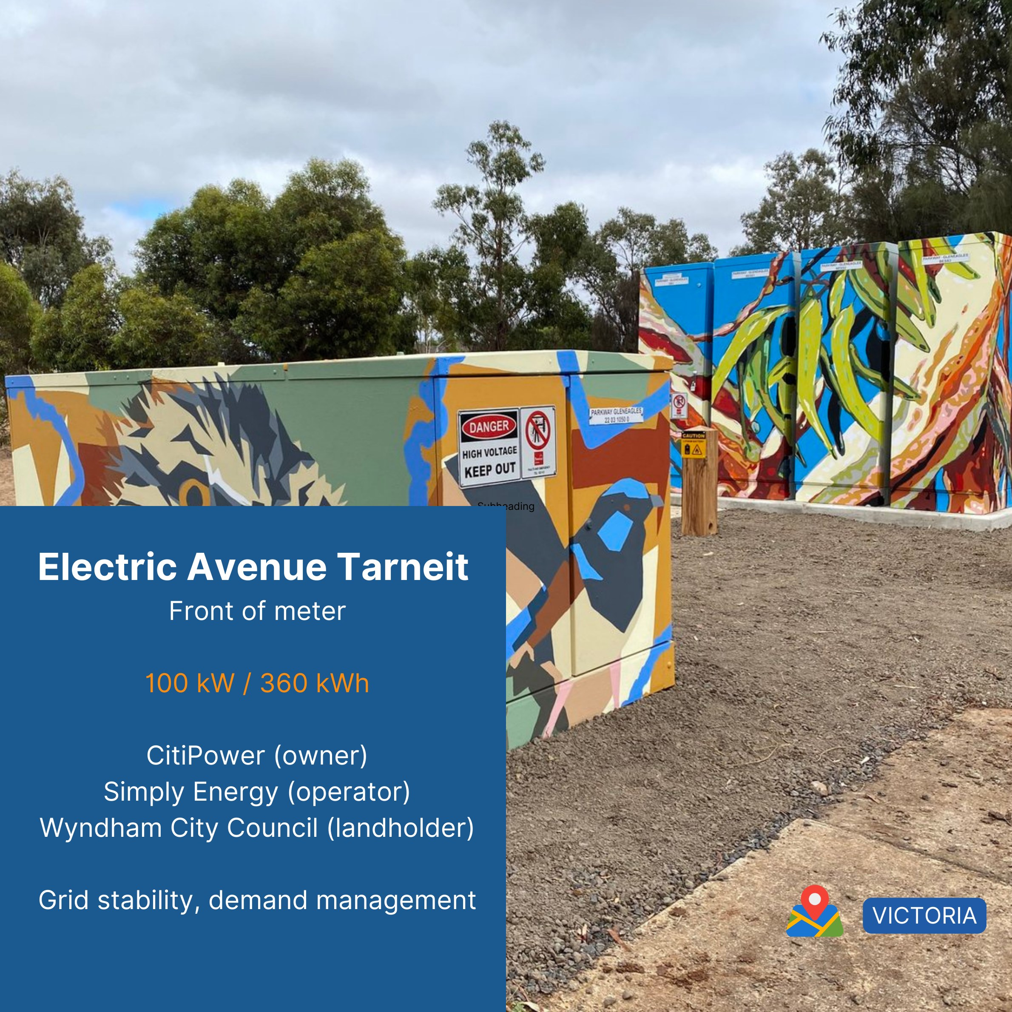
8 - Learn more
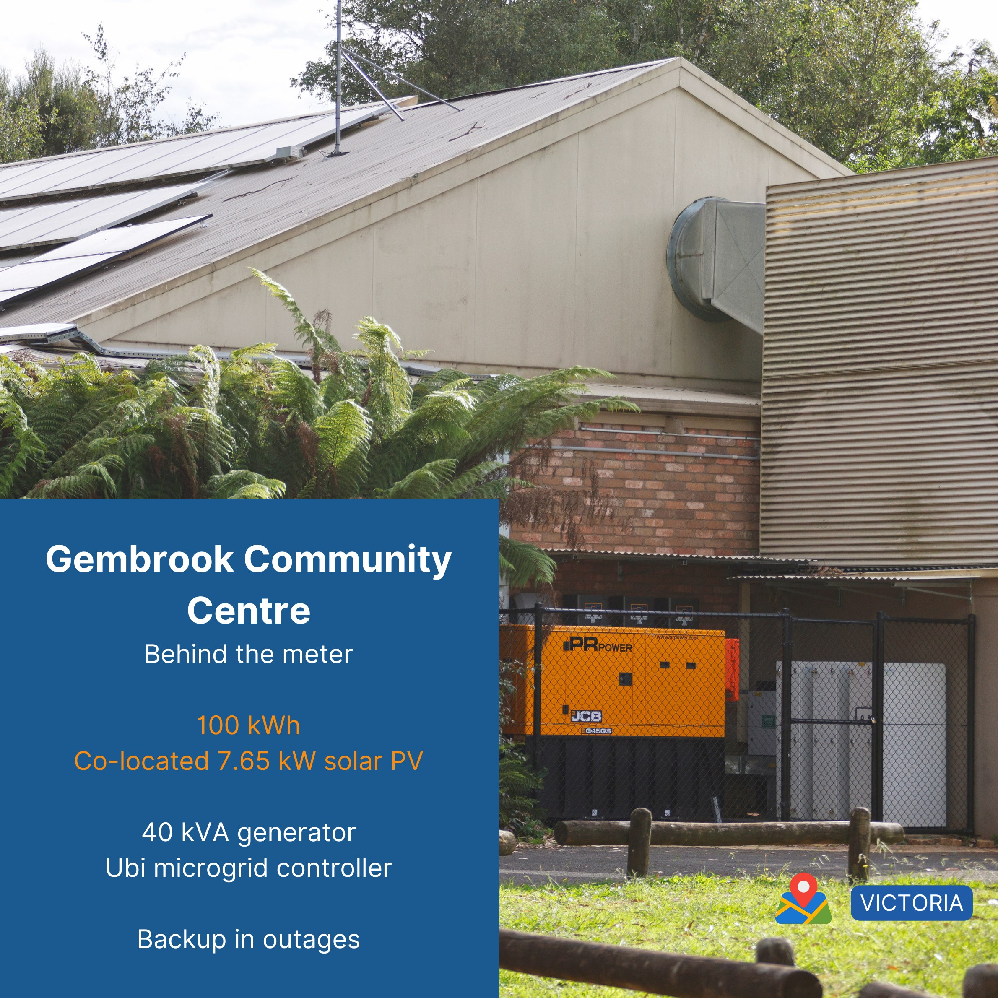
9 - Learn more
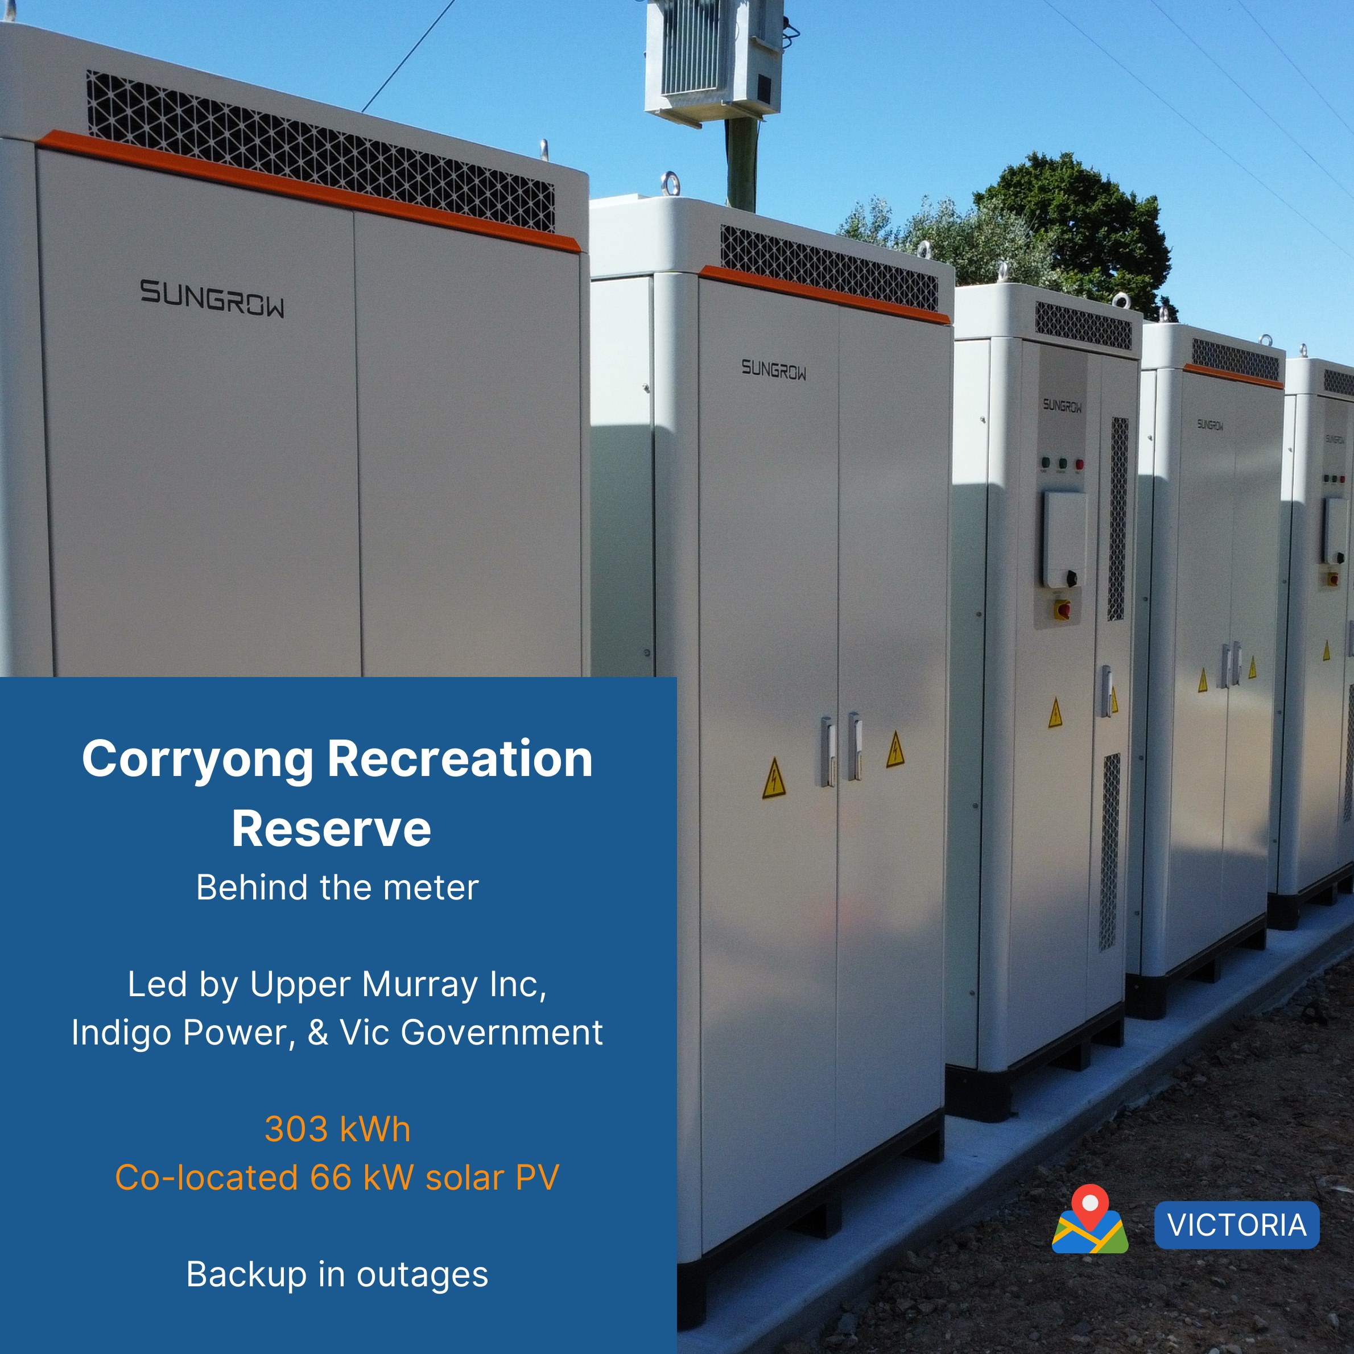
10 - Learn more
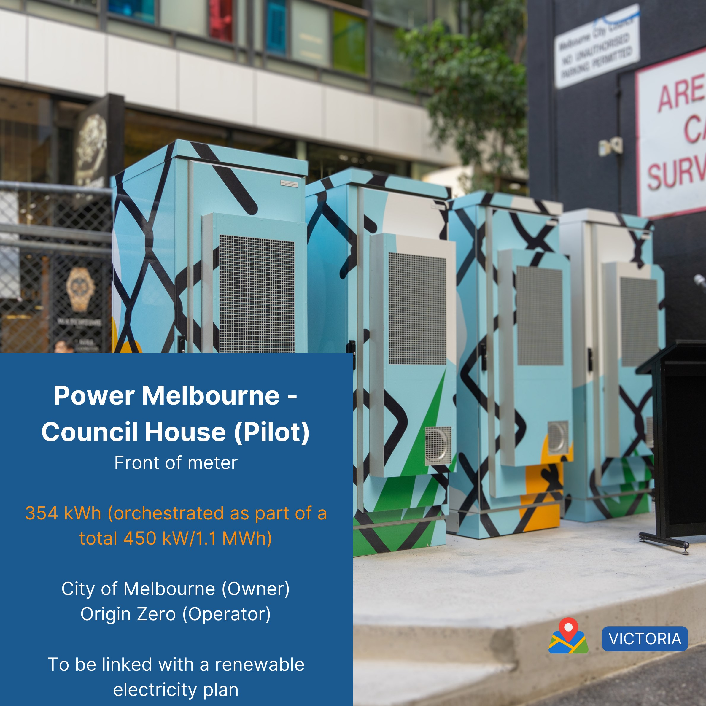
11 - Learn more
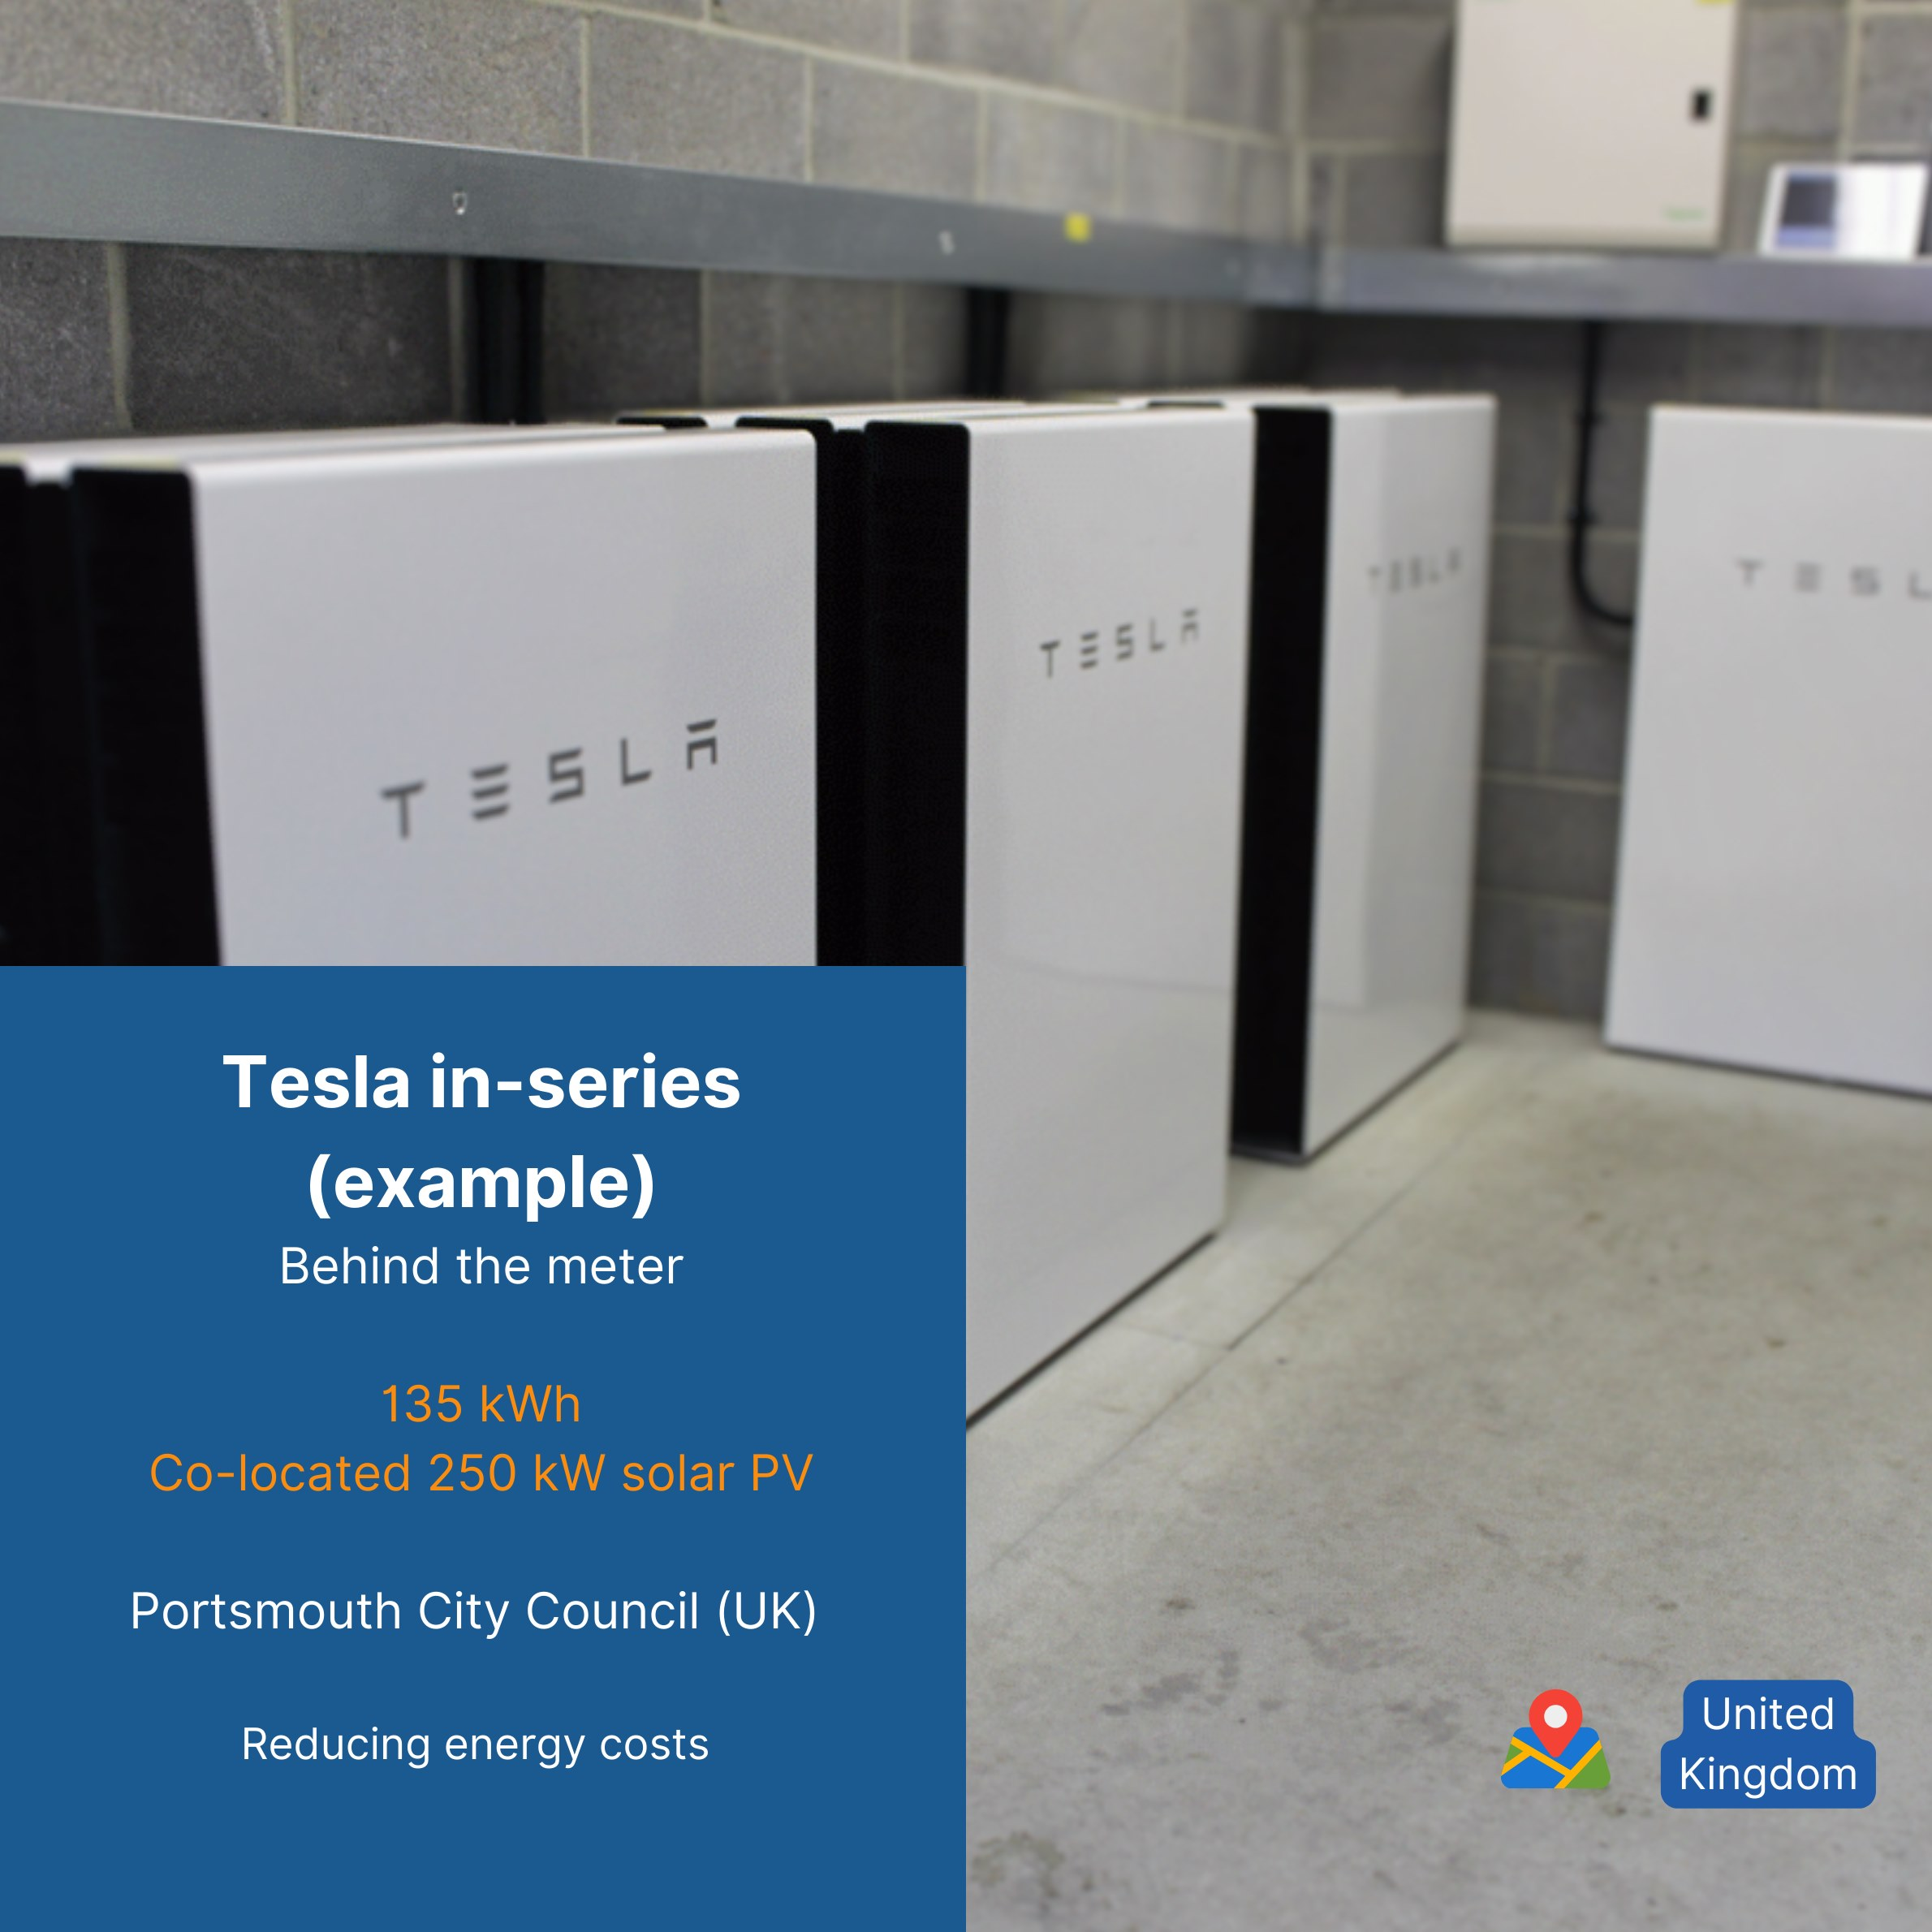
12 - Learn more - note, a project under development funded under round 1 of the 100 Neighbourhood Batteries program is pursuing a similar arrangement of 7 Tesla Powerwalls connected in series.
Neighbourhood batteries can be categorised as either 'front-of-meter' (FOM) or 'behind-the-meter' (BTM).
Front-of-meter batteries, also known as 'grid-side' systems, are designed to feed power directly into the electrical grid. They are usually owned or contracted by the utility or a third-party operator and serve multiple grid-connected customers.
In contrast, behind-the-meter neighbourhood batteries are located on a customer's side of the electricity meter. Often, these systems aim to reduce the customer's dependency on grid power, and can help with demand management, providing electricity during peak demand.
In some cases, such as the Yackandandah community battery, the battery charges from co-located solar but exports to the grid.
BTM and FOM batteries have overlapping but different features although both contribute to the total storage and functional requirements of a renewable-powered grid.
By contrast, grid-scale batteries provide bulk storage for the electrical system, contributing to grid stability. Neighbourhood batteries are smaller, serving a community by storing locally generated power. Household batteries, like those paired with home solar systems, provide individual homes with energy storage. The ‘chemistry’ of a battery, whether it’s lithium-ion (numerous varieties), vanadium redox flow, lead-acid, or another technology, determines its energy capacity, charge/discharge speed, and lifecycle.
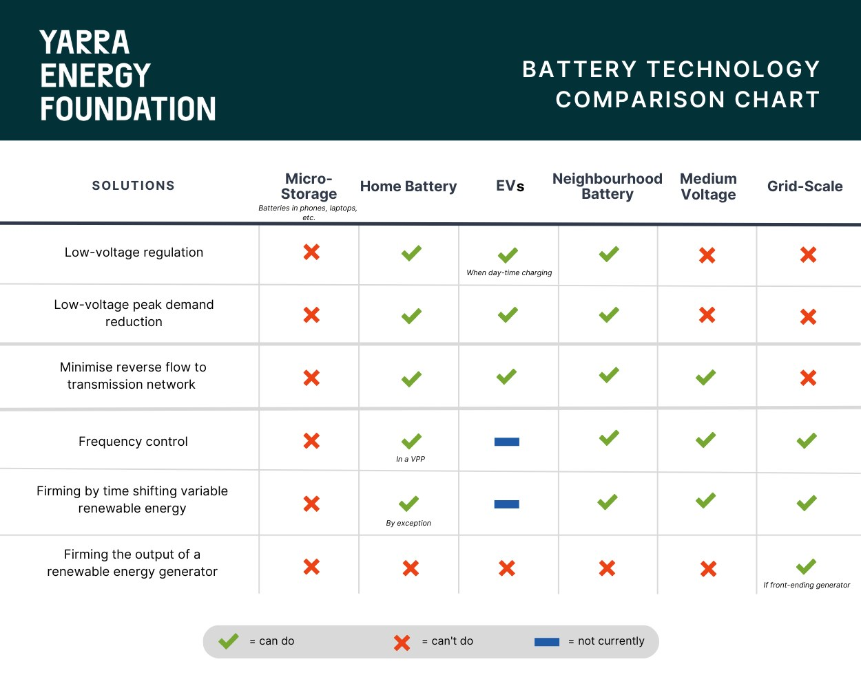
13 - This table shows how different sizes of battery can provide different services. Originally published by YEF in RenewEconomy, August 2023: https://reneweconomy.com.au/home-neighbourhood-grid-scale-batteries-whats-the-difference-and-why-does-it-matter

Existing ownership models
There are a variety of ownership models currently being explored for neighbourhood batteries across Australia. In some cases, the owners are also the operators, and in other cases, operation and/or market participation is carried out through a third-party such as a retailer. DNSPs are legally not allowed to participate in energy markets, but are currently allowed to lease batteries to market participants through a ring-fencing waiver.
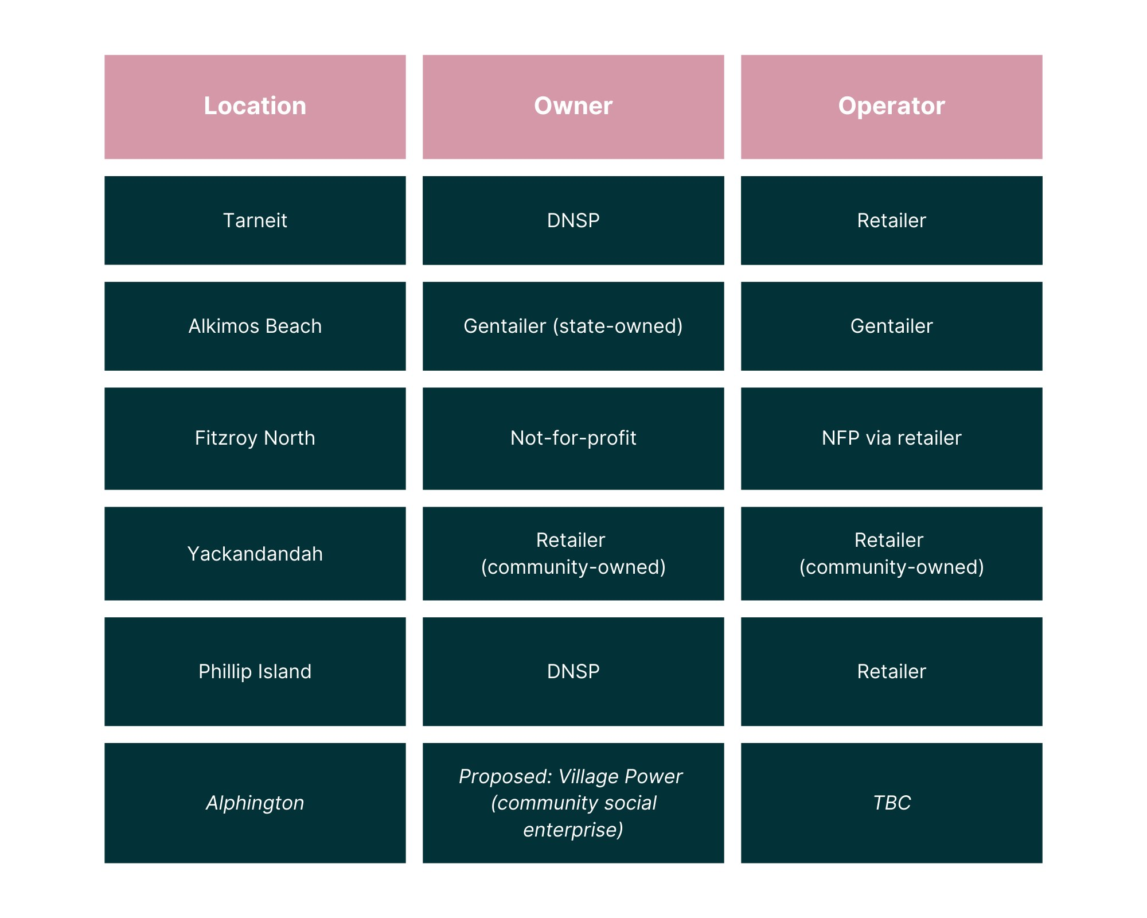
14 - This table shows a variety of possible owner/operator models.
The components of an electricity bill, and how they relate with a neighbourhood battery
An electricity bill is composed of five main elements:
- Energy charges: the cost of energy purchased by the retailer on the customer's behalf through the wholesale energy market.
- Network charges (from the DNSP): the cost incurred by the distributor to recoup the cost of operating, maintaining and upgrading the distribution network.
- Retail costs: the cost the energy retailer incurs in providing retail and customer services.
- Retail margin: the difference between the retailer's price and the wholesale supply cost.
- Environmental costs: generally make up around 10% of the total cost of supplying electricity. They are composed of national and state schemes, such as the large-scale renewable energy target (LRET) and the small-scale renewable scheme (SRES).
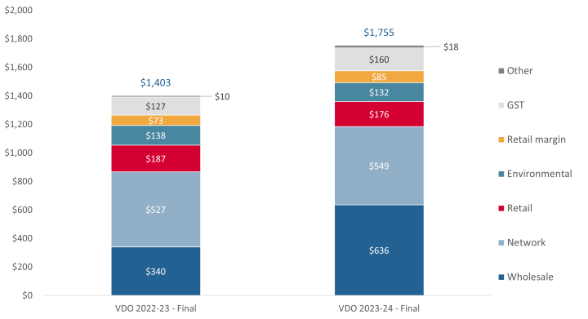
15 - Breakdown of an electricity bill - graph from the Essential Services Commission, comparing change in average Victorian Default Offer annual bill by cost component with annual usage of 4,000kWh, $ nominal.
Stabilising the grid with Frequency Control Ancillary Services (FCAS)
Some electricity market participants, such as NB operators, support the continuous and stable operations of the electricity system by providing services such as frequency control.
FCAS includes:
- Regulation FCAS, whereby generators (like a battery) continuously adjust their output to maintain the grid's frequency. These services are contracted and provided in response to signals sent by AEMO every 4 seconds.
- Contingency FCAS, whereby market participants respond to sudden frequency disturbances caused by unplanned events, such as a weather event leading to a failed transmission line. Contingency FCAS comprises six markets in which participants are paid to be available to provide generation or load to balance the frequency. Batteries providing contingency FCAS services do not need to charge or discharge in order to fulfil their obligation.
- The markets include:
  - Four raise markets (1sec, 6sec, 60sec and 300sec), which are used to raise the frequency by supplying power or reducing load in response to frequency disturbances.
  - Four lower markets (as above), which are used to lower the frequency by decreasing generation or increasing load (e.g., charging a battery).
Battery Energy Storage Systems can earn revenue through FCAS. However, the threshold capacity for participating in these markets is at least 1 MW, and bid in 1 MW increments. A NB of less than 1 MW power capacity would have to be aggregated with other assets to be allowed to bid on this market. Typically, this can be done for <1MW batteries through an operator that has an existing fleet of market assets and necessary licences.

Planning communications and engagement
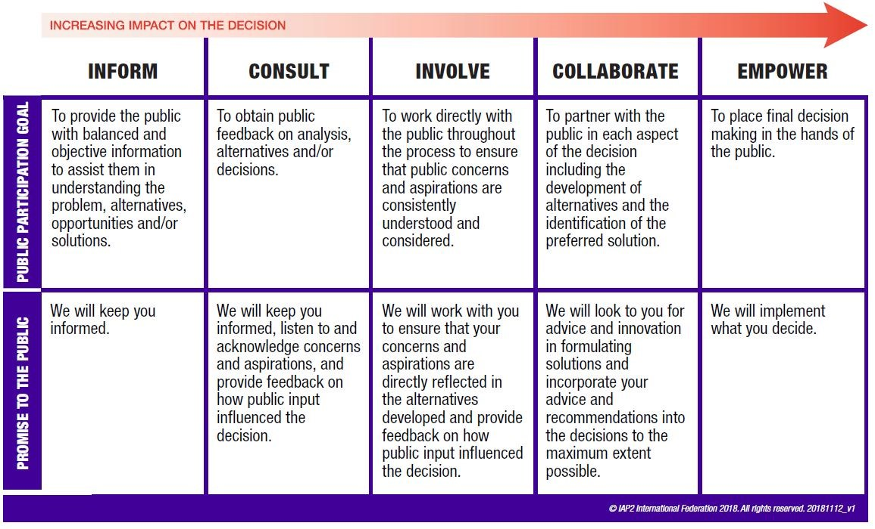
16 - The IAP2 Public Participation Spectrum
The IAP2 Public Participation Spectrum is a useful framework to understand to what extent you want to handover decisions to other stakeholders, such as the local community. A version of this framework was published in the Victorian Government's Community Engagement and Benefit Sharing in Renewable Energy Development in Victoria (2021).
The further to the right of the spectrum, the more power you give others to make decisions. So how could this apply to a neighbourhood battery project?
For batteries which are visible to the public and may be located in a public space such as a park or street corner, it may be important to deliberately engage with local stakeholders (such as local residents, businesses, schools, or the local government).
If local stakeholders that may be impacted by your battery installation are not given an opportunity to engage, they could feel like your project is being imposed on them. Communities often prefer to have an opportunity to understand what is going to impact them and how their interests will be considered.
Community pushback can pose a real risk to project timelines, costs, and reputation.
As part of developing your neighbourhood battery plan, it could be a good idea to develop a Communications & Engagement Plan, which typically comprises these key elements
- The aim of your engagement (e.g., to obtain the social licence to design, install and operate a battery)
- Key stakeholders
- Key messages
- Risk assessment
- Engagement methodology and timeline
- Negotiables and how negotiable they are (as per the Spectrum)
- Evaluation

Who's who in the NEM?
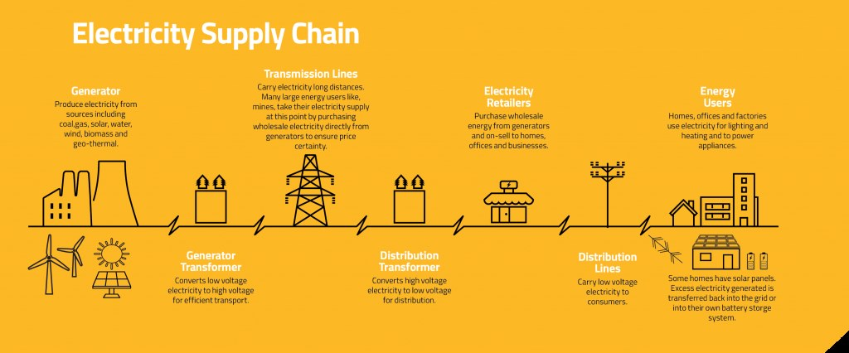
The National Electricity Market refers to the geographical region and and power system stretching from Queensland in the north, to Tasmania in the south, and South Australia to the west. The NEM comprises numerous markets from power system services, wholesale energy and other services, such as reserve capacity.
The Australian Energy Market Operator, AEMO, is the market operator that coordinates the electricity and gas markets, as well as ensuring the safe, secure and reliable operation of the physical power system.
The Australian Energy Market Commission, the AEMC, is the rule maker for Australia's gas and electricity markets and systems. They make and amend the National Electricity Rules (NER), review proposed rule changes, and provide advice to government.
The Australian Energy Regulator (AER) hold all stakeholders accountable to the NER by regulating generators, retailers, DNSPs, and other industry participants. For example, both network spending and tariffs proposed by DNSPs are reviewed by the AER prior to approval.

Resources
100 Neighbourhood Batteries Program grants
Tools and resources for the 100 Neighbourhood Batteries
CitiPower / Powercor's cloud-based flexibility marketplace, Piclo Flex
Fact Sheet: Community Battery Services, CitiPower, Powercor
Fact Sheet: Community Battery Services, United Energy
Neighbourhood Battery Knowledge Hub (by Australian National University)
Neighbourhood Battery Initiative - project reports
Approaches to Community Engagement (spectrum), pg 11. Community Engagement and Benefit Sharing in Renewable Energy Development in Victoria (2021)
Neighbourhood Battery Site Selection Matrix template (excel)

