Parties

Memorandum of Understanding
Department of Environment, Land, Water and Planning | Energy Safe Victoria
Department of Environment, Land, Water and Planning (DELWP) ABN: 90 719 052 204
Victorian Energy Safety Commission trading as Energy Safe Victoria (ESV), ABN: 27 462 247 657

Background
- The purpose of this Memorandum of Understanding (MOU) is to set out a voluntary statement of intent and commitment between the parties for the duration of the MOU.
- This MOU arises out of the findings of the Independent Review of Victoria's Electricity and Gas Network Safety Framework and replaces the MOU between ESV and the former Department of Primary Industries.
- The MOU recognises and facilitates ESV’s independence in regulatory decision making, and DELWP’s role as the principal source of policy advice to the responsible Minister.
- Both parties aim to ensure the energy safety regulatory system protects public and worker safety and promotes consumer confidence in energy products and networks, by providing a consistent safety regime for stakeholders across the regulatory responsibilities of DELWP and ESV.
- The parties enter into this MOU on the basis that the parties will work together in good faith and in a spirit of cooperation and mutual support to maximise the effectiveness by which the parties carry out their statutory duties and functions on behalf of the Victorian public.

Principles
- The MOU is underpinned by the following guiding principles:
  - Communication between the organisations is clear, open, prompt and considered.
  - Parties consult early on issues of shared interest, including technical and operational issues with implications for regulatory design and policy; and regulatory design and policy issues with implications for regulatory implementation and practice.
  - Information, including data, is shared confidentially but openly, except where prohibited by law.
  - Provision of advice, documents and information is done in a timely and responsive manner.
  - Where delays occur, the delay will be communicated promptly to the other party.
  - Products and advice shared is high quality, evidence-based and fit-for-purpose.
  - Where appropriate, access to and membership of external entities is shared.
  - Both parties comply with all applicable laws, policies, and government directions.

Cooperation
- Working cooperatively promotes the free exchange of ideas and expertise, strengthens both organisations and results in better regulatory outcomes.
- The parties will perform their roles and responsibilities and otherwise work cooperatively together as specified in Schedule 1 which is attached to this MOU.
- DELWP and ESV will meet on a regular basis, and more often when required, with the intention of building a shared understanding of their respective and common work programs and emerging issues.

OFFICIAL-Sensitive

- In the interest of efficiency, each meeting will seek to either resolve some matter; whether that is to obtain an understanding of an issue or to resolve a ‘way forward’ on the matter of interest, or to communicate on ongoing briefs, emerging, high risk or emergency issues and target dates for delivery.

Role Clarity
- Both ESV and DELWP have regulatory responsibilities under the Pipelines Act 2005 and associated subordinate regulation. ESV also has responsibilities under the Energy Safe Victoria Act 2005, Gas Safety Act 1997, Electricity Safety Act 1998, and subordinate regulations made under those Acts.
- ESV is an independent statutory authority responsible for the regulation of safety and technical regulation of electricity, gas and pipelines in Victoria, through enforcement and education. ESV acts independently on enforcement, compliance and prosecutorial matters; and sets regulatory implementation policy.
- DELWP and ESV exercise the delegated authority of the Minister responsible for the Pipelines Act 2005.
- DELWP is also responsible for regulatory design policy for energy, building policy, planning, environment, and forestry. DELWP is the principal source of policy advice to responsible Ministers, runs energy grant programs and is responsible for specific regulations related to planning and forestry. Additionally, DELWP is the portfolio relationship manager for ESV and supports the responsible Minister with ESV’s corporate and regulatory reporting requirements under applicable legislation.

Confidentiality
- Each party agrees to protect the confidentiality and sensitivity of information received from the other party in accordance with the applicable legislative requirements.
- The party providing information has the right to specify the level of confidentiality attached to the information it provides to the other, consistent with applicable legislative requirements.
- The parties agree not to disclose any confidential information obtained under this MOU to a third party unless prior consent has been obtained from the originating party, or disclosure is required, authorised or permitted by law.

Terms
- This MOU is a public document and transparently communicates the administrative arrangements between the parties. Each party will publish this MOU on its website.
- This MOU will have effect for five years from date of final signature.
- Unless otherwise agreed, each party will comply with its obligations under this MOU at its own cost.
- Any variation to this MOU must be in writing, signed by both parties.
- This MOU is intended to be a flexible tool to facilitate the performance of DELWP and ESV. It is not legally binding and does not limit a party in the performance of its responsibilities. Nothing in this MOU is intended to limit, override or interfere with the obligations of the parties at law.

Executed for DELWP | Executed for Energy Safe Victoria
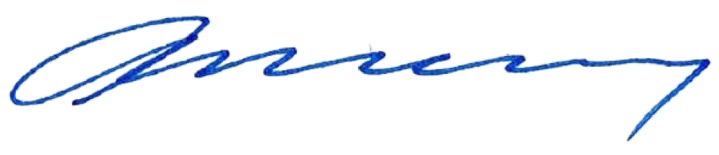  John Bradley, Secretary  Department of Environment, Land, Water and Planning | 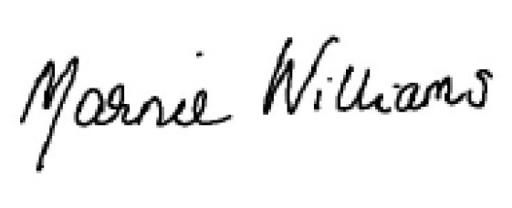  Marnie Williams, Chairperson  Energy Safe Victoria
Date: 3 May 2021 | Date: 3 May 2021

Schedule 1
Schedule of arrangements

Description | Examples | Arrangements
Committees | Section 8 Committees  Energy Safe Victoria Act 2005 | ESV establishes such section 8 committees as it determines, including appointing members to those committees  ESV informs DELWP of policy issues raised by committees
 | Statutory Committees appointed by the Minister  - Technical Advisory Committee, s 22A Energy Safe Victoria Act 2005  - Electric Line Clearance Consultative Committee, s 87 Electricity Safety Act 1998  - Victorian Electrolysis Committee, s 91 Electricity Safety Act 1998 | DELWP leads the briefing and probity processes to appoint statutory committees on behalf of the Minister  DELWP conducts the search for members of statutory committees appointed by the Minister  ESV supports DELWP to identify potential members of statutory committees appointed by the Minister and, unless otherwise agreed, provides secretariat support to these committees and informs DELWP of policy issues raised by these committees
Corporate Reporting and Functions | Corporate Plan Annual Plan  Financial Management Act Freedom of Information Request ESV Enterprise Agreement | ESV will deliver corporate reporting and administration functions as required by law  DELWP leads the preparation of advice to support the Minister and Secretary to deliver any responsibilities they have in respect of ESV’s corporate reporting and administration  ESV will provide information and advice to DELWP to support preparation of this advice  On occasion ESV will provide a draft for consideration and feedback from DELWP  Where relevant DELWP briefs the responsible Minister
Emergency Management | Preparations for emergency management  Major weather events  Supply outages and major energy incidents | As per the Victorian State Emergency Management Plan, noting DELWP is a control agency and ESV is a support agency. DELWP therefore represents energy sector interests at the State Control Centre.  ESV reviews its emergency management framework and participates in / runs annual exercises including some that have DELWP’s participation.
Emergency and High Risk Issues, and Adverse Safety Trends | Incidents – fatalities, injuries and property damage  Reports of unsafe work or situations | DELWP and ESV to share information at executive level in the first instance when an incident of sufficient importance or an adverse safety trend has been identified

 |  | ESV also assists DELWP on safety aspects relating to other renewable programs such as windfarms, batteries and development of hydrogen as a fuel source. This requires sharing of information between ESV and DELWP to facilitate procurement processes
External Communications | Media Releases  Industry Communications Safety Campaigns | DELWP and ESV agree to inform each other of external communications where appropriate and cooperate on communication where messaging has potential regulatory design policy implications
Interagency Communications | Coordination Comments Interagency Cooperation | DELWP to seek feedback from ESV on policy initiatives from other government bodies, and vice versa  ESV to inform DELWP of policy issues raised by other government bodies, and vice versa
Ministerial Powers | Ministerial Directions Statement of Expectations  Levy Determination | DELWP lead briefings to the Minister with input from ESV
Pipeline Regulation | Pipelines | DELWP is responsible for administering pipeline licensing and the exercise of delegated powers for licencing and environmental management plans, including required emergency response arrangements for pipelines  ESV provides DELWP technical advice  ESV is responsible for the exercise of powers over safety management plans, in compliance with licence conditions, and any powers delegated to ESV and/or its staff by the Minister
Programs | Solar Homes Program | As per the Solar Homes Program Information Sharing Agreement
 | Powerline Bushfire Safety Program | DELWP and ESV cooperate on the delivery of key projects relating to powerline bushfire safety, including guiding the installation of Rapid Earth Fault Current Limiters by distribution businesses  ESV Chairperson sits as a member of the Powerline Bushfire Safety Panel  ESV processes exemptions under the ESA and synchronises the timing of exemptions under the relevant regulations in consultation with DELWP

 |  | ESV also consults with DELWP regarding extensions of time under the relevant Act and regulations
 | Open flued gas heaters | DELWP and ESV cooperate on the phasing out of open flued gas heaters
Regulatory Design and Strategic Policy | Legislation Regulations Orders in Council  Policies Interpreting Regulation Briefing Minister on Policy  Emerging Technologies and Other Strategic Policy | ESV will identify issues with implications for regulatory design and strategic policy with supporting evidence  DELWP and ESV work together to analyse issues and options  Unless otherwise agreed, DELWP leads consultation, advice and drafting, with input from ESV
Regulatory Implementation Policy | Enforcement Strategies/Policies Policies to Clarify Regulation  Industry Standards | ESV leads development and implementation with DELWP input
Regulatory Implementation Reporting | Legislative Reporting Monthly Report  Fire Report Reform Reporting  Annual Safety Report ELCCC Annual Report  Briefing Minister on ESV Regulatory Decisions where required at law or appropriate to do so | ESV produces reporting for provision to the responsible Minister, copied to DELWP  DELWP also produces reports on reform initiatives and may brief the Minister on these reports
Technical Advice | Policy Initiatives Emerging Technologies | ESV provides technical advice on new initiatives to DELWP  DELWP and ESV to flag emerging trends and issues to the other party
 | Ad-hoc Enquiries | DELWP requests technical advice from ESV on ad-hoc enquires

Document Control

Version | Date | Revision Information | Author | Edited by | Authorised by | Revision Date
1.0 | Feb 20 | Initial draft from ESV | MM / RA | NJ | SZR | 11 Feb 21
2.0 | Feb 21 | Revised draft - DELWP | CH | RT | JA | 04 Mar 21
3.0 | Mar 21 | Revised draft – ESV | NJ |  |  | 22 Mar 21
4.0 | Mar 21 | Revised draft – DEWLP | CH |  |  | 31 Mar 21
5.0 | Apr 21 | Revised draft – ESV | NJ |  |  | 1 Apr 21
6.0 | Apr 21 | Revised draft - DELWP | RT |  | JA | 9 Apr 21
7.0 | Apr 21 | Final version – ESV | MM | SZR | LH | 28 Apr 21

