# Victorian Government Energy Assistance Program

Social Media Content

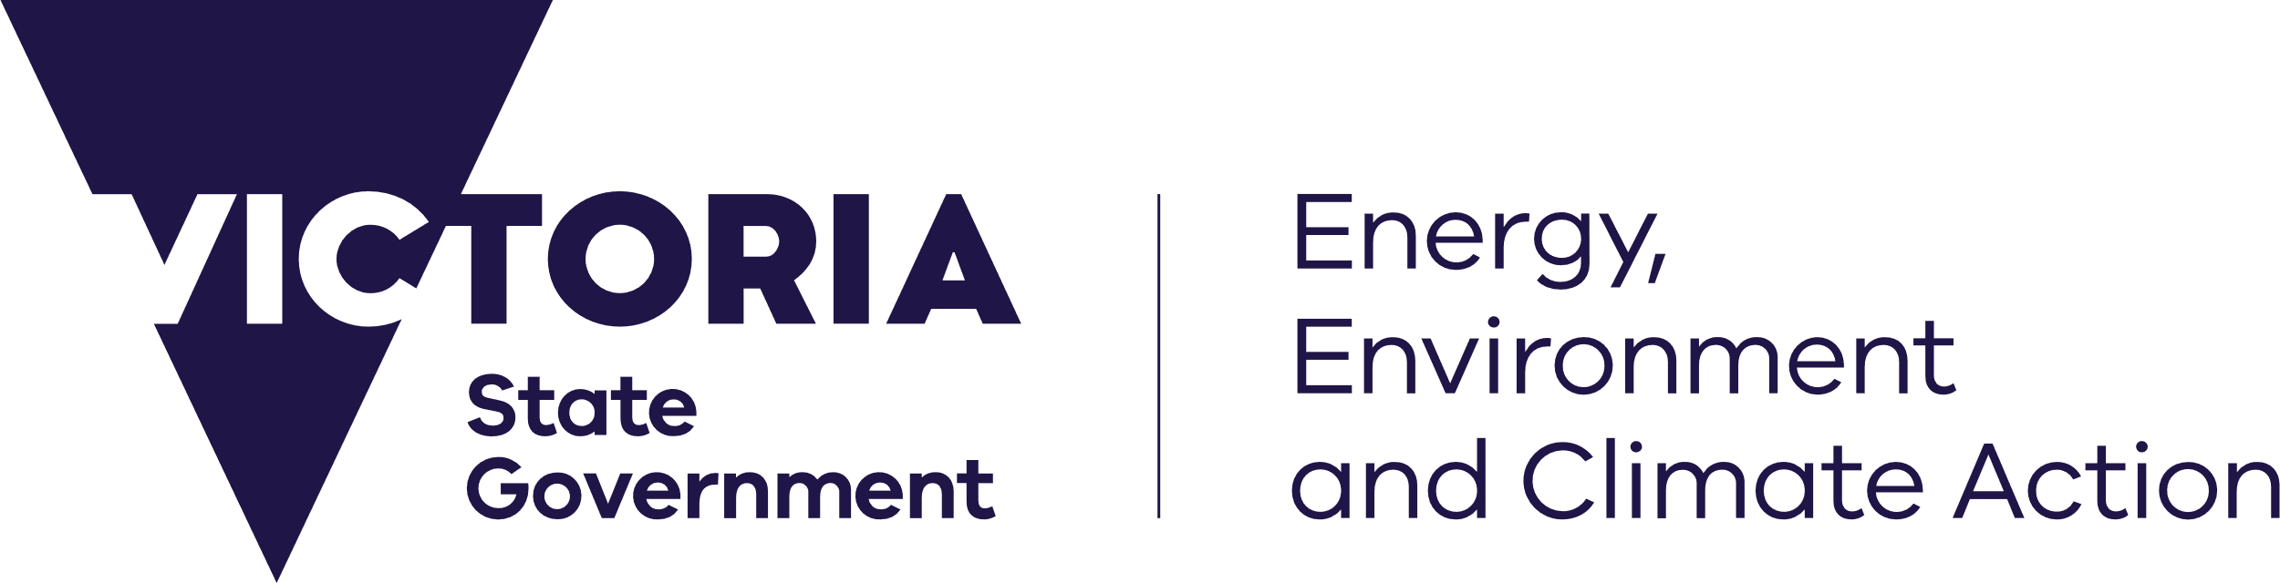

## Social Media Tile One

deeca.vic.gov.au

## Social Media Tile Two

## Social Media Tile Three

## Social Media Tile Four

## Social Media Tile Five

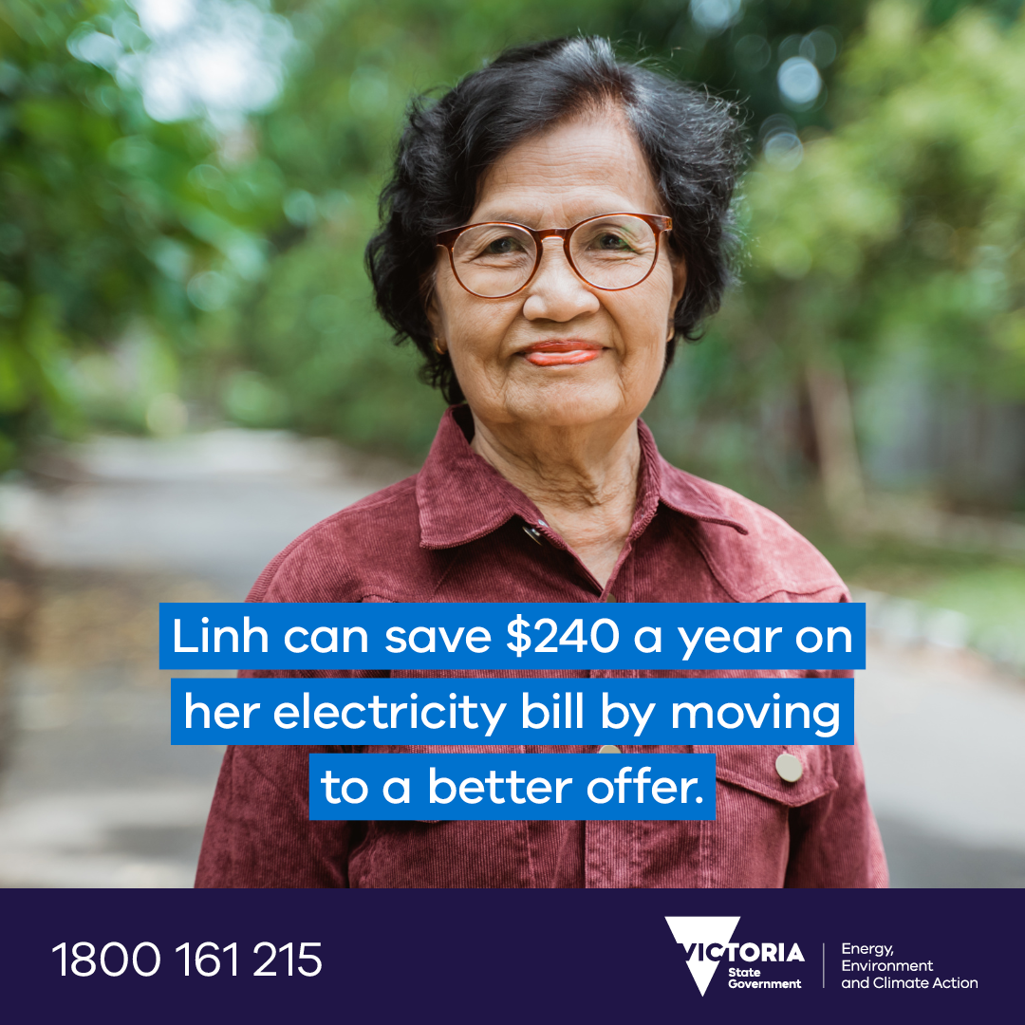

## Suggested Text Tile One

Free one-on-one support with your energy bills 💲

✏ Get help to apply energy concessions

⚡ Access extra support if you are having trouble paying your energy bills

📞Get advice on how to save energy and money around the home.

Visit https://www.energy.vic.gov.au/for-households/help-paying-your-bills/energy-assistance-program or call 1800 161 215 to get support in person or over the phone.

## Suggested Text Tiles Two-Four

Get advice on how to save energy and money around the home ⚡

Access a free service that can provide you with one-on-one assistance if you need to save money on your energy bills.

Learn more about the Victorian Government’s Energy Assistance Program https://www.energy.vic.gov.au/for-households/help-paying-your-bills/energy-assistance-program or call 1800 161 215.

## Suggested Text Tile Five

Check you’re not missing out on savings today 💰

Linh* will save $240 a year on her electricity bills through the Energy Assistance Program.

💸 Check if you can save money by switching to a better energy deal.

✏ Get help to apply energy concessions

⚡ Access extra support if you are having trouble paying your energy bills

📞Get advice on how to save energy and money around the home.

Learn more: https://www.energy.vic.gov.au/for-households/help-paying-your-bills/energy-assistance-program or calling 1800 161 215.