**Supporting material**

**An Introduction to Neighbourhood Batteries**

From concept to feasibility

**Published August 2024**

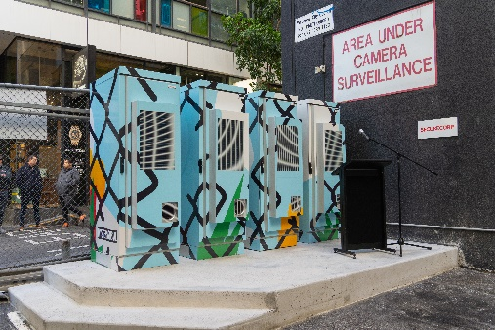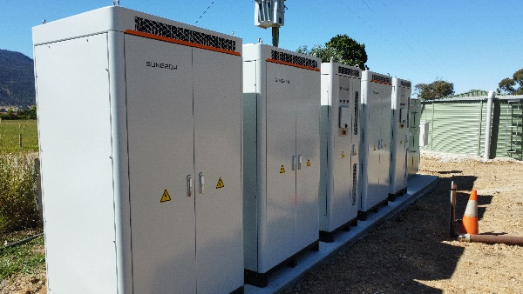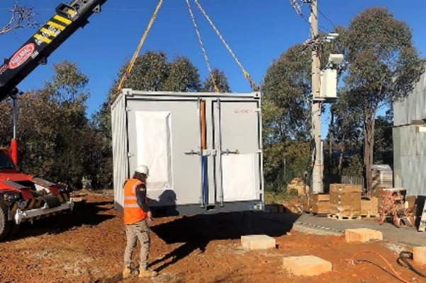

**About**

The Victorian Government’s Department of Energy, Environment and Climate Action (DEECA) engaged the Yarra Energy Foundation (YEF), an independent not-for-profit organisation, to develop online training on the fundamental concepts of neighbourhood-scale batteries. This document serves as supporting material to these videos. See also the [online pre-training materials](https://sway.cloud.microsoft/PVI4szihIIM6GLyi?ref=Link) which provide an overview of foundational concepts.

**Acknowledgment of Aboriginal land and peoples**

We acknowledge Aboriginal and Torres Strait Islander people as the Traditional Owners and custodians of the land and water on which we all rely. We acknowledge the Wurrundjeri Woi Wurrung peoples as the custodians of the land on which the Yarra Energy Foundation is based.

**Disclaimer**

This document is property of the Victorian Government’s Department of Energy, Environment and Climate Action (DEECA) and was produced by the Yarra Energy Foundation Ltd (YEF) to support the clean energy transition. DEECA and YEF undertake no duty to and accept no responsibility to any third party who may rely upon this document. All rights reserved. As DEECA and YEF are committed to advancing a better energy system for all, the parties encourage the use of this document and information contained in it for this purpose. However, this document cannot be reproduced whole or in part for commercial or business purposes without prior written consent of DEECA.

# Session 1

**Key learning outcomes:**

1. Define and distinguish neighbourhood batteries from alternative solutions with respect to their purpose and function
2. Understand the emerging role neighbourhood batteries can play in the energy system and transition
3. Analyse the benefits, limitations, opportunities, and risks of neighbourhood batteries

### 1.1 What do you consider to be the main *advantages* of neighbourhood batteries (NBs) compared with household or utility-scale battery storage?

### 1.2 What do you consider to be the main *disadvantages* of NBs compared with household or utility-scale battery storage?

### 1.4 What are three ways in which neighbourhood batteries can support the clean energy transition?

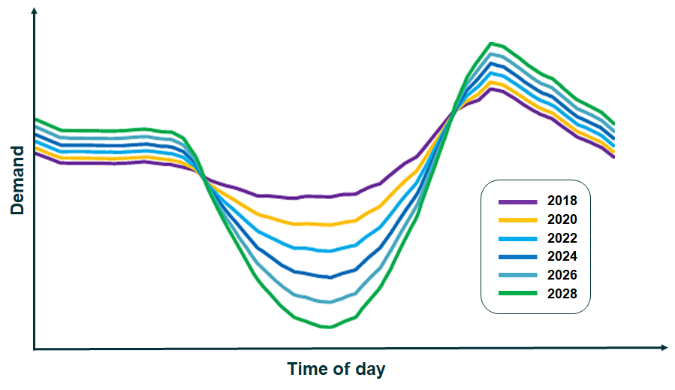

Figure 1: Illustration of the 'duck curve': average operational demand across the system over the course of a day. Note that operational demand is forecast to be progressively lower during the middle of the day due to increasing distributed solar generation, followed by a sharper ramp up to a higher peak demand in the evening.

Adapted from AEMO data of the Wholesale Electricity Market (WEM) in Western Australia.

**1.5 What are the relevant benefits and opportunities of pursuing a neighbourhood battery in your context? What are the main challenges and limitations?**

**1.6 What are some potential alternative solutions to achieve the aims and objectives that lead you to consider a neighbourhood battery project? What are the trade-offs?**

## Reflections, thoughts, ideas – session 1:

# Session 2

**Key learning outcomes:**

1. Identify the key components in a typical BESS
2. Identify the most common neighbourhood battery chemistries
3. Recognise how different contexts shape the success of a neighbourhood battery
4. Understand how neighbourhood batteries can generate value for stakeholders

**BESS hardware components and functions**

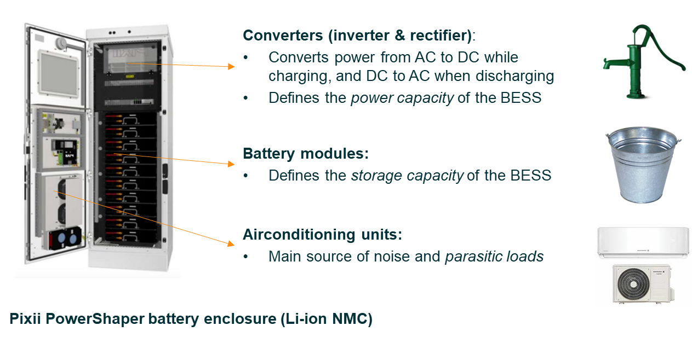

Figure 2: Key components of a battery energy storage system (BESS). Note that BESS come in varying shapes and sizes, employ different cooling systems (e.g., liqud-cooling), and configurations (e.g., dedicated cabinets for energy storage or power conversion).

### 2.1 What aspects of the BESS hardware is most important to your project, and why? What considerations does this raise for procurement? (chemistry, size and footprint, noise etc.)

**Battery degradation**

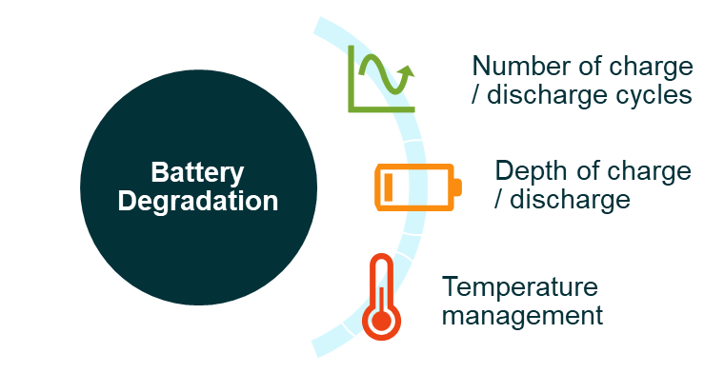

Figure 3: Three key factors influencing battery degradation.

Figure 4: Example of battery degradation over time (figures are indicative, seek actual degradation specifications from the BESS manufacturer).

**Metering arrangements**

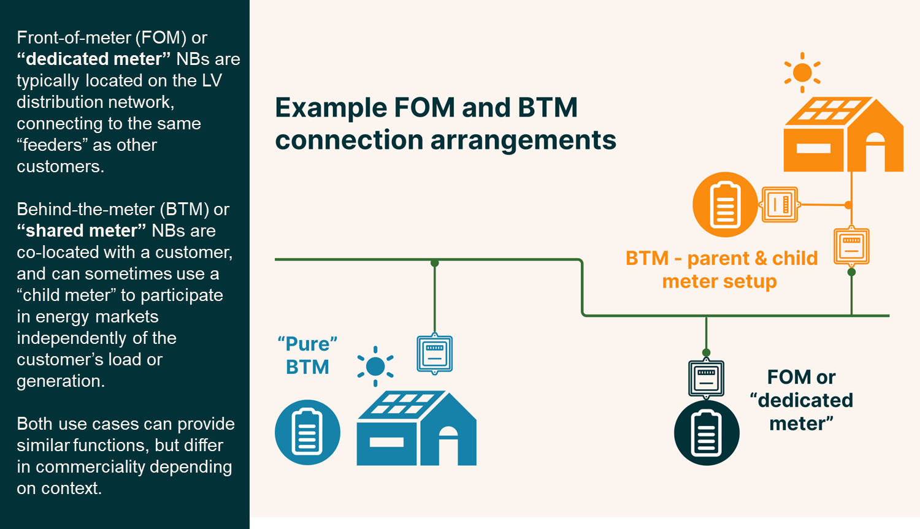

Figure 5: Three archetypal battery metering arrangements.

|  |  |  |  |
| --- | --- | --- | --- |
| Functions / benefits | “Pure”  BTM | Market-facing  BTM | Front-of-meter |
| Absorb solar from co-located generation | **ü** | **ü** | **û** |
| Absorb solar exports from surrounding network | **û** | When profitable | **ü** |
| Supply energy to multiple sites | Not typically | **ü** | **ü** |
| Reduce energy expenses for host | **ü** | **ü** | **û** |
| Access wholesale energy and frequency markets | **û** | **ü** | **ü** |
| Can reduce the need to upgrade the LV network | **ü** | **ü** | **ü** |

|  |  |
| --- | --- |
| **Front-of-Meter (FoM)** | |
| **Advantages** | **Disadvantages** |
| Commerciality can be supported by favourable network tariffs | May not provide direct benefit to site owner |
| Well-suited to providing network support (e.g., voltage regulation or peak demand reduction) | May require use of public land |
| Can participate in electricity and FCAS markets | Cannot access BTM value streams |
| Well-suited to wider community participation / engagement | Can only charge from grid; commerciality dependent on market conditions |
| Replicable model suited to scaled deployment and dispatch | Renewable content of stored energy dependent on grid’s generation mix |

|  |  |
| --- | --- |
| **Behind-the-Meter (BTM)** | |
| **Advantages** | **Disadvantages** |
| Can charge for free from co-located solar (if “pure” BTM) | Is not currently eligible for two-way network tariffs |
| Can offset on-site consumption and energy costs | Must pay standard SME network tariffs for energy drawn from grid |
| Can reduce site’s peak demand and network charges | Connection capacity may be constrained by customer’s existing connection (unless upgraded) |
| Can participate in energy and FCAS markets (if using a child meter; note that this would negate the top two advantages in the table) | Less suited to providing network support (e.g., voltage regulation or peak demand reduction) |

**Wholesale Energy Arbitrage**

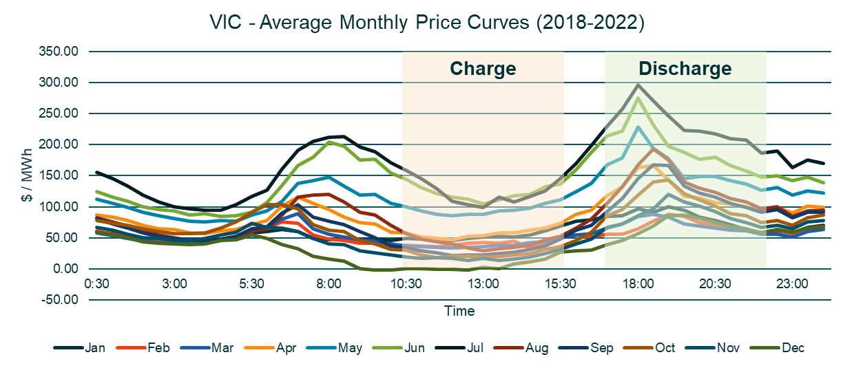

Figure 6: Average monthly prices in Victoria between 2018-2022 by month. The graph shows a consistent pattern (the 'duck curve') each month, with average prices *lower* during summer compared to winter months.

**Network Tariffs**

|  |  |  |
| --- | --- | --- |
| **Fixed  charge** | **Peak**  **import** | **Off-peak**  **import** |
| **$/year** | **c/kWh** | **c/kWh** |
| 3,629.159 | 5.266 | 0.000 |
| **Solar soak import** | **Peak  export** | **Summer Demand** |
| **c/kWh** | **c/kWh** | **c/kVA/summer day** |
| -1.500 | -1.500 | 0 |

CitiPower, Powercor and United energy community battery trial tariff (left);

Jemena community battery trial tariff (right) as of August 2024.

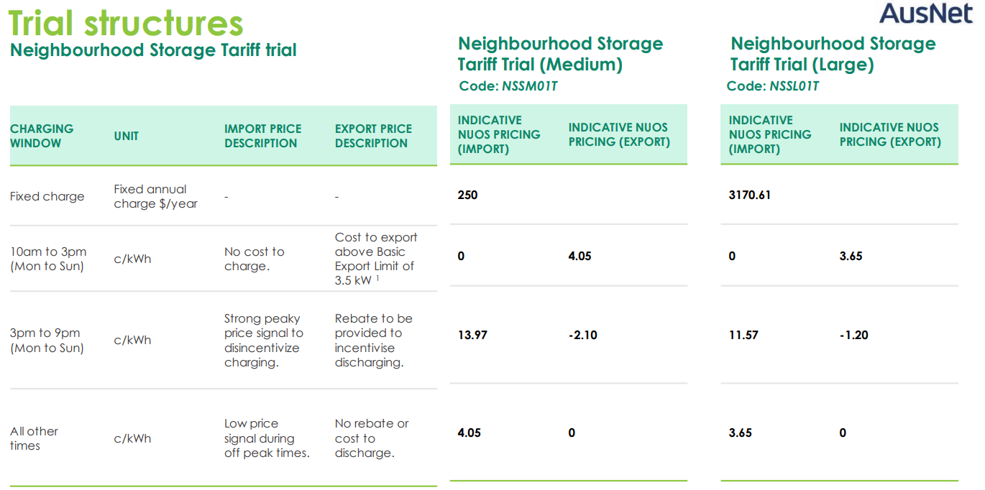

AusNet community battery trial tariff (FY2024-25).

**Dispatch Control**

|  |  |  |
| --- | --- | --- |
|  | **Optimiser** | **Rules-based scheduler** |
| **Approach** | Forward-looking algorithm; considers state of charge and price forecast to make ‘optimal’ economic decision | Uses simple logic to dispatch the system according to basic rules re: spot price and state of charge |
| **Prioritisation** | Can prioritise services/markets by profitability or opportunity cost | Prioritisation set by rules |
| **Profitability** | Responds dynamically to prices; potential for higher profitability *if inputs are accurate* | Fairly inflexible schedule; price response set by rules |
| **Environmental outcomes** | Usually ‘emissions-agnostic’ | May help to firm and enable solar |
| Potential innovation: respond to emissions intensity as well as price | |
| **Ease of use and reliability** | Complex and highly dependent on inputs, but potentially more lucrative | Simple to implement but lacks flexibility; more assurance for DNSP re: connection |

Figure 7: Comparing optimised vs rules-based scheduler dispatch.

### 2.4 What are the main ways by which neighbourhood batteries can generate revenue?

**Reflections, thoughts, ideas – session 2:**

# Session 3

**Key learning outcomes:**

1. **Understand** which factors influence metering and connection capacity
2. **Identify** and explain the main considerations in identifying sites
3. **Explain** the role of communications and engagement
4. **Use** the public participation spectrum to map your negotiables

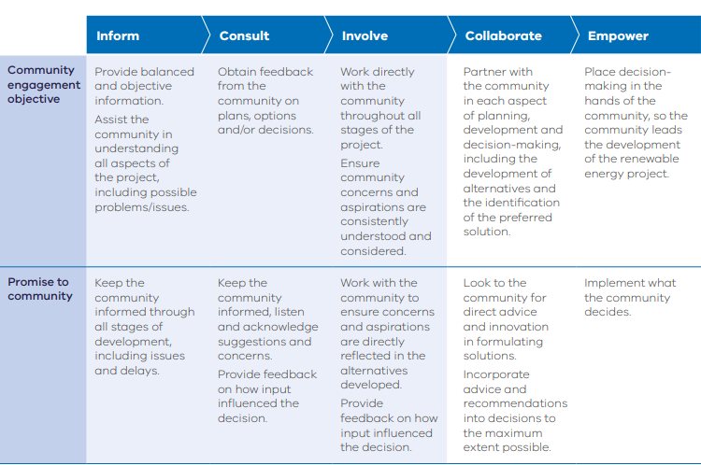

“Participation Spectrum”, pg. 11. [*Community Engagement and Benefits Sharing in Renewable Energy Development in Victoria*](https://www.energy.vic.gov.au/__data/assets/pdf_file/0026/580625/community-engagement-and-benefit-sharing-guide.pdf)*,* DELWP, 2021; adapted from the International Association for Public Participation (2014). Public Participation Spectrum.

### 3.1 What could be negotiable with the community? Where on the spectrum of engagement could it fall?

**Communications and Engagement Plan summary (*plan on a page*)**

|  |  |  |  |  |
| --- | --- | --- | --- | --- |
| **Goal and objectives** – What objectives would you need to achieve in order to achieve the overarching goal? | | | | |
| **Overarching goal** | E.g., to develop the social licence to design, install, and operate a neighbourhood battery for its lifetime. | | | |
| **Objectives** | E.g., Enable and respond to community and stakeholder feedback. |  | | |
| **Stakeholders** – Who are the stakeholders in this project? Who is most impacted? Who benefits the most? Who has influence over the project? | | | | |
|  | Tier 1 | | Tier 2 | Tier 3 |
| E.g., Local residents | |  |  |
| **Methodology** – Which methods are suitable for engaging various stakeholders? Over what time period? | | | | |
| **Methods and messages** | E.g., letter-drop, surveys, information sessions. |  | | |

**Site selection criteria**

|  |  |  |  |
| --- | --- | --- | --- |
| **Criteria** | **Weighting (100 pts)** | **Score (0-4)** | **Weighted score** |
| Environmental / physical | | | |
| 1. Footprint / available space |  |  |  |
| 2. Fire risk |  |  |  |
| 3. Flood/inundation risk |  |  |  |
| 4. Traffic risk |  |  |  |
| 5. Noise |  |  |  |
| 6. Vegetation disturbance / proximity / enhancement |  |  |  |
| 7. Visibility / visual impact |  |  |  |
| Stakeholders | | | |
| 8. Potential landholder support for site/project |  |  |  |
| 9. Lease negotiation complexity and costs |  |  |  |
| 10. Disruption to existing use of space |  |  |  |
| 11. Awareness raising & education opportunities |  |  |  |
| 12. Accessibility impact |  |  |  |
| 13. EV charging potential |  |  |  |
| Network | | | |
| 14. Connection capacity |  |  |  |
| 15. Connection & install complexity and cost |  |  |  |
|  |  | Weighted total: |  |

Figure 8: Example selection criteria matrix. Criteria and weightings can be customised. [Download excel template](https://drive.google.com/file/d/159AzrClifQQBjhrzTOKcdq1NHasc295R/view?usp=sharing)

## Reflections, thoughts, ideas– session 3:

# Session 4

**Key learning outcomes:**

1. Identify the typical phases of a neighbourhood battery project
2. Outline scope and steps of a neighbourhood battery feasibility study
3. Identify key CAPEX and OPEX for neighbourhood battery implementation
4. Identify possible outcomes of a neighbourhood battery project (commercial, stakeholder, and energy transition)
5. Apply your understanding to align a potential project with funding guidelines

### 4.2 What key questions should a feasibility study seek to answer?

### 4.3 In what ways does your project idea align with the funding priorities and objectives of the Victorian Government’s [100 Neighbourhood batteries program](https://www.energy.vic.gov.au/grants/neighbourhood-batteries/100-neighbourhood-batteries-program-grants)?

### 4.4 From concept to funding-ready

1. Describe your proposed project in a few sentences, specifying the **use case, site, ownership model, and estimated size.**

If youdo not currently have a project in mind, consider a hypothetical example and a location you may already be familiar with.

1. Identify three ways your project will provide **technical benefits** or **support decarbonisation.**
2. Identify three ways your project will **share benefits with the community** (local or beyond).
3. Suggest three potential **revenue streams** you hope for the battery to target.
4. Outline three **potential risks or limitations** relating to your project.
5. Identify three **key stakeholders** and their **role or relevance** to the project.
6. Suggest three aspects of the project through which you wish to **involve the community**, and **why.**
7. Assess your proposed or hypothetical site using the site assessment matrix provided on p. 18 (or by using the Excel file provided), or an equivalent tool or set of criteria.
   1. What are the major ‘unknowns’ of the site? How would you clarify these?
   2. What are the key advantages/disadvantages?

**Example feasibility study structure and guidance**

1. **Executive summary**

This will succinctly summarise each of the sections to provide sufficient context, indicate key insights, and provide a recommendation regarding the technical and economic feasibility of pursuing the project.

1. **Context analysis** (inc. issue identification and rationale for NB)

This should provide sufficient information for the reader to understand the key drivers of the project, potential aims and objectives, and potentially a needs assessment of the proponent, customer and/or community.

1. **Site identification and assessment** – may require DNSP support/data

This should indicate (where possible):

* The specific installation site, potentially including BESS placement
* The proposed connection point and trenching/boring required
* Any available information regarding network infrastructure specifications or indicative connection capacity
* Potential site disadvantages and risks (e.g., traffic collision risk mitigation may be required, vegetation may need to be removed, proximity to residents)
* Identified advantages and opportunities of the site (e.g., discreet/highly visible location, potential EV charger co-location, straightforward connection, distance from nearby structures)

1. **Outline of proposed ownership and operating model** – may require expert consultation

This should identify the target value streams, dispatch principles, retail arrangements, and potentially, any associated benefit-sharing mechanisms. Consider the use of a diagram for communicating value flows and operational responsibilities.

Example (front-of-meter connection):

*Ownership:* The BESS will be owned by the proponent, Common Climate Community Energy, Inc., (CCCE).

*Target value streams:* Wholesale energy arbitrage, FCAS, network flexibility markets and wholesale demand response.

*Retail arrangement:* CCCE will enter a revenue-sharing agreement with the retailer, GlowMode, with 50% going to CCCE, 25% going to GlowMode, and 25% directed into GlowMode’s electrification subsidy program for low-income households.

*Dispatch principles:* The BESS will be dispatched through the cloud using GlowMode’s proprietary optimisation software. The dispatch will be subject to the DNSP’s Dynamic Connection Agreement.

*Benefit-sharing mechanism:* Funds allocated to GlowMode’s electrification subsidy program will directly fund the installation of energy efficient heating and cooling across Gippsland for eligible customers. CCCE’s earnings will contribute towards the continuation of their efforts to develop community renewable energy and climate adaptation projects.

1. **Technology** (BESS hardware specifications, procurement priorities) – may require expert consultation

As a choice of BESS is likely to be subject to a procurement process dependent on award of grant funding, this may simply indicate a proposed power and storage capacity – for example, what has been modelled or is likely to be feasible at the site with respect to physical dimensions and connection capacity. There may be features or configurations you wish to specify.

1. **Financial analysis** (economic modelling of revenue, operating expenses, est. CAPEX) – requires modelling capabilities

The economic modelling of a BESS can be highly complex, given the uncertainty of the energy market, and even the available revenue streams. It may be prudent to engage expert consultants in the field, as effectively modelling a BESS requires specialist understanding of the interaction of BESS physical characteristics, dispatch behaviour and market price forecasts.

1. **Proposed / anticipated outcomes**

This should highlight the main benefits of the project, in particular, how it is expected to address the aims, objectives and needs identified in the context analysis. These may include technical/network, social/community, economic, environmental and other outcomes. It is also prudent to identify where these outcomes align with the goals of the target funding program/source.

1. **Findings and recommendations**

This should pull together the threads of the previous section to concisely state a perspective on the technical and financial feasibility of the proposed project, highlighting key benefits, limitations, opportunities, and risks of the project. The reader should be left with a clear understanding of the rationale for the project, as well as the challenges, risks, and uncertainties that may need to be addressed.

[**100 Neighbourhood Batteries Program Grants**](https://www.energy.vic.gov.au/grants/neighbourhood-batteries/100-neighbourhood-batteries-program-grants)

For more information about the 100 Neighbourhood Batteries Program [click here](https://www.energy.vic.gov.au/grants/neighbourhood-batteries/100-neighbourhood-batteries-program-grants).

# Appendices

# Appendix 1. Glossary of Abbreviations

|  |  |
| --- | --- |
| Acronym | Meaning |
| **AEMO** | Australian Energy Market Operator |
| **BESS** | Battery Energy Storage System |
| **CAPEX** | Capital expenditure(s) |
| **DEECA** | Department of Energy, Environment and Climate Action (Victorian Government) |
| **DNSP** | Distribution Network Service Provider |
| **EV** | Electric vehicle |
| **FCAS** | Frequency Control Ancillary Services |
| **GW** | Gigawatt |
| **kW** | Kilowatt |
| **kWh** | Kilowatt-hour |
| **LV** | Low voltage |
| **MVA** | Megavolt-ampere |
| **NEM** | National Electricity Market |
| **OPEX** | Operating expenses |
| **PFR** | Primary Frequency Response |
| **SOC** | State of charge |
| **VPP** | Virtual Power Plant |
| **VRE** | Variable renewable energy |
| **YEF** | Yarra Energy Foundation |

# Appendix 2. Glossary of terms

|  |  |
| --- | --- |
| Term | Definition |
| **Alternating current (AC)** | Electrical **current** in which the direction of the flow of electrons switches back and forth at regular intervals or cycles. Current flowing in power lines and normal household electricity is alternating current. |
| **Average emissions factor** | The average emissions intensity of the generation mix for a given interval. |
| **Consumption** | The amount of **energy** consumed by a **load** over a specific period of time. |
| **Contingency FCAS** | Comprises eight markets whereby market participants bid **power capacity** to be available to respond to **frequency** excursions beyond a band of 49.85—50.15Hz by either supplying generation (to raise the frequency) or load (to lower the frequency). The eight markets comprise both Raise and Lower markets in four time periods each: Very Fast (2sec), Fast (6sec), Slow (60sec) and Delayed (300sec/5min).  AEMO procures sufficient capacity by 'enabling' (accepting the bids of) the required market participants, who are paid to be available, rather than upon delivery. Batteries are well suited to providing contingency FCAS as they can respond almost instantaneously. The minimum threshold for FCAS market participation is 1MW, so neighbourhood batteries of less than 1MW must be aggregated into a larger asset portfolio by a **Financially Responsible Market Participant**. See also: **Regulation FCAS**. |
| **Current** | A quantitative property of the flow of electrical charge, measured in amperes or amps. In alternating current, the flow of electrical charge changes direction many times per second (as does **voltage**). The product of current and voltage is **power**. |
| **Curtailment** | Refers to instances when generation is curtailed due to technical or economic reasons; e.g., when wholesale prices are below -$50/MWh and renewable generators must limit their output to avoid paying to generate; or when LV line voltages rise high enough to cause household solar inverters to reduce their output. See also: **Export limits; Spot price; Voltage rise/drop.** |
| **Demand** | The amount of **power** being consumed by customers (and losses) within the system, part of the network, or a customer. |
| **Demand response** | Initiatives or programs whereby customers or service providers are incentivised to reduce demand in response to signals from the DNSP, AEMO or retailers. |
| **Direct current (DC)** | Electrical **current** which flows consistently in one direction. The current that flows from batteries and in most consumer electronics is direct current. |
| **Dispatch** | Instructing a generation or storage asset to either generate or charge through a control system, e.g., AEMO dispatches generators every 5-minute interval; NB operators dispatch the BESS using a **rules-based schedule** or **optimiser**. |
| **Distribution transformer** | The central 'node' of a specific LV network from that receives electricity from the HV distribution network, and from which different LV feeder cables emanate, supplying electricity throughout a neighbourhood. Distribution transformers reduce voltage from high (66kV/33kV/22kV/11kV/6.6kV+) to low (~400V), suitable for distribution throughout a neighbourhood. |
| **DNSP** | Distribution Network Service Provider; the utility that takes electricity from the transmission network to distribute to customers. In Victoria, there are five: Powercor, AusNet, Jemena, United Energy and CitiPower. |
| **Duration** | Refers to the ratio of **power** and **storage capacity** of a storage asset. E.g., a 100kW/300kWh BESS might be described as a "3-hour battery", as it can theoretically deliver its full **power capacity** for three hours before exhausting its storage capacity. Note that in practise, a Li-ion BESS is unable to truly reach 100% **state of charge**, nor discharge entirely to 0% state of charge. BESS are sometimes described using power capacity and duration, rather than storage capacity. |
| **Energy** | The 'quantity' of a force that can 'perform work', such as electrical energy, which can be stored or transform into other forms of energy such as heat, light or kinetic energy. In a BESS, energy is stored in the battery modules, and is charged or discharged at a particular rate (**power**). Electrical energy is often measured in kilowatt-hours (kWh), which is the product of power and time. |
| **Export limiting** | The practise of imposing capacity limits on household connections to limit the export of solar energy to reduce **voltage rise** or maintain **minimum operational demand**. See also: **Curtailment**. |
| **FCAS (Frequency Control Ancillary Services)** | Services provided through contracts or markets as part of a series of mechanisms AEMO uses to balance supply and demand to maintain **grid stability**. See also: **Frequency;** **Regulation FCAS;** **Contingency FCAS**. |
| **Financially Responsible Market Participant (FRMP)** | The registered entity, such as a generator, small generation aggregator, or retailer, who is financially responsible for the bids, purchases and transactions associated with participating in the electricity markets. In the case of neighbourhood batteries, the FRMP is likely to be the retailer who sends bids to AEMO in line with the BESS' dispatch controls, and handles the financial settlements of energy transactions or services provided. |
| **Firming** | Managing the variability of electricity generation, e.g., by charging storage when renewable energy is abundant in order to supply power when renewable energy is insufficient to meet demand. |
| **Frequency** | The number of cycles (waveforms) per second of **alternating current** systems, which in Australia is 50Hz. Frequency is a global property of the grid, and it is essential it is kept as close to 50Hz as possible for the security of the power system. Changes in frequency are caused by imbalances between power generation and demand, either due to fluctuating demand or due to asset failure (such as a generator/major load tripping, or loss of transmission lines). Changes in frequency are managed by various frequency control mechanisms. See also **FCAS (Frequency Control Ancillary Services), Contingency FCAS, Regulation FCAS.** |
| **Grid stability** | General term referring to the necessity of maintaining the safety, security and reliability of the power system with respect to **frequency**, **inertia**, **system strength**, **voltage** and generation. |
| **Inertia** | The resilience of the power system to **frequency** deviations, traditionally provided by the rotating mass of turbines in thermal generation power plants or synchronous condensers. As thermal generation exits the system, inertia must be sourced by new means, such as grid-forming inverters that can similarly provide resilience against frequency deviations using power electronics. Without inertia, imbalances in supply and demand would result in more rapid and significant rates of change of frequency (RoCoF). |
| **Load** | Something that consumes or absorbs power from the system, such as a household, a factory, a hot water heater, or a BESS while charging. |
| **Load shedding** | A safeguarding mechanism whereby AEMO or a DNSP may instantaneously cut off supply to parts of the grid, thus balancing supply and demand, in order to maintain grid stability for the power system as a whole. See also: **Frequency.** |
| **Marginal emissions factor** | The emissions intensity of the **marginal generator** of a specific interval. |
| **Marginal generator** | In the **wholesale energy market**, generators are **dispatched** in ascending order of their bid prices (merit order bidding), taking into account the physical constraints of the grid. The marginal generator is the last and highest bidding (most expensive) generator dispatched to meet electricity demand. Unlike other generators dispatched for that 5-minute interval, the marginal generator is only enabled for a proportion of their bid capacity to meet demand, and their bid price sets the **spot price** for that interval. Assuming bids stay the same, if demand increases beyond the capacity of the marginal generator from one interval to the next, further generation must be procured from the next generator in the merit order, who then sets the spot price as the marginal generator. |
| **Minimum operational demand** | The minimum level of demand required to ensure **grid stability** such that the power system can operate safely and securely. |
| **Network support** | Services to manage network constraints, such as **peak demand reduction** for an overloaded **distribution transformer** or conductor, or voltage regulation for areas experiencing **voltage rise/drop**. |
| **Operating model** | The overarching principles and specific actions by which the battery is operated, including the **dispatch** rules and control system, target value streams, market participation and retail arrangements, and the management of operating expenses and revenue. |
| **Operational emissions** | Emissions from electricity generation. |
| **Optimiser** | Forward-looking algorithmic approach to dispatching a BESS which considers **state of charge** and price forecasts to make ‘optimal’ economic decisions. See also: **Rules-based schedule.** |
| **Peak demand management/reduction** | In the context of neighbourhood batteries, this refers to discharging the BESS to reduce **demand** on the **distribution transformer** or the cable to avoid overloading. See also: **Network support**. |
| **Power** | The instantaneous rate at which **energy** flows and can do 'work'; a product of voltage and current. |
| **Power capacity** | The amount of **power** that can be delivered or tolerated by a given asset, such as a BESS, connection point, or generator. |
| **Regulation FCAS** | A service provided by generators whereby their output is adjusted to correct for minor deviations in **frequency** caused by slight imbalances in generation and **demand**. These services are contracted and provided in response to signals sent by AEMO every 4 seconds. See also: **Contingency FCAS**. |
| **Rules-based schedule** | Logic-based approach to **dispatching** a BESS by following rules regarding power, **state of charge** thresholds, time periods, and price thresholds. See also: **Optimiser**. |
| **Solar penetration** | The percentage of **demand** met by distributed solar in a given region; or the number of customer solar installations in a given region, represented as a percentage of the total number of customers. |
| **Solar soaking** | Charging a BESS during periods of peak local solar generation for discharge at a later time, often supporting the network through peak demand reduction and reducing daytime voltage rise. See also: **Time-shifting** |
| **Spot price** | The price of wholesale energy for a 5-minute interval, determined by the bid price of the **marginal generator** - the highest bidding generator required to meet demand. See also: **Wholesale energy market.** |
| **State of charge** | The amount of energy stored in a battery at a given time, represented as a percentage. |
| **Storage capacity** | The total amount of **energy** that can be stored in a BESS or other form of energy storage, measured in kWh, MWh or GWh. |
| **System strength** | The ability of the power system to maintain stable **voltage** waveforms across the network following a fault, such as a short circuit. System strength is growing more challenging to ensure as inverter-based, distributed energy resources (DER) play an increasing role in the energy system. This is because historically, power distribution was unidirectional, while distributed generation and reduced daytime demand mean that the flow of power is more complex and variable. See also: **Inertia**. |
| **Time shifting** | Storing energy generated at one point in time for consumption at a later time, usually to offset peak demand. |
| **TNSP** | Transmission Network Service Provider: the utility that takes electricity from large generators and delivers it to the distribution utilities (see DNSP). In Victoria, the TNSP is AusNet. |
| **Use case** | The overarching context, purpose and function of a neighbourhood battery, such as a market-exposed behind-the-meter installation that offsets energy costs for the host site and trades on the energy market. |
| **Virtual storage** | An operating model whereby residents receive credits for exported energy that offset their consumption charges. |
| **Voltage** | The 'pressure' at which **power** is delivered. Along a powerline, power flows from higher to lower voltage. Power is often transmitted at high voltages in order to lower current and therefore resistive heat losses. In **alternating current**, voltage reverses direction many times per second and forms a sine wave. Lights flicker imperceptibly as the voltage waveform crosses 0. |
| **Voltage rise/drop** | **Voltage** settings for different levels of the distribution network are typically set at transformers by the DNSP. While the nominal voltage at the customer connection point is 230V, DNSPs generally set the voltages at >240V to account for 'voltage drop' caused by loads and resistance along cables to ensure compliant voltage at the point furthest from the **distribution transformer**. While voltage drop is especially an issue in residential areas during peak demand periods, 'voltage rise' is a similar, inverse problem during peak solar generation periods. Exported solar energy increases voltages in the local LV network. If there is minimal **demand** during the day, the voltage can increase further down the cable - potentially beyond compliance - and lead to other solar inverters decreasing output or shutting down entirely. |
| **Wholesale energy market** | The market in which **energy** is traded. Generators bid a price and **power capacity** for energy to be delivered in 5-minute intervals, and AEMO **dispatches** generators based on what is economically efficient within the physical constraints of the grid (e.g., the capacity of interconnectors and transmission between regions). |

P: +61 3 7037 6040  
E: information@yef.org.au

W: yef.org.au

V123 / 425 Smith Street  
Fitzroy 3065, Victoria

Australia  
  
ABN: 31 145 846 091  
ACN: 145 846 091