# 100 Neighbourhood Batteries Program

Delivering energy resilience

[deeca.vic.gov.au](/Users/fionadurante/Downloads/deeca.vic.gov.au)



## Funding for local energy resilience projects now available under the 100 Neighbourhood Batteries (100NB) Program

The 100NB Program provides grants to support the installation of 100 neighbourhood-scale batteries to:

* improve energy reliability
* provide energy storage capacity for locally generated solar power
* increase access to renewable energy
* help to lower energy bills.

The objectives of the Program have now been expanded to support installation of neighbourhood batteries for improved energy resilience.

#### Energy Resilience Grant Stream

DEECA are providing funding of up to $400,000 per battery to successful applicants with projects that:

* implement one or more energy back-up systems that will be capable of continuing to supply power to one or more publicly accessible buildings during grid outages. Each energy back-up system must include an eligible neighbourhood battery and may also include installation of any or all of the following:
  + solar photovoltaics (PV)
  + generator
  + management systems
* quantify benefits for the local community
* include a cash co-contribution of at least 5% of the requested grant amount
* each battery must be a chemical battery of a minimum size 20kW/40kWh and maximum 5MW/20MWh
* will complete project delivery by 31 August 2026.

An energy back-up system can vary significantly in size and complexity. The cost of a basic system similar to the one outlined below may range from $100,000 to $600,000, depending on your local needs.

## What could energy back-up systems look like?

For instance at **Gembrook Community Centre** a system was installed via the Victorian Government’s ‘Energy Resilience Solutions’ Program.

The system consists of 7.79 kW of additional Solar Panels integrated with an existing Solar PV system for a total of 20 kW of PV.

The system also includes:

* 100kWh of battery storage
* 3 battery inverters
* 8.2 kW solar inverter
* 45kVA diesel generator
* associated minor switch board upgrades
* a smart energy controller
* a concrete slab and security fencing.

#### Community benefits

The integrated system seamlessly switches to back up power. If the battery is fully charged and grid power drops out, it will provide 15 hours of back up and the generator would add another 62 hours of power until either more solar generation or fuel would be needed.

The energy back-up system will reduce the cost and carbon emissions associated with operation of the site. Importantly it will provide back-up power supply to the building enabling community members to use the site during grid outages.

#### Who was involved

The Gembrook Community Centre energy back-up system was funded by the Victorian Government’s Energy Resilience Solutions Program, designed by AusNet and Mondo and installed by RACV Solar. Cardinia Shire and the Centre’s Committee of Management also supported the project as owner and operator of the site and energy back-up system.

#### 100NB Round 2 further information

Please visit the Victorian Government Neighbourhood Batteries website: <https://www.energy.vic.gov.au/100-neighbourhood-batteries>

**Photo: Gembrook Community Centre** **energy back-up system, Wurundjeri Country** Credit: HiVis Pictures

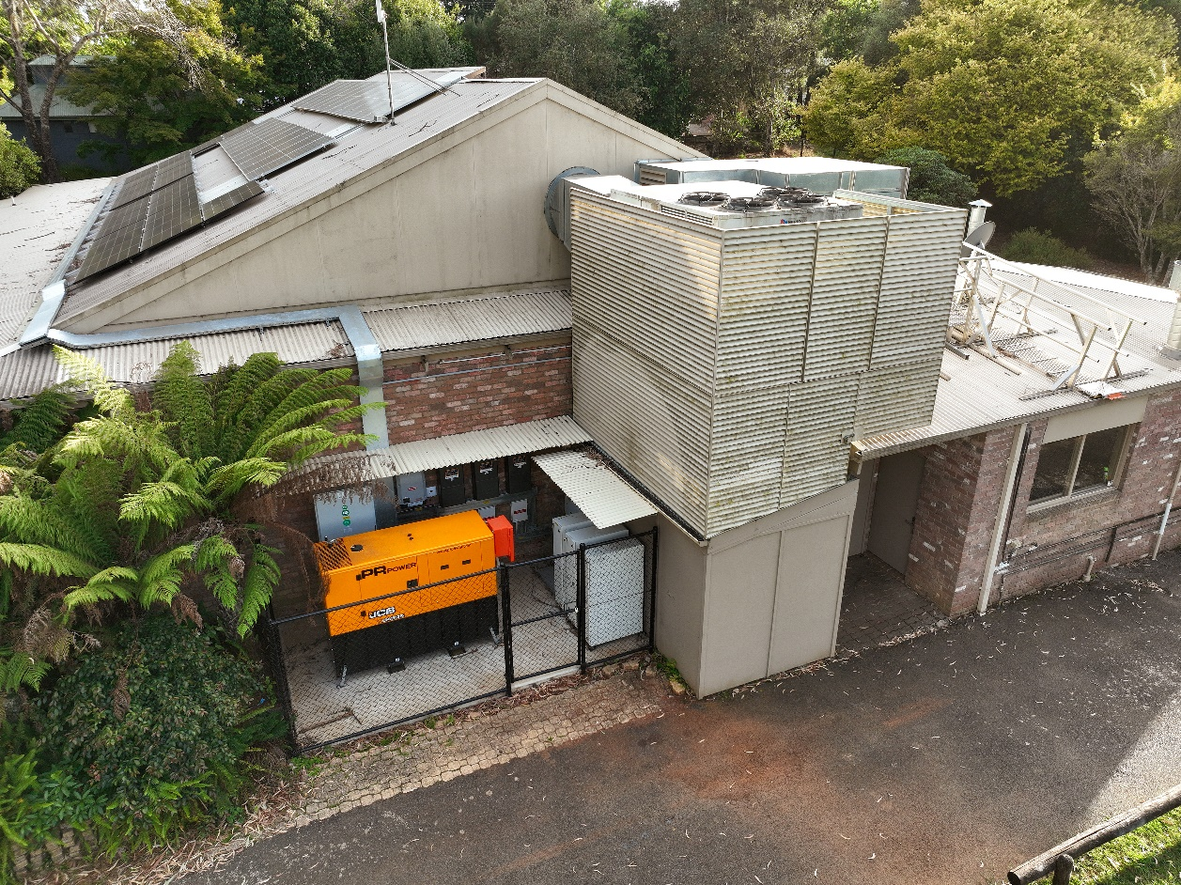



We acknowledge Victorian Traditional Owners and their Elders past and present as the original custodians of Victoria’s land and waters and commit to genuinely partnering with them and Victoria’s Aboriginal community to progress their aspirations.

© The State of Victoria Department of Energy, Environment and Climate Action August 2024.

Creative Commons

This work is licensed under a Creative Commons Attribution 4.0 International licence, visit the [Creative Commons website](http://creativecommons.org/licenses/by/4.0/) (<http://creativecommons.org/licenses/by/4.0/>).

You are free to re-use the work under that licence, on the condition that you credit the State of Victoria as author. The licence does not apply to any images, photographs or branding, including the Victorian Coat of Arms, and the Victorian Government and Department logos.

**ISBN** 978-1-76136-888-2 **(Print)**  
**ISBN** 978-1-76136-889-9 **(pdf/online/MS word)**

Disclaimer

This publication may be of assistance to you but the State of Victoria and its employees do not guarantee that the publication is without flaw of any kind or is wholly appropriate for your particular purposes and therefore disclaims all liability for any error, loss or other consequence which may arise from you relying on any information in this publication.

Accessibility

To receive this document in an alternative format, phone the Customer Service Centre on 136 186, email [customer.service@delwp.vic.gov.au](mailto:customer.service@delwp.vic.gov.au), or contact National Relay Service on 133 677. Available at [DEECA website](http://www.deeca.vic.gov.au/) (www.deeca.vic.gov.au).