Gippsland offshore wind transmission

Approach to refining the transmission location
December 2024
VicGrid is developing the shared transmission line to connect offshore wind energy generated off the Gippsland coast to the grid.
This factsheet explains how VicGrid will refine the study area to decide the location for the new transmission.
The new transmission in Gippsland is an overhead transmission line from a connection hub near Giffard to a grid connection point at the Loy Yang Power Station.
In March 2024, VicGrid confirmed the study area for the transmission needed to achieve at least 2 gigawatts (GW) of offshore wind energy by 2032. Read more about our process to decide the study area in the Gippsland options assessment report go.vic.gov.au/3StZDij
The study area is about 50 km to 55 km long and varies in width from 3 km to 12 km. It starts about 6 km from the coast near Giffard and extends north-west past Stradbroke West to Willung, across to Flynns Creek to the Loy Yang Power Station.
VicGrid is now refining the transmission study area through consultation with landholders and in-depth technical assessments that will help us understand important areas and features and minimise impacts on host communities.
VicGrid will continue to use our guiding principles as the foundation of the refinement process to narrow the study area to a preferred corridor then a route, then a transmission easement.

VicGrid’s guiding principles
- Minimise impact on host landholders and communities, including visual amenity.
- Minimise impact on the environment.
- Minimise impact on First Peoples’ cultural values and aspirations.
- Minimise impact on existing and future land use.
- Minimise cost impacts to energy consumers and generators.
- Limit engineering complexities during construction and impacts on existing infrastructure.

How we will refine and decide the transmission location
To refine the transmission study area we will apply a range of criteria to help us understand and compare potential impacts and identify suitability of land for hosting transmission. We will share the results of our work for consultation and feedback.
The criteria are informed by VicGrid’s guiding principles, industry expertise, community feedback and engagement.
Refining from a study area to an easement through engagement and technical assessments
Study area – Broad area 3 km to 12 km wide and possible alignment with other infrastructure to reduce impacts.
Corridor – Area of connected land identified through desktop review and tested through consultation and site investigations to minimise overall impacts.
Route – Narrower area and final stage before easement selection, with micro-siting of towers to minimise impacts on land use and operations.
Easement – A legally secured right-of-way for the transmission infrastructure to be built and maintained.

Refinement criteria
This table provides a summary of the criteria and examples of how they will be applied.
All feedback gathered through consultation will be considered in the refinement process.
Criteria | Examples of areas that are less suitable for further investigation | Examples of areas that are more suitable for further investigation
Scenic places and visual amenity | Land closer to dwellings, heritage places or scenic lookouts. | Land further from a dwelling, open landscapes and land screened by vegetation.
Land uses and zones | Areas closer to homes, schools and recreation areas and land zoned for rural living, recreation, conservation or environmental significance. | Land already zoned for utilities and infrastructure or used for livestock grazing or grain growing.
Land size | Smaller parcels of land which would be detrimentally fragmented by transmission. | Larger parcels with potential to minimise fragmentation by locating transmission along the boundary, taking account of impacts for neighbouring properties.
Biodiversity | Land with mostly native flora and fauna and a higher likelihood or confirmed presence of threatened species. | Land with little or no native flora and fauna.
Waterways | Areas where waterway flow impacts and flooding effects might be greater. | Areas less likely to be affected by flow changes and flooding.
Cultural heritage | Areas of high Aboriginal cultural heritage significance, where ancestral remains, songlines or ceremonial sites may be found. | Land already disturbed by other infrastructure or industry.
Buildings, tracks, other infrastructure | Areas with more buildings or infrastructure, particularly active irrigation, dams and homes. | Land with fewer buildings or less critical infrastructure.
Technical and constructability | Land featuring mountainous terrain, large water bodies, regular flooding, contamination or swampy areas which would present greater construction complexity and cost. | Less mountainous land and areas which do not require long spans between towers and sharp turns in the transmission alignment.

Progress on refining the study area to help identify a transmission corridor
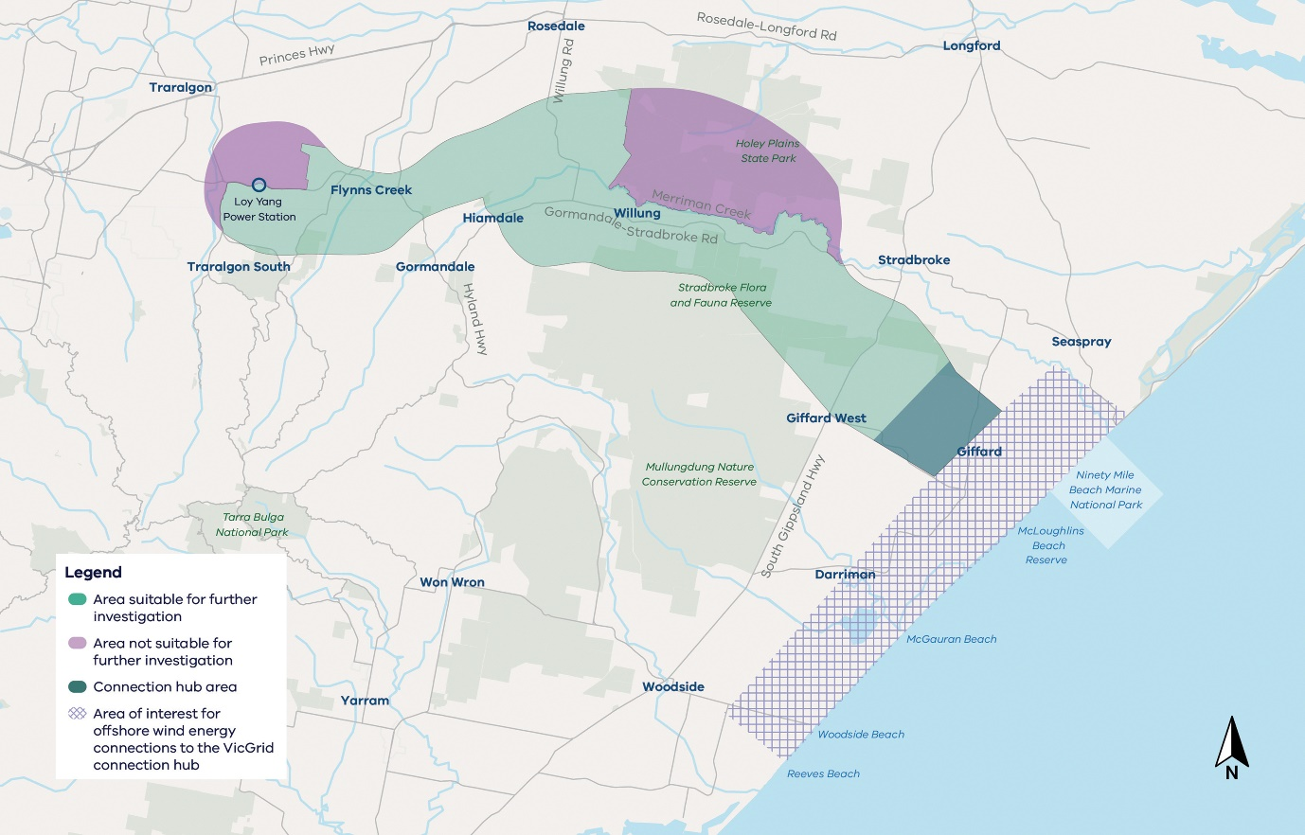

Our work to refine the study area
VicGrid has completed desktop analysis and applied the refinement criteria to identify and assess areas suitable for further investigation to host transmission for the first 2 GW of offshore wind.

What is shown on this map?
Areas not suitable for further investigation – This land has been identified through our assessments so far as not suitable to host transmission and has been removed from the study area.
Areas suitable for investigation – Information is still needed to identify whether these areas may be suitable for transmission.

Summary of areas identified as not suitable for further investigation
So far we’ve completed desktop analysis to assess the suitability of land in Gippsland to host transmission. Some areas have been identified as not suitable for further investigation for a range of reasons, such as presence of significant biodiversity values and construction challenges.
Each land parcel is carefully considered through this refinement process and we’re continuing our work to understand the suitability of land in the study area to host transmission.
We still need to complete field studies and other investigations of private and public land. Information gathered will help us to balance competing priorities and minimise impacts as much as possible.

Holey Plains State Park
Land identified with rare or threatened native flora and fauna with a high likelihood or confirmed presence is less suitable for further investigation. For example, the Wellington Mintbush, listed as vulnerable under the Environment Protection and Biodiversity Conservation Act 1999 (Cth), is a rare native species and the majority of remaining plants are found in the Holey Plains State Park. Building transmission in this area would have an unavoidable impact on this species.

West of Loy Yang Power Station
The transmission line is proposed to connect at the Loy Yang switch yard, at the Loy Yang Power Station. Areas located west of the switch yard would not be required as they are beyond this proposed connection point. Some land parcels would also require transmission to span across the Loy Yang open cut mine, which would not be technically feasible.

Landlocked areas
Some areas have been identified as not suitable as they are landlocked between other areas that have been identified as not suitable for investigation.

Approaches to minimising, assessing and managing impacts
VicGrid will use these approaches to inform our assessment criteria and refinement work:
Landholder engagement | Discussions with landholders on farming operations, agricultural practices, locations of dwellings, structures and high value areas to minimise fragmentation of blocks, manage construction access and respect landscape and local amenity.
Traditional Owners and First Peoples engagement | Discussions with Traditional Owners and First Peoples to learn more about places of tangible and intangible cultural heritage value.
Community and stakeholder engagement | Discussions with communities and local groups to learn more about local areas of importance, landscape features and environmental values.
Technical studies | Technical specialists complete visual, on-site and desktop investigations to identify and understand environmental values and assess the project’s potential environmental, social, economic and cultural impacts.
Planning and environmental assessment and approvals | Assessment of the project’s potential impacts under the Environment Protection Biodiversity Conservation Act 1999 (Cth) and preparation of an Environment Effects Statement (EES) which will be exhibited for public submissions.

Working with landholders to refine the study area
Consultation with landholders will help inform the next phase of refinement and build on our understanding of the local values and characteristics of their properties and communities.
We have a dedicated landholder engagement team working with landholders in the study area.
We’re seeking to understand what is important to landholders about their properties. We want to learn more about property features such as buildings, waterways and farming practices, and conduct environmental and technical surveys.
If you are a landholder in the transmission study area and would like to discuss land access, please contact your land liaison adviser or VicGrid at landholders@deeca.vic.gov.au

Working with Traditional Owners
VicGrid understands and respects Traditional Owners’ legal and cultural rights, along with their deep connection with Land, Sea and Sky Country as original custodians.
Building on the principles of the Gunaikurnai Land and Waters Aboriginal Corporation (GLaWAC) Pathways to Partnership approach, VicGrid will continue discussions with GLaWAC on ways to minimise potential impacts to tangible and intangible cultural heritage and values. To learn more about the Pathways to Partnership approach visit gunaikurnai.org/our-news/publications and download “Pathways to Partnerships”.

Contact us
Phone: 1800 418 341
Email: vicgrid@deeca.vic.gov.au
Deaf, hearing or speech impaired? Please contact the National Relay Service on 133 677 or communications.gov.au/accesshub/nrs
Need an interpreter? Contact Translating and Interpreting Service (TIS) on 131 450 (within Australia) or visit www.tisnational.gov.au
ISBN 978-1-76136-988-9 (Print)
ISBN 978-1-76136-989-6 (pdf/online/MS word)
Disclaimer: The information in this document is current at the time of printing, may be subject to change and should not be relied upon. Please visit vicgrid.vic.gov.au for the latest updates.

