# Energy Assistance Program

Summer Promotional Materials

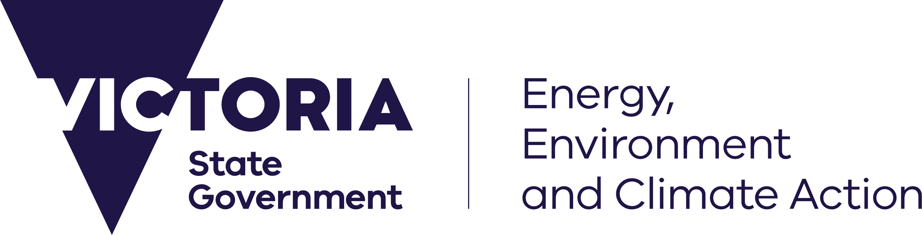

## Social Media Content

deeca.vic.gov.au

### Social Media Tile One

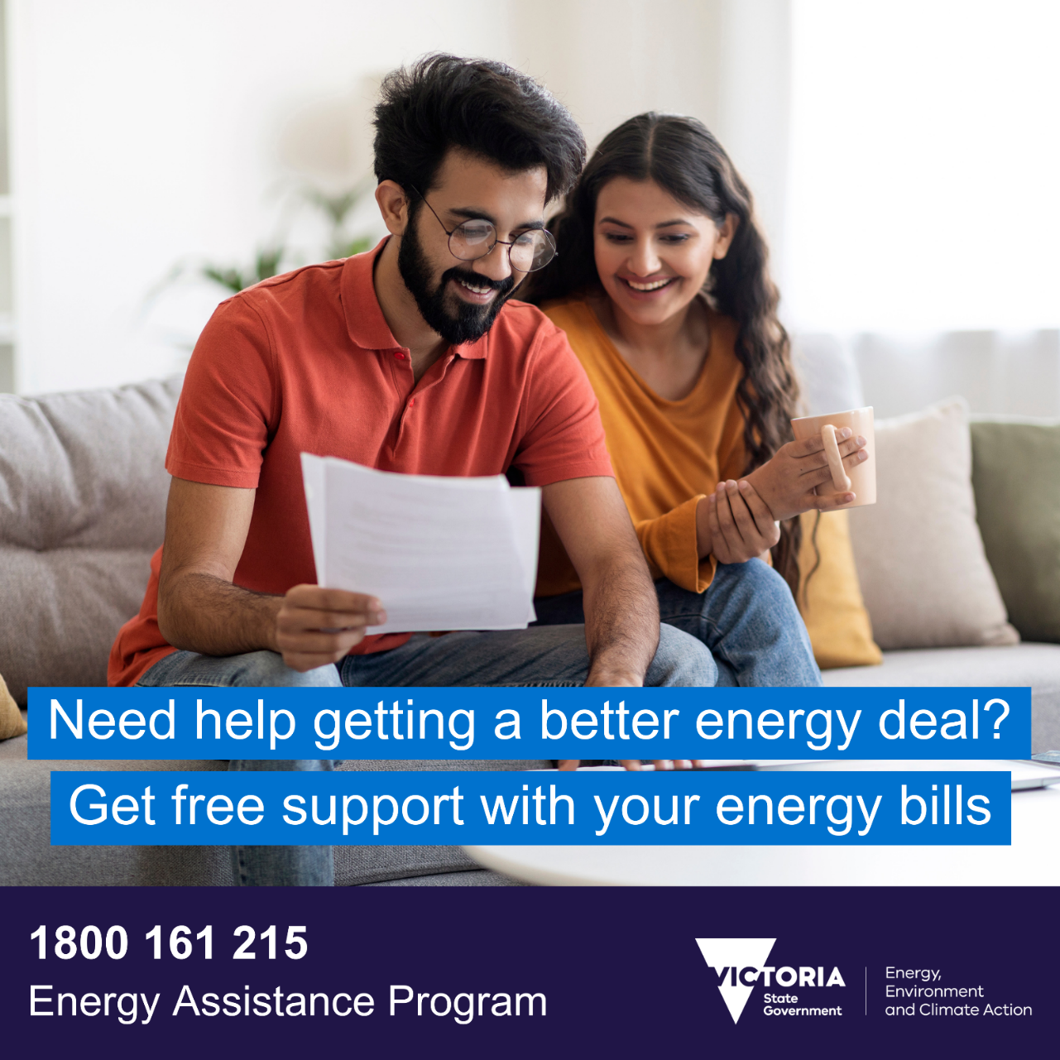

#### Suggested Caption

As the weather is warming up, you’re probably thinking about the cost of staying cool this summer.

If you’re having trouble keeping up with energy bills – or want to get ahead of your summer cooling costs, get help through the Victorian Government’s Energy Assistance Program.

Visit <https://www.energy.vic.gov.au/households/help-paying-your-energy-bills/energy-assistance-program> or call 1800 161 215 to get free help to save on energy bills.

### Social Media Tile Two

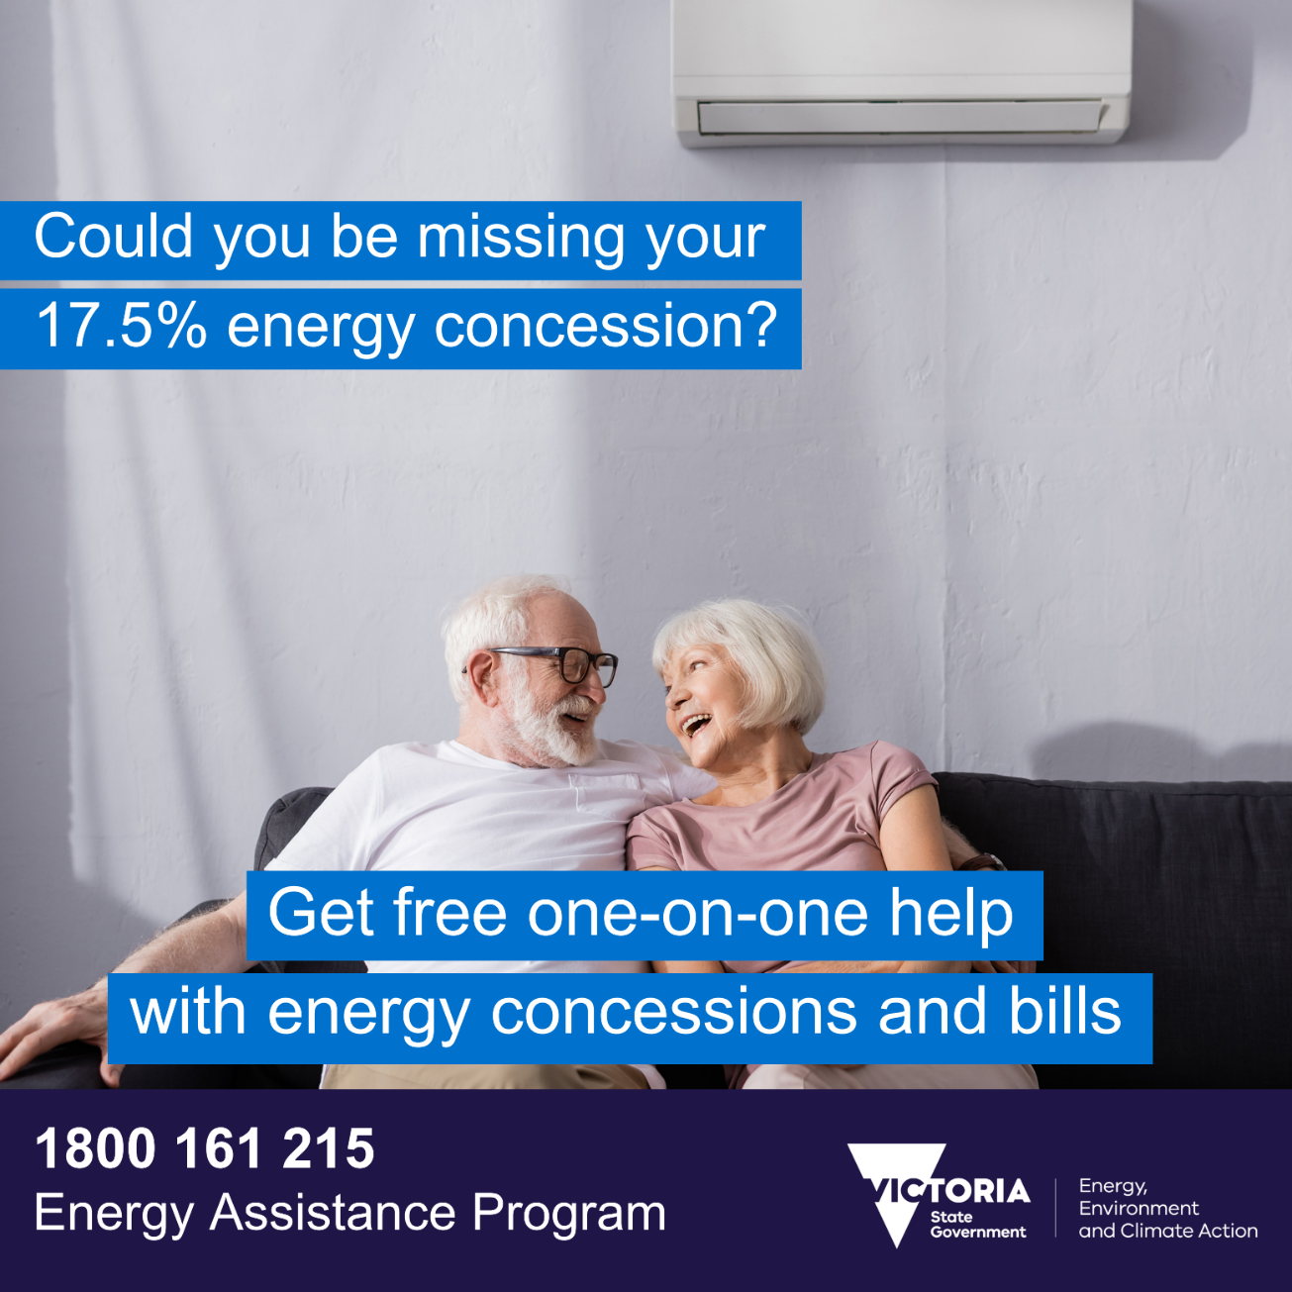

#### Suggested Caption

Did you know concession card holders are eligible for 17.5% off electricity bills? But you could be missing out.

Get ahead of your summer energy bills and check you’re getting your eligible electricity concession – so you can save on staying cool.

If you need help checking your electricity concession and want to find more ways to save on energy bills you can get free help through the Victorian Government’s Energy Assistance Program.

Visit <https://www.energy.vic.gov.au/households/help-paying-your-energy-bills/energy-assistance-program> or call 1800 161 215 today.

### Social Media Tile 3

#### Suggested Caption

We all want to save money for the things that matter this summer, whether that’s taking a well-earned break, catching up with friends, or a gift for a loved one. Put money back in your summer budget by making sure you’re not paying too much for energy.

If you need help with energy bills, free one-on-one support is available through the Victorian Government’s Energy Assistance Program.

🔍Find a better energy deal

💸Get help to apply energy concessions

⚡Access extra financial support if you’re having trouble paying your energy bills

📞Get advice on how to save energy and money around the home

Visit [https://www.energy.vic.gov.au/households/help-paying-your-energy-bills/energy-assistance-program](https://www.energy.vic.gov.au/households/help-paying-your-energy-bills/energy-assistance-program%20) or call 1800 161 215 today.  

## Newsletter Content

As warmer weather sets in across the state, many Victorians are thinking about the cost of staying cool this summer.

If you’re having trouble keeping up with energy bills – or want to get ahead of your summer cooling costs, [**you can get help through the Victorian Government’s free Energy Assistance Program.**](https://www.energy.vic.gov.au/households/help-paying-your-energy-bills/energy-assistance-program)

Did you know cooling your home makes up a big part of your energy bill? The Energy Assistance Program can help you make sure you’re not paying too much to stay cool through the hot months ahead.

**Call 1800 161 215 today to get free one-on-one assistance to start saving on your summer energy bills.** The Energy Assistance Program can help you to save energy at home, switch to a better energy deal, access eligible energy concessions, manage energy debt and contact your retailer.