# Energy Assistance Program

Suggested Newsletter Text (Shortened Version)

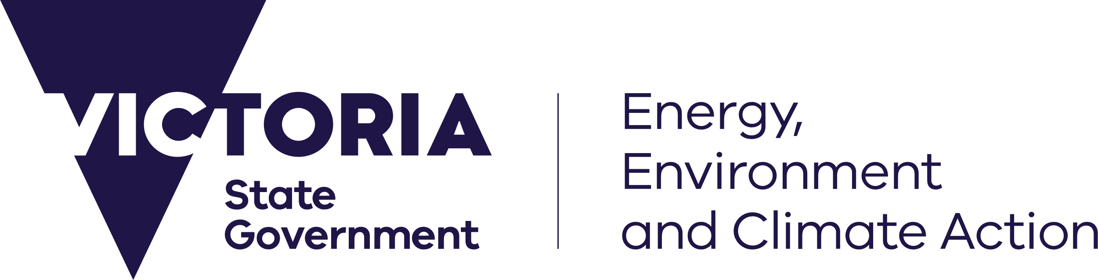

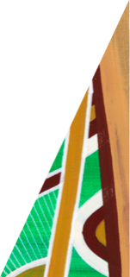

deeca.vic.gov.au

**Having trouble with energy bills? Get free help through the Victorian Government’s Energy Assistance Program.**

If you’re having trouble with energy bills, you’re not alone. [You can get free help through the Victorian Government’s Energy Assistance Program.](https://www.energy.vic.gov.au/households/help-paying-your-energy-bills/energy-assistance-program)

The Energy Assistance Program can help you to save energy at home, switch to a better energy deal, access eligible energy concessions, manage energy debt and contact your retailer.

**To save on your energy bills call 1800 161 215 today** and you’ll be connected to Energy Assistance Program delivery partner Anglicare Victoria.