# Energy Assistance Program

Suggested Newsletter Text

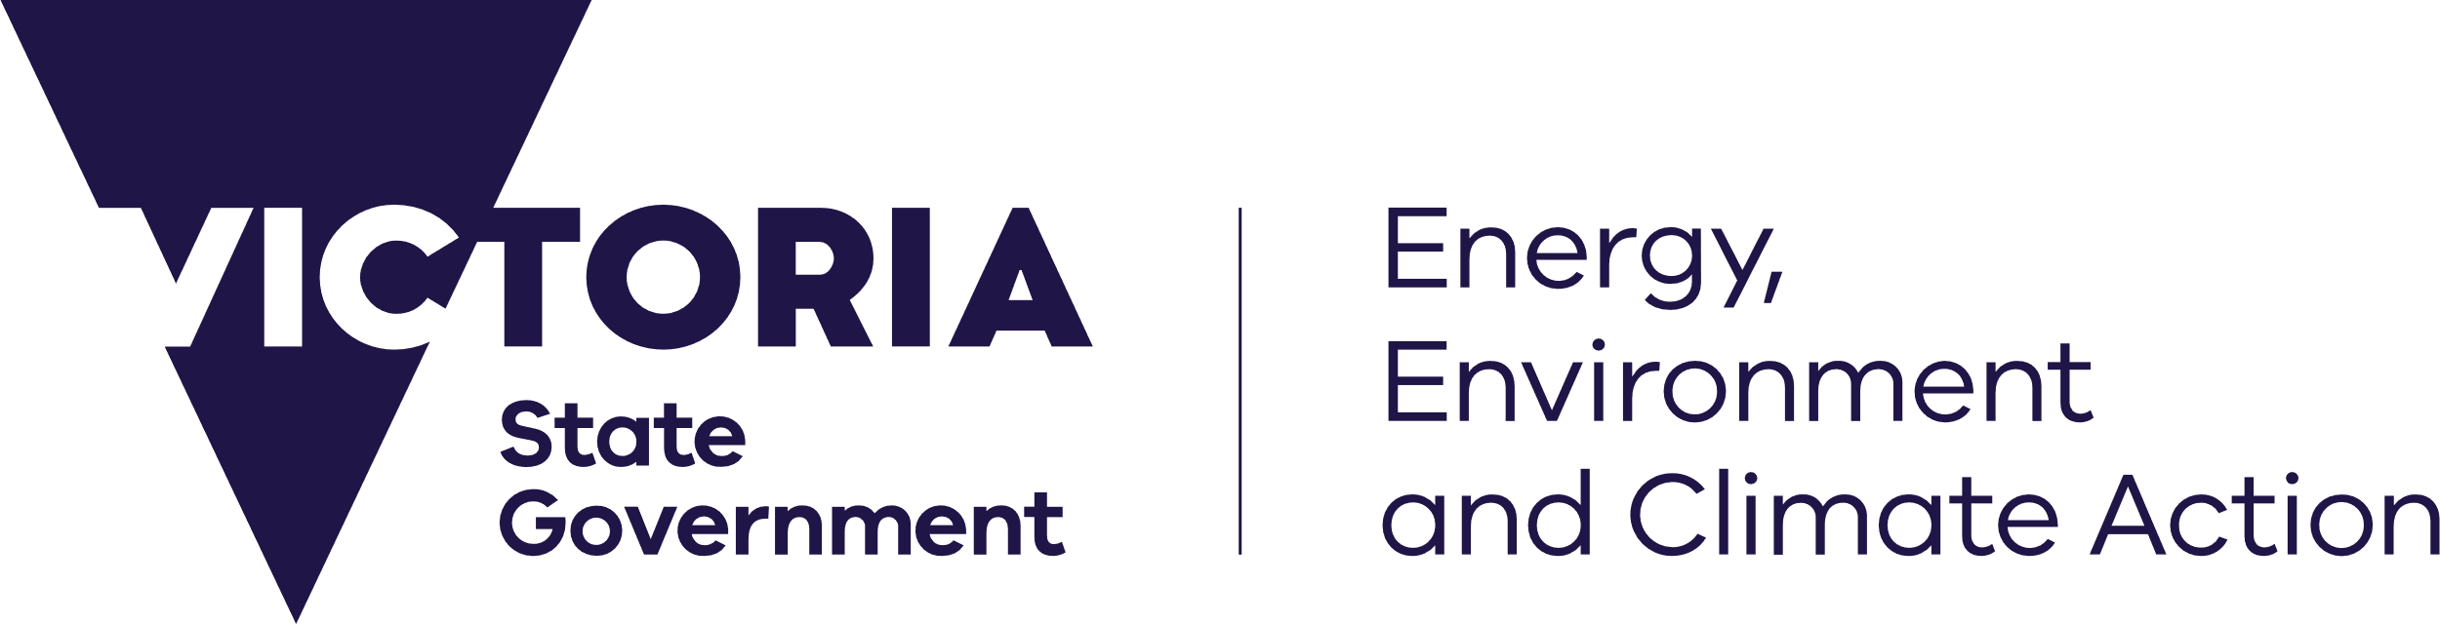

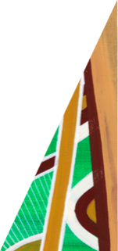

deeca.vic.gov.au

**Having trouble with your energy bills? Get help through the Victorian Government’s free Energy Assistance Program.**  
  
Whether you’re a student, pensioner, or full-time worker – we know that rising energy bills are putting pressure on the household budget.   
  
If you’re having trouble with energy bills, you’re not alone. [You can get help through the Victorian Government’s free Energy Assistance Program.](https://www.energy.vic.gov.au/households/help-paying-your-energy-bills/energy-assistance-program)   
  
The Energy Assistance Program can help you to save energy at home, switch to a better energy deal, access eligible energy concessions, manage energy debt and contact your retailer.   
  
Join more than 11,000 Victorians who’ve saved money on energy bills through the Energy Assistance Program. To find your savings, **call 1800 161 215 today** and you’ll be connected to Energy Assistance Program delivery partner Anglicare Victoria.