Victorian Government Response to the Network Outage Review

Introduction
The independent Network Outage Review examined the operational response of Victoria’s networks to the February 2024 power outages. It made recommendations which place community at the centre and aims to get better outcomes for all Victorians.
The Review’s 19 recommendations form a clear pathway for Victoria’s transmission and distribution businesses to prepare better, to prevent outages, and to more effectively reconnect and provide support to communities during and after events, and to continuously improve by learning from these experiences.
Implementation of the recommendations will contribute to:
- reducing prolonged power outage impacts on Victorian communities, including improvements in supporting the community and infrastructure in areas of high risk.
- Improving the planning and preparation for business continuity for other critical infra-structure operators, like telecommunications and water, for the first 72 hours of an event.
Figure 1: Victoria’s energy sources – how electricity reaches our home
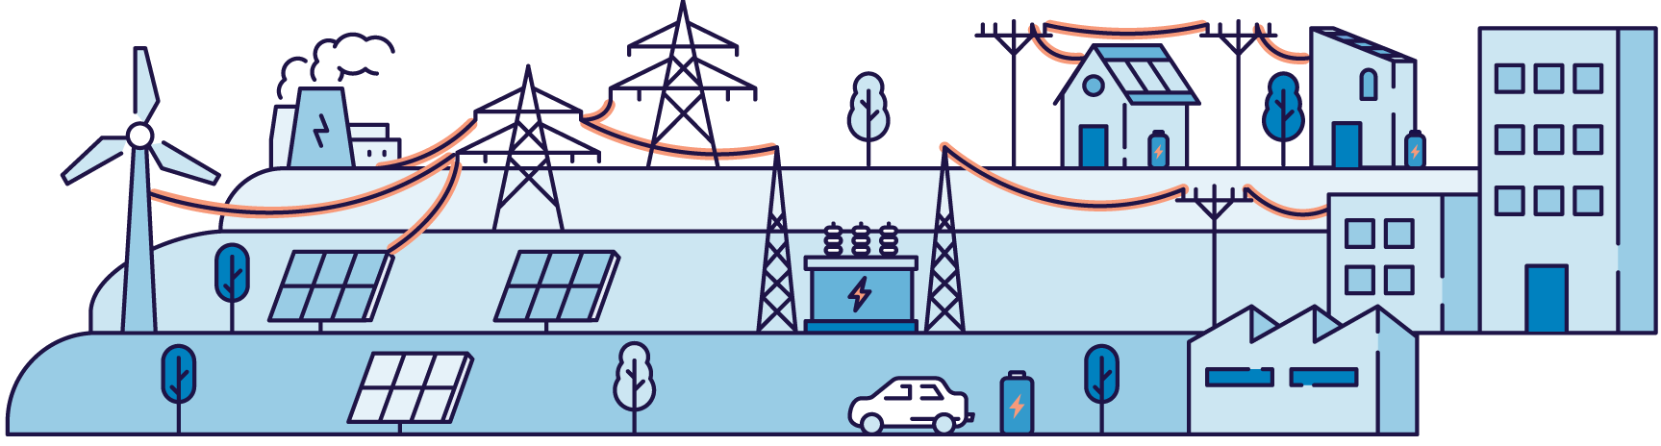

Actions the Victorian Government is taking to improve outcomes for the community

Stronger oversight and accountability of the Victorian network’s emergency risk management

Recommendations 1-4, and 18-19
- Heightened reporting to the Minister for Energy and Resources on the transmission and distribution businesses’ emergency risk management – signed off at the highest level (e.g. company boards). Government oversight to ensure lessons from the 13 February event are learnt and results in improved emergency risk management.
- A future independent review after the next comparable event to measure how effective the Network Outage Review recommendations have been.
An independent assessment of AusNet’s transmission emergency risk management.

Stronger planning and coordination between government, industry and community

Recommendations 5, 6, 8, 9, 10, 16
- Better support for community to prepare for prolonged power outages.
- Undertake an exercise with the networks, emergency agencies and critical infrastructure to test what has been learnt from the 13 February 2024 event, and improve coordination between those involved.
- Driving stronger planning and resilience of critical infrastructure (including telecommunications) so they can continue to operate for longer during power outages.
- Formalise how the networks provide support to each other (mutual aid) during events, to restore customers more quickly.

Address gaps in the regulatory frameworks so the networks better prepare, respond, and support impacted communities

Recommendations 11-13
- Examine heightening accountability on the distribution businesses to restore customers quickly, and provide more appropriate financial support to customers through an ELOSS scheme.
- Examine a Minimum Service Level Scheme – a safety net so that investment occurs in areas of poor network performance that accounts for prolonged power outages.
While the above is examined, take quick action and require AusNet to improve its network performance and install ‘quick connection points’ in known areas of high risk of prolonged outages.

Improve how networks communicate with community, and better support Life Support Customers

Recommendations 5, 7, 14, 15
- Address barriers to supporting Life Support Customers in prolonged outages.
- Examine how to achieve more accurate customer details, and additional household contact details – so better communication with customers can occur before and during events.
- Examine the introduction of a consumer duty to enhance customer communication and service.

Publication information

Acknowledgements
The Victorian Government acknowledges Aboriginal Traditional Owners of Country throughout Victoria and pays respect to their cultures and Elders past and present.

Copyright
© The State of Victoria Department of Energy, Environment and Climate Action,
December 2024.

Creative Commons
This work is licensed under a Creative Commons Attribution 4.0 International licence, visit the Creative Commons website (http://creativecommons.org/licenses/by/4.0/).
You are free to re-use the work under that licence, on the condition that you credit the State of Victoria as author. The licence does not apply to any images, photographs or branding, including the Victorian Coat of Arms, and the Victorian Government and Department logos.

Disclaimer
This publication may be of assistance to you but the State of Victoria and its employees do not guarantee that the publication is without flaw of any kind or is wholly appropriate for your particular purposes and therefore disclaims all liability for any error, loss or other consequence which may arise from you relying on any information in this publication.

Accessibility
To receive this document in an alternative format, phone the Customer Service Centre on 136 186, email customer.service@delwp.vic.gov.au, or contact National Relay Service on 133 677. Available at DEECA website (www.deeca.vic.gov.au).
deeca.vic.gov.au

