Energy Assistance Program

# Free one-on-one support with your energy bills.

## Are you having trouble paying your energy bill or want to move to a cheaper energy deal?

We can help you:

* Understand your energy bill
* Check you aren’t missing out on your energy concessions
* Access extra financial support and get help with energy debt
* Find a more affordable energy deal
* Understand the best ways to save energy at home to reduce your bills
* Speak to your energy retailer and access hardship support

All you need is a copy of your most recent bill.

## What is the Energy Assistance Program?

* The Energy Assistance Program is a free service to support you if you are having trouble paying or understanding your energy bills.
* It will help you save energy and money at home.
* You’ll receive one-on-one support to access eligible energy concessions, find the cheapest energy offer for your household, get financial support with energy debt, and help with contacting your retailer.

## Eligibility Requirements

To access the program, you should:

* Hold a Commonwealth Government Concession card; or
* Be struggling or expecting to have trouble paying your energy bill.

# Need help with your energy bill? Call 1800 161 215 for free support

## How it works

To get help with your energy bills just follow 3 simple steps:

1. Find a copy of your **most recent energy bill**
2. Phone **1800 161 215** to get connected with our community partners
3. One of our **energy advocates can help you** understand and save money on your energy bills, access debt help and can speak to your energy retailer on your behalf.

Scan the QR code below or call **1800 161 215** to get help through the Energy Assistance Program

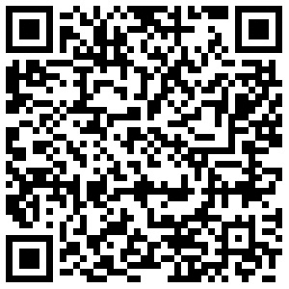

[**energy.vic.gov.au/households**](http://energy.vic.gov.au/households)

© The State of Victoria Department of Energy, Environment and Climate Action August 2024

This work is licensed under a Creative Commons Attribution 4.0 International licence, visit the [Creative Commons website](http://creativecommons.org/licenses/by/4.0/) (<http://creativecommons.org/licenses/by/4.0/>). You are free to re-use the work under that licence, on the condition that you credit the State of Victoria as author. The licence does not apply to any images, photographs or branding, including the Victorian Coat of Arms, and the Victorian Government and Department logos.

**ISBN:** 978-1-76136-962-9 (pdf/online/MS word).

**Disclaimer**

This publication may be of assistance to you but the State of Victoria and its employees do not guarantee that the publication is without flaw of any kind or is wholly appropriate for your particular purposes and therefore disclaims all liability for any error, loss or other consequence which may arise from you relying on any information in this publication.

**Accessibility**

To receive this document in an alternative format, phone the Customer Service Centre on 136 186, email customer.service@delwp.vic.gov.au, or contact National Relay Service on 133 677. Available at DEECA website (www.deeca.vic.gov.au).

For assistance in languages other than English, contact Translating and Interpreting Services (TIS) on 131 450.

**End of document.**