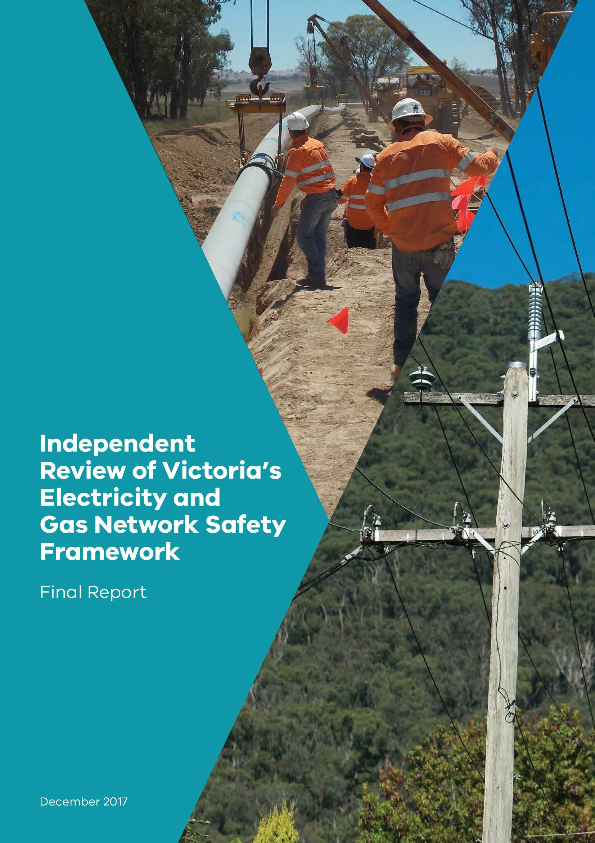

ISBN 978-1-76047-854-4 (Print)
ISBN 978-1-76047-855-1 (pdf/online)

Disclaimer
This publication may be of assistance to you but the State of Victoria and its employees do not guarantee that the publication is without flaw of any kind or is wholly appropriate for your particular purposes and therefore disclaims all liability for any error, loss or other consequence which may arise from you relying on any information in this publication.

Contents
Overview 4
Executive Summary 6
Recommendations 31
PART A: THE REVIEW 39
PART B: THE SAFETY FRAMEWORK 42
PART C: LEADING PRACTICE 63
PART D: THE BUILDING BLOCKS OF A WORLD LEADING ENERGY NETWORK
SAFETY REGIME 82
Chapter 1: ESV’s Regulatory and Corporate Governance 83
Chapter 2: ESV’s Regulatory Approach and Capabilities 101
Chapter 3: Engagement Across Regulatory and Interagency Boundaries 135
Chapter 4: Integrating Safety Regulation with Economic Regulation 148
Chapter 5: Promoting Workforce Engagement 165
Chapter 6: Programs to Address Bushfire Risk in Victoria 175
Chapter 7: Regulating Underground Energy Assets 197
Chapter 8: Regulating the Networks of the Future 212
Chapter 9: Strengthening the Foundations for Future Network Safety Regulation 227
PART E: APPENDICES 251

Overview
This Final Report presents the Review’s findings and recommendations to position Victoria at the forefront of the safety regulation of electricity and gas networks.
It incorporates ten essential elements, chiefly focussed on strengthening the capabilities and regulatory approach of the regulator, Energy Safe Victoria (ESV), underpinned by consolidated and improved legislation.

Strengthening the Energy Safety Framework: Ten Essential Elements

Strengthen governance by establishing ESV as a three-person commission
  - stronger governance of regulatory decisions and approach
  - stronger corporate governance of ESV itself

Build a stronger and more active ESV presence out 'on the ground'
  - more safety inspectors and auditors to 'test, challenge and expose'

Strengthen ESV's capabilities and preparedness to take strong regulatory action
  - ESV must operate as a confident regulator, always prepared to take strong action if necessary – and backed with the capabilities to do this well

Maintain active and positive engagement with network businesses
  - with ESV clearly recognised, and respected, as the safety regulator, with a fundamental obligation to serve the Victorian community first

Emphasise building and supporting deep safety cultures within network businesses
  - safety must be deeply embedded within the organisational cultures of network businesses, their systems and processes, with strong and highly engaged leadership from the board and chief executive level down
  - strong engagement with the workers who maintain and build the networks

Substantially strengthen ESV's analytical capabilities
  - stronger data analytics to provide statistically robust information about safety risks for the Victorian community
  - a comprehensive integrated intelligence system – to target audits and inspections and to identify emerging risks earlier

Create a single energy safety law, with "safety-case" based regulation at its core
  - providing the foundations of a regulatory system built on achieving safety outcomes

  - with a longer-term aspiration of more 'outcomes-based' regulation and less prescriptive regulation – but only when there is deep confidence established in the maturity of the safety-case based regulatory framework
: the onus is on network businesses and ESV collectively to build this confidence

Better guidance to network businesses and sharing of best practices
  - helping network businesses to efficiently comply with safety regulation requirements
  - using ESV's 'convening power', and its national leadership position, to identify and share best practices

Position ESV as a modern and progressive regulator looking over the horizon
  - to anticipate the challenges and opportunities of new energy markets
  - and assist the economic regulator as a trusted and expert safety adviser

Strong accountability for implementation of actions in response to the recommendations of this Review following government consideration
  - implementation reporting must not be a 'box ticking' exercise

Executive Summary

Context
Energy network safety has long been a concern for the Victorian community and a high priority for successive Victorian governments.

The Longford gas explosion in 1998, while occurring in a production facility outside the transmission and distribution network itself, highlighted the impacts of a major accident disrupting gas supply to the state, and emphasised the dangers that workers in the gas industry face.

The Black Saturday bushfires in February 2009 brought electricity network safety concerns to the fore, particularly as most of the 173 lives lost that day were ultimately linked with fires initially sparked by faults in electricity lines running through tinder-dry bushland.

Both the Longford and Black Saturday incidents were examined by Royal Commissions, and the recommendations from those Royal Commissions have influenced the development of safety frameworks for Major Hazard Facilities and energy networks in Victoria.

This Review examines the safety frameworks applying to electricity and gas networks in Victoria administered by the safety regulator, Energy Safe Victoria (ESV).

While the safety regime applying to Major Hazard Facilities is outside the scope of the Review, there are some close connections in the way safety regulation in the two areas has
developed in Victoria over the past two decades, particularly with the adoption of so-called “safety case” systems of regulation.

The Review was commissioned by the Minister for Energy, Environment and Climate Change in January 2017, and was required to present its Final Report by the end of 2017.

This Final Report presents the Review's findings and recommendations. In developing the Final Report, the Review considered submissions provided by interested groups on the Interim Report, released on 31 October 2017. The Review team wishes to thank all stakeholders who contributed to the Review.

Approach of the Review

The Review has centred its consideration around two key questions:

- What are the characteristics of leading practice safety regulation frameworks applying to electricity and gas networks, or to other similar sectors, and how does the current Victorian safety framework compare with leading practice?

- What are the characteristics required by a highly effective safety regulator, and are there any areas in which the Victorian regulator, ESV, needs to invest greater effort?

The Review’s conclusions in this Final Report are that Victoria has many of the key elements of a leading safety regulatory system in place – but there are areas requiring attention, particularly around implementation.

The Victorian Government has initiated a major program of work to address bushfire risk, including internationally pioneering research and development, and ESV has established a national reputation for its work in leading energy safety initiatives. Nevertheless, there are several areas where improvement is required to ensure that the state maintains an internationally leading network safety system.

The Review's assessment has been informed by formal submissions in response to two issues papers released earlier in 2017 and to the Interim Report released on 31 October 2017. It has also been informed by meetings with a wide range of relevant organisations and individuals, including with:

- all state regulators of electricity and gas networks in Australia;
- all gas and electricity transmission and distribution businesses operating in Victoria;
- the Electrical Trades Union;
- academic experts; and
- national and state government agencies that have responsibilities with an interest in energy network safety.

To assist its consideration, the Review commissioned reports on leading practice safety regulation for electricity and gas networks from the consulting firm Marsden Jacob, and on ESV's data capabilities from the University of Melbourne.

The Review was greatly helped by very open and constructive engagement through a series of wide-ranging roundtable discussions with the Director of Energy Safety, his executive leadership team, and with staff of ESV. The Review was also assisted by field inspections of facilities and infrastructure managed by AusNet Services and Powercor.

Making the case for safety: The characteristics of leading safety frameworks
International thinking around the most effective safety regulatory frameworks for hazardous industries has been heavily shaped by several major catastrophic incidents over the past four or five decades.

In Australia, and many other countries, leading practice has coalesced around a “safety case” approach, whereby regulated operators must have comprehensive systems and processes to identify and manage safety risks – and they must be able to demonstrate the effectiveness of their systems to an external regulator.

This broad approach was originally pioneered in the United Kingdom’s nuclear industry in the 1960s, and was adopted more widely across the European Union from the 1980s through the EU’s “Seveso directive”, named after the Italian town that was exposed to the release of highly toxic dioxin following a chemical plant explosion in 1976.

While not specifically using the term “safety case”, the original Seveso directive required the operators of certain hazardous industrial facilities in EU member states to prove they had the necessary comprehensive procedures in place to effectively manage safety.

The safety case approach was extended to the United Kingdom’s offshore oil and gas industry following the official inquiry by Lord Cullen into the Piper Alpha oil platform disaster in 1988. It was subsequently applied to offshore oil and gas production in Australia from 1996.

Victoria – and, indeed, one of ESV’s two predecessor agencies, the Office of Gas Safety – was an early adopter of the safety case approach. Safety cases were introduced as a statutory requirement for gas transmission and distribution networks in Victoria from late 1997.

The Royal Commission examining the 1998 Esso Longford Plant explosion found that the plant itself was subject to less stringent safety regulation than the safety case requirements in place both upstream and downstream of the plant. The Royal Commission recommended that the safety case approach be applied more broadly to all Major Hazard Facilities in Victoria.

Outcomes-based regulation and the capabilities required by an effective safety regulator
The safety case approach is an outcomes-based form of regulation. The overarching requirement is for regulated businesses to achieve safe outcomes by reducing risks as far as they can "reasonably practicably" be reduced.

Businesses must have systems and processes in place to achieve this objective. However, they retain flexibility, provided that they can make a sufficiently compelling case to the regulator, that the systems and processes will, in fact, reduce risks as far as reasonably practicable.

International experience has shown that the safety case approach does not provide a silver bullet. Everything depends on how well the safety case is prepared; how deeply it is embedded in the working arrangements and cultures within the organisation that is being regulated; how effectively it is implemented and updated; and how well it is regulated by the external regulator.

In a speech in June this year, Justice Haddon-Cave, who conducted a major inquiry for the British Government into the causes of a catastrophic mid-air loss of an RAF Nimrod aircraft in 2006, summarised this point clearly:

“Safety Cases and the Safety Case regime and methodology are invaluable tools in modern risk management. Safety Cases are here to stay. Properly used, they provide an invaluable intellectual and practical structure for analysing, anticipating and
ameliorating risks. However, like so many ‘paper-based’ solutions, they are open to abuse and lassitude and can become a ‘comfort blanket’ to keep one warm from the chill of having to face the realities of multifarious risk.”

The approach of the regulator is fundamentally important, as highlighted by the Australian National University’s Professor Andrew Hopkins:

“Many jurisdictions around the world have fallen into the trap of thinking that all they need to do to institute a safety case regime is enact the necessary legislation. This is a serious error. Safety case regimes have only functioned well when there is a competent, independent and well-resourced regulator. Importantly, the initial process of evaluating and accepting (or rejecting) a safety case requires a high level of expertise, if it is not to degenerate into a rubber stamp exercise.”

In Part C of this Final Report, the key capabilities required by an effective safety regulator are identified, including:

- an appropriate degree of organisational independence – the capacity of the regulator to make objective, impartial, consistent and expert decisions without any perception of being influenced by conflict or bias, whether from regulated entities or government;

- strong analytical capabilities and reporting;

- technical expertise and understanding of the industry being regulated;

- effective tools and capabilities to achieve compliance and enforce regulatory obligations, including through rigorous audit and inspection programs;

- strong engagement with entities being regulated, including effective communication of regulatory requirements.

A substantial part of this Final Report examines ESV's current capabilities and seeks to identify areas that require additional focus in order for ESV to be at the forefront of regulatory practice.

As outlined in further detail below, much of the work that needs to be done by ESV has been identified through ESV's own strategic planning and review processes over the past two years or so. The imperative now is to ensure that the necessary strengthening of ESV's systems and processes is implemented expeditiously and with high degrees of transparency to promote confidence in the safety framework.

The evolution of the safety framework in Victoria over the past two decades
The preparation and implementation of safety cases and associated safety management systems form the foundation of ESV's approach to network safety regulation. At the same time, the current electricity and gas network safety frameworks in Victoria also include extensive prescriptive statutory requirements, particularly in relation to electricity networks and bushfire risk.

The current Electricity Safety Act 1998 and Gas Safety Act 1997 were established almost exactly 20 years ago, at a time when Victoria embarked on the privatisation of electricity and gas assets. The Gas Safety Act 1997 was passed in late 1997, and was presented to the Victorian Parliament at the time as a “light-handed” approach to regulation built around the new safety case system.

The Electricity Safety Act 1998 was legislated in early 1998. It incorporated various prescriptive requirements, particularly relating to the management of bushfire risk through electric line clearance regulations. Consistent with the trend towards an outcomes-based approach, the Act also incorporated provision for Electricity Safety Management Schemes that could be adopted on a voluntary basis. If approved, network businesses with Electricity Safety Management Schemes would be exempt from some prescriptive requirements of the Act.

In any event, the Electricity Safety Act 1998 has evolved through a series of amendments over the past two decades. Since 2009, Electricity Safety Management Schemes have been a compulsory requirement, operating in addition to other prescriptive requirements set out in the Act or in associated regulations under the Act.

The prescriptive elements that currently apply to the regulation of gas networks and regulation of electricity networks include:

- the Gas Safety (Gas Quality) Regulations 2007, prescribing quality standards, requirements for gas odourisation, and requirements for testing gas quality;

- the Electricity Safety (Electric Line Clearance) Regulations 2015, specifying a code of practice for the management of vegetation near powerlines, and requiring electricity network businesses to submit a management plan to ESV relating to compliance with the code on an annual basis; and

- the Electricity Safety (Bushfire Mitigation) Regulations 2013, specifying content for bushfire mitigation plans submitted to ESV every five years for acceptance, and prescribing requirements for the inspection of overhead electric lines and supply networks and the achievement of other safety standards, including requiring the installation of fault suppression equipment in certain zone substations.

ESV's regulatory and corporate governance
The Review has considered two key aspects of governance:

- the structures and arrangements that apply to ESV's regulatory decision making – that is, its

regulatory governance framework; and

- the structures and arrangements that apply to its organisational decision making – that is, its

corporate governance framework.

ESV is established as an independent regulator. The Energy Safe Victoria Act 2005 sets out the ways in which ESV is accountable to the responsible Minister – the Minister for Energy, Environment and Climate Change – and it provides mechanisms that allow the Minister to set expectations for ESV's performance and corporate direction.

The Act also provides a mechanism to allow the Minister to commission advice and inquiries into certain matters by ESV. However, the Act does not provide for the Minister to direct ESV in its regulatory decision making.

In many areas of regulation, including safety regulation, it is generally recognised that there are broad public benefits in having a regulator that operates independently, removed from political or commercial interests. The Review considers that ESV's independent status should be preserved, but that ESV's regulatory governance should be strengthened by formally constituting it as a three- person commission.

The intention of this recommendation is to broaden accountability for ESV's regulatory decisions and approach from a single decision maker, the Director of Energy Safety. This should promote consideration of a wider range of perspectives in regulatory decision making and lessen the pressure that may fall to one individual when strong, independent decision making is required, free from commercial or political interests.

As a technical regulator requiring specialist skills, ESV relies on staff, including at senior decision making levels, who have previously been employed by the network companies that ESV regulates, or staff who may wish to join such companies as part of their future career development. The movement of staff has a number of benefits, including sharing knowledge to improve network safety. However, it also brings the risk of perceived and actual conflicts of interest in regulatory decision making. The Review proposes that ESV should develop stronger and more formal arrangements to manage this risk.

The Review also proposes that ESV continues to strengthen its internal governance and associated management processes and systems. External reviews commissioned by the Director of Energy Safety in late 2015 and 2016 highlighted several areas of weakness in ESV’s systems and processes. Key issues requiring attention included:

- organisational drift, with ESV lacking a well-defined “organisational model”;
- unbalanced spans of control;
- insufficient team based approaches;
- weaknesses in ESV's strategic foundations;
- insufficient analytical capacities; and
- a lack of a consistent basis for understanding and communicating risk within the organisation.

Following these external reviews, the Director of Energy Safety and ESV’s senior management team have initiated a significant organisational reform program. Reporting structures have been rationalised, investments made in new capabilities, including strengthened analytical capabilities, and a formal Executive Management Board has been established.

While much initial progress has been made, the senior leadership of ESV has indicated to the Review that it considers that the process of organisational reform is an “evolving and continuing work”.

In a very real sense ESV has been on what its senior leadership described to the Review as an “organisational journey”. The relative lack of maturity in formal corporate governance and management structures that seems evident in the conclusions of some relatively recent reports may, in part, reflect the fact that ESV was originally established from technical offices that had originally been located within much larger organisations.

In a series of roundtable discussions held with the Review, the Director of Energy Safety and ESV’s senior leadership team engaged openly and constructively to identify key areas where further work was required to strengthen ESV’s processes and capabilities. An open and transparent approach will greatly assist in boosting internal and external confidence in the steps being taken to improve the quality and maturity of ESV’s corporate governance and management arrangements.

Summary of recommendations: ESV's governance

Recommendations presented by the Review include:

- establishing ESV as a three-person commission, with a full-time chair and two part-time members (Recommendation 1);

- the development of greater guidance and strengthened formal protocols around regulatory decision making by ESV in circumstances where there may be potential or perceived conflicts of interest, particularly in relation to staff who may previously have been employed by regulated network businesses (Recommendation 3); and

- implementation of a workforce strategy to attract and retain high performing staff, and promote workforce diversity, including increased gender diversity (Recommendation 5).

Strengthening ESV's network safety regulation capabilities
The Review set out to evaluate ESV's capabilities as a leading safety regulator, recognising its established strengths and identifying areas that could be strengthened further.

It is perhaps inevitable that most focus is placed on those capabilities that the Review considers should be strengthened. However, the assessment should be viewed in the context of a regulator that has established a reputation as a national leader, and an organisation that is actively seeking to identify ways in which it can improve its effectiveness.

All the same, it is apparent that ESV has further work to do to before it can justifiably claim to be at the very forefront of regulatory practice.

ESV's most recent Corporate Plan, which was prepared during the course of the Review's initial work, sets out the objective of substantially strengthening its regulatory capabilities. If anything, the Review's examination of ESV's systems and processes has reinforced the importance of the work ESV has identified that it needs to do.

As noted earlier, when the safety case approach was first introduced through the Gas Safety Act in 1997 it was presented as a form of “light handed” regulation. Even though international practice over the past two decades has seen increasing adoption of the safety case approach, experience has demonstrated that a robust safety case system requires strong “hands on” engagement by the regulator. Rigorous and highly active audit and inspection programs sit at the very heart of an effective safety case system.

Consistent with the broad directions set out in ESV's most recent Corporate Plan, there needs to be a substantial increase in ESV's inspection and audit activity. More inspectors need to be out in the field and they need to be administering an expanded audit program that strongly implements the ESV goal to “test, challenge and expose”.

Behind the scenes ESV needs to develop significantly stronger analytical capabilities for effective risk-based regulation. Good progress has recently been made in developing more robust approaches to collecting and managing data, but much more needs to be done.

The Victorian Bushfires Royal Commission highlighted the importance of ESV developing stronger analytical capacities to determine whether safety risks were improving or deteriorating. ESV still has more to do before it has the required capabilities in place. At this stage, ESV does not have the data analysis capabilities to make statistically robust judgements around changes in the level of bushfire risk. Addressing this gap should be a high priority. Similarly, there needs to be investment in developing more mature, integrated surveillance systems to inform compliance activities and target audit and inspection programs.

ESV has established a broad reputation for working constructively with the businesses that it regulates. The Review sees this as a strength that should be maintained. However, in maintaining this strength, ESV has been less effective in developing a similar external reputation for being prepared to take stronger compliance actions.

In its most recent Corporate Plan, ESV has signalled an intention to refine its “responsive regulation approach” and adopt a more robust approach to “serious non-compliances”. The Review considers this to be a high priority – ESV needs to have the approach of a confident and independent regulator that is prepared to take strong action when required, grounded in law.

As part of this, ESV needs to maintain the capabilities necessary to successfully launch stronger actions, including prosecutions, if they become necessary. Maintaining such capabilities is a challenge for any small to medium-sized regulator like ESV, particularly when there may only be the occasional need for such action. Consequently, having standing arrangements in place to be able to effectively harness outside expertise and assistance is critical.

In 2015 and 2016, ESV commissioned external advice on its regulatory practices from the consulting firm Advisian. In addition to identifying the need for ESV to develop deeper analytical capabilities and an integrated surveillance approach, Advisian recommended the development of strengthened strategic regulatory capabilities more generally. It also recommended the greater adoption of well-developed formal guidance, both internally for ESV itself, and externally to assist businesses to better meet ESV's safety case requirements. It emphasised, moreover, the need for quality management systems to support team decision making.

The recommendations of the Advisian reports provide a useful reference point for the changes that ESV needs to make to strengthen its regulatory systems and approach.

The Review has also considered the regulatory tools that ESV has available to it under the relevant safety legislation. ESV currently has most of the tools necessary to facilitate a graduated approach to compliance and enforcement, allowing ESV to adopt “lighter touch” measures when this is appropriate, but to escalate to stronger interventions in the case of more serious noncompliance.

However, the Review has identified that ESV does not have some tools that are available to similar regulators, including the capacity to enter into enforceable undertakings and secure adverse publicity orders and injunctions.

In addition, there would also be scope to further refine and improve ESV's regulatory tools, including making their application more consistent across electricity and gas networks, and removing unnecessary limitations on their use.

Finally, some of the penalties for serious breaches of safety responsibilities available to ESV are significantly lower than for other safety regulators. Penalties should be reviewed with a view to bringing them into greater alignment with the penalties applying under other leading safety frameworks.

Summary of recommendations: Compliance and enforcement

Recommendations presented by the Review include:

- a substantial increase in ESV's audit and inspection resources and activity in accordance with the directions set out in ESV's Corporate Plan 2017–2020, and with strong and transparent reporting of ESV's performance (Recommendation 6);

- the implementation by ESV of a more robust approach to compliance and enforcement and the preparation of an updated Charter of Consultation and Regulatory Practice and Compliance and Enforcement Policy, to reflect this change (Recommendation 9);

- an expansion in the range of regulatory tools available to ESV, including a capacity to enter into enforceable undertakings and seek injunctions and adverse publicity orders (Recommendation 12); and

- a review of penalties, with a view to increasing penalties to bring them into greater alignment with other leading safety regimes (Recommendation 13).

Summary of recommendations: Strategic and analytical capabilities

Recommendations presented by the Review include:

- the development by ESV of an action plan to strengthen its analytical capabilities and processes, including to support an integrated surveillance approach (Recommendation 8); and

- a mature data analytics capability, including the data collection and management systems to support robust statistical analysis, should form a central component of ESV’s integrated plan to strengthen its analytical capabilities. Consistent with the approach to the overall action plan, clear milestones should be developed to promote accountability (Recommendation 14).

The balance between statutory prescription and outcomes- based regulation
The current electricity and gas network safety framework in Victoria could be best described as an outcomes-based system built around requirements for safety cases and safety management systems and augmented by extensive statutory prescriptive requirements, particularly in relation to bushfire risk associated with electricity networks. In short, it is a hybrid mix of outcomes-based and prescriptive regulation.

In reviewing a safety regulatory framework that incorporates prescriptive statutory elements within an outcomes-based safety case framework, it is natural to ask whether there should be more statutory prescription or less statutory prescription. Submissions to the Review presented mixed views on this question.

At a very broad level, and at the risk of overgeneralising, major network operators argued in favour of less prescription, while submissions from the Electrical Trades Union and the South East Community Forum suggested there should be more prescription and greater policing by the regulator, ESV.

The case for less prescription revolves around its greater flexibility, including its greater capacity to adapt in the face of changing technology. If operators are given greater freedom to find the most efficient way of reducing risk, the argument goes, it could be expected that they will do so. And, all other things being equal, energy consumers – the Victorian community – would benefit from lower energy prices, or smaller increases in energy prices. Evidence was presented to the Review of cases where prescriptive requirements introduced in response to recommendations of the Victorian Bushfires Royal Commission (most notably, some aspects of the requirements around the use of vibration dampeners on electricity lines) have led to greater network costs without a material improvement in safety.

On the other hand, the case for maintaining, or even raising, the existing degree of prescription rests on concerns that economic incentives alone will not be sufficient for network operators to achieve the level of safety desired by the Victorian community. Following this line of reasoning, it may be argued that there needs to be clear and unambiguous standards set by the government and these should be strongly enforced by the safety regulator.

Carefully weighing up the competing arguments, and informed by the broader literature on safety regulation, the Review considers that a longer-term aspiration to reduce the level of statutory prescription, and place greater reliance on the safety case approach, would be in the best interests of Victorian energy consumers.

However, the Review does not propose that there should be a significant change in the broad balance of prescriptive statutory requirements at this time.

This is because a major shift towards a greater reliance on the outcomes-based safety case approach should only occur when there can be deep confidence in the capabilities and capacity of the regulator to strongly enforce such a system. International experience has clearly shown that

such a system relies on a highly active and engaged regulator implementing a visible, and rigorous, program of audits and inspections.

In addition, network businesses would need to demonstrate a sustained track record of producing rigorous safety cases. Strong safety cases and safety management systems must be based on strong technical standards and disciplined internal operating procedures. There may be less external prescription set out in legislation or legislative instruments, but if anything, there is likely to be a need for more internal prescription within network businesses.

From the Review's engagement with other network safety regulators in Australia, it is clear that ESV enjoys a reputation as a leading network safety regulator in Australia, perhaps as the leading regulator. Even so, there is much scope for ESV to strengthen its systems, processes, and governance.

This process needs to be completed before consideration should be given to significantly changing the degree of prescription set out in current legislation. Network businesses, similarly, need to build deep confidence in the quality of their systems. Strong leadership, and deep engagement, from the board and chief executive levels down, is essential.

Engagement with other regulators and government agencies
There are extensive areas of interaction between the network safety responsibilities of ESV and the responsibilities of other national and state regulators. Confronting such an extensive web of regulatory relationships it could be asked whether there may be a case to substantially rationalise roles and responsibilities.

Proper consideration of the question of whether safety regulation across several Victorian regulatory agencies should be brought together under a single organisation or communities of practice would require a broader review. However, there could be benefits in such an approach, particularly in reaping the benefits of greater scale and fostering the development of deeper capabilities in key dimensions, such as legal and analytical functions.

Within the scope of this current review of electricity and gas network safety, the central issues relate to the effectiveness of the arrangements ESV has in place to manage functions that overlap or interact closely with other regulators or other government departments and agencies.

ESV has endeavoured to place its key regulatory and operational relationships on solid foundations through a system of formal Memoranda of Understanding (MOU). It has a number of MOUs or similar agreements in place, spanning other Victorian regulators, national energy regulators, emergency services and Victorian government departments.

The arrangements that ESV has implemented are generally working effectively. ESV has a reputation for working well with other agencies and it is respected for its expertise in electricity and gas safety. Nevertheless, strong institutional relationships always benefit from regular ongoing maintenance and review. The Review proposes that ESV should implement a more formal process of review to ensure that its various MOUs and similar agreements are up-to-date and working

relationships remain sound. Several of ESV’s current MOUs are out of date or have technically expired, and there are some gaps that should be addressed.

Relationship between ESV and DELWP
The relationship that ESV has with the Department of Environment, Land, Water and Planning (DELWP) is particularly important. Several submissions to the Review expressed some concern around a perceived lack of clarity in the respective responsibilities of the department and ESV.

The relationship between the ESV and DELWP goes beyond the traditional policy department– regulatory agency dichotomy. This is because DELWP has specific regulatory responsibilities that overlap with ESV, particularly in relation to planning involving gas transmission pipelines. In addition, DELWP has been very actively involved in delivering bushfire safety programs and developing further regulatory interventions in recent years, and this may have contributed to external perceptions of a blurring of responsibilities between the department and ESV.

Irrespective of the causes, the Review proposes that DELWP and ESV should develop a MOU that sets out their respective roles and responsibilities in the areas of electricity and gas safety. ESV maintains an MOU on its website that covers matters relating to the regulation of gas transmission pipelines. However, the MOU is with the former Department of Primary Industries and dates back to 2007.

At a broad level, a newly developed MOU should recognise:

- DELWP’s role in developing policy and advising the Minister for Energy, Environment and Climate Change on energy policy matters;
- ESV’s role as the regulator of electricity and gas safety;
- DELWP’s roles in relation to planning and environmental regulation.

The arrangements should recognise, and help preserve, ESV’s independence in regulatory decision making, and the department’s role as the principal source of policy advice to the Minister for Energy, Environment and Climate Change.

Relationship between ESV and the Essential Services Commission
As part of the licensing regime for the energy network businesses, the Essential Services Commission (ESC) administers and enforces both the Electricity Distribution Code and Gas Distribution Code. These codes regulate how electricity and gas distributors operate their networks in a safe, efficient and reliable manner. They include prescribed obligations regarding the quality and reliability of electricity and gas supply, both of which have safety implications for consumers and the community more generally.

Several submissions to the Review raised concerns around inconsistencies between new safety regulatory obligations applying to electricity distribution businesses, administered by ESV, and obligations under the distribution code administered by ESC. There are also some general concerns around ESC’s limited technical capabilities in the area of network operations.

Any potential or actual inconsistencies in the regulatory requirements applying to distribution companies should be addressed as a matter of high priority. The planned review of the Electricity Distribution Code’s voltage standards should be completed by ESC as soon as practicable.

The ESC has indicated that it will be reviewing the distribution codes more broadly. In
its review, the ESC should consider a number of options relating to the technical components within the codes. In particular, a review of the codes should clearly define the technical elements of the electricity and gas distribution codes, and consider the role that ESV could play in the compliance and enforcement of the technical elements.

Relationship with emergency services agencies
ESV has particularly important responsibilities in the event of emergencies that might be caused by, or might affect, electricity and gas networks. Strong protocols are necessary to ensure that operational responsibilities are well understood and that emergency services can access the information they require as quickly and efficiently as possible. ESV has critical roles to play in assisting emergency services agencies to plan for major incidents, as well as to respond to incidents when they occur.

ESV’s current emergency services handbook relates to electricity hazards and safety only and it was last updated in 2008. Having been in place for almost a decade, it would now be timely for ESV to review the handbook in consultation with the relevant emergency services agencies to ensure that it is current and meets the needs of emergency services.

The Review is also proposing that ESV should develop a similar hazards and safety handbook for the gas networks that it regulates.

Summary of recommendations: Engagement with other regulators and government agencies

Recommendations presented by the Review include:

- ESV's memoranda of understanding with other regulators and government departments and agencies should be reviewed annually to ensure they remain current and fit-for-purpose (Recommendation 16);

- the ESC should complete its review of the voltage variation standards under the Electricity Distribution Code as soon as practicable. A broader review by the ESC of the Electricity Distribution Code and the Gas Distribution Code should consider the role of ESV in promoting and enforcing compliance with technical standards under the codes (Recommendation 18);

- ESV and DELWP should jointly develop an MOU to help manage their respective responsibilities, with:

– the MOU recognising DELWP's role in planning and environmental matters and as

the principal source of policy advice to the Minister; and

– with the MOU recognising and facilitating ESV's independence in regulatory decision making. (Recommendation 17)

- the Electricity Hazards & Safety Handbook for Emergency Service Personnel should be updated and a new Gas Hazards and Safety Handbook should be prepared for emergency services. Formal MOUs should be developed by ESV with each of the relevant emergency services agencies (Recommendation 19).

Integrating safety regulation with economic regulation
The Terms of Reference for the Review required consideration of the relationship between the economic and safety regulatory regimes. These two systems overlap significantly, but have different points of focus. In very broad terms:

  - the economic regulatory system seeks to ensure that energy is distributed as efficiently as possible at the lowest possible cost to consumers; and

  - the safety regulatory system seeks to ensure that energy is distributed safely with risks to the community reduced to as low as reasonably practicable.

There will always be the potential for tension between the two systems. If economic regulation attempts to reduce revenues too zealously, the community may be exposed to excessive risk. At the same time, if safety regulation is not carefully designed, it may result in excessive costs to consumers.

Within current frameworks, the key to resolving these tensions productively is an effective relationship between the Australian Energy Regulator (AER) and ESV, as the Victorian network safety regulator.

The National Electricity Rules and National Gas Rules require the AER to take safety requirements into account in its pricing determinations. To be able to do this effectively, ESV needs to be equipped to act as an authoritative advisor to the AER, having the capacity to advise on safety requirements while also maintaining an appreciation of the need for efficiency and cost effectiveness.

Several submissions to the Review indicated that the relationship between the AER and ESV is generally working well, although some submissions suggested that ESV could play a more active role in facilitating the AER’s consideration of safety-related funding needs.

The Review is presenting two recommendations that relate to the relationship between ESV and the AER. The first recommendation is intended to ensure that the relationship between the two regulators is periodically evaluated, and this is done in a structured way that is transparent. The Review considers that the relationship between the two regulators is of such importance that an annual review is warranted, including to ensure that any concerns or weaknesses that may emerge are identified and addressed expeditiously.

It is evident from submissions to the Review that there remains confusion among some stakeholders around how safety is factored into economic regulatory decisions by the AER. This is compounded by concerns that the safety-related programs that are factored into the AER's decision making processes may not be delivered in a timely fashion by regulated businesses, or, in some cases, may not be delivered at all. When this occurs, questions may naturally arise as to whether Victorian energy consumers have, in effect, been required to pay higher prices without promised safety benefits being delivered.

The Review is not proposing fundamental changes to the system of economic regulation, which, in any case, would raise complex issues beyond the Terms of Reference. Nevertheless, the Review is proposing that the integration of the economic and safety systems should be reinforced through greater transparency and accountability around the delivery of safety-related programs. Ultimately, the regulatory responsibility for ensuring that safety commitments are satisfactorily met by regulated businesses should rest with ESV as the safety regulator.

In relation to gas supply specifically, the Review is also presenting recommendations aimed at strengthening coordinated planning and the consideration of the development of a clear reliability standard. This responds in part to concerns expressed by the Australian Energy Market Operator that the economic regulatory system is not sufficiently facilitating new investments in gas pipeline infrastructure. Without timely investments, there may be a deterioration in the reliability of supply to gas consumers. Following feedback on the draft recommendations contained in the Interim Report, the Review is proposing a more staged approach to the consideration of these issues by the Victorian Government.

Summary of recommendations: Integrating safety regulation with economic regulation

Recommendations presented by the Review include:

- strengthening the working arrangements between ESV and the AER (Recommendation 20);

- the development of better protocols to facilitate more effective engagement between ESV and regulated network businesses as an input into pricing review processes conducted by the AER (Recommendation 21);

- strengthened transparency around the implementation of safety programs by network operators that have been accepted by the AER in its pricing decisions, including through progress reporting by ESV in its annual network safety performance reports (Recommendation 22); and

- consideration of improved arrangements to plan for future expansion in gas networks and to ensure that necessary investments to maintain reliability are recognised in economic regulatory decision making (Recommendations 23 and 24).

Engaging the workforce
Organisations that are at the forefront of safety management make sure that safety is deeply embedded in their organisational cultures. It becomes part of what they “live and breathe” each day.

Strong workforce engagement is an important part of achieving this culture. Employees need to embrace a safety-first approach and they must be actively engaged in identifying and resolving safety risks.

From a regulatory perspective, the regulator’s task is to ensure that regulated businesses have the systems and processes – and the engagement mechanisms – to promote a strong safety culture. The regulator may also be able to use its “convening power” to bring together different groups to develop and share best practice models.

Frontline workers maintaining gas and electricity networks can be a valuable source of advice on risks, including the broader risks to the community. They are working on the networks every day and can see where problems are emerging.

There are some examples of effective workforce engagement to promote safety, including the non- profit Step Change in Safety Organisation that operates in the United Kingdom to promote safety in the offshore oil industry. This initiative brings together operators, contractors, trade unions, regulators and the workforce, all working together to promote safety. The United Kingdom regulator, Health and Safety Executive (HSE) is actively engaged.

There are also several examples of industry-led initiatives to promote safety cultures in other sectors, and states, including the Safer Together initiative in the natural gas sector in Queensland.

None of the many workforce engagement models adopted in other countries or industries may be precisely appropriate for electricity and gas networks in Victoria. Nevertheless, each may offer some approaches that, suitably adapted, could be adopted in Victoria.

The Review considers that ESV should take a leadership role in promoting active workforce engagement in network safety. As a first step, a formal committee should be established under Section 8 of the Energy Safe Victoria Act 2005 to provide advice to ESV and to contribute to the development of a broader workforce engagement agenda.

Summary of recommendations: Workforce engagement

The Review proposes that ESV should establish a consultative committee under Section 8 of the Energy Safe Victoria Act 2005 (Recommendation 25). This committee should:

- provide advice to ESV to assist in its consideration of workforce engagement issues;

- contribute to the development of broader workforce engagement strategies, including the sharing of best practices; and

- be comprised of representatives from network operators, major contractors, trade unions, WorkSafe Victoria and the workforce.

Programs to reduce bushfire risk in Victoria
A major focus for the Victorian electricity network safety framework in recent years has been the implementation of measures in response to the recommendations of the Victorian Bushfire Royal Commission (VBRC). This has included investments in research and development, infrastructure replacement programs, and the introduction of new regulations.

The VBRC recommended a suite of measures designed to reduce bushfire risk. Recommendation 27 proposed that the government amend the regulations under the Electricity Safety Act 1998 to progressively replace all single wire earth return (SWER) and 22 kV powerlines with new technologies to reduce bushfire risk. The VBRC also recommended that an expert taskforce be established to advise on the best means of achieving the intent of this recommendation.

The subsequent Powerline Bushfire Safety Taskforce (the Taskforce) reported in September 2011. The Taskforce was comprised of an independent chair, Mr Tim Orton, and a panel of expert members. The Taskforce recommended that the risk of powerlines starting bushfires could be reduced by:

  - installing fault suppression equipment known as Rapid Earth Fault Current Limiters (REFCLs) on select 22 kV powerlines to reduce the risk of polyphase powerlines starting fires by automatically reducing the electric current in some types of powerline faults;

  - installing remotely controlled Automatic Circuit Reclosers (ACRs) on SWER lines to reduce the risk of SWER lines starting fires by enabling the devices to be set remotely so that they turn off those powerlines quickly when faults occur; and

  - putting powerlines underground or insulating conductors in the areas of highest bushfire risk.

The Taskforce also indicated the need for further research and development – noting that REFCLs had not previously been used for bushfire suppression.

In December 2011, the Victorian Government accepted the Taskforce’s recommendations, and established the Powerline Bushfire Safety Program (PBSP) to implement the response to the recommendations.

The Program is now overseen by DELWP and is on track to achieve its key objectives:

  - powerline replacement works are now well advanced – over 500 kilometres of bare-wire powerlines have been replaced with safer alternatives in high bushfire risk areas and all works are scheduled to be completed, ahead of time, by the end of 2019;

  - several key regulatory initiatives have been implemented – around 1,600 ACRs have been installed on single wire earth return lines to minimise fire risk on Total Fire Ban days; REFCL fault detection and suppression capabilities are being deployed; and

  - the $10 million research and development program has been largely delivered, with the final projects scheduled for completion over the next two years.

The most complex element of the PBSP involves implementing fault detection and suppression technology on polyphase 22 kV powerlines. The Victorian Government has mandated new standards that will require this new equipment to be installed in 45 zone substations that distribute electricity in high bushfire risk parts of the state.

In practice, the only equipment that will currently allow the standards to be met is a REFCL system currently supplied by a single company based in Sweden. This equipment rapidly limits the energy released when an electrical fault occurs on a powerline. A REFCL can reduce the fault current to very low levels within a few hundredths of a second on an affected circuit while, at the same time, maintaining supply by increasing voltage on the unaffected circuits.

The use of REFCL technology to reduce bushfire risk is being adopted for the first time in Victoria following successful field trials in partnership with distribution businesses, funded through the PBSP’s research and development program. Although REFCLs have been used in Europe since the early 1990s to improve supply reliability, they have never previously been used for fire safety measures.

The REFCL program is technically challenging and considerable works are required to support the implementation of units in zone substations. This includes extensive “network hardening” to manage voltage rises that can occur when REFCLs are triggered, and re-engineering of network operations.

A regulatory impact assessment was prepared before the new fault suppression standards that effectively require REFCLs to be mandated through the Electricity Safety (Bushfire Mitigation) Regulations 2013. This assessment was prepared by the consulting firm, ACIL Allen, and incorporated a detailed cost-benefit analysis indicating that the estimated costs of deploying REFCLs would be more than outweighed by the reliability and bushfire risk reduction benefits.

More recent experience has shown that the costs of deploying REFCLs will be considerably higher than originally estimated by distribution businesses. The best currently available information on these costs comes from the Australian Energy Regulator’s decision on project funding determinations for the initial phase of REFCL installations by AusNet Services and Powercor.
Extrapolating the current estimated costs, the deployment of REFCLs would now have marginally higher estimated costs than estimated benefits, assuming no changes in any of the other elements of the ACIL Allen methodology. A more complete analysis would be required to fully determine the best estimated cost-benefit ratio at this time, noting also that it is inherently difficult to develop precise quantitative estimates of the benefits of lower risk to the community.

In its Interim Report, the Review indicated that a measured approach should be adopted to the implementation of REFCLs, allowing policy settings to be considered with the benefit of greater experience and information. As a draft recommendation, the Review proposed that the deployment of REFCL technology to satisfy the Electricity Safety Act 1998 and the Electricity Safety (Bushfire Mitigation) Regulations 2013 be subject to review prior to each tranche by an independent expert panel appointed by the Minister for Energy, Environment and Climate Change.

Submissions in response to the Interim Report and further consultations undertaken by the Review have drawn out practical difficulties with the implementation of the draft recommendation as originally presented. Firstly, there would be very substantial challenges – perhaps insurmountable challenges – in assembling a suitably equipped independent expert panel with a sufficient understanding of the technical issues in a timely fashion. Second, the current scheduling of the regulatory requirements involves considerable overlaps between the tranches, and the distribution businesses have advised that planning for the second tranche is already well advanced. In their submissions responding to the Interim Report, AusNet Services and Powercor have indicated that they consider a full program review could not be completed without 'stopping the clock' on the implementation of the second tranche.

While an independent review of the kind proposed in the Review's draft recommendation may not be feasible without substantial delays, it is important that a careful approach to implementation is taken and that program settings can be adjusted in a measured fashion when justified. This requires carefully weighing considerations around technical feasibility and the cost to consumers together with core policy objectives to reduce bushfire risks to Victorians as quickly as possible.

Given the broader public interest and policy implications involved, the Review proposes that the current Powerline Bushfire Safety Committee be tasked with preparing annual implementation reports to the Minister for Energy, Environment and Climate Change. The reports should provide information on the costs and risk reduction benefits of the program in light of practical implementation experience, and an assessment of emerging issues that may require adjustments to program timing or technical requirements (such as exemptions from requirements on certain feeder lines where risks can be more cost-effectively met through alternative mechanisms other than REFCLs).

The first report should be provided by May 2018. While it is expected that this report would inform the implementation of the already commenced first tranche and the forthcoming second tranche, it should not delay the presentation of contingent project applications to the Australian Energy Regulator.

Separately, as proposed in the Review’s Interim Report, there is an urgent need for the Electricity Distribution Code that applies to electricity distribution businesses to be reviewed. A number of submissions to the Review raised concerns that the requirements of the Electricity Safety (Bushfire Mitigation) Regulations 2013, which effectively mandate the adoption of REFCLs, will cause them to breach some of the provisions of the Electricity Distribution Code.

The potential inconsistency between the regulatory requirements arises because the operation of a REFCL following a single-phase fault leads to an increase in voltage levels at the point of supply to high voltage customers, which exceeds the permissible level as currently specified in Clause 4.2.2 of the Electricity Distribution Code. The Essential Service Commission has committed to a review of the relevant parts of the Code to ensure it is consistent with the bushfire mitigation regulations.

Future research and development
The $10 million in funding for research and development provided through the PBSP has helped drive innovations that have placed Victoria at the forefront of new approaches to the management

of bushfire risk. With this Program now largely complete, it is timely to ask whether there is a case for continued research and development funding by the Victorian Government.

There are several relevant considerations to take into account, including:

  - Is there scope for further technological innovation to address bushfire risk?

  - Would further research and development have a sufficient public good component to warrant government funding?

  - What arrangements should be considered to maximise involvement from distribution businesses?

The information that has been provided to the Review indicates that the potential for technical innovation to achieve greater safety has not been exhausted. Moreover, research in this area is likely to involve clear public good dimensions that would justify government funding.

It is, however, very difficult to be definitive in any way as to how much funding might be justified, at least given the available information. As a broad judgement, the Review would suggest a modest program of around $1 million per annum may be sufficient to continue focused areas of research, including through university researchers. If such a program were to be maintained, it should be undertaken jointly with distribution companies, and on the basis that government funding would be more than matched by contributions from distribution companies. This research and development fund should be technology neutral to allow the entry of emergent technologies in the future or to facilitate improvements to existing technologies.

Summary of recommendations: Bushfire safety programs

Recommendations presented by the Review include:

- the progress of the deployment of REFCL technology to satisfy the Electricity Safety (Bushfire Mitigation) Regulations 2013 should be subject to annual evaluation by the Powerline Bushfire Safety Committee. The first report should be provided through the Director of Energy Safety to the Minister for Energy, Environment and Climate Change by May 2018 (Recommendation 27);

- ESV should continue to work closely with distribution businesses, and with the assistance of the Powerline Bushfire Safety Committee, provide timely advice to the Minister for Energy, Environment and Climate Change on the need for any exemptions from the performance standards contained in the Electricity Safety (Bushfire Mitigation) Regulations 2013 (Recommendation 28); and

- the Victorian Government should consider providing ongoing funding for further research and development into new technology to manage the bushfire risk from electric lines, with:

– any government funding to be contingent on being at least matched by contributions

from distribution companies; and

– the research and development program being managed jointly with distribution companies (Recommendation 29).

Regulating underground assets
The Review has given particular consideration to the issues around the safety regulation of underground assets, both electricity lines and gas transmission and distribution pipelines.

There are several questions of interest, including:

  - Do network companies have strong systems in place to make sure their underground assets are properly designated (for instance, through clear signage) to minimise the risk of accidental contact being made by third parties (for example, contractors undertaking excavation works) and does ESV provide effective regulation?

  - Does the planning system effectively minimise potential sensitive use developments around high-risk underground assets, particularly high pressure gas transmission lines?

It is evident from the submissions to the Review that gas network companies see third party interference as a significant source of risk. An important part of the system for managing this risk is the Dial Before You Dig service. This “one-call” service allows individuals and businesses that might be planning excavation works to receive information about the underground assets that may be in the vicinity of their proposed activity.

The Dial Before You Dig service operates on a voluntary basis in Victoria. However, use of the service has been a mandatory legal obligation in New South Wales since 2010. Several submissions have advocated that Victoria should adopt a similar approach.

Given the continuing level of third party damage to underground assets, the Review supports this approach, contingent on a positive regulation impact assessment confirming that the expected benefits would outweigh the additional costs.

In addition, the Review supports consideration of initiatives to strengthen planning processes around future developments that might be proposed in close vicinity to high pressure gas pipelines. In its submission, AEMO has raised concerns about developments that have been allowed close to high pressure pipelines and the longer-term risks that may be involved.

The final report of the Major Hazard Facility Advisory Committee established in 2015 included recommendations to review land use around high pressure pipelines, to provide a vehicle for the management of the emerging risks within the planning system. This would include establishing a formal advisory committee under the Planning and Environment Act 1987, providing a more formal status to the current Land Development Around Pipelines Working Group.

Summary of recommendations: Regulating underground assets

Recommendations presented by the Review include:

- formalising membership and operation of the Land Development Around Pipelines Working Group and tasking the working group with providing advice to government to improve planning around high pressure gas pipelines (Recommendation 30); and

- Dial Before You Dig should be made mandatory in Victoria following the approach that has been adopted in New South Wales, subject to the completion of a positive regulation impact assessment (Recommendation 31).

Regulating the networks of the future
Energy networks in Victoria are facing transformational change over coming decades with new forms of generation, storage and distribution. Indeed, the transformation of networks has already commenced, particularly with the widespread adoption of smaller-scale solar electricity generation, including roof-top solar, and the increasing use of battery storage.

The transition to a new energy future will raise new safety risks that need to be managed. At a very broad level, there are two key challenges for the network safety framework:

  - firstly, that new emerging safety risks are not properly identified and managed through appropriate regulatory responses; and

  - secondly, the adoption of new technology is delayed, or unnecessary costs are added, because the regulatory system has failed to identify emerging risks and efficient regulatory responses sufficiently early.

In both cases, ESV and network businesses need to stay “ahead of the curve”, working together closely to identify emerging issues and develop effective responses.

The energy network industry is already highly engaged in preparing for change, and has been active in mapping out the emerging challenges and opportunities, including through Gas Vision 2050 and the Electricity Network Transformation Roadmap developed by Energy Networks Australia and CSIRO.

At the same time, ESV has been active in horizon-scanning and identifying emerging issues and challenges as they relate to network safety specifically, including through a major commissioned report in 2016, Potential Impacts of New Energy. This report identified a number of emerging risks, including:

  - increased risks of shocks to linesmen due to back energisation of the grid from residential- based solar PV systems;

  - voltage regulation and control pressures, requiring changes to current practices to avoid over or under-voltage conditions that could present potential hazards to personnel and equipment;

  - potential degradation in power quality arising from the increased number of inverters on the network, potentially leading to equipment malfunctions, failures and fires;

  - risks arising from poor installation practices, with some poor quality installations already causing safety problems in solar PV installations; and

  - risks arising from poor maintenance practices – new technologies are likely to require maintenance activities that householders are often not equipped to identify and undertake.

To assist in developing effective regulatory responses, the Review proposes that ESV should establish a formal advisory committee under Section 8 of the Energy Safe Victoria Act 2005. The committee would comprise members with relevant experience and expertise in energy networks and renewable energy generation, and an understanding of the future challenges arising from a changing energy sector.

The development of a roadmap that clearly sets out what actions ESV needs to undertake to effectively respond to the emergence of new networks and the introduction of new technologies, would also assist ESV to be ready to meet the likely challenges. Regular reporting would also help inform stakeholders, including potential new entrants to the energy market, about emerging issues and the regulatory responses that may be required.

ESV should also maintain a national leadership role in considering regulatory responses to new technologies and network structures through the relevant national bodies, the Electrical Regulatory Authorities Council and the Gas Technical Regulators Committee.

Summary of recommendations: Regulating the networks of the future

The Review presented two recommendations:

- establishment of an expert advisory committee under Section 8 of the Energy Safe Victoria Act 2005, including members with expertise in energy networks and renewable energy (Recommendation 32); and

- development of a roadmap by ESV that identifies emerging issues from new technologies and network structures and proposed actions in response, with annual reporting on progress (Recommendation 33).

Strengthening the foundations for the future
The electricity and gas safety framework has evolved over the past 20 years. The advent of privatisation saw dedicated regulators established for the two sectors, each operating under sector-specific safety legislation.

In 2005 the Office of the Chief Electrical Inspector was merged with the Office of Gas Safety to create ESV under a dedicated Energy Safe Victoria Act 2005. ESV has subsequently become the largest electricity and gas safety regulator in Australia.

As noted earlier, ESV has embarked on a program of internal reform over the past two years or so, and its most recent Corporate Plan, published a few months ago, sets out a blueprint to strengthen its capabilities and its approach to regulation. It is critical that the vision of ESV operating as a confident, well-resourced, and strongly independent regulator is realised.

The Review has presented recommendations that would provide strong foundations for the evolution of ESV as a leading network safety regulator and to allow Victoria to better manage the transition to new energy systems.

A further aspiration is to create a pathway that would allow greater emphasis on safety case based regulation, focused on achieving strong safety outcomes for the Victorian community, with less reliance on the statutory prescription of rules and standards. This approach would help foster the most cost-effective approaches to achieving high safety standards, reducing cost pressures on consumers over time.

At the heart of the Review's recommendations are proposed measures to strengthen ESV's regulatory and corporate governance.

The Director of Energy Safety and ESV’s senior leadership team have, as noted earlier, made important recent progress in establishing a formal Executive Management Board and bringing greater collective approaches to the administration of ESV's network safety regulation. This direction should be consolidated by establishing ESV as a multi-person commission operating under consolidated energy safety legislation. The Review proposes that the Energy Safe Victoria Act 2005, the Electricity Safety Act 1998, the Gas Safety Act 1997 and the safety elements of the Pipelines Act 2005 should be consolidated and the provisions applying to the electricity and gas sectors be aligned as far as possible. The consolidated Act should provide the foundations of a strong safety case based approach to network regulation.

The existing statutory prescriptive requirements should be maintained under the new consolidated Act. This includes the regulations relating to electric line clearance and bushfire mitigation plans.

Following the establishment of ESV as a commission, the capacity of the Minister under recently introduced civil penalty provisions to commence proceedings should be removed. The current legislation allows civil penalty proceedings to be initiated by either ESV or the Minister. This means that there are now potentially two regulatory decision makers: ESV itself and the Minister, supported by departmental advice. This arrangement has the potential to blur regulatory accountabilities over time. Establishing ESV as a commission, with the additional more formal regulatory governance that this model entails, should provide the necessary confidence for the enforcement of the civil penalties regime to be fully assigned to ESV as the independent regulator.

Looking further ahead, the prescriptive elements established under current regulations administered by ESV should be subject to a future review, with a view to identifying areas where the current degree of statutory prescription could be reduced. This should occur only after the new Act has been in operation for some time.

It is not possible to be definitive on a precise timeframe, but roughly four to five years would seem appropriate. As a basic condition, ESV and the network operators it is regulating would need to demonstrate the strong management of safety risk under an outcomes-based safety case framework. This would allow policy makers to consider any changes to the prescriptive degree of statutory regulation, confident in the knowledge that safety of the Victorian community was properly assured.

As an immediate priority, ESV should develop and implement a far more active audit and inspections program as outlined in its Corporate Plan 2017–2020. A rigorous program of audit and inspections should be supported by substantially strengthened analytical and integrated intelligence capabilities. ESV should ensure that it has the capabilities to effectively implement the more robust approach addressing serious non-compliance foreshadowed in its Corporate Plan 2017–2020.

Finally, the Review proposes that the new consolidated safety Act should include a provision for ESV to be reviewed by an independent expert panel every five years. A similar provision applies to the national offshore safety regulator, NOPSEMA. The safety of Victorians depends on the quality of the network safety framework, and periodic reviews would help ensure that Victoria is at the forefront of effective regulation.

Summary of recommendations: Establishing strong foundations for future network safety regulation

Recommendations presented by the Review include:

  - all energy safety legislation should be consolidated in a single new energy safety Act (Recommendation 34);

  - general safety duties within the new consolidated energy safety legislation should be based around a consistent application of the principle that risks should be reduced so far as is “reasonably practicable” aligning with the precaution-based approach under the Occupational Health and Safety Act 2004 (Recommendation 35);

  - the full responsibility for administering the civil penalty provisions applying to electricity network businesses should be assigned to ESV when it is established as a commission under the new consolidated safety legislation (Recommendation 39);

  - the consolidated safety legislation should provide consistent foundations for the safety case regime in the regulation of electricity and gas network safety (Recommendation 37); and

  - further improvements should be made to ensure the effective operation of safety cases, including stronger guidance from ESV to assist businesses in the preparation of safety cases (Recommendation 42).

Recommendations

ESV’s Regulatory and Corporate Governance

Recommendation 1

Energy Safe Victoria should be established as a commission with three commissioners. One commissioner should serve as a full-time chair, with reserve powers in the event of emergencies. The remaining two commissioners should be appointed on a part-time basis. The commissioners should each have equal voting rights, with decisions being made by consensus, or by a simple majority if a consensus cannot be achieved. Commissioners should be appointed for five year terms, with the ability for these terms to be renewed once only.

Recommendation 2

The Chair of the Energy Safe Victoria Commission should also serve as Chief Executive of ESV and should have responsibility for the corporate leadership of ESV, advised by an Executive Management Board.

Recommendation 3

Building on its existing Conflict of Interest Policy, ESV should develop documented protocols and additional guidance to ensure that perceived and potential conflicts of interest are addressed in its regulatory decision making, particularly in cases where regulatory staff have previously been employed by network businesses or undertaken previous consulting engagements with network businesses.

Recommendation 4

The Executive Management Board of ESV should develop an overarching organisational reform roadmap that details key actions that have already been taken to strengthen ESV’s corporate governance and management structures and processes, and the actions that have yet to be completed.
This roadmap should take account of actions in response to the recommendations of this Review of Victoria’s Electricity and Gas Network Safety Framework and in response to the findings of previous reviews commissioned by the Director of Energy Safety. The roadmap should be reported publicly on ESV’s website and updated quarterly until all key actions have been completed.

Recommendation 5

ESV should develop and implement a formal workforce strategy to support the attraction and retention of high performing staff. This strategy should include a specific focus on broadening the diversity of ESV’s workforce over time, including gender diversity.

Regulatory Approach and Capabilities

Recommendation 6

ESV should substantially increase its audit and inspection resources and activity compared to recent years, in accordance with the directions set out in its Corporate Plan 2017-2020.
Performance against this plan should be reported publicly, including summary information that clearly explains, at a “plain English” level, what ESV has achieved and what more remains to be done to fully deliver its more intensive audit program. This should be supported by detailed information on the audits conducted each year, including: the number of audits, the sites and distribution businesses covered, the focus of the audits and the results of those audits. This should build on and extend existing safety performance reporting by ESV.

Recommendation 7

ESV should conduct an internal review of its expanded audit and inspections program in 2020 to determine whether a further change in the resourcing of these functions is required.

Recommendation 8

ESV should develop an integrated plan of action to strengthen its analytical capabilities and processes to support effective risk-based regulation. This action plan should build on the initiatives outlined in ESV’s Corporate Plan 2017-2020. To promote accountability, it should include clear actionable milestones. Progress against the action plan should be reported annually until all planned milestones have been completed.

Recommendation 9

ESV should implement the more robust approach to regulatory compliance and enforcement outlined in its Corporate Plan 2017-2020, and prepare an updated Charter of Consultation and Regulatory Practice and an updated Compliance and Enforcement Policy, to reflect this amended approach.

Recommendation 10

ESV should maintain a sufficient capability to initiate strong enforcement actions, including legal prosecution, when justified on public interest grounds. This should include standing arrangements to ensure it can effectively draw on specialist external resources if and when required. ESV’s capabilities to support strong enforcement actions should be reviewed by ESV’s Executive Management Board annually.

Recommendation 11

ESV should continue to strengthen its internal systems and processes to facilitate robust and consistent compliance and enforcement decision making. This should include the continued operation of the recently re-established Compliance and Enforcement Panel, and any necessary improvements in the internal guidance to ESV officers in compliance and enforcement related roles to ensure timely and consistent decision making.

The range of compliance and enforcement tools provided in legislation should be expanded, including provision for injunctions and adverse publicity orders, and giving ESV the capacity to enter into enforceable undertakings. In addition, existing regulatory tools available to ESV should be reviewed to:

- remove unnecessary limitations on what the tools can be used for, including expanding the scope for infringement and improvement notices to be used;
- better align them between electricity and gas sectors; and
- identify any further improvements that may be required.

Recommendation 13

The penalty levels for offences related to electricity and gas networks should be reviewed with a view to increasing them to levels that apply in other leading safety regimes in Australia. As part of this process, the penalties for similar offences applying to pipelines, gas and electricity networks should be aligned.

Recommendation 14

The development of a mature data analytics capability, including the data collection and management systems to support robust statistical analysis, should form a central component of ESV’s integrated action plan to strengthen its analytical capabilities. Clear milestones should be developed to promote accountability.

Recommendation 15

ESV should consider and respond to all recommendations of the report Assessment and Analysis of Incident Data Held by Energy Safe Victoria as part of strengthening and expanding its Data Management and Analytics Strategy.

Engagement Across Regulatory and Interagency Boundaries

Recommendation 16

ESV should review each existing MOU with other regulators and government departments and agencies annually to ensure they remain current and fit-for-purpose.

Recommendation 17
ESV and DELWP should jointly develop an MOU to help manage their respective responsibilities. This should replace the MOU with the former Department of Primary Industries and update the arrangements to reflect the current allocation of responsibilities between ESV and the department. The MOU should recognise and facilitate ESV’s independence in regulatory decision making, and the department’s role as the principal source of policy advice to the Minister for Energy, Environment and Climate Change.

The ESC should complete its review of the voltage variation standards under Clause 4.2.2 of the Electricity Distribution Code as soon as practicable. The planned broader reviews by the ESC of the Electricity Distribution Code and the Gas Distribution Code should ensure technical standards are clearly defined and consider the role of ESV in promoting and enforcing compliance with these standards.

Recommendation 19

ESV should review, and update where necessary, the Electricity Hazards & Safety Handbook for Emergency Service Personnel in consultation with DELWP, network businesses and the relevant emergency services agencies. This review should consider any areas in which current operational responsibilities require clarification. In addition, ESV should prepare a Gas Hazards and Safety Handbook in consultation with DELWP, the industry and the relevant emergency services agencies.

Integrating Safety Regulation with Economic Regulation

Recommendation 20

In consultation with the AER, ESV should annually evaluate the operation of its MOU with the AER. A summary of each evaluation should be published in ESV's Annual Report.

Recommendation 21

In consultation with the AER, ESV should prepare public guidance that sets out clear protocols to facilitate effective engagement between ESV and regulated network businesses as an input into price review processes conducted by the AER.

Recommendation 22

ESV should, in consultation with regulated network operators and the AER, evaluate its requirements for safety cases to ensure that all safety-related elements that have been factored into AER determinations, are identified and supported by clear implementation plans.

ESV should report on the progress made by regulated network operators in its annual network safety performance reports. The reporting should be sufficient to ensure that there is a high degree of transparency to the Victorian community about the progress in the implementation of safety programs.

Recommendation 23

The Victorian Government should consider the case for a formal reliability standard for the gas network, in consultation with relevant stakeholders. If the adoption of a formal reliability standard is preferred, the Victorian Government should request the AEMC to determine the best approach to develop a framework and governance arrangements for establishing a reliability standard to

support consideration of a robust, economically justified level of investment for reliable and secure gas supply.

Recommendation 24

The Victorian Government, in consultation with relevant stakeholders, should consider the development of mechanisms to support effective coordination in system planning for the declared transmission system and gas distribution network in an economically efficient manner.

Promoting Workforce Engagement

Recommendation 25

ESV should establish a consultative committee under Section 8 of the Energy Safe Victoria Act 2005. This committee should:

- provide advice to ESV to assist in its consideration of workforce engagement issues;
- contribute to the development of broader workforce engagement strategies, including the sharing of best practices; and
- be comprised of representatives from network businesses, major contractors, trade unions, WorkSafe Victoria and the workforce.

Programs to Address Bushfire Risk in Victoria

Recommendation 26

DELWP should develop a transition plan that outlines a clear pathway for the closure of its program components of the Powerline Bushfire Safety Program and handover arrangements for residual components to ensure the learning gained through the program is maintained into the future.

Recommendation 27

The mandate of the Powerline Bushfire Safety Committee should be expanded to require it to provide annual implementation reports on the deployment of REFCL technology to satisfy the Electricity Safety (Bushfire Mitigation) Regulations 2013. The implementation reports should include information on the costs and risk reduction benefits in light of actual experience, and an assessment of emerging issues that may require adjustments to program timing or technical requirements. The first report should be provided through the Director of Energy Safety to the Minister for Energy, Environment and Climate Change by May 2018.

Recommendation 28

ESV should continue to work closely with distribution businesses, and with the assistance of the Powerline Bushfire Safety Committee, to provide timely advice to the Minister for Energy, Environment and Climate Change on the need for any exemptions from the performance standards contained in the Electricity Safety (Bushfire Mitigation) Regulations 2013.

The Victorian Government should provide ongoing funding for further research and development into new technology to manage the bushfire risk from electric lines. Any funding should be contingent on being at least matched by contributions from distribution companies. The ongoing program should be managed jointly with distribution companies and involve input from university researchers. It should be subject to evaluation at least every four years, with the continued provision of public funding to be contingent on satisfactory research performance.

Regulating Underground Energy Assets

Recommendation 30

The Victorian Government should note the Review’s support for the Major Hazard Facilities Advisory Committee’s recommendations to formalise the membership and operation of the Land Development Around Pipelines Working Group and to task the working group with providing advice to government to improve planning around high pressure gas pipelines.

Recommendation 31

Subject to the completion of a positive regulation impact assessment, Dial Before You Dig should be made mandatory in Victoria following the approach that has been adopted in New South Wales.

Regulating the Networks of the Future

Recommendation 32

ESV should establish an expert advisory committee under Section 8 of the Energy Safe Victoria Act 2005 to advise on emerging trends in electricity and gas networks and possible changes to regulatory settings that might be considered necessary to manage new sources of safety risk.

Recommendation 33

ESV should develop a roadmap of emerging issues and proposed actions to ensure the safety risks arising from new technologies and network structures are identified early and managed effectively. Progress against the roadmap should be reported annually in ESV’s Annual Report and network safety performance reports.

Strengthening the Foundations for Future Network Safety Regulation

Recommendation 34

All energy safety legislation should be consolidated in a single new energy safety Act, replacing the Gas Safety Act 1997, Electricity Safety Act 1998, those elements of the Pipelines Act 2005 that relate to safety, and the Energy Safe Victoria Act 2005.

The general safety duties within the new consolidated energy safety legislation should be based around a consistent application of the principle that risks should be reduced so far as is “reasonably practicable” aligning with the definition adopted in the Occupational Health and Safety Act 2004.

Recommendation 36

The general safety duties within the new consolidated energy safety legislation should be presented clearly, with the aim that they:

- are aligned, but retain necessary sector-specific differences;
- cover a range of circumstances in energy network safety;
- do not easily become outdated and can cover emerging risks and industry changes;
- are clearly expressed as to the obligations imposed and classes of duty holders;
- are enforceable in practice;
- function effectively with safety case provisions under the Act, including enabling the regulator to take compliance and enforcement action in response to unacceptable risk; and
- remain outcomes-based allowing flexibility in compliance arrangements.

Recommendation 37

The consolidated energy safety legislation should provide consistent foundations for the safety case regime in the regulation of electricity and gas network safety. The legislation should make it clear that safety case based regulation must be supported by detailed systems and prescribed standards applied within network businesses. It should also be clear from ESV’s objectives, functions, and business’ safety duties that long-term asset integrity and sustainability are encompassed within the safety case regime and ESV’s regulatory remit.

Recommendation 38

In developing new consolidated energy safety legislation, consideration should be given to improving the structure and operation of regulations under the Act, including, for example, integrating the Code of Practice for Electric Line Clearance into the Electricity Safety (Electric Line Clearance) Regulations 2015 and setting the expiry period to ten years rather than five.

Recommendation 39

The full responsibility for administering the civil penalty provisions applying to electricity network businesses should be assigned to ESV when it is established as a commission under the new consolidated safety legislation. Any decision to exempt a business from the application of the requirements subject to civil penalties should remain with the responsible Minister.

Recommendation 40

The safety case provisions in the consolidated energy safety legislation should facilitate effective regulation by ESV including:

- providing broad discretion for ESV to request changes;
- providing the capacity for ESV to accept changes or request revisions without it requiring a full revision resetting the five-year revision period;
- providing the capacity for ESV to require a full revision of a safety case resetting the five-year revision period, under circumstances where there has been a material change warranting a full revision; and
- incorporating effective provisions to ensure network businesses have adequate safety cases in place.

Recommendation 41

As part of the consolidated safety legislation, ESV should be given sufficiently wide powers across sectors for requesting information to assist ESV in performing its functions. This should be informed by the powers available to the AER under the National Electricity Law.

Recommendation 42

ESV should, in consultation with network businesses, further develop internal and external guidance on its expectations for safety cases, and its approach to evaluating safety cases for acceptance. This should include its approach and expectations for:

- safety case components being clear, measurable and targeted to safety obligations;
- how a precaution-based approach is applied to managing safety risk; and
- safety case submission and revision processes.

Recommendation 43

The consolidated safety legislation should provide for the review of ESV by an independent expert panel appointed by the responsible Minister every five years.

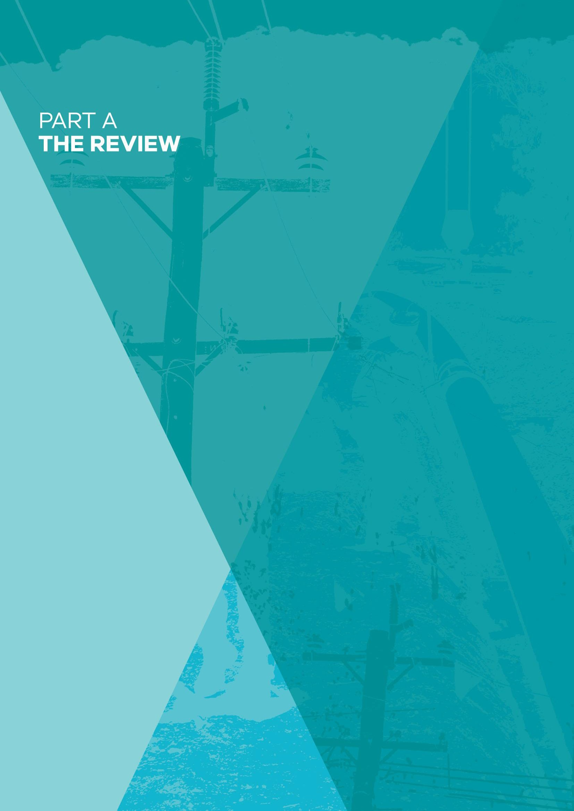

PART A: THE REVIEW

39

Introduction
On 19 January 2017, the Minister for Energy, Environment and Climate Change announced an independent Review of Victoria’s electricity network safety framework. On 5 May 2017, the Minister announced an expansion of the Review to include Victoria’s gas network safety framework.

The Victorian Government appointed an independent Chair for the Review, Dr Paul Grimes supported by a Secretariat administered by the Department of Environment, Land, Water and Planning (DELWP). The Review published an Interim Report on 31 October 2017. This Final Report was provided to the Minister for Energy, Environment and Climate Change in December 2017.

Scope of the Review

The Review has considered the design and adequacy of the safety regulatory obligations, incentives and other arrangements governing the safety of Victoria’s electricity and gas networks.

The Terms of Reference for the Review are outlined in Appendix A.

The scope of the Review is limited to the electricity and gas transmission and distribution networks. It includes:
- the electricity transmission and distribution network infrastructure (the poles and wires) that transports electricity from a generation facility to consumers, and the gas transmission and distribution network infrastructure (the gas pipelines) that transports natural gas from the production facility to consumers.
- the network up until the point of connection to a home or business. It does not consider electricity or gas installations beyond the energy customer’s meter.

The scope also does not include the electricity or gas generation or production facilities, off-shore pipelines or pipelines that carry products other than natural gas.

A detailed definition of the electricity and gas transmission and distribution networks is provided in Part B of this Report.

Conduct of the Review
The Review has been conducted in four phases:

- Initial scoping and preparation of an Issues Paper on the Review of Victoria’s Electricity Network Safety Framework released in April 2017.

- Initial scoping and preparation of a Supplementary Issues Paper on the Review of Victoria’s Electricity and Gas Network Safety Framework released in May 2017.

- Release of an Interim Report (October 2017).

- Presentation of the Final Report to the Minister (December 2017).

Stakeholder consultation
The Review has consulted with a wide variety of organisations and individuals, including:

  - all state regulators of electricity and gas networks in Australia;
  - all gas and electricity transmission and distribution businesses operating in Victoria;
  - the Electrical Trades Union;
  - academic experts; and
  - national and state government agencies that have responsibilities with an interest in energy network safety.

A stakeholder consultation forum was held on 4 April 2017. Over 30 attendees representing a variety of organisations participated in the forum.

The Review sought submissions on an Issues Paper published in April 2017 and a Supplementary Issues Paper published in May 2017. Thirteen submissions were received in response to the Issues Paper and twelve in response to the Supplementary Issues Paper.

The Review also sought submissions on its Interim Report published in October 2017. Seven public submissions were received. The papers and submissions are available at engage.vic.gov.au/electricity-network-safety-review.

The Review conducted site visits with AusNet Services and Powercor. The Review also conducted a series of roundtable discussions with ESV including the Director of Energy Safety, senior executive management, ESV’s Audit and Risk Committee Chair, auditors, electricity and gas site inspectors and data analysts.

Expert advice and commissioning of reports
To inform the Review findings, the Secretariat conducted research and analysis of leading regulatory practice; data analysis; and commissioned expert consultants:

  - Marsden Jacob was commissioned to conduct a best-practice review of international jurisdictions; and

  - the Centre for Excellence in Biosecurity Risk Analysis at the University of Melbourne was commissioned to report on the quality and integrity of the existing electricity and gas network safety performance data held by ESV.

Further information on the Review can be found on the Engage Victoria website at engage.vic.gov.au/electricity-network-safety-review.

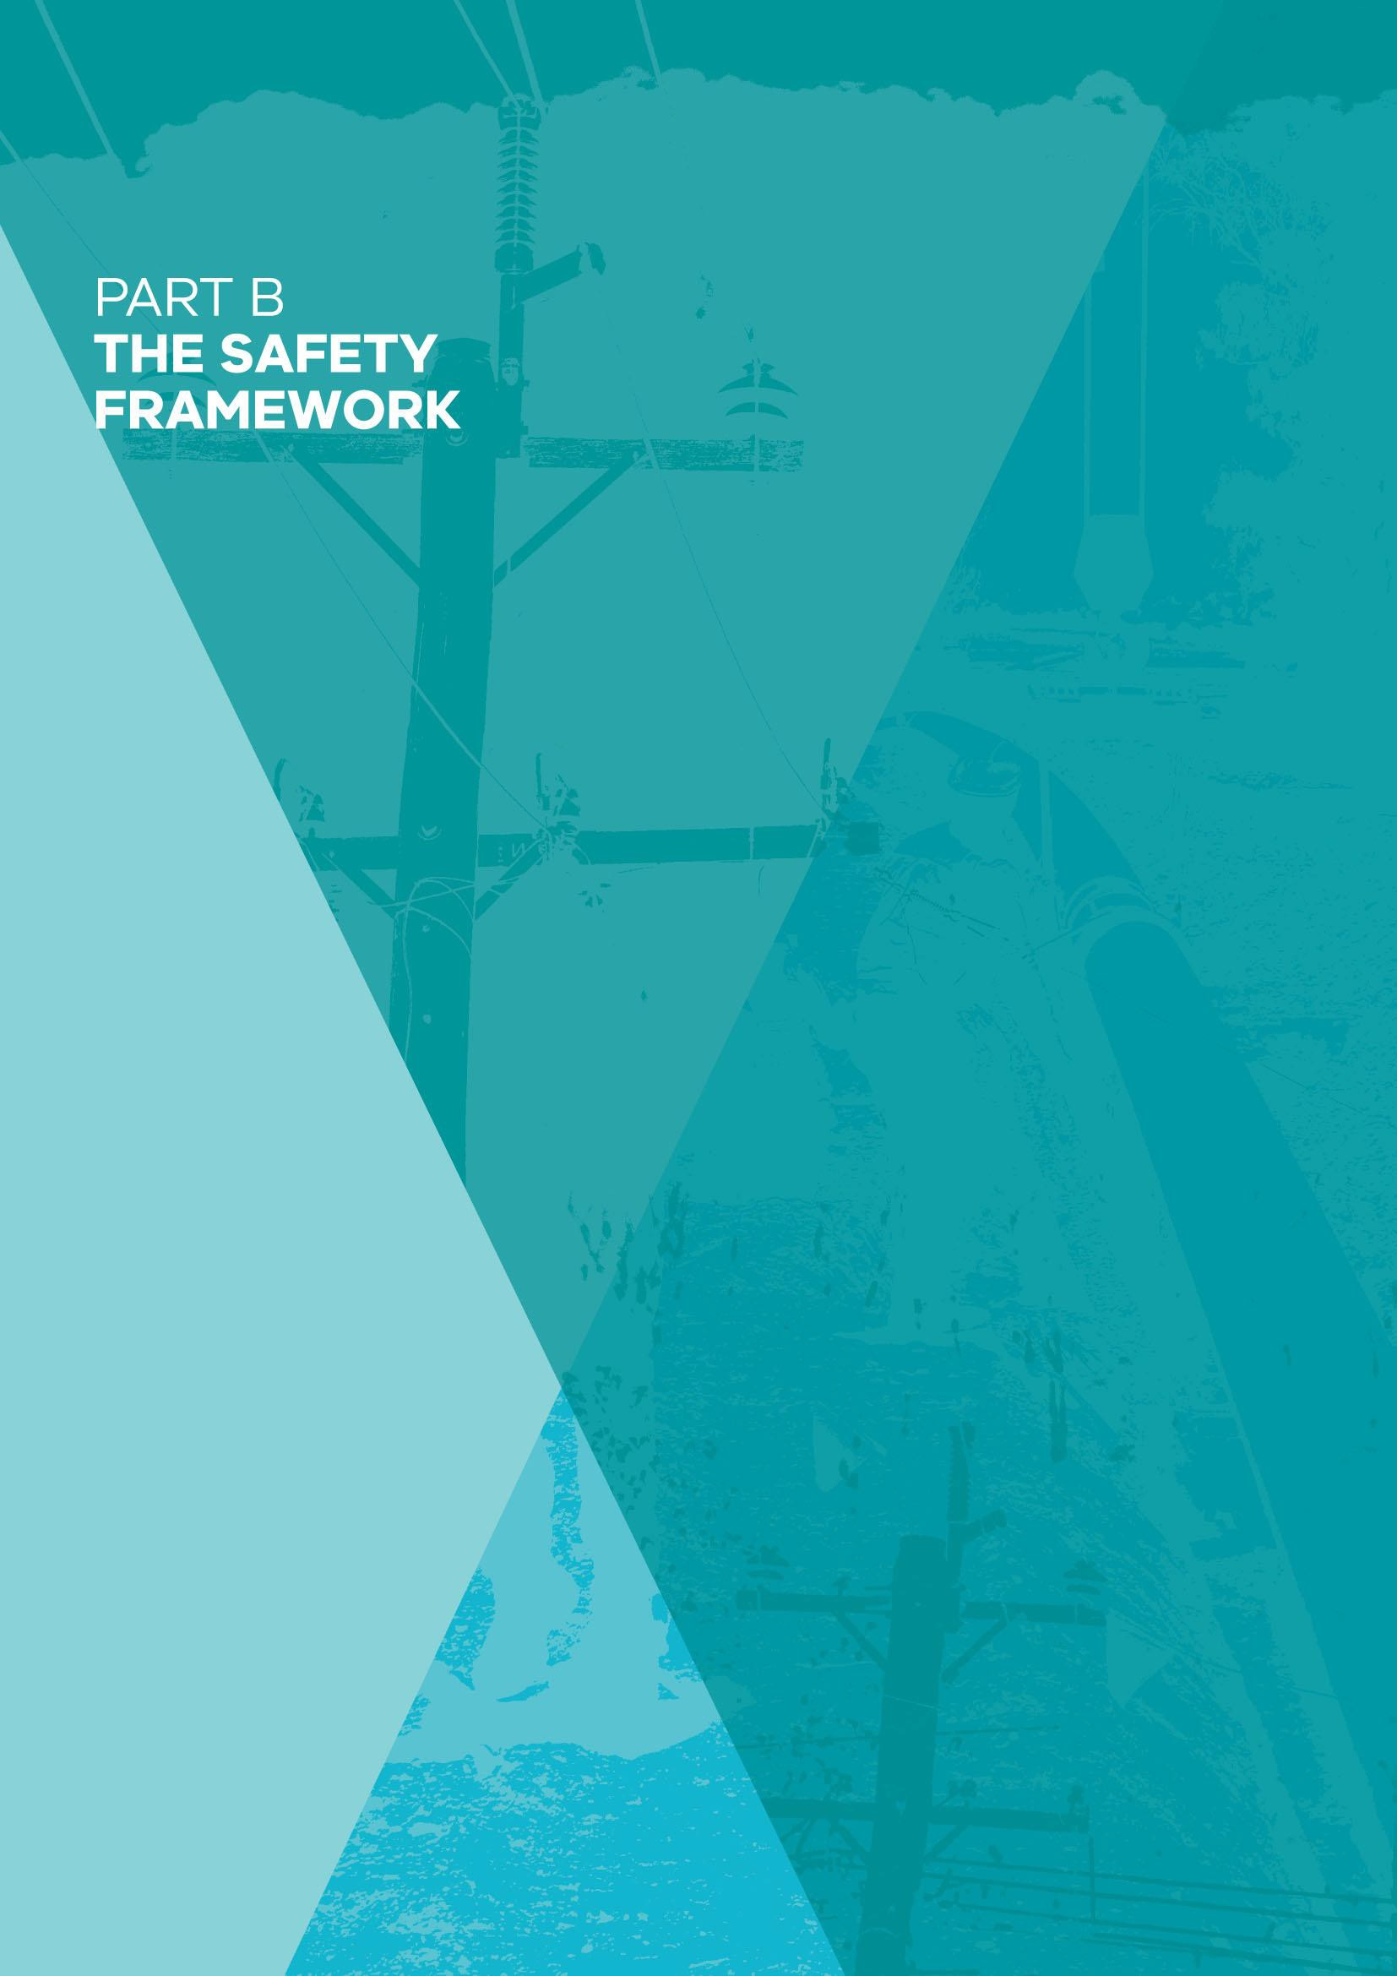

PART B: THE SAFETY FRAMEWORK

42

The safety framework

Energy is critical to the wellbeing of Victorians and underpins the growth and development of the Victorian economy.

The key objective of the electricity and gas network safety framework is to protect the Victorian community from the risks associated with the supply and use of electricity and gas.

This includes the safety of the public who rely on the supply of electricity and gas, the people who live and work near electricity and gas infrastructure, and the workers who work on the network assets.

Safety extends across the lifecycle of electricity and gas infrastructure, which includes the planning, design, construction, commissioning, operation, maintenance and decommissioning of network assets. Safety is achieved through a continuing process of hazard identification, risk assessment and risk management.

The safety framework has evolved significantly over the past three decades with the deregulation and privatisation of the energy industry, the establishment of a new single energy safety regulator, and the introduction of new technologies and changing consumer behaviour.

Defining electricity and gas networks
The electricity and gas networks in Victoria operate under a regulated market model with transmission and distribution in designated regions, the responsibility of monopoly businesses. Electricity and gas supply is made up of four separate industries and systems – generation/production, transmission, distribution and retail.

Electricity
Generation refers to power plants which generate electricity either through combustion of fossil fuels (coal, gas), or the use of renewable resources (wind, hydro, solar). These are outside the Review’s scope.

Transmission refers to the movement of this power along large powerlines across the state, at very high voltages (500, 330 or 220 kV’s). The electricity is taken to a limited number of network locations (terminal stations) for conversion to lower voltages.

The transmission sector in Victoria is comprised of 6,500 kilometres of high-voltage electricity transmission owned and maintained by AusNet Services (AER, 2015). Basslink owns the overhead lines and underground cable that link Victoria and Tasmania. The transmission system is subject to the operational control of the Australian Energy Market Operator (AEMO), a market and system operator owned by state and federal governments.

Distribution refers to the portion of the electricity supply network stemming from terminal stations and ending with individual customers. At a terminal station, sub-transmission voltage (66 kV) is taken to a number of network locations (zone substations) to be converted to a lower voltage (22

kV), and distributed on individual feeders. Feeders then radiate outward, with further transformation to low voltage to service individual customers¹.

The distribution sector comprises powerlines delivering electricity at voltages of 66 kV or less. In recent times, the electricity distribution sector has been consolidated following international mergers and acquisitions of energy businesses. AusNet Services, CitiPower, Powercor, United Energy and Jemena hold distribution licenses to deliver electricity to homes and businesses.

Figure 1: Electricity distribution areas in Victoria

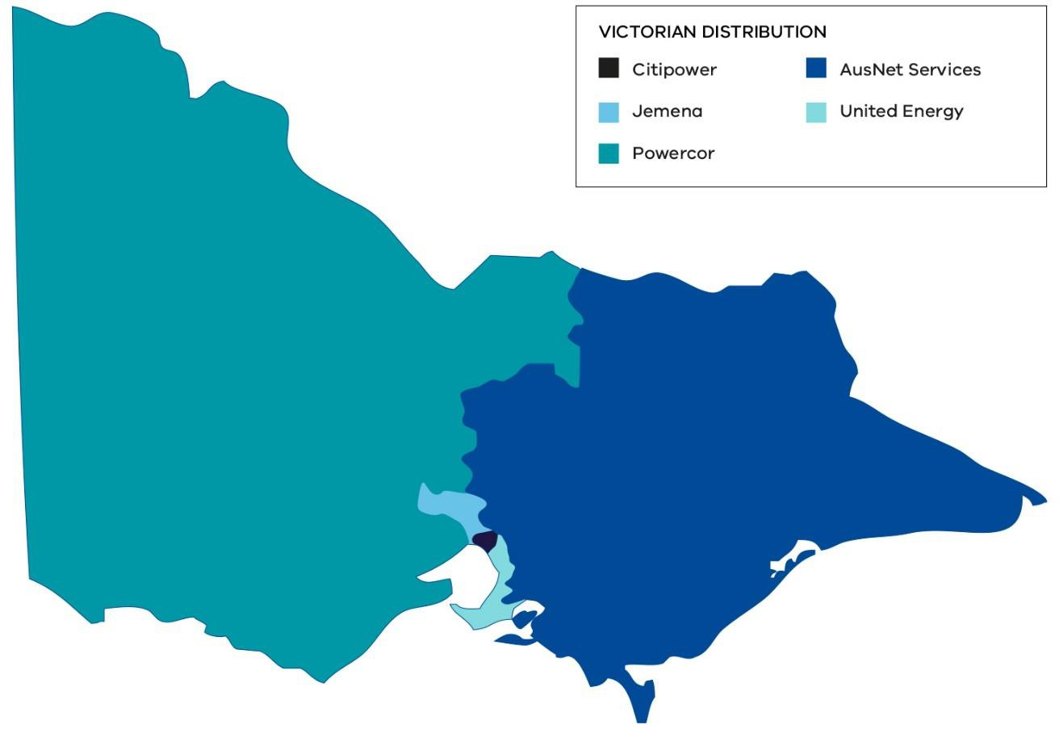

Source: Adapted from ACIL Allen Consulting (2015)

1 Low voltage is defined as any voltage under 1,000 volts. See ANZ Standard 3000. In Australia low voltage principally comprises voltage of 415 phase-to-phase, or 240 phase-to-ground. As the majority of customers are supplied by single phase power 240

Retailers are responsible for maintaining the billing interface between the industry and individual customers. Retail functions are outside the Review’s scope.

Figure 2: The modern electricity network

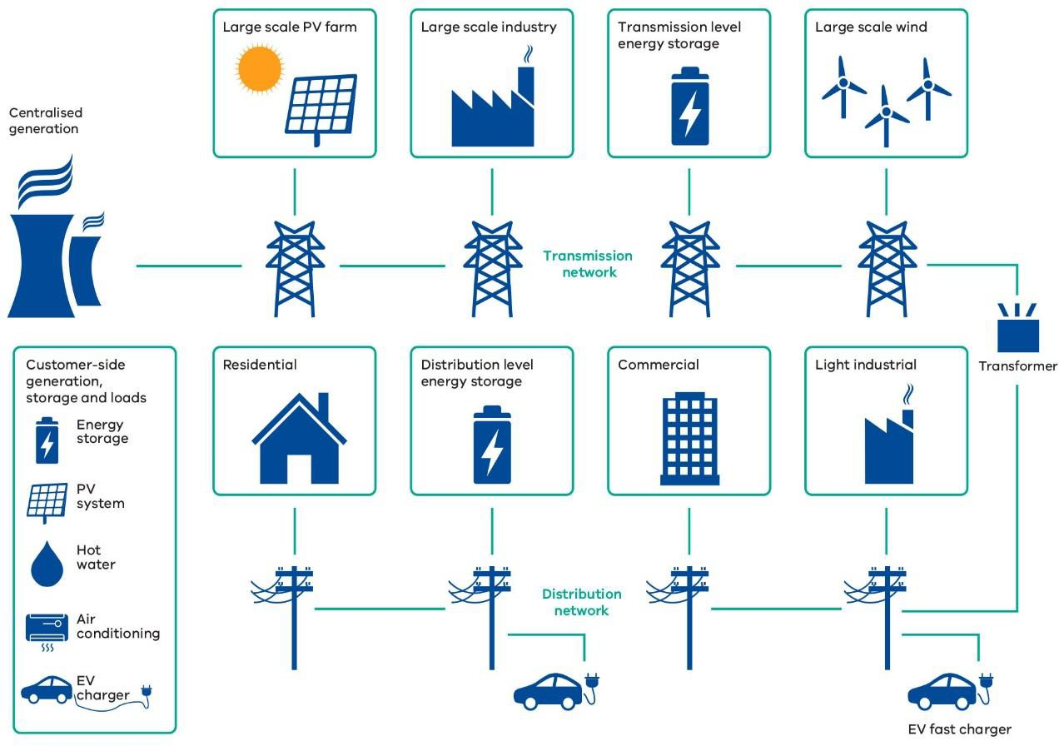

Source: Adapted from CSIRO (2015)

Gas
Production facilities process natural gas sourced from oil and gas fields located offshore in the Gippsland and Otway Basins, and the Bass Coast area. The gas is odourised and then injected into the transmission system. Some gas is also supplied from interstate (South Australia and New South Wales). Production infrastructure is not within the Review’s scope.

Victoria’s transmission system is made up of pipelines and compressor stations that transport natural gas at high pressure to the distribution networks. The main transmission system, known as the Declared Transmission System (DTS) is a network of 2,000 km of pipelines carrying natural gas at pressures typically between 2,000 to 15,000 kPa (AEMO, 2015).

The DTS is owned by APA VTS Australia (Operations) Pty Ltd (a subsidiary of APA Group) and operated by AEMO. Separate businesses own and operate gas pipelines that connect Victoria with neighbouring states. Other transmission pipelines, including the Eastern Gas Pipeline, SEA gas pipeline and the Tasmanian Gas Pipeline fall outside of the DTS and are not operated by AEMO.

Figure 3 below shows the Victorian gas system, comprising both the Declared Transmission System in green and other transmission pipelines in grey.

Figure 3: Victorian gas transmission system

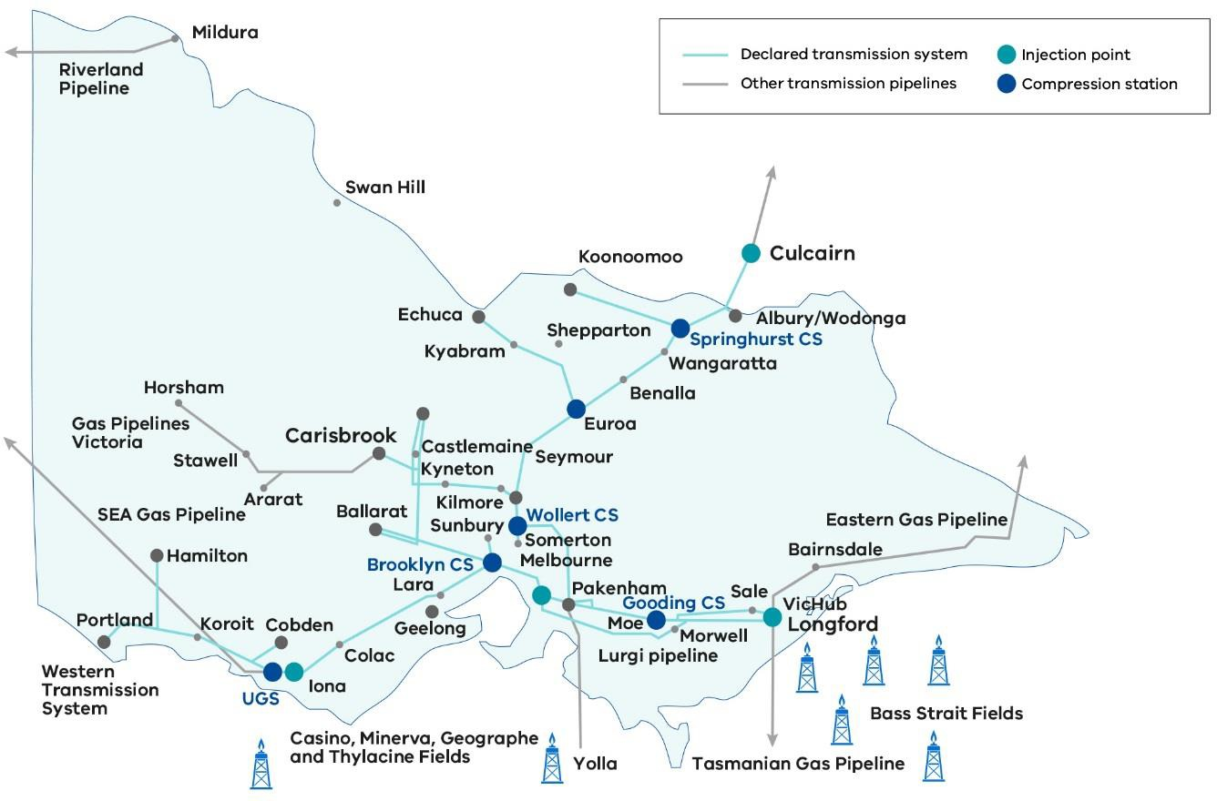

Source: Adapted from AEMO (2012)

Distribution networks transport lower pressure natural gas (between a range of 700 to 2,800 kPa) from pressure-reduction facilities to end users. AusNet Services, Australian Gas Networks and Multinet Gas hold distribution licenses to deliver natural gas to homes and businesses.

Retailers purchase the gas and sell it to end users. The retailer is the point of contact between the industry and individual customers with specific duties contained within the Gas Safety Act 1997 and associated regulations. A retailer’s key responsibility includes maintaining the billing interface between the industry and individual customers.

Figure 4: Natural gas production and delivery

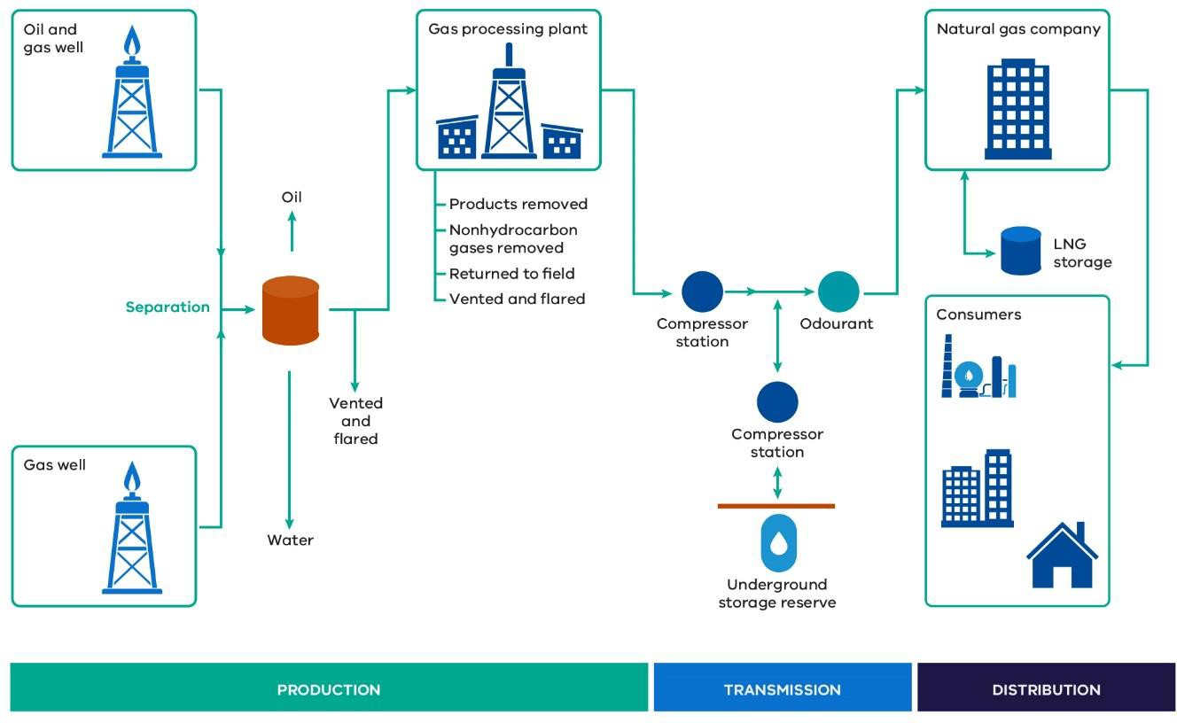

Source: Adapted from U.S Energy Information Administration (2017)

Consistent with the Terms of Reference, this Review is restricted to the electricity and gas transmission and distribution sector only.

The safety risks

Electricity
The key risks associated with the electricity network relate to electrocution and the impacts of bushfires ignited by electrical infrastructure. A lack of supply can also have a significant impact on the safety and wellbeing of individuals and the community.

Electrocution
Electrocution can occur through contact with electrical assets as a result of:

- damaged infrastructure such as fallen powerlines, equipment failure, traffic accidents or third party damage (either accidental or intentional); or as a result of high winds, thunderstorms, flooding, earthquake, or bushfires;

- unauthorised access to substations or climbing of electrical infrastructure;

- contact with excavators, cranes or earth-moving machinery working in the vicinity of electrical infrastructure, or low flying aerial activities; or

- people working on live electrical infrastructure.

Bushfires
Victoria is one of the most bushfire-prone regions of the world. While there are many causes of bushfire ignitions including lightning and human activity (whether intentional or unintentional), electrical infrastructure has long been known to be one of the causes of fires (CSIRO, 2014). In conditions of abundant fuel, high temperature, low humidity and high winds, a small spark can quickly grow to a major bushfire and cause widespread damage to people, property and the environment.

Fires starting as a result of electrical infrastructure can be caused by:

- an electric current that flows through vegetation, animal or other material, causing ignition, when they contact live parts of the network (either between two different live parts or between one live part and the ground);

- equipment failure;

- an electric arc igniting surrounding vegetation or other combustible material, for example, if a line falls to the ground; or

- hot molten metal particles released when two live parts of powerlines make physical contact, for example, in wire clashing incidents, igniting dry materials on which they fall.

Contact between overhead electric lines and trees has the potential to cause fires, electrocution and loss of power supply. The risk of these events occurring can be substantially reduced by managing vegetation to maintain appropriate clearance spaces between overhead electric lines and trees, to reduce the potential for contact, whether through natural growth or when a tree or branch falls on the electric lines (PBSP, 2011).

Disruptions to supply
Disruption to supply may be caused by extreme weather conditions such as high winds, thunderstorms, flooding or bushfires, or by other causes such as traffic accidents or animals coming into contact with equipment, or third party damage.

Because of people’s reliance on electricity, prolonged or widespread disruptions can have a significant impact on households, as well as on businesses, industry and major infrastructure. Impacts on the community can include health and wellbeing consequences due to lack of air conditioning and fans, and loss of telecommunications, refrigeration, lighting and cooking facilities.

Community impacts may also include traffic disruption due to traffic signal failures; disruption to the rail or tram networks; and disruption to essential services such as the healthcare or banking systems. The impact on vulnerable people and other sectors of the community will vary significantly.

Gas
A key objective of the gas network safety framework is to protect the Victorian community from injury or death caused by gas leakages, loss of integrity of the pipelines transporting the gas, or other issues that could affect the integrity, security and quality of the gas supply. While significant gas incidents are rare, the consequences could have major economic and safety impacts on the community.

The dangers associated with the production of natural gas were made apparent in 1998 when an event at Esso’s gas plant in Longford, Victoria caused the death of two workers and severed the State’s gas supply for two weeks. This resulted in major disruption to the Victorian community and caused significant economic damage. Although gas production is out of scope for this Review, the Esso Longford incident highlights the potential impacts of a catastrophic incident.

Damage to pipelines or loss of containment
Damage to pipelines can occur through inadequate maintenance, ageing infrastructure, corrosion, accidental damage caused by third parties digging (the risk and consequences of which can be exacerbated by encroachment), sabotage, weather events such as flooding and land movement (earthquake, landslides).

Leakages of gas from pipelines can occur as a result of damage to the pipeline or from inadequate operation, human error or technical malfunction.
The hazardous nature of combustible gas as well as the high pressure at which it is transported can, if there is a loss of containment, lead to the conditions for a potentially large explosion, presenting a major risk to public safety.

Gas quality
Gas conveyed through the network must meet prescribed quality standards. By ensuring that gas meets relevant quality parameters, the standards help to prevent explosion and fire occurring. Gas quality can also affect the integrity of the pipeline. Because domestic and industrial appliances are designed to operate safely within a certain gas quality specification range, off-specification gas can yield a risk to the community through a potential explosion.

Gas is also intentionally odourised so that the people can detect it at a concentration well below the explosive range. By ensuring that gas contains a distinctive and unpleasant odour, gas leaks are readily detected by consumers and members of the public, thus helping to ensure leaks are addressed to avert explosion, fire and suffocation risks.

Loss of supply
Due to the high penetration level of reticulation in Victoria, natural gas is an integral part of Victorians’ livelihoods and businesses, and is used for heating, hot water, cooking and in industrial processes in manufacturing and gas-fired electricity generation.

Victoria has the largest residential gas demand of any Australian state. While significant gas incidents are rare, the consequence of an incident occurring could have a major economic and safety impact on the community. A significant disruption to natural gas supply during peak summer periods may also impact on natural gas fired peaking electricity generation, and hence on the availability of electricity.

A disruption to supply may also arise when natural gas in the system is off-specification and is therefore unsafe to use.

Loss of gas supply can also result in a risk to public safety at the time of reinstatement. For example, air penetrating the gas supply network would need to be purged from gas installations and appliances before the installation is relit, or the appliance is used, to avoid the possibility of an explosive air–gas mixture existing or forming in the pipeline, or gas appliance.

The objectives of the safety framework
The key objective of the electricity and gas network safety framework is to protect the Victorian community from the risks associated with the supply and use of electricity and gas. More specifically, this includes protecting the community from injury or death caused by electrocution or from the dangers posed from bushfires starting as a result of electrical infrastructure, or from the dangers associated with gas exposure, or an explosion or fire as a result of loss of containment or gas quality.

While the primary responsibility for electricity and gas network safety rests with the electricity and gas companies that own and operate these networks, the energy safety regulator is charged with ensuring these companies meet their obligations in relation to the safe transmission and distribution of energy.

The Energy Safe Victoria Act 2005 established ESV as Victoria’s independent energy safety regulator, vesting ESV with this responsibility. The Energy Safe Victoria Act 2005 confers on ESV the objectives to perform its functions and exercise its powers in such a manner as it considers best to achieve the objectives specified in the Electricity Safety Act 1998 and the Gas Safety Act 1997 and any other Act.

The nature and scope of ESV’s activities are defined in its mission, objectives, functions and responsibilities which are described in the Energy Safe Victoria Act 2005, the Electricity Safety Act 1998, the Gas Safety Act 1997 and the Pipelines Act 2005 and the corresponding regulations. ESV operates within, and enforces compliance with, this legislation and can prosecute breaches of these safety Acts.

Box 1: ESV’s objectives

The objectives of ESV as stated in the Electricity Safety Act 1998 are:

- to ensure the electrical safety of electrical generation, transmission and distribution systems, electrical installations and electrical equipment;

- to control the electrical safety standards of electrical work carried out by electrical workers;

- to promote awareness of energy efficiency through energy efficiency labelling of electrical equipment and energy efficiency regulation of electrical equipment;

- to promote the prevention and mitigation of bushfire danger;

- to protect underground and underwater structures from corrosion caused by stray electrical currents; and

- to maintain public and industry awareness of electrical safety requirements.

The objectives of ESV under the Gas Safety Act 1997 are:

- to ensure the safety of the conveyance, sale, supply, measurement, control and use of gas;

- to control the safety standards of gas work;

- to maintain public and industry awareness of gas safety requirements; and

- to promote awareness of energy efficiency through energy efficiency labelling of gas installations, appliances and components and energy efficiency regulation of gas installations, appliances and components.

The objectives of ESV are to:

Promote Energy Awareness:
Promote awareness of energy efficiency through energy efficiency labelling and regulation of electrical equipment and gas installations; and maintain public and industry awareness of electrical and gas safety requirements.

Ensure Electrical Safety:
Ensure electrical safety of electrical generation, transmission and distribution systems, electrical installations and equipment; control the electrical safety standards of work carried out by electrical workers; and promote the prevention and mitigation of bushfire danger.

Ensure Gas Safety:
Ensure the safety of the conveyance, sale, supply, measurement, control and use of gas; and control the safety standards of gas work.

Ensure Pipeline Safety:
Protect underground and underwater structures from corrosion; and protect the public from environmental, health and safety risks resulting from the construction and operation of pipelines.

ESV’s core regulatory functions are to:

Licence, Approve or Accept:
Ensure that appliances meet stringent safety and energy efficiency standards before they are sold.
Administer licensing, registration and approval systems that maintain safety standards and skills.

Monitor and Audit:
Inspect and audit safety systems (including safety management systems, safety cases and plans), and also safety practices in relation to the design, construction and maintenance of all electricity, gas and pipeline networks and installations.
Monitor, audit and enforce compliance with Standards and requirements.

Educate and Encourage:
Cooperatively engage with industry and the community to facilitate safety outcomes.
Conduct comprehensive public awareness campaigns to educate the community and industry on the hazards associated with electricity, gas and pipelines.

Enforce Compliance:
Take appropriate enforcement action (based on the severity of risk and harm), and while accounting for responsible behaviour, may take action anyway if negligence can be shown and others have been placed at risk.

In its Corporate Plan 2017–2020, ESV notes that in addition to its stated objectives and functions, ESV also invests significant effort and resources into overseeing the operation and maintenance of electricity networks to, as far as is practical, prevent significant fires caused by electrical assets (ESV, 2017).

The evolution of the Victorian safety framework
The electricity and gas network safety framework has undergone significant change from its origins in the state-owned entities of the State Electricity Commission of Victoria (SECV) and the Gas and Fuel Corporation of Victoria. Over the past three decades the safety framework has evolved with the deregulation and privatisation of the energy industry.

Figure 5: A chronology of the key dates in the evolution of the Victorian energy safety framework

1920s | SECV established
1950s | Gas and Fuel Corporation of Victoria established
1983 | Ash Wednesday bushfires, mandatory code of practice for vegetation management near electric lines introduced
1993 | Chief Electrical Inspector established within SECV
Late 1990s | Victoria’s state-owned electricity and gas assets privatised
1997 | Gas Safety Act 1997 passed, Office of Gas Safety established, safety cases introduced for gas supply in Victoria
1998 | Electricity Safety Act 1998 passed, Office of the Chief Electrical Inspector becomes independent of SECV
1998 | Longford gas plant explosion
2005 | Energy Safe Victoria Act 2005 passed to establish ESV, Pipelines Act 2005 passed to improve pipeline safety, f-factor Incentive Scheme introduced
2009 | Black Saturday bushfires
2010 | Electricity Safety Management Scheme becomes mandatory for MECs, VBRC recommendations published
2011 | Powerline Bushfire Safety Taskforce presents bushfire risk reduction recommendations, Powerline Bushfire Safety Program established
2013 | ESV requires MECs to submit bushfire mitigation plans
2015 | ESV requires MECs to submit safety cases with their Electricity Safety Management Scheme
2017 | Civil Penalties Scheme introduced

MEC – Major Electricity Companies
VBRC – Victorian Bushfires Royal Commission

The entities
The SECV was established in the 1920s, absorbing a number of private and municipal electricity generation and distribution companies. The Gas and Fuel Corporation of Victoria was established in 1951, absorbing the Melbourne Metropolitan Gas Company, before acquiring the remaining private gas companies that supplied gas to Victorian customers. The

safety regulation of electricity and gas was the responsibility of these entities up until their disaggregation and sale in the late 1990s.

The Chief Electrical Inspector initially operated within the SECV to regulate electrical safety throughout Victoria. Privatisation of Victoria’s state-owned electricity and gas assets necessitated new regulatory arrangements. The Electricity Industry Act 1993 was the principal Act for restructuring the electricity industry, including achieving the economic separation of electricity generation, transmission and distribution assets. As part of the reforms related to electricity privatisation, the Office of the Chief Electrical Inspector was established as an independent regulator, firstly in accordance with the Electricity Industry Act 1993 and then in accordance with the Electricity Safety Act 1998 (ESV, 2009).

The Gas Industry Act disaggregated the monopoly utility into three new gas distribution companies and three new gas retail companies. That Act also established the Office of Gas Safety in July 1997, to oversee the safety of the distribution and use of gas. The accompanying Gas Safety Act 1997 gave the Office of Gas Safety legislative and regulatory force, and inspection powers. The Gas Safety Act 1997 also introduced safety case requirements into the gas supply sector in Victoria, particularly in relation to the operation of gas transmission, distribution and retail companies.

Box 2: Definition of a safety case

A safety case is a document produced by the operator of infrastructure, including energy networks which:

- identifies the hazards and risks associated with the asset;
- describes how the safety risks are controlled; and
- describes the safety management system in place to ensure the controls are effectively and consistently applied.

In 2004, the Victorian Government engaged Impaq Consulting to conduct a Review of Energy Safety Regulators in Victoria. The purpose of the review was to consider the organisational effectiveness and efficiency of the regulatory agencies responsible for safety in the electrical and gas industries in Victoria. The review recommended a merger of the Office of the Chief Electrical Inspector and the Office of Gas Safety to establish a single, integrated electricity and gas safety regulator to streamline its work and improve efficiency. This led to the establishment of ESV, an independent statutory entity, enacted through the Energy Safe Victoria Act 2005.

Electricity
The causal links between powerlines and bushfire ignitions have long been known. Powerlines have been the cause of a number of major fire events in Victoria, with electricity assets thought to have started:

- nine of the 16 major fires on 12 February 1977;
- four of the eight major fires on Ash Wednesday (16 February 1983); and
- six of the 11 major fires on Black Saturday (ACIL Allen Consulting, 2015).

The primary causes of bushfires in 1977 and 1983 were vegetation touching live wires; fuses that produced hot metal particles when they operated; and clashing wires (PBSP, 2011).

Formal inquiries were held after the 1977 and 1983 fires and a number of actions were taken by the former SECV and the Victorian Government. These included:

- installation of spreaders on low voltage lines to prevent wires clashing;

- replacement of old fuses;

- installation of neutral earthing resistors in some zone substations in high bushfire risk areas to reduce the fault current;

- increased inspection and maintenance obligations on distribution companies and customers with private overhead lines;

- a requirement that all new and reconstructed private overhead lines in high bushfire areas are placed underground;

- the introduction of a mandatory code of practice prescribing the management of vegetation near powerlines. Prior to this, a voluntary code existed between the SECV in conjunction with local government.

Prior to 1 January 2010, safety-related regulation of electricity operators in Victoria under the Electricity Safety Act 1998 and its associated regulations, had historically been undertaken on a largely prescriptive basis. However, most electricity network businesses had provided an Electricity Safety Management Scheme on a voluntary basis. Amendments made to the Electricity Safety Act 1998 and the corresponding Electricity Safety (Management) Regulations 2009 made the requirement to submit an Electricity Safety Management Scheme to ESV every five years, mandatory for major electricity companies.

Box 3: Definition of an Electricity Safety Management Scheme

An Electricity Safety Management Scheme involves setting out the safety management system an electricity company has in place to acquit its general duties and ensure it has built safety procedures into all aspects of its processes

The Victorian Bushfires Royal Commission
The VBRC conducted following the February 2009 Black Saturday bushfires, was convened to investigate the causes of the bushfires and identify ways in which future, similar tragedies could be avoided.

The VBRC provided its final report in July 2010, making 67 separate recommendations about how to better protect Victorians. The Victorian Government committed to implementing each of the 67 recommendations.

Eight of the VBRC recommendations relate directly to the prevention of bushfires linked to electricity assets. The VBRC identified powerlines as being the cause of five of the major fires that occurred on 7 February 2009, and responsible for 119 deaths. A sixth fire (Murrindindi) was not investigated by the VBRC as it was then under investigation by Victoria Police on suspicion of arson. Victoria Police subsequently concluded that arson was not the cause, and referred the matter to the Coroners Court for inquiry.

On 27 November 2015, the Coroners Court found that the Murrindindi fire was also caused by electricity distribution assets, adding the loss of a further 40 lives to the total deaths attributable to fires that were associated with electricity distribution assets.

In October 2010, Mr Neil Comrie AO APM, was appointed as the Bushfires Royal Commission Implementation Monitor (BRCIM), to oversee and report on the implementation of all VBRC recommendations.

Following his appointment, the BRCIM reported annually to the Victorian Government. With most of the recommendations assessed as having been implemented, this monitoring function was discontinued, and the final BRCIM report was provided to Parliament in July 2014 (IGEM, 2014).

The Inspector-General for Emergency Management (IGEM) assumed responsibility for future monitoring of the implementation of outstanding VBRC recommendations in August 2014.

Established on 1 July 2014 by the Emergency Management Act 2013, the IGEM works with its emergency management partners and the community to strengthen emergency management arrangements and community safety in Victoria. IGEM’s primary role is providing assurance to government and the community regarding emergency management arrangements in Victoria, and fostering their continuous improvement.

In its inaugural report in August 2015, IGEM reported it considered the sector to be making satisfactory progress towards completing the implementation of the remaining seven recommendations – many of which are scheduled for completion by the end of 2017.

Since 2013, the Electricity Safety Act 1998 has required each electricity distribution business to submit a bushfire mitigation plan to ESV every five years for acceptance. The Electricity Safety (Bushfire Mitigation) Regulations 2013 make provision for the preparation of the

bushfire mitigation plans and for the inspection of overhead electric lines and supply networks.

The bushfire mitigation plan sets out how each network business will manage the bushfire risk presented by its networks. These plans, and the safety management scheme of which bushfire mitigation plans are a part, must be accepted by ESV as a condition of network operation.

In September 2017, civil penalty provisions were introduced into the Electricity Safety Act 1998. This allows ESV or the Minister to commence a civil proceeding against an electricity distribution business if it fails to comply with the civil penalty provisions.

The civil penalties regime requires electricity network businesses to deliver heightened powerline fault detection and suppression capabilities by installing new capital infrastructure over a seven-year period, which concludes in 2023. In addition, electricity businesses must replace bare-wire powerline conductors with covered conductors or underground powerlines in designated high consequence bushfire areas. The businesses will face financial penalties if they fail to meet the prescribed requirements.

Gas
While significant gas incidents that impact the pipelines transporting gas are rare, the consequences of an incident could have major economic and safety impact on the community. Over the last decade, pipeline disasters across North America, Europe and Asia have resulted in around 50 fatalities and many hundreds more injured; town evacuations; and damage to major roads and infrastructure.

By contrast, the Australian pipeline industry has no recorded fatalities associated with pipeline damage and far lower injury rates. Deloitte Access Economics (2016) in its regulatory impact statement (RIS) for the Proposed Pipelines Regulations commented in December 2016 that the absence of such severe incidents in Australia, particularly when compared to some international jurisdictions, is likely to be due to the generally high level of compliance with regulatory requirements, the fact that the majority of pipelines are owned or operated by generally large and experienced firms, as well as locational issues and the age profile of the pipelines.

The table below shows reportable gas safety incidents in Victoria in the last decade. A reportable safety incident is defined by the Gas Safety Act 1997 as an incident or event relating to:

“the conveyance, supply or use of gas which causes or has the potential to cause —
- the death of or injury to a person; or
- significant damage to property; or
- an explosion.”

These incidents listed below, while serious, have generally been limited in their severity.

Table 1: Victoria reportable safety incidents since 2007

Incident date | Incident location | Incident description | Impact
20 October 2008 | Pressure reduction metering station | Sudden retraction of Welker probe during maintenance. | Maintenance operative suffered soft tissue crush injury requiring surgery.
13 November 2012 | Compressor station | Unrestrained movement of gas turbine engine during compressor package maintenance. | Two injuries suffered by maintenance personnel, one requiring surgery and the other medical treatment at hospital.
1 September 2014 | Longford to Melbourne Pipeline | Pipeline damaged during third party excavation works. | Operating pressure reduced for safety and curtailment narrowly avoided.
28 September 2016 | Gas transmission main at Arthurs Seat | Pipeline damaged during third party excavation works. | Immediate area evacuated due to gas leak.
20 February 2017 | Wollert to Wodonga Pipeline | Near miss by third party excavation of transmission pipeline. | Pipeline pressure reduced to allow inspection.

The current Victorian safety framework

The electricity and gas network safety framework is a combination of the regulation, obligations and economic incentives that apply to electricity and gas distribution and transmission network businesses, and the means by which the safety and reliability of the networks are regulated. Table 2 lists the current legilsation that applies to the safety and economic regulation of electricity and gas networks, and associated regulations and codes.

A detailed description of the legilsation that applies to electricity and gas networks is available in Appendix C. Information on the economic framework and how it applies to the electricity and gas networks is avialable in Appendix D.

Table 2: Electricity and gas safety legislation and associated regulations including broader economic regulation

Legislation and incentives | Administered by
Electricity
National Electricity (Victoria) Act 2005  National Electricity Law  National Electricity Rules f-factor Incentive Scheme | ESV and DELWP  AER  AER AER
Electricity Safety Act 1998  Electricity Safety (Management) Regulations 2009 Electricity Safety (Installations) Regulations 2009 Electricity Safety (Equipment) Regulations 2009  Electricity Safety (Registration and Licencing) Regulations 2010 Electricity Safety (Bushfire Mitigation) Regulations 2013 Electricity Safety (Bushfire Mitigation Duties) Regulations 2017 Electricity Safety (Electric Line Clearance) Regulations 2015  Electricity Safety (Cathodic Protection) Regulations 2009 | ESV ESV ESV ESV ESV ESV ESV ESV  ESV
Electricity Industry Act 2000  Electricity Distribution Price Review  Service Target Performance Incentive Scheme | ESC AER AER
Essential Services Commission and Electricity Industry Act 2000  Electricity Distribution Code Guaranteed Service Level | ESC ESC ESC
Financial Management Act 1994
Gas
Gas Safety Act 1997  Gas Safety (Safety Case) Regulations 2008 Gas Safety (Gas Quality) Regulations 2007  Gas Safety (Gas Installation) Regulations 2008 | ESV ESV ESV  ESV
Energy Safe Victoria Act 2005
Pipelines Act 2005  Pipelines Regulations 2017 | ESV and DELWP  ESV
Gas Industry Act 2001  Gas Access Arrangement Review | ESC  AER
Occupational Health and Safety Act 2004 Occupational Health and Safety Regulations 2017 Dangerous Goods Act 1985  Dangerous Goods Safety (Major Hazard Facilities) Regulations 2007 | WorkSafe Victoria WorkSafe Victoria WorkSafe Victoria WorkSafe Victoria
National Gas Victoria Act 2008  National Gas Law National Gas Rules | AER AEMC AEMC
Essential Services Commission and Gas Industry Act 2001  Guaranteed Service Level Gas Distribution Code  Unaccounted for Gas Incentive Mechanism | ESC ESC ESC ESC

References
2009 Victorian Bushfires Royal Commission, 2010. Final Report.
ACIL Allen Consulting, 2015. Regulatory Impact Statement: Bushfire Mitigation Regulations Amendment. AEMO, 2012. Guide to Victoria's Declared Wholesale Gas Market.
AEMO, 2015. An Overview of the Vic Gas Market.
AER, 2015. State of the energy market 2015.
CSIRO, 2014. Links between bushfires from powerlines and catastrophic fire events. CSIRO, 2015. Electrical energy storage: Technology overview and applications.
Parliament of Victoria, 1998. Electricity Safety Act 1998
Deloitte, 2016. Proposed Pipelines Regulations 2017: Regulatory Impact Statement.
ESV, 2009. Electricity Safety (Installations) Regulations 2009: Regulatory Impact Statement.
ESV, 2012. Code of Practice on Electrical Safety for Work on or Near High Voltage Electrical Apparatus- Blue Book.
ESV, 2017. Energy Safe Victoria Corporate Plan 2017-2020. Parliament of Victoria, 2001. Gas Industry Act 2001
Parliament of Victoria, 2008. Gas Safety (Safety Case) Regulations 2008
Parliament of Victoria, 1997. Gas Safety Act 1997
IGEM, 2014. Bushfires Royal Commission Implementation Monitor: Annual Report.
IGEM, 2015. Progress Report: Victorian Bushfires Royal Commission Implementation of recommendations and actions.
Marchment Hill Consulting, 2016. ESV Executive Structure Review: Final Report.
Parliament of Victoria. 2000. Occupational Health and Safety (Major Hazard Facilities) Regulations 2000
PBSP, 2011. Powerline Bushfire Safety Taskforce: Final Report.
U.S. Energy Information Administration, 2017. EIA Energy Kids- Natural Gas. [Online] Available at: https://www.eia.gov/KIDS/energy.cfm?page=natural_gas_home-basics

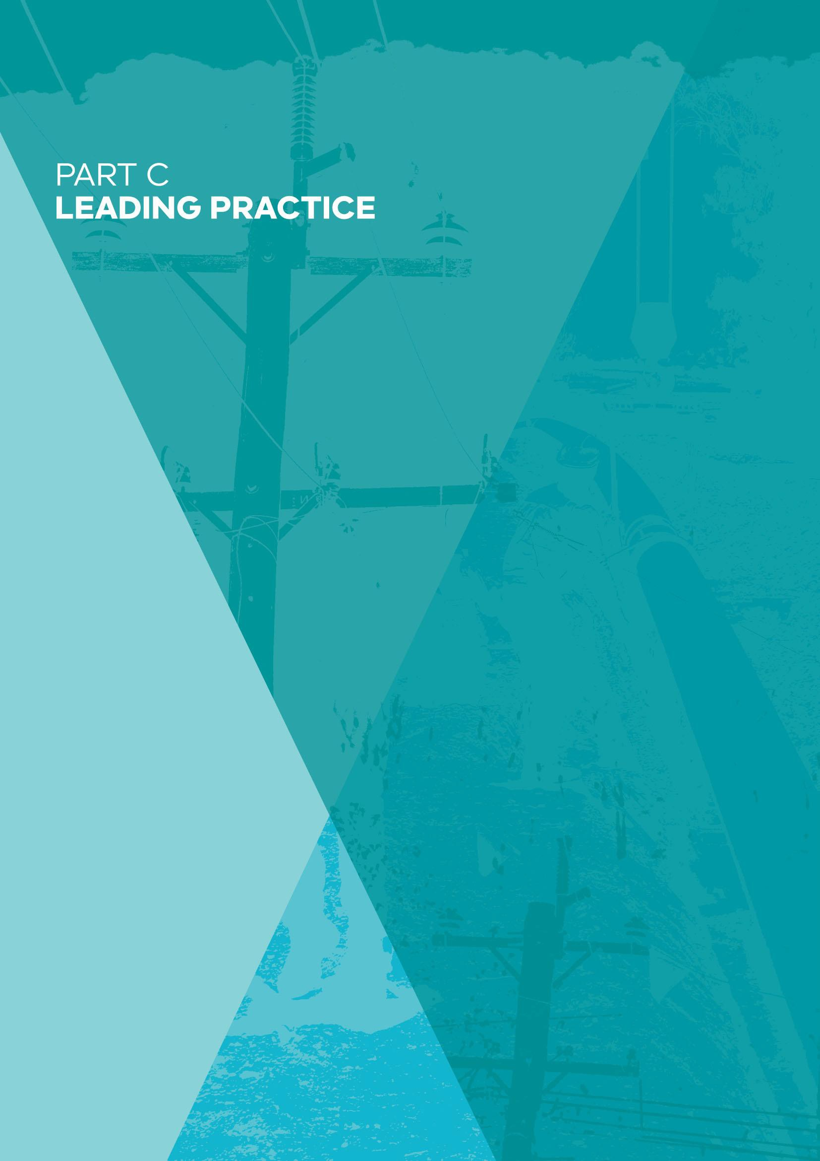

PART C: LEADING PRACTICE

63

Leading practice and network safety regulation

Summary
Safety regulation in major industrial settings has progressed significantly over the past three to four decades, heavily influenced by several major incidents. Leading practice has coalesced around the concept of the “safety case” as the foundation of safety management and regulation of hazardous industries.

A safety case describes how a regulated entity will run its operations to meet its safety obligations. It requires the entity to identify safety risks, describe how those risks are to be controlled, and the system for implementing and maintaining those controls effectively.

Victoria has been on the forefront of national reforms to strengthen industrial and workplace safety frameworks over the past two decades.

Having been adopted in legislation for Victorian gas transmission and distribution networks as early as 1997, the broader application of a safety case regime to Major Hazard Facilities was a recommendation of the Longford Royal Commission in 1999.

Over the past two years or so, Energy Safe Victoria (ESV) has sought to apply a safety case approach more consistently across its regulation of electricity and gas networks.

A safety case regime provides a strong foundation for safety regulation, but effective implementation is critical.

The effectiveness of the framework depends on how well each safety case is prepared; how deeply it is embedded in the working arrangements and cultures within each regulated organisation; how effectively it is implemented and updated; and how well it is regulated by the external regulator.

A safety case regime offers flexibility for network operators to determine the standards and approaches that might allow them to most efficiently achieve safety outcomes, with potential price benefits for energy consumers.

External technical standards and well-designed prescriptive requirements remain relevant, and often play a critical role within a mature and robust safety case based system.

The safety case: Promoting a comprehensive approach to safety
The foundation for the Review’s analysis is an assessment of leading practice frameworks for safety regulation, in particular, for the effective regulation of electricity and gas networks.

Perhaps the closest reference point for the regulation of safety in large-scale electricity and gas networks is the regulation of safety in other major industrial settings. International thinking and practice around the best way to regulate safety has progressed significantly over the past three to four decades, heavily influenced by several major incidents, especially those involving offshore oil and gas production, nuclear power, chemicals production, aviation and rail transport.

There are some important common threads across these sectors:

- all involve complex systems and processes, or large-scale networks, or a combination of both;
- all involve hazardous processes that potentially expose large numbers of people to risk;
- the circumstances in which major incidents may occur are relatively rare, but the consequences are likely to be significant, indeed they may be catastrophic.

There is a broad consensus that effective safety regulation in these sectors requires a comprehensive, multi-dimensional approach to ensure that a safety mindset is deeply embedded, not only within the systems and processes of regulated businesses, but also as an entrenched part of their organisational cultures.

It is also broadly recognised that safety within complex and large-scale systems cannot be achieved by simply mandating and applying central technical rules and standards, even though such standards may have an important place in the overall regulatory framework.

In Britain, Australia and New Zealand, leading practice has coalesced around the concept of the “safety case” as the foundation of safety management and regulation of hazardous industries. A safety case describes comprehensively how a regulated entity will run its operations to meet its safety obligations. It requires the entity to identify safety risks, describe how those risks are to be controlled, and the system for implementing and maintaining those controls effectively.

In Australia, Victoria and Western Australia were the first states to formally apply a safety case regime to the safety regulation of Major Hazard Facilities. In Victoria’s case, the Royal Commission inquiring into the gas explosion at the Esso Longford plant in 1998 recommended that a legislative change be made to require Major Hazard Facilities to conform to a safety case procedure. Regulations giving effect to this recommendation were introduced in 2000 and have been applied by WorkSafe Victoria since that time (Cooke, 2003).

While the application of a safety case was not a statutory requirement applying to Esso’s Longford plant in 1998, the Victorian Government had already applied a safety case regime to gas distribution and transmission networks under the Gas Safety Act 1997, and the Commonwealth had also applied similar safety requirements to offshore gas production under the Petroleum (Submerged Lands) Management of Safety on Offshore Facilities Regulations 1996. ESV’s predecessor agency, the Office of Gas Safety, was therefore one of the earliest safety regulators in Australia to adopt a safety case regime. As discussed further in Chapter 9: Strengthening the Foundations for Future Network Safety Regulation, ESV has recently focused on the safety case regime for regulating electricity network safety, building on the Electricity Safety Management Scheme.

Despite the widespread recognition that a safety case regime is a leading practice approach to safety regulation, its effective implementation is critical. The simple existence of a safety case that sets out how safety will be managed across a major facility or across a complex network may be necessary and desirable, but is not sufficient. Everything depends on how well the safety case is prepared; how deeply it is embedded in the working arrangements and cultures within the organisation that is being regulated; how effectively it is implemented and updated; and how well it is regulated by the external regulator.

In a recent speech, Justice Haddon-Cave, who conducted a major inquiry for the British Government into the causes of a catastrophic mid-air loss of an RAF Nimrod aircraft in 2006, summarised this point clearly:

“Safety Cases and the Safety Case regime and methodology are invaluable tools in modern risk management. Safety Cases are here to stay. Properly used, they provide an invaluable intellectual and practical structure for analysing, anticipating and ameliorating risks. However, like so many ‘paper-based’
solutions, they are open to abuse and lassitude and can become a ‘comfort blanket’ to keep one warm from the chill of having to face the realities of multifarious risk.” (Haddon-Cave, 2017, p. 9)

Professor Andrew Hopkins, of the Australian National University, has identified the following features of an effective safety case system (Hopkins, 2012):

- The entity identifies hazards, controls for their management, and measures for ensuring controls remain effective.

- The entity receives input from employees for development of its safety documentation, and regulators auditing consult with staff representatives.

- The entity puts the case to the regulator on its processes to identify hazards, methodology to determine risk and decision making for the use of controls, and the regulator accepts or rejects the entity’s case.

- The regulator is competent, independent, engaged and well-resourced. A high degree of expertise is needed to scrutinise a safety case for acceptance and thorough audit.

- A general duty of care is imposed for the entity to do what is reasonably practicable to identify and control hazards.

The duty of care and approach to managing risks
Effective safety management requires clarity around the objectives to be achieved and how they are to be achieved.

The central questions are:

- What is an acceptable level of safety?
- How can the community be sure that everything that should be done to achieve acceptable safety has been done?

The notion of what constitutes acceptable safety immediately raises questions about the trade-offs between the benefits of extra safety, that is, the benefits of less risk and the costs of reducing risk. These costs could be capital costs – the expenses from investing in more heavily engineered infrastructure or new technology. Or they could be higher operating costs – greater spending on maintenance, inspections or similar activities.

In almost any endeavour, risks cannot be eliminated entirely. This is certainly true of electricity and gas networks. It may be stating an obvious point, but perfectly safe electricity and/or gas networks only ever exist on paper. Therefore, if zero safety risk cannot be achieved, at what point should network operators cease making the additional capital investments or incurring the additional operating costs necessary to make electricity or gas networks safer?

In its submission to the Review, AusNet Services (2017) has illustrated this question with the aid of a simple diagram (see Figure 6). In this diagram, the benefits from investments in safety are measured against the costs of these investments. As more investment in safety is made, the safety benefit increases. However, the relationship is not a straight line that increases no matter how much expenditure is incurred, but rather is a curve. This is because as more investment is made in safety, it becomes increasingly difficult to squeeze additional safety benefits from that expenditure.

In economic terms, efficiency is maximised to the point at which the additional benefit from extra expenditure on safety is equal to the cost of the additional investment (the first point noted on the curve). Any greater expenditure would have more cost than the additional safety benefit it delivers.

As discussed further below and in Chapter 9: Strengthening the Foundations for Future Network Safety Regulation, safety legislation and the legal tests applied by the courts typically imply that investments should continue to be made until a point at which the cost of securing additional safety is disproportionate to the benefits (the second point noted on the curve).

Figure 6: An illustration of the economic analysis of the optimum balance between safety benefit relative to safety cost

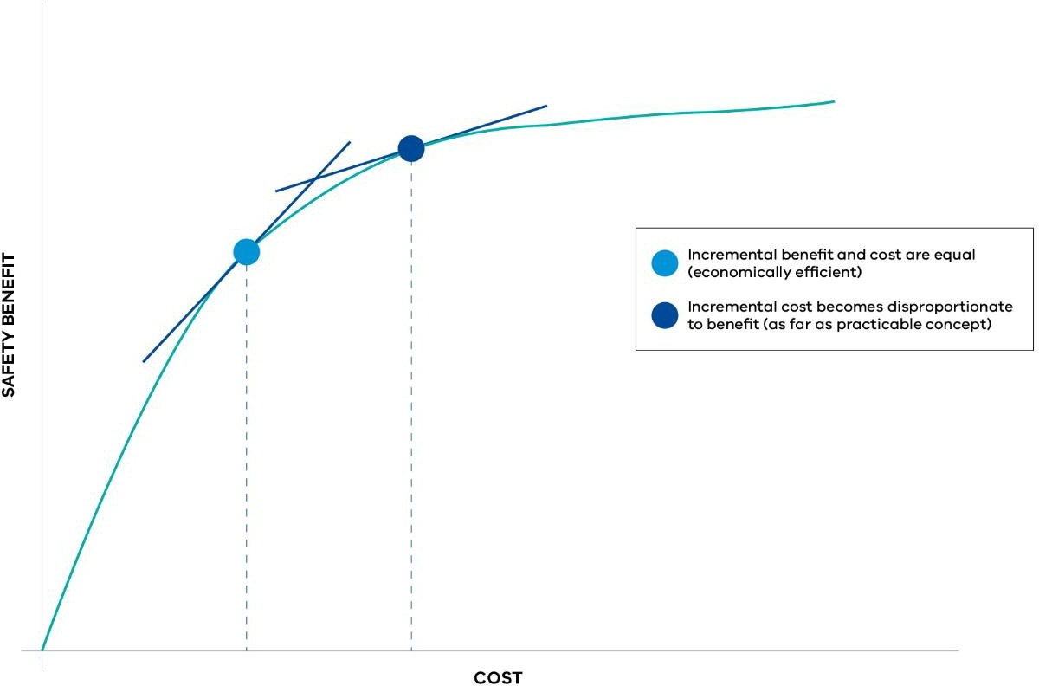

Source: Adapted from AusNet Services submission (2017, p. 13)

The simple diagram is very useful for illustrating the concepts that need to be considered. However, there can be significant practical and methodological problems in measuring marginal safety benefits and costs with high degrees of precision.

In 2010, the Powerline Bushfire Safety Taskforce invested a great deal of effort in exploring questions around the benefits of investments in additional safety for the Victorian electricity network. Among other things, the Powerline Bushfire Safety Taskforce commissioned detailed customer research to better understand what Victorians might regard as an acceptable balance between these competing objectives of more safety and additional cost. The survey included a variety of individuals and businesses across metropolitan areas, regional centres and rural areas, including fire-affected areas. The research revealed that participants in the survey were overwhelmingly of the view that it was important to reduce the bushfire risk associated with powerlines when there was no cost associated with this (Powerline Bushfire Safety Taskforce, 2011).

When cost was added to the equation, participants indicated that, on average, they were only willing to pay a little more to reduce the likelihood of bushfire starting by powerlines – eight per cent more with no deterioration in the reliability of the electricity supply, reducing to two per cent if there was a deterioration in the reliability of supply.

Figure 7: Willingness of Victorians to pay for reduced bushfire risk from powerlines

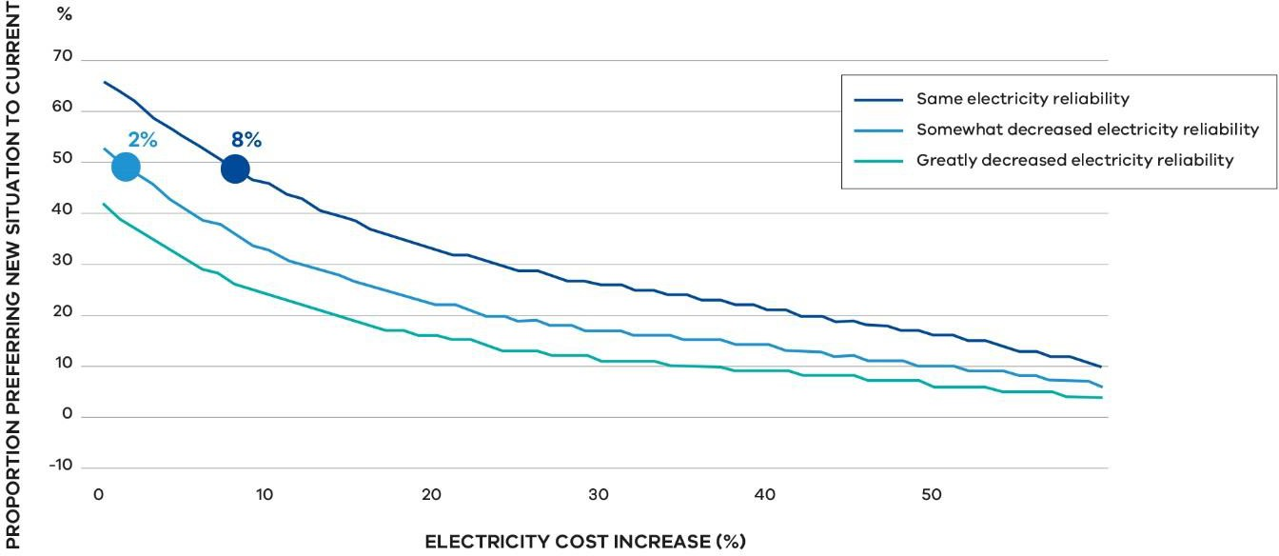

Source: Adapted from Powerline Bushfire Safety Taskforce (2011, p. 51)

While the Taskforce estimated that the likelihood of powerlines starting bushfires could be reduced by around 99 per cent by undergrounding cables, the capital cost to underground all powerlines in non-urban areas of the state was estimated to be around $40 billion (real 2011). This cost was vastly above the broad assessment of the amount that Victorian consumers would be prepared to fund through higher prices (Powerline Bushfire Safety Taskforce, 2011).

Reducing risks as far as reasonably practicable
Since the landmark 1949 British case Edwards v National Coal Board, the principle that organisations with a duty of care for the safety of others should seek to reduce risks as far as “reasonably practicable” has been firmly entrenched in legal judgements and statutory frameworks.

In Edwards v National Coal Board, the Court found that: “Reasonably practicable is a narrower term than ‘physically possible’ and it requires an assessment of risk and measures to avert the risk”.

A central question for the Review is what should constitute “reducing risks as far as reasonable practicable” in a leading practice system of safety regulation? While not dealing with electricity and gas network safety specifically, the 2008 National Review into Model Occupational Health and Safety Laws considered the definition of “reasonably practicable” to support general safety duties and proposed the following:

“Reasonably practicable means (except in relation to obligations for consultation) that which is, or was at a particular time, reasonably able to be

done in relation to ensuring health and safety, taking into account and weighing up all relevant matters including:

- the likelihood of the hazard or the risk concerned occurring; and
- the degree of harm that might result from the hazard or the risk; and
- what the person concerned knows, or ought reasonably to know, about:
  - the hazard or the risk; and
  - ways of eliminating or minimising the risk; and
- the availability and suitability of ways to eliminate or minimise the risk; and
- after assessing the extent of the risk and the available ways of eliminating or minimising the risk, the cost associated with available ways of eliminating or minimising the risk, including whether the cost is grossly disproportionate to the risk.” (Workplace Relations Ministers’ Council, 2008, p. 44)

A similar definition is found in the Victorian Occupational Health and Safety Act 2004.

In its submission to the Review, R2A has expressed a view that there needs to be clarity and consistency around the question of what constitutes “reasonably practicable” and, in addition, the language that is adopted to express the objective of the safety framework.

There are two broad approaches to determining whether risks have been reduced as far as practicable. These are:

- a precaution-based approach, looking at all reasonably practicable precautions;
- a target risk approach, looking to reduce all risks to an acceptable or tolerable target level of risk or safety.

The two approaches overlap considerably and the differences between them may seem quite subtle at first. However, R2A has drawn attention to some significant differences in the practical implications of the two approaches.² In doing so, in its submission R2A has identified several difficulties with the target risk approach, including:

- “hazard analysis and risk calculations are inherently unrepeatable”;
- “risk criteria are subjective”; and

² R2A has effectively characterised the precaution based approach as involving reducing risks so far as is reasonably practicable (SFAIRP); while the target risk approach involves reducing risks as low as reasonably practicable (ALARP). There is, however, no generally established agreement on the precise distinction between the terms ALARP and SFAIRP, and other authorities suggest that the two terms can be used interchangeably (see, for example, the UK Health and Safety Executive guidance, Principles and guidelines to assist HSE in its judgements that duty-holders have reduced risk as low as reasonably practicable, available on its website). Nevertheless, the methodological distinction between the target risk and a precaution- based approaches, and the other important practical implications identified by R2A, are highly relevant to the Review’s consideration and have helped inform its assessment of leading practice.

  - “if the risk associated with a hazard is below the acceptable or tolerable threshold, there is a tendency to say that nothing further needs to be done, which is always problematic with low frequency, high severity events.” (R2A, 2017, p. 10)

The Review is persuaded by the arguments that a pure target risk approach, while having some theoretical elegance, is less robust in practice than a precaution-based approach, as embedded in the definitions applied in safety-related legislation, including the Victorian Occupational Health and Safety Act 2004. Indeed, as outlined further in Chapter 9: Strengthening the Foundations for Future Network Safety Regulation, the Review is proposing a recommendation that this definition be formally adopted for electricity and gas network safety.

Box 4: Regulatory guidance on the precaution-based approach

In its first submission to the Review, R2A highlighted the problem for the electricity sector of the risk management standard ISO 31000 requiring a risk target approach, and internal contradictions with references to precaution and risk target approaches in AS 5577 Electricity network safety management systems and the EG(0) Power System Earthing Guide.

In its guidance to auditors, in the context of AS 5577, the NSW regulator for electricity network safety attempts to clarify the precaution-based approach is to be used. It states that where AS 5577 requires implementation of controls that reduce hazard to “as low as reasonably practicable” (ALARP), it means that “network operators consider all options and implement further reasonable practicable risk reduction options even if they have reduced risks to established tolerable criteria.” It also states, “more serious consequences may be justification for greater expenditure on a control even if the likelihood is low” (IPART, 2017, p. 7).

Similar guidance is found within the draft AS 2885.6 for pipeline safety which states, “ALARP is not an equation, a specific test that applies in only some cases, nor something that is unique to this Standard… It is not intended that achievement of a low or negligible risk rank means that further risk reduction is unnecessary. If there are additional readily available and cost-effective risk reduction measures it would be inconsistent with the ALARP principle to ignore them solely because the risk is already low or negligible” (Australia/New Zealand Standard, 2017, pp. 71–72).

In relation to rail safety, the Office of the National Rail Safety Regulator (ONRSR) also provides some useful guidance on the precautionary approach. The Rail Safety National Law (RSNL) uses “so far as is reasonably practicable” (SFAIRP) and in its guidance, the Office of the National Rail Safety Regulator states it considers both “SFAIRP” and “ALARP” call for the same tests, but: “Duty holders should be cautious of using ALARP guidance documents produced by other jurisdictions or for legal frameworks other than the RSNL. Any such guidance should be used only if it supports compliance with the RSNL.” And that, “should a duty holder define a ‘broadly acceptable’ region in its criteria, the ONRSR will still expect the duty holder to eliminate or minimise risks assessed as being in this region SFAIRP – in other words a risk cannot be excluded from the requirements of the RSNL merely because it is assessed as being small” (Office of the National Rail Safety Regulator, 2016, p. 13).

Bowtie diagram
It is widely accepted that the so-called “bowtie diagram” provides an effective foundation for the consideration of safety risks (see Figure 8 below). Professor Andrew Hopkins has noted

the importance of this framework within a safety case regime, particularly in relation to effective auditing:

“The outcome of any risk management process can be summarised in a bowtie diagram, or series of such diagrams. A good auditor will therefore find it useful to study the bowtie diagrams and check whether the controls indicated in these diagrams are indeed in place. Auditing in this way breathes life into safety case documents. Unless regulators are willing and able to do this, a safety case may be no more than a lifeless set of documents sitting on some inaccessible shelf, gathering dust.” (Hopkins, 2012, p. 6)

On one side of the bowtie diagram are all the things that might cause a major safety incident and the preventative controls that are in place to try to stop those risks from materialising.
On the other side are the outcomes that might follow from a major safety incident and the mitigative controls that are in place to try to reduce the severity of the outcomes if there is a major incident.

Figure 8: Bowtie diagram

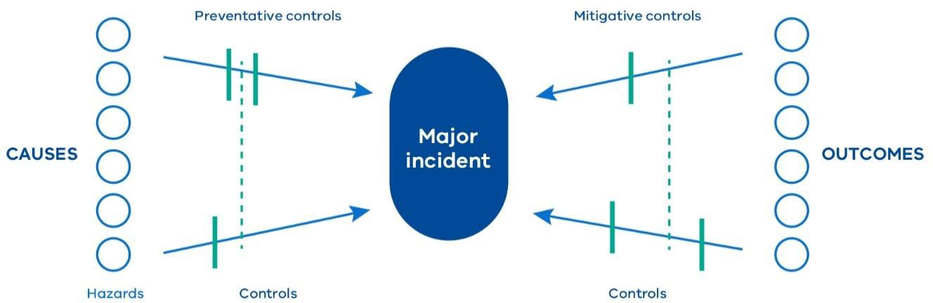

Source: Adapted from WorkSafe Victoria (2011, p. 16).

Efficient regulation: Integrating prescription and outcomes-based regulation
Policy consideration around the optimal approach to the regulation of safety risks frequently centres around these questions:

  - To what extent should regulated operators be required to meet formally prescribed rules and standards, with little or no discretion to depart from them?

  - To what extent should they be required to meet certain safety outcomes, but with the flexibility to determine how they might most effectively deliver required safety levels?

The distinction is between “prescriptive regulation” and “outcomes-based regulation”, and what constitutes the most appropriate balance between the two.

In its submission to the Review, AusNet Services has noted the advantages, including the greater flexibility, of an outcomes-based approach:

“The flexibility of a non-prescriptive framework enables the continued application of precautionary measures until monitoring of safety outcomes indicates the measures need to be reduced, stopped or investment directed toward other measures to achieve the required outcomes. A prescriptive approach requires the continued application of a measure regardless of network safety outcomes.” (AusNet Services, 2017, p. 5)

Similarly, CitiPower and Powercor Australia noted the limitations of applying prescriptive approaches in a complex environment:

“The complex dynamics of the electricity network, and the different environments that the businesses operate in, limit the cost-effectiveness of the prescribed measures such as a broad one-size-fits-all solutions.” (CitiPower & Powercor Australia, 2017, p. 14)

By itself, a safety case approach (or a similar, but less comprehensive, safety management system approach) may be considered as providing for outcomes-based regulation. In this case, the government sets out in legislation its requirements around the general safety duties that operators have, leaving operators the flexibility, through their individual safety cases, to determine how they might best achieve those safety outcomes.

In practice, many legislative frameworks built on an outcomes-based regime also contain more specific measures to be implemented. The inquiry by Lord Cullen following the explosion at the UK Piper Alpha oil platform in 1988 recommended that both prescriptive and outcomes-based regulation was needed (Wilkinson, 2014).

Outcomes-based regulation was also considered following the 2009 Montara oil spill. The Montara Commission of Inquiry noted that the offshore oil and gas framework had removed prescription for well integrity. It found the safety obligation was ambiguous and likely to have led to deficiencies, suggesting “the pendulum may have swung too far away from prescriptive standards” and that in some areas minimum standards are required. It noted that a “balance between prescriptive standards and technical innovation and flexibility must be achieved. In attempting to strike an appropriate balance, a stead‐fast eye must be kept on the ultimate goal of health, safety and environmental protection” (Montara Commission of Inquiry, 2010, p. 188).

The appropriate mix of outcomes-based and prescriptive regulation within a framework can be influenced by industry characteristics, technical expertise needed and the number of regulated entities (Advisian, 2015). Advantages of prescriptive regulation are that it can

create certainty about exactly what must be done to meet legislative obligations, and can also facilitate a greater level of transparency.

In energy network safety regulation, an example of prescriptive regulation for entities also subject to outcomes-based regulation is mandated electric line clearance distances.
Prescription in this case may be based on the advantage of clear obligations that can be checked easily and there being less scope to innovate (Marsden Jacob Associates, 2017). Another common example is prescribed incident reporting requirements.

In Victoria, following recommendations of the Victorian Bushfires Royal Commission and the Powerline Bushfire Safety Taskforce, prescriptive regulation was introduced to mandate specific measures for bushfire mitigation, including enhanced fault detection and suppression capacity and heightened powerline conductor technology standards for particular powerlines. The Powerline Bushfire Safety Taskforce noted that:

“Consistent with contemporary work on risk management, the Taskforce has adopted a precautionary-based risk management framework to identify and assess actions that can be taken to reduce bushfire risk from powerlines. Under the precautionary-based approach, all reasonable practicable precautions are adopted based on the balance of the significance of the risk and the effort required to reduce the risk.” (Powerline Bushfire Safety Taskforce, 2011, p. 4)

In addition, it noted:

“Consistent with principles for best practice regulation and the current regulatory regime, the Taskforce has sought, wherever possible, to make recommendations that are outcomes-based rather than prescriptive. However, it is recognised that some prescriptive elements might be appropriate.” (Powerline Bushfire Safety Taskforce, 2011, p. 55)

In adopting the recommendations of the Taskforce and the Victorian Bushfires Royal Commission, the government considered that prescriptive legislation was warranted to minimise bushfire risk. Victoria faces some of the highest bushfire risks in the world.

Box 5: Early adoption of outcomes-based safety regulation for gas and electricity networks in Victoria

Victoria was an early adopter of outcomes-based regulation for electricity and gas network safety. As noted earlier in this chapter, the requirement for safety cases to be produced by gas network operators was introduced with the Gas Safety Act in 1997, almost 3 years before the requirement was applied to major hazard facility operators following the Longford gas explosion. In introducing the Gas Safety Bill 1997, the then Minister for Finance outlined the rationale for the safety case regime:

“The safety case regime has been identified as the most appropriate regulatory framework for the supply sector of the Victorian gas industry. It represents a light-handed approach in that it avoids prescriptive regulation and therefore reduces compliance burdens for gas companies, but at the same time is able to minimise the risks associated with the conveyance and supply of gas.” (Parliament of Victoria, 1997, p. 673)

The then Victorian Government adopted a different approach to electricity safety regulation when the Electricity Safety Bill 1998 was introduced a few months after the passage of the Gas Safety Act 1997. The new legislation for electricity safety incorporated prescriptive requirements, including for electric line clearance. Nevertheless, the legislation also made provision for voluntary outcomes-based electricity safety management schemes. In the second reading speech, the then Minister for Finance noted that the voluntary provisions allowing network operators to prepare Electricity Safety Management Schemes would provide an alternative way to satisfy the legislation’s safety outcomes:

“The new regime of electrical safety management schemes, as provided for in the bill, is designed to introduce greater flexibility to the regulation of electrical safety and provide cost savings to industry participants and consumers alike. The introduction of safety management schemes is intended to give industry participants the option of putting forward an alternative way of achieving the safety outcomes of the legislation.

… A scheme may be accepted only if it can be demonstrated that safety outcomes will not be compromised by the operation of the scheme.” (Parliament of Victoria, 1998, p. 505)

The role of prescription and standards in a safety case regime
In most, if not all circumstances, outcomes-based regulation is likely to provide the most efficient approach to achieving acceptable safety. This is because of the flexibility it provides – operators are freer to innovate and find more cost-effective methods of achieving safety. In its report, Best Practice Electricity and Gas Network Safety Frameworks in International Jurisdictions, Marsden Jacob found that of five selected international jurisdictions, all except the gas safety framework in Texas followed an outcomes-based approach to energy network safety regulation (Marsden Jacob Associates, 2017).

However, there can sometimes be a misconception that the safety case approach does not involve the application of prescription or standards, or involves the regulator “vacating the field”. As Hopkins (2012) has noted, this is not what happens in an effective safety case regime:

“A safety case does not give operators a free rein in how they respond to hazards. They need to specify the procedures and standards they intend to adopt. Where an operator proposes to adopt an inadequate standard, a safety case regulator may challenge the operator to adopt a better standard. For instance, if an operator indicated in its safety case that it intended to rely on a manifestly inadequate standard, the regulator could challenge it to adopt the best international standards. However, the success of this challenge may depend on whether or not the jurisdiction imposes a general duty on the operator to reduce risk as low as reasonably possible … which would in effect mandate that operators adopt the best international standards.

One of the misconceptions … about safety case regulation is that it involves the abandonment of prescription. That is not so. A safety case requires that technical standards be specified and regulators can then enforce those standards.
Moreover, there remains room for prescriptive, government-imposed regulation. For example, regulations can specify the kinds of incidents that operators are required to report.” (Hopkins, 2012, p. 5)

While a safety case approach may be an outcomes-based approach in the sense that it offers flexibility for operators to determine what standards and methods might be most effective in reducing safety risk as far as reasonably practicable, Wilkinson (2002, p. 6) also notes that it does not involve abandoning prescription completely:

“… effective application of the safety case approach requires there to be
elements of prescription … the ‘prescription’ is not the traditional government imposed prescription but comes about as a result of the operator describing (or prescribing?) in their safety case how safety is to be achieved.”

Core capabilities for an effective safety regulator
There is a large and growing literature identifying the key capabilities and characteristics that regulators require to be successful. A number of these are particularly valuable for regulators administering safety case based regulation.

A highly capable and well-resourced regulator
In its report, Regulatory Institutions and Practices, the New Zealand Productivity Commission noted one feature of successful regulators is “an appropriate institutional form and degree of independence to enable them to function as intended” (The New Zealand Productivity Commission, 2014, p. 3).

Regulators must be able to make objective, impartial, consistent and expert decisions without any perception of being influenced by conflict or bias, whether from regulated entities or government. They should have capacity to work collaboratively with regulated entities, and take independent action when required.

Analytical capabilities and reporting
An effective regulator possesses strong analytical capabilities and processes, and a strategy for the use of data. This provides a regulator with confidence in its decisions, backed by evidence from a variety of sources and a strong analytical framework.

Strong analytical capabilities enable a sophisticated understanding of risks, regulated industries and the operating environment (such as emerging risks and technologies). Leading regulators typically embrace regular reporting to foster business and community confidence.

Expertise
A regulator should have a deep technical understanding of the industry and functions it is regulating. It must also possess clear organisational knowledge of the obligations it is imposing, and its compliance and enforcement approach.

Such expertise is needed across management and front-line staff, for:

- informed, swift and consistent decisions on safety case acceptance;
- monitoring whether controls specified are functioning as the entity and regulator intended;
- detecting risks and emerging issues;
- useful guidance and engagement to encourage better performance; and
- responding appropriately to noncompliance.

Regulatory approach
For its compliance and enforcement approach to be effective, a regulator should have a range of tools, from education at one end, through to stronger measures such as prosecution and revocation of licence to operate at the other. With a range of options, the regulator can develop and apply its policies to select the most appropriate tool(s) to improve performance and deter noncompliance.

Effectiveness of regulation is not only dependent on the design of the regulation, but also on a clear and tailored compliance and enforcement approach that is put into practice. As noted by the Productivity Commission: “Even where new or reformed regulation is appropriate and well designed, poor enforcement practices can risk rendering it ineffective, or unduly burdensome, or both” (Productivity Commission , 2011, pp. 14-15).

Ayres and Braithwaite explain how both cooperative and deterrent activities can be used by the regulator through a responsive approach in Figure 9. Under their model, persuasive techniques are used in the first instance, with more punitive responses where the desired behaviour is not achieved.

Figure 9: How cooperative and deterrent activities can be used by the regulator

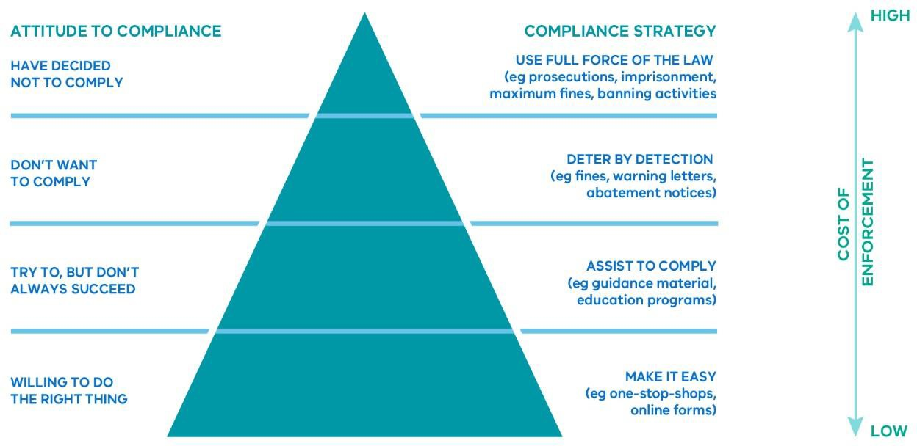

Source: Adapted from The New Zealand Productivity Commission (2014, p. 56)

Under a risk-based approach, responses are targeted based on assessed risk.

In his report, Compliance, Enforcement, and Regulatory Excellence, Gunningham outlines various approaches and suggests different strategies can be applied and used in combination, according to their suitability to regulatory contexts (Gunningham, 2015, p. 13).

Audit and inspections
Targeted and extensive audit and inspection programs give the regulator and businesses confidence that systems continue to work in practice, based on an accepted safety case. They require a significant level of activity and expertise to determine whether the safety case is achieving desired outcomes, rather than a simple desktop compliance process.

Workforce engagement
Worker involvement in safety case development enables input from all levels, promotes business-wide understanding of the approach to safety to be followed, and the implementation of the safety case can be challenged in response to detected deficiencies.

As part of the Ladbroke Grove Inquiry, a commissioned report found that worker involvement in developing a safety case was important for worker “ownership” and commitment to the safety case, rather than simply advising the workers of the safety case (Haddon-Cave, 2017).

References
Advisian, 2015. Developing Best Practice.
AusNet Services, 2017. Safety Review Submission.
Australia/New Zealand Standard, 2017. Pipelines- Gas and liquid petroleum Part 6: Pipeline safety management (Draft for Public Comment).
CitiPower & Powercor Australia, 2017. Additional Information to Support the Review of Victoria’s Electricity Network Safety Framework.
Cooke, G., 2003. Safety Case Implementation– An Australian Regulator's Experience. Symposium Series, Issue 149, pp. 605-617.
Edwards v National Coal Board (1949).
Gunningham, N., 2015. Compliance, Enforcement, and Regulatory Excellence.
Haddon-Cave, J., 2017. Zen and the Art of Safety Case Maintenance in the Post-Nimrod World. London. Hopkins, A., 2012. Explaining “Safety Case”.
IPART, 2017. Electricity Networks Audit Guideline- Consultation Paper.
Marsden Jacob Associates, 2017. Best practice electricity and gas network safety frameworks in international jurisdictions.
Montara Commission of Inquiry, 2010. Report of the Montara Commission of Inquiry.
Office of the National Rail Safety Regulator, 2016. Guideline: Meaning of duty to ensure safety so far as is reasonably practicable- SFAIRP, Adelaide.
Parliament of Victoria, 1997. Gas Safety Bill: Second Reading. Parliament of Victoria, 1998. Electricity Safety Bill: Second Reading.
Powerline Bushfire Safety Taskforce, 2011. Powerline Bushfire Safety Taskforce: Final Report. Productivity Commission, 2011. Identifying and Evaluating Regulation Reforms, Canberra.
R2A, 2017. R2A’s Response to the Review of Victoria’s Electricity Network Safety Framework. The New Zealand Productivity Commission, 2014. Regulatory institutions and practices.
Wilkinson, P., 2002. Safety Cases: Success or Failure?.
Wilkinson, P., 2014. “The use of Safety Cases in Certification and Regulation” by Professor Nancy Leveson: A review by Peter Wilkinson, Sydney: Noetic Risk Solutions.
Workplace Relations Ministers’ Council, 2008. National Review into Model Occupational Health and Safety Laws: First Report.
WorkSafe Victoria, 2011. Safety Assessment for a major hazard facility.

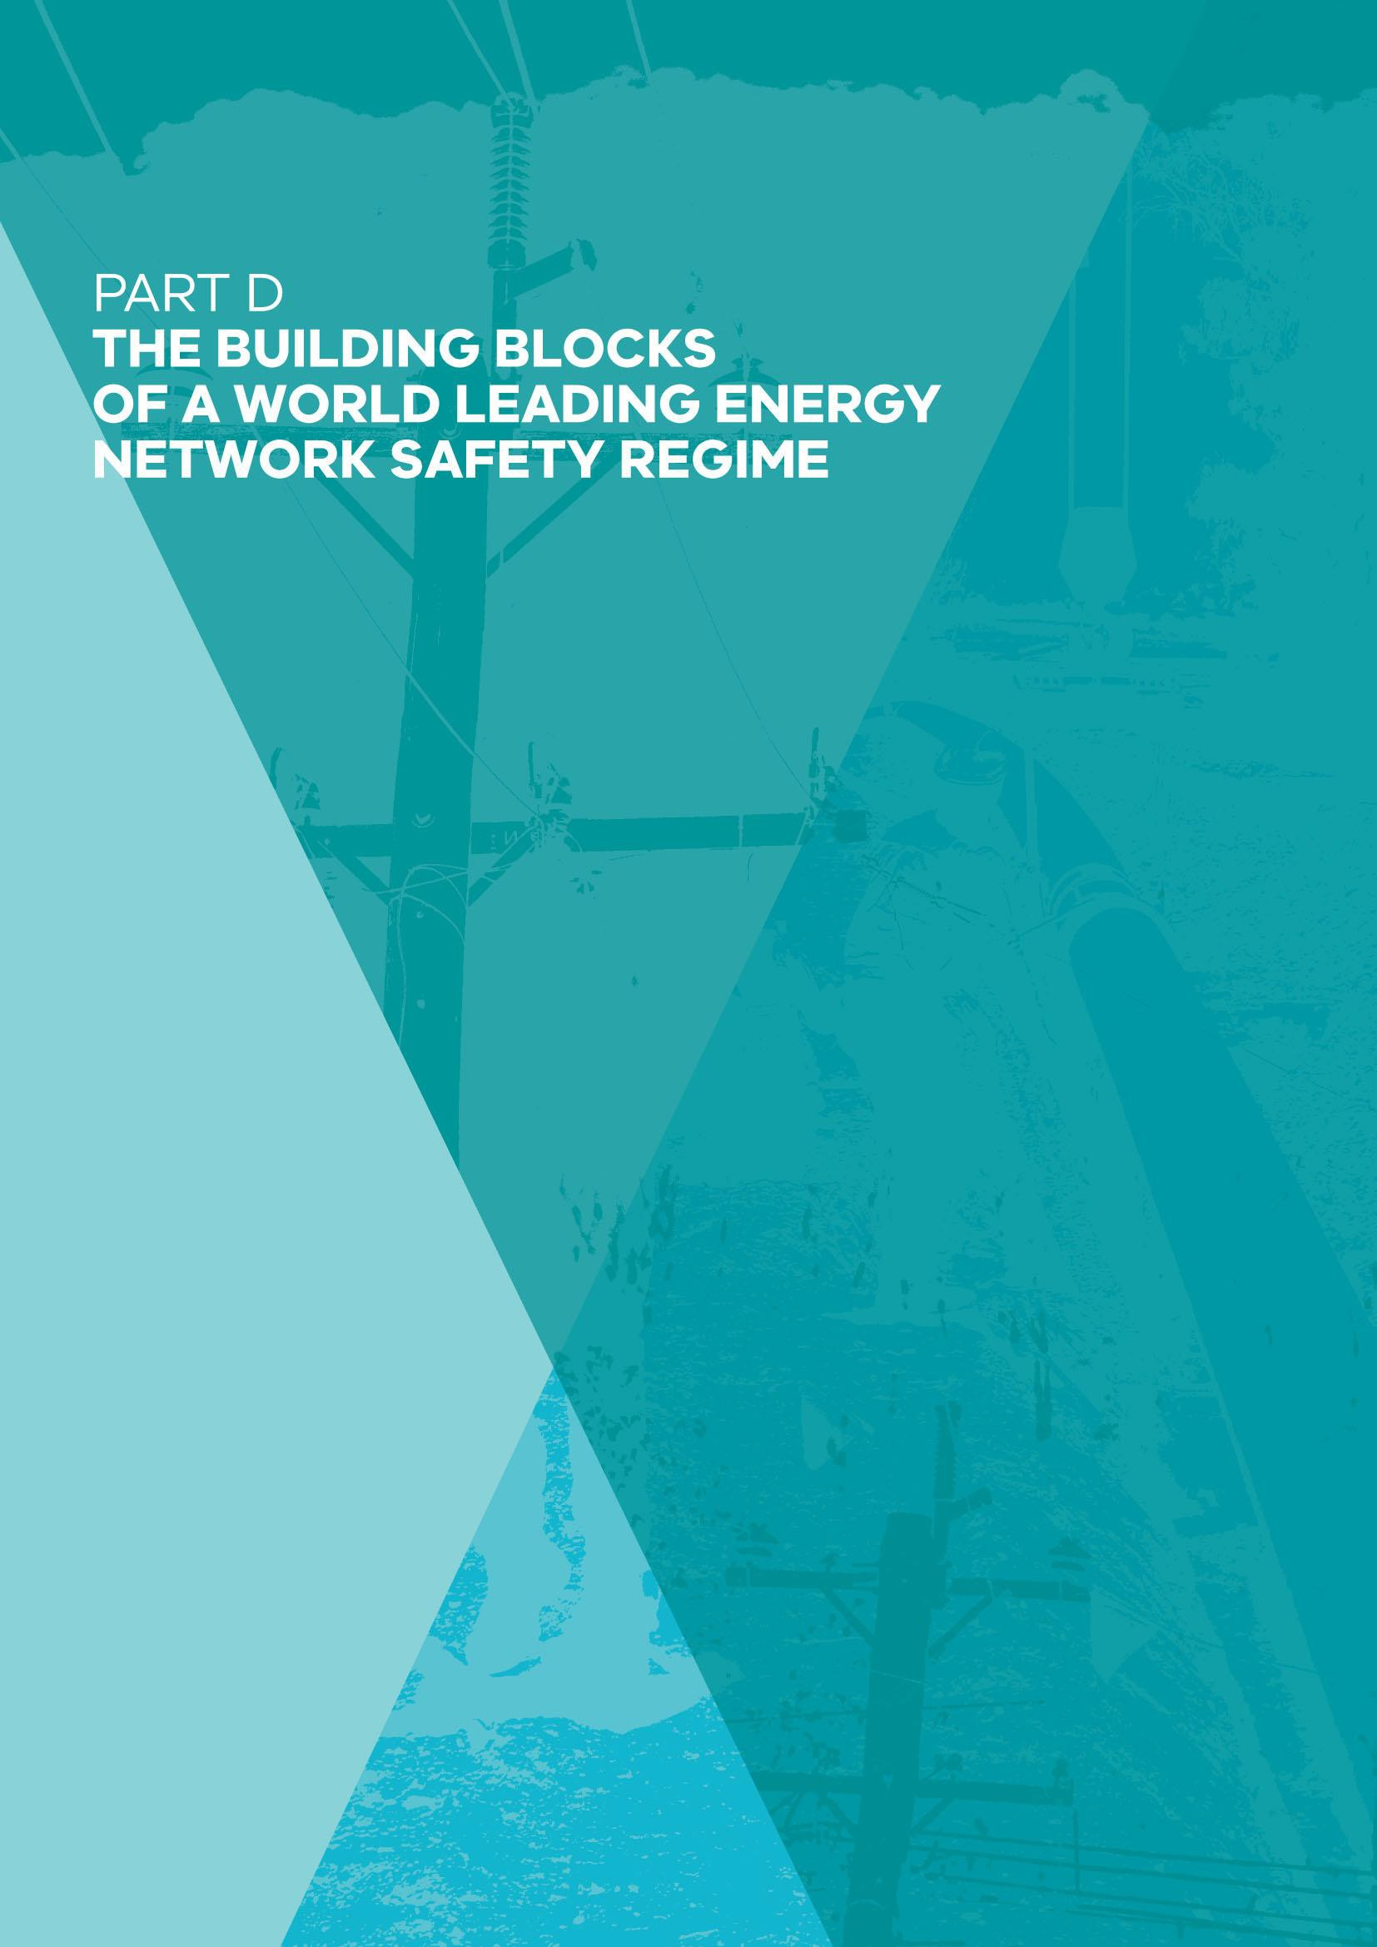

PART D: THE BUILDING BLOCKS OF A WORLD LEADING ENERGY NETWORK SAFETY REGIME

82

Chapter 1: ESV’s Regulatory and Corporate Governance

Summary
Energy Safe Victoria (ESV) has developed a strong reputation as a regulator that seeks to work collaboratively with energy network businesses. There is less consensus around the degree to which ESV strikes an effective balance in enforcing its regulation.

ESV should be constituted as a three-person commission to buttress its independence.

This would broaden accountability for ESV's regulatory decisions and approach from a single Director of Energy Safety. It would also promote consideration of a wider range of perspectives in regulatory decision making and support strengthened corporate governance (Recommendations 1 and 2).

ESV is a technical regulator requiring specialist skills. It relies on staff who have previously been employed by the network businesses that ESV regulates or who have consulted to those businesses.

The movement of staff has a number of benefits, but it also brings risks of perceived and actual conflicts of interest in regulatory decision making. Building on its current Conflict of Interest Policy, ESV should develop stronger and more formal arrangements to manage these risks (Recommendation 3).

ESV should continue to strengthen its internal corporate governance and associated management processes and systems (Recommendation 4). Recent external reviews commissioned by ESV have identified areas of weakness in ESV’s systems and processes.

The Director of Energy Safety and ESV’s senior leadership team have commenced a significant internal reform program aimed at promoting more formal collective management structures and governance. This ongoing work should continue as a high priority for the organisation.

Principles for effective regulatory governance
The hallmark of an effective and mature outcomes-based safety system is one in which the regulated businesses accept full accountability for the management of safety risks. This assignment of accountability does not mean that the regulator has a secondary role. In fact, a strong, well-resourced and confident regulator plays an essential role.

For businesses that are well led, a strong and independent regulator provides robust external assurance that safety risks are being managed effectively. Conversely, it provides assurance to the community that if risks are not being managed effectively, there is a high probability that the regulator will discover systemic weaknesses early, and it will act.

In considering ESV’s governance arrangements, the Review has been guided by the Organisation for Economic Co-operation and Development’s (OECD) best practice principles for regulatory policy as set out in The Governance of Regulators (OECD, 2014). These internationally accepted principles for modern, fit-for-purpose regulation have been strongly influenced by principles developed earlier in Victoria (Government of Victoria, 2010). The OECD’s principles include:

- Preventing undue influence and maintaining trust – all decisions and activities of a regulator should be objective, impartial, consistent and expert. The OECD notes that “establishing the regulator with a degree of formal independence both from those it regulates and from government can provide greater confidence that decisions are impartial” (OECD, 2014, p. 48).

- Governing body structure – the governing body structure of a regulator should depend on the nature of the regulatory task including “the level of risk, degree of discretion level of strategic oversight required and the importance of consistency over time” (OECD, 2014, p. 68). The OECD has identified three main governance structures for independent regulators:

  - Governance Board Model – the board is primarily responsible for the oversight, strategic guidance and operational policy of the regulator, with regulatory decision making functions largely delegated to the Chief Executive Officer and staff;

  - Commission Model – the commission itself makes most substantive, regulatory decisions; and

  - Single-Member Regulator – an individual is appointed as regulator and makes most substantive regulatory decisions and delegates other decisions to his or her staff.

- Accountability and transparency – a regulator needs to be accountable to its minister and the legislature, as well as the entities it is regulating and the public. The OECD notes that “accountability and transparency is the other side of the coin of independence and a balance is required between the two” (OECD, 2014, p. 81).

Confidence in the integrity and impartiality of regulatory decision making can be fostered by the regulator being open and transparent about its decisions.

- Funding – it is important for a regulator to have a transparent source and level of funding to protect its independence and objectivity (OECD, 2014). Clarity on how the regulator is funded can further strengthen public confidence that the regulator is both efficient and effective. The regulator should not set cost recovery fees without an arm’s- length oversight.

Box 6: Multi-Member Versus Single Member Governance Structures – Selected Considerations Identified by OECD

The OECD’s principles incorporate a range of considerations in considering the potential value of a multi-member structure compared with a single-member decision making model, including,

- “a group of decision makers is less likely to be ‘captured’ than an individual and a group will bring differing perspectives to decisions”;

- “diversity of wisdom, experience and perceptions (is) required for informed decision making … collective decision making provides better balancing of judgement factors and minimises the risks of varying judgements”;

- “collegiate support for strategic decision making”;

- “where regulatory decisions require a high degree of judgement, a multi-member decision making body provides more ‘corporate memory’ over time”; and

- “a board will be less susceptible to political or industry influence than a single decision maker.” (OECD, 2014, pp. 70-71)

ESV’s current regulatory and organisational governance
ESV is currently established as an independent statutory authority, with a single member – the Director of Energy Safety. As a single-member regulator, the Director is the statutory and accountable officer responsible for regulatory decisions. The governance structure of ESV also vests the administrative responsibilities with the Director, and ESV notes that “the Director is also the Chief Executive Officer (CEO) of ESV” (ESV, 2017a).

ESV’s funding sources are provided for within its Corporate Plan and reported in its Annual Report. The main sources of funding for ESV are from industry levies approved by the Minister and other fees. ESV is fully industry funded and does not receive State budget appropriations.

As an independent statutory authority, ESV must ensure high consequence risks are managed adequately, and impacts on the community and industry are balanced proportionately. In accordance with the Standing Directions as part of the Financial Management Act 1994, the Minister is required to articulate the expectations of ESV by issuing a formal and publicly available Ministerial Statement of Expectations.

In turn, ESV is required to detail within its Corporate Plan how it intends to meet the requirements as set out in the Statement of Expectations. The Corporate Plan must include the following elements as defined within the Energy Safe Victoria Act 2005:

- Statements of corporate intent for the current financial year and the two following financial years, incorporating:

  - the objectives of ESV;
  - the nature and scope of activities to be undertaken by ESV;
  - accounting policies to be adopted;
  - performance targets and other measures;
  - the kind of information to be provided to the Minister during the year; and
  - other matters agreed between the Minister and ESV.

- a Business Plan containing information required by the Minister; and

- financial statements containing information as required by the Minister.

Under the Energy Safe Victoria Act 2005, the Corporate Plan may be published or made publicly available only after approval by both ESV and the Minister.

The Annual Report also reports ESV’s progress in achieving the outcomes set out in its Corporate Plan. The Ministerial Statement of Expectations, ESV’s formal response to the Statement of Expectations, Corporate Plan and Annual Report are all publicly available on ESV’s website.

In comparison with other Australian energy safety regulators, only ESV and the Independent Pricing and Regulatory Tribunal (IPART) in New South Wales have been established on an independent statutory basis. The remaining states have their energy safety regulation established as a division or statutory office within a department.

The current ESV structure comprises five divisions with the General Manager for each reporting to the Director of Energy Safety. The five divisions are as follows:

- Electrical Safety and Technical Regulation (ESTR) – Responsible for the safety of electrical networks, installations and equipment, and provides analytical support to the GPSTR division.

- Gas and Pipeline Safety and Technical Regulation (GPSTR) – Responsible for the safety of natural gas, LPG, and LP distribution networks, complex and type B gas

installations, and gas appliances. GPSTR also has oversight of licensed pipeline safety and the protection of metallic structures from stray currents.

- Licensing, Standards and Certification Development – Accountable for the administration of electrical worker licensing, and compliance of the electrical installation safety certification scheme (COES).

- Risk, Regulatory Planning and Policy – Provides legal support for ESV’s activities, and oversees the organisational risk, planning, regulatory practice and policy functions.

- Corporate Services – Provides fundamental support services to the operational arms of the business including finance, strategy, information services, people services, occupational health and safety (OH&S) and communications.

Figure 10: ESV current organisational chart
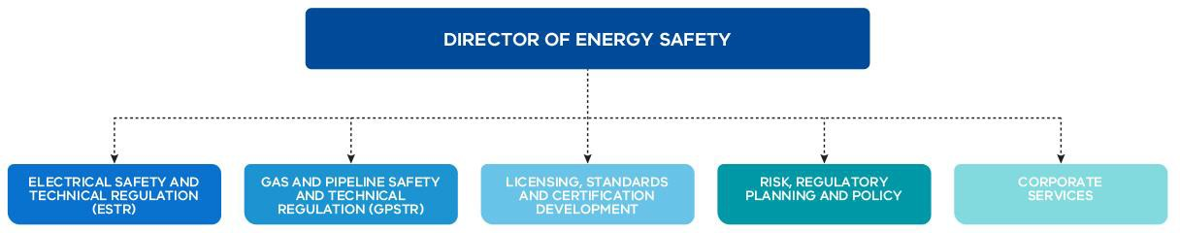

Establishing ESV as a commission
The Review proposes that ESV be reconstituted as a multi-member commission.

The current single-member model, which sees the Director of Energy Safety having sole accountability for regulatory decision making, has some strengths – it is simple, individual accountability is clear (it is the Director who ‘carries the can’) and it avoids the additional overheads that are inherent in collective decision making structures.

However, the single-member structure also has several potential weaknesses:

- it does not provide the broader perspectives and experience that a multi-member group can bring to difficult regulatory decision making;

- it can leave the regulator more exposed to allegations of regulatory capture; and

- it increases the pressure on a single individual when difficult regulatory decisions need to be made.

In the Review’s judgement, the advantages of the current single-member model are outweighed by the disadvantages. Accordingly, it is proposed that a multi-member structure should be adopted instead.

Constituting ESV as a commission would bring it broadly into line with a number of energy regulators that are structured as commissions (see Table 3). This broad alignment is not a definitive consideration in itself: the precise governance arrangements should depend on the specific circumstances and objectives of each regulator. Nevertheless, a commission structure is common among other major regulators and this provides a useful reference point for consideration of ESV’s governance arrangements.

Table 3: Other major energy regulators structured as commissions

Regulator | Single or multi-member | Governance structure
Australian Energy Market Commission | Multi-member | Commission
Australian Energy Regulator | Multi-member | Commission
Australian Competition and Consumer Commission | Multi-member | Commission
Essential Services Commission (Victoria) | Multi-member | Commission

The Review considers that ESV should be structured as a small commission with a full-time chair and two part-time members. The chair should have significant regulatory experience, while the part-time members should have previous experience in technical or safety regulation. At least one of the commissioners should have extensive legal experience and one commissioner should have extensive economic experience.

Although ESV is classified as a major Victorian government regulator, it is a medium-sized organisation when measured in terms of number of staff (145 according to the Annual Report 2016–17), and its regulatory functions are technical and tightly focused on the electricity and gas sectors (ESV, 2016). These considerations would tend to weigh against appointing all members on a full-time basis.

Similarly, while it is not uncommon for large regulators constituted as commissions to have separate chief executives, the case for adopting this structure for an organisation of ESV’s scale and scope does not seem compelling. Accordingly, the Review proposes that the chair of the commission should also serve as the Chief Executive of Energy Safe Victoria.

As noted later in this chapter, the Director of Energy Safety has recently established a formal Executive Management Board to bring greater structure and collective leadership to ESV’s corporate management. This Board should continue under the recommended commission model.

It will be important that the governance model clearly distinguishes between the corporate governance of ESV – for which the commission chair would be responsible as the Chief Executive of ESV advised by the executive management board – and the governance of statutory regulatory decisions, which should solely be the responsibility of the three commission members. Decision making by the commission should be by consensus, or majority vote if a consensus cannot be reached. The commission should have the capacity to delegate routine decision making to the relevant regulatory staff within ESV.

The governance structure should provide for effective and rapid decision making in emergencies. The Energy Safe Victoria Act 2005 contains specific provisions for the Director of Energy Safety to have emergency powers. Under the proposed commission structure, the full-time chairperson should retain these powers.

Statutory advisory committees currently constituted under Section 8 of the Energy Safe Victoria Act 2005 and under certain sections of the Electricity Safety Act 1998, should continue under the revised structure as advisory bodies to the commission. The existing advisory committees that have been established by ESV on a non-statutory basis should also be maintained.

Figure 11: Proposed governance structure with a new Energy Safety Commission

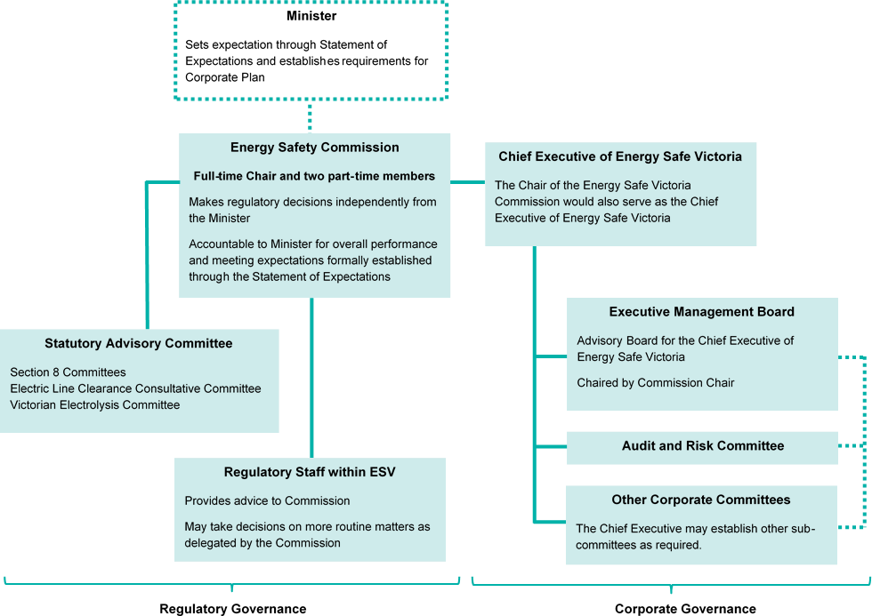

Recommendation 1
Energy Safe Victoria should be established as a commission with three commissioners. One commissioner should serve as a full-time chair, with reserve powers in the event of emergencies. The remaining two commissioners should be appointed on a part-time basis. The commissioners should each have equal voting rights, with decisions being made by consensus, or by a simple majority if a consensus cannot be achieved.
Commissioners should be appointed for five year terms, with the ability for these terms to be renewed once only.

Recommendation 2
The Chair of the Energy Safe Victoria Commission should also serve as Chief Executive of ESV and should have responsibility for the corporate leadership of ESV, advised by an Executive Management Board.

Strengthening ESV’s Internal Governance to Support Independence
As a technical safety regulator, regulating complex electricity and gas networks, ESV requires highly skilled staff with the necessary knowledge and experience. Given the relatively small pool of professionals with this experience in Victoria, it is unavoidable that ESV must employ some staff who have previously worked in the regulated network businesses or have consulted these businesses, or who may work in these businesses in the future.

This movement of staff between regulated businesses, consultancies and the regulator creates risks of perceived or actual conflicts of interest.

Technical regulators in other settings and in other jurisdictions often confront this same risk. If independence and integrity in regulatory decision making are to be preserved, it is essential that there are strong internal mechanisms for ensuring that any actual or perceived conflicts of interest are handled effectively.

The OECD best practice principles for regulatory governance recommend that senior staff involved in decision making that involves their former employers should excuse themselves from the decision making process:

“Board members, senior staff and staff on secondment should not be involved (recused) in any decisions that affect previous employers.” (OECD, 2014, p. 46)

The Department of Premier and Cabinet’s (DPC) Improving Governance of Regulators: Principles and Guidelines, is less specific, but highlights the need for robust arrangements to manage the conflicts:

“Effective management of actual and potential conflicts of interest is particularly important for regulators. The governing body needs to be mindful of the range of risks that might arise and tailor processes and oversight to minimise them.” (Government of Victoria, 2010, p. 12)

At the same time, DPC’s guidelines and principles recognise some of the benefits of mobility of staff between the regulator and regulated entities:

“Many of the staff and members of regulators’ governing boards will have backgrounds in the industry they are regulating, and in many cases, will return to roles in that industry. These staff movements transfer skills and experience between regulators and industry, and can have benefits in:

- building shared understandings of the context within which each is operating;
- helping regulators stay in touch with current operating processes within the industry;

- improving the industry’s understanding and navigation of the regulatory system; and
- improving industry compliance.” (Government of Victoria, 2010, p. 12)

The majority of ESV’s current Executive Management Board and a majority of ESV’s current infrastructure regulatory staff have not previously been employed by network businesses.
However, as noted above, some movement of staff is inevitable, and will continue in the future.

ESV has had a Conflict of Interest Policy since 2009 that sets out the requirements for staff to disclose and properly manage actual, potential and perceived conflicts. This policy was most recently updated in July 2017. As part of this updated policy, ESV has introduced a Declaration and Management of Private Interests Form of which the following people are required to complete upon appointment:

- all executive officers (including senior executives);
- Audit and Risk Committee members;
- persons employed by ESV holding a financial delegation of $25,000 or more; and
- persons employed by ESV assessed by the Director of Energy Safety as requiring declaration of private interests on the basis of potential, perceived or actual conflict of interest.

The Conflict of Interest Policy includes the requirement for staff to declare any conflicts of interest and to abstain from involvement in official decisions that could be reasonably seen as being compromised by a conflict of interest.

Recognising the broad scope of ESV’s current Conflict of Interest Policy, the Review considers that further steps could be taken to strengthen the current arrangements. In particular, specific guidance should be given to staff who have previously been employed by network businesses or by consulting firms providing services to network businesses.

Recommendation 3
Building on its existing Conflict of Interest Policy, ESV should develop documented protocols and additional guidance to ensure that perceived and potential conflicts of interest are addressed in its regulatory decision making, particularly in cases where regulatory staff have previously been employed by network businesses or undertaken previous consulting engagements with network businesses.

Strengthening ESV’s corporate governance and management systems more generally
As noted earlier in this chapter, the effectiveness of a regulator relies not only on the quality of its regulatory governance, the formal structures, processes and systems that support its regulatory actions and decision making, but also on the quality of its broader corporate governance, management and leadership.

The Director of Energy Safety and the senior leadership team have recognised the need for ESV’s corporate governance, management systems and capabilities to be substantially strengthened. This process has commenced, but more remains to be done.

In late 2015, the Director of Energy Safety commissioned an independent Executive Structure Review conducted by Marchment Hill Consulting. The final report of this review was delivered in February 2016.

Marchment Hill’s report noted that its “health check” review was conducted against a backdrop of ESV having grown in scale, complexity and maturity. It identified a number of key issues, including:

- Organisational drift, with no well-defined “organisational model” for ESV.

- Unbalanced spans of control, with the Director of Energy Safety having a very wide span of control while executive managers had very narrow spans of control.

- Elements of business culture appearing “to contribute to sub-optimal outcomes and collaboration between divisions and teams”.

- Technical areas openly speaking of working in “silos” or “stovepipes”.

- Weakness in ESV’s strategic foundations, and that aspects of ESV’s strategy could be “further developed, better supported and better understood” (Marchment Hill Consulting, 2016).

Further information on the key findings of the Marchment Hill report is detailed in a box below.

To assist with further consideration of the changes to be made to ESV’s organisational structure, the Director of Energy Safety commissioned a subsequent Functional Review by Huegin Consulting, which reported in June 2016.

Huegin noted that its review had “highlighted some areas where the way in which ESV delivers value could be made more robust”, and specifically that these related to ways in which ESV:

- “manages risk and makes accountable decisions”; and

- “the degree to which processes are traceable and outputs are defensible.” (Huegin Consulting, 2016, p. 10)

Huegin (2016) identified areas of weakness in ESV’s formal approach to risk management including:

- the lack of a consistent basis for understanding and communicating risk;
- risk assessment being largely qualitative; and
- insufficient analytical support to allow a quantitative approach.

Huegin also made recommendations to provide for more robust and transparent decision making processes.

As a “working paper only”, Huegin attached a set of key themes from its interviews with ESV management and staff. Among other things, the interviews revealed a number of perceived weaknesses around risk management, intervention, systems support and performance measurement.

Further information on the key findings of the Huegin report is provided in a box below.

Both the Marchment Hill and Huegin reviews were commissioned by the Director for Energy Safety as part of an overarching organisational reform process. The Director of Energy Safety and ESV’s senior management team have responded across a range of fronts:

- a formal Executive Management Board has been established;

- spans of control have been adjusted, with the number of direct reports to the Director of Energy Safety being reduced, and spans of control for executive managers increased;

- a “fuel-centric, full value chain” that is, gas and electricity organisational focus has been implemented, overlaid by functional and regulatory practice capabilities; and

- a Chief Operating Officer role has been created to coordinate corporate functions, and a separate General Manager role dedicated to improving the effectiveness and controls around regulatory risk, enforcement and compliance policies and practices of ESV.

While much initial progress has been made, the senior leadership of ESV has indicated to the Review that it considers the process of organisational reform an “evolving and continuing work stream”.

In a very real sense, ESV has been on what its senior leadership described to the Review as an “organisational journey”. The relative lack of maturity in formal corporate governance and management structures that seems evident in the conclusions of the Marchment Hill and Huegin reports may, in part, reflect the fact that ESV was originally established from technical offices that had been located within much larger organisations.

Irrespective of the reasons, the need to substantially improve in formal corporate governance and processes has been recognised by ESV through work undertaken over the past two years. It is essential that the internal reform process that has commenced is completed and is deeply entrenched within all aspects of ESV’s operations.

In a series of roundtable discussions held with the Review, the Director of Energy Safety and ESV’s senior leadership team engaged openly and constructively in identifying the key areas where further work was required to strengthen ESV’s processes and capabilities. A continued open and transparent approach will greatly assist in boosting internal and external confidence in the steps being taken to improve the quality and maturity of ESV’s corporate governance and management arrangements.

Greater transparency around ESV’s management and internal governance reforms in formal external reporting would also assist.

At the outset of its Corporate Plan 2017–2020, ESV has highlighted “strengthening of our governance processes to support informed, predictable and transparent regulatory decision- making” as one of four critical success factors that underpin its plan (ESV, 2017b, p. 6).

This should now be followed up with clear public reporting around the specific steps that ESV has already taken, or is proposing to take as part of a process of continuous improvement.

Recommendation 4
The Executive Management Board of ESV should develop an overarching organisational reform roadmap that details key actions that have already been taken to strengthen ESV’s corporate governance and management structures and processes, and the actions that have yet to be completed.

This roadmap should take account of actions in response to the recommendations of this Review of Victoria’s Electricity and Gas Network Safety Framework and in response to the findings of previous reviews commissioned by the Director of Energy Safety. The roadmap should be reported publicly on ESV’s website and updated quarterly until all key actions have been completed.

Box 7: The Marchment Hill Review

The Director of Energy Safety commissioned an external Executive Structure Health Check by Marchment Hill Consulting in December 2015. The purpose of the review was to ensure that the executive structure and functional groupings of ESV were “best aligned to achieve ESV’s strategic objectives” (Marchment Hill Consulting, 2016, p. 5).

The Marchment Hill report identified a number of weaknesses in ESV’s structure and organisational culture at the time:

- organisational drift – Marchment Hill (2016, p. 13) noted “no well-defined ‘organisational model’, concerns with performance that have been historically addressed by changing reporting arrangements.”

- span of control – Marchment Hill (2016, p. 14) noted “two extremes between the DoES [Director of Energy Safety] and Executive Managers” with a number of implications including:

  - a flat management structure, with eight executive managers reporting to the Director of Energy Safety, creating “an entrenched DoES dependency and succession risk”

  - Executive Managers having an average of only two direct reports each, and that that this “narrow span of control limits leadership development opportunities and has a tendency to pull Executive Mangers into operational matters” and that “some Executive Managers believe that the structure, which has a tendency to emphasise the DoES’s and EM’s engagement in regulation and operational matters, limits the focus on strategic considerations”.

- business culture – Marchment Hill concluded that “elements of business culture appear to contribute to sub-optimal outcomes and collaboration between divisions and teams”, and, among other things it noted:

  - “The technical areas openly spoke about working in ‘silos’ or in ‘stovepipes’, which appeared to result in limited ‘sharing’ or ‘learning from others’ across the technical areas – noting regulatory requirements do differ between technical areas.”

  - “Employees (particularly in technical areas) either had little opportunity or displayed little desire or need to understand the workings of other Divisions and teams.”

  - “ESV appears to be primarily run as a series of multi-bilateral dialogues between the DoES and his direct reports, despite regular meetings of the technical Divisions and full executive.” (Marchment Hill Consulting, 2016, p. 15)

- strategic foundations — Marchment Hill concluded that “aspects of ESV’s strategy, which would guide organisational design could be further developed, better supported and better understood”.

Box 8: The Huegin Review

Following the Marchment Hill report in February 2016 (above), the Director of Energy Safety commissioned a further Functional Review by Huegin Consulting. Huegin reported its findings in June 2016, drawing on insights from interviews with ESV’s management and staff.

Huegin considered ESV’s “value proposition” in managing safety risk on behalf of the community and undertook an “Integrated Definition Mapping” exercise.

As “areas of opportunity”, Huegin identified that risk management and accountable decision making were functions that could be made more robust.

Risk management
Huegin identified effective risk management as an essential requirement for ESV. There are a number of elements that are required for the effective management of technical safety risk. These elements are:

- “A list of risks that are to be managed.
- A framework or 'mental model' through which an initial understanding of the risk topology can be derived.
- A suitable methodology for providing a quantitative assessment of the level of risk being borne, both now and in the future.
- An understanding of the risk appetite.
- A methodology for understanding the effect that potential interventions might have on the level of risk being borne.” (Huegin Consulting, 2016, p. 11)

While noting that “all interviewees recognised that effective risk management is essential for ESV”, Huegin made a number of observations about ESV’s risk management: “As a result of undertaking desktop analysis and conducting interviews with ESV personnel there are a number of observations that can be made regarding the way in which ESV manages risk”.

- “There are different definitions of the elements of risk.
- There is not a consistent mental model for understanding and communicating risk
- Risk assessment is largely qualitative.
- There is presently insufficient analytical support to allow a quantitative approach.”
(Huegin Consulting, 2016, p. 11)

Decision making processes
Huegin identified “accountable decisions and product” as a further key theme arising from its interviews and analysis. Huegin did not seek to examine the appropriateness of decisions made by ESV and noted its view that “all interviewees seemed eminently knowledgeable in their field and there is no reason to question the output of decisions

made”. Nevertheless, the observations in the report point to areas of systemic weakness that emerge from the interviews undertaken.

In making recommendations that “focus on a more robust and transparent process of decision making and an identification of accountable product, decisions and advice”, Huegin noted:

… “it is reasonable to assume that ESV should ideally have four components in place:

- Defined accountable and non-accountable outputs.
- A process for producing accountable outputs.
- Designated levels of authority in the production of accountable outputs.
- An ability to trace the steps undertaken in producing accountable outputs.”
(Huegin Consulting, 2016, p. 12)

Analytical decision support
Huegin recommended that ESV should “formally establish an ESV-wide capability for analytical decision support”, noting in its report:

… “in providing an assurance of safety to the Community it is reasonable to expect that ESV would have some ability to quantitatively forecast the level of risk likely to be borne. To this end, it is important the ESV is able to leverage analytical decision support in the execution of key functions.” (Marchment Hill Consulting, 2016, p.13)

Huegin (2016, p. 13) further noted:

“The value of an effective analytical decision support capability is in the delivery of insights to both ESV decision makers and other stakeholders”.

It concluded that effective analytical decision support requires access to both sufficient data and sophisticated analytical tools.

Strengthening ESV’s capabilities for effective regulation
In addition to recognising the need to strengthen its processes to support “informed, predictable and transparent regulatory decision-making”, ESV’s Corporate Plan 2017–2020 recognises the need to build a range of capabilities, including:

- “building ESV’s internal capability and expertise to respond to the dynamic technological and engineering changes in industry

- collecting, analysing and reporting performance data to inform community, industry and government of emerging risks

- developing sophisticated IT systems to enable work flow, database management and digital platforms and portals for improved access and interaction with industry, such as ESVConnect and GasTrac.” (ESV, 2017b, p. 1)

Strong corporate governance and leadership will be necessary to ensure that the objectives set out in the Corporate Plan are delivered.

Building ESV’s workforce capabilities and diversity
As reflected in its Corporate Plan 2017–2020, ESV faces a changing environment, with new technologies, imported equipment, and distributed energy and storage raising new challenges and opportunities. At the same time, ESV needs to adopt new and sophisticated approaches to support its work, including analytical and auditing approaches. These themes are explored in further detail in the following chapters of this Final Report.

Ultimately ESV’s capacity to effectively meet the current and emerging challenges depends on the quality and skills of its people. Much will depend on ESV’s workforce strategy and leadership, and the extent to which it can position itself as a highly attractive place to work. Younger professionals in particular will wish to see how working in ESV may contribute to their broader career development.

The Review considers that ESV should, as a key element of its workforce strategy, seek to broaden the diversity of its workforce. There is significant and growing literature suggesting that greater workforce diversity can improve general organisational performance (McKinsey & Company, 2015).

While the Review is not aware of formal research around the impact of diversity in regulatory decision making specifically, it seems reasonable to hypothesise that a more diverse workforce may also help provide independent perspectives in regulatory decision making, even if only at the margin.

Recommendation 5
ESV should develop and implement a formal workforce strategy to support the attraction and retention of high performing staff. This strategy should include a specific focus on broadening the diversity of ESV’s workforce over time, including gender diversity.

References
ESV, 2016. Energy Safe Victoria Annual Report 2016-17, Melbourne.
ESV, 2017a. About ESV. [Online] Available at: http://www.esv.vic.gov.au/about-esv/corporate-information/about- esv/ [Accessed 05 October 2017].
ESV, 2017b. Energy Safe Victoria Corporate Plan 2017–2020, Melbourne. Huegin Consulting, 2016. Functional Review: Energy Safe Victoria.
Marchment Hill Consulting, 2016. ESV Executive Structure Review: Final Report.
McKinsey & Company, 2015. Why diversity matters. [Online] Available at: https://www.mckinsey.com/business- functions/organization/our-insights/why-diversity-matters [Accessed 05 October 2017].
OECD, 2014. The Governance of Regulators: OECD Best Practice Principles for Regulatory Policy, OECD Publishing.
Government of Victoria, 2010. Improving governance of regulators: principles and guidelines. Melbourne: Department of Premier and Cabinet.

Chapter 2: ESV’s Regulatory Approach and Capabilities

Summary
This chapter considers Energy Safe Victoria’s (ESV) regulatory approach and its regulatory capabilities, with a particular focus on compliance and enforcement, and the broader analytical capabilities necessary to support effective risk-based regulation.

International practice over the past two decades has seen increasing use of the safety case approach adopted by ESV in its network safety regulation. Experience has demonstrated that a robust safety case system requires strong “hands on” engagement by the regulator.

As foreshadowed in ESV’s Corporate Plan 2017–2020, there needs to be a substantial increase in ESV's inspection and audit activity.

More inspectors need to be out in the field and they need to be administering an expanded audit program that strongly implements the ESV goal to “test, challenge and expose” (Recommendation 6).

Behind the scenes ESV needs to develop significantly stronger analytical capabilities and an integrated approach to surveillance (Recommendation 8).

As part of this, ESV’s data analytics capability including the data collection and management systems to support robust statistical analysis, should form a central component (Recommendation 14).

ESV has also publicly signalled an intention to refine its “responsive regulation approach” and adopt a more robust approach to “serious noncompliances”. This should be a high priority – ESV needs to have the approach of a confident and independent regulator that is prepared, and equipped, to take strong action when required (Recommendations 9 and 10).

ESV currently has most of the tools necessary to facilitate a graduated approach to compliance and enforcement, allowing ESV to adopt “lighter touch” measures when this is appropriate, but to use stronger interventions in the case of more serious noncompliance.

However, ESV does not have some tools that are available to some other similar regulators. There is also scope to refine and improve the regulatory tools currently available to ESV to support risk-based regulation (Recommendation 12).

Key features of effective compliance and enforcement
The Victorian Guide to Regulation prepared by the Department of Treasury and Finance (DTF) identifies the central importance of achieving compliance in any regulatory system, noting that: “Without adequate enforcement, the credibility of [a] regulation may be compromised and the desired objectives are unlikely to be achieved” (Department of Treasury and Finance, 2014, p. 44).

DTF has set out the key features of an effective compliance regime:

- it provides motivation for regulated entities to comply voluntarily;
- the compliance strategy uses graduated deterrence with penalties applied at the level necessary for compliance and proportionate to the risks of noncompliance; and
- enforcement measures are consciously selected by the regulator from a range of graduated options.

In its report OECD Best Practice Principles for Regulatory Policy Regulatory Enforcement and Inspections, the Organisation for Economic Co-operation and Development (OECD) has set out the principles for an effective approach to regulatory compliance and enforcement.
These principles include that compliance activities should be evidence-based, proportionate and risk-focused. The approach should be supported by transparent governance, information integration and a long-term vision (OECD, 2014).

Box 9: OECD best practice principles: Improving regulatory enforcement and inspections

  - Evidence-based enforcement. Regulatory enforcement and inspections should be evidence-based and measurement-based: deciding what to inspect and how should be grounded on data and evidence, and results should be evaluated regularly.

  - Selectivity. Promoting compliance and enforcing rules should be left to market forces, private sector and civil society actions wherever possible: inspections and enforcement cannot be everywhere and address everything, and there are many other ways to achieve regulatory objectives.

  - Risk focus and proportionality. Enforcement needs to be risk-based and proportionate: the frequency of inspections and the resources employed should be proportional to the level of risk and enforcement actions should be aiming at reducing the actual risk posed by infractions.

  - Responsive regulation. Enforcement should be based on “responsive regulation” principles: inspection enforcement actions should be modulated depending on the profile and behaviour of specific businesses.

  - Long-term vision. Governments should adopt policies and institutional mechanisms on

regulatory enforcement and inspections with clear objectives and a long-term road-map.

  - Co-ordination and consolidation. Inspection functions should be co-ordinated and, where needed, consolidated: less duplication and overlaps will ensure better use of public resources, minimise burden on regulated subjects, and maximise effectiveness.

  - Transparent governance. Governance structures and human resources policies for regulatory enforcement should support transparency, professionalism, and results oriented management. Execution of regulatory enforcement should be independent from political influence, and compliance promotion efforts should be rewarded.

  - Information integration. Information and communication technologies should be used to maximise risk-focus, co-ordination and information-sharing – as well as optimal use of resources.

  - Clear and fair process. Governments should ensure clarity of rules and process for enforcement and inspections: coherent legislation to organise inspections and enforcement needs to be adopted and published, and clearly articulate rights and obligations of officials and of businesses.

  - Compliance promotion. Transparency and compliance should be promoted through the use of appropriate instruments such as guidance, toolkits and checklists.

  - Professionalism. Inspectors should be trained and managed to ensure professionalism, integrity, consistency and transparency: this requires substantial training focusing not only on technical but also on generic inspection skills, and official guidelines for inspectors to help ensure consistency and fairness (OECD, 2014).

ESV’s regulatory approach and arrangements
Consistent with the requirements of the Energy Safe Victoria Act 2005, ESV is required to publish a Charter of Consultation and Regulatory Practice. The Charter sets out how ESV will consult with its stakeholders and undertake its regulatory responsibilities. The most recent Charter available on ESV’s website was published in April 2015 (ESV, 2015).

The Charter provides general information on ESV’s approach to regulation. It has not yet been updated to take account of the recent changes that ESV has already made, or is in the process of making, to its regulatory structures, systems and processes.

ESV also maintains a published Compliance and Enforcement Policy, which was last updated in December 2014. This is a high-level document that sets out the broad principles that underpin ESV’s decisions about compliance actions (ESV, 2014a).

Further information on ESV’s intended regulatory approach is contained in its Corporate Plan, prepared in accordance with the requirements of the Energy Safe Victoria Act 2005.

In March 2017, ESV published a statement on Regulation and the Performance of Electricity Network Assets on its website. This statement, which had previously been published as an attachment to the 2015–16 Performance Report on Victorian Electricity Networks, articulates the role of safety cases in regulation and how they are incorporated into ESV’s regulatory activities.

The compliance and enforcement approach
ESV has a range of compliance and enforcement tools, including:

- providing advice and information to electricity and gas network businesses;
- issuing notices to prevent or remedy problems that may detected; and
- prosecuting breaches of the law.

The extent to which network businesses are complying with their safety obligations is monitored by ESV through inspections and audits undertaken by “enforcement officers” under the Electricity Safety Act 1998 and “inspectors” under the Gas Safety Act 1997 as well as other audit staff. ESV also receives information on the extent of compliance from incident reports and regular reporting by network businesses.

Enforcement officers and inspectors have certain powers to respond to noncompliance, such as serving infringement notices. Some compliance decisions may be made at an organisational level rather than by an individual ESV staff member, such as commencing a prosecution, which requires Director approval, and activities that involve multiple ESV staff (ESV, 2014c).

As outlined in its internal Compliance Strategy, ESV uses a progressive “educate, encourage, enforce” compliance pyramid model where the majority of regulatory resources are allocated to lower level compliance and enforcement activities (ESV, 2014b). When this proves insufficient to obtain compliance, ESV progressively escalates its response to higher levels of enforcement.

Figure 12: ESV compliance and enforcement pyramid

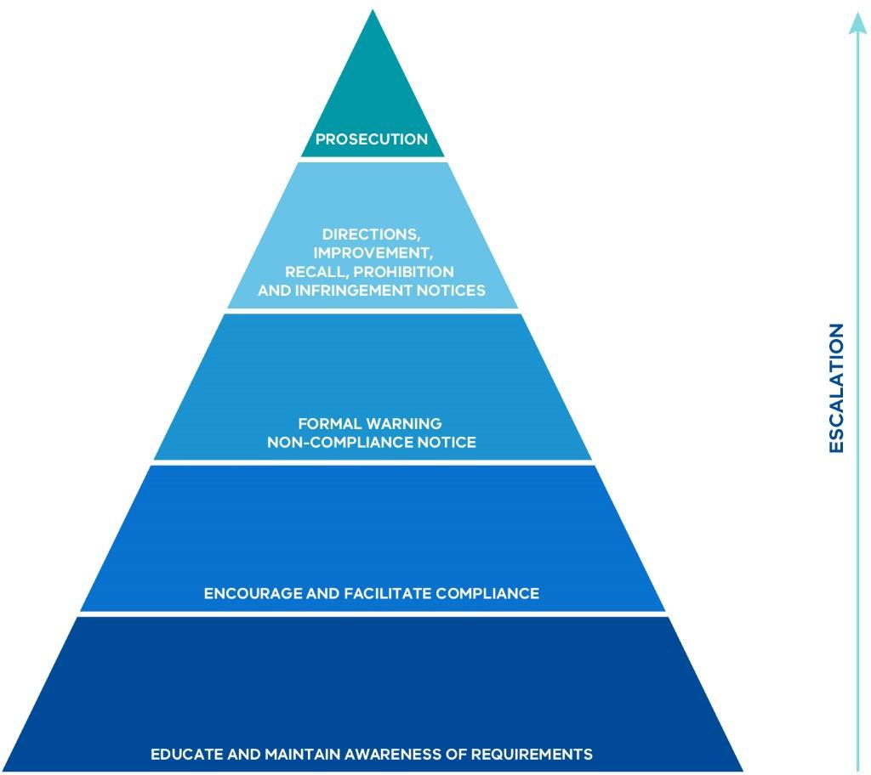

Source: Adapted from ESV (2014).

As part of the enforcement regime, electricity and gas network businesses can face penalties for breaches of the law. The legislation for network safety specifies a range of criminal penalties. Offences with higher maximum penalty amounts include the offences for noncompliance with directions, general safety duties and incident reporting obligations. In addition, civil penalties were introduced into the Electricity Safety Act 1998 this year and they apply to specific obligations on electricity distribution businesses relating to bushfire mitigation.

The sources of information that ESV utilises to identify compliance risks, and areas where enforcement action may be required, include:

- incident reports from energy businesses, emergency services and the community;
- regular periodic compliance reporting from operators of electricity networks, gas networks and pipelines;
- inspections and audits; and
- investigations of serious incidents and complaints – which might also lead to ESV taking enforcement actions (ESV, 2014b).

In its Compliance Strategy, ESV states that the risk management process it employs requires ESV to:

- establish the context of the risk;
- identify and assess the risk;
- analyse effectiveness of existing controls (the framework and ESV’s approach); and
- treat unacceptable risks.

ESV undertakes a formal, externally facilitated risk assessment biennially to analyse sector risks, and updates this register with new and emerging risks. The risk management process is used by ESV to determine where compliance resources and efforts are directed, the volume of compliance resources, and the effort allocated to managing each risk and how severe ESV’s response to noncompliance needs to be (ESV, 2014b).

ESV’s compliance and enforcement activities are published in its annual reports and annual network safety performance reports for the electricity sector. The network safety performance reports for the gas sector have not been published in the past, but following industry consultation over the last three years, ESV intends to publish future reports including the 2016–17 report.

In addition, following the Minister’s statement of expectations, ESV has published (since 2016) quarterly reports on its compliance and enforcement activities.

Box 10: Reporting of compliance and enforcement activity by ESV in its annual report

ESV’s Annual Report 2016–17 provides tables with compliance and enforcement data over four consecutive financial years. These include:

Electricity network plans and audits
- Number and types of plans accepted/approved
- Number and types of audits
- Number of compliance actions from audits

The explanatory notes include the reporting on the status of Electricity Safety Management Schemes and Safety Cases of the network businesses; overall 2015–16 safety report findings; the results of Electric Line Clearance Plan audits; and the number of Electric Line Clearance Plans approved and findings.

Gas network plans and audits
- Number of consents to operate
- Number and type of safety plans accepted
- Number of audits

The explanatory notes contain further information about various audits, consents to operate, consents to construct, and number of hits on services. The Report also contains information and tables on electrolysis mitigation and cathodic protection systems.

Enforcement activities
- Number of warning letters issued (numbers are specified for electricity infrastructure and for gas infrastructure)
- Number of improvement notices (numbers are specified for gas infrastructure)
- Number of infringement notices (total)
- Number of prosecutions (total)

The explanatory notes provide information on some common subjects of investigations, notices and prosecutions (ESV, 2017a).

ESV’s network regulation organisational arrangements and capabilities
ESV has three divisions that are directly involved in the regulation of electricity and gas networks, or closely support that regulation:

- Electrical Safety and Technical Regulation;
- Gas and Pipeline Safety and Technical Regulation; and
- Risk, Regulatory Planning and Policy.

Of ESV’s 140 full-time equivalent staff, 92 fall within these divisions.

ESV is currently progressing a broad set of initiatives to boost its systems, processes and capabilities. In its Corporate Plan 2017–2020, ESV states it will establish and manage a regulatory practice program as a foundation to its monitoring and enforcement activities. Proposed activities under this program include:

- developing policy and assuring consistent application;
- collecting evidence to determine effectiveness of regulations and their administration;
- developing guidance to articulate ESV’s expectations of regulated entities;
- strategy and planning to establish priorities for ESV’s compliance and enforcement activities;
- developing centralised oversight systems for compliance and enforcement;
- establishing an effective Compliance and Enforcement Panel for accountability, oversight and improved outcomes;
- reviewing event priority and investigation purpose and practices; and
- embedding the risk framework as an input to developing lead indicators, guiding targeted regulatory surveillance activities and processing findings of compliance and enforcement activities (ESV, 2017b).

In terms of networks specifically, in its Annual Report 2016–17, ESV states it has focused its efforts on, and continues to prioritise:

  - ensuring safety cases are of a sufficient quality to demonstrate safety arguments and critical controls are in place and managed;

  - building capacity for testing network business performance in managing controls underpinning safety cases;

  - collecting a wide range of data on incidents, trends and feedback from audits and inspections; and

  - having the expert technical skills and experience to establish and test hypotheses, and identify early indicators of risk exposure (ESV, 2017b).

To support its regulatory approach across its areas of responsibility, ESV is progressing with recruitment for 29 additional frontline staff for enhanced audits and inspections, best practice asset management and an expanded regulatory role (ESV, 2017c).

Monitoring and auditing is a core regulatory function of ESV, and for network safety, this is primarily undertaken by ESV staff. ESV can and does engage additional resources for auditing when necessary.³ In addition to ESV audits, network businesses will also conduct their own internal and external assurance activities in accordance with the safety management approaches they have proposed in their documented safety cases.

In general, safety plans are reviewed by ESV prior to being accepted by ESV and are also audited once they are in force. ESV has typically conducted two audits of each Electricity Safety Management Scheme per year, which each address particular system components such as emergency management, programs and technical standards, based on risk as assessed by ESV. In addition, for electricity network businesses ESV conducts annual audits of Bushfire Mitigation Plans as well as work practices, and annually reviews Electric Line Clearance Plans with subsequent compliance inspections. Elements of gas Safety Cases are audited annually and, similarly to Electricity Safety Management Schemes, address system components based on risk.

The duration of each audit varies depending on topic, with the majority involving a combination of desktop analysis and field work, with the on-site audit component generally ranging between two to five days.

3 In addition, under section 120H of the Electricity Safety Act 1998 ESV has powers to request an electricity network business to obtain an independent audit, but uses this sparingly.

In addition to audit and inspection, and periodic compliance reporting, ESV collects data on network safety incidents.

The Electricity Safety Act 1998, Gas Safety Act 1997 and Pipelines Act 2005 place obligations on network businesses to submit data to ESV on incidents occurring on their networks. Reporting obligations also extend to fire control agencies such as the Country Fire Authority and Metropolitan Fire Brigade which must report any electricity or gas-related fires or explosions to ESV.

For the electricity sector, ESV has published the Electrical Incident and Safety Performance Reporting Guidelines to provide guidance on what information ESV expects to be provided (ESV 2016). ESV has also developed an online web portal for network businesses, known as the Online Safety Incident Reporting and Intelligence System (OSIRIS), which has simplified the reporting process for incidents involving those businesses by having a set template and options.

OSIRIS feeds directly into the data analysis engine “Conduit”, which provides a dashboard environment where standard analyses can be performed on near real-time data to allow risks to be targeted and addressed.

For the gas sector, reporting requirements are less developed. Unlike electricity, there are no reporting guidelines and the system for reporting gas incidents is manually based.
Incident data is transcribed into ESV’s Complaints and Incident Management System (CIMS) cataloguing system manually by ESV staff.

While ESV does construct a monthly report on gas incident statistics, this report requires manual extraction from the CIMS.

The role of strong compliance and enforcement within a safety case based framework
Over the past two years, ESV has introduced the safety case approach as the foundation of its regulation of electricity network safety, building on the Electricity Safety Management Scheme requirements that became mandatory for electricity network businesses in 2009.

ESV has greater experience in the application of safety cases for the regulation of gas networks, as they have been a statutory requirement for network businesses under the Gas Safety Act 1997 since its commencement in 1997.

As discussed in Part C: Leading Practice and Network Safety Regulation, safety regulation built around a requirement that each regulated entity must have a comprehensive enterprise- wide approach to safety – that is, a full safety case – has been adopted by major regulators both in Australia and internationally, and is widely considered to represent leading practice.

For all the advantages that a safety case approach may bring – and it is an approach supported by this Review – it depends critically on there being a strong safety regulator. As Professor Andrew Hopkins has noted, it must be one that is “competent, independent and well-resourced”:

“Many jurisdictions around the world have fallen into the trap of thinking that all they need to do to institute a safety case regime is enact the necessary legislation. This is a serious error. Safety case regimes have only functioned well when there is a competent, independent and well-resourced regulator.
Importantly, the initial process of evaluating and accepting (or rejecting) a safety case requires a high level of expertise, if it is not to degenerate into a rubber stamp exercise.” (Hopkins, 2012, p. 5)

Over the course of the past two-and-a-half years, ESV has commissioned several external reports to assist it to identify areas where it might improve and strengthen its organisational structures, processes and capabilities.

The external reports on ESV’s organisational structures by the consulting firms Marchment Hill and Huegin, discussed in Chapter 1: ESV’s Regulatory and Corporate Governance, provided recommendations and findings that have assisted ESV in reconfiguring its regulatory structures and developing a work program for further improvements.

ESV also commissioned an earlier review by the consulting firm Advisian, to examine its electricity network regulation with a specific focus on:

  - the regulatory compliance and enforcement approaches by significant Australian safety regulators and effective good practices that could be adopted by ESV in its electricity network regulation; and

  - the “endorsement gateways for entry and re-licensing used by significant Australian safety regulators”, including safety case regimes.

Advisian’s report, Electrical Infrastructure Compliance and Enforcement: Good Practices and Opportunities for Enhanced Regulatory Performance, was completed in March 2015. It identified significant areas for improvement in the approach of the former Electrical Infrastructure Safety Division (EISD):

“Our review identified a number of opportunities to enable EISD to improve their regulatory effectiveness, raise EISD’s profile in the Electrical Infrastructure Division industry, and commence the step change required to influence and improve safety performance across industry.” (Advisian, 2015, p. 1)

The Advisian report made eight recommendations, all of which were accepted by ESV in principle. Briefly, these recommendations included that ESV should:

  - translate strategic regulatory principles and develop a communication strategy to create awareness of the principles internally and externally;

  - develop an integrated surveillance approach to inform strategic safety priorities and document and improve data gathering systems;

  - develop a strategic approach and guidance to using enforcement levers for documenting performance deficiencies;

  - develop an encouragement and engagement strategy/framework and restructure and refocus its engagement channels;

  - establish a sufficiently detailed requirement to guide network businesses in making a convincing safety case when requesting Electricity Safety Management Scheme re- approval; and

  - develop/update quality management systems to support team decision making (Advisian, 2015).

Following this report, ESV has implemented a number of initiatives to strengthen its approach and associated systems and processes. These initiatives included providing greater guidance on Safety Case and Electricity Safety Management Scheme requirements, improvements to data systems, requiring electricity network businesses to provide a clear and structured safety argument through a safety case, establishing a regulatory practice program, and establishing panels for team decision making.

As outlined further in this chapter and in subsequent chapters, the work that ESV is undertaking to strengthen its capabilities remains “work in progress”. Much has still to be done to ensure that it has the deep capabilities required for a robust safety case based regulatory system.

Strengthening audit and inspection activity
Strong audit and inspection processes are critical to effective safety regulation. There are varying views on the effectiveness of ESV’s recent level of audit and inspection activity.

For example, in its submission to the Review, United Energy has commented positively on ESV’s general performance, including in relation to auditing and incident investigations:

“ESV effectiveness is generally good … To remain effective ESV needs to continue developing its expertise to support the risk based regime and improve network safety. ESV audits and incident investigations are generally sound and completed in a professional manner.” (United Energy, 2017, p. 10)

In contrast, the Electrical Trades Union has noted its view that ESV does not conduct sufficient audits and inspections:

“ESV only conduct 2 audits of safe work practices per distributor per year. ESV does not disclose how many sites or workers it monitors for each Audit.

Given the wide range of practices in the sector, and the wide use of contractors 2 Audits per year are unable provide a real measure of systemic practices – or identify the wide range of different practices which occur across different distributors and contractors at different times …

The majority of Lineworkers in the field have never seen an ESV Inspector and never expect to see one. They have no confidence in the regulator’s ability to or willingness to encourage or support safe work practices.” (Electrical Trades Union, 2017, p. 38)

As at 31 August 2017, ESV had a total of 26 staff conducting audits and inspections for gas and electricity network infrastructure. In addition to ESV resources conducting Electric Line Clearance Management Plan and Bushfire Mitigation Plan audits, ESV also engaged an external provider for field audits of these plans.

Box 11: Activity and performance reporting by ESV in its Annual Report 2016-17

ELECTRICITY INFRASTRUCTURE COMPLIANCE
 | Measure- numbers | Target 2016–17 | 2013–14  Result | 2014–15  Result | 2015–16  Result | 2016–17  Result | Average
 | Electric Line Clearance plans approved | – | 29 | 28 | 45 | 38 | 35
 | Bushfire Mitigation plans accepted | – | 15 | 15 | 6 | 22 | 15
 | Electricity Safety Management Schemes & Safety Cases accepted | – | 1 | 1 | 1 | 2 | 1
 | Bushfire Mitigation exemptions approved | – | 0 | 0 | 0 | 0 | 0
 | Electric lines on public land exemptions assessed | – | 155 | 166 | 2358 | 2490 | 1292
 | Electricity Safety Management Scheme audits | 5 | 56 | 14 | 24 | 0 | 24
 | Electric line clearance audits | 20 | 39 | 53 | 17 | 27 | 34
 | Compliance actions from | – | – | – | – | 607 | 607

 | audits
 | Bushfire mitigation audits | 10 |  | 20 | 5 | 10 | 10
 | Compliance actions from audits | - | 23 | 15 | 31 | 39 | 27
 | Work practice audits | 14 | 30 | 30 | 22 | 28 | 28
 | Compliance actions from audits | – | 118 | 30 | 71 | 88 | 77
GAS AND PIPELINE INFRASTRUCTURE SAFETY COMPLIANCE

In its submission, APA VTS has suggested that the audit approach adopted by WorkSafe Victoria provides an effective audit model:
Measure- numbers | Target 2016–17 | 2013–14  Result | 2014–15  Result | 2015–16  Result | 2016–17  Result | Average
Construction Safety Management Plan (SMP) construction and repair plans accepted | – | 34 | 24 | 1 | 34 | 27
SMP construction and repairs audits/field inspections completed | – | 584 | 495 | 451 | 238 | 442
Consent to operate | – | 12 | 18 | 19 | 44 | 23
Operational Gas safety cases (SC) and pipeline SMP and Environment Management Plans (EMP)
Field compliance audits completed | – | 30 | 36 | 77 | 67 | 53
Compliance/effectiveness audits completed | – | 48 | 7 | 1 | 79 | 34
New and revised SC/SMP/EMP accepted | – | 21 | 7 | 11 | 7 | 12

“Worksafe Victoria undertake site visits to conduct a 5 yearly Safety Case verification audit, where the licensee demonstrates the safety processes in practice and is then supported by an annual oversight inspection audit

scrutinising elements of the safety management and verifying risk control measures …

We consider the Worksafe method to regulation as being highly effective and contributing to strengthening the effectiveness of safety management.” (APA VTS, 2017, p. 3)

As part of its Corporate Plan 2017–2020, ESV has committed that it will “test, challenge and expose the sustainability and performance” of gas and electricity asset management and integrity systems, safety practices and risk controls (ESV, 2017b).

Consistent with a strengthening of its compliance approach, ESV has identified “enhanced audits and inspections” as a key future priority in its Corporate Plan 2017–2020 for increased resourcing:

“A longstanding function of ESV has been the administration of the Electricity Safety (Electric Line Clearance) Regulations, the significance of which was reinforced by the 2009 Victorian Bushfires Royal Commission.

ESV needs to increase its capacity to test and challenge the safety performance of regulated entities and requires sufficient resources to collect evidence that line clearance programs and practices are ‘acceptably safe’.

In the gas and pipelines space, field inspection activity will be coordinated with system audits of safety cases. This is to provide evidence for regulatory action based on safety cases that will enable systemic change. This will complement ESV’s continued ‘raising of the bar’ for safety case acceptance as a mechanism to drive improvement in safety management. Increased resources will support a 30 per cent rise in safety case field inspections and increased capacity to inspect complex and Type B installations while also transitioning to a more enforcement based approach.” (ESV, 2017b, p. 7)

In presenting the case for increased audit activity, ESV has noted that there has been an average of fewer than ten gas infrastructure effectiveness and compliance audits per annum in its recent program.

It is also noted that for the electricity sector, ESV determined that it would not conduct Electricity Safety Management Scheme audits in 2016-17 to focus its resources on ensuring that network businesses produced a higher quality of Electricity Safety Management Scheme as an essential foundation for more rigorous systems and field audits into the future.

Since the start of this year, ESV has sought to boost its resources for audits and inspections. Staff numbers in early 2017 compared with proposed staff numbers once recruitment is complete are outlined in Table 4.

Table 4: ESV audit and inspection staff

Area | Staff numbers early 2017 | Proposed staff numbers
Gas and pipeline infrastructure | 7 | 13
Electrolysis mitigation | 6 | 7
Electricity infrastructure | 8 | 12
Electric line clearance | 5 (plus 1 manager oversight) | 6

The Review supports the assessment that there should be a significant increase in ESV’s audit and inspection activity. There should be strong internal oversight of this expansion by ESV’s executive management group, and clear public reporting. The expanded audit and inspections program should be reviewed by ESV in 2020 to determine whether any further expansion is required.

Recommendation 6

ESV should substantially increase its audit and inspection resources and activity compared to recent years, in accordance with the directions set out in its Corporate Plan 2017–2020. Performance against this plan should be reported publicly, including summary information that clearly explains, at a “plain English” level, what ESV has achieved and what more remains to be done to fully deliver its more intensive audit program. This should be supported by detailed information on the audits conducted each year, including: the number of audits, the sites and distribution businesses covered, the focus of the audits and the results of those audits. This should build on and extend existing safety performance reporting by ESV.

Recommendation 7

ESV should conduct an internal review of its expanded audit and inspections program in 2020 to determine whether a further change in the resourcing of these functions is required.

As noted earlier, auditing electricity and gas networks for compliance is primarily undertaken by ESV staff. However, ESV draws on external auditors to augment its inhouse resources. As a general principle, the Review considers that ESV should favour the use of inhouse resources and minimise its reliance on external auditors as far as possible.

A larger pool of inhouse auditors would contribute to building the depth of ESV’s capabilities. It would facilitate better intelligence and feedback into safety and regulatory performance, and contribute to higher overall standards. It would also reduce the potential for conflicts of interest arising from energy network businesses engaging the same third party auditors as ESV.

Several submissions responding to the Review’s Interim Report questioned the proposed increase in ESV’s resourcing for auditing and inspections, and advocated that ESV should focus instead on increasing its effectiveness, including adopting a greater risk-based approach. The Review considers that ESV should strive to be as efficient as possible and that it should adopt a risk-based approach. However, the Review has not accepted the view that auditing resources should not be increased at this time.

Building stronger analytical and strategic foundations for compliance and enforcement
An increase in ESV’s auditing and inspections activity may be judged necessary to achieve more effective safety regulation. However, an increase in auditing and inspections is not sufficient by itself.

Just as important is boosting the analytical capabilities that support ESV’s compliance and enforcement programs. Indeed, these capabilities are central to achieving effective risk- based regulation, including addressing concerns that auditing and inspection activities are efficient and well-targeted.

In particular, strong analytical capabilities – systems, processes and people – are necessary to ensure:

- audits and inspections are targeted to the areas of highest risk;
- there is strong internal quality assurance of the audit and inspection programs;
- audit and inspections are underpinned by a sophisticated understanding of effective safety cases and safety management systems;
- there is not an under-investment in audit and inspection activity, but nor is there over- investment in this activity – provided rigorous analysis shows that effective safety compliance can be maintained;
- compliance and enforcement activities are efficient and do not impose unnecessary burdens; and
- the results of audits and inspections are rigorously analysed and support the consideration of further compliance and enforcement activities.

The need for ESV to build stronger analytical capabilities to support its network regulation functions is a common theme across several recent reports commissioned by ESV.

The functional review by Huegin Consulting in June 2016, summarised in Chapter 1: ESV’s Regulatory and Corporate Governance, made a number of observations indicative of areas of weakness in ESV’s capabilities, including:

- different definitions among ESV officers of the elements of risk;
- the lack of “a consistent mental model for understanding and communicating risk”
- “risk assessment is largely qualitative”; and
- “there is presently insufficient analytical support to allow a quantitative approach” (Huegin Consulting, 2016, p. 11).

Huegin recommended that ESV should “formally establish an ESV-wide capability for analytical decision support”, noting among other things:

“… The value of an effective analytical decision support capability is in the delivery of insights to both ESV decision makers and other stakeholders.

To enable effective analytical decision support requires access to both sufficient data and sophisticated analytical tools. Further, the practitioners in this area need not be industry specialists, rather have significant functional expertise.” (Huegin Consulting, 2016, p. 13)

In addition to supporting regulatory practice at the “sharp end” – auditing and inspections, other compliance and enforcement activities, and the scrutiny and acceptance of safety cases – effective analytical capabilities are essential to establishing and maintaining a clear and shared strategic regulatory direction.

Marchment Hill Consulting (2016) identified “strategic foundations” as one of four key themes arising from its review of ESV executive structures in February 2016. While the focus of its report was broader than regulatory practice alone, some of the observations made by Marchment Hill are indicative of the challenges that ESV has been grappling with.

For example, in the area of “strategic guidance”, Marchment Hill noted:

- “Some Executive Managers say there is no clear strategy, business model or business architecture (noting that various terms are used for this broad sentiment)
- Some Executive Managers were not fluent in their own description of the ESV strategy
- Some Executive Managers showed a desire to improve ESV’s strategic planning process.” (Marchment Hill Consulting, 2016, p. 16)

Similarly, in the area of “leadership”, Marchment Hill noted:

- “Executive management can become heavily focused on BAU [business as usual] Leadership;

- Delivery teams potentially lack a clear understanding of ESV’s strategy and focus;
- Little focus and time is allocated to productive sharing and collaboration among the Executive Managers and their teams.” (Marchment Hill Consulting, 2016, p. 16)

Earlier, in its review of electrical infrastructure compliance and enforcement, Advisian noted:

“All regulators have an overarching set of principles governing their approach to compliance and enforcement activities. The extent to which an organisation interprets, incorporates, and implements these principles into their day to day regulatory activities has a direct impact on the type of relationship the regulator has with industry and overall regulatory effectiveness, as well as helping to ensure consistency of interpretation by inspectors, and constraining advice and compliance activity.” (Advisian, 2015, p. 2)

Against this context, Advisian found:

“Whilst it was noted that ESV has a set of principles, during our review it was evidenced that they were not well understood or applied within EISD to transactional level interactions with MECs [major electricity companies]. Effective regulators ‘live & breathe’ a set of principles (not values) that guides all levels of interaction and transaction with the industry/Operators.” (Advisian, 2015, p. 2)

In relation to regulatory surveillance and monitoring specifically, Advisian noted that mature regulators had processes in place to harness knowledge captured and continuously refined their compliance and enforcement approach allowing better targeting of resources. In providing summary context, Advisian also noted:

“The regulatory monitoring approach typically includes Surveillance activities such as audit, inspections and investigations, Endorsement activities such as assessment and evidence testing of an Operator’s Safety Case, and Compliance activities which are ongoing activities such as audits, inspections and investigations. Regulators with an effective monitoring approach had developed and integrated their monitoring activities with information from one activity captured and used to inform other monitoring activities, as well as building comprehensive views at both the industry and Operator levels.” (Advisian, 2015, p. 2)

Against this context, Advisian found:

“EISD's monitoring approach includes audit, inspection, performance reviews and investigations. During our review it was noted that despite conducting a number of monitoring activities EISD’s integration of these activities is in its early stages and a more integrated approach would be beneficial for building a

detailed picture of both industry and Operator (MEC) performance.” (Advisian, 2015, p. 2)

For ESV, Advisian recommended better integration of monitoring activities to undertake “root cause” analysis of systemic issues and to identify trends, issues and opportunities to inform strategic priorities:

“EISD should investigate developing an integrated surveillance approach; utilise existing data channels to undertake root cause analysis of systemic issues; identify trends, issues and opportunities to inform strategic safety priorities for discussion with industry to influence change. Develop and document existing processes and systems used to gather data and identify areas for improvement prior to implementation.” (Advisian, 2015, p. 2)

Advisian’s subsequent review of ESV’s gas Safety Case and Safety Management Plan evaluation approach identified similar themes to those in its earlier review of ESV’s electricity infrastructure compliance and enforcement. For example, in relation to ESV’s then Gas Infrastructure Safety Division (GISD), Advisian noted:

“However there is currently no formal requirement within GISD to ensure that SC/SMP [Safety Case / Safety Management Plan] evaluation process outcomes are used to inform its own strategic and annual audit plans, and thereby ensure that evidence is collected in an ongoing manner to continue to verify the accuracy of the Gas Company/ Licensee’s SC/SMP safety proposition.” (Advisian, 2015, p. 31)

Advisian recommended establishing procedures that ensure evaluation outputs (for example risk assessments and safety priorities) directly inform ongoing surveillance activities after a safety case has been accepted.

The need for a strong analytical base was an important observation arising from the 2009 Victorian Bushfires Royal Commission. It is essential that there are strong accountability arrangements to ensure that the apparent remaining gaps are now closed as quickly as possible. The roundtable discussions that the Review held with senior ESV managers indicated that the leadership team is focused on the need to further strengthen ESV’s analytical systems and processes and is committed to further improvement.

In its Corporate Plan 2017–2020, ESV has identified a need for its monitoring capabilities to grow and has noted: “ESV will also continue towards a risk and evidence-based regulatory practice, utilising a business intelligence approach to the sizeable amounts of data it collects” (ESV, 2017b, p. 8).

Recommendation 8

ESV should develop an integrated plan of action to strengthen its analytical capabilities and processes to support effective risk-based regulation. This action plan should build on the initiatives outlined in ESV’s Corporate Plan 2017-2020. To promote accountability, it should include clear actionable milestones. Progress against the action plan should be reported annually until all planned milestones have been completed.

Strengthening ESV’s analytical and strategic capabilities may have broader, longer-term benefits in better informing effective risk-based approaches, and in strengthening ESV’s input into economic regulatory decision making (as discussed further in Chapter 4: Integrating Safety Regulation with Economic Regulation).

AusNet Services has identified these benefits in its submission:

“Given the success of the current risk based regime it is important that ESV continue to develop its depth of experience and capability to assess and encourage risk based asset management frameworks and processes. At the moment ESV resources are heavily weighted to deep technical expertise at the asset and work practice level which can skew assessments to focus on inputs rather than outputs. Likewise, due to the crucial interaction of improving safety performance and funding, it is important an understanding of the economic regulation framework is maintained at senior levels of the organisation.” (AusNet Services, 2017, p. 12)

Capabilities for effective enforcement
Consistent with other leading regulators, ESV has adopted a graduated “compliance pyramid” model for its regulatory compliance activity, commencing with “encouragement” measures at the base and moving through to more punitive measures, including prosecution, if required and justified on public interest grounds.

This broad approach is supported by the Review. Indeed, the first priority of any regulator should be to ensure that entities it is regulating achieve compliance with the law as efficiently as possible, underpinned by constructive and mutually respectful relationships.

The key indicator of success is compliance with the law, not the number or extent of more punitive actions taken by the regulator.

Nevertheless, if there is not effective compliance with the law, the regulator must be prepared – and equipped – to intervene strongly and take the action required.

ESV has sometimes been perceived as having a reluctance to adopt more strict enforcement methods for energy network businesses. Earlier, the Victorian Bushfires Royal

Commission was critical of ESV’s broad approach to regulation, expressing concerns that its “focus is on ticking boxes rather than substantive matters” (2009 Victorian Bushfires Royal Commission, 2010, p. 177).

In its 2015 review of ESV’s electrical infrastructure compliance and enforcement, Advisian noted:

“It is understood that EISD operates primarily in the compliance and encouragement space, and have been reluctant to use enforcement methods to address MEC safety performance deficiencies.” (Advisian, 2015, p. 3)

In roundtable discussions conducted by the Review, it was apparent that there may have been a concern among some ESV officers that strong regulatory action might be counterproductive and not consistent with a “co-regulation” approach. However, ESV has signalled in its Corporate Plan 2017–2020 an intention to refine the previous expression of its “responsive regulatory” approach:

“ESV has refined its responsive regulation approach to directly enforce compliance for the non-negotiables, which are issues of strict compliance with the potential for serious consequences. ESV will seek to ensure that effective risk management forms the basis for ‘acceptably safe’, and that serious noncompliances (including the absence of required risk mitigations) attract a proportionate and evidence-based enforcement response.” (ESV, 2017b, p. 20)

The Review supports this change in approach and considers that the previous description of ESV adopting a practice of “co-regulation”, while an established term in regulatory practice, may have contributed to a blurring of accountabilities and understanding of ESV’s role.

The Review considers that ESV should always seek to work positively and constructively with the network businesses it is regulating, but it should always be understood that it is the regulator, and the network businesses are the entities being regulated. A decisive shift away from describing the regulatory approach as being one of “co-regulation” may help clarify roles and responsibilities.

Recommendation 9

ESV should implement the more robust approach to regulatory compliance and enforcement outlined in its Corporate Plan 2017-2020, and prepare an updated Charter of Consultation and Regulatory Practice and an updated Compliance and Enforcement Policy, to reflect this amended approach.

As noted earlier, the Review favours graduated approaches to compliance and enforcement, with a public interest approach determining the point at which ESV might legally prosecute. Constructive engagement between ESV and the businesses it is regulating is desirable.

However, there is a critical condition – the relationship must always be built on a deep recognition that, no matter how constructive the relationship might be, ESV has a duty to act strongly when required, without fear or favour.

It must also be understood that the regulator has the capabilities necessary to be able to initiate significant legal action successfully if that is ever required.

Small and medium-size regulators, such as ESV, need to ensure they have the capacity to effectively augment their inhouse resources as needed, particularly if they typically take very few or no legal actions against large commercial entities from one year to the next.

In ESV’s case, its inhouse legal team has extensive experience initiating actions against smaller operators outside its network regulatory functions, for example against persons carrying out electrical or plumbing work without a licence (ESV, 2017a). However, it has considerably less experience in supporting legal actions against major network operators. Over the past 20 years, ESV and its predecessor the Office of the Chief Electrical Inspector, have pursued just three prosecutions against network businesses, the last in 2006.⁴

Looking to the future, if compliance by major regulated network businesses is very high, the fact that there may be few or no prosecutions initiated by ESV against network businesses should be seen as a success. However, ESV must always maintain the capabilities to be able to launch effective actions whenever required and justified on public interest grounds.

Recommendation 10

ESV should maintain a sufficient capability to initiate strong enforcement actions, including legal prosecution, when justified on public interest grounds. This should include standing arrangements to ensure it can effectively draw on specialist external resources if and when required. ESV’s capabilities to support strong enforcement actions should be reviewed by ESV’s Executive Management Board annually.

4 For two of these, the network businesses pleaded guilty. The third case was CitiPower Pty v Leahy [2007] VSC 95 (12 April 2007) which was ultimately unsuccessful.

Box 12: Enforcement activities in the gas sector

In 2015–16, ESV’s enforcement activities relating to the gas sector included:

- Investigation of 19 incidents involving third party damage to gas mains, resulting in issuing three infringement notices and five warning letters.

- Investigation of 12 incidents involving unauthorised works within three metres of licensed pipelines. This resulted in six warning letters being issued.

- An improvement notice being issued to a network business following an incident investigation involving an unodourised gas injection. (ESV, 2016)

In submissions to the Review, some gas network businesses indicated concerns with ESV’s level of enforcement in relation to third party damage.

For example, APA VTS noted:

“On the issue of third party encroachment where an APA pipeline was contacted by a horizontal direction drill from a third party, ESV applied a resource to investigate the issue and went through their own processes prior to deciding whether to prosecute the offender. APA was able to recoup the cost of repairing the pipeline from the perpetrator without intervention from the regulator. The regulator declined to take action against the third party for breaching the Pipelines Act, despite the prima facie evidence available. This practise of neglecting to enforce sections of the Act on individuals and organisations that are not Licensees is common.” (APA VTS, 2017, p. 8)

Similarly, Australian Gas Networks stated in its submission:

“Many instances of third party damage and interference with gas network assets are routinely reported to ESV. We understand that ESV’s resources in this area had been significantly increased. Due to the significant safety risk arising from third party strikes on assets, the industry supports strong action by the regulator in this area, and increasing the regulator’s powers under the framework if required in this area.” (Australian Gas Networks, 2017, p. 4)

The problem of third party interference with gas pipelines is discussed further in Chapter 7: Regulating Underground Energy Assets.

Box 13: ESV’s engagement activities to support compliance

Engagement forms an important part of ESV’s legislated mandate. For example, under the Gas Safety Act 1997 its functions include to issue guidelines, to provide advisory and consultative services in relation to gas safety, and to consult with and advise industry and the community in relation to gas safety.⁵ ESV also states in its Annual Report 2016–17 that one of its four core functions is education and engagement, and in its Charter of Consultation and Regulatory Practice ESV explains how it consults with stakeholders. Its education pathways include publications, safety plan assessment feedback, industry and committee meetings,⁶ and inspection and audit activities.

In its 2015 review of ESV’s electrical infrastructure compliance and enforcement, Advisian made findings around ESV’s approach to engagement with electricity network businesses:

“… EISD’s approach to encouragement levers includes engagement with industry on an unstructured basis, and education and provision of advice is generally on a one on one basis with each MEC. It was identified that whilst there is significant work at an organisational and strategic level there was an opportunity to undertake more at EISD’s direct level, including the development of a strategic encouragement and engagement strategy.” (Advisian, 2015, p. 3)

In addition to further developing its guidance (discussed further in Chapter 9: Strengthening Foundations for Future Network Safety Regulation), ESV could benefit from a more structured approach to encouragement and engagement for network businesses.

In their submission to the Interim Report, CitiPower and Powercor Australia and United Energy noted the value of a structured engagement framework:

“Transparent and meaningful engagement with stakeholders is a key component of regulatory success. We believe ESV should develop a principles-based stakeholder engagement framework, with similar principles to the AER’s [Australian Energy Regulator’s] recently developed framework.” (CitiPower & Powercor Australia & United Energy, 2017, p. 6)

5 Similarly, under section 7 of the Electricity Safety Act 1998, functions include to advise the electricity industry and the community in relation to electricity safety, and to provide advisory and consultative services in relation to electricity safety and electrical equipment, electrical installations and electrical work.
⁶ For example, the Electric Line Clearance Consultative Committee, Distribution Businesses General Manager Forum, Gas Emergency Management Consultative Forum, gas transmission consultative committee and the gas distribution consultative committee.

Strengthening ESV’s internal guidance and processes for regulatory decision making
Effective regulatory decision making requires the regulator to have strong internal processes and internal guidance. There should be robust internal governance, including the use of collective processes to inform more significant compliance and enforcement decisions.

ESV has recently set up initiatives to promote more formal collective governance and oversight of policy and processes, independent of line management reporting arrangements and less divided with regards to energy stream. This should assist in developing clear and consistent practices regarding ESV’s investigation, compliance and enforcement functions. One action has been the reestablishment of ESV’s Compliance and Enforcement Panel for compliance and enforcement accountability and oversight. This Panel had been in abeyance for more than 12 months and was re-established in May 2017. It is comprised of members of the Executive Management Board and provides its advice to ESV executive management and the Director of Energy Safety. It has an assurance role relevant to programs, strategies and significant enforcement decisions. Its mandate includes consideration of consistency of decision making with regulatory policy, practice and frameworks; risk (regulatory risks and regulator operating risks); and legal issues.

The move to greater collective approaches, including to inform advice to the Director of Energy Safety, is consistent with the broad approach recommended by Advisian in its 2015 Review of ESV’s electrical infrastructure regulation arrangements. In its report, Advisian observed that:

“Team decision making is used by a number of regulators to minimise the risk of inconsistent individual opinion and to ensure consistency across the regulator’s interactions. This practice permeates throughout the organisation from infringement notifications through to accreditation approvals. Team decision making is seen by regulators as an opportunity to provide consistency and strong internal quality control measures with no one individual responsible for critical decisions.” (Advisian, 2015, p. 22)

Recommendation 11

ESV should continue to strengthen its internal systems and processes to facilitate robust and consistent compliance and enforcement decision making. This should include the continued operation of the recently re-established Compliance and Enforcement Panel, and any necessary improvements in the internal guidance to ESV officers in compliance and enforcement related roles to ensure timely and consistent decision making.

Broadening ESV’s compliance and enforcement toolkit
It is widely considered to be good practice for a regulator to have a suitable range of tools at its disposal to allow a proportionate and risk-based approach. ESV has a relatively broad toolkit, but it lacks some important enforcement tools that are available to some other regulators.

Table 5 below compares the regulatory tools that ESV has at its disposal for network safety with some of the tools available to other regulators.

Table 5: Regulatory tools
SEVERITY

Regulatory tools available to ESV | Regulatory tools NOT available to ESV
- Educate and maintain awareness of requirements  - Encourage and facilitate compliance  - Information notice or request for information  *information notice available for electricity sector (not gas)  - Unofficial warning  - Non-compliance notice (informal)  - Official warning (for infringement notice offences)  - Infringement notice  - Improvement notice  - Prohibition notice (immediate risk)  *available for gas sector (not electricity)  - Section 86 and 95 notices (to keep electric lines clear or mitigate stray current erosion)  - Audit/audit request  - Directions  - Requirement to revise plan  - Determined plan  - Civil proceeding in respect of a civil penalty provision  *available for particular bushfire mitigation provisions only; some court orders available following declaration of contravention  - Criminal prosecution | - Injunctions (for example, are available under Electricity Act 1996 (SA); Gas Act 1997 (SA); Electrical Safety Act 2002 (Qld); Petroleum and Gas (Production and Safety) Act 2004 (Qld); Offshore Petroleum and Greenhouse Gas Storage Act 2006 (Cth))  - Enforceable undertakings (for example, are available under Electrical Safety Act 2002 (Qld); Civil Aviation Act 1988 (Cth); National Rail Safety Law; Occupational Health and Safety Act 2004 (Vic))⁷  - Orders following prosecution including adverse publicity orders, restoration orders, training orders, project orders, and health and safety undertakings (for example, are available under Electrical Safety Act 2002 (Qld); Offshore Petroleum and Greenhouse Gas Storage Act 2006 (Cth); Occupational Health and Safety Act 2004 (Vic)) ⁸

⁷ South Australian gas and electricity safety laws also have ‘assurance’ provisions (Electricity Act 1996 (SA) and Gas Act 1997 (SA)).
⁸ Adverse publicity orders: Offshore Petroleum and Greenhouse Gas Storage Act 2006 (Cth); Occupational Health and Safety Act 2004 (Vic); section 187B of the Electrical Safety Act 2002 (QLD). Other orders: see Division 3 Electrical Safety Act 2002 (QLD) and sections 136 and 137 of the Occupational Health and Safety Act 2004 (Vic).

One of the tools currently not available under the framework is the enforceable undertaking. This tool involves an agreement between the regulator and the entity whereby the entity agrees to one or more actions to ensure compliance. Actions can include significant commitments to address the noncompliance and improve performance. They are available to some other regulators in Victoria and Australia, including Queensland’s Electrical Safety Office. They can be less costly than court proceedings, be tailored and responsive to the circumstances of a case, and provide constructive outcomes. If not complied with, the regulator can apply to the court for an enforcement order (Johnstone & Parker, 2010).

Another tool currently not available under Victoria’s energy network safety legislation is the adverse publicity order, which the Australian Law Reform Commission considers “can have a significant impact and deterrent effect on a corporation” (Australian Law Reform Commission, 1994). These are court orders following a finding that an offence has been committed, that can require an entity to publish or notify information surrounding the offence. Adverse publicity orders are available under the National Offshore Petroleum Safety and Environmental Management Authority’s (NOPSEMA) legislation and Queensland’s electricity safety legislation.

A recent review of NOPSEMA concluded that the regulator had an adequate graduated set of enforcement tools (Noetic Solutions, 2015). These tools include adverse publicity orders and injunctions.

In terms of injunctions, a report on the national model occupational health and safety law noted their value:

“We consider that the model Act should include provision for injunctions (including interim injunctions) to be obtained to restrain a breach of a prohibition notice, or to compel compliance with an improvement notice after the expiry of the time for compliance. This provides a timely means for the regulator to ensure that breaches and health and safety risks are addressed, rather than having to wait for the lengthy process of prosecution.” (Department of Education, Employment and Workplace Relations, 2009, p. 337)

These tools should form part of an expanded range in relation to network safety. This would better enable ESV to proportionately and effectively address noncompliance (i.e. remedy a problem), punish the offender and deter noncompliance.

It is recommended that consideration is also given to a statutory requirement that particular enforcement activity information be published on ESV’s website. This would be in addition to other avenues that may be available to ESV to publish enforcement information such as

ESV’s public reporting. Appropriate safeguards would be needed to protect privacy and avoid the premature disclosure of information where a case has not concluded.

In proposing this approach, it is relevant to note that NOPSEMA publishes improvement and prohibition notices on its website, which is required under its legislation.⁹ Similarly, in Queensland’s electricity safety legislation, the regulator must publish on its website notice of a decision to accept an electrical safety undertaking and the reasons for that decision.
Moreover, in South Australia’s electricity safety legislation, a “warning notice” can require the publication of advertisements relating to a contravention or action to rectify it.

In addition to expanding the range of regulatory tools, there is also room for improvement to provisions around ESV’s existing tools. This includes infringement, information notice, audit, improvement notice, and prohibition notice provisions in the Acts and regulations.

As discussed further in Chapter 9: Strengthening the Foundations for Future Network Safety Regulation, the Review proposes that current electricity and gas safety legislation administered by ESV should be consolidated in a single new energy safety Act. As part of the preparation of consolidated electricity and gas safety legislation, the regulatory tools available to ESV should be reviewed to:

- remove unnecessary limitations on what the tools can be used for, for example improvement and infringement notices should be available to address a wider range of contraventions;

- better align them between electricity and gas sectors; and

- identify any further improvements that may be required (further improvements could include, for example, the ability for infringement notices to require additional steps to expiate the offence, similar to provisions under the Building Act 1993 (Vic)).

Recommendation 12

The range of compliance and enforcement tools provided in legislation should be expanded, including provision for injunctions and adverse publicity orders, and giving ESV the capacity to enter into enforceable undertakings. In addition, existing regulatory tools

⁹ Clause 80AA(1) of Schedule 3 and Clause 12A of Schedule 2A of the the Offshore Petroleum and Greenhouse Gas Storage Act 2006 requires that NOPSEMA publish on its website prohibition notices and improvement notices within 21 days after the notice is issued. For instance, NOPSEMA issued and published on its website an OHS improvement notice earlier this year. The notice was issued to an offshore platform operator for a lack of detailed internal inspection of hazardous area electrical equipment. It required the company to implement an inspection program and to gather condition history data, or to implement such other controls to reduce risk.

available to ESV should be reviewed to:

- remove unnecessary limitations on what the tools can be used for, including expanding the scope for infringement and improvement notices to be used;
- better align them between electricity and gas sectors; and
- identify any further improvements that may be required.

Updating penalties to support effective compliance
As mentioned earlier in this chapter, offence provisions with associated penalties are found throughout the energy safety legislation. Penalties are expressed as the maximum amount that can be imposed.

According to the Commonwealth Attorney-General’s Department, two aims of a maximum penalty are that it should:

“… provide an effective deterrent to the commission of the offence, and should reflect the seriousness of the offence within the relevant legislative scheme. A higher maximum penalty will be justified where there are strong incentives to commit the offence, or where the consequences of the commission of the offence are particularly dangerous or damaging.” (Attorney General, 2011, p. 38)

For offences applicable to energy network businesses, the highest maximum penalty is 10,000 penalty units (currently approximately $1.5 million) for noncompliance with a direction to make an emergency situation safe, and additionally in a gas emergency, a direction relating to available supply, reliability or security.

For noncompliance with the general safety duties, safety plan submission requirements, safety plans, directions, and incident reporting obligations, the maximum penalty is 1,500 penalty units (currently $237,000). Other higher penalties in legislation are for noncompliance with prohibition notices (gas and pipelines) which are 2,500–3,000 penalty units.

Whilst a direct comparison with other legislation cannot be made given differences in offences, frameworks and operating environments, some higher penalties can be found in other relevant legislation.

For example, under the Rail Safety (Local Operations) Act 2006, the penalty for a rail operator failing to meet its safety duties is $3 million. For duties in the Gas Industry Act 2001 and Electricity Industry Act 2000 the penalty level for a company failing to safely exercise a power, so far as is reasonably practicable, is 9,000 penalty units (currently approximately
$1.4 million).

Under the Occupational Health and Safety Act 2004, the penalty for the general duty offence is 9,000 penalty units. This Act also imposes a duty not to recklessly endanger a person at a

workplace, for which the offence is 20,000 penalty units (currently approximately $3.2 million). Similarly, in the Electrical Safety Act 2002 (Qld) reckless breach of duty with serious risk carries a penalty of 30,000 penalty units (currently approximately $3.6 million).

Considering the potential harms that can result from noncompliance, a comparison of penalty levels in other similar laws, and the potential economic incentives for noncompliance, it is recommended that penalty levels for offences related to network safety be increased, and that penalty levels for similar offences across the sectors be aligned.

The above examples of penalties of other regulatory regimes are limited to the more substantial safety obligations, but support reviewing all penalty levels and revising where appropriate, having regard to other frameworks in Victoria and Australia.

In terms of decreasing the financial motive of reducing, postponing or avoiding spending on meeting safety obligations, other tools can include:

- availability of court orders regarding economic benefits of non-compliance;
- the application of civil penalties; and
- incentive schemes such as the f-factor scheme.¹⁰

A greater likelihood of detection and enforcement by ESV, the nature of a penalty, and education are also important factors for deterring noncompliance.

Recommendation 13

The penalty levels for offences related to electricity and gas networks should be reviewed with a view to increasing them to levels that apply in other leading safety regimes in Australia. As part of this process, the penalties for similar offences applying to pipelines, gas and electricity networks should be aligned.

Strengthening data analysis and reporting
A consistent theme of external assessments has been the need for ESV to build stronger analytical capabilities and frameworks. As outlined earlier in this chapter, the Review considers these capabilities to be the foundation on which effective, risk-based regulatory systems and processes can be built.

10 Another factor businesses may take into account that deters noncompliance is the potential for third party civil litigation. In addition, whilst they can insure, there is a risk that incidents will lead to higher future insurance costs.

Data analytics capabilities are, in turn, an essential element of a mature, integrated surveillance and intelligence system. They provide fundamental information to ensure that ESV’s regulatory focus – including its program of audits and inspections – is directed towards high risks and emerging areas of concern. They are also critically important to provide the foundation for the provision of reliable information to the Victorian community about trends in risks over time.

Strong analytical capacities allow key questions to be answered such as:

- Are Victoria’s electricity and gas networks becoming more or less risky over time?
- Is the management of bushfire risks, in particular, improving or deteriorating?
- How can the community be assured that ESV is targeting its efforts to the areas of greatest risk?

To assist the Review to understand how well ESV is currently positioned to answer some of these questions, a team expert in the use of data to evaluate risks, particularly in natural environments, at the University of Melbourne was commissioned to provide a report on ESV’s safety incident data.

The assessment found that ESV was headed in a “fruitful direction” with work to improve its data capture and analysis, and develop productive partnerships with third parties such as the CSIRO, but was still in a development phase (Robinson & Lane, 2017).

The focus that ESV is now placing on improving its data analytics capabilities is encouraging and is supported by the Review. However, close attention needs to be given to ensure that ESV moves decisively now from a development phase to a mature capability.

Strengthened project planning and robust accountability mechanisms would assist in ensuring ESV makes the necessary progress. The nomination of “data collection, analysis and reporting” as one of the highest critical success factors nominated in ESV’s Corporate Plan 2017–2020 provides an indication of ESV’s recognition of the importance of this work.

In the meantime, important initial steps have been made with the development of the online web portal for capturing data on incidents within the electricity networks (OSIRIS) that enables electricity distributors to directly report incidents online.

The roll-out of OSIRIS in 2015 facilitated the collection of data in a more consistent manner across the electricity network by making it clear which fields are mandatory and using common terminology to describe incidents.

OSIRIS feeds directly into the data analysis engine “Conduit”, which provides a dashboard environment where standard analyses can be performed on near real-time data to allow risks to be targeted and addressed.

ESV has taken this further with the creation of a Data Management and Analytics Strategy which seeks to identify how ESV may improve upon its current data capture and analysis

framework. This includes an understanding of moving from the current state to a “desired state” followed by an optimal “future state”. As part of this process, ESV has acknowledged the importance of a robust data management and analytical framework and identified “quick- wins” which can be more easily implemented.

Recommendation 14

The development of a mature data analytics capability, including the data collection and management systems to support robust statistical analysis, should form a central component of ESV’s integrated action plan to strengthen its analytical capabilities. Clear milestones should be developed to promote accountability.

The report by the University of Melbourne’s Centre for Excellence in Biosecurity Risk Analysis, Assessment and Analysis of Incident Data Held by Energy Safe Victoria, has made 20 recommendations. ESV should consider and respond to all of these recommendations in preparing an overall action plan to strengthen its data analytics capabilities.

An important focus of the recommendations is the need for ESV to work closely with expert agencies, including CSIRO, the Country Fire Authority and the Metropolitan Fire Brigade – and particularly with distribution business – to undertake the “statistical appropriate analysis of spatio-temporal fire incident data”. The critical requirement is for ESV to develop a complete understanding of the full range of factors that contribute to bushfire risk, and how they should be taken into account in assessing fire incident data.

Currently ESV does not maintain the necessary data sets to allow statistically robust conclusions to be drawn from its fire incident data, as indicated in the report:

“The motivating question for this report was: is the risk of ﬁre starts that arise from network assets increasing or decreasing in time, after taking account of other sources of variability? At this point, ESV is not positioned to make a convincing claim about the effect of network assets upon ﬁre starts, because it is not possible to take account of other sources of variability. This report makes recommendations that, if followed, would develop the data resources necessary to address the question.” (Robinson & Lane, 2017, p. 3)

Recommendation 15

ESV should consider and respond to all recommendations of the report Assessment and Analysis of Incident Data Held by Energy Safe Victoria as part of strengthening and expanding its Data Management and Analytics Strategy.

References
2009 Victorian Bushfires Royal Commission, 2010. Final Report: Summary.
Advisian, 2015. Electrical Infrastructure Compliance and Enforcement: Good Practices and Opportunities for Enhanced Regulatory Performance.
APA VTS, 2017. Review of Victoria’s Electricity and Gas Network Safety Framework - Supplementary Issues Paper: APA VTS Operations (Australia) Pty Ltd Submission.
Attorney General, 2011. A Guide to Framing Commonwealth Offences, Infringement Notices and Enforcement Powers.
AusNet Services, 2017. Safety Review Submission.
Australian Gas Networks, 2017. AGN Response to the Review of Victoria's Gas Network Safety Framework. Australian Law Reform Commission, 1994. Compliance with the Trade Practices Act 1974: ALRC 68, Sydney. CitiPower & Powercor Australia & United Energy, 2017. Submission to the Interim Report.
Department of Education, Employment and Workplace Relations, 2009. National Review into Model OccupationalHealth and Safety Laws: Second Report to the Workplace Relations Ministers’ Council.
Department of Treasury and Finance, 2014. Victorian Guide to Regulation. Electrical Trades Union, 2017. ETU Submission to the Review.
ESV, 2014a. Compliance and Enforcement Policy.
ESV, 2014b. Energy Safe Victoria Compliance Strategy. ESV, 2014c. ESV Compliance and Enforcement Manual. ESV, 2015. Charter of Consultation and Regulatory Practice.
ESV, 2016. Gas and Pipeline Infrastructure Safety Management Report 2015-2016. ESV, 2017a. Energy Safe Victoria Annual Report 2016-17.
ESV, 2017b. Energy Safe Victoria Corporate Plan 2017-2020. ESV, 2017c. Energy Safe Victoria Monthly Report: August 2017. Hopkins, A., 2012. Explaining “Safety Case”.
Huegin Consulting, 2016. Energy Safe Victoria Functional Review.
Johnstone, R. & Parker, C., 2010. Enforceable Undertakings in Action- Report of a Roundtable Discussion with Australian Regulators.
Marchment Hill Consulting, 2016. ESV Executive Structure Review: Final Report.
Noetic Solutions, 2015. 2015 Operational Review of the National Offshore Petroleum Safety and Environmental Management Authority: Report for the Minister for Industry and Science.
OECD, 2014. OECD Best Practice Principles for Regulatory Policy: Regulatory Enforcement and Inspections. United Energy, 2017. United Energy Submission to Review of Victoria’s Electricity Network Safety Framework.
Robinson, A. & Lane, S., CEBRA, University of Melbourne, 2017. Assessment and Analysis of Incident Data Held by Energy Safe Victoria: Final Report: CEBRA, University of Melbourne.

Chapter 3: Engagement Across Regulatory and Interagency Boundaries

Summary
Energy Safe Victoria (ESV) has a broad reputation for working well with other government agencies, both nationally and in Victoria, and is respected for its technical expertise in electricity and gas safety.

ESV has formally documented many of its working arrangements with other regulators and agencies, principally through a system of bilateral memoranda of understanding (MOUs).

In general, ESV maintains effective arrangements for working with other regulators. Some formal agreements that ESV maintains are not up-to-date or have formally expired. ESV should maintain more structured arrangements for reviewing and updating its MOUs and similar interagency agreements (Recommendation 16).

An updated MOU should be developed between ESV and the Department of Environment, Land, Water and Planning (DELWP) that sets out their respective roles and responsibilities (Recommendation 17). Several stakeholders have raised concerns about a perceived lack of clarity in the current division of responsibilities between ESV and DELWP.

The Essential Services Commission (ESC) should complete its planned review of voltage variation standards under the Electricity Distribution Code as a matter of priority. The ESC has also signalled its intention to commence a much broader review of the electricity and gas distribution codes to ensure they are fit-for-purpose, and in the long-term interests of Victorian consumers.

A review of the codes should consider options regarding the technical components within the codes (Recommendation 18).

ESV has a particularly important role to play in supporting emergency management agencies. ESV’s Electricity Hazards & Safety Handbook for Emergency Service Personnel should be reviewed and updated to ensure it fully meets the needs of emergency service agencies. A similar handbook should be developed for gas hazards (Recommendation 19).

ESV’s relationships with other regulators and governmental entities
As the technical regulator for energy safety in Victoria, it is important that ESV is clear on its role and that its functions and scope are promoted effectively to other regulators and government entities. A clear allocation of regulatory roles and responsibilities is therefore essential.

Without this clarity, there is the risk of gaps opening up between regulators, or regulated entities being subject to additional costs and frustration in having to work out how to navigate between agencies with overlapping responsibilities.

ESV’s Charter of Consultation and Regulatory Practice sets out its broad approach to working across institutional boundaries:

“As a technical regulator, ESV operates within a complex legislative framework interacting with energy industry participants, employer and employee associations, consumers and other government agencies, all of which have different objectives and obligations. Consultation with industry representatives, technical experts, regulators of other jurisdictions and other stakeholders is essential for developing efficient and effective regulation, industry safety standards, and codes and practices to support compliance. ESV coordinates and participates in a range of committees that facilitate such consultation.
Development of Memoranda of Understanding between ESV and other agencies supports consultation and regulatory practice by clarifying roles and expectations. In addition, ESV directly communicates with, and seeks information from, industry stakeholders and the public as it performs its regulatory role.” (ESV, 2015, p.1)

A number of important relationships that ESV maintains with other regulators are discussed later in this Final Report, including the relationship with the Australian Energy Regulator in relation to the economic regulation of networks (Chapter 4: Integrating Safety Regulation with Economic Regulation), and Worksafe Victoria in relation to workplace safety regulation (Chapter 5: Promoting Workforce Engagement).

Table 6 provides a summary of the key relationships that ESV has with other regulators and government departments and agencies.

Strong institutional relationships benefit from being regularly reviewed to ensure they are working well and that any documented procedures remain current.

While it might be seen as simply a matter of “good housekeeping”, it is important that formal interagency agreements are reviewed on a regular cycle so that:

- the details of the agreements are kept up-to-date;

- clear and effective pathways are maintained to help regulated businesses navigate intersecting regulatory requirements efficiently and without unnecessary bureaucratic double handling; and

- any emerging difficulties in working arrangements between agencies are identified early and resolved.

Table 6: Summary of ESV’s relationship with other regulators and government agencies

Entity | Core function | Relationship with ESV | MOU with ESV
Australian Energy Market Operator (AEMO) | Operates Australia’s largest gas and electricity markets. | AEMO operates the National Electricity Market and the Victorian Gas Declared Transmission System. | Yes
Australian Energy Regulator (AER) | Responsible for the economic regulation of the electricity and gas markets. | AER approves the expenditure for energy safety programs and sets the economic incentives for performance and safety. | Yes
Country Fire Authority | Control agency for various emergencies outside metropolitan Melbourne. | CFA investigates and responds to electrical fire starts and gas-related incidents in regional areas. | In part, via Victorian Fire Investigation Inter Agency Agreement
Department of Environment, Land, Water and Planning | Energy Policy  Provides energy policy advice to the Minister. | ESV has the technical expertise on electricity and gas issues while the department is more policy focused. | No

Entity | Core function | Relationship with ESV | MOU with ESV
Department of Environment, Land, Water and Planning | Fire and Emergency Management  Control agency for various emergencies including fires on public land. | DELWP – FEMD investigates and responds to electrical fire starts on public land. DELWP also conducts planned burns which may occur around electricity and gas easements. | In part, via Victorian Fire Investigation Inter Agency Agreement
 | Powerline Bushfire Safety Program  Responsible for the implementation of measures in response to Recommendations 27 and 32 of the 2009 Victorian Bushfires Royal Commission. | The program includes legislated physical safety upgrades for the electricity networks. | No
 | Planning  Responsible for the Victoria Planning Provisions and state-wide land use policy. | DELWP Planning is responsible for setting the state- wide land use policy on developments on or near electricity and gas easements. | No
 | Pipelines  Responsible for the licensing of high pressure hydrocarbon pipelines. | DELWP Pipelines is responsible for the licensing of high pressure gas pipelines and assessment of environmental issues for new and licensed pipelines. | In part, via MOU with former Department of Primary Industries (DPI)

Entity | Core function | Relationship with ESV | MOU with ESV
Dial Before You Dig Vic/Tas Inc | Referral service for enquiries on underground registered utilities. | DBYB acts as a one-call referral service for identifying underground electrical assets and gas pipelines. An accurate plan of underground assets is essential in reducing safety risks from other works hitting these assets. | Yes
Environment Protection Authority (EPA) | Responsible for protecting the Victorian environment from pollution. | EPA is responsible for environmental management of gas pipeline leaks. | Yes
Essential Services Commission (ESC) | Responsible for the Electricity Industry Act 2000 and Gas Industry Act 2001. | Licences the electricity transmission and distribution companies and gas distribution companies. | Yes
Metropolitan Fire Brigade | Control agency for various emergencies in metropolitan Melbourne | MFB investigates and responds to electrical fire starts and gas-related incidents in metropolitan Melbourne. | In part, via Victorian Fire Investigation Inter Agency Agreement
WorkSafe Victoria | Responsible for enforcing OHS laws and workers’ safety. | WorkSafe Victoria is responsible for health, safety and welfare in the workplace including in and around energy assets under the Occupational Health & Safety Act 2004. WorkSafe Victoria is also responsible for licensing of gas assets which are Major Hazard Facilities. | Yes

As summarised below in Table 7, several of ESV’s MOUs contain out of date references or have technically expired.

Table 7: Status of ESV’s Memoranda of Understanding and interagency agreements

Assessment of MOU | Entity
Current | Australian Energy Market Operator (AEMO) Australian Energy Regulator (AER) Essential Services Commission (ESC)  WorkSafe Victoria
Current with outdated references and arrangements | Department of Environment, Land, Water and Planning  - Pipelines
In part with outdated references, via the Victorian Fire Investigation Inter Agency Agreement | Country Fire Authority Metropolitan Fire Brigade
Expired | Dial Before You Dig Vic/Tas Inc  Environment Protection Authority (EPA)
No established MOU | Department of Environment, Land, Water and Planning  - Energy Policy  - Planning  - Powerline Bushfire Safety Program

The Review proposes that ESV and relevant agencies implement a formal process of reviewing each of its MOUs and interagency agreements annually. This process need not be excessively burdensome – where it is clear that working arrangements are operating well, a relatively “light touch” approach could be adopted.

There may also be value in ESV considering establishing MOUs with some other regulatory agencies. In particular, ESV has regulatory overlaps with Transport Safety Victoria and the National Rail Safety Regulator for the electric train and tramway systems.

Recommendation 16
ESV should review each existing MOU with other regulators and government departments and agencies annually to ensure they remain current and fit-for-purpose.

Relationship between ESV and DELWP
There is inevitably a great deal of interaction between ESV and DELWP as the relevant government department responsible for energy policy, as well as the department responsible for planning and environmental policy issues. However, the relationship goes beyond the traditional policy department – regulatory agency dichotomy, as DELWP itself has regulatory responsibilities relating to planning and the environment, especially in relation to gas transmission pipelines. In addition, the department has, in recent years, been heavily involved in developing regulatory interventions through the Powerline Bushfire Safety Program.

Some stakeholders in their submission to the Review, pointed to a perceived lack of role clarity between ESV and DELWP. CitiPower and Powercor Australia noted that while there is an implicit understanding of the roles of DELWP and ESV, the relationship between the two is not communicated or defined clearly:

“There are several examples of where these roles and responsibilities have not been clear or have not been consistently applied.” (CitiPower & Powercor Australia, 2017b, p. 3)

“We recommend strengthening the role of ESV as the regulator and enforcer of the rules, with DELWP focusing on defining policy and safety outcomes rather than defining methods or solutions.” (CitiPower & Powercor Australia, 2017a, p. 17)

CitiPower and Powercor Australia also maintained that in order for ESV to regulate effectively in an outcomes-based setting, it needs to have role clarity:

“… an effective outcome-based approach to safety regulation involves clearly defined and separated roles and responsibilities of DELWP as the policy maker and the Energy Safe Victoria (ESV) as the independent safety regulator.” (CitiPower & Powercor Australia, 2017a, p. 1)

ESV does not have a Memorandum of Understanding, or similar documented framework, with DELWP. It does have a published MOU with the former Department of Primary Industries, dating back to 2007 when that department had responsibility for energy policy. The MOU is presented as a current document on ESV’s website and continues to be treated as a guiding document. It applies specifically to functions relating to the regulation of transmission pipelines under the Pipelines Act 2005, for which ESV and DELWP both have regulatory responsibilities.

Areas in which DELWP’s Powerline Bushfire Safety Program relates to ESV are discussed in
Chapter 6: Programs to Address Bushfire Risk in Victoria.

The lack of a current, formal MOU between ESV and DELWP may partly reflect the fact that departmental responsibilities for energy policy have been subject to several changes within the Victorian Government over the past decade, and were only allocated to DELWP in 2016.

It would be timely for an MOU to be established between ESV and DELWP following the Victorian Government’s consideration of this Final Report. In developing this MOU, consideration should be given to ensuring that regulated network businesses have clarity around the respective roles and responsibilities of ESV and DELWP. At a broad level, the MOU should recognise:

- DELWP’s role in developing policy and advising the Minister for Energy, Environment and Climate Change on energy policy matters;
- ESV’s role as the regulator of electricity and gas safety; and
- DELWP’s roles in relation to planning and environmental regulation.

The arrangements should recognise, and help preserve, ESV’s independence in regulatory decision making, and the department’s role as the principal source of policy advice to the Minister for Energy, Environment and Climate Change.

Recommendation 17
ESV and DELWP should jointly develop an MOU to help manage their respective responsibilities. This should replace the MOU with the former Department of Primary Industries and update the arrangements to reflect the current allocation of responsibilities between ESV and the department. The MOU should recognise and facilitate ESV’s independence in regulatory decision making, and the department’s role as the principal source of policy advice to the Minister for Energy, Environment and Climate Change.

Relationship between ESV and the Essential Services Commission
The ESC licenses energy network businesses involved in the supply of electricity and gas in Victoria. The ESC also regulates the retail sale of energy and the consumer service standards for energy distribution.

As part of the licensing regime for the energy network businesses, the ESC administers and enforces both the Electricity Distribution Code and Gas Distribution Code (ESC, 2014) which set out how the licenced network businesses operate their network in a safe, efficient and reliable manner. This includes prescribed obligations regarding the quality and reliability of electricity and gas supply, both of which have safety implications for the public.

The distribution codes are set out in various clauses with several containing technical components for regulation of the quality and reliability of the electricity and gas distribution systems. These components require a high degree of technical capacity to understand, monitor and enforce compliance.

For example, Clauses 3 and 4 of the Electricity Distribution Code prescribe requirements for the quality of the electricity supply in accordance with the elements of good asset management for electricity distributors. This includes further reporting on distribution system planning to meet demand, acceptable voltage variations and power factor (ESC, 2015).

In the gas sector, Clause 2 of the Gas Distribution Code details the technical components for the operation of the gas distribution system, while Clause 9 specifies the procedures for curtailment. Both clauses contain technical components such as references to gas pressure, availability and maintenance of the system (ESC, 2014).

The ESC has relatively limited capabilities in relation to the technical operational aspects of electricity and gas networks. The Electrical Trades Union has raised concerns about ESC’s technical capabilities in its submission:

“ESC has enormous responsibility (but) it appears to lack the technical or operational understanding of the industry to genuinely evaluate causes and solutions to identified breaches. Without operational knowledge or input into their decisions they are exclusively informed by the Businesses they are seeking compliance from.” (Electrical Trades Union, 2017, p. 54)

In a related, but somewhat different vein, CitiPower and Powercor Australia have identified in their submission, a lack of alignment that might arise from the separation of technical distribution standards from safety regulation:

“NSPs [Network Service Providers/Network Businesses] are subject to the Victorian Electricity Distribution Code (EDC) which is administered by the Essential Services Commission (ESC). There is no clear process or responsibility for ensuring the technical standards in the EDC are aligned with changes in safety regulations. The separation of the technical standards from the responsibility of the safety regulator is not conducive to consistent regulation. We recommend technical standards be
administered by ESV, rather than the ESC.” (CitiPower & Powercor Australia, 2017b, p. 3)

United Energy has expressed a view that there should be a review of the Victorian Electricity Distribution Code:

“The Distribution Code is not consistent with the Australian standard employed by other Australian jurisdictions. It is more onerous than the other standards, which drives up costs to customers without delivering additional benefits. A review of the Code should be carried out to align Victorian technical regulations with that of the other states.” (United Energy, 2017, p. 11)

A commonly cited example of the lack of consistency between the safety framework and the distribution codes is the recently mandated installation of Rapid Earth Fault Current Limiters (REFCLs). REFCLs may be used to minimise bushfire risk from electrical faults, and legislation has recently passed to require installation of REFCLs, or similar technology, in high-risk areas to reduce bushfire risk (Parliament of Victoria, 2017).

When REFCLs are activated due to an electrical fault, voltage increases can occur that exceed the permissible level specified in the Electricity Distribution Code. (This is further discussed in Chapter 6: Programs to Address Bushfire Risk in Victoria). Therefore, network businesses run the risk of breaching the Electricity Distribution Code when there is a temporary change in voltage as part of the normal operation of a REFCL.

As part of its work program to review the electricity and gas distribution codes, the ESC has committed to review the voltage variation standards outlined in Clause 4.2.2 of the Electricity Distribution Code in the 2017–18 financial year. The purpose of the voltage standards review is to see whether there is a need to amend these standards in light of the new Electricity Safety (Bushfire Mitigation) Regulations 2013. The ESC has signalled its intention to work closely with ESV on its review.

The distribution codes include both consumer protection and technical regulation standards. The Commission must set these standards in a manner that promotes the long-term interests of Victorian consumers, having regard to impact of these standards on the price, quality and reliability of the essential service.

The ESC has indicated that it will be reviewing the distribution codes more broadly. In its review, the ESC should consider a number of options relating to the technical components within the codes. In particular, a review of the codes should clearly define the technical elements of the electricity and gas distribution codes, and consider the role that ESV could play in the compliance and enforcement of the technical elements.

The ESC, as the State’s economic regulator, ensures that technical standards for the energy industry are set at an economically efficient level, having regard to relevant safety legislation. ESV, as the safety regulator, has relevant technical expertise to monitor and enforce compliance with the relevant standards.

The ESC already has arrangements with the AER where standards set by the ESC are enforced by the AER. Similar arrangements could be considered with ESV in relation to the technical elements of the codes.

Recommendation 18
The ESC should complete its review of the voltage variation standards under Clause 4.2.2 of the Electricity Distribution Code as soon as practicable. The planned broader reviews by the ESC of the Electricity Distribution Code and the Gas Distribution Code should ensure technical standards are clearly defined and consider the role of ESV in promoting and enforcing compliance with these standards.

ESV’s relationship with emergency services
ESV has particularly important responsibilities in the event of emergencies that might be caused by, or might affect, electricity and gas networks. Strong protocols are necessary to ensure that operational responsibilities are well understood and that emergency services can access the information they require as quickly and efficiently as possible. ESV has a critical role to play in assisting emergency services agencies to plan for major incidents, as well as to respond to incidents when they occur.

The emergency services handbook published by ESV and the Metropolitan Fire Brigade relates to electricity hazards and safety only, and was last updated in 2008 (MFB & ESV, 2008). Having been in place for almost a decade, it would now be timely for ESV to review the handbook, in consultation with industry and the relevant emergency services agencies, to ensure that it is current and meets the needs of emergency services.

ESV should also develop a similar hazards and safety handbook for the gas networks that it regulates. Finally, ESV should develop MOUs with each of the emergency services agencies to ensure clarity in working protocols and effective planning for emergencies. The current interagency agreement to which ESV is a party relates to the investigation of fires only.

Recommendation 19
ESV should review, and update where necessary, the Electricity Hazards & Safety Handbook for Emergency Service Personnel in consultation with DELWP, network businesses and the relevant emergency services agencies. This review should consider any areas in which current operational responsibilities require clarification. In addition, ESV should prepare a Gas Hazards and Safety Handbook in consultation with DELWP, the industry and the relevant emergency services agencies.

References
Australian Gas Networks, 2017. AGN Response to the Review of Victoria's Gas Network Safety Framework.
CitiPower & Powercor Australia, 2017a. Additional Information to Support the Review of Victoria's Electricity Network Safety Framework.
CitiPower & Powercor Australia, 2017b. Submission on Review of Victoria's Electricity Network Safety Framework Issues.
Deloitte, 2016. Proposed Pipelines Regulations 2017: Regulatory Impact Statement. Electrical Trades Union, 2017. ETU Submission to the Review.
Emergency Management Victoria, 2017. EMMV Part 7 – Emergency Management Agency Roles. In: Emergency Management Manual Victoria. Melbourne.
ESC, 2014. Gas Distribution System Code. ESC, 2015. Electricity Distribution Code.
ESV, 2017. Corporate Plan 2017–2020.
Jemena, 2017. Jemena Submission– Review of Victoria’s Gas Network Safety Framework.
MFB & ESV, 2008. Electricity Hazards & Safety Handbook for Emergency Services in Victoria. 2nd ed. Multinet Gas, 2017. Review of Victoria’s Gas Network Safety Framework: Issues for consideration.
Parliament of Victoria, 2017. Electricity Safety Amendment (Bushfire Mitigation Civil Penalties Scheme) Bill 2017. United Energy, 2017. United Energy Submission on Review of Victoria’s Electricity Network Safety Framework.

Chapter 4: Integrating Safety Regulation with Economic Regulation

Summary
Electricity and gas network businesses are subject to extensive economic regulation. This system overlaps directly with the safety regulation system.

The economic regulatory system seeks to ensure that energy is distributed as efficiently as possible at the lowest possible cost to consumers.

The safety regulatory system seeks to ensure that energy is distributed safely with risks to the community reduced as far as reasonably practicable.

There will always be the potential for tension between the two systems. If economic regulation attempts to reduce costs too zealously, the community may be exposed to excessive risk. If safety regulation is not carefully designed it may result in excessive costs to consumers.

The National Electricity Rules and National Gas Rules require the Australian Energy Regulator (AER) to take safety requirements into account in its pricing determinations.

Victoria has been leading innovation in regulation to make greater use of economic incentives in promoting safety with the f-factor Incentive Scheme that rewards electricity distributors if they achieve better fire risk outcomes, and penalises them if they achieve poorer outcomes.

While many aspects of the current arrangements work well, there is scope to further strengthen the interactions between the system of economic regulation administered by the AER and safety regulation administered by Energy Safe Victoria (ESV) including:

- Strengthening the already good working arrangements between ESV and the AER (Recommendation 20).

- The development of better protocols to facilitate more effective engagement between ESV and regulated network businesses as an input into pricing review processes conducted by the AER (Recommendation 21).

- Strengthened transparency around the implementation of safety programs by network operators that have been accepted by the AER in its pricing decisions, including through progress reporting by ESV in its annual network safety performance reports (Recommendation 22).

Key elements of leading practice
Economic and safety regulatory systems that are effectively integrated must achieve at least two central objectives:

- Economic regulation must provide sufficient revenue to support necessary capital and operating expenditure by network operators to ensure adequate safety outcomes.

- Safety regulation must promote efficient, cost-effective safety outcomes to ensure that consumers do not have to pay unnecessary costs.

Ideally, economic regulation would also promote the achievement of safety outcomes by providing a system of incentives to network operators to reward good safety and penalise poor safety – at least to the extent that it is possible to design and implement suitable incentive mechanisms.

In order to achieve the first objective – that is, to ensure that network operators can raise the revenue they need to maintain safe electricity and gas networks – the economic regulator must have reliable information about necessary capital works and operating activities, including essential maintenance, to ensure adequate safety. If the information is not sufficiently reliable, or the available information is not evaluated correctly, there is a danger that the economic regulator might not allow network operators sufficient revenue for desirable safety activities. Similarly, there is a potential risk that the regulator might overestimate how much investment and operating expenditure is required for safety, and for consumers to be confronted with higher energy prices than necessary.

To achieve the best balance of safety and cost, the safety regulator and the economic regulator must be independent of each other and of the entities they regulate, but must not work in silos from each other. Each regulator has a role in scrutinising the information provided by the network operators but must assist each other in the understanding of this information.

The relationship between the AER, as the relevant economic regulator, and ESV, as the independent safety regulator, is therefore central to getting the right balance. This requires ESV to be equipped to act as an authoritative advisor to the AER, with a sufficient understanding of the networks it is regulating. At the same time, it is essential that ESV has an appreciation of the need for safety requirements to be designed with the ultimate cost to consumers in mind. In addition to ESV, the Australian Energy Market Operator (AEMO) has an important role to play in decision making. AEMO, as the independent market operator with planning functions for both the Victorian gas and electricity transmission systems, already works closely with the AER in determining appropriate capital works.

The additional characteristic of leading practice identified above – that the economic regulatory system should ideally incorporate direct incentive mechanisms to reward good safety performance and penalise poor safety performance – may, in practice, be constrained by significant practical difficulties in designing and administering effective mechanisms. Nevertheless, Victoria has been a leader in developing such mechanisms, specifically the f-factor Incentive Scheme that applies to the electricity network.

The AER also administers the Service Target Performance Incentive Scheme (STPIS), which has a safety dimension due to the impact that poor electricity supply reliability can have on the safety of consumers dependent on power. The STPIS does not apply to gas supply.

The current regulatory system
The purpose of the economic regulatory framework is to give effect to the National Electricity Objective (NEO) and the National Gas Objective (NGO), which promote efficient investment in, and efficient operation and use of, electricity and natural gas services respectively, for the long-term interests of consumers with respect to price, quality, safety, reliability and security of supply.

The AER is responsible for the economic regulation of electricity networks in the National Electricity Market under the National Electricity Law, and gas pipelines in all jurisdictions other than Western Australia and Tasmania, under the National Gas Law. The AER encourages businesses to undertake efficient investment by setting maximum revenues a business can recover from consumers (AER, 2015).

Electricity
The economic framework for electricity is set out in chapters 6 and 6A of the National Electricity Rules. The National Electricity Rules are made pursuant to the National Electricity Law. The National Electricity Law relies on template legislation in each participating state. This structure has been adopted to create uniformity in an industry that is principally governed by state law under the Constitution.

Every five years, electricity transmission and distribution businesses submit a proposal to the AER forecasting how much they will need to spend over the next five years to provide services, and meet reliability and service obligations. This process is an Electricity Distribution Price Review (EDPR). EDPRs determine the amount of revenue (the ‘revenue cap’) a regulated electricity network business can recover from its customers through distribution tariffs. These tariffs form a component of a customer’s final electricity bill.

In determining the prices that a network business can charge, the AER reviews the business’s:

- capital expenditure (the cost of purchasing and installing network assets);

- operating-related expenditure (the cost of running the network and maintaining the assets);

- asset depreciation costs; and

- taxation liabilities (and allows a commercial return on capital), to ensure that the expenditure is prudent and justified.

The National Electricity Rules incentivise network businesses to be efficient in their spending. In accordance with the National Electricity Rules, an efficiency gain is where actual operating expenditure (opex) incurred by a network business in a regulatory control period is less than the forecast opex set by the AER for that period. An efficiency loss is where a network business’s actual opex in a regulatory control period is more than the forecast opex set by the AER for that period (AER, 2013).

Incentive schemes introduced by the AER are designed to give electricity network businesses incentives to spend efficiently and share the benefits of efficiencies with consumers. These incentive schemes are designed to reward network businesses for over-performance or penalise

them for under-performance, as measured against predefined benchmarks of reliability and efficiency.

The AER uses the actual opex a business spends in one year of the regulatory period to forecast its opex for the next regulatory period. This is referred to as the ‘base year’. Under the Efficiency Benefit Sharing Scheme (EBSS), network businesses are allowed to retain opex underspends for six years regardless of the year in which they underspend. This decreases the incentive to increase opex in the base year, meaning consumers then benefit from lower forecast opex in future regulatory periods (AER, 2013).

The Capital Expenditure Sharing Scheme (CESS) provides financial rewards for network businesses whose capital expenditure (capex) becomes more efficient, and financial penalties for those that become less efficient. It reduces the incentive to spend less early on, by applying the same reward for saving and penalty for loss regardless of the year it occurs (AER, 2013).

Gas
The National Gas Law and National Gas Rules provide the regulatory framework governing gas networks and set out a ‘coverage’ process, which determines whether a gas pipeline should be subject to a mandated third-party access arrangement and in what form. Pipelines that are ‘covered’ (regulated) are subject to set-pricing regimes, determined by the AER. Various tiers of regulation apply, based on competition and significance criteria.

Full regulation requires a pipeline provider to periodically (typically every five years) submit an access arrangement to the AER for approval. An access arrangement sets out the terms and conditions under which third parties can use a pipeline. It sets out the tariffs, and terms and conditions for pipeline users, including charges to retailers for transmission and distribution services. A business can also submit variations to its approved access arrangement (AER, 2015).

The AER assesses the revenues needed to cover efficient costs and provide a commercial return on capital, then derives reference tariffs for the pipeline.

A more limited access arrangement can be lodged for light regulation pipelines. Under light regulation, the pipeline provider determines its own tariffs. The AER decides whether to approve a proposed access arrangement and may request amendments.

Part 8 of the National Gas Rules provide that an access arrangement may include one or more incentive mechanisms to further encourage efficiency in the provision of services by the service provider. Under the National Gas Rules, the AER has full discretion about whether to approve the introduction of an incentive mechanism. By contrast, the National Electricity Rules include more prescriptive requirements on the incentive arrangements the AER must apply to electricity distribution businesses (Farrier Swier Consulting, 2016).

In relation to gas networks, the AER has only approved an operating expenditure incentive mechanism (referred to as the Efficiency Benefit Sharing Scheme) to date (Farrier Swier Consulting, 2016). The Efficiency Benefit Sharing Scheme gives network businesses incentives to spend efficiently and share the benefits with consumers. Among other things, the incentive mechanism provides for carrying over increments for efficiency gains and decrements for losses of efficiency from one access arrangement period to the next. Changes to existing incentive

mechanisms and the potential introduction of new incentive mechanisms may be considered by the AER in the forthcoming regulatory period.

Figure 13: The relationship between the national objectives and the markets

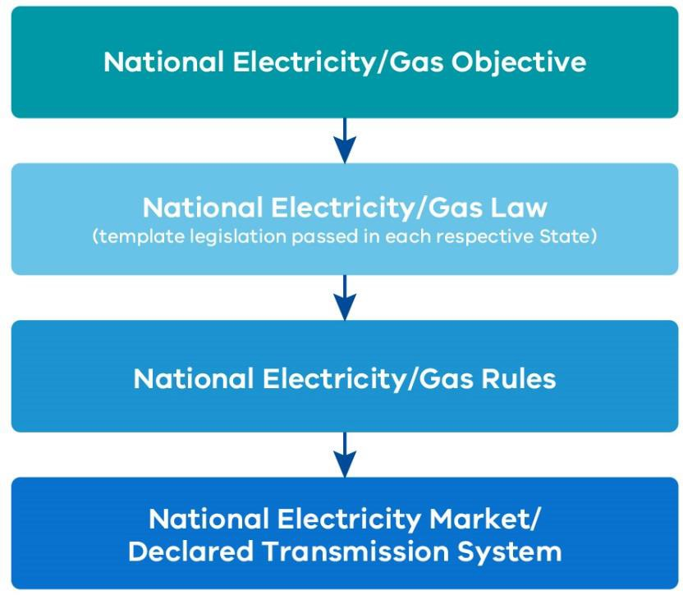

In relation to the interaction of safety regulation and economic regulation, the AER has characterised this as a two-stage process for network safety in Victoria (AER, 2017a, p. 1):

- In stage 1, the relevant government departments and ESV set the safety standards following relevant cost-benefit analysis for all safety programs, consistent with the ‘as low as reasonably possible’ (ALARP) principle.

- In stage 2, the AER calculates in its revenue determinations the efficient amounts of capex and opex required to meet these standards. ESV monitors the delivery of the safety programs that it has approved to ensure its safety objectives are met.

Electricity Incentive Schemes

Service Target Performance Incentive Scheme (STPIS)
The AER administers the STPIS in accordance with the requirements of the National Electricity Rules. The purpose of the STPIS is to provide incentives to the network businesses to maintain and improve electricity supply reliability, and to improve reliability of supply where energy consumers are willing to pay for these improvements (AER, 2017b).
The Scheme rewards electricity distributors that are shown to have improved supply reliability, but penalises electricity distributors where they allow supply to decline below their reliability targets (which are based on the existing level achieved by the distributors). STPIS is intended to ensure that electricity distributors’ service levels do not reduce as a result of the distributors’ efforts to

achieve efficiency gains, which typically are associated with a reduction in expenditure (AER, 2017b).
The performance targets are typically amended every five years to be representative of the most up-to-date levels achieved by the businesses as part of the regulatory determination process. A network business may only receive a financial reward after actual improvements are delivered to consumers. Moreover, a business will only retain its rewards if it can maintain the reliability improvements on an ongoing basis. Once an improvement is made, the benchmark performance targets are tightened in future years. The reward for improved performance is paid to a business for five years, after which consumers effectively retain the benefit of the reliability improvement (AER, 2017b).
The current version of the STPIS has operated since 2009. The AER has recently commenced a process to review the STPIS and to develop a Distribution Reliability Measures Guideline (AER, 2017b). The review is considering how new technologies may impact, or be impacted by, the Scheme and whether new measures in addition to supply reliability matters should be included.
In its issues paper, the AER (2017) outlined observations that customers have benefited from overall reductions in the frequency and duration of power supply outages, however, it also observed that the average time taken to restore power has increased substantially compared to historic levels. The AER considers that these observations warrant a review of the STPIS design, regarding the ratio of the reward/penalty incentive rates between the average duration of the power outages and the average frequency of the power outages. The AER is currently consulting on a draft of the revised STPIS design and a final decision is expected later in the year.
The STPIS review does not include a review of the overall effectiveness of STPIS and there is no set timeframe designated, or terms of reference, for a regular review of the overall effectiveness (AER, 2017b). An evaluation of the effectiveness of the STPIS would ideally consider the overlap and any negative interactions between the STPIS and f-factor incentive schemes.

f-factor Incentive Scheme
In response to the role electricity assets played in the Black Saturday fires, the Victorian Government introduced the f-factor Incentive Scheme. The Scheme is a regulatory instrument under the National Electricity (Victoria) Act 2005, designed around a quantitative benchmark (number of fires started by distribution assets in a year) with rewards and penalties – a revenue adjustment – with respect to the historical performance.

This Scheme was first introduced in 2011. It was revised in 2016 by the Victorian Government in recognition of newly introduced infrastructure upgrades to electricity assets, applying more stringent performance benchmarks and reporting obligations on the distribution businesses.

The revised Scheme weights all network fire ignitions by time and geographical location and applies an increasing financial incentive to ignitions, relative to their bushfire risk. The revised Scheme focuses fire start reduction efforts at high fire risk locations and times, such as code red days, which are subject to the highest penalty rates. The revised Scheme also allows for performance benchmarks to reflect the introduction of Rapid Earth Current Fault Limiters.

The revised Scheme has been operating since July 2016, and the first reports will be released by early 2018 for the 2016–17 financial year. In the f-factor Incentive Scheme: Regulatory Impact

Statement, the Department of Environment, Land, Water and Planning (DELWP), indicated that once the revised Scheme is better established, it will be possible to form a view on the effectiveness of the revised Scheme (DELWP, 2016).

Insurance
Insurance premiums act as an economic incentive for network businesses to minimise safety risks because incidents resulting in a claim on insurance often lead to higher future insurance costs. As a result of the significant risks posed by bushfires, bushfire liability insurance premiums are costly and form a significant proportion of an electricity distribution business’s operating expenditure.

This is highlighted by AusNet Services, in its EDPR proposal for 2016–20 which noted:

“Bushfire liability insurance, which forms a central part of AusNet Services’ risk management strategy, also accounts for a significant proportion of operating expenditure. In 2014, insurance premiums of $10 million (real 2015) accounted for more than five per cent of total opex. Commensurate with the level of bushfire risk of its service area (as assessed by Aon), AusNet Services has the highest bushfire liability insurance limit of any utility in Australia. Coupled with the market’s response to the Black Saturday bushfires, obtaining this limit has driven substantial increases to
AusNet Services’ insurance costs since 2009.” (AusNet Services, 2015, p. 37)

Discussions with Victorian electricity network businesses and with the Insurance Council of Australia identified insurance premiums as a significant driver to focus on risk reduction. Effective oversight by ESV of the progress of safety initiatives conducted by distribution businesses plays an important part in providing assurance to insurers that safety is highly prioritised in Victoria’s regulatory regime.

Strengthening engagement between ESV and the AER
The relationship between the safety regulator and the economic regulator is critical to achieving effective regulation that meets the dual objectives of promoting efficient prices for consumers, while achieving high safety standards. This is important to ensure that energy consumers only pay for the safety outcomes they need, and receive the safety outcomes they pay for.

This relationship must be based on:

- effective communication, including early engagement between regulators to identify emerging issues that may have significant implications for the safe operation of electricity and gas networks;

- mutual respect and high levels of trust between regulators; and

- robust protocols for sharing data and information between regulators.

In addition, regulated network businesses require clear pathways to understand how they might effectively engage with the two regulators in the consideration of safety initiatives.

ESV and the AER have recognised the importance of maintaining a strong relationship through the Memorandum of Understanding (MOU) agreed by the two regulators in March 2014.

A number of submissions to the Review have highlighted the need for good collaboration between ESV and the AER.

In its submission, Australian Gas Networks noted that:

“... consultation and coordination between the AER and the ESV during access arrangement reviews is important to ensure that safety and economic issues are considered jointly.” (Australian Gas Networks, 2017, p. 5)

Nevertheless, Australian Gas Networks has expressed a view that there is room for greater collaboration between the two regulators:

"It appears that there is significant scope for closer collaboration between the AER and the ESV when making decisions that will ultimately determine available funding for ensuring the safety of gas networks and the community. This could be achieved by making ESV input a formal step in the AER review process.” (Australian Gas Networks, 2017, p. 5)

While commenting positively on recent engagement between ESV and the AER, Multinet has proposed that ESV could play a broader role in assisting the AER, and that the interactions between the regulators could be codified to ensure effective input by ESV:

“Multinet Gas is encouraged by the interaction between the AER and ESV on their current review of Multinet’s proposed Mains Replacement program for the 2018–22 Access Arrangement Period … ESV’s role in assisting the AER in assessing Multinet Gas’ proposal could be extended to include all safety and integrity related programs. It would be useful to codify this interaction so it is planned, well-resourced and Gas Distribution Networks have an opportunity to provide an explanation of safety related expenditure programs to ESV on a timeframe that allows ESV effective input to the Access Arrangement process.” (Multinet Gas, 2017, p. 6)

In a similar vein, AusNet Services, in its submission to the electricity Issues Paper, has proposed the development of a formal economic framework to assist in guiding decision making by the AER:

“... the development of an accepted economic framework to address network safety risks, along with values and key inputs such the value of human life and disproportionality factors that is consistent across the industry, and has ESV endorsement would significantly improve economic regulatory processes.” (AusNet Services, 2017, p. 13)

In its submission, APA VTS noted its concern with the AER's past consideration of some proposed safety-related expenditures:

“... the AER, as economic regulator, has not always understood or recognised how safety expenditure created through a duty translates to a positive regulatory obligation. There have been times when the AER has rejected safety related expenditure without consulting the relevant safety regulator in the State in question. APA’s emerging approach in Victoria has been to seek support from the ESV in respect of significant safety projects through letters of support and similar. This has been largely successful in bringing issues to the AER’s attention where they drive specific costs within the pipeline.” (APA VTS, 2017, p. 9)

The importance of early engagement by ESV in the pricing decisions made by the AER is further highlighted in submissions made by electricity distribution businesses to the Review.

Under current practice, the delivery of safety-related initiatives is only formally factored into AER price determinations when tied to a specific regulatory obligation. Proposals not tied to a specific regulatory obligation are referred to as ‘network initiated improvements’. The AER may decide to allow provision for the initiatives directly in its revenue determinations or on a contingent project- funded basis, such as the safety programs funded to meet the Victorian Bushfires Royal Commission recommendations, or it may do so through a specific economic incentive such as the f-factor Incentive Scheme.

Submissions to the Review raised concerns around the capacity of the economic regulatory system to accommodate expenditure proposals that seek to deliver greater safety, where these proposals have not been specifically mandated by the Victorian Government.

In its submission to the Review, AusNet Services has expressed concerns around how the National Electricity Rules act to prevent network-initiated improvements designed to improve safety being factored into pricing decisions by the AER:

"...the National Electricity Rules state AER must only fund a network to maintain risk unless a changed external standard, regulation or law imposes new obligations.
Therefore, a network initiated improvement will not be funded regardless of its merits.”
(AusNet Services, 2017, p. 12)

United Energy has also highlighted this issue:

“The Electricity Safety Act requires DNSPs [Distribution Network Service Providers] to reduce bushfire and safety risk to ‘as low as is reasonably practicable’ (ALARP), whilst the AER only funds DNSPs to maintain safety. As new technology emerges, ALARP necessitates reducing bushfire and safety risk, not merely maintaining safety. However, the AER funds the DNSPs to maintain safety, and expects ESV to monitor progress of the programs. Whilst the AER and ESV have been working together closely to manage this mismatch, it is recommended changes are made to correct it.” (United Energy, 2017, p. 13)

Early engagement by ESV in the price revenue determination process would allow a more informed debate between stakeholders when considering the merits of network-initiated improvement proposals to improve safety.

The Review is proposing two recommendations that relate to the relationship between ESV and the AER. The first recommendation is intended to ensure that the relationship between the two regulators is evaluated, and this is done in a structured way that is transparent. The Review considers that the relationship between the two regulators is of such importance that an annual review is warranted, including to ensure that any concerns or weaknesses that may emerge are identified and addressed expeditiously.

Among other things, the relationship between the two regulators may be affected by changes in experienced personnel over time, as AusNet Services has noted in its electricity network submission:

"The AER and ESV manage [their] relationship particularly well but coordination is currently built on good relationships and communication at executive and staff levels. Therefore, the networks remain exposed to risks of the loss of key experienced personnel who are currently effectively managing this relationship." (AusNet Services, 2017, p. 13)

Recommendation 20
In consultation with the AER, ESV should annually evaluate the operation of its MOU with the AER. A summary of each evaluation should be published in ESV's Annual Report.

The Review also considers that more formal protocols should be developed by ESV, in consultation with the AER, to provide greater guidance on how ESV may be engaged by regulated network businesses in economic regulatory processes conducted by the AER.

Recommendation 21
In consultation with the AER, ESV should prepare public guidance that sets out clear protocols to facilitate effective engagement between ESV and regulated network businesses as an input into price review processes conducted by the AER.

Closing the economic and safety regulatory loop
It is evident from submissions to the Review that there remains confusion among some stakeholders around how safety is factored into economic regulatory decisions by the AER. This is compounded by concerns that the safety-related programs that are factored into the AER's decision making processes may not be delivered in a timely fashion by regulated businesses, or in some cases may not be delivered at all. When this occurs, questions may naturally arise as to whether Victorian energy consumers have, in effect, been required to pay higher prices without promised safety benefits being delivered.

The Review is not proposing fundamental changes to the system of economic regulation, which would raise complex issues beyond this Review’s Terms of Reference. Nevertheless, the Review is proposing that the integration of the economic and safety systems should be reinforced through greater transparency and accountability around the delivery of safety-related programs. Ultimately, the regulatory responsibility for ensuring that safety commitments are satisfactorily met by regulated businesses should rest with ESV as the safety regulator.

In its submission to the Review, the Electrical Trades Union has noted a concern around the extent to which safety considerations are factored into the AER's determination processes:

“A major flaw in the AER regulatory model of determining operating and capital expenditure for electricity networks is that by law the AER can only consider the efficient cost to the Distribution businesses. The AER does not and cannot factor the cost to energy users from network failings as a result of under-investment in the safety of the network.” (Electrical Trades Union, 2017, p. 60)

Similarly, R2A has expressed a view that the AER’s approach may not sufficiently recognise safety, particularly over longer time periods:

"In view of the ‘natural’ monopoly nature of distribution networks, the AER has been given the role of economic regulator in an attempt to replicate the commercially beneficial effects of a ‘market’. This is subject to a number of methodological confusions especially the use of models. These can have serious impacts on the safety resourcing of distribution networks. In particular for example, is the five year horizon of AER economic determinations in relation to the management of long term network assets. Failure to maintain a presently well maintained asset is unlikely to cause safety issues within a five year cycle. However deferred maintenance always has long term consequences, particularly for safety and the reliability of networks." (R2A, 2017, p. 5)

In contrast, the AER has noted in its submission that it recognises the importance of network businesses being able to meet their safety obligations:

“We assess the efficiency of all capex and opex against prescribed parameters in the NER (National Electricity Rules), including the capex and opex objectives, criteria and factors. One of the objectives is that the capex and opex forecasts must be sufficient to enable the network operators to meet their regulatory obligations, including safety obligations.” (AER, 2017a, p. 3)

The existence of differing views around how adequately the AER takes account of safety may be partly explained by differing interpretations of how the economic regulatory processes work in practice. In particular, if network businesses, working with ESV as the safety regulator, do not adequately make the case for specific investments on safety grounds, or if the AER fails to adequately take account of safety considerations that have been presented to it, there is a potential that desirable safety initiatives may not be delivered fully.

This underscores the importance of the Review's message in the previous section – that the relationship between ESV and AER is critical. While final economic regulatory decision making should rest with the AER, it must rely on ESV as a trusted expert source of advice. If the AER proposes a decision that may compromise safety outcomes, including in the long term, it is incumbent on ESV to draw the AER's attention to the risks. ESV must also be mindful of the costs of safety initiatives and assist the AER when required to understand what is both technically and economically feasible.

As noted earlier, a particular concern with current processes is that safety initiatives that have been factored into revenue decisions by the AER are not delivered in a timely fashion, and perhaps not delivered at all.

Unless incorporated into safety case documents, with progress monitored by ESV, there is no legal requirement for the network businesses to complete the projects funded through the AER process. Nor is there any legal requirement for the businesses to report on the outcomes of their revenue determinations (that is, what work they have completed in the five-year timeframe).

A lack of reporting on whether safety-related activities have been undertaken creates a situation where network businesses can submit a revenue forecast to undertake a series of activities, fail to undertake these activities, but are not required to provide any justification of why an activity was not undertaken or what the revenues were spent on instead.

The Electrical Trades Union has noted:

“… once the AER has approved Distributors Forecast expenditure, it does not monitor or validate that the Distribution Businesses expend their revenue as forecast. It is entirely up to the Distribution Business how and where it expends the revenue it’s been authorised by the AER to charge.” (Electrical Trades Union, 2017, p. 60)

There are examples of network businesses submitting the same uncompleted project in the next revenue determination proposal, highlighting a continuing need for such a network enhancement, while failing to provide a justification for why the project wasn’t completed in the original five-year timeframe. While the Review understands that there may be valid reasons why a project was not completed, the reasons why it was not completed or what project the money was spent on instead, is important to maintain transparency and accountability. This information can be incorporated into the updated safety cases.

AEMO identifies an example of the Warragul Looping Project where funding was received by APA in the 2008–12 APA access arrangement and the 2013–17 APA access arrangement, but APA did not proceed with this investment. As a result, following the publication of the 2017 Victorian Gas Planning Report in March, AEMO issued a notice of a threat to system security due to AEMO’s modelling forecasting that Warragul gas supply may be interrupted on a peak day during winter 2019 (AEMO, 2017, p. 9).

As discussed earlier, unless incorporated into safety case documents, ESV has no legal avenue with which to enforce the completion of projects it deems essential for the safety of the Victorian community. The proposals discussed in Chapter 2: Regulatory Approach and Capabilities including strengthened compliance and enforcement and other measures to improve the effectiveness of the safety case regime, will assist in closing this loop.

Recommendation 22
ESV should, in consultation with regulated network operators and the AER, evaluate its requirements for safety cases to ensure that all safety-related elements that have been factored into AER determinations, are identified and supported by clear implementation plans.

ESV should report on the progress made by regulated network operators in its annual network safety performance reports. The reporting should be sufficient to ensure that there is a high degree of transparency to the Victorian community about the progress in the implementation of safety programs.

In their submission to the Interim Report, CitiPower and Powercor Australia and United Energy raise concerns that the approach proposed by the Review would limit business' ability to make changes to projects in response to emerging technologies. However, the Review does not advocate the elimination of flexibility, provided that safety outcomes are preserved. Rather, the

Review is recommending greater transparency around the implementation of safety programs, including where more efficient ways are found to achieve safety outcomes at lower cost.

As further outlined in Chapter 9: Strengthening the Foundations for Future Network Safety Regulation, the framework should support businesses to be flexible in responding to emerging technologies and meeting safety obligations at lowest cost, whilst at the same time, ensuring businesses remain accountable for safety. The Review proposes changes to legislation and guidance to provide clarity on how safety cases may be kept up to date, and to improve ESV’s oversight of changes businesses may wish to make as circumstances change over time.

Longer-term planning
Effective planning is essential to ensure the networks are able to provide safe and reliable energy supply to consumers into the future. The Independent Review into the Future Security of the National Electricity Market (2017) acknowledges that strategic planning is needed to provide a clear direction to incentivise appropriate, timely investments and innovation.

“…policymakers and the community must have confidence that the system is working well and that emerging issues, risks and opportunities are being identified and managed or capitalised on as appropriate.” (Finkel, 2017, p. 122)

Some stakeholders have suggested that potential adverse impacts may arise from differences between the time horizon in economic determinations and the long-term reliability and maintenance needs of the networks.

In its submission to the Review, R2A has raised concerns with the five-year time horizon of the economic determinations by the AER and how this might affect longer-term maintenance of the electricity network:

“Failure to maintain a presently well maintained asset is unlikely to cause safety issues within a 5 year cycle. However deferred maintenance always has long term consequences, particularly for safety and the reliability of networks.” (R2A, 2017, p. 5)

In relation to the gas network, AEMO has raised a number of specific concerns around planning, including its concerns around the economic regulatory system not sufficiently facilitating new investments in gas pipeline infrastructure. Without timely investments, there may be a deterioration in the reliability of supply to gas consumers.

AEMO has noted that Section 79 of the National Gas Rules can make it difficult to justify expenditure to accommodate future gas demand “unless it meets a positive net present value test or is required to comply with a regulatory requirement” (AEMO, 2017, p. 3).

AEMO has highlighted its view that there is a disconnect in the intent of Section 32 of the Gas Safety Act 1997 (which requires gas companies to minimise, as far as practicable, the hazards and risks to community safety arising from the interruption or reinstatement of gas supply), and the National Gas Rules (which require AEMO to publish a bi-annual planning review of the Declared Transmission System, but doesn’t require the Declared Transmission System service provider to make pipeline investments consistent with these planning reviews). AEMO has also noted that

“there is no requirement for integrated planning between the DTS and distribution systems, which could promote more efficient investment” (AEMO, 2017, p. 3).

AEMO has concluded:

“… these disconnects can lead to inefficient outcomes over the long term, and have contributed to a current need for urgent investment to maintain reliability of gas supply.” (AEMO, 2017, p. 3)

Given the critical role that network reliability plays in overall community safety, the economic framework needs to facilitate investment decisions to cater for growth.

“A reliable gas network is one that is planned, designed and operated to meet reasonable expectations of peak demand, with a prudent level of redundancy (security) to allow continued supply with some elements of the system out of service.” (AEMO, 2017, p. 3)

AEMO (2017) has proposed a number of possible changes and areas for further consideration:

- Expand and clarify the obligations in section 32 of the Gas Safety Act, or amend Part 19 of the National Gas Rules to specify how the Declared Transmission System service provider should respond to AEMO planning reviews.

- The development of a clearer reliability standard to represent an economically justified level of investment for reliable and secure gas supply.

- The consideration of reduced pipeline capacity scenarios and diversity of gas supply sources as part of overall supply reliability assessments.

- The introduction of a coordinated planning process to improve the reliable supply of gas to all declared transmission system and distribution network gas customers in an economically efficient manner.

Coordinated planning and a clear reliability standard will help ensure the economic framework facilitates efficient and timely investment in the longer-term reliability of the gas networks. In its Interim Report, the Review proposed that the Victorian Government should request the Australian Energy Market Commission (AEMC) to develop a clear reliability standard to support consideration of a robust, economically justified level of investment for reliable and secure gas supply.

Several submissions responding to the Review’s Interim Report questioned the need for a reliability standard for the gas network. In its submission to the Interim Report, the AER noted it was “not aware of evidence to indicate that investment in the DTS has been inefficient.” (AER, 2017, p. 2)

The Australian Gas Infrastructure Group questioned the necessity for a gas supply reliability or planning standard noting:

“AGIG does not consider there is a need for the AEMC to develop a gas supply reliability or system planning standards. Gas supply reliability in Victoria is such that a customer can expect to have an unplanned interruption about once every 40 years. It is not clear what

benefit regulatory intervention would provide and additional regulation is likely to result in reduced efficiency.” (Australian Gas Infrastructure Group, 2017, p. 5)

APA VTS supported a considered and long-term approach to pipeline safety including security of supply issues, which included ESV having an expanded advisory role:

“A closer more considered and longer term outlook on pipeline safety in economic regulation is supported, including security of supply issues. We would support ESV having an expanded role as an authoritative advisor to the AER.” (APA VTS, 2017, p. 4)

Following the consideration of these submissions to the Interim Report, the Review proposes a staged approach to the consideration and development of a reliability standard. In the first instance, the case for Victoria adopting a reliability standard for gas should be considered by the Victorian Government in consultation with the relevant regulatory agencies and stakeholders.

Consultation with other jurisdictions would also assist in determining whether the reliability standard would be a Victorian specific reliability standard or a broader cross jurisdictional reliability standard. A Value of Customer Reliability Survey should also be utilised to inform the government’s understanding of the value that customers place on gas reliability.

Reliability standards present in the National Electricity Market and in European gas networks are examples which could be drawn upon in consideration of an appropriate reliability standard for Victoria’s gas network.

Following the Victorian Government’s consideration of the case for a formal reliability standard, the Victorian Government, through the COAG Energy Council, could request the AEMC to determine the best approach to develop the framework and governance arrangements for establishing a reliability standard.

Recommendation 23
The Victorian Government should consider the case for a formal reliability standard for the gas network, in consultation with relevant stakeholders. If the adoption of a formal reliability standard is preferred, the Victorian Government should request the AEMC to determine the best approach to develop a framework and governance arrangements for establishing a reliability standard to support consideration of a robust, economically justified level of investment for reliable and secure gas supply.
Recommendation 24
The Victorian Government, in consultation with relevant stakeholders, should consider the development of mechanisms to support effective coordination in system planning for the declared transmission system and gas distribution network in an economically efficient manner.

Persistent underinvestment in asset management practices may lead to poor long-term outcomes, impacting the integrity and sustainability of electricity and gas assets. This in turn can lead to

electricity asset failures such as pole or conductor failures, transformer or switchgear explosions, or pipeline degradation, resulting in potential pipeline ruptures or failure of pipeline equipment such as compressors and heaters.

As the investment in the management of assets is a crucial aspect of long-term network safety, ESV’s mandate for the long-term safety and integrity of the networks should be recognised in legislation. Section 7A of the Electricity Safety Act 1998 describes ESV’s function in relation to the link between safety and reliability with specific regard to bushfire mitigation and electric line clearance, however ESV’s objectives and functions in respect to the long-term integrity and sustainability of assets could be more clearly articulated in the legislation.

The nexus between gas supply reliability and safety outcomes is even stronger due to the purging requirements for gas before ‘relighting’ after a loss of gas supply. Introducing provisions linking safety and the long-term integrity and sustainability of gas network assets may assist gas network businesses to give greater focus to projects that strengthen the reliability of gas supply when making submissions to the AER. The need for gas-fired electricity generators to have a reliable supply of gas, particularly during high temperature days when electricity demand is high, adds further weight to the importance of ensuring gas network assets are well-managed.

In consolidating the safety Acts, consideration should be given to clarifying the role of ESV in ensuring that the long-term integrity and sustainability of network assets is an aspect of safety covered by the safety framework. This is discussed further in Chapter 9: Strengthening the Foundations for Future Network Safety Regulation.

References
AEMO, 2017. AEMO Submission on Victorian Gas Network Safety Framework Review, Melbourne. AER, 2013. Better Regulation Factsheet: Expenditure Incentives. [Online]
Available at: https://www.aer.gov.au/system/files/AER%20Better%20Regulation%20factsheet%20-
%20expenditure%20incentives%20-%20November%202013.pdf [Accessed 17 September 2017].
AER, 2015. Our role in networks. [Online] Available at: https://www.aer.gov.au/networks-pipelines/our-role-in- networks#our-role-in-electricity-networks-and-gas-pipelines [Accessed 07 September 2017].
AER, 2016. AER Statement of intent 2016-17, Canberra.
AER, 2017a. AER response to the Review of Victoria’s Electricity Network Safety, Melbourne.
AER, 2017. Issues paper: Reviewing the Service Target Performance Incentive Scheme and Establishing a new Distribution Reliability Measures Guidelines, Melbourne.
Aon Risk Solutions, 2015. Insurance Advice Report: Networks NSW. [Online] Available at: https://www.aer.gov.au/system/files/Essential%20Energy%20-%20Attachment%201.3%20-
%20Insurance%20Advice%20Report%20Networks%20NSW%20-%20January%202015.pdf [Accessed 12 September 2017].
APA VTS, 2017. Review of Victoria’s Electricity and Gas Network Safety Framework - Supplementary Issues Paper: APS VTS Operations (Australia) Pty Ltd Submission.
AusNet Services, 2015. Electricity Distribution Price Review 2016-20. AusNet Services, 2017. Safety Review Submission.
Australian Energy Market Commission, 2017. Economic Regulation of Distribution Services. In: National Electricty Rules Version 96.
Australian Gas Networks, 2017. AGN Response to the Review of Victoria's Gas Network Safety Framework.
DELWP, 2016. f-factor Incentive Scheme: Regulatory Impact Statement. [Online] Available at: https://www.energy.vic.gov.au/data/assets/pdffile/0022/44419/f-factorRegulatoryImpactStatmentOct16.pdf [Accessed 12 September 2017].
Electrical Trades Union, 2017. ETU Submission to the Review, Melbourne.
Farrier Swier Consulting, 2016. Issues Paper, Incentive Mechanisms for the Victorian Gas Distribution Business. 2018 to 2022 Gas Access Arrangement Review, pp. 1-53.
Finkel, A., 2017. Independent Review into the Future Security of the National Electricity Market.
Multinet Gas, 2017. Review of Victoria’s Gas Network Safety Framework: Issues for consideration, Melbourne. R2A, 2017. R2A’s Response to the Review of Victoria’s Electricity Network Safety Framework.
United Energy, 2017. United Energy Submission on Review of Victoria’s Electricity Network Safety Framework,
Melbourne.

Chapter 5: Promoting Workforce Engagement

Summary
Organisations that are at the very forefront of safety management make sure that safety is deeply embedded in their organisational cultures. It becomes part of what they “live and breathe” each day.

- Safety is led from the Board and Chief Executive level down, and it permeates virtually every aspect of the organisation.

Strong workforce engagement is an important part of achieving this culture. Employees need to embrace a safety-first approach and they must be actively engaged in identifying and resolving safety risks.

A regulator’s task is to ensure that regulated businesses have the systems and processes – and the engagement mechanisms – to promote a strong safety culture.

The regulator may also be able to use its “convening power” to bring together different groups to develop and share best practice models.

Front line workers maintaining gas and electricity networks can be a valuable source of advice on risks. They are working on the networks every day and can see where problems are emerging.

Energy Safe Victoria (ESV) should take a leadership role in promoting active workforce engagement in network safety. As a first step, a formal committee should be established under Section 8 of the Energy Safe Victoria Act 2005 to provide advice to ESV and to contribute to the development of a broader workforce engagement agenda (Recommendation 25).

The importance of effective workforce engagement
Strong workforce engagement is essential to an effective safety case regime. Front line workers maintaining gas and electricity networks can be a valuable source of advice on risks, including the broader risks to the community. They are working on the networks every day and can see where problems are emerging.

In a mature safety case system, a key role of the regulator should be to ensure that regulated businesses have systems in place to promote the effective engagement of their workforce. If regulated businesses rely significantly on external contractors – for example, to undertake maintenance and other operational work – the systems should extend to ensure that there is strong engagement with the contract workforce as well.

The regulator may also use its “convening power” to bring together different groups to share best practice models of workforce engagement.

The importance of workforce engagement is recognised in Victoria’s occupational health and safety framework. In particular, the Occupational Health and Safety Act 2004, mandates employers to consult with employees regarding workplace hazards, risks to safety, and on internal systems to manage such risks.

The Australian Standard that underpins the safety management of electricity networks, AS 5577, recognises the importance of consultation in the preparation and implementation of Electricity Safety Management Schemes (refer to the box below).

The standard refers broadly to groups that should be consulted in the development and implementation of an Electricity Safety Management Scheme. The requirements as stated in Section 4.4.6 – Consultation, Communication and Reporting of AS 5577 are for the network businesses to:

- “identify individuals, stakeholder groups and organizations that have a relevant interest in the safety aspects of the design, construction, commissioning, operation, maintenance and decommissioning of the network.

- establish procedures for regular consultation and communication with, and reporting to, these identified stakeholders during the development, implementation and review of the ENSMS [i.e. the Electricity Safety Management Scheme].”

Box 14: Recognition of work health and safety regulations in Australian Standard AS 5577 – Electricity Safety Management Schemes

AS 5577 (Australian Standard, 2013) outlines the standards for developing and implementing Electricity Safety Management Schemes. Section 1.2 – Fundamental Principles sets out how the arrangements under AS 5577 are intended to operate in conjunction with relevant occupational health and safety requirements:

“This Standard exists in the context of and is complementary to National Work Health and Safety regulations. Nothing in this Standard relieves any persons designing or working on or near electricity networks of any safety obligations imposed under jurisdictional or national work health and safety legislation.

The Network Operator is responsible for the safe design, construction, commissioning, operation, maintenance and decommissioning of an electricity network.

- The Network Operator cannot delegate its accountability for the safety and integrity of the electricity network.

- The Network Operator cannot delegate its accountability for the safety of its works and its contractors.”

The role of WorkSafe Victoria in energy safety
Working on or near electricity and gas network assets can result in serious consequences to workers if safe work practices are not adhered to. Examples of such risks include contact with powerlines, which can result in serious injury or death from electrocution, and accidental damage to gas pipelines that can result in a fire or explosion, with serious consequences if due diligence is not followed.

As ESV and WorkSafe Victoria are both safety regulators, it is inevitable that there are areas of regulatory overlap regarding the investigation of energy network workplace incidents and issuing guidance for employers and any persons working on or near these network assets. Further information on the workplace health and safety obligations of network businesses is summarised in the box below.

Box 15: Network businesses and the workplace health and safety system

In very broad terms, electricity and gas network businesses are subject to two safety regimes:
- the workplace health and safety regime, which principally regulates the safety risks faced by employees; and

- the energy network safety framework, which principally regulates the risks affecting consumers and the broader community.

In Victoria, WorkSafe Victoria is the regulator for workplace health and safety as set out in the Occupational Health and Safety Act 2004 (OHS Act). In its submission to the Review, WorkSafe Victoria has summarised the framework:

  - Each network business in Victoria has general health and safety duties as an employer under Section 21 of the OHS Act. Every employer must, so far as is reasonably practicable, provide and maintain for employees a working environment that is safe and without risks to health. This duty extends to contractors engaged by the employer, and any employees of those contractors.

  - Under Section 26 of the OHS Act, a person who has, to any extent, the management or control of a workplace must ensure so far as is reasonably practicable that the workplace and the means of entering and leaving it are safe and without risks to health.

  - The Occupational Health and Safety Regulations 2017 (OHS Regulations) prescribe the way in which duties or obligations imposed by the OHS Act must be met in relation to certain hazards and risks.

Under Part 4 of the OHS Act, employers must consult with employees (including any contractors engaged by the employer, and the contractor’s employees) and their health and safety representatives on health and safety matters that directly affect them, so far as is reasonably practicable.

To facilitate effective engagement, ESV and WorkSafe Victoria have established a Memorandum of Understanding (MOU). This MOU details the arrangements for cooperation between the two regulators, particularly regarding joint inspection and incident investigation.

Submissions to the Review have identified scope for improving aspects of the way the two regulators work together. For example, United Energy in its submission to the Review, noted that there is some lack of clarity in the role of the two regulators:

“The industry would benefit from improved role clarity between ESV and WorkSafe in attending to ESI [electricity supply industry] matters. Whilst there is an MOU between WorkSafe and ESV it does not appear to be universally applied.” (United Energy, 2017, p. 9)

The Electrical Trades Union expressed a view that responsibilities need to be better delineated and there needs to be better information sharing:

“Without delineating responsibilities, it is not possible to attribute and measure accountability to those responsibilities. The information sharing requirements in the MOU are also very vague. It appears, for example that the Work Practices Audit information is not shared with WorkSafe and the sharing of information still only occurs on a very ad hoc basis.” (Electrical Trades Union, 2017, p. 39)

Box 16: Examples of cooperative work between ESV and WorkSafe Victoria

ESV and WorkSafe Victoria have a long track record of working together on issues that cross their respective regulatory boundaries, including through establishing relevant safety standards and participating in joint committees addressing worker safety.
Two examples are: the establishment of No Go Zones and the associated Utilities Safety Committee; and the operation of the Electrical Safety Committee which determines standards for working safely on the electrical networks.
For the No Go Zones, ESV (and its predecessor electrical and gas safety offices) and WorkSafe Victoria worked together to develop a consistent set of rules for workers when they are working near overhead powerlines and underground utilities. These rules are reviewed by a Utilities Safety Committee on which both ESV and WorkSafe Victoria sit.
The Electrical Safety Committee is an advisory committee established by ESV under Section 8 of the Energy Safe Victoria Act 2005, and includes members from network businesses, the Electrical Trades Union, WorkSafe Victoria and ESV itself. This committee was established to review ESV’s so-called “blue book”, or more formally, the Code of Practice on Electrical Safety for Work on or Near High Voltage Electrical Apparatus.

Contractors and effective safety regulation
The heavy reliance on contractors by network businesses and the presence of third party contractors outside of the energy sector (e.g. the construction industry) raises risks that must be effectively managed. ESV has highlighted the emerging challenges in its Corporate Plan 2017– 2020 (2017, p. 16):

“There has been disaggregation and commercial specialisation within the energy sector which has resulted in more legal entities involved in asset works, complicated ownership structures and sub-contracting arrangements. This has led to industry incidents with common factors that include:

- gaps in control and oversight systems, with inconsistent management practices;

- unsupervised delegation of energy safety accountabilities to third parties without adequate assurance practices.”

Competing priorities to work quickly under payment arrangements, and to carry out safety planning and activities has been identified by Associate Professor Jan Hayes as having the potential to impact negatively on safety outcomes.

In their paper We're Still Hitting Things, Dr Vanessa McDermott and Associate Professor Jan Hayes identified how financial risk and so also management of the potential for pipeline strikes are shifted down the third party contractor chain. They noted that incentives for timely project completion can unintentionally lead to situations where the potential for contractors to strike pipelines increases (McDermott & Hayes, 2016).

McDermott and Hayes concluded in a further paper, that “... sub-contracting chains present particular challenges in terms of safety management and risk coordination” (McDermott & Hayes, 2017, p. 2). They have recommended better engagement between industry and contractors to minimise the potential for failures.

In its submission to the Review, Engineers Australia expressed the need for comprehensive arrangements, backed by effective metrics, to support workforce engagement in network safety. Engineers Australia has particularly highlighted its view that third party contractors should be held to the same processes, metrics and standards as network businesses themselves:

“To assist in the facilitation of a safety culture workforce, a form of ongoing regulatory assessment/audit should to be considered to ensure these documents are functional and integral to the culture of the licensees/operators of these pipelines. In the assessment/audit, regulators should consider if the corporate safety framework is a primary organisational focus, communicated routinely, tracked, recognised and rewarded throughout all levels of the organisation. Are there specific safety metrics illustrating that: a) each employee is responsible and accountable for safety performance, and b) clear safety policy, process and procedures are communicated throughout the organisation through training, tailgate sessions, and field coaching, with no opt‐out. Third‐party contractors utilised by the corporations must be held to the same processes, metrics, and standards.” (Engineers Australia, 2017, p. 1)

Apart from third party contractors, the Electrical Trades Union has also raised concerns around the management of safety obligations by contractors working directly on the electricity networks:

“The current high prevalence of contractor labour, where maintenance workers used to be primarily employed by the Distribution businesses, means that workers are severely constrained from raising safety issues without the threat of sacking and potentially blacklisting from the sector... Under these circumstances there is no ‘engagement’ of the workforce in safety issues.” (Electrical Trades Union, 2017, p. 41)

“It is recommended that Distribution Businesses contracting arrangements are reviewed by ESV to ensure that they are providing for contractors to be able to meet safety obligations of the Distribution Businesses.” (Electrical Trades Union, 2017, p. 55)

Workforce engagement in network safety generally
Submissions to the Review expressed a range of views on the effectiveness of current arrangements relating to the involvement of the workforce in network safety.

In their submission, CitiPower and Powercor Australia has noted the strengths of an outcomes- based approach in engaging the workforce in safety:

“The current safety framework with its outcomes based approach, promotes a safe culture and engages the workforce to be active participants in creating a safe workplace and a safe electrical distribution service to our communities.” (CitiPower & Powercor Australia, 2017, p. 3)

In a similar vein, AusNet Services has suggested that the current Electricity Safety Management Scheme process is successful in engendering a robust safety culture as it “requires active participation in safety culture across all operational levels” (AusNet Services, 2017, p. 15).

Australian Gas Networks has expressed the view that apart from the legislative requirements to consult with the workforce, it is often the organisation itself that drives a good safety culture:

“… the industry has made significant advancements in safety culture and workforce engagement, and contributed to improvements in the industry Standards AS-4645 and AS-2885. Such improvements have occurred regardless of the regulatory framework, driven by the desire of businesses (particularly distribution businesses), to achieve high levels of safety.” (Australian Gas Networks, 2017, p. 3)

Several other submissions to the Review have also highlighted the belief that the current safety framework is sufficient in promoting a strong safety culture. For instance, APA VTS noted:

“Workforce engagement is well served through the consultation requirements contained within occupational health and safety legislation, risk assessment and permit to work systems, which are part of the safety management systems and specified within the Safety Case and safety management plans … Whilst never wanting to become complacent, there is already a strong safety leadership culture within the industry, which is demonstrated by the policies, systems and resources applied by this company and others in the industry. We are not of the view that further regulation is required to strengthen leadership culture.” (APA VTS, 2017, p. 4)

The Electrical Trades Union noted there needs to be an avenue for workers to raise safety concerns:

“One of the biggest current concerns of the Lineworkers maintaining Victorian networks is that they have been and are increasingly being prevented from raising, reporting or rectifying identified safety issues – that have a high probability of causing harm in the near future.” (Electrical Trades Union, 2017, p. 35)

It is evident that effective workforce engagement requires continuing focus and attention. Open dialogue is needed to ensure any gaps are addressed. A greater emphasis should be placed on considering leading practices from other industries and jurisdictions to promote active workforce engagement. In the Review’s assessment, more could be done in this area.

There are some examples of effective workforce engagement to promote safety, including the non- profit Step Change in Safety Organisation that operates in the United Kingdom to promote safety in the offshore oil industry. This initiative brings together operators, contractors, trade unions, regulators and the workforce, all working together to promote safety. The United Kingdom regulator, Health and Safety Executive is actively engaged.

There are also several examples of industry-led initiatives to promote safety cultures in other sectors, and states, including the Safer Together initiative in the natural gas sector in Queensland.

None of the many workforce engagement models adopted in other countries or industries may be precisely appropriate for electricity and gas networks in Victoria, however, each may offer some approaches that, suitably adapted, could be adopted in Victoria.

Strengthening workforce engagement
Looking to the future and the development of strong workforce engagement, there are a number of key issues and actions that could be taken:

- promoting and sharing better engagement practices between network businesses, including those businesses that are more effective in engaging their workforces in safety sharing their experiences;

- developing arrangements to ensure that workforce engagement is effectively promoted as part of a mature safety case system of regulation;

- consideration of measures to ensure that competency standards are maintained and that workers are well-trained and have the necessary skills to maintain safe networks;

- maintaining arrangements to ensure there is effective engagement of the workforce of third party contractors and emerging risks are addressed; and

- developing systems to provide better measurement and monitoring of workforce engagement.

The Review considers that there is a sufficient range of issues and actions, and they are of sufficient importance, to warrant the establishment of a formal consultative committee under Section 8 of the Energy Safe Victoria Act 2005. This committee should comprise of members representative of network businesses, major contractors, trade unions, WorkSafe Victoria, and the network workforce.

AusNet Services has noted in its submission to the Interim Report that cross industry engagement may lead to improved safety outcomes particularly in the areas of network asset risk mitigation and third party contractors working near energy assets (AusNet Services, 2017b). AusNet Services further suggested that a sub-working group could be established to focus on non-industry third parties working safely near energy assets, to feed into strategies developed by the Section 8 committee. The Review supports this proposed approach.

Recommendation 25
ESV should establish a consultative committee under Section 8 of the Energy Safe Victoria Act 2005. This committee should:

- provide advice to ESV to assist in its consideration of workforce engagement issues;

- contribute to the development of broader workforce engagement strategies, including the sharing of best practices; and

- be comprised of representatives from network businesses, major contractors, trade unions, WorkSafe Victoria and the workforce.

References
APA VTS, 2017. Review of Victoria’s Electricity and Gas Network Safety Framework - Supplementary Issues Paper: APA VTS Operations (Australia) Pty Ltd Submission.
AusNet Services, 2017a. Safety Review Submission.
AusNet Services, 2017c. Safety Review Submission - Interim Report.
Australian Gas Networks, 2017. AGN Response to the Review of Victoria's Gas Network Safety Framework. Australian Standard, 2013. Electricity network safety management- AS5577.
CitiPower & Powercor Australia, 2017. Additional Information to Support the Review of Victoria’s Electricity Network Safety Framework.
Electrical Trades Union, 2017. ETU Submission to the Review.
Engineers Australia, 2017. Engineers Australia submission to Review of Victoria’s Electricity and Gas Safety Framework.
ESV, 2017. Energy Safe Victoria Corporate Plan 2017–2020, Melbourne.
Haddon-Cave, J., 2017. Zen and the Art of Safety Case Maintenance in the Post-Nimrod World. London.
McDermott, V. & Hayes, J., 2016. We're still hitting things: the effectiveness of third party processes for pipeline strike prevention. Calgary.
McDermott, V. & Hayes, J., 2017. Risk shifting and disorganization in multi-tier contracting chains: The implications for public safety. Safety Science, pp. 1-10.
Hopkins, A., 2012. Explaining “Safety Case”.
Occupational Health and Safety Act 2004 (2004) Parliament of Victoria.
United Energy, 2017. United Energy Submission on Review of Victoria’s Electricity Network Safety Framework,
Melbourne.
WorkSafe Victoria, 2006. Framework for undertaking work near overhead and underground assets.

Chapter 6: Programs to Address Bushfire Risk in Victoria

Summary
Responding to the recommendations of the 2009 Victorian Bushfires Royal Commission (VBRC), the Victorian Government established a Powerline Bushfire Safety Program (PBSP) to oversight a major package of related measures to reduce bushfire risks from electricity networks.

The PBSP has been subject to external Gateway assessment, confirming that most elements are progressing well. Some elements are very close to completion.

With the program nearing its end, a clear pathway is required to ensure the valuable learning and expertise gained through the program, is maintained into the future (Recommendation 26).

World leading research conducted under the PBSP has confirmed the technical feasibility of adopting Rapid Earth Fault Current Limiters (REFCLs) to manage a major source of bushfire risk from certain polyphase electricity lines. Initial deployments have been completed and the Australian Energy Regulator has recently approved the funding determinations to enable the first major tranche of REFCLs to be deployed.

The installation of REFCLs is technically challenging and the total costs are substantially higher than previously estimated.

A measured approach should be adopted, allowing program settings to be carefully considered as implementation continues and experience is accumulated. The mandate of the current Powerline Bushfire Safety Committee should be expanded to provide an annual implementation report on the deployment of REFCL technology. The first report should be provided through the Director of Energy Safety to the Minister for Energy, Environment and Climate Change by May 2018 (Recommendation 27).

The deployment of REFCLs has been a long-term policy commitment of successive governments following the Powerline Bushfire Safety Taskforce’s advice on the best way to respond to a core recommendation of the VBRC. The best available information continues to show that the installation of REFCLs will have a material impact on bushfire risk in a state that faces some of the highest risks in the world.

The VBRC and the Powerline Bushfire Safety Taskforce
The VBRC recommended a suite of measures designed to reduce bushfire risk. Recommendation 27 proposed that the State amend the regulations under the Electricity Safety Act 1998 to progressively replace all single wire earth return (SWER) and 22 kV powerlines with new technologies to reduce bushfire risk. The VBRC also suggested that an expert taskforce be established to advise on the best means of achieving the intent of this recommendation (2009 Victorian Bushfires Royal Commission, 2010, p. 23).

The subsequent Powerline Bushfire Safety Taskforce (the Taskforce) provided its report to the Victorian Government in September 2011. The Taskforce was comprised of an independent chair and members from:

- the electricity industry;
- Country Fire Authority;
- the affected community;
- a network expert;
- a risk management expert; and
- a stakeholder engagement expert.

The Taskforce recommended that the risk of powerlines starting bushfires could be reduced by:

- Installing fault suppression equipment known as Rapid Earth Fault Current Limiters (REFCLs) on select 22 kV powerlines to reduce the risk of polyphase powerlines starting fires by automatically reducing the electric current in some types of powerline faults.

- Installing remotely controlled Automatic Circuit Reclosers (ACRs) on SWER lines to reduce the risk of SWER lines starting fires by enabling the devices to be set remotely so that they turn off those powerlines quickly when faults occur.

- Putting powerlines underground or insulating conductors in the areas of highest bushfire risk.

The Taskforce also indicated the need for further research and development – noting that REFCLs had not previously been used for bushfire suppression.

In December 2011, the then Victorian Government accepted the Taskforce’s recommendations, and established the Powerline Bushfire Safety Program (PBSP) to implement these recommendations.
In accepting the recommendations, the Victorian Government committed to invest significantly in measures to reduce powerline-initiated bushfire risk, including up to $500 million (real, 2011) of consumer-funded investment in new network technologies such as REFCLs:

“As recommended by the Taskforce, the Government will now require electricity distribution businesses to install both of these devices [Automatic Circuit Reclosers and REFCLs] across the State over the next decade. Electricity distribution businesses will be required to specify, through their Bushfire Mitigation Plans, the location and timing of asset roll-out. Progress against these Bushfire Mitigation Plans will then be reviewed by Energy Safe Victoria on an annual basis. This is estimated by the Taskforce to cost approximately $500 million over 10 years.” (Government of Victoria, 2011, p. 4)

Investment in these new network safety devices was driven by the need to take decisive and timely action to reduce the risk of catastrophic bushfires caused by powerlines. The focus on a new generation of network safety devices offered significant risk benefits at much lower costs compared to alternative solutions, such as undergrounding all powerlines.

Powerline Bushfire Safety Program (PBSP)
The PBSP is a $750 million program that is responsible for implementing the VBRC Recommendations 27 and 32 (see Appendix E: VBRC Recommendations). The Program is being implemented within a ten year timeframe concluding by 2019. Of the Program’s total budget, $250 million comes from the Victorian Government, and $500 million is funded by the network businesses to meet the obligations (and is therefore effectively passed on to electricity consumers over time via their power bills).

The challenge posed to the PBSP in implementing VBRC Recommendation 27 was to develop a way to direct the investment to maximise the safety benefit for Victorians.

The PBSP is using the full funding commitment to deliver a reduction in powerline-related bushfire risk through five interrelated projects outlined in Table 8.

Table 8: Projects delivering reduced powerline-related bushfire risks

Project name | Project description | Maximum investment value
Powerline Replacement Fund | Replacing bare wire powerlines in the areas of highest risk with either:  - insulated overhead powerlines;  - underground powerlines; or  - new conductor technologies. | $200m government funded
Regulatory Initiatives and Network Assets Project | This project has enacted key legislation to require electricity distribution businesses to install new network technologies to better avoid or suppress the faults in Victorian networks which may cause fires.  Technologies include:  - replacing bare wire powerlines at end-of-life in high- risk areas with undergrounding or covered conductor;  - remotely controlled Automatic Circuit Reclosers (ACRs); and  - heightened fault detection and suppression standards on 22 kV lines emanating from 45 targeted zone substations. | $500m consumer funded

Project name | Project description | Maximum investment value
Network Operations Project | The project informs the settings of ACRs that are set for each Victorian bushfire season.  These settings inform how electricity distribution businesses control their networks on Total Fire Ban days, as these are the days of greatest bushfire risk. | government funded from annual budget
Research and Development (R&D) Project | The project allocates funds to priority research and development, in areas such as:  - bushfire mapping and modelling, to direct activity to the locations of greatest bushfire risk;  - powerline faults and fire ignition, to understand how powerlines may fail and cause bushfires; and  - improved powerline technology, to minimise faults and make powerlines as safe as possible. | $10m government funded
Local Infrastructure Assistance Fund (LIAF) | This project provides for back-up generators to be installed in residential care facilities throughout rural and regional Victoria.  The LIAF generators ensure that facilities are able to maintain the continuous supply of power to their residents where power outages occur due to settings made to ACRs and other network safety equipment on Total Fire Ban days. | $40m government funded

Oversight of the Powerline Bushfire Safety Program
The PBSP operates within the Department of Environment, Land, Water and Planning (DELWP). Its performance and delivery is subject to oversight by a Program Control Board, a multi-agency governance body comprised of senior executives from DELWP, ESV and the Department of Premier and Cabinet that reports to the Secretary of DELWP. The Program Control Board is advised by the Emergency Management Commissioner, ESV and the Australian Energy Regulator (AER).

When first established, the PBSP was overseen by the Powerline Bushfire Safety Oversight Committee (PBSOC), chaired by the Secretary of the Department of Premier and Cabinet. Progress of the Program was tracked though an annual review process overseen by the PBSOC until 2015.

On 30 January 2015, the Secretary of the Department of Premier and Cabinet dissolved the PBSOC, noting:

“Since 2011, the program has developed and deployed infrastructure throughout regional and rural Victoria, and has a strong record of program delivery, with the Program Control Board demonstrating sound decision making and effective program management.” (PBSP, 2015, p. 66)

Between 2010 and 2014, oversight of the PBSP’s progress was also provided through the Bushfires Royal Commission Implementation Monitor, chaired by Neil Comrie, which reported to the Victorian Government annually on the implementation of all 67 VBRC recommendations. In 2015, the Inspector-General for Emergency Management assumed responsibility for ongoing monitoring of the remaining recommendations of the VBRC (IGEM, 2016).

In its inaugural report in August 2015, the Inspector-General for Emergency Management considered Recommendation 27 to be predominantly complete, and in its subsequent 2016 report, updated Recommendation 27 to complete, given recent amendments to the Electricity Safety (Bushfire Mitigation) Regulations 2013, requiring major electricity companies to increase safety standards on specific network components, and work being done under programs such as the PBSP (IGEM, 2016).

The single remaining governance body, the Program Control Board, has now assumed governance responsibility for all functions of the PBSP, including its strategic oversight function.

Figure 14: Overview of the current PBSP governance structure

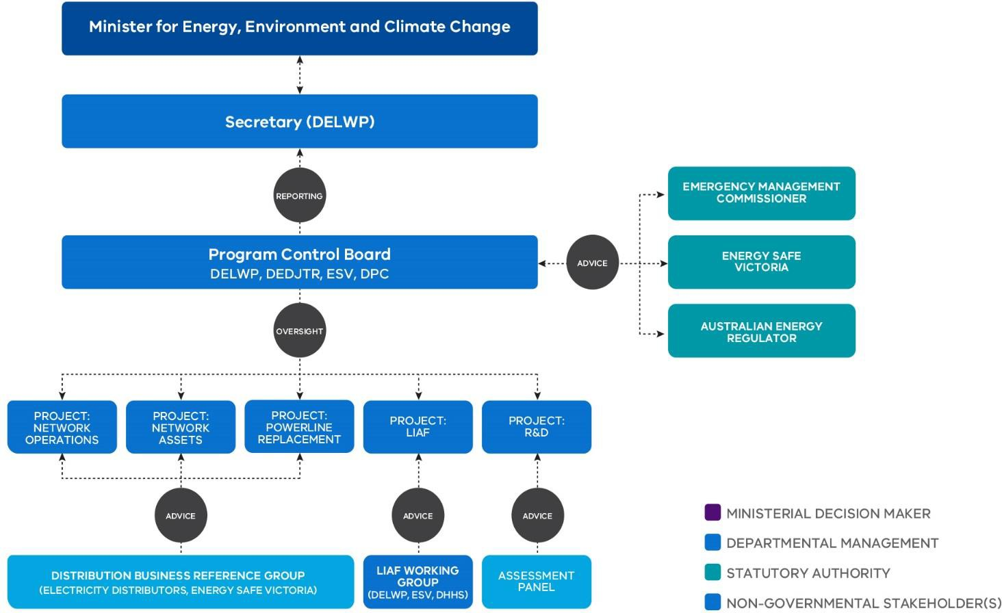

DEDJTR: Department of Economic Development, Jobs, Transport and Resources DPC: Department of Premier and Cabinet
DHHS: Department of Health and Human Services
Source: Adapted from PBSP Gateway Review, Mid-cycle program review (2017. p. 24)

PBSP is subject to the Gateway Review process stipulated by the Department of Treasury and Finance to be conducted on high value, high risk programs such as PBSP. The Gateway review process is an independent external review of a program’s progress and likelihood of delivery success. Gateway Reviews have been conducted on PBSP initiatives in 2014 and 2016. A summary of the 2016 Gateway review findings included:

- PBSP project components are on track to be delivered on time.

- The PBSP has been granted permission to accelerate delivery of key powerline bushfire initiatives. All powerline replacement works and back-up generator installations (LIAF) will now be completed by the end of 2019.

- The R&D project is expected to be completed by the end of 2017.

- The PBSP program team has applied robust and effective project management disciplines, including a conscientious approach to continuous improvement.

- Program governance arrangements and effective stakeholder engagement have underpinned the successful delivery to date of the program (Department of Treasury and Finance, 2016).

While many PBSP components are expected to be completed by the end of 2019, ongoing activities will include the administration of the 1 May 2016 amendments to the Electricity Safety (Bushfire Mitigation) Regulations 2013 and the maintenance of risk reduction data used to inform the risk reduction standards identified in these regulations.

To assist it in its role in administering the 1 May 2016 amendments to the Electricity Safety (Bushfire Mitigation) Regulations 2013 and to advise the Minister for Energy, Environment and Climate Change on exemptions under the Civil Penalties Scheme, ESV has established a formal advisory body – the Powerline Bushfire Safety Committee under Section 8 of the Energy Safe Victoria Act 2005. The Committee consists of independent members with experience in risk management, strategic and project planning, regulatory practice, powerline ignition and electricity networks. Representatives from ESV and DELWP and industry also participate.

PBSP status and achievements

Table 9: The current status of PBSP programs as reported by DELWP:
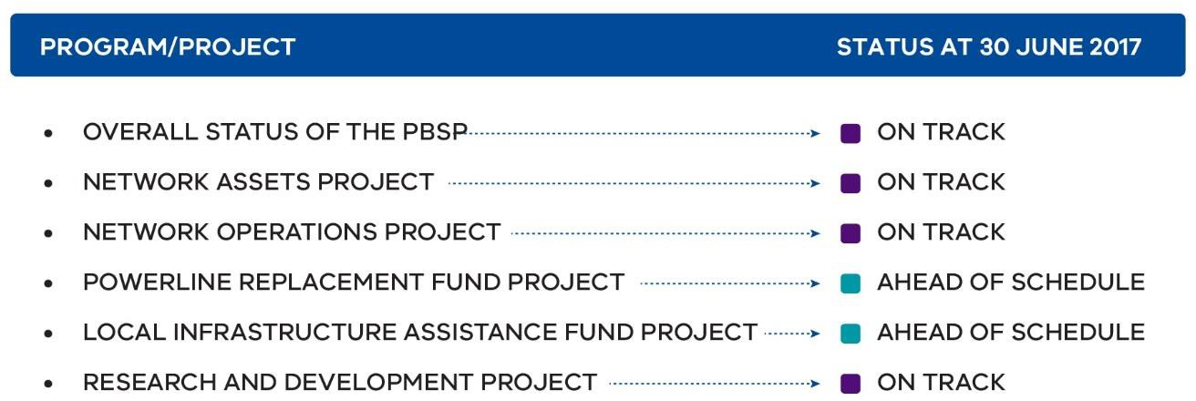

Source: Adapted from PBSP Presentation to the Program Control Board meeting on 27 September 2017.

Table 10: PBSP achievements to date

PBSP initiatives | Achievements to date
Powerline Replacement Fund | Approximately 500 kilometres of bare-wire powerlines have been replaced with safer alternatives in high bushfire risk areas.
Regulatory Initiatives and Network Assets Project | As at 30 June 2017, 1598 ACRs have been installed on single wire earth return lines to minimise fire risk in the network on Total Fire Ban days.  On 1 May 2016, three PBSP enhanced fault detection and suppression capabilities were prescribed within the Electricity Safety (Bushfire Mitigation) Regulations 2013.  In September 2017, the Victorian Government introduced a strengthened enforcement regime for the three standards into the Electricity Safety Act 1998.  The f-factor Incentive Scheme, introduced by the Victorian Government and revised in 2016, weights all network fire ignitions by time and geographical location and applies an increasing financial incentive to ignitions, relative to their bushfire risk and reflects the introduction of REFCLs.
Research & Development Project | Currently providing grant funding to IND Technology to test and develop their Early Fault Detection Technology on the Single Wire Earth Return network. The project will conclude in June 2019.  Currently providing grant funding to Groundline Engineering Pty Ltd for a covered conductor solution on the 22 kV network. This project is due to conclude in October 2019.  Currently running a Vegetation Detection Challenge project, for the development of an algorithm that can identify what particular plant species is causing a fault if a branch were to touch/fall onto a powerline.
Local Infrastructure Assistance Fund | As at 30 June 2017, 276 facilities and approximately 13,700 vulnerable Victorians are protected by back-up diesel generators. The final stage of the LIAF is currently underway, with an additional 63 facilities to receive generators, protecting an extra 2,100 vulnerable Victorian’s by Christmas 2017.

Figure 15: Achievements by PBSP

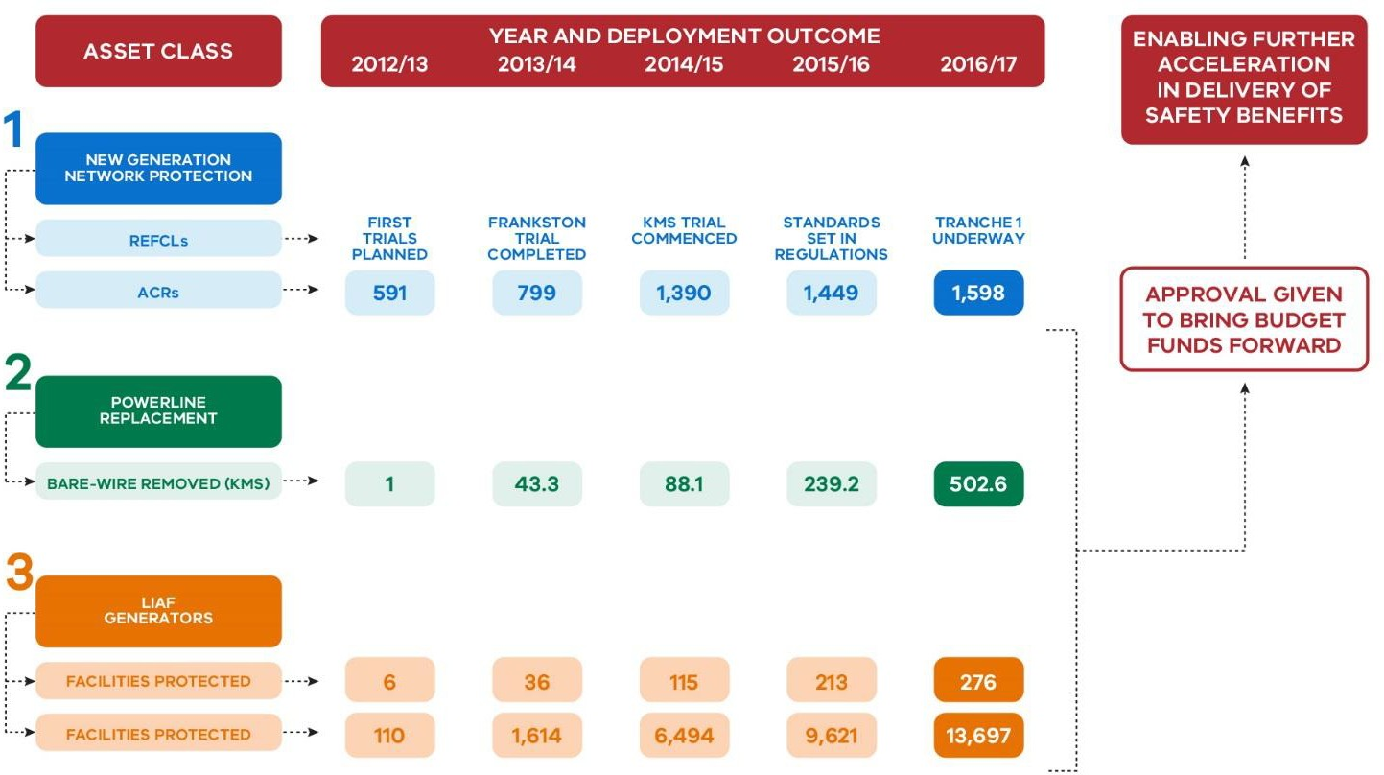

Source: Adapted from PBSP (2016)

With many of the PBSP components wrapping up in the next couple of years, it is important that the valuable learning gained through the Program is maintained. The Gateway Review recognised the valuable knowledge gained through the PBSP and the need to ensure that these learnings are utilised beyond the tenure of PBSP:

“The Program has generated valuable knowledge and tools that have actively informed other elements of the Program (including regulations), and must be considered as part of program transition planning.” (Department of Treasury and Finance, 2016, p. 3)

The Gateway Review recommended that a new phase of planning is required to:

- propagate the good practices introduced through the PBSP;
- ensure that data and knowledge accumulated by PBSP is available to key stakeholders in industry and government; and
- preserve the legacy of raised powerline safety standards that have been directly informed by PBSP activities and now codified in new regulatory instruments (Department of Treasury and Finance, 2016).

In its response to the Gateway Review, the PBSP noted that during 2017–18 it will prepare and present a transition plan to the Program Control Board that deals with the closure of the LIAF and R&D components, and the handover arrangements for residual obligations to DELWP. PBSP further noted it has commenced transition planning to ensure that the benefits of PBSP will be available to other parties beyond the tenure of the program (PBSP, 2017).

Recommendation 26
DELWP should develop a transition plan that outlines a clear pathway for the closure of its program components of the Powerline Bushfire Safety Program and handover arrangements for residual components to ensure the learning gained through the program is maintained into the future.

New technology to better manage bushfire risk
In a world first, Rapid Earth Fault Current Limiter (REFCL) technology is being used in Victoria to reduce the risk of bushfires being started by powerlines. As its name suggests, a REFCL can reduce the fault current to very low levels within a few hundredths of a second on an affected circuit while, at the same time, maintaining supply by increasing voltage on the unaffected circuits.

Bushfires can start when a powerline fault allows an electrical current (arc) to flow from the powerline into the surrounding environment, causing a fire ignition which can lead to a bushfire in certain weather conditions. Wire-to-earth faults can occur as a result of a fallen powerline, a tree falling against a powerline, or wildlife touching the pole and powerline at the same time (ACIL Allen Consulting, 2015).

Figure 16: How a REFCL works

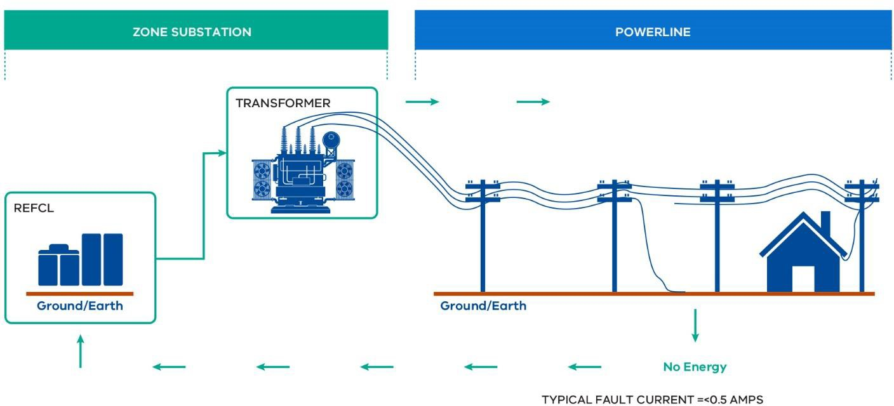

Source: Adapted from AusNet Electricity Services Pty Ltd, Non-network options to comply with Bushfire Mitigation Regulations Notice of Determination under Clause 5.17.4(c) of the National Electricity Rules (2017, p.8).

The effectiveness of REFCLs as a fire-prevention technology has been demonstrated in a series of trials conducted by the Victorian Government in close cooperation with electricity distribution businesses and research experts. The field trials demonstrated that REFCLs can suppress arc- induced bushfire ignitions from wire-to-earth faults on 22 kV polyphase powerlines by reducing fault currents to very low levels almost instantaneously (Marxsen Consulting, 2015).

REFCL technology tested in Victoria has been developed further than in any other REFCL installation in the world, particularly to prevent fire ignitions. Whilst REFCLs have been used in Europe since the early 1990s to improve supply reliability, they have not previously been used for fire safety measures.

The research program
The Powerline Bushfire Safety Taskforce conducted an analysis of fires started by powerlines and presented its final report to the Victorian Government in September 2011. The Taskforce found that the majority of fires in rural distribution areas in 2009 were started by polyphase powerlines (PBSP, 2011) and identified that:

- the consequence of starting a bushfire varies across the State, and is determined by population exposure based on expected bushfire behaviour;
- electrical arcs (caused by faults) can, in worst weather conditions, start a bushfire in milliseconds;
- different types of electrical faults require different technological approaches; and
- REFCLs are the most cost-effective means of treating risk on polyphase lines – and lessen likelihood of ignition by 70 per cent.

Traditional protection technology in Victoria detects faults and turns off the affected powerline within a timeframe that allows the action of switches along the powerline to be coordinated, to minimise the number of customers that lose supply when a fault occurs. However, this regime does not operate fast enough to be able to turn off powerlines within the timeframe required to minimise the likelihood that a fire will be ignited.

The Taskforce research on fire ignitions indicated that the likelihood of powerlines starting bushfires could be substantially reduced if the sensitivity and speed of the protection equipment was improved so that more faults were detected more quickly (PBSP, 2011).

The Taskforce estimated that:

“If a REFCL is installed at all zone substations in Victoria, the state‘s bushfire risk is reduced by around 50 per cent. If a REFCL is installed at all zone substations that have at least part of one powerline that is in an extreme fire loss consequence area, the
state‘s bushfire risk is reduced by around 35 per cent.” (PBSP, 2011, p. 67)

This led to the Taskforce recommendation to install REFCLs on 22 kV powerlines to reduce the risk of bushfires. The Taskforce also indicated the need for further research and development, noting that REFCLs had not previously been used for bushfire suppression.

The PBSP, tasked with implementing these recommendations, conducted a research program in conjunction with electricity distribution businesses to determine the optimal way to deploy REFCLs for bushfire prevention in worst-case, Black Saturday type conditions. Testing of REFCL technology first occurred at United Energy’s Frankston South zone substation in 2014 to:

- determine whether REFCL technology was effective in reducing fire starts from electrical arcs in powerline faults on a real polyphase 22 kV network; and

- determine the optimum operational settings for REFCLs to reduce fire starts initiated by electric arcs in powerline faults (ACIL Allen Consulting, 2015, p. 25).

Findings from the Frankston South zone substation trial demonstrated that REFCLs are highly effective in significantly reducing arc ignitions on 22 kV powerlines. The tests demonstrated the capability of REFCL technology to detect and suppress faults on the network which otherwise would lead to bushfires (PBSP, 2015).

Further testing of REFCL technology at AusNet Services’ Kilmore South zone substation was completed in 2015. These trials tested the comparative performance of a range of REFCL configurations to identify optimal fault detection and suppression capability on the live network (PBSP, 2015).

The test program sought to build a deeper understanding of how RECL technologies work and how they can be effectively applied to Victoria’s rural electricity distribution network to reduce fire risk.
The program sought to review and refine a draft REFCL performance standard proposed for application in high bushfire risk areas in Victoria and tested the performance of different REFCL technologies against this draft performance standard. Fault detection speed and fault response performance is an essential part of a REFCL performance standard if fire risk reduction is to be achieved (Marxsen Consulting, 2015).

The findings from the REFCL testing program informed development of a performance standard that if met, would significantly reduce bushfire risk. Essentially the performance standard is comprised of the following elements:

- fault detection time limit requirements;
- fault suppression requirements; and
- and fault management requirements.

The testing program demonstrated that Ground Fault Neutralisers developed by Swedish Neutral Technologies offered superior fire risk reduction over other REFCL technology types tested, and are the only REFCL type that can meet the performance standard at present (Marxsen Consulting, 2015).

Box 17: Definitions related to fault detection

Ground Fault Neutralisers, a type of REFCL developed by Swedish Neutral, reduce fault currents rapidly by injecting an anti-phase current into the neutral. Residual current is also cancelled out, meaning the fault can be reduced to levels well below one amp. Fire risk can be reduced by 90 per cent if the supply is interrupted when the fault current reaches 0.5 amps. This technology also reduces bounce ignition risk more than other fault suppression technology types.

A high impedance fault results when an energised conductor comes in contact with a tree or other structure, or the ground. It is characterised by having a high impedance that makes it more difficult to detect. A high impendence fault means a resistance value in ohms that is equal to twice the nominal phase-to-ground network voltage in volts (Electricity Safety

(Bushfire Mitigation) Regulations 2013, incorporating amendments as at 1 May 2016).

A low impendence fault can be caused when a conductor falls to the ground. It is easier to detect and has a resistance value in ohms that is equal to the nominal phase-to-ground network voltage in volts divided by 31·75 (Electricity Safety (Bushfire Mitigation) Regulations 2013, incorporating amendments as at 1 May 2016).

When a fault occurs, diagnostic tests must determine whether the fault is permanent or transient and identify which powerline it is on. These tests are performed by allowing current to flow which can reintroduce the risk of a fire start, however REFCL’s use soft fault confirmation which only allows a very small amount of current to flow during testing.

Balancing cost and safety outcomes
The cost of the Black Saturday bushfires was estimated to be over $4 billion. The VBRC summarised the impact of the Black Saturday fires as follows:

“The most serious consequence of the fires was the death of 173 people. Left behind are families, friends and communities still trying to come to terms with their loss.

Accompanying this loss of life is the fires’ impact on property and the infrastructure that supports communities, as well as the substantial environmental impact, which will take years to fully reveal itself – let alone be ameliorated. It is extremely difficult to quantify the cost of a disaster like this, but the Commission estimates it to be more than $4 billion.” (2009 Victorian Bushfires Royal Commission, 2010, p. 1)

The Taskforce estimated the cost of installing REFCL’s would range from around $1 million to around $9 million per zone substation, depending on the amount of ancillary work required.

The Taskforce initially recommended REFCLs be installed on all 108 zone substations servicing powerlines in non-urban areas. Risk-reduction modelling performed by PBSP targeted the roll-out of REFCLs to 45 zone substations servicing powerlines in areas of the highest bushfire risk to maximise cost-effective risk reduction.

The PBSP REFCL Technologies Program, in its Final Report concluded:

“Although REFCL installation and requisite network hardening and balancing works are relatively expensive, the delivered fire risk reduction benefit per dollar spent is comparatively attractive because each REFCL provides protection against earth fault fires on all multi-phase powerlines in an entire substation network – on average 400– 500km of powerline route length.” (Marxsen Consulting, 2015, p. 11)

In 2015, as part of the requirements to conduct a regulatory impact analysis for the amendments to the Electricity Safety (Bushfire Mitigation) Regulations 2013, ACIL Allen was commissioned to conduct the Regulatory Impact Statement (RIS), including an assessment of the costs and benefits (ACIL Allen Consulting, 2015).

To determine the net benefits of installing REFCLs at 45 high risk zone substations, ACIL Allen considered the present value of:

- the direct costs associated with installing REFCLs at the zone substations and the ancillary equipment required;
- the avoided cost by installing REFCLs, and replacing ancillary equipment, earlier than would otherwise occur;
- additional maintenance costs arising from the installation of REFCLs;
- additional costs incurred by customers that are directly connected to the electricity network;
- administrative and compliance costs;
- the benefits associated with an improvement in the bushfire risk; and
- the benefits associated with an improvement in the reliability of supply.

The costs and benefits were modelled over a 40 year period with a discount rate of 4.0 per cent. REFCLs were found to be the most cost-effective means of reducing risk on polyphase lines and to lessen the likelihood of ignition by 70 per cent. The cost of installing REFCLs on 45 high-risk zone substations was estimated by ACIL Allen to be $151 million. ACIL Allen estimated the benefits associated with improvements in the bushfire risk and reliability of supply to be $411 million, and net benefits $260 million (ACIL Allen Consulting, 2015).

In considering the costs and benefits of deploying REFCLs, ACIL Allen took into account the benefits to supply reliability on high-risk fire days. A reliable electricity supply, particularly on high- risk fire days, is required by communities for equipment such as computers, radio scanners or telephones to monitor and communicate fire activity, and for pumps for fuel or water.

ACIL Allen (2015, p. 45) in its RIS notes:

“Improved supply reliability is a major motivator of utilities’ adoption of REFCLs around the world. Experience at Frankston South supports published studies that show substantial improvements in reliability indices such as SAIDI [the minutes off supply] and MAIFI [the frequency of momentary interruptions] following REFCL installation”.

More recent experience has shown that the costs of deploying REFCLs will be considerably higher than originally estimated by distribution businesses in 2015. The best currently available information on these costs comes from the AER’s decision on project funding determinations for the initial phase of REFCL installations by AusNet Services and Powercor.
Box 18: AER response to the AusNet Services and Powercor contingent project application

In 2017, AusNet Services and Powercor submitted contingent project applications to the AER for funding to install the first tranche of REFCLs. In its response, the AER identified points of difference between their cost estimations and the RIS conducted by ACIL Allen in 2015. The AER found there was no disparity between item costs, but there were notable differences in the amount of work required to the network to accommodate the REFCL:

“The AER has found there is no material disparity between the RIS and the contingent project application for the costing of specific items. However, we have found that there are departures in the volumes of work associated with a number of items, which has significantly affected costs.” (AER, 2017, p. 16)

The AER approved AusNet Services and Powercor’s contingent project application subject

to some adjustments to amounts sought, noting that:

“… the RIS was prepared in 2015 largely based on preliminary costing information provided by the DNSPs [Distribution Network Service Providers]. We have investigated the reasons for the differences between the preliminary costing and the more detailed scope of works assessments which are now available. We are satisfied that the increased volumes of work are well substantiated and should be accepted.” (AER, 2017, p. 17)

Extrapolating the current estimated costs, the deployment of REFCLs would now have marginally higher estimated costs than estimated benefits, assuming no changes in any of the other elements of the ACIL Allen methodology. However, a more complete analysis would be required to fully determine the best estimated cost-benefit ratio at this time, noting also that it is inherently difficult to develop precise quantitative estimates of the benefits of lower risk to the community.

Introducing legislation to mandate specific bushfire mitigation measures
The PBSP has advised that all measures that have been, and are yet to be, introduced to implement VBRC Recommendation 27, will result in a relative reduction of over 60 per cent in powerline-related bushfire risk. Approximately two-thirds of this safety benefit is directly attributable to REFCL protection.

To ensure this safety benefit is delivered to its full extent and in a timely manner, the Victorian Government has enshrined new powerline safety standards in law.

On 1 May 2016, the performance standard requirements that effectively require REFCLs to be adopted, were prescribed within the amended Electricity Safety (Bushfire Mitigation) Regulations 2013 for 22 kV polyphase powerlines emanating from 45 targeted zone sub-stations identified across rural and regional Victoria to protect high-risk bushfire areas.

Electricity distribution businesses operating in high risk bushfire areas, are required to meet a defined quota of zone substations with operational REFCLs by 1 May 2019, with an additional quota to be operational by 1 May 2021, and the remaining designated zone substations fitted with REFCLs by 1 May 2023.

Section 7 of the Electricity Safety (Bushfire Mitigation) Regulations 2013 does not specifically mention REFCLs, but rather prescribes that each polyphase electric line originating from the list of selected zone substation must have the following required capacity in the event of a phase-to- ground fault.

  - To reduce the voltage on the faulted conductor in relation to the station earth when measured at the corresponding zone substation for high impedance faults to:

    - 250 volts within 2 seconds of fault occurrence and for as long as the fault is present.¹¹

  - When conducting diagnostic tests to confirm if the fault is sustained or not or to identify which powerline is on to:

    - limit the fault current to less than 0.5 amps; and
    - limit the thermal energy to a maximum I2t value of 0·10.¹²

  - To reduce the voltage on the faulted conductor in relation to the station earth when measured at the corresponding zone substation for low impedance faults to:

    - 1900 volts within 85 milliseconds of fault occurrence;
    - 750 volts within 500 milliseconds of fault occurrence; and
    - 250 volts within two seconds of fault occurrence and for as long as the fault is present.¹³

Other obligations placed on the network businesses operating in high-risk bushfire areas, introduced by these 2016 amendments, included:

  - each new or replaced line with a nominal voltage from 1 kV to 22 kV must be covered or undergrounded from 1 May 2016 in 33 prescribed electric line construction areas;

  - each SWER line must have an ACR installed by 1 May 2023.

Civil penalty provisions were introduced into the Electricity Safety Act 1998 in September 2017. This means that electricity network businesses can now face penalties under a civil penalties scheme for contraventions to the required capacity standards.

To date, the only available technological solution that is capable of meeting the required performance standard specified in the regulations is Swedish Neutral’s REFCL. Electricity distribution businesses have expressed a concern that this may expose them to risks associated with having a monopolistic supplier. For example, CitiPower and Powercor Australia have noted:

“… the REFCLs technology is provided by a single supplier globally. The prescriptive regulation requires us to only use this technology. This exposes us to risks associated with relying on a monopolistic supplier, including potential extortions in price and quality of products and services provided.” (CitiPower & Powercor Australia, 2017, p. 15)

11 These performance requirements are specified in the definition of ‘required capacity’ in the Electricity Safety (Bushfire Mitigation) Amendment Regulations 2016.
¹² These performance requirements are specified in the definition of ‘required capacity’ in the Electricity Safety (Bushfire Mitigation) Amendment Regulations 2016.
¹³ These performance requirements are specified in the definition of ‘required capacity’ in the Electricity Safety (Bushfire Mitigation) Amendment Regulations 2016.

Electricity distribution businesses have also expressed concern that the technical challenges associated with installing REFCLs within existing zone substation infrastructure were not sufficiently addressed for the seven-year rollout timeframe. Network businesses in their discussions with the Review, noted that zone substations serving large rural networks may require installation of more than one REFCL unit to meet the required standard.

AusNet Services, in its Notice of Determination in response to complying with these amendments, sees the program as a commercial risk that can result in higher costs to consumers:

“AusNet Services has advised the Government on numerous occasions that the hugely ambitious REFCL timeframe and performance standard are inconsistent with the technological, operational and commercial challenges that exist in relation to the REFCL program and the likely outcome will be higher costs to consumers.” (AER, 2017, p. 16)

In identifying a way forward, AusNet Services has proposed that DELWP work closely with industry to draw on their experience in rollout of new technology such as REFCLs:

“… we would encourage the Department to work even more closely with distributors drawing on their considerable experience on the implementation of these often quite complex initiatives and strong record of delivering performance improvement cost effectively. For example, while consulting on new obligations with respect to the installation of REFCLs, the genuine implementation concerns of distribution businesses have been [too] easily dismissed despite valuable lessons learned being readily available from previous new technology roll outs. By ignoring these concerns, higher costs will be borne by the community.” (AusNet Services, 2017, p. 11)

On 29 June 2012, ESV accepted changes to the Electricity Safety Management Scheme of SP Ausnet, which included the plan to install a REFCL at Woori Yallock, making the installation of this REFCL subject to regulatory oversight.

Box 19: Network requirements to install REFCLs

- Network compatibility: With a REFCL operational, the high voltage system has a floating earth rather than a solid earth. For the earth fault protection to operate, all earths on the same high voltage system as the REFCL will need to have a floating earth, which will require the replacement of some existing protection devices and additional protection devices.

- Network hardening: When a REFCL operates, the voltage on the healthy phases will increase. Some network equipment will need to be replaced to be able to withstand the increased voltages expected.

- Network balancing. The operation of the REFCL will be most effective where the three phases are balanced with respect to load and capacitive current. Some rebalancing may be required to optimise the operation of the REFCL.

- Fault identification and reliability. The REFCL is very sensitive and will detect faults that other protection devices do not. The number of faults detected is likely to increase and it may be difficult to identify where those faults have occurred.

- Changes of work practices. The installation of a REFCL is a fundamental change in the way in which the network is protected and controlled. It will require changes to operational procedures, and training and change management of staff (ACIL Allen Consulting, 2015, p. 31).

CitiPower and Powercor Australia have expressed a view that some level of flexibility should be allowed for businesses to seek exemptions from the requirements of the Electricity Safety (Bushfire Mitigation) Regulations 2013:

“… if prescription-based approaches are employed it is crucial some level of flexibility is provided for NSPs [Network Service Providers] to seek deviations from the specific requirements through exemptions. The safety regulator should be empowered to provide exemptions where NSPs can demonstrate the same level of safety outcomes can be achieved at a lower cost to customers or where NSPs face unforseen challenges in implementation which present no additional performance risk. This should be the case particularly when severe penalties of non-compliance apply, such as the proposed Bushfire Mitigation Civil Penalties Scheme. The procedure of obtaining an exemption should be reasonably straightforward, to minimise the associated administrative and financial cost.” (CitiPower & Powercor Australia, 2017, p. 14)

In recognition of the fact that the initial achievement of full fault detection capability in certain zone substations may be technically challenging, the Victorian Government has provided a mechanism for exemptions and timeline variations from the scheduled prescribed powerline bushfire safety standards by including provisions in the Civil Penalties Scheme in the 2017 amendments to the Electricity Safety Act 1998.

Section 120W of the Electricity Safety Act 1998 allows recommendations for technical exemptions from the Electricity Safety (Bushfire Mitigation) Regulations 2013 to be made by the Minister for Energy, Environment and Climate Change to the Governor in Council.

Section 120X of the Electricity Safety Act 1998 allows ESV in consultation with the Minister, to grant timeline variations for the installation of REFCLs against milestone dates specified in the legislation. Under section 13 of the Electricity Safety (Bushfire Mitigation) Regulations 2013, ESV may also provide exemptions from the bushfire mitigation activities prescribed in these Regulations. The capacity to provide these exemptions already existed prior to the introduction of the Civil Penalties Scheme (Department of Environment, Land, Water and Planning, 2016).

Technical exemptions are intended to cover circumstances where a distribution business:
- demonstrates practical impossibility of meeting the stated requirements at a particular zone substation;
- demonstrates any zone substation that is not fully compliant has reached its best practicable level of fault detection;
- provides a written undertaking as to how it will achieve full compliance with the Regulations within a defined period; and
- provides these details in a Bushfire Mitigation Plan (Department of Environment, Land, Water and Planning, 2016).

ESV may refer requests for extensions or exemptions to the Powerline Bushfire Safety Committee to inform its judgements.

Approach to further implementation and evaluation of the REFCL program
The deployment of REFCLs has been a long-term policy commitment of successive governments following the Powerline Bushfire Safety Taskforce’s advice on the best way to respond to a core recommendation of the Victorian Bushfires Royal Commission. The best available information continues to show that the installation of REFCLs will have a material impact on bushfire risk in a state that faces some of the highest risks in the world.

In responding to the high risks, Victoria is leading the way internationally, with the attendant costs and challenges that come with being the world leader in deploying a new approach to bushfire risk.

In its Interim Report, the Review indicated that a measured approach should be adopted to the implementation of REFCLs, allowing policy settings to be considered with the benefit of greater experience and information. As a draft recommendation, the Review proposed that the deployment of REFCL technology to satisfy the Electricity Safety Act 1998 and the Electricity Safety (Bushfire Mitigation) Regulations 2013 be subject to review prior to each tranche by an independent expert panel appointed by the Minister.

Submissions in response to the Interim Report and further consultations undertaken by the Review have drawn out practical difficulties with the implementation of the draft recommendation as originally presented. In practice, there would be substantial challenges in assembling a suitably equipped independent expert panel with a sufficient understanding of the technical issues in a timely fashion. In addition, the current scheduling of the regulatory requirements involves

considerable overlaps between the tranches, and the distribution businesses have advised that planning for the second tranche is already well advanced. In their submissions responding to the Interim Report, AusNet Services and Powercor have indicated that they consider a full program review could not be completed without 'stopping the clock' on the implementation of the second tranche.

While an independent review of the kind originally proposed in the Review's draft recommendation may not be feasible without substantial delays to the program roll-out, it is important that a careful approach to implementation is taken and that program settings can be adjusted in a measured fashion when justified. This requires consideration around the technical feasibility of the deployment and the cost to consumers together with core policy objectives to reduce bushfire risks to Victorians as quickly as possible.

The Review proposes that the current Powerline Bushfire Safety Committee be tasked with preparing annual implementation reports to the Minister for Energy, Environment and Climate Change. The reports should provide information on the costs and risk reduction benefits of the program in light of practical implementation experience, and an assessment of emerging issues that may require adjustments to program timing or technical requirements (such as exemptions from requirements on certain feeder lines where risks can be more cost effectively met through alternative mechanisms other than REFCLs).

The first report should be provided by May 2018. While it is expected that this report would inform implementation of the already commenced first tranche and the forthcoming second tranche, it should not delay the presentation of contingent project applications to the AER.

Recommendation 27
The mandate of the Powerline Bushfire Safety Committee should be expanded to require it to provide annual implementation reports on the deployment of REFCL technology to satisfy the Electricity Safety (Bushfire Mitigation) Regulations 2013. The implementation reports should include information on the costs and risk reduction benefits in light of actual experience, and an assessment of emerging issues that may require adjustments to program timing or technical requirements. The first report should be provided through the Director of Energy Safety to the Minister for Energy, Environment and Climate Change by May 2018.

Recommendation 28
ESV should continue to work closely with distribution businesses, and with the assistance of the Powerline Bushfire Safety Committee, to provide timely advice to the Minister for Energy, Environment and Climate Change on the need for any exemptions from the performance standards contained in the Electricity Safety (Bushfire Mitigation) Regulations 2013.

Inconsistencies with the Electricity Distribution Code
A number of submissions to the Review have raised concerns that the requirements of the Electricity Safety (Bushfire Mitigation) Regulations 2013, which effectively mandate the adoption of REFCLs, will cause them to breach some of the provisions of the Electricity Distribution Code.

The potential inconsistency between the regulatory requirements arises because the operation of a REFCL following a single-phase fault leads to an increase in voltage levels at the point of supply to high voltage customers that exceeds the permissible level as specified in Clause 4.2.2 of the Electricity Distribution Code. The Essential Services Commission has committed to review the voltage variation standards outlined in Clause 4.2.2 of the code to ensure they are fit-for-purpose and support network businesses in meeting the requirements of the Electricity Safety (Bushfire Mitigation) Regulations 2013.

Ongoing research and development
Although the PBSP’s research and development work on REFCLs has now ended, further research and development will be required to ensure that the most efficient and effective technologies are adopted to reduce the risk of fires starting from powerlines into the future.

Technological advancements, particularly in relation to line monitoring and remote sensing, are likely to open up further opportunities to cost-effectively manage bushfire risk. For example, Attentis Technologies, in its submission to the Review, has noted the contribution that monitoring and detection technologies may make:

“Installing components (REFCL/ACR) on existing networks still fails to address the issue of visibility. In the event of a line contact with the ground, it is still unknown whether a fire start has occurred – the entire point of installing REFCL/ACR technology. Remote monitoring, combining detection (thermal, arc, smoke) visibility and live conditions needs to be incorporated to provide a level of intelligence to make informed response to REFCL/ACR technology being activated.” (Attentis Technology, 2017, p. 3)

AusNet Services in its submission to the Review, has highlighted the key role that government can play in helping to fund innovative solutions to enhance community safety:

“New network technology also offers the potential for step change improvements to community safety, the most recent example being the research into and development of REFCL technology for its bushfire mitigation potential… Government has a key role in encouraging and helping to fund safety innovation and R&D as the economic regulatory regime does not provide funding.” (AusNet Services, 2017, p. 14)

The $10 million funding for research and development provided through the PBSP has helped drive innovations that have placed Victoria at the forefront of new approaches to the management of bushfire risk. With this Program now largely complete, it is timely to ask whether there is a case for continued research and development funding by the Victorian Government.

There are several relevant considerations to take into account:

- Firstly, is there scope for further technological innovation to address bushfire risk?
- Secondly, would further research and development have a sufficient public good component to warrant government funding?
- Thirdly, what arrangements should be considered to maximise involvement from distribution businesses?

The information that has been provided to the Review indicates that the potential for technical innovation to achieve greater safety has not been exhausted. Moreover, research in this area is likely to involve clear public good dimensions that would justify government funding.

It is, however, very difficult to be definitive in any way as to how much funding might be justified, at least given the available information. As a broad judgement, the Review would suggest a modest program of around $1 million per annum may be sufficient to continue focused areas of research, including through university researchers and, where appropriate, areas of research by other parties with expertise such as equipment suppliers. If such a program were to be maintained, it should be undertaken jointly with distribution companies, and on the basis that government funding would be more than matched by contributions from distribution companies. The research and development fund should be technology neutral to allow the entry of emergent technologies in the future, or to facilitate improvements to existing technologies. ESV may be well placed to manage this program following the closure of the PBSP.

Recommendation 29
The Victorian Government should provide ongoing funding for further research and development into new technology to manage the bushfire risk from electric lines. Any funding should be contingent on being at least matched by contributions from distribution companies. The ongoing program should be managed jointly with distribution companies and involve input from university researchers. It should be subject to evaluation at least every four years, with the continued provision of public funding to be contingent on satisfactory research performance.

References
2009 Victorian Bushfires Royal Commission, 2010. Final Report: Summary.
ACIL Allen Consulting, 2015. Regulatory Impact Statement: Bushfire Mitigation Regulations Amendment. AER, 2016. AER Statement of intent 2016-17, Canberra.
AER, 2017. FINAL Decision AusNet Services Contingent Project: Installation of Rapid Earth Fault Current Limiters (REFCLs)– Tranche 1.
AER, 2017. Final Decision Powercor Australia Contingent Project: Installation of Rapid Earth Fault Current Limiters (REFCLs) – Tranche 1.
Attentis Technology, 2017. Submission to the Review of Victoria’s Electricity Network Safety Framework. AusNet Services, 2017. Safety Review Submission.
CitiPower & Powercor Australia, 2017. Additional Information to Support the Review of Victoria's Electricity Network Safety Framework.
Department of Environment, Land, Water and Planning, 2016. Electricity Safety (Bushfire Mitigation) Amendment Regulations 2016: Statement of Reasons for Decision to Make Regulations.
Department of Treasury and Finance, 2016. Gateway Review Process Program Review: Powerlines Bushfire Safety Program.
Government of Victoria, 2011. Power Line Bushfire Safety: Victorian Government Response to The Victorian Bushfires Royal Commission Recommendations 27 and 32.
IGEM, 2016. Progress Report Victorian Bushfires Royal Commission: Implementation of recommendations and actions. Marxsen Consulting, 2015. REFCL Technologies Test Program Final Report.
Minister for Energy, Environment and Climate Change, 2017. Contingent Projects- Installation of Rapid Earth Fault Current Limiters- Tranche 1.
PBSP, 2011. Powerline Bushfire Safety Taskforce: Final Report. PBSP, 2015. 2014-15 Annual Performance Report.
PBSP, 2015. Research & Development Project- Investing in new technology, research and development. [Online] Available at: https://www.energy.vic.gov.au/safety-and-emergencies/powerline-bushfire-safety-program/research-and- development
PBSP, 2017. 2016 Mid-Cycle Gateway Review: Response to Gateway Report.
SP AusNet, 2012. AMS- Electricity Distribution Network: Enhanced Network Safety..

Chapter 7: Regulating Underground Energy Assets

Summary
Throughout Victoria, there are numerous underground electricity and gas network assets that are critical to the functioning of the State.

Victoria has never suffered a large-scale pipeline incident, but there have been many smaller scale incidents, some with more serious consequences or potential consequences. Third party interference with pipelines remains one of the biggest threats to pipeline safety and has the potential to cause highly serious incidents.

Physical encroachment on these assets due to changes in the land use surrounding easements can exacerbate the risk of accidental damage to the asset from third parties.

Energy Safe Victoria (ESV) should continue to take the lead in promoting awareness for underground energy assets, including by requiring asset owners to ensure their assets are clearly marked and able to be located when required. Strong compliance and enforcement is necessary. This extends to the enforcement of regulation on third parties that interfere with network assets.

A report into the land use buffers around Major Hazard Facilities, conducted in 2015, found that planning issues relating to residential and other sensitive-use encroachment on Major Hazard Facilities, also applied to high pressure pipelines.

The report included recommendations to formalise the membership and operation of the Land Development Around Pipelines Working Group and to task the working group with providing advice to government to improve planning around high pressure gas pipelines (Recommendation 30). These recommendations would provide a mechanism for the more effective consideration of pipelines in planning decisions.

The Dial Before You Dig referral service or equivalent should be made mandatory, subject to a positive regulatory impact assessment. This proposal would bring Victoria into line with current arrangements applying under electricity and gas legislation in New South Wales (Recommendation 31).

Principles for safeguarding underground energy assets
Underground assets can present a danger to the public or workers when excavation work is undertaken in their vicinity. Accidental contact with an electrical asset can lead to electrocution, while a strike to a gas pipeline has potential to cause a gas leak or explosion.

To ensure these risks are minimised as far as is reasonably practicable, ESV as the energy safety regulator, needs to ensure that network businesses are active in promoting awareness of their underground assets. To ensure safety, these assets must be clearly marked and linked to accurate location data that can be accessible to third parties when required.

Within Australia, there is a Dial Before You Dig one-call referral service available for locating underground utilities including energy assets. Third party contractors planning to excavate in the vicinity of these assets should utilise this service prior to commencing works, but the current system operates on a voluntary basis in Victoria. New South Wales, in contrast, has legislated a mandatory requirement to utilise Dial Before You Dig since 2010.

The risks presented by underground electrical assets
Submissions to the Review highlighted the dangers to third parties working in the vicinity of underground powerlines. CitiPower and Powercor Australia identified this as one of their greatest concerns:

“It is this network interaction with third parties that we recommend ESV, and the safety framework, should focus on in order to improve community safety outcomes.” (CitiPower & Powercor Australia, 2017, p. 7)

As part of this submission, CitiPower and Powercor Australia presented data showing an increasing trend in construction-related incidents. This is particularly related to excavation equipment making contact with the hidden underground electrical assets as is evident in Figure 17.

Figure 17: Backhoe/excavator contacts with underground electrical assets, 2004–2016

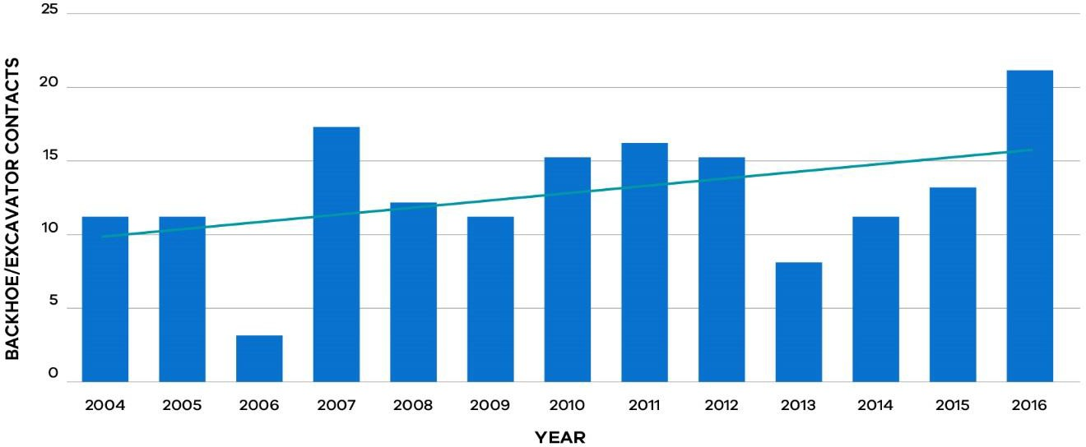

Source: Adapted from CitiPower & Powercor Australia (2017)

The risks presented by underground gas pipelines
In the gas industry, third party damage to pipelines remains one of the biggest threats to pipeline safety and has the potential to cause high consequence events involving death and significant supply interruption.

Unlike other countries, there has never been a death from a high pressure gas pipeline strike in Australia. Yet external interference due to third parties building or maintaining infrastructure such as roads, water pipelines, electricity or telecommunications cabling, continues to be the most common cause of pipeline damage despite the range of technical and legislative measures in place (McDermott & Hayes, 2016).

High pressure natural gas pipelines are present in many urban and suburban areas but because they are buried and there has never been a death or serious injury as a result of a high pressure gas pipeline leak in Australia, public awareness is low (McDermott & Hayes, 2016).

While there have not been deadly events occurring to high pressure pipelines in Australia historically, there have been numerous incidents of third party damage to low pressure gas distribution pipelines. ESV in its Annual Report 2015–16, reported that in Victoria, 219 gas mains were damaged and 2,828 gas services damaged in 2015–16 compared with 227 and 2,996 respectively from the 2014–15 reporting period (ESV, 2016a).

Figure 18: Damaged mains (less than 1,050 kPa) since 2012–13

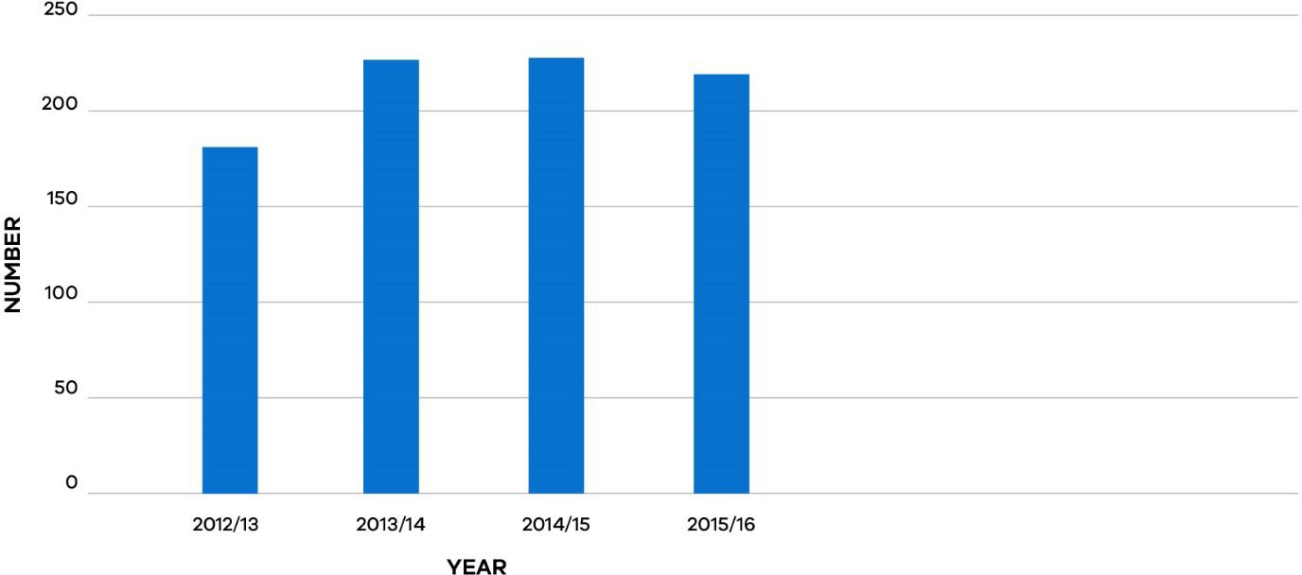

Source: Adapted from ESV (2016, p. 61)

Figure 19: Damaged services (less than 1,050 kPa) since 2012–13

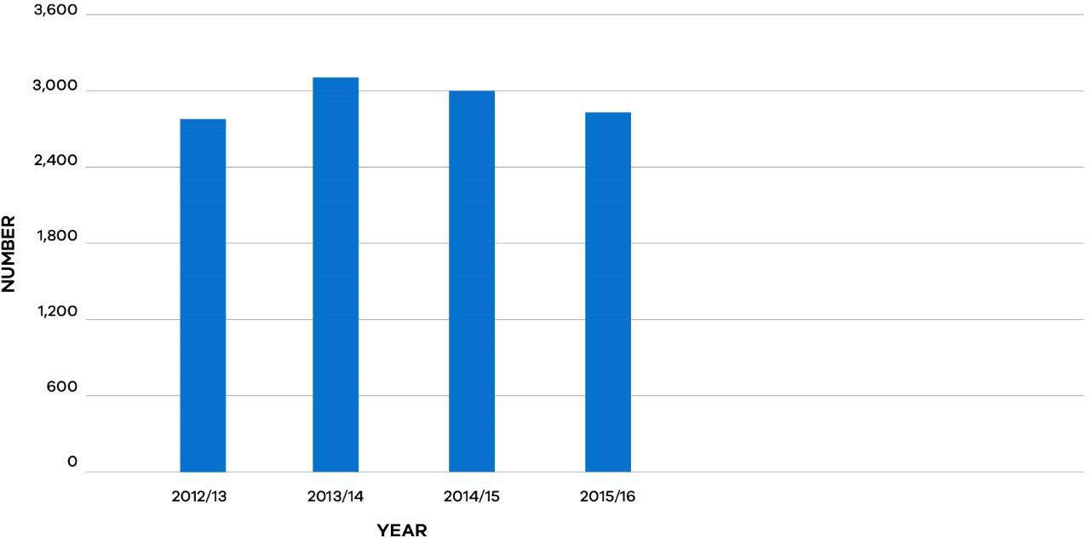

Source: Adapted from ESV (2016, p. 61)

There has been little change in the incidence of pipeline strikes in the past few years that would indicate any real improvement in the management of these risks, and the number of hits on low pressure gas mains and services remains high (ESV, 2016b).

In its Annual Report 2015–16, ESV reported an increase in unauthorised excavation within three metres of licensed high pressure transmission pipelines – an offence under the Pipelines Act 2005 (Major Hazard Facilities Advisory Committee, 2016). AEMO also expressed concern in its submission to the Review that the frequency of incidents appears to be increasing (AEMO, 2017, p. 7), and it remains a major concern:

“… impacts on buried gas pipelines due to unauthorised excavation or boring presents a high risk to public safety, both in terms of the immediate danger to people in the vicinity of a pipeline rupture and gas customers whose gas supply may be interrupted as a result.” (AEMO, 2017, p. 6)

AusNet Services in its submission to the Review, has made a similar point:

“Gas leaks also occur when third-parties encroach and make contact with underground mains or services. This is usually due to contractors performing works failing to make a dial-before-you-dig enquiry, or making the enquiry and not proving the actual location
of the assets on site.” (AusNet Services, 2017, p. 3)

Discussions with stakeholders and public submissions to the Review’s Supplementary Issues Paper, identified a number of causal factors contributing to third party interference, the risk and consequences of which are exacerbated by encroachment of pipeline easements. An encroachment can involve a change in the land use surrounding a pipeline easement, leading to a physical intrusion of a structure, or item into the land subject to a pipeline easement.

The factors identified as making gas pipelines more susceptible to damage from third parties included encroachment on pipeline easements and difficulties locating gas pipelines due to:

- absence of accurate plans identifying the location of pipes;
- difficulty obtaining timely confirmation from asset owners about the location of the assets;
- the practice of using polyethylene pipes with no metal tracer wire, making detection difficult using traditional underground asset-locating devices;
- a lack of hand digging to confirm the exact location of pipes; and
- pipes not being installed in accordance with Australian Standards.

The Australian Standards – AS 2885: Pipelines – Gas and liquid petroleum for high pressure gas pipelines and AS 4645: Gas distribution networks for low pressure gas pipelines – prescribe:

- minimum separation distances or the use of protection measures, from other utilities;
- minimum requirements for ensuring pipelines are visibly marked;
- consideration of participation in a one-call service such as Dial Before You Dig (Australia/New Zealand Standard, 2008) (Australian Standard, 2008).

Additionally, AS 4645 prescribes the use of an appropriate marker or tracer wire to enable detection of plastic pipes, while AS 2885 prescribes consideration of land use and approved developments along the route when determining pipe route (Australia/New Zealand Standard, 2008) (Australian Standard, 2008).

Situations where these standards have not been adhered to, can increase the risk of third party contractor interference, particularly if pipes are difficult to locate, not located where expected, or laid in very close contact to other utility service cables or pipes.

The impact of planning on underground assets easements
As Victoria’s population continues to grow, there has been a shift in land use, with urban development increasingly occurring in areas close to existing hazardous facilities and high pressure gas pipelines. Gas pipelines are long-term assets that can have a lifespan of more than 60 years. The safety of their operation can be affected by land use changes and intensification after their construction. Changing land use may also affect the strategic planning of pipeline route options for the Victorian high pressure gas pipeline network.

Figure 20: Melbourne residential growth corridors showing major gas pipelines
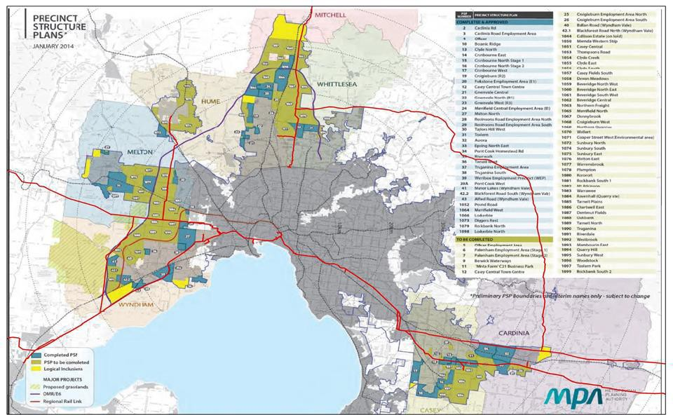

Source: AEMO submission to the Review (2017)

Clause 19.03-6 of the Victoria Planning Provisions provides guidance for developing pipeline infrastructure subject to the Pipelines Act 2005 to ensure that gas is safely delivered at minimal risk (Victorian Planning Provisions, 2010).

The Victoria Planning Provisions detail strategies to:

- “recognise existing transmission-pressure gas pipelines in planning schemes and protect from further encroachment by residential development or other sensitive land uses, unless suitable additional protection of pipelines is provided;

- plan new pipelines along routes with adequate buffers to residences, zoned residential land and other sensitive land uses.” (Victorian Planning Provisions, 2010, p. 6)

However, there have been examples where existing gas infrastructure has been encroached by new housing developments. Photos provided by AEMO in its submission to the Review, show an example where encroachment has occurred and another example where an appropriate easement has been maintained (see Figures 21 and 22).

Figure 21: A new residential development along the Longford to Melbourne pipeline easement in Pakenham. This major pipeline runs along a residential street with houses built up against the easement.
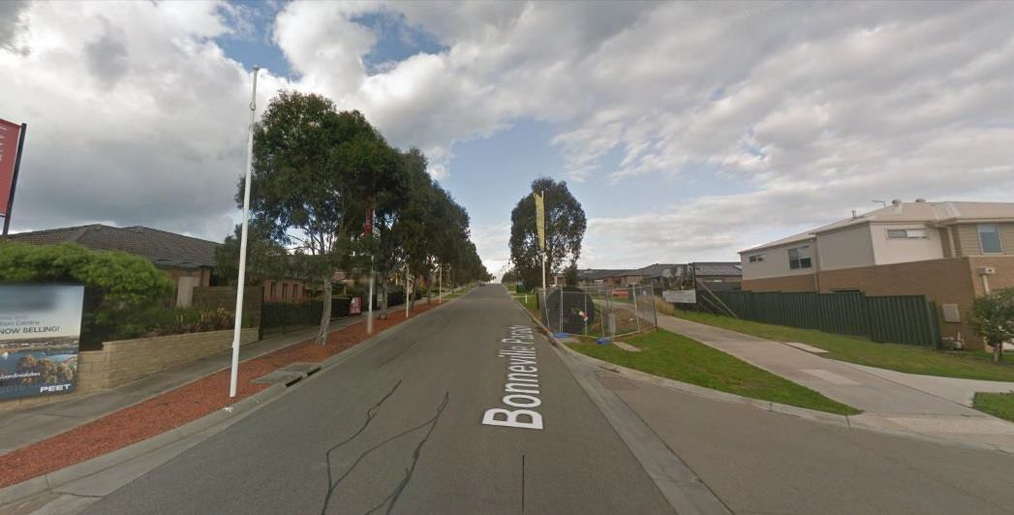

Source: AEMO submission (2017); Google

Figure 22: Easement development along the Outer Ring Main (Pakenham to Wollert pipeline) in Doreen.
Source: AEMO submission (2017); Google

Review of land use around Major Hazard Facilities and high pressure pipelines
In 2015, the Minister for Planning appointed an Advisory Committee under Section 151 of the Planning and Environment Act 1987 to report on improvements to the way land use buffers around Major Hazard Facilities are determined and implemented. The Advisory Committee found that planning issues relating to residential and other sensitive-use encroachment on Major Hazard Facilities, also applied to high pressure pipelines. The Advisory Committee, therefore extended its consideration to include the risks surrounding high pressure pipelines and how planning tools can better protect pipeline assets and communities (Major Hazard Facilities Advisory Committee, 2016).

Submissions to the Advisory Committee noted that existing policy measures relating to residential and other sensitive-use encroachment on Major Hazard Facilities and high pressure pipelines, were inadequate or inconsistently applied. Three of the recommendations made by the Advisory Committee, proposed improvements to land use planning for areas surrounding high pressure pipelines. A response to the recommendations is currently being considered by the Victorian Government.

Box 20: Recommendations 15–17 of the Major Hazard Facilities Advisory Committee’s Final Report

Recommendation 15
The Land Development Around Pipelines Working Group nominate essential high pressure gas and liquid hydrocarbon pipelines and consider recognising them in the State Planning Policy Framework as being of State significance.

Recommendation 16
Refer the following issues to the revised Land Development Around Pipelines Working Group for consideration:

- Clause 66.01 subdivision referrals be amended to replace the gas supply authority as the determining referral authority for proposals to subdivide land crossed by a gas transmission pipeline or a gas transmission easement with ESV as the determining referral authority.

- For lower risk pipelines consider including a referral to the pipeline licensee in Clause
66.02 for building and works within the pipeline measurement length.

Recommendation 17
Refer the following potential planning responses to the revised Land Development Around Pipelines Working Group for consideration:

- The development of Environmental Significance Overlay schedules for urban residential areas and rural areas to reflect a more responsive approach to manage the balance between development control and “at pipeline” protection.

- The Environmental Significance Overlay schedules include sensitive uses to be protected including as a minimum the sensitive uses identified in AS 2885.

- The Environmental Significance Overlay schedules include application, referral and notice requirements to ESV and the pipeline operator/owner as relevant.

- The Environmental Significance Overlay schedules be mapped on a priority basis, with the pipeline measurement length being the starting point for the relevant area to be mapped.

- The application of the Environmental Significance Overlay schedules to pipelines that do not meet the High Density T2 rating as defined in AS 2885.

- The preparation of a Planning Practice Note to assist in the implementation of an improved planning process.

The Advisory Committee concluded that the Victorian planning system does not always adequately address land use planning for areas around underground assets such as gas pipelines, and noted some instances where pipeline easements had already been encroached upon. The Lara Precinct Structure Plan listed below highlights an example where this occurred (Major Hazard Facilities Advisory Committee, 2015, p. 59).

Box 21: Lara West Precinct Structure Plan, Greater Geelong Planning Scheme Amendment C246

The presence of a significant high pressure gas pipeline only emerged in the period after Council had already adopted the Lara West Structure Plan in 2011.

The pipeline concerned was completed in 1999, only a little more than a decade prior to the Council’s consideration of the structure plan, and one of main natural gas transmission pipelines supplying Melbourne. The safety buffer required for this pipeline is considerable due to its size and pressure – a radial distance of up to 554 metres.

If a full rupture of this pipeline occurred, the effect of exposure within this 554 metres zone would be likely to cause injury and burns. Within 324 metres of the pipeline, there would be a significant chance of a fatality and a high chance of injury if the pipeline ruptured.

The Advisory Committee noted that there is no reference to this pipeline in the relevant section of the Structure Plan in the Greater Geelong Planning Scheme and the presence of this gas pipeline had not been considered previously when considering Planning Scheme Amendments for the Lara area.

There is limited interaction between the Pipelines Act 2005 and the Planning and Environment Act 1987 to ensure changes in land use around a pipeline are communicated to the pipeline licensee. A background report was prepared by external consultants, Spiire, in February 2016 to assist ESV in its preparation of a submission to the Advisory Committee. The background report found that the changing nature of cities and towns presents challenges for the pipeline industry in meeting their legislative and regulatory obligations to assess risk.

Spiire identified:

“The current land use planning system provides little direction in relation to development around pipelines, and there is no requirement for planning authorities to either consult with or refer applications to relevant licensees. The Pipelines Act 2005 and AS2885 similarly fail to recognise the planning system, using terminology that is not only inconsistent with the planning system but also contrary to it.” (Spiire, 2016b, p. 4)

In its submission to the Review, AusNet Services noted that the process for planning authorities and land developers who wish to develop in the vicinity of licenced or transmission gas assets is confusing:

“Currently, referrals come to AusNet Services from ESV, from councils and some notifications come through from DELWP [Department of Environment, Land, Water and

Planning]. AusNet Services suggests there should be one centralised organisation for developers to submit plans.” (AusNet Services, 2017, p. 4)

Spiire noted that that there appeared to be a lack of awareness and understanding within the planning industry around the presence of high pressure gas pipeline infrastructure and the potential impacts that development around pipelines can have on the community and the pipeline. Likewise, there are inconsistencies in the understanding of the potential risks across state and local government and an inconsistent approach adopted by different local councils and State government departments concerning appropriate land use around high pressure pipelines (Spiire, 2016a).

In its submission to the Review, Jemena recommended that potential encroachment on pipelines could be addressed by better engagement between asset owners and government:

“Tightening up of interactions between asset owners and planning departments / governments and municipal councils would be welcomed. For example, when taking into consideration land-use planning in the vicinity of pipelines, local councils may not fully consider the dangers of high pressure gas release and associated encroachment issues.” (Jemena, 2017, p. 3)

APA VTS in its submission to the Review observed that protection of pipelines from encroachment should be enshrined in planning legislation:

“Until there is protection enshrined within planning legislation and planning schemes the issue of pipeline safety will continue to escalate in relation to new precincts being developed within close proximity to pipeline easements and routes.” (APA VTS, 2017, p. 5)

This recognition of the increasing risk posed by pipelines to new communities and areas of urban renewal, and the need for strong engagement between industry and government, led to the establishment of a voluntary Land Development Around Pipelines Working Group which comprises officers from ESV, the Metropolitan Planning Authority (now Victorian Planning Authority), DELWP, the Department of Economic Development, Jobs, Transport and Resources (DEDJTR) and the Australian Pipelines and Gas Association (the peak body representing Australasia’s pipeline infrastructure industry in 2013). The Working Group aims to identify improvements to the way pipelines and surrounding land are identified and managed, but has not met since the Advisory Committee handed down the Major Hazard Facilities Final Report.

In its recommendations, the Advisory Committee recommended that this working group be formalised and tasked with providing advice to the Victorian Government on improving planning around high pressure gas pipelines:

“The Minister for Planning consult with the Minister for Energy with a view to formalising the membership and operation of the Land Development Around Pipelines Working Group as a Section 151 Advisory Committee with an independent Chairperson under the Planning and Environment Act 1987; and for this group to advise on improving planning around high pressure gas and liquid hydrocarbon pipelines.” (Major Hazard Facilities Advisory Committee, 2016, p. 59)

The key to identifying and minimising safety risks associated with pipelines and planning is early coordination between the licensee, planning authorities and the energy safety regulator. The Review supports the Advisory Committee’s (2016) recommendations to formalise the membership and operation of the Land Development Around Pipelines Working Group and to task the working group with providing advice to the government on improving planning around high pressure gas pipelines.

Recommendation 30
The Victorian Government should note the Review’s support for the Major Hazard Facilities Advisory Committee’s recommendations to formalise the membership and operation of the Land Development Around Pipelines Working Group and to task the working group with providing advice to government to improve planning around high pressure gas pipelines.

Legislation to protect underground energy assets
Any construction project, irrespective of size, has the potential to damage assets located around the work site, leading to service interruptions, delays, costly repairs and in the worst case scenario, injury or death. When excavating near underground assets, information on the exact location of these assets is crucial for avoiding accidental damage by third parties. Existing legislation under the Electricity Safety Act 1998, Gas Safety Act 1997 and the Pipelines Act 2005, has provisions in place to ensure that network businesses maintain a register of the locations of their underground assets. These Acts also contain provisions to allow ESV to apply penalties for damage to assets to deter third parties from interfering with underground assets.

The national Dial Before You Dig scheme is designed to prevent damage to underground pipe and cable networks which provide Australia with essential services, such as electricity, gas, communications or water. Dial Before You Dig is a not for profit organisation consisting of member organisations who own or operate these networks. In 1999, the Association of Australian Dial Before You Dig Services Ltd (AADBYDS Ltd) was established to ensure a consistent national approach to the provision of the Dial Before You Dig service.

Dial Before You Dig aims to promote the importance of safe digging practices by facilitating access by all people working in and around buried infrastructure, to plans and information directly from the asset owners. Enquires can be lodged for free via its website, iPhone app or phone call.

While most of Australia’s major infrastructure asset owners are members of Dial Before You Dig, not all organisations with underground assets are members. For example, VicRoads is not a member, but has underground services for traffic lights and cameras.

Once an enquiry is lodged, details including the location, date and type of work being carried out are then sent to all listed infrastructure owners or operators with assets in the vicinity of the project. The network asset businesses will then respond directly to the individual enquiring with information on the location of their infrastructure assets. This information is normally provided in the form of plans and is required to be on site to ensure the right information is available before the excavation commences. Member organisations of Dial Before You Dig are required to pay membership fees.

Box 22: Locating underground energy assets

Excavators have a duty of care to find what assets are on site and to verify their location if they are in close proximity to where they are excavating. Underground asset-locating devices are used to determine the location and depth of underground assets, but can only find assets that conduct and reflect electro-magnetic signals used by the locating device. Many gas pipes now are made from polyethylene, which does not contain metal and therefore cannot be located using traditional asset location devices. In the past, pipes had contained tracer wire, which provided a conducive surface that allows location by these devices. For non-conductive assets, a radar-based method like ground-penetrating radar must be used.

Dial Before You Dig recognises that pipelines are not always built in a straight line, mainly due to obstacles that may have been in the vicinity when the pipes were installed. It also advises that the depth or alignment of pipes is not consistent and therefore manual excavation (if instructed by the asset owner) may be required to determine the exact location of infrastructure assets to avoid any mishaps (Dial Before You Dig, 2017).

Unlike in NSW, the use of Dial Before You Dig is not mandatory in Victoria. Since July 2010, it has been compulsory in NSW to notify the “designated information provider” such as Dial Before You Dig, of the time and place of work no more than thirty days before the work starts. Amendments were made to the NSW Electricity Supply Act 1995 and Gas Supply Act 1996 which were passed in the NSW parliament via the Energy Legislation Amendment (Infrastructure Protection) Act 2009.

These amendments made it a condition of a network business’s licence to be a member of Dial Before You Dig and comply with its obligations to provide the relevant information on underground assets when requested by people intending to carry out excavation works. The NSW legislation also mandates the requirement for persons to contact Dial Before You Dig and allow reasonable time to receive the information prior to commencing any excavation work.

In its submission to the Review, Jemena expressed a view that a mandatory Dial Before You Dig
requirement in Victoria should be adopted:

“There is no legislative requirement in Victoria for civil contractors and some other construction companies to obtain Dial Before You Dig details prior to commencement of works whereas this is mandatory in NSW. This would lead to better safety outcomes and should be adopted in Victoria.” (Jemena, 2017, p. 3)

APA VTS also advocates for a mandatory Dial Before You Dig requirement:

“We also advocate that the use of ‘Dial Before You Dig’ by third parties undertaking excavation works should be mandated in legislation, as it is in NSW.” (APA VTS, 2017, p. 5)

Making Dial Before You Dig mandatory in Victoria would help prevent unauthorised contact with underground assets, by strengthening the requirements on asset owners to provide accurate information to third parties in a timely manner, and for third parties conducting excavations to seek information from asset owners prior to any work commencing.

A mandatory scheme would involve compliance costs and would involve implementation details requiring further consideration. Accordingly, the implementation of a mandatory scheme in Victoria through legislation should be contingent on a full regulation impact assessment, including a suitable cost-benefit assessment.

Recommendation 31
Subject to the completion of a positive regulation impact assessment, Dial Before You Dig should be made mandatory in Victoria following the approach that has been adopted in New South Wales.

References
Major Hazard Facilities Advisory Committee, 2015. Planning and Environment Act 1987 - Advisory Committee Discussion Paper: Major Hazard Facilities.
Major Hazard Facilities Advisory Committee, 2016. Planning and Environment Act 1987 Advisory Committee Final Report: Major Hazard Facilities.
AEMO, 2017. AEMO Submission on Victorian Gas Network Safety Framework Review.
APA VTS, 2017. Review of Victoria’s Electricity and Gas Network Safety Framework - Supplementary Issues Paper: APA VTS Operations (Australia) Pty Ltd Submission.
AusNet Services, 2017. Safety Review Submission- Gas.
Australia/New Zealand Standard, 2008. Gas distribution networks: AS/NZS 4645. Australian Standard, 2008. Pipelines- Gas and liquid petroleum: AS 2885.
CitiPower & Powercor Australia, 2017. Additional Information to Support the Review of Victoria's Electricity Network Safety Framework.
Dial Before You Dig, 2017. Best Practice Guide for Locating Underground Services. ESV, 2016a. Energy Safe Victoria Annual Report 2015-16.
ESV, 2016b. GPI Safety Management Report 2014/15- Executive Briefing.
Hayes, J. & McDermott, V., 2016. 'We're still hitting things': The effectiveness of third party processes for pipeline strike prevention. New York, American Society of Mechanical Engineers, pp. 1-10.
Jemena, 2017. Submission- Review of Victoria’s Gas Network Safety Framework. Spiire, 2016a. Land Development around Pipelines: Background Report.
Spiire, 2016b. Land Development around Pipelines: Options Report.
Victorian Planning Provisions, 2010. Clause 19.03-6. [Online] Available at: http://planningschemes.dpcd.vic.gov.au/schemes/vpps. [Accessed 31 August 2017].

Chapter 8: Regulating the Networks of the Future

Summary
Traditionally, the role of transmission and distribution networks has been to transport energy in one direction, from large centralised power stations and gas production facilities to consumers. The shift toward a cleaner energy future will see dramatic changes in the operation of the networks in coming decades.

The technological transformation creates new opportunities to manage safety. It also will bring new safety risks and greater network complexity.

The energy network industry has been highly active in mapping out the emerging challenges and opportunities, including through Gas Vision 2050 and the Electricity Network Transformation Roadmap developed by Energy Networks Australia (2017a) and the CSIRO.

Energy Safe Victoria (ESV) has also been active in horizon-scanning and identifying emerging issues and challenges as they relate to network safety specifically, including through a major commissioned report in 2016, Potential Impacts of New Energy.

Looking ahead, strong engagement between ESV and industry stakeholders will be necessary. Emerging risks need to be identified early to facilitate the safe adoption of new technologies.

If a sufficiently proactive approach is not maintained, new risks may arise without being properly addressed, or they may not be addressed in a timely fashion – potentially adding unnecessary costs and barriers to the introduction of new forms of energy generation, storage and distribution.

Building on its existing work, ESV should:

- Establish an expert advisory committee under Section 8 of the Energy Safe Victoria Act 2005 (Recommendation 32).

- Develop a roadmap that identifies emerging issues from new technologies and network structures and proposed actions in response (Recommendation 33).

ESV should also take a national leadership role in considering regulatory responses to new technologies and network structures through the relevant national bodies – the Electrical Regulatory Authorities Council and the Gas Technical Regulators Committee.

The evolving energy sector
The introduction of new energy technologies, changing consumer patterns and a trend towards cleaner energy is transforming the energy sector. Traditionally, the role of transmission and distribution networks has been to transport energy in one direction, from large centralised power stations or gas production facilities to consumers. Energy legislation and the network business it applies to, evolved to facilitate this one-way model of energy transfer.

The past decade, however, has seen Victorian energy customers take more control over how they generate and consume energy. Victoria has seen a rapid uptake of distributed energy resources, new energy efficient products and the increasing use of information technology to enable consumers to control their own energy use. Similarly, network providers are increasingly employing new technologies to enhance the safety and efficacy of their transmission and distribution networks.

Recognising the potential for these changes to create new safety risks, ESV commissioned the consulting firm, Advisian, to report on the potential impacts of new energy in 2016. Advisian’s report for ESV on the Potential Impacts of New Energy found that continuing advancements in energy technologies and new business models over the next decade will likely include:

- significant uptake of energy storage technologies such as battery storage systems;
- continuing adoption of distributed energy resources such as rooftop solar;
- continuing deployment of large-scale renewable generation;
- adoption of low emission technologies including fuel cells;
- development of microgrids as an alternative to traditional networks;
- adoption of innovative solutions to allow more gas to be supplied to the domestic market such as the use of biogas or hydrogen to complement natural gas supply using existing gas infrastructure;
- further advancements in the use of information technology in energy networks;
- new market entrants offering new business models of energy supply; and
- more widespread uptake of electric vehicles (Advisian, 2016a).

Distributed energy resources and energy storage have many potential applications ranging from being employed by individuals in isolation, shared with neighbours to form a microgrid, or deployed on a large scale to manage the intermittency of renewables in the national electricity market (CSIRO, 2015). They can be utilised as an alternative to grid augmentation for a single customer or small group of customers located at the edge of the grid, or to supplement the existing grid where there is insufficient network capacity.

However applied, the connection of large numbers of distributed generation and storage systems add to the complexity of the energy networks. Networks need to adapt and change their role to facilitate two-way flows of energy both to and from consumers, while integrating a range of new decentralised energy resources (AEMC, 2016a).

New ways of supplying energy bring new challenges and potential safety risks. Advisian’s report for ESV on the Potential Impacts of New Energy highlighted the safety issues that can arise from new technologies and provided examples of some of the challenges the sector is seeing, including:

  - shocks to linesmen due to back energisation of the grid from residential based solar PV systems;

  - voltage regulation and control – current practices of grid voltage regulation requiring changes to avoid over or under voltage conditions that present a possible hazard to personnel and equipment;

  - power quality – poor power quality from the increased number of inverters on the network potentially leading to equipment malfunctions, failures and fires;

  - overloading of networks – wide-scale embedded generation, combined with larger load, for example, due to electric vehicles, may overload local power networks;

  - poor installation practices – the larger number of companies that supply and install various new energy products is likely to lead to a greater variation in equipment and installation standards. Poor quality of installations has already caused safety problems in solar PV installations;

  - poor maintenance practices – new technologies are likely to require maintenance activities that householders are often not equipped to identify and undertake; and

  - network analysis, planning and design – traditional methods of analysing power system networks, planning and design do not consider the impacts of new technologies (Advisian, 2016b).

The Advisian report noted the emerging regulatory challenges that the development of smaller microgrids owned by private networks may present to a current regulatory system designed for interconnected distribution networks owned and operated by large distribution businesses. It concluded that changes might need to be made to safety regulation to ensure that the safety management standards that currently apply to large distribution businesses also apply to microgrid operators (Advisian, 2016b).

ESV has recognised these challenges surrounding energy systems supplied by non-traditional participants noting in its Corporate Plan 2017–2020:

“The creation of interconnected power systems that include energy contributions from a range of the non-traditional participants is leading to non-linear and complex power demand and generation dynamics that may destabilise the power networks. In addition some participants may not be adequately covered by the regulatory regimes.” (ESV, 2017, p. 13)

ESV and the businesses it regulates must have the capabilities to understand and manage the emerging risks. They must be supported by a safety framework that is flexible enough to allow new opportunities to be fostered through innovation, whilst ensuring emerging risks are identified early and managed efficiently. Good engagement is key to anticipating and managing the challenges posed by new technologies as they emerge.

ESV has noted in its Corporate Plan 2017–2020 that it has a role in identifying and monitoring emerging risks and sector trends:

“ESV will need to apply expert judgment to establish what ‘acceptably safe’ looks like due to gaps between new technology/applications and the currency of Australian standards. This may apply to the emergence of new asset classes such as microgrids, domestic battery storage, new technology large-scale renewables (e.g. solar collectors), and experimental biogas and carbon dioxide capture/storage systems.” (ESV, 2017, p. 19)

Submissions to the Review have noted the importance of effective collaboration between safety regulators such as ESV and industry:

“Emerging technologies are both an opportunity and a risk for gas networks. Care needs to be taken to ensure that legislation does not impede the development and introduction of these technologies. Implementation of the new technology is best facilitated by the Gas Distribution Networks and ESV working closely together.” (Multinet Gas, 2017, p. 6)

APA VTS (Victorian Transmission System) has also recognised the importance of collaboration between the industry and government to ensure the safety framework can cater for new technologies:

“…industry and Government shall need to work on collaboratively as new technologies emerge. The safety aspects of emerging technology will need proper assessment and flexibility to adjust regulatory frameworks to cater for the new technology.” (APA VTS, 2017, p. 9)

The potential impacts of a changing energy sector
The transformation occurring in the energy sector is altering the operating dynamics of both the electricity and gas networks. Some of these technologies and their implications for safety regulation are summarised in further detail below.

Distributed energy resources and storage
As new forms of distributed generation become cheaper and therefore more viable to install, they will become more widespread. Over the past ten years, there has been a rapid increase in the uptake of rooftop solar, much of it in residential settings. Between 2009 and 2015, the installed capacity of small-scale solar PV in the National Electricity Market (NEM) increased from 0.14 GW to 4.24 GW – a more than thirty-fold increase (AEMC, 2017a). The CSIRO and Energy Networks Australia estimate that 30 to 45 per cent of annual electricity consumption could be supplied from consumer-owned generators by 2050 (CSIRO & Energy Networks Australia, 2017).

Figure 23: Total solar PV in the NEM

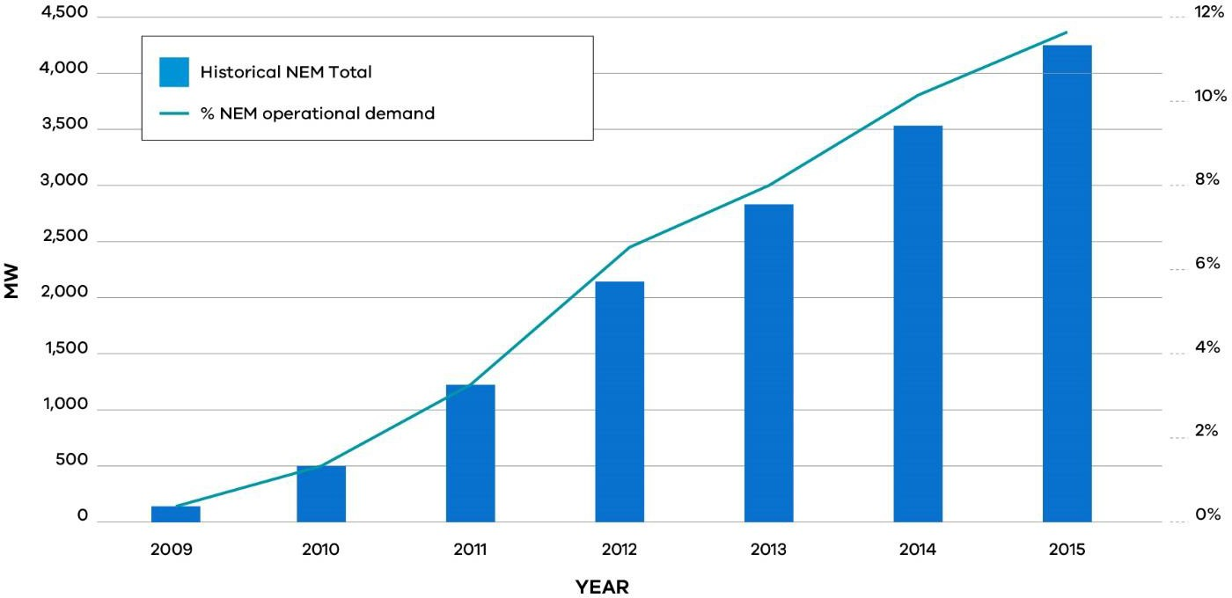

Source: Adapted from Electricity Network Economic Regulatory Framework Review, (AEMC 2017a, p.74)

Storage of energy allows system flexibility and can be utilised to enhance system reliability. Energy storage comes in many forms, including battery technologies that convert chemical energy into electrical energy, thermal storage, hydrogen fuels and pumped hydro that can be used at residential, commercial and grid scale. Batteries can contain a variety of chemicals including lead- acid, nickel metal hydride or lithium ion. Lithium ion batteries are also being used in electric vehicles (CSIRO, 2015).

While less than 200MW capacity of battery storage is currently installed in Australia, its uptake is expected to increase rapidly in the future as costs decrease.

Figure 24: Projected installations of on-site battery storage by state

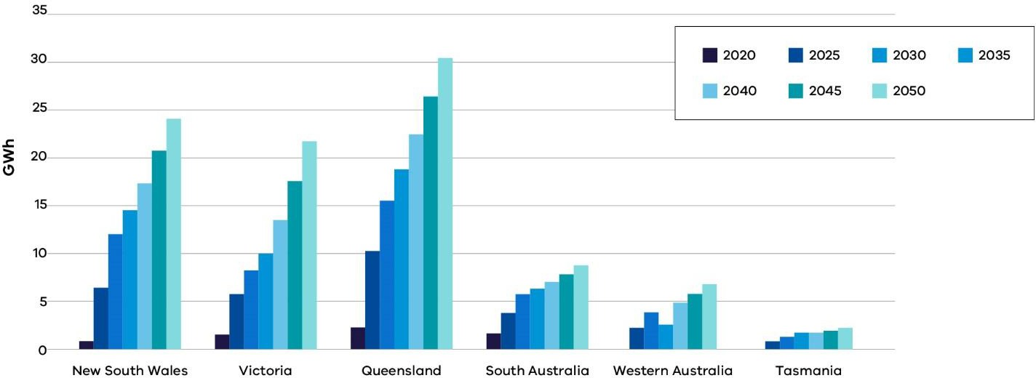

Source: Adapted from Electricity Network Transformation Roadmap (ENA & CSIRO, 2017, p. 102)

In addition to being utilised by individual customers, solar photovoltaics coupled with battery storage can be utilised by a group of customers forming their own microgrid and can be grid- connected or independent from the main electricity network.

The benefits of distributed energy resources and storage
Battery storage has many potential benefits. When deployed at scale and in a coordinated manner, battery storage can play a significant role in improving grid stability. Large-scale battery storage will have an increasing role in better integrating renewable energy generation and improving system reliability. The Victorian Government has committed to build two 20 MW battery storage facilities in western Victoria by the end of 2018 to help improve grid reliability.

Battery storage can also be utilised as an alternative option to grid augmentation or to the replacement of single wire earth return (SWER) lines. SWER lines are typically used in rural areas in Victoria and operate using the ground as a return path for electrical current. The Victorian Bushfires Royal Commission’s Recommendation 27 recommended that the State amend the Regulations under the Electricity Safety Act 1998 to progressively replace all bare-wire SWER and 22 kilovolt powerlines with new technologies to reduce bushfire risk (Victorian Bushfires Royal Commission, 2010). In cases where grid augmentation is required or where SWER lines need to be replaced, battery storage could be a safer, cheaper option.

The challenges of distributed energy resources and battery storage
Consumers need to be educated regarding the installation and operation of these new technologies.

Emergency services, including fire-fighting services, need good information to deal with fire when battery storage is present. At the same time, they need to be engaged in the development of standards for these emerging technologies (Advisian, 2016b).

There have already been cases of linesmen experiencing electric shocks due to energisation of the grid from residential based solar PV systems (Advisian, 2016b). The dangers of solar photovoltaics during bushfires were highlighted in the December 2015 Wye River–Jamieson Track fire, in which live cables attached to domestic solar power units remained a threat to emergency services even though the power had been cut to the area. ESV subsequently published an information sheet titled Working safely around electricity and alternative power sources, which provides emergency service workers with information on how to safely work around distributed generation including solar photovoltaics and battery storage technologies (Energy Safe Victoria, 2016).

Batteries have a characteristic voltage range in which the desired chemical reactions occur. Working outside these ranges (i.e. overcharging/discharging) results in unwanted chemical changes and a reduced lifetime. For some technologies, such as lithium ion, these unwanted reactions can cause a fire or explosion if the limits are not strictly adhered to (CSIRO, 2015).

As penetration rates of distributed energy and energy storage increase, the aggregate impact on distribution networks and the potential safety implications affecting energy consumers and workers may also increase. Significant reverse power flow in the distribution grid could potentially impact on existing protection and voltage control schemes (CSIRO, 2015).

United Energy in its submission to the review, has outlined the impacts that the increasing deployment of solar and battery storage can have on the network:

“The increasing penetration of customers’ PV and battery storage technologies presents an opportunity and a challenge for the operation of the network. DNSPs (Distribution Network Service Providers) need to manage reverse energy flow, supply quality, protection coordination, and stability of networks that were originally designed for one way energy flow from a remote power station.” (United Energy, 2017, p. 14)

AusNet Services has noted the positive contribution new technologies can make to the network if their integration is well-managed:

“If the integration is managed well, these new technologies can contribute positively to system reliability and security without compromising safety. The crucial component in maximising the community benefits will be getting the network integration right.” (AusNet Services, 2017a, p. 14)

The Independent Review into the Future Security of the National Electricity Market noted the importance of a good framework for proof of concept testing of new technologies and their integration into the market (Finkel, 2017). Under the Commonwealth’s Australian Renewable Energy Agency Act 2011, the Australian Renewable Energy Agency (ARENA) is required to promote the sharing of information and knowledge about renewable energy technologies where appropriate. Distributed energy resource and energy storage pilot demonstration projects funded by ARENA or the Clean Energy Finance Corporation can play an important role in facilitating the sharing of learning obtained through these demonstration projects. The identification of any regulatory barriers, requirement for network related standards or learning on performance, reliability and safety can be shared to the benefit of all energy market participants.

The importance of design and installation standards
Submissions to the Review have highlighted the need for effective regulation and installation standards for distributed energy and storage. The establishment of safety standards and guidelines are required to provide greater consistency in installation practices and manage the potential risks associated with distributed energy resources and battery technologies.

The National Electrical and Communications Association (NECA) has highlighted the need for regulations and training to keep pace with the changing market trends, drawing attention to the danger of batteries being installed in rural areas causing a fire if they are not installed correctly:

“We are concerned the regulations and training concerned with these are lagging the market and people are making best effort … Rural property owners face the tyranny of long distances and are seeking a more affordable solution and are turning to renewables as a potential solution. We are concerned much of this installation work is being done under the auspice of the handyman as it is considered low voltage. Without the correct installation method these microgeneration plants (solar and battery) could be a source of danger to the people and further to the community in the event the installation initiates a fire situation.” (NECA, 2017, p. 1)

Advisian noted in its report that the absence of storage design and installation standards has led to differing design and installation practices presenting a potential risk to safety:

“…there is now also a significant diversity of construction and design practices, product quality and installation quality in the industry. This variation will be a potential source of risk to personnel and property health and safety until a more mature industry emerges.” (Advisian, 2016a, p. 9)

While there is currently no existing Australian standard setting the rules and guidelines for battery storage in Australia, Standards Australia has been drafting a new Australian Standard 5139:201 Electrical installations – safety of battery systems for use with power conversion equipment, to enable the safe installation of battery energy storage systems.

Standards Australia released the draft standard for public consultation in June this year. Submissions closed in August 2017 and over 3000 comments were received, many raising public policy issues related to public safety, clean energy and minimum residential construction requirements. Standards Australia has stated that given the significant response to the draft standard, along with the fact that this is a new building technology with limited existing direction from governments, its technical committee is not the appropriate forum to resolve the public policy tensions raised. It has offered to bring key stakeholders together to establish a framework through which these public policy tensions can be addressed (Standards Australia, 2017).

The Clean Energy Council (CEC) accredits designers and installers of solar PV systems and battery storage systems to ensure systems meet industry best practice. The CEC advocates for reforms to protect the safety of consumers with battery storage systems including that state government safety regulators should require that all battery installations must be performed by a qualified installer with demonstrated competency in battery installation, such as those accredited for battery installation under the CEC’s accreditation scheme (Clean Energy Council, 2017).

Gas networks
The initial structure of the gas networks were based on transporting gas directly from production facilities located in Gippsland to Victorian based consumers via continuous pipelines. However, the increase in connectivity through fixed pipelines, two-way flow of gas between states and the deployment of embedded gas networks, can have impacts on the network for which the safety framework must be able to accommodate.

The regulatory framework must be able to adapt to changes in the mix and type of gas supplied and the way gas products are delivered to consumers.

Among other things, the Regional Gas Infrastructure Program will supply reticulated natural gas to eleven regional towns in Victoria via a compressed natural gas delivery system, which involves compressing natural gas in compressor stations in regional and metro locations, trucking the compressed gas to the outskirts of each town where the gas is stored, depressurised and in turn reticulated via pipes to homes and businesses within each town (Regional Development Victoria, 2017).

Australian Gas Networks in its submission to the Review, has identified the need for the safety framework to adapt to the change in the way energy products are delivered:

“An emerging trend that the regulatory framework may need to consider are changes in the way energy products are delivered to consumer groups, for example larger

embedded networks and associated participants offering a new range of services for such networks.” (Australian Gas Networks, 2017, p. 6)

AusNet Services has noted that businesses are already acting in this space:

“As governments move toward fulfilling their global carbon emissions reduction obligations and consumer demand habits evolve, gas networks will look to innovate and adapt; some gas distribution businesses are already in this space.” (AusNet Services, 2017b, p. 5)

In the future, gas suppliers may incorporate new technologies such as the blending of renewable gases including bio-methane and hydrogen with natural gas into the existing natural gas distribution network. Existing gas infrastructure can tolerate a percentage of hydrogen content without requiring pipeline upgrades, therefore small amounts of hydrogen could be injected into the natural gas distribution network (Finkel, 2017).

ActewAGL, an electricity and gas retailer and distributer based in the Canberra, is working with the Australian National University on a research initiative producing hydrogen from renewable energy that can be injected into the Australian Capital Territory gas distribution system (Energy Networks Australia, 2017b). A business case for a pilot scheme is being developed. Jemena is also working on a trial to demonstrate how excess renewable energy can be converted to hydrogen to be stored in gas pipelines.

Australian Gas Networks will soon inject hydrogen into its gas network in Adelaide backed by a $5 million grant from ARENA.

The potential safety impacts of blending renewable gas into distribution networks will need to be considered by ESV to ensure there are no adverse impacts on safety.

AusNet Services in its submission to the Review has highlighted the importance of good collaboration between regulators, industry and other stakeholders to ensure the safety and integrity of gas network infrastructure is maintained:

“Trials of the introduction of gases other than methane into distribution networks will require collaboration between network businesses, regulators and stakeholders in developing common understandings of the drivers and consequences to ensure the safety and integrity of gas network infrastructure and installations are maintained.” (AusNet Services, 2017b, p. 5)

Information and communications technology (ICT)
Integrated communications and interoperability will be fundamental to the performance of the electricity grid of the future. The Energy Networks Australia and CSIRO (2017) Electricity Network Transformation Roadmap has identified key gaps in standards required to enable the future requirements of the electricity system. These include areas such as system interoperability, communications systems, data protocols and cyber security. The roadmap supports a significant enhancement of monitoring and control functionality to provide for the robust connection of distributed energy resources and an enhanced level of communication and data exchange on distribution substations and on the low voltage network.

Increasing connectivity and integration of ICT can make networks more vulnerable to the risk of cyber-attacks. While the NEM has not suffered a successful cyber-attack, there is growing concern about the cyber security of Australia’s critical infrastructure (Finkel, 2017). In 2014, CERT Australia issued a warning that some malicious cyber activity was specifically targeting organisations in the energy sector (Australian Cyber Security Centre, 2015).

Box 23: CERT Australia

CERT Australia provides advice and support on cyber threats and vulnerabilities to the owners and operators of Australia’s critical infrastructure and provides businesses with strategies to mitigate cyber security incidents (CERT Australia, 2017). CERT Australia is part of the Federal Attorney-General’s Department and is a key element in the Australian Cyber Security Centre, sharing information and working closely with the Australian Security Intelligence Organisation, the Australian Federal Police, the Australian Signals Directorate, the Defence Intelligence Organisation and the Australian Criminal Intelligence Commission (Australian Signals Directorate, 2017).

The Finkel review noted the threat posed by cyber-attacks and recommended an annual report be developed by a newly formed Energy Security Board, in consultation with the Australian Cyber Security Centre and the Secretary of the Commonwealth Department of the Environment and Energy (Finkel, 2017). The report would include:

- an assessment of the cyber maturity of energy market participants;

- an assessment of the Australian Energy Market Operator’s (AEMO) cyber security capabilities;

- a stocktake of current regulatory procedures to ensure they are sufficient to deal with any potential cyber incidents in the NEM;

- an update from energy market participants on how they undertake testing and assessment of cyber security awareness and detection, and requirements for employee training.

The Electricity Network Transformation Roadmap noted that cyber security strategies will be essential to mitigate the risks of damage as a result of cyber-attacks (CSIRO & Energy Networks Australia, 2017).

The changing way services are provided
In addition to the emergence of new technologies, the way services are provided to consumers is changing rapidly, allowing new entrants to enter the market offering a new range of electricity and gas services to consumers. The Australian Energy Market Commission (AEMC) Power of Choice reforms are designed to encourage this transition by encouraging competition in the market and promoting contestable arrangements for services, such as metering and distributed energy resources (AEMC, 2012). Consistent regulation and standards must apply to all service providers to ensure safety is a priority for all businesses.

In its submission to the review, CitiPower and Powercor Australia highlighted the necessity for the same level of safety regulation to apply to all network service providers:

“Contestable services such as the installation and operation of distributed energy resources and metering services have serious electrical safety risks, particularly through their interaction with the distribution network. It is important that the same level of safety regulation applied to NSPs is also applied to contestable service providers.
The policy objective should be to achieve a certain level of safety outcomes irrespective of the party providing the service.” (CitiPower & Powercor Australia, 2017, p. 18)

As discussed earlier in this chapter, ESV must be proactive to ensure that safety regulations and standards apply to all network operators and service providers. This includes third party operators and microgrids owned by private networks, particularly in regard to electricity safety management, electric line clearance and bushfire mitigation (Advisian, 2016b).

Energy system security and reliability
Interruptions to the supply of energy have a direct impact on the safety and wellbeing of the community. The System Security Market Frameworks Review was initiated by the AEMC in July 2016 to consider changes to the regulatory frameworks to support security and reliability in the current shift towards new forms of generation in the National Electricity Market (NEM) (AEMC, 2017b).

Figure 25: Components of system security and reliability

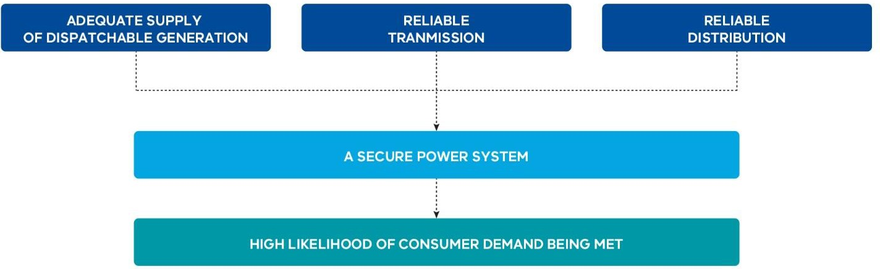

Source: Adapted from System Security Market Frameworks Review: Interim Report (AEMC, 2016b, p. 10)

The Finkel review acknowledged the transition that Australia’s energy market is currently undergoing, making recommended enhancements to the NEM to optimise security and reliability: the review recognised that whilst this transition presents significant opportunities, there are also challenges presented by new and emerging generation technologies connecting to a system not designed for them:

“The deployment of new technologies and improved integration of variable renewable electricity generators needs to be supported by better data, early testing of technology, cyber threat awareness and workforce preparedness.” (Finkel, 2017, p. 5)

The Finkel review also recognised the need for government and industry to strengthen their capabilities to understand the emerging risks and ensure appropriate risk management strategies are in place:

“… emerging risks may not be as predictable or as amenable to traditional risk management strategies. It is crucial for governments, energy market bodies and the electricity industry to enhance their engineering, technical and ICT capabilities. In addition, ensuring appropriate risk management strategies are in place will improve the resilience of the NEM.” (Finkel, 2017, p. 50)

ESV has recognised the importance of applying its capabilities to monitor and analyse the emerging trends occurring in the network to ensure network safety, functional performance and supply security is maintained, noting in its Corporate Plan 2017–2020:

“ESV will need to monitor the technical and risk management [strategies] of energy networks, and apply its technical capability and resources with respect to network functional performance and supply security.” (ESV, 2017, p. 13)

Electric vehicles
A significant increase in the uptake of electric vehicles could have a significant impact on electricity demand profiles in Victoria. To avoid detrimental effects on the electricity grid, re-charging would need to be managed carefully to ensure vehicles were not all charged at the same time. Managed properly, electric vehicles could benefit the grid by acting as energy storage to aid grid security and reliability. A coordinated plan of action would be required to facilitate this. Safety standards will be required, particularly in relation to the safety of batteries while driving and when charging.

Figure 26: Projected share of electric vehicles in light vehicle road transport

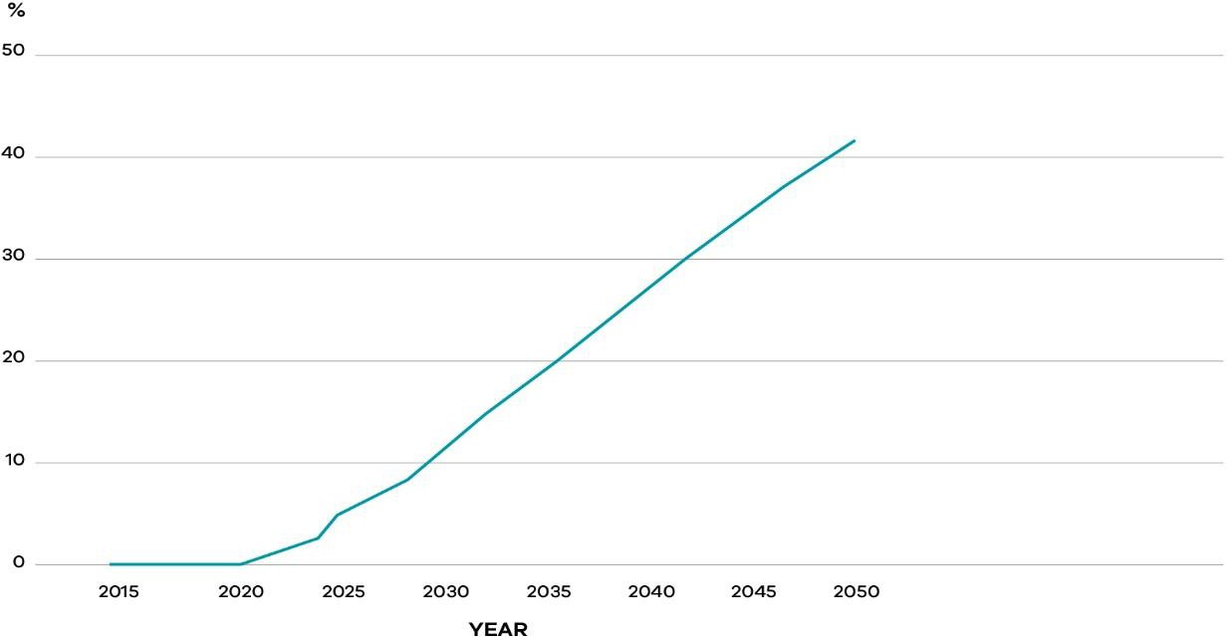

Source: Adapted from Electricity Network Transformation Roadmap (ENA & CSIRO, 2017, p. 33)

Strengthening the safety framework to regulate the networks of the future
As noted earlier, network operators need to manage challenges arising from bi-directional electricity flows, voltage fluctuations, frequency changes and any potential impacts on supply quality and stability on networks traditionally designed for one way energy flows and, large, stable energy generation sources.

Advanced network planning and active management of the energy network is required, aided by greater levels of monitoring. Visibility of network data and an understanding of consumer behaviour is essential.

ESV already plays a key role in facilitating discussions with industry and the Victorian Government to ensure the safety of consumers is protected.

As the sector evolves rapidly and new technologies and trends emerge, the need for the regulator to ensure the safety framework can effectively regulate the networks of the future becomes more paramount. ESV has provided leadership in the development of a new standard for the installation of battery storage systems for use with solar installations. As the technical energy safety regulator, it is well-positioned to educate the Victorian public about emerging safety risks and to lead the industry and other regulators in embracing the reforms required to effectively regulate the energy networks of the future.

Looking ahead, the pace of change is not likely to diminish. To assist ESV to develop effective regulatory responses to the emerging challenges, it would be beneficial for it to establish more formal and enduring consultative and advisory mechanisms. Among other things, the establishment of an advisory committee under Section 8 of the Energy Safe Victoria Act 2005 would formalise and strengthen ESV’s ongoing engagement. The committee should consist of members with relevant experience and expertise in energy networks and an understanding of the future challenges arising from a changing energy sector. Representatives from government and other relevant stakeholders should also participate.

Recommendation 32
ESV should establish an expert advisory committee under Section 8 of the Energy Safe Victoria Act 2005 to advise on emerging trends in electricity and gas networks and possible changes to regulatory settings that might be considered necessary to manage new sources of safety risk.

The development of a roadmap that clearly sets out what actions ESV needs to undertake to effectively respond to the emergence of new networks and the introduction of new technologies, would assist ESV to be ready to meet the challenges. Regular reporting would also assist in informing stakeholders, including potential new entrants to the energy market, about emerging issues and the regulatory responses that may be required.

Recommendation 33
ESV should develop a roadmap of emerging issues and proposed actions to ensure the safety risks arising from new technologies and network structures are identified early and managed effectively. Progress against the roadmap should be reported annually in ESV’s Annual Report and network safety performance reports.

Leading the engagement with other jurisdictional regulators on emerging technologies and trends
New types of energy technologies may be subject to overlapping jurisdictions and differing regulatory oversight requiring engagement and coordinated thinking from a range of regulators and industry participants.

ESV acknowledges the need for inter-agency and cross-jurisdictional engagement in regulating new technologies in its Corporate Plan 2017-2020:

“New forms of large-scale renewables with novel technology (e.g. solar collectors, battery storage farms) may be subject to overlapping jurisdictions and differing regulatory oversight. It may be that no single government agency will have an ‘end to end’ view of safety across the entire energy supply chain, requiring the establishment and execution of inter-agency regulatory strategies.” (ESV, 2017, p. 13)

ESV chairs the Electrical Regulatory Authorities Council (ERAC) which comprises representatives of the regulatory authorities responsible for electrical safety, supply and energy efficiency in New Zealand and the Australian states, territories and the Commonwealth. ERAC meets twice a year and corresponds both internally and with industry on regulatory issues related to electrical safety. ERAC coordinates the electrical regulatory strategies, policies and ongoing reform activities including:

- legislation and regulations;
- general safety promotion and accident prevention;
- safety of electrical installations and electricity generation and supply; and
- licensing of electrical workers and safety and energy efficiency of electrical equipment (ERAC, 2017).

ESV also chairs the Gas Technical Regulators Committee (GTRC), which is an association of government agencies responsible for gas safety and supply with representatives from each state and territory in Australia and New Zealand (GTRC, 2017).

Consistent with the national leadership role that ESV has traditionally played, it would be well placed to lead national responses to emerging technologies through ERAC and GTRC. This would, however, require expanding the focus of both committees to give greater emphasis to network regulatory issues.

References
Advisian, 2016a. Potential Impacts of New Energy: Stage 1 Report- The New Energy Landscape, Melbourne. Advisian, 2016b. Potential Impacts of New Energy: Stage 2 Report- Electricity Network Safety Issues, Melbourne. AEMC, 2012. Power of choice review - giving consumers, Final Report, Sydney.
AEMC, 2016a. Electricity Network Economic Regulatory Framework Review: Approach Paper. AEMC, 2016b. System Security Market Frameworks Review: Interim Report.
AEMC, 2017a. Electricity Network Economic Regulatory Framework Review, 2017 Report , Sydney. AEMC, 2017b. System Security Market Frameworks Review: Final Report.
AEMO, 2017. Gas Statement of Opportunities: For Eastern and South-Eastern Australia. Austalian Gas Networks 2017. Review of Victoria's Gas Network Safety Framework.
APA VTS, 2017. Review of Victoria's Electricity and Gas Network Safety Framework - Supplementary Issues Paper: APA VTS Operations (Australia) Pty Ltd Submission.
AusNet Services, 2017a. Safety Review Submission. AusNet Services, 2017b. Safety Review Submission - Gas.
Australian Cyber Security Centre, 2015. ACSC 2015 Threat Report.
Australian Signals Directorate, 2017. Strategies to Mitigate Cyber Security Incidents: A New Cyber Security Baseline.
[Online] Available at: https://www.asd.gov.au/infosec/mitigationstrategies.htm [Accessed 28 August 2017].
CERT Australia, 2017. Advice: CERT Australia. [Online] Available at: https://www.cert.gov.au/advice [Accessed 28 August 2017].
CitiPower & Powercor Australia, 2017. Additional Information to Support the Review of Victoria’s Electricity Network Safety Framework.
Clean Energy Council, 2017. Charging Forward: Policy and Regulatory Reforms to Unlock the Potential of Energy Storage in Australia.
CSIRO, 2015. Electrical Energy Storage: Technology Overview and Applications.
CSIRO & Energy Networks Australia, 2017. Electricity Network Transformation Roadmap: Final Report.
Energy Networks Australia, 2017a. Gas Vision 2050: Reliable, Secure Energy and Cost-Effective Carbon Reduction. Energy Networks Australia, 2017b. Media Release: Gas industry to capture carbon-free fuels.
Energy Safe Victoria, 2016. Working safely around electricity and alternative power sources: Information for emergency services, Melbourne.
ERAC, 2017. ERAC- What is ERAC?. [Online] Available at: http://www.erac.gov.au/index.php?option=com_content&view=article&id=68&Itemid=472 [Accessed 5 September 2017].
ESV, 2017. Energy Safe Victoria Corporate Plan 2017-2020.
Finkel, A., 2017. Independent Review into the Future Security of the National Electricity Market.
GTRC, 2017. National Database of Certified Gas Appliances and Components. [Online] Available at: http://www.gtrc.gov.au/ [Accessed 05 September 2017].
Minister for Energy, Environment & Climate Change, 2017. Australia’s Largest Battery To Be Built In Victoria. [Online] Available at: http://www.premier.vic.gov.au/australias-largest-battery-to-be-built-in-victoria/
Minister for Energy, Environment and Climate Change, 2016. Energy Safe Victoria- Reissue of Statement of Expectations 2016. [Online] Available at: http://www.esv.vic.gov.au/wp-content/uploads/2017/03/Ministers-statement-of- expectations-1-July-2016.pdf [Accessed 05 October 2017].
Multinet Gas, 2017. Review of Victoria’s Gas Network Safety Framework: Issues for Consideration. NECA, 2017. NECA submission to the Safety Review.
Regional Development Victoria, 2017. Regional Gas Infrastructure program. [Online] Available at: http://www.rdv.vic.gov.au/regional-projects/regional-gas-infrastructure#CNG [Accessed 28 August 2017].
Standards Australia, 2017. Media Release: Consultation commences on new draft standard for On-Site Battery Systems.United Energy, 2017. United Energy Submission on Review of Victoria’s Electricity Network Safety Framework.Victorian Bushfires Royal Commission, 2010. Final Report.

Chapter 9: Strengthening the Foundations for Future Network Safety Regulation

Summary
The integrated package of measures presented by the Review would place Victoria at the very forefront of the safety regulation of electricity and gas networks internationally.

A single consolidated law that supports risk-based regulation would strengthen the foundations for effective network safety regulation.

The Gas Safety Act 1997, Electricity Safety Act 1998, the safety provisions of the Pipelines Act 2005 and the Energy Safe Victoria Act 2005 should be consolidated under a new energy safety Act (Recommendation 34).

The development of a new consolidated energy safety Act would:

- facilitate consistency in the broad regulatory approach across electricity and gas sectors, including general safety duties;
- promote clarity around objectives and functions;
- provide for the more effective implementation of safety case based regulation;
- promote greater consistency in Energy Safe Victoria’s (ESV) regulatory approach; and
- provide ESV with a broader range of regulatory tools.

The foundations of the safety case based approach should be supported by further development of guidance from ESV to assist network businesses to efficiently comply with their obligations (Recommendation 42).

ESV should work closely with regulated network businesses as it continues to strengthen its approach to safety case based regulation. Effective safety cases must be underpinned by rigorous underlying systems, procedures and processes adopted by network business.

If safety cases are to form an effective basis for robust regulation, it is essential that the legislation supports the safety case framework so that the regulator can use it confidently and efficiently to protect safety – including through legal prosecution if necessary.

The longer-term aspiration should be to increase the emphasis on outcomes-based approaches to safety regulation governed by strong safety cases, and with less emphasis on statutory prescription. This shift should only occur when deep confidence has been built in safety case based systems and ESV’s regulation.

The onus is on network businesses and ESV collectively to build this confidence. This will require sustained high performance over several years.

The current framework – separate safety legislation based on sector
The safety of the electricity and gas sectors in Victoria is regulated under three separate pieces of primary legislation – the Gas Safety Act 1997, Electricity Safety Act 1998 and the Pipelines Act 2005.

Following privatisation of the networks, the 2004 review of Victoria’s energy safety regulators recommended a merger of the Office of the Chief Electrical Inspector and the Office of Gas Safety to establish a single, integrated electricity and gas safety regulator. However, the three Acts remained separate. While there have been amendments to align the legislation over time, unnecessary inconsistencies in their application and interpretation remain.

A maturing safety case regime
As discussed in Part C: Leading Practice and Network Safety Regulation, an outcomes-based approach to regulating network safety is common to the three Acts. Network businesses are required to identify hazards, assess risk, and identify controls and management systems, demonstrating how they will meet their safety duties and any other prescribed matters. The businesses must document and submit these plans to ESV.

Once formally accepted by ESV, businesses must comply with these documents. The legislation provides for major five yearly revisions.

Although this approach is applied in both the gas and electricity sectors, there are some differences. For the gas sector, ‘Safety Cases’ were mandated from 1997 and the current round of submissions represent the fourth revision cycle.

For the electricity sector, from the introduction of the Electricity Safety Act 1998, companies could apply for exemptions from prescriptive regulations if they elected to have a voluntary Electricity Safety Management Scheme. The electricity distribution businesses made use of this option, each developing voluntary Electricity Safety Management Schemes which were approved by the Governor in Council in 2003 (AusNet Services, 2017c). From December 2009 Electricity Safety Management Schemes became mandatory for major electricity companies. ESV is currently partway through the second cycle of Electricity Safety Management Scheme (and Safety Case) acceptance processes since they became compulsory.

ESV has continued to learn and adapt its approach as the regime has developed. In recent years, it has required the demonstration of safety obligations by businesses to be of a higher standard. The two reviews that ESV commissioned by the consulting firm Advisian, both included findings and recommendations in relation to ESV’s approach to safety case based regulation. These are summarised in Box 24. Leading up to, and following, these reviews ESV has implemented reforms to lift its regulatory performance, discussed further below.

Box 24: Summary of Advisian findings and recommendations on ESV’s approach to safety case based regulation.

In 2015, ESV engaged Advisian for advice, including on good practices that could be adopted in Electricity Safety Management Scheme assessments. Advisian made recommendations, including that ESV:

- Establish a sufficiently detailed requirement to guide businesses in making a convincing safety case when requesting Electricity Safety Management Scheme reacceptance. Advisian found that ESV had not required businesses to provide a clear and structured argument.

- Develop internal guidance on approval requirements and performance/competency standards for renewals, providing clarity on matters including safety case demonstration requirements and risk-based asset management approaches that represent acceptable compliance with safety legislation.

- Formalise team decision making practices for Electricity Safety Management Scheme acceptances and enforcement decisions. (Advisian, 2015)

In 2016, ESV engaged Advisian to further assess factors influencing gas Safety Case and pipeline Safety Management Plan production and acceptance cycles. Advisian found that requirements for Safety Cases and Safety Management Plans were not understood due to a range of factors including:

- ESV’s expectations, expert knowledge and policy interpretation to evaluate Safety Cases and Safety Management Plans were not documented within ESV nor publicly;

- strategic safety priorities or objectives were not widely known;

- feedback was usually directly verbal with individuals from companies; and

- the Safety Case and Safety Management Plan evaluation process was not structured, relying on a small group of specialists and with limited governance and quality assurance.

Advisian recommended ESV develop revised guidance materials including industry safety priorities and safety case requirements, and provide these to industry before starting Safety Case and Safety Management Plan development. Other recommendations included:

- documenting formal evaluation methods and a structured approach to developing and providing feedback;

- guidance on what “triggers” a notification of Safety Case changes to ESV; and

- establishing procedures that ensure evaluation outputs (for example risk assessments and safety priorities) directly inform ongoing surveillance activities after a Safety Case has been accepted. (Advisian, 2016)

Consolidating legislation
The Review proposes that the safety legislation applying to electricity and gas safety in Victoria should be consolidated in a single Act.

The current legislative framework is fragmented and could be better structured to support strong safety case based regulation. The current multiple Acts have evolved separately; have undergone ad hoc amendments over time; are duplicative in parts; and also contain unnecessary differences.

The benefits of a single consolidated Act would include:

- promoting greater consistency in regulatory approach, supporting ESV’s recent internal governance changes to reduce siloed operational areas;

- providing a more consistent framework for businesses operating in both sectors;

- providing greater clarity of obligations for gas network businesses with obligations under both the Pipelines Act 2005 and the Gas Safety Act 1997;

- facilitating better communication of Victoria’s energy network safety regulation as a complete package; and

- assisting with ongoing consistency when future legislative or regulatory amendments are made.

The Energy Safe Victoria Act 2005 could also be incorporated into the consolidated Act as ESV would be the sole responsible regulator.¹⁴

The consolidated legislation would involve incorporating all other areas of energy safety currently provided for separately under the three Acts, for example, appliances and conveyed substances other than natural gas.

The Pipelines Act 2005 would retain the planning and environment provisions administered by the Department of Environment, Land, Water and Planning (DELWP). This would include the provisions relating to licensing and environment management plans.

Recommendation 34

All energy safety legislation should be consolidated in a single new energy safety Act, replacing the Gas Safety Act 1997, Electricity Safety Act 1998, those elements of the Pipelines Act 2005 that relate to safety, and the Energy Safe Victoria Act 2005.

14 Other legislation that houses provisions establishing the relevant authority within the operational legislation, rather than separately, includes the Offshore Petroleum and Greenhouse Gas Storage Act 2006 (Cth) and the Building Act 1993 (Vic).

Consistent application of general duties
There are inconsistencies across the existing Acts and regulations in relation to the general duties underpinning the regulatory regime. This includes provisions that specify how businesses must minimise risks as far as reasonably practicable in order to satisfy their general safety duties. These inconsistencies extend to the Australian Standards and other legislation businesses have duties under, as noted by United Energy in its submission:

“Some conflicting requirements of the various legislation should be addressed. The OHS Act refers to SFAIRP ‘so far as is reasonably practicable’, the ESA refers to MAFAP ‘minimise as far as practicable’, and the Electricity Safety (Management) Regulations (AS 5577) refer to ALARP ‘as low as is reasonably practicable’.” (United Energy, 2017, p. 13)

The differences apparent in the legislation may be due to drafting based on other legislation in force at the time. Some of these differences are listed in Box 25. The Pipelines Act 2005 is more similarly worded to the current Occupational Health and Safety Act 2004. Consistency with the language used in the Occupational Health and Safety Act 2004 is preferred to the extent that there is no reason for inconsistency.

Box 25: Inconsistencies in defining the precaution-based approach

There are differences in drafting across the various safety Acts dealing with the application of the precaution-based approach to reducing risks:

- Duties under the Gas Safety Act 1997 and Electricity Safety Act 1998 require hazards and risks to safety to be minimised “as far as practicable”, whilst the Pipelines Act 2005 requires them to be minimised “as far as is reasonably practicable”.¹⁵

- The explanations of “practicable” under the Gas Safety Act 1997 and Electricity Safety Act 1998 require businesses to “remove or mitigate” the hazard or risk, whilst under the Pipelines Act 2005 they must “eliminate or reduce” the hazard or risk.

- The explanations of “practicable” are found in the definitions section of the Gas Safety Act 1997 and Electricity Safety Act 1998, but in the Pipelines Act 2005 “reasonably practicable” is defined following the general duty provision.¹⁶

- Compared to the Occupational Health and Safety Act 2004, it is less clear in the energy safety legislation that the highest level of protection that is reasonably practicable is required – specifically, that a duty holder must eliminate risk so far as is reasonably practicable, or if it is not reasonably practicable to eliminate risks, to reduce them so far

15 In the 2004 Occupational Health and Safety Act Review, Maxwell QC considered it is difficult to reconcile the term “practicable” with qualifications, and that “reasonably practicable” is therefore preferable should qualifications such as severity and cost remain.
¹⁶ In the 2004 Occupational Health and Safety Act Review, Maxwell QC recommended that qualifiers be listed where the general duty provisions are positioned in the legislation.

as is reasonably practicable (this is, however, stated in Australian Standards).¹⁷

- Under the Occupational Health and Safety Act 2004 the duties incorporate the language “so far as is” reasonably practicable, whilst the energy safety legislation uses “as far as” practicable/reasonably practicable.

It may be that the intention is to achieve the same outcomes under the Acts. However, the persistence of inconsistencies in drafting across the Acts is unlikely to help promote a common understanding of obligations.

The general duty provisions should be based around a consistent application of the principle that risks should be reduced as far as reasonably practicable. The Review considers that the definition of “reasonably practicable” and the language around it should align with the approach of the Occupational Health and Safety Act 2004. This would ensure consistency across the safety obligations of regulated businesses, whether it be in relation to their occupational health and safety obligations or their network safety obligations. It would also ensure consistency with the approach taken to the regulation of Major Hazard Facilities.

The definition in section 20(2) of the Occupational Health and Safety Act 2004 is:

“To avoid doubt, for the purposes of this Part and the regulations, regard must be had to the following matters in determining what is (or was at a particular time) reasonably practicable in relation to ensuring health and safety–

- the likelihood of the hazard or risk concerned eventuating;
- the degree of harm that would result if the hazard or risk eventuated;
- what the person concerned knows, or ought reasonably to know, about the hazard or risk and any ways of eliminating or reducing the hazard or risk;
- the availability and suitability of ways to eliminate or reduce the hazard or risk;
- the cost of eliminating or reducing the hazard or risk.”

Recommendation 35

The general safety duties within the new consolidated energy safety legislation should be based around a consistent application of the principle that risks should be reduced so far as is “reasonably practicable” aligning with the definition adopted in the Occupational Health and Safety Act 2004.

In addition, other aspects of the general duties should be reviewed and consolidated in the single new energy safety Act proposed by the Review, and the regulations amended to be consistent with

17 For example, AS 2885.1 p. 25 and AS 5577 p. 6 &18.

the language in that Act. Relevant matters that should be addressed in drafting this legislation should include:

- Removing unnecessary differences across electricity and gas sectors. The details of the duties to ensure safety are different under each Act. This includes the activities the duties apply to, whether the duties extend to the protection of property, and whether they refer to any specific causes of risk. Any differences that are not justified based on sector differences should be removed so that the provisions are better aligned.

- Ensuring sufficient specificity in safety duties. The details of the duties in the current electricity and gas safety Acts are also different to other relevant legislation, such as the Occupational Health and Safety Act 2004 (Vic), the Offshore Petroleum and Greenhouse Gas Storage Act 2006 (Cth), Rail Safety National Law and the Electrical Safety Act 2002 (Qld).

  - In practice, providing a sufficient degree of specificity is important for effective regulation. For example, the National Offshore Petroleum Safety and Environmental Management Authority (NOPSEMA) (2017) has relied upon specific duties such as “to take all reasonably practicable steps to ensure that any plant, equipment, materials and substances at the facility are safe and without risk to health” and “to take all reasonably practicable steps to implement and maintain systems of work at the facility that are safe and without risk to health”, more so than the more general safety duties under its Act or the requirement to comply with a safety case. The Occupational Health and Safety Act 2004 (Vic), and recently remade Occupational Health and Safety Regulations 2017 (Vic) which have specific duties in relation to Major Hazard Facilities, could also be used to inform revised duties for energy network safety.

- Ensuring incentive-compatible legislation. Other safety legislation applying in similar sectors does not provide for compliance with a safety case as a defence.

  - This has the potential to provide perverse incentives – particularly, a possibility that businesses could seek to pass off risk to the regulator (“the regulator has accepted the safety case, so therefore we now have our defence against legal claims for breach of duty”).

  - Robust safety legislation should be incentive-compatible – it should not provide a mechanism to effectively allow risk to be off-loaded from the businesses that are best placed to manage those risks, to the regulator.

- Ensuring accountability for safety flows to contractors and other parties. Multiple classes of duty holders are provided for in other similar legislation. This helps ensure clear accountabilities, and is particularly important given the common practice of network businesses engaging contractors.

  - The strengths of this approach, and other relevant legislation, are further discussed in Box
26. In revising the legislation, attention should be given to how safety obligations apply to both businesses and workers and to ensure these duties are non-delegable and do not shift responsibility to individuals for safety case failures.

In revising the general duty provisions, there are general principles that the Review considers should be followed. They are outlined in Recommendation 36.

Recommendation 36

The general safety duties within the new consolidated energy safety legislation should be presented clearly, with the aim that they:

- are aligned, but retain necessary sector-specific differences;
- cover a range of circumstances in energy network safety;
- do not easily become outdated and can cover emerging risks and industry changes;
- are clearly expressed as to the obligations imposed and classes of duty holders;
- are enforceable in practice;
- function effectively with safety case provisions under the Act, including enabling the regulator to take compliance and enforcement action in response to unacceptable risk; and
- remain outcomes-based allowing flexibility in compliance arrangements.

Box 26: The importance of setting out clear accountabilities in safety case based legislation

Workers should be involved in, influence and operate under the safety case, and be held to account for safety. It is recommended that the framework better supports this.

This is particularly important given the common practice of network businesses engaging contractors. Unless carefully managed, these practices can lead to gaps in control and oversight systems, and inconsistent management practices (ESV, 2017).

Other legislation imposes certain duties on entities in addition to the business, including contractors and employees. This legislation includes:

- the model national Work Health and Safety Law;
- Victorian occupational health and safety legislation;
- the National Rail Safety Law; and
- Queensland energy safety legislation.

As an example, the model Work Health and Safety Law lists duties of different parties, noting more than one person can concurrently have the same duty and a duty cannot be transferred. Contractor duties include taking reasonable care for their own safety and that their acts or omissions do not adversely affect the safety of others. They must comply, so far as they are reasonably able, with any reasonable instruction by the operator to allow the operator to comply with the law, and must cooperate with any reasonable policy or procedure relating to health or safety at the workplace that has been notified to workers. In addition, for workers at Major Hazard Facilities, there are specific duties under the model regulations. For example, workers must comply with any procedure imposed by the operator as a control measure in relation to major incidents.

Consistent ESV functions for safety case regulation
ESV’s functions under the existing safety Acts do not consistently provide for regulation of the safety case regime. The Gas Safety Act 1997 specifies regulation of the regime more so than the other safety Acts.

Under the Gas Safety Act 1997 the functions of ESV specifically relating to safety case regulation are:

- to issue guidelines in relation to the preparation of safety cases;
- monitor compliance of gas companies with accepted safety cases; and
- audit accepted safety cases to determine their adequacy and effectiveness.

Under the Electricity Safety Act 1998 ESV’s functions include encouraging and monitoring the use of Electricity Safety Management Schemes (the Act refers to “Electricity Safety Management Schemes” rather than “Safety Cases” specifically).

The Pipelines Act 2005 does not specify ESV’s functions.

Given the centrality of the safety case to network safety, it is recommended that ESV’s functions set out in consolidated energy safety legislation expressly reflect its responsibility for safety case regulation.

Consistent safety case regime
In addition to inconsistencies across the current Acts and regulations in relation to the general duties that a safety case is required for, there are differences in the terminology and components of the outcomes-based regimes. The Gas Safety Act 1997 requires a “Safety Case”, the Electricity Safety Act 1998 requires an “Electricity Safety Management Scheme”, and the Pipelines Act 2005 requires a “Safety Management Plan” (noting natural gas transmission pipeline businesses currently operate under Safety Cases deemed as Safety Management Plans). Whilst some components prescribed in regulations are expressed similarly, other elements differ. The Electricity Safety (Management) Regulations 2009 rely more heavily on an Australian Standard, AS 5577. ¹⁸

As discussed in Part C: Leading Practice and Network Safety Regulation, ESV has moved towards a more robust and broader safety case approach for its regulation of the electricity sector. For the most recent Electricity Safety Management Scheme submission cycle, ESV requested additional information to drive this change, without there being explicit provisions for a safety case in the legislation. Prior to Scheme submission, ESV requested businesses to prepare a Safety Case to

18 Currently, under the Electricity Safety (Management) Regulations 2009 content requirements for an Electricity Safety Management Scheme include details of person responsible for the network and the person responsible for the scheme, the scheme description and specification of a safety management system in accordance with AS 5577. As outlined in AS 5577, its objective is to provide nationally consistent requirements. It was developed following endorsement to develop the standard by the Intergovernmental Agreement on Energy Supply Industry Safety in 2012.

communicate risks, how each business proposed to safely manage those risks, and a reasoned argument for why the approach was considered acceptably safe.

The new energy safety Act and regulations should provide strong foundations supporting a leading practice safety case approach. Provisions across the electricity and gas sectors should be consistent where possible, noting some sector-specific requirements would remain. Relevant parts of the Acts and regulations governing safety for Major Hazard Facilities in Victoria, and offshore oil and gas nationally, could inform the approach.

As discussed above, and in Chapter 5: Promoting Workforce Engagement, workforce engagement is essential for an effective safety case regime. The requirements for this should be aligned where possible, and emphasise that businesses must have systems to support workers to operate safely, for example through supervision, consultation, information and training, including in relation to the development and implementation of the safety case itself.¹⁹

In addition, how assets are operated, maintained and replaced for long-term sustainability is a key consideration in developing a safety case. This issue is discussed in Box 27 below.

Box 27: Long-term asset integrity and effective safety cases

An important aspect of network safety is the design, monitoring and maintenance of assets to manage their integrity and sustainability, as poor practices can lead to dangerous asset failures. The South East Community Forum and Electrical Trades Union suggested in their submissions to the Review that the current framework is not operating well in the regulation of asset replacement and maintenance:

“Notwithstanding the findings of the Black Saturday Royal Commission that the majority of fatality related fires were caused by electricity assets that were aged to at or beyond their engineering life, that has not been effectively identified or rectified during inspections, there is still no oversight or regulation of the age or condition of the assets or requirements for inspection quality or frequency.” (Electrical Trades Union, 2017, p. 6)

“Prescription-based asset management could be used at a point in time, to facilitate asset replacement. For example, a threshold could be triggered in relation to an asset, leading to its replacement… We believe there should be a prescription- based (common-sense) approach to asset replacement and maintenance in this regard. Such an approach can complement the existing risk framework and could decrease the number of actual failures, resulting in a stronger network, with greater security and availability.” (South East Community Forum, 2017, p. 11)

ESV has noted a need for increased focus in this area in its Corporate Plan 2017–2020:

19 See, for example, section 35 of the Occupational Health and Safety Act 2004 and regulations 388 and 389 of the Occupational Health and Safety Regulations 2017.

“Further investment is necessary to test and challenge the major electricity companies’ asset and risk management practices as infrastructure ages and climatic conditions change. ESV will deploy people with specific expertise and experience to challenge the safety and sustainability of risk and asset management practices.” (ESV, 2017, p. 7)

An increased focus on asset management should assist ESV when assessing and auditing safety cases, to ensure businesses are adequately addressing long-term safety. In addition, (and as discussed in Chapter 4: Integrating Safety Regulation with Economic Regulation), it should be clear in looking at objectives, functions and safety duties in legislation that the long-term integrity and sustainability of assets is clearly part of the safety case regime and ESV’s regulatory remit.

Recommendation 37

The consolidated energy safety legislation should provide consistent foundations for the safety case regime in the regulation of electricity and gas network safety. The legislation should make it clear that safety case based regulation must be supported by detailed systems and prescribed standards applied within network businesses. It should also be clear from ESV’s objectives, functions, and business’ safety duties that long-term asset integrity and sustainability are encompassed within the safety case regime and ESV’s regulatory remit.

Other improvements
In preparing consolidated legislation, consideration should be given to any areas where existing requirements could be streamlined or made to operate more effectively. This includes simplifying the legislation and reducing administrative burden where appropriate, for example, integrating the Code of Practice for Electric Line Clearance into the Electricity Safety (Electric Line Clearance) Regulations 2015 rather than it existing as schedules, and setting the expiry period for the regulations to ten years rather than five.

Another measure that may increase efficiency is sequencing the expiry of relevant regulations to occur in advance of Electricity Distribution Price Reviews and Gas Access Arrangement Reviews. This would allow businesses to take into account any changes to regulations, reducing the need for additional applications between review cycles. The misalignment was identified as problematic by CitiPower and Powercor Australia in its submission (CitiPower & Powercor Australia, 2017).

The establishment of ESV as a commission (recommended in Chapter 1: ESV’s Regulatory and Corporate Governance) should also allow the assignment of full accountability for administering the civil penalties scheme to ESV. Under the current legislation both ESV and the Minister, presumably supported by advice from DELWP, may commence proceedings and apply for orders. This has the potential to blur regulatory accountabilities.

Decisions to allow exemptions from the provisions that may attract civil penalties, however, raise broader policy judgements and it is appropriate that they should continue to be subject to consideration by the responsible Minister to recommend an exemption to the Governor in Council.

Recommendation 38

In developing new consolidated energy safety legislation, consideration should be given to improving the structure and operation of regulations under the Act, including, for example, integrating the Code of Practice for Electric Line Clearance into the Electricity Safety (Electric Line Clearance) Regulations 2015 and setting the expiry period to ten years rather than five.

Recommendation 39

The full responsibility for administering the civil penalty provisions applying to electricity network businesses should be assigned to ESV when it is established as a commission under the new consolidated safety legislation. Any decision to exempt a business from the application of the requirements subject to civil penalties should remain with the responsible Minister.

Safety case submission, acceptance and revision
Effective safety case implementation requires ongoing consideration of whether any changes may be required. For example, new risks may emerge or better ways of managing existing risks may become available. Ensuring that safety cases are treated as “living documents” and remain under review is particularly important for gas and electricity networks, given the evolution of networks over time and the growth in emerging technologies.

Under the Electricity Safety Act 1998 and the Gas Safety Act 1997, the framework requires safety cases to be submitted every five years from the latest submission/revision. In addition, a network business must submit a revised safety case at any time if ESV requests it. It must also do so under certain defined circumstances, including a change to the network that increases risk, and a significant change to the safety case. ESV can accept, provisionally accept for a given period, or not accept a submitted safety case.

The Advisian report commissioned by the Director of Energy Safety in 2016, Review of the ESV (GISD) Safety Case/Safety Management Plan Evaluation Approach, recommended that ESV provide guidance on what would trigger a business to notify ESV of changes:

“Provide explicit guidance on what ‘triggers’ a notification of SC/SMP [Safety Case/ Safety Management Plan] changes to ESV, so that ESV is more aware of evolving changes in facility safety practices, can educate/communicate regulatory policy and interpretations of compliance, and direct either revision or updating of the SC/SMP.” (Advisian, 2016, p. 9)

The implementation of this approach would help ensure ESV has appropriate oversight, and provide regulated business with greater guidance. In developing such guidance, ESV could consider WorkSafe Victoria’s Revision of a Safety Case for a Major Hazard Facility guidance (WorkSafe Victoria, 2011).

Under the Electricity Safety Act 1998 and the Gas Safety Act 1997 ESV can request a safety case be revised by a specified date. ESV may find a safety case to be deficient, for example, through audits and inspections, a change notification from business, or changes to obligations (for example via new regulations or directions). The legislation should make it clear ESV has wide discretion to request a revision to address any deficiencies identified, including in response to new information or changes to assets, systems or staff.

In addition, it is important ESV has the ability to accept changes to safety cases and request revisions so that an updated version is in force, with or without it requiring a full revision and resetting the five-year revision timeline. This would promote ongoing maintenance of the safety case.

It is also important that the legislation provides the right incentives for businesses to submit an acceptable safety case in the allowable time period. Currently, if a safety case is not accepted, a business has 28 days to resubmit an acceptable version. It is an offence not to submit a safety case at the end of five years from the latest acceptance, and also for failing to submit within the period allowed following a revision request by ESV.

A robust safety case based system would ensure that there are strong provisions to avoid a network business ever operating without an accepted safety case in place. The regulator should have the capacity to apply a range of measures to ensure compliance. This could include financial penalties to be applied for any period that a network business operates without having submitted an acceptable safety case by the required date.

The provisions under the Pipelines Act 2005 for submission, acceptance and revision are currently significantly different to those under the Electricity Safety Act 1998 and the Gas Safety Act 1997 and should be consolidated as per these recommendations.

Recommendation 40

The safety case provisions in the consolidated energy safety legislation should facilitate effective regulation by ESV including:

- providing broad discretion for ESV to request changes;

- providing the capacity for ESV to accept changes or request revisions without it requiring a full revision resetting the five-year revision period;

- providing the capacity for ESV to require a full revision of a safety case resetting the five-year revision period, under circumstances where there has been a material change warranting a full revision; and

- incorporating effective provisions to ensure network businesses have adequate safety cases in place.

Information to assess compliance
Good information is essential to ESV’s assessment of whether a business is meeting safety obligations. ESV’s ability to access information is provided for in the legislation in multiple places, and differs between sectors. ESV should have wide powers to access any information from businesses in either sector that may assist ESV to meet its functions and objectives under the legislation. This includes information to assess safety cases, safety performance, risks, and compliance with obligations, such as asset condition and integrity data. Sufficiently wide provisions for requesting information similar to those found in other legislation, such as the National Electricity Law, would better serve ESV in accessing such information.

Recommendation 41

As part of the consolidated safety legislation, ESV should be given sufficiently wide powers across sectors for requesting information to assist ESV in performing its functions. This should be informed by the powers available to the AER under the National Electricity Law.

The safety case – reaching a common understanding
In their submissions to the Review, APA VTS and AusNet Services have noted concerns around delays in the approval of safety cases by ESV:

“Currently there are significant issues with Safety Case approval, auditing processes, and also the oversight of construction work for gas pipelines. Processes are overly complicated and time consuming compromising effectiveness. APA considers that there should be more certainty on timeframes for government decision making as well as a greater focus in the Safety Case on the key risks and their mitigation … In relation to Safety Cases, ESV has allowed Safety Cases to be submitted without providing approval after a number of years. The same Safety Cases that are approved by other regulators.” (APA VTS, 2017, p. 2)

“Safety Cases are the cornerstone to ensuring appropriate and approved risk based asset management systems are in place to maintain and enhance network safety outcomes. AusNet Services believe there are opportunities to improve the efficiency and timeliness for ESV’s review and approval of revised Safety Cases. AusNet Services recommend written notification and articulation of aspects of a Safety Case that ESV considers are deficient in meeting the legislative requirements, would facilitate a more timely approval process.” (AusNet Services, 2017b, p. 4)

It is important that ESV continues to develop guidance and well-structured processes to assist regulated network businesses to meet their safety case requirements.

At the same time, network businesses need to accept responsibility for producing high quality safety cases. There is a risk that a “blame the regulator” strategy could be too easily adopted.

If a business is unable to clearly articulate its processes for identifying and comprehensively managing risks through a sound safety case, reasonable people are entitled to question either: (i)

the genuine commitment by the business to safety as one of the very highest priorities for the senior management and board of directors; or (ii) the competence of internal processes within the business; or both.

A mature safety case based system is not a “light touch” system. It is one that requires the strongest commitment by regulated businesses working in partnership with the regulator to produce high quality material supported by rigorous underlying systems and processes. In turn, it requires the regulator to be clear about its expectations and to have strong systems in place to support its consideration of safety cases.

A case study illustrating why the Review might be concerned about the maturity of current safety case regulation is provided by the sequence surrounding the submission and acceptance of Multinet’s gas Safety Case. The previous fully revised Safety Case was submitted in 2006, with an updated version submitted and accepted in 2009. For the following five-yearly full revision, Multinet submitted documentation on a number of occasions however ESV did not consider it acceptable. ESV requested a third party write the Safety Case but this was also unsatisfactory. Multinet submitted a further revised Safety Case in June this year which has now been provisionally accepted by ESV.

Some of the difficulties surrounding safety cases may arise due to ESV’s more recent efforts to lift the performance of the framework. This has required safety cases across sectors to be of sufficient quality to demonstrate clear and structured safety arguments and that the critical controls are in place and being managed. For the electricity sector, this has included the new requirement for a Safety Case in addition to the Electricity Safety Management Scheme. Some businesses have found this problematic:

“ESV requested the businesses to prepare a Safety Case document in addition to fully documenting an Electrical Safety Management Scheme (ESMS). All other safety regulators only require businesses to write one comprehensive document … Clarification between the Safety Case and ESMS regimes is required.” (Jemena, 2017, p. 2)

“The recent revision of the electricity safety case regime, whilst sound in underlying principles, has delayed the submission of all ESMSs…” (United Energy, 2017, p. 5)

Amongst other things, AusNet Services made a recommendation to:

“… remove overlap and duplication involved in the Safety Case and ESMS approval process.” (AusNet Services, 2017a, p. 11)

In the electricity sector, the development of new legislation will provide an opportunity to address the concerns around duplication of processes. As noted earlier in this chapter, the Review proposes that the legislation would provide for regulation around a single safety case.

Currently electricity network businesses are required to prepare a Safety Case and an Electricity Safety Management Scheme, which, in turn, must specify its safety management system developed in accordance with the requirements of AS 5577. The approach proposed by the Review would be intended to bring the requirements together in a more integrated package.

In the meantime, ESV should continue its work to build its internal capabilities to provide more effective and timely analysis of safety cases, and to help it better articulate its expectations of network businesses.

The Advisian reports commissioned by the Director of Energy Safety over the past two years, and the initial steps taken responding to those reports, provide the foundations for more effective processes and the development of stronger capabilities within ESV. Some of Advisian’s findings are outlined in Box 28 below.

Box 28: Advisian findings on safety case production and acceptance

The Advisian report Review of the ESV (GISD) Safety Case/Safety Management Plan Evaluation Approach identified gaps in systems and processes and provided recommendations about the use and value of structured evaluation processes for ESV’s then Gas Infrastructure Safety Division (GISD):

“The SC/SMP [Safety Case / Safety Management Plan] evaluation processes used by GISD are largely unstructured, and rely completely on the expertise of a small group of specialists.” (Advisian, 2016, p. 26)

“ESV may wish to consider how work systems and processes could be formalised and structured to allow a more robust and efficient evaluation process to ensure a consistent approach to SC/SMP evaluation, reduce reliance on individual opinion and decision-making, and develop evaluation capabilities and expertise to provide redundancy within GISD.” (Advisian, 2016, p. 27)

It also recommended:

“GISD should… consider adopting a more formal and structured approach to developing and providing feedback, suitable for supporting a formal decision by ESV, and sufficient for Gas Companies/Licensees to understand and rectify SC/SMP compliance deficiencies.” (Advisian, 2016, p. 23)

In terms of guidance, Advisian noted that whilst ESV had direct interactions with individual businesses, that:

“In contrast to larger, more mature regulators … ESV does not generally publish policy interpretations to inform industry.” (Advisian, 2016, p. 17)

Advisian identified key concepts/knowledge and expert models GISD used to evaluate safety cases, recommending that this should be formalised and included in guidance. Advisian noted the benefits of doing so:

“... ESV stands to reduce Gas Company/Licensee efforts spent speculating on expectations, provide transparency and consistency, improve the quality of submissions, streamline the feedback and evaluation process, reduce the number of revisions and interactions required to reach an acceptable submission, and shift the focus from compliance to increased safety outcomes.” (Advisian, 2016, pp. 19- 20)

In its earlier 2015 report, Advisian made similar recommendations for ESV’s former Electrical Infrastructure Safety Division (EISD) to document its position, recommending:

“… EISD should consider developing a position with respect to the demonstration of fitness to operate that takes into account [considerations identified by Advisian], and document this in order to guide both EISD staff and MECs [major electricity companies] through the next ESMS submission and renewal process.” (Advisian, 2015, p. 26)

Submissions to the Review highlighted the importance of clear and consultative guidance:

“Guidelines issued for both Safety Case and Construction Safety Management Plans are of poor quality and uncertainty of the requirements results in an oversupply of paperwork during submissions… We understand that ESV have been going through a process of internal change since September 2016 with the way it regulates and the end result of any change is yet to be seen.” (APA VTS, 2017, p. 28)

“ESV has attempted to clarify its requirements through the issuing of guidelines to make clear its expectations on how Gas Distribution Network businesses are to comply with regulations.

The concept of guidelines is welcomed but care is needed in their development and application. Unlike regulations, ‘guidelines’ are not subject to regulatory impact statements or evaluations of benefits or costs. The further development of guidelines would benefit from increased consultation with industry stakeholders and a flexible approach by ESV in assessing compliance against guidelines.” (Multinet Gas, 2017, p. 5)

The Advisian report recommended ESV publish guidance materials with objectives, interpretations, requirements and process.²⁰

Building on the recommendations from the Advisian reports, ESV has been developing a more thorough understanding across ESV of its own requirements for safety cases and related processes, and working to communicate it to businesses. Activities have included:

- The use of safety case review panels for each sector to provide advice on assessment and decision making processes, and proposed compliance and enforcement activities following a decision.

- Building its capacity to test safety cases.

- Enhancing its regulatory policy capability for a more consistent approach within ESV. This should assist in communicating obligations more clearly, for example by explaining interpretation of “as far as practicable”.

- Updating gas Safety Case guidance taking into account the Advisian recommendations including outlining expectations, safety case requirements and the process, to help clarify

20 The report cited the guidance of Western Australia’s Department of Mines and Petroleum as guidance with a useful level of detail, and recommended ESV review that guidance, as well as guidance of Queensland’s Petroleum and Gas Inspectorate and NOPSEMA, to identify useful concepts to incorporate into its own materials. In addition, WorkSafe Victoria’s guidance note for major hazard facilities and guidance issued by Safe Work Australia were considered effective by APA VTS (2017, p.8) in its submission.

ESV’s expectations.²¹ ESV considers that whilst it has made progress, education around safety cases is still a major priority for the organisation. (ESV, 2017)

This suite of improvements will enable a more robust assessment and review process and help ESV and entities reach a common understanding of what is required for safety case development and review, essential for a successful framework.

As noted in Advisian’s 2015 report on better practices in electricity regulation, other regulators that it had identified as “mature regulators” had continuously refined and altered their approach to safety case accreditation which had led to improvements in submissions over time.

Good engagement between ESV and network businesses could greatly assist in a process of “continuous improvement”. In its submission, United Energy has suggested that a post- implementation review process could be useful:

“A post implementation review of the safety case and ESMS revision process would be beneficial to clarify the objective of each document, reducing prescription, duplication, and the time taken to prepare the documents.” (United Energy, 2017, p. 5)

Further development of ESV’s approach to the safety case regime should include ESV’s expectations on how documents required under the safety case regime should be drafted. The importance of clear and measurable drafting is discussed in Box 29.

Box 29: Clear and measurable drafting

The safety case formally demonstrates the adequacy of control measures, performance standards for those measures, and the safety management system to support them and ensure their appropriateness and sustainability.

Amongst other things, it requires assessment to identify hazards, assess risks and describe treatments or controls. There must be an integrated system for managing the risks and controls and ensuring the system and controls are monitored, audited, reviewed and continuously improved. The management system can cover matters including policy, organisational structure, personnel, operational controls, standards, work and staffing systems, emergency response plans, incident reporting, competence and training, monitoring and review.

Whilst some matters are regulated more prescriptively than others, all the safety case components should contain sufficient detail and be clear and measurable to the extent possible. They must also be targeted to the legislated safety obligations.

21 As at August 2017, ESV’s new guidelines were in draft form and scheduled for discussion at industry consultation meetings. Its guidance to network businesses includes: General guidance and requirements for developing acceptable Electricity Safety Management Schemes; Guidance and requirements for developing Safety Cases to support Electricity Safety Management Scheme Approval; and Guidance and requirements for developing acceptable pipeline Safety Cases and Safety Management Plans (not yet formally released but updated since the 2012 Safety Case Guideline Gas Company (Distribution & Transmission)).

In its guidance on Electricity Safety Management Schemes, ESV states that the document “must be written using statements of compliance and commitments, e.g. ‘Business X will do A, B and C on a weekly basis to ensure asset types Y meet the requirements specified in AS. 5577 section Z’. Aspirational statements should not be used … In addition, ESV expects to see a supporting explanation of how the stated outcome will be delivered.” They also must “adequately describe how the ESMS actually works in the field to control risks associated with identified hazards, and not be limited to just high level system descriptions” (ESV, 2016, p. 17).

Measurable content that links to safety obligations makes it clearer for the regulator to determine adequacy of a safety case, and once in force, whether operations are compliant with obligations. It also makes compliance more certain for the regulated entity.

Another key area that requires a common understanding is the application of the precaution-based approach to managing risk. This is discussed further in Part C: Leading Practice and Network Safety Regulation, and Box 30.

Box 30: ESV’s guidance on the precaution-based approach

As discussed in Part C: Leading Practice and Network Safety Regulation, meeting safety duties requires an assessment of reasonably practicable precautions.

ESV explains the approach in its Electricity Safety Management Scheme and gas Safety Case guidance. In its Electricity Safety Management Scheme guidance, it states:

“The correct treatment of credible threats with a low frequency/likelihood of occurrence should be in the demonstration that risk is considered to be reduced so far as practicable (SFAP); where a case is made for why it is unreasonable to implement further risk controls on the basis that the cost associated with implementing the additional control is grossly disproportionate to the risk.” (ESV, 2016, p. 1)

ESV’s guidance is more in line with a precaution-based approach to meeting safety obligations, and ESV is currently working further on its policy around this.

A clear and published position is essential so that it is understood by ESV and government, is in line with modern practice, and guidance and advice is communicated accordingly. Any future ESV input into revisions of the Australian Standards should look to further clarify that a precaution-based approach is to be followed.

In addition, ESV should make clear its expectations around the submission, acceptance and revision process, in line with Recommendation 40 earlier in this chapter. It should include the time periods allowable for submission and resubmission (whether set in the legislation or by ESV, and in relation to five yearly submission, provisional acceptance, or a change requested to an unaccepted safety case or to an accepted safety case) and associated penalties. Guidance should also cover the type of circumstances in which a business should notify ESV of safety case changes.

Recommendation 42

ESV should, in consultation with network businesses, further develop internal and external guidance on its expectations for safety cases, and its approach to evaluating safety cases for acceptance. This should include its approach and expectations for:

- safety case components being clear, measurable and targeted to safety obligations;
- how a precaution-based approach is applied to managing safety risk; and
- safety case submission and revision processes.

The mix of prescriptive and outcomes-based requirements
As noted earlier in this Report, the current network safety framework in Victoria is a hybrid mix of outcomes-based regulation – based around the development and implementation of safety cases and safety management schemes – and prescriptive requirements set out in legislation or associated statutory regulations.

The prescriptive elements that currently apply to the regulation of gas networks and electricity networks include:

- the Gas Safety (Gas Quality) Regulations 2007, prescribing quality standards, requirements for gas odourisation, and requirements for testing gas quality;

- the Electricity Safety (Electric Line Clearance) Regulations 2015, specifying a code of practice for the management of vegetation near powerlines, and requiring electricity network businesses to submit a management plan to ESV relating to compliance with the code on an annual basis; and

- the Electricity Safety (Bushfire Mitigation) Regulations 2013, specifying content for bushfire mitigation plans submitted to ESV every five years for acceptance, and prescribing requirements for the inspection of overhead electric lines and supply networks and the achievement of other safety standards, including requiring the installation of fault suppression equipment in certain zone substations.

The Issues Papers released by the Review requested submissions addressing the balance between outcomes-based regulation and prescriptive regulation in the current safety framework.

Submissions to the Review have presented mixed views on this issue. At a very broad level, major network businesses have generally argued in favour of less prescription. The position APA VTS has expressed in its submission is broadly representative:

“The Safety Case regime is fundamentally a good one to ensure the appropriate safety management and risk management systems are in place and APA VTS Operations would support that the Safety Case regime be prescribed above all other safety obligations for all industry segments… We would advocate that the degree of prescription in the current framework should be reduced.” (APA VTS, 2017, pp. 1-2)

In submissions to the Review, several network businesses (CitiPower and Powercor Australia, United Energy and AusNet Services) raised specific examples of areas of concern around the prescriptive elements of the current framework. These include some of the more prescriptive regulations and directions developed in response to the recommendations of the Victorian Bushfires Royal Commission that relate to bushfire mitigation for the electricity sector, such as prescribed inspection intervals and fault detection and suppression capacity, and installation of armour rods and vibration dampeners.

Some businesses also considered less prescription was appropriate in the area of electric line clearance distances (United Energy, 2017) (AusNet Services, 2017a). More broadly, some network businesses suggested that used inappropriately, prescriptive regulation stifles innovation and leads to inefficiencies (United Energy, 2017) (AusNet Services, 2017b) (CitiPower & Powercor Australia, 2017).

Some business stakeholders did, nevertheless, note the value of prescriptive regulation in certain circumstances (United Energy, Multinet Gas, Jemena and AusNet Services). For example, setting requirements for customer installations, incident response times, and electric line clearance distances and management plans.

The South East Community Forum (2017) and Electrical Trades Union (2017) have expressed a view that that there should be more prescription around asset management and replacement.

The case for less prescription revolves around its greater flexibility, including its greater capacity to adapt in the face of changing technology. On the other hand, the case for maintaining, or even raising, the existing degree of prescription rests on concerns that outcomes-based approaches will not be regulated sufficiently strongly, and that commercial incentives will not be sufficient for network operators to achieve the level of safety desired by the Victorian community.

Carefully weighing up the competing arguments, and informed by the broader literature on safety regulation, the Review considers that a longer-term aspiration to reduce the level of statutory prescription, and place greater reliance on the safety case approach, would be in the best interests of Victorian energy consumers.

However, deep confidence in the operation of safety cases and their regulation by ESV needs to be established as a necessary precondition for any major change in the balance of regulation.
More still needs to be done to build this confidence.

In the meantime, it is not the Review’s intention to suggest that all of the current prescriptive elements should be set in stone. In consultation with DELWP, ESV should work closely with network businesses and other interested groups to ensure timely advice to the Minister for Energy, Environment and Climate Change where there is a good case for refinements to be made to the details of existing regulations.

As part of the preparation of new consolidated energy safety legislation, consideration should be given to desirable refinements. However, this should occur in the context of leaving the broad degree of prescription roughly where it is now until strong confidence in the maturity of the safety case based regulatory system has been established.

Ongoing review and continuous improvement
Even the most mature of regulatory systems benefit from ongoing monitoring and review. In fact, one of the key indicators of a strong system is that it provides for periodic assessment to ensure that the regulator is operating effectively. A system of periodic assessments can also help support and reinforce a “continuous improvement” approach.

The importance of effective monitoring of regulators was identified by a major New Zealand Productivity Commission review in 2014:

“Monitoring of regulators plays an important part in ensuring that regulatory agencies are effective, efficient and accountable and that regimes are working as intended … Monitoring helps provide ministers with the “business intelligence” necessary to judge whether the objectives of the regime are being achieved, and whether changes need to be made, either to legislation or the regulator’s behaviour.” (NZ Productivity Commission, 2014, p. 11)

The Review considers that ESV’s operations under the proposed consolidated legislation should be reviewed every five years. This would be consistent with the arrangements that apply to NOPSEMA under Commonwealth legislation.

The periodic reviews should be undertaken by an independent expert panel appointed by the responsible Minister with terms of reference determined by the Minister.

The first review might also provide a suitable opportunity to consider more broadly whether the safety case based system, and ESV’s regulation of that system, has matured to a point that would allow a significant reduction in the degree of prescription under statutory regulations.

Recommendation 43

The consolidated safety legislation should provide for the review of ESV by an independent expert panel appointed by the responsible Minister every five years.

References
Advisian, 2015. Energy Safe Victoria Electrical Infrastructure Compliance & Enforcement: Good Practices & Opportunities for Enhanced Regulatory Performance.
Advisian, 2016. Review of the ESV (GISD) Safety Case / Safety Management Plan Evaluation Approach.
APA VTS, 2017. Review of Victoria’s Electricity and Gas Network Safety Framework - Supplementary Issues Paper: APA VTS Operations (Australia) Pty Ltd Submission.
AusNet Services, 2017a. Safety Review Submission. AusNet Services, 2017b. Safety Review Submission - Gas.
AusNet Services, 2017c. Safety Review Submission - Interim Report.
CitiPower & Powercor Australia, 2017. Submission to Review of Victoria's Electricity Network Safety Framework Issues Paper.
Electrical Trades Union, 2017. ETU Submission on the Victorian Electricity Network Safety Review's Issues Paper. ESV, 2016. General guidance and requirements for developing acceptable Electrical Safety Management Schemes. ESV, 2017. Energy Safe Victoria Corporate Plan 2017-2020.
Hayes, J. & McDermott, V., 2016. Risk shifting and disorganization in multi-tier contracting chains: The implications for public safety. Safety Science, pp. 1-10.
Jemena, 2017. Submission- Review of Victoria's Electricity Network Safety Framework, s.l.: s.n. Multinet Gas, 2017. Review of Victoria’s Gas Network Safety Framework: Issues for consideration.
NOPSEMA, 2017. Published Notices. [Online] Available at: https://www.nopsema.gov.au/resources/published-notices/ [Accessed September 30 2017].
NZ Productivity Commission, 2014. Regulatory institutions and practices.
South East Community Forum, 2017. South East Community Forum Submission to the Review of Victoria’s Electricity Network Safety Framework.
United Energy, 2017. United Energy Submission to the Review of Victoria’s Electricity Network Safety Framework. WorkSafe Victoria, 2011. Guidance Note: Revision of a Safety Case for a major hazard facility.

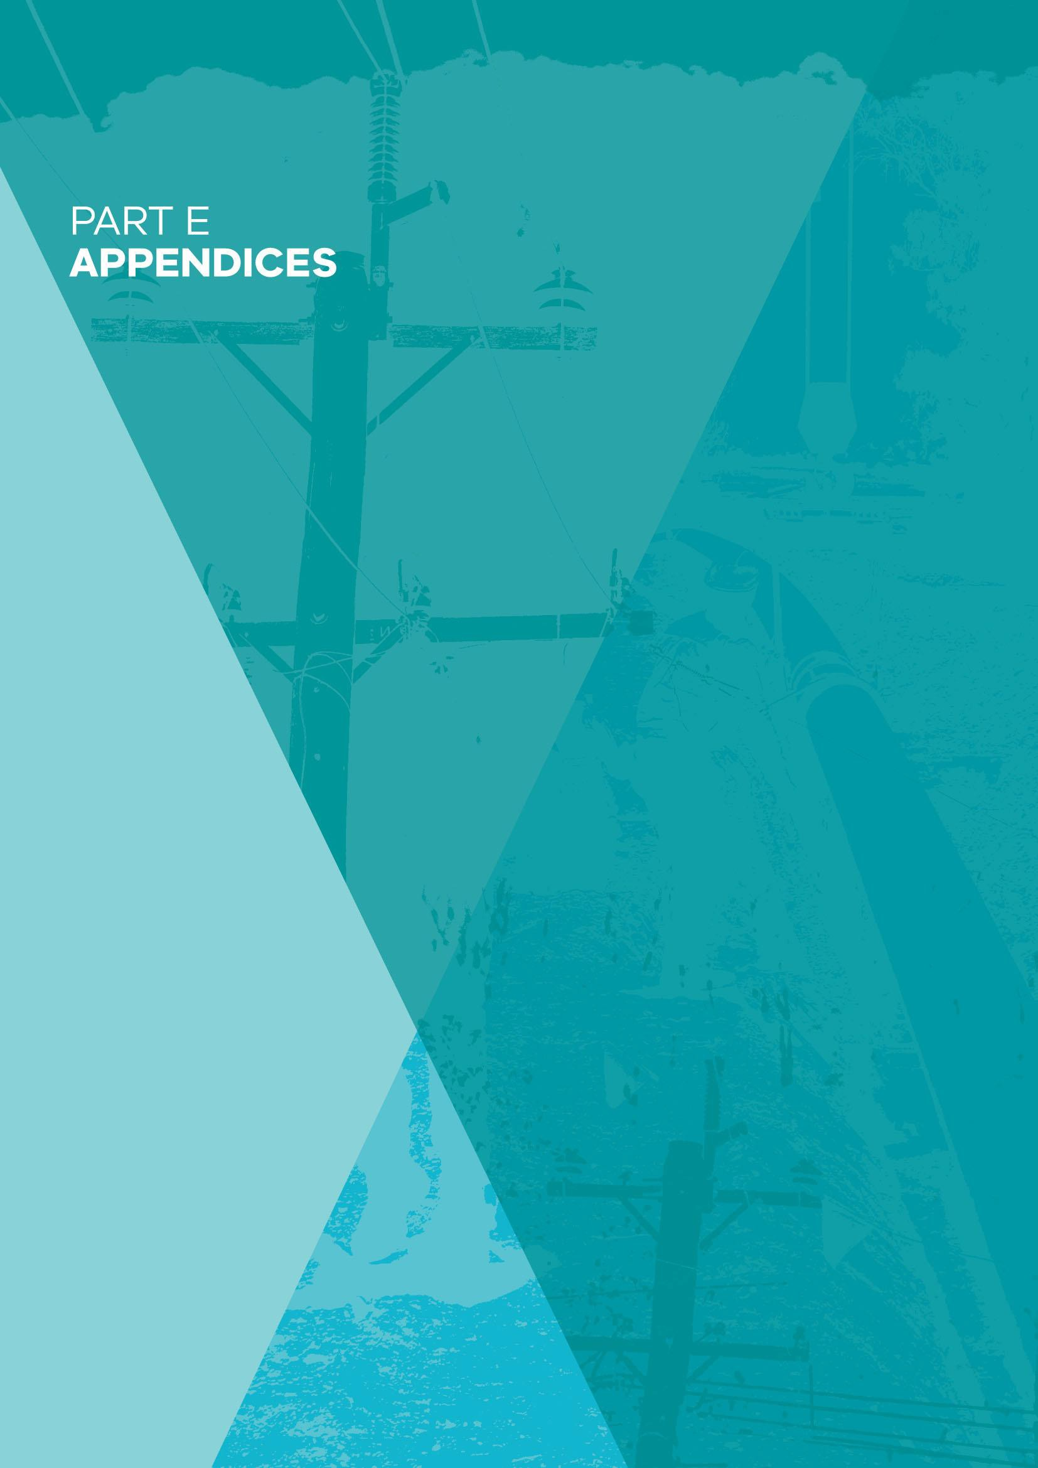

PART E: APPENDICES

251

The Review is intended to examine the safety framework applicable to electricity and gas networks in Victoria.

The Review will consider:

- The objectives of the safety framework in Victoria and an assessment of its effectiveness in achieving electricity and gas network safety outcomes.

- The design and adequacy of the safety regulatory obligations (including safety cases and the Electricity Safety Management Scheme), incentives and other arrangements governing energy network businesses and any opportunities for improvement.

- The extent to which the regulatory framework governing network safety ensures effective risk management by energy network businesses.

- The effectiveness of the regulator and governance arrangements in place to monitor and enforce compliance with safety obligations by energy network businesses.

- Any other matters that the Chair considers relevant.

In undertaking the Review, the Chair will have regard to:

- Best practice electricity and gas safety and risk management frameworks in other jurisdictions, including nationally and internationally.

- The relationship between the safety regime and the economic regulatory regime to ensure a balance between safety objectives and economic impacts including the cost impost on consumers.

Process
The Review will be conducted by an independent Chair supported by a dedicated secretariat. The Chair may seek expert advice.

The Review should be informed by extensive consultation with all relevant stakeholders. This will include public consultation.

Outcomes
The Chair will produce an interim report and a final report and recommendations to be presented to the Minister for Energy, Environment and Climate Change by December 2017. Unless specifically excluded, the interim and final report and recommendations will be made publicly available.

Appendix B: Electricity network and gas networks in Victoria

Electricity

Table B1: Transmission and distribution business statistics in Victoria

Transmission businesses
AusNet Services
Voltages: | 500 kV AC and 220 kV AC transmission across Victoria 66 kV AC sub-transmission across Victoria  330 kV AC on interconnector to New South Wales  275 kV AC on interconnector to South Australia
Powerline length: | 6574 km
No. of towers: | 13,000 approx.
Basslink
Voltages: | 500 kV AC and 400 kV DC link between Loy Yang power station in south east Victoria and George Town in northern Tasmania
Powerline length: | 67 km total in Victoria  3.2 km of 500 kV AC overhead line  57.4 km of 400 kV DC overhead line  6.6 km of 400 kV DC underground cable
No. of towers: | 142
Transmissions Operations Victoria
Voltages: | 132 kV from Mt Mercer wind farm to Elaine Terminal Station.
Powerline length: | 22 km
No. of towers: | 162
Distribution businesses
AusNet Services
Customers: | 685,194 (90% residential)
Service area: | 80,000 km²
Powerline length: | 41,000 km (85% rural, 13% underground)

No. of poles: | 383,000 approx.
CitiPower
Customers: | 325,917 (85% residential)
Service area: | 157 km²
Powerline length: | 3190 km (25% CBD, 30% underground)
No. of poles: | 58,200 approx.
Jemena
Customers: | 327,386 (90% residential)
Service area: | 950 km²
Powerline length: | 6301 km (75% urban, 29% underground)
No. of poles: | 103,000 approx.
Powercor
Customers: | 765,241 (85% residential)
Service area: | 145,651 km²
Powerline length: | 67,000 km (92% rural, 11% underground)
No. of poles: | 562,000 approx.
United Energy
Customers: | 658,453 (90% residential)
Service area: | 1472 km²
Powerline length: | 12,900 km (25% rural, 20% underground)
No. of poles: | 204,300 approx.

Note: AC = Alternating current, DC = direct current, kV = kilovolt

The geographic distribution of these businesses is shown below:

Figure B1: Electricity distribution and transmission areas

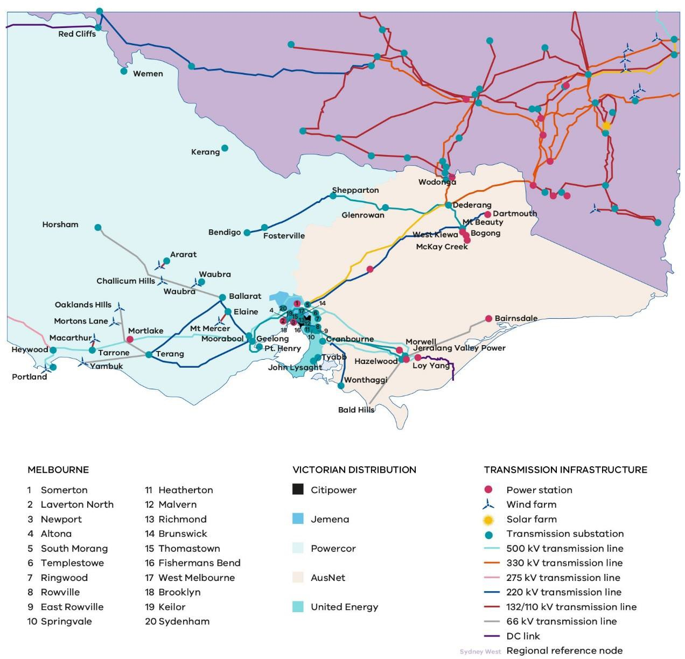
Source: Adapted from AEMO (2017)

Gas

Table B2: Natural gas transmission and distribution networks in Victoria²²

Transmission pipelines in the Victorian Transmission System
Declared Transmission System (GasNet)
APA Group | The Declared Transmission System (DTS) is a transmission pipeline network owned by APA Group through its wholly owned subsidiary APA VTS Australia (Operations) Pty Ltd.  The DTS transports natural gas within Victoria, supplying the Melbourne metropolitan area and country areas. It also supplies gas to NSW via the Interconnect with the Moomba Sydney Pipeline (MSP) at Culcairn and to South Australia via the SEA Gas Pipeline at Port Campbell. The average annual throughput of the DTS is in excess of 200 PJ per annum.
Transmissions pipeline holders that are not part of the Declared Transmission System
APA Group | Operates the SESA pipeline from Poolajeilo to South Australia
AusNet Gas Services Pty Ltd | AusNet Gas Services holds 33 pipeline licences supplying gas to metropolitan and regional areas throughout Victoria. This is approximately 15% of the total pipeline licences in Victoria.
Australian Gas Networks (Vic) Pty Ltd | AGN holds 34 pipeline licences supplying gas to metropolitan and regional areas throughout Victoria. This is approximately 15% of the total pipeline licences in Victoria.
Australian Gas Networks Pty Ltd | This pipeline operates from the Victoria – South Australian border to the Mildura City Gate.
BHP Billiton Petroleum (Bass Strait) Pty Ltd and Esso Australia Resources Pty Ltd | BHP and ESSO jointly hold two pipeline licences supplying natural gas to metropolitan and regional areas throughout Victoria.
Cooper Energy (PBGB) | Cooper Energy holds one pipeline licence supplying gas to regional area in Victoria.
Gas Pipelines Victoria Pty Ltd | The GPV pipeline operates from Carisbrook to Horsham.
IPM Australia Pty Ltd | The IPM pipeline operates from Traralgon to the Loy Yang Power Station.
Jemena Eastern Gas Pipeline (1) | The Jemena pipeline operates from Longford to New South Wales

22 Not all pipeline licences are for pipelines, a number of these licences were issued for City Gate facilities. Not all pipelines convey natural gas, some convey liquid/gaseous hydrocarbons

Pty Ltd and Jemena Eastern Gas Pipeline (2) Pty Ltd | and to the East Coast Power Plant at Bairnsdale.
Jemena VicHub Pipeline Pty Ltd | The Jemena Vichub pipeline operates from the Longford Compressor Station to APA’s Longford Metering Station.
Multinet Gas Pty Ltd | Multinet holds 16 pipeline licences supplying gas to metropolitan and regional areas throughout Victoria. This is approximately 5% of the total pipeline licences in Victoria.
Origin Energy Resources Ltd | Origin holds six pipeline licences supplying gas to regional areas throughout Victoria.
Qenos Olefins Pty Ltd | The Qenos pipeline operates from Qenos Plant to the Esso Plant at Altona.
Santos Ltd and Santos (NT) Pty Ltd | Santos holds four pipeline licences supplying gas to regional areas throughout Victoria.
South East Australia Gas Pty Ltd and Partners | The SEAGAS pipeline operates from the Iona Gas Plant to the Victoria – South Australian border.
Tasmanian Gas Pipeline Pty Ltd | The TGP pipeline operates from Longford to the shore crossing near Seaspray.
Storage facilities
Iona Underground Gas Storage Facility | Owner: Lochard Energy Location: South-west Victoria
Dandenong LNG Storage Facility | Owner: APA Location: Dandenong
Distribution networks
Multinet Gas | Owner: Cheung Kong Infrastructure  Location: Inner Melbourne and the outer East, the Yarra Ranges and South Gippsland
AusNet Services | Owner: Listed company (Singapore Power International 31%, State Grid Corporation 20%)  Location: Central and western Victoria

Figure B2: Gas distribution and transmission areas

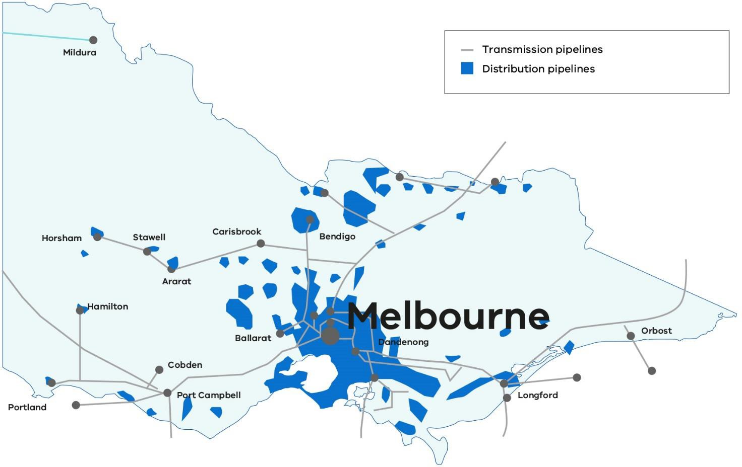

Source: Adapted from Review into the scope of economic regulation applied to covered pipelines: Issues paper (AEMC, 2017)

Appendix C: Electricity and Gas Network Legislation

Electricity

The safety of the electricity network is regulated through the Electricity Safety Act 1998 and the corresponding regulations. The Act is administered by ESV. There are various safety regulations that govern the safety of the electricity network.

Electricity Safety (Electric Line Clearance) Regulations 2015
The Act requires responsible persons including owners of network assets and private lines, many local councils, and other relevant parties, to keep vegetation clear of those lines to reduce the likelihood of fires or electric shocks occurring. The Electricity Safety (Electric Line Clearance) Regulations 2015 prescribe management procedures for standards and practices for tree cutting or removal in the vicinity of electric lines.

The clearance regulations establish the requirement for each major electricity company to submit an Electric Line Clearance Management Plan to ESV for acceptance on an annual basis. These plans provide ESV with some visibility of how each business manages its network assets and vegetation clearance obligations.

Electricity Safety (Management) Regulations 2009
The Act requires that each distribution business (or each “major electricity company”) – design, construct, operate, maintain and decommission its supply network to minimise the following as far as practicable:

- hazards and risks to the safety of any person arising from the supply network
- hazards and risks of damage to the property of any person arising from the supply network
- the bushfire danger arising from the supply network.

The Act requires all major electricity companies to prepare safety management schemes for each of their supply networks. An Electricity Safety Management Scheme involves setting out the safety management system an electricity company has in place to acquit its general duties and ensure it has built safety procedures into all aspects of its processes. An Electricity Safety Management Scheme must be submitted to ESV every five years.

The Electricity Safety (Management) Regulations 2009 prescribe the requirements relating to the acceptance of Electricity Safety Management Schemes.

Since 2015, ESV has also required transmission and distribution businesses to submit an accompanying safety case with their safety management scheme. The safety case requires the electricity network business to demonstrate it has systems in place to identify and mitigate safety risks throughout its organisation.

Electricity Safety (Bushfire Mitigation) Regulations 2013
The Electricity Safety Act 1998 requires each major electricity company to submit a bushfire mitigation plan to ESV every five years for acceptance. The Electricity Safety (Bushfire Mitigation)

Regulations 2013 make provision for preparing bushfire mitigation plans and for inspecting overhead electric lines and supply networks.

Each bushfire mitigation plan is required to set out how the company will manage the bushfire risk presented by its networks. These plans, and the safety management scheme of which bushfire mitigation plans are a part, must be accepted by ESV as a condition of network operation.

Bushfire mitigation plans provide a means for businesses to demonstrate to ESV how they will undertake capital improvements to improve network bushfire safety.

Electricity Safety (Installation) Regulations 2009
The Electricity Safety (Installation) Regulations 2009 prescribe the methods and materials required in electrical installations; the standards for the design, construction, operation and maintenance of electrical installations; and provide for the protection of persons from risk, and property from damage, associated with the generation, transmission, distribution and use of electricity. These regulations establish minimum standards required to be met by electric line workers in addition to other occupational safety and health requirements.

A Code of Practice on Electrical Safety for Work on or Near High Voltage Electrical Apparatus (2012) facilitates the electrical safety of electrical generation, transmission and distribution systems and high voltage electrical installations.

Civil Penalties Scheme
In May 2017, the Victorian Government introduced a civil penalties compliance mechanism into the Electricity Safety Act 1998 by the Electricity Safety (Bushfire Mitigation Civil Penalties Scheme) Act 2017. This mechanism allows ESV or the Minister to commence a civil proceeding against an electricity distribution businesses if they fail to comply with the civil penalty provisions.

The civil penalties regime requires electricity network businesses to deliver heightened powerline fault detection and suppression capabilities by installing new capital infrastructure over a seven- year period concluding in 2023. In addition, electricity distribution businesses must replace bare- wire powerline conductors with covered conductors or underground powerlines in designated high consequence bushfire areas.

The electricity distribution businesses will face financial penalties if they fail to meet the prescribed requirements.

Electricity Industry Act 2000
The Electricity Industry Act 2000 regulates the Victorian electricity supply industry. It requires persons who generate, transmit, distribute, supply or sell electricity to obtain a licence from the Essential Services Commission of Victoria (ESC), or a licence exemption.

The ESC administers the Electricity Distribution Code, which sets out how licenced electricity network businesses operate their network in a safe, efficient and reliable manner. This includes prescribed obligations regarding the quality and reliability of electricity supply.

Gas
The safety of gas transmission and distribution is regulated through the Gas Safety Act 1997, the Pipelines Act 2005 and the corresponding regulations²³. These Acts and associated regulations stipulate a duty to protect the community, property and environment from any risks arising from the conveyance and supply of gas, to take steps to avoid an unreliable supply of gas, and to achieve technical compliance with the relevant Australian Standards. The Australian Standards require the identification of threats and the implementation of control measures so that risks to people, property and the environment are reduced to a level as low as reasonably practicable.

The Gas Safety Act 1997 makes provision for the safe conveyance, sale, supply, measurement, control and use of gas and to generally regulate gas safety. The Act is administered by ESV and imposes duties on gas companies to minimise safety risks and to submit a plan (safety case) setting out the company’s safety management policies and procedures relating to gas safety. It is ESV’s responsibility to assess the plan for acceptance and to conduct ongoing audits to ensure that each gas company complies with the provisions of its plan. According to Section 46 of the Act, revised safety cases must be submitted every five years.

The AEMO, natural gas transmission pipeline companies, natural gas distribution companies, and natural gas retailers are all defined as gas companies for the purposes of the Gas Safety Act 1997. Liquefied petroleum gas (LPG) businesses become gas companies under the Gas Safety Act 1997 if they are declared to be so by Order of the Governor in Council.

There are various safety regulations that govern the safety of the gas network.

Gas Safety (Safety Case) Regulations 2008
The Gas Safety (Safety Case) Regulations 2008 regulate activities of gas companies, owners or operators of gas facilities or installations, in relation to the hazards and risks to the safety of the public arising from gas. The regulations set out content requirements for safety cases which include safety management systems, and requirements for reporting gas incidents.

The safety case requires the gas company to demonstrate it has systems in place to identify and mitigate safety risks throughout its organisation. Safety cases of transmission and distribution businesses must contain a formal safety assessment (containing, for example, identified hazards having the potential to cause a gas incident, assessment of risk and measures to reduce risk), published technical standards applied, and an emergency response plan. Australian Standards AS 2885 Pipelines – Gas and Liquid Petroleum, and AS 4645 Gas distribution network management

23 The National Gas Law and Rules also regulate safety, for example:
- 91BA National Gas Law: one of AEMO’s functions is to coordinate the interaction of producers, storage providers and service providers for ensuring a safe, secure, reliable and efficient declared transmission system.
- 91BC National Gas Law: AEMO may give binding directions to registered participants to maintain and improve reliability or security or in the interests of public safety
- 288 National Gas Rules: covered service providers are required to provide a gas quality monitoring system, for approval by AEMO, at each gas injection point and other points on the DTS to enable AEMO to monitor the quality of gas injected into and withdrawn from the DTS.
The National Gas Law is the Schedule to the National Gas (South Australia) Act (SA), applied in Victoria under the National Gas (Victoria) Act 2008 (Vic). It authorises the gas market and provides for the governance framework. It provides for the making of National Gas Rules, and formal Procedures.

are generally adopted by gas companies to give further safety case guidance with AS 2885 being the prescribed standard in the Pipelines Regulations 2017 for transmission pipelines.

Like transmission and distribution businesses, gas retail businesses are required to submit a safety case, although content requirements under the regulations differ (for example, retailers are not required to include a formal safety assessment).

Gas Safety (Gas Quality) Regulations 2007
Under the Act, in addition to a gas company’s duty to manage and operate facilities to minimise risk, a company must ensure gas conveyed meets prescribed standards of quality and complies with any other prescribed requirements.

The Gas Safety (Gas Quality) Regulations 2007 regulate activities of gas companies in relation to the quality of gas they convey and supply to customers. They prescribe quality standards, requirements for gas odourisation, and requirements for testing gas quality.

Gas Safety (Gas Installation) Regulations 2008
The Gas Safety (Gas Installation) Regulations 2008 regulate the activities of licensed and registered gasfitters, and gas appliance manufacturers and suppliers.

They provide standards for gas fitting work, procedures for the acceptance of appliances and gas installations, and contain general provisions for the safety of gas appliances, gas installations and work on gas appliances and installations.

Pipelines Act 2005
A pipeline is constructed to a certain standard depending on the type of land use surrounding it at the time of building. There are two main types of pipelines: “rupture” and “non-rupture”. Non- rupture pipeline is more expensive and generally used in areas where there is increased risk of third party interference, whereas rupture pipeline is significantly cheaper and more suitable to low- risk areas.

The Pipelines Act 2005 is intended to facilitate the development of pipelines within a regulatory framework that establishes sound consultative processes and protects the public from environmental, health and safety risks resulting from the construction and operation of pipelines. It is also designed to deliver greater certainty and efficiency to pipeline proponents so that they can access finance and minimise costs.

The Pipelines Act 2005 is jointly administered by ESV and DELWP. Under the Act, licensees have general duties for safety and environmental protection and are obliged to comply with safety management and environmental management plans. Plans must be accepted prior to operation and licensees must review and report on the plans every five years.

As transmission pipelines must be licensed under the Pipelines Act 2005, to avoid duplication a safety case accepted under the Gas Safety Act 1997 for a licensed natural gas transmission pipeline is deemed to be an accepted Safety Management Plan under the Pipelines Act 2005.

The Pipelines Act 2005 and licence conditions oblige pipeline licensees to comply with Australian Standard AS 2885 Pipelines – Gas and Liquid Petroleum. AS 2885 is the overarching standard that applies to licensed pipelines in Australia. It relates to the design, construction, testing,

operations and maintenance of high pressure gas and petroleum pipelines. Under the Standard, the pipeline licensee is responsible for the safety of the pipeline and it places a range of obligations on the pipeline licensee including maintenance of the pipeline, a safety assessment when there is a change in land use along the pipeline and if required, the upgrade or relocation of the pipeline or the implementation of physical barriers²⁴.

Pipelines Regulations 2017
The Pipelines Regulations 2017 provide for the regulation of pipelines which carry hazardous and combustible gaseous and liquid substances. The regulations prescribe:

- information required in the pre-licence and licence application process;
- conditions that apply to licences;
- contents of a decommissioning plan;
- provisions for reporting safety and environment incidents in relation to pipeline operations;
- standards for the construction and operation of pipelines;
- matters to be included in safety and environment management plans;
- infringement offences and penalties; and
- various forms, fees and procedures authorised by the Pipelines Act 2005.

Gas Industry Act 2001
The Gas Industry Act 2001 regulates the Victorian gas supply industry. It requires persons who distribute or sell gas to obtain a licence from the Essential Services Commission of Victoria (ESC), or a licence exemption. Section 156 of the Act has specific safety aspects, for example emergency powers of gas company officers and employees.

The ESC also administers the Gas Distribution Code, which sets out how licensed gas network businesses operate their network in a safe, efficient and reliable manner. This includes prescribed obligations regarding the quality and reliability of gas supply.

Major Hazard Facilities
Throughout the Victorian gas system, there are several specific sites in which the gas is produced or stored and injected into the Victorian transmission system. Gas used by the Victorian gas system is defined as dangerous goods in accordance with the Dangerous Goods Act 1985. Due to the large quantity of gas stored at these sites, they are classified as Major Hazard Facilities under

24 A key part of AS 2885 is the Safety Management Study process, which requires holder to identify all credible threats to the safety of the pipeline, assess the risk level for threats that could cause failure, and apply appropriate mitigation measures.
Under AS 2885.1 each pipeline segment is assigned a location class based on the land use within the ‘Measurement Length’ (ML). The ML is the distance from the pipeline that a full bore rupture would affect the surrounding area causing serious injuries to people. The ML is dependent on operating pressure and diameter of the pipeline, thus each pipeline has a different ML. This standard requires physical and procedural mitigation measures to be applied during design and operation. The number of physical and procedural measures required depends on the location classification and is mandatory for new pipelines. For existing pipelines, the standard requires that they are assessed against the requirements of Clauses 4.7.2 and 4.7.3, which set out the criteria for “no rupture” and maximum energy release rate in high consequence areas. Where existing pipelines do not comply with either clause, mitigation options must be assessed in accordance with Clause 4.7.4 and ALARP shall be achieved.

the Occupational Health and Safety Regulations 2017. WorkSafe Victoria is required to licence and approve such sites. Major gas-related sites include:

- Esso Australia Pty Ltd, Longford;
- Lochard Energy (Iona Operations) Pty Ltd, Port Campbell;
- APA GasNet Australia (Operations) Pty Ltd, Dandenong;
- Origin Energy Resources Limited (BassGas), Lang Lang; and
- Origin Energy Resources Limited (Otway Gas Plant), Port Campbell.

The operators of Major Hazard Facilities are required by the Occupational Health and Safety Regulations 2017 to develop a safety case to the satisfaction of WorkSafe Victoria.

Appendix D: The Economic Framework
The electricity and gas networks are also subject to national and state legislation that governs the economic regulation of the network businesses.
The purpose of the economic regulatory framework is to give effect to the National Electricity Objective and the National Gas Objective, which promote efficient investment in, and efficient operation and use of, electricity and natural gas services respectively, for the long-term interests of consumers with respect to price, quality, safety, reliability and security of supply.

The Australian Energy Regulator (AER) is responsible for the economic regulation of electricity networks in the National Electricity Market under the National Electricity Law, and gas pipelines in all jurisdictions other than Western Australia and Tasmania, under the National Gas Law. The AER encourages businesses to undertake efficient investment by setting maximum revenues a business can recover from consumers (AER, 2015).

Energy networks are capital intensive and have declining average costs as output rises. Accordingly, network services in a particular geographic area can be most efficiently provided by a single supplier. In Australia, the networks are regulated to manage the risk of monopoly pricing in this natural monopoly industry structure.

The rules which govern the electricity and gas markets are made by the Australian Energy Market Commission (AEMC), a national body that is jointly funded by the States and Territories.

Electricity
To ensure consumers face prices based on efficient costs, these monopoly businesses are subject to an economic regulatory framework. This framework is comprised principally of chapter 6 of the National Electricity Rules.

The National Electricity Rules are made pursuant to the National Electricity Law. The National Electricity Rules rely on template legislation in each participating state. This structure has been adopted to create uniformity in an industry which is principally governed by state law under the Constitution.

The National Electricity Rules aim to incentivise network businesses to be efficient in their spending and to meet reliability service standards. These incentive schemes are designed to reward network businesses for over-performance or penalise them for under-performance, as measured against predefined benchmarks of reliability and efficiency.

Electricity Distribution Price Review
Distribution businesses have discretion in how they spend available funds for operational, maintenance and minor capital items, apart from the construction of mandated assets.

Every five years, electricity network businesses submit a proposal to the AER forecasting how much they will need to spend over the next five years to provide electricity services, and meet reliability and service obligations. The AER evaluates the revenue proposals against the national electricity objective set out in the National Electricity Rules which states: “to promote investment in, and efficient operation and use of, electricity services for the long term interests of electricity consumers”.

The process whereby this occurs is an Electricity Distribution Price Review (EDPR). EDPRs determine the amount of revenue (the ‘revenue cap’) a regulated electricity network business can recover from its customers through distribution tariffs. These tariffs form a component of a customer’s final electricity bill.

In determining the prices that a network business can charge, the AER reviews the business’s:

- capital expenditure (the cost of purchasing and installing network assets);
- operating-related expenditure (the cost of running the network and maintaining the assets);
- asset depreciation costs; and
- taxation liabilities (and allows a commercial return on capital), to ensure that the expenditure is prudent and justified.

Gas
The National Gas Law and National Gas Rules provide the regulatory framework governing gas networks and set out a “coverage” process, which determines whether a gas pipeline should be subject to a mandated third party access arrangement and in what form. Pipelines that are “covered” (regulated) are subject to set-pricing regimes, determined by the AER. Various tiers of regulation apply, based on competition and significance criteria.

Full regulation requires a pipeline provider to periodically (typically every five years) submit an access arrangement to the AER for approval. An access arrangement sets out the terms and conditions under which third parties can use a pipeline. It sets out the tariffs, and terms and conditions for pipeline users, including charges to retailers for transmission and distribution services. A business can also submit variations to its approved access arrangement. The AER assesses the revenues needed to cover efficient costs and provide a commercial return on capital, then derives reference tariffs for the pipeline.

A more limited access arrangement can be lodged for light regulation pipelines. Under light regulation, the pipeline provider determines its own tariffs. The AER decides whether to approve a proposed access arrangement and may request amendments.

Part 8 of the National Gas Rules provide that an access arrangement may include one or more incentive mechanisms to further encourage efficiency in the provision of services by the service provider. Under the National Gas Rules, the AER has full discretion about whether to approve the introduction of an incentive mechanism.

In relation to gas networks, the AER has only approved an operating expenditure incentive mechanism (referred to as the Efficiency Benefit Sharing Scheme) to date (Farrier Swier Consulting, 2016). The Efficiency Benefit Sharing Scheme gives network businesses incentives to spend efficiently and share the benefits with consumers. Among other things, the incentive mechanism provides for carrying over increments for efficiency gains and decrements for losses of efficiency from one access arrangement period to the next. Changes to existing incentive mechanisms and the potential introduction of new incentive mechanisms may be considered by the AER in the forthcoming regulatory period.

Appendix E: Recommendations 27-34 of the VBRC

Recommendation 27
The State amend the Regulations under Victoria’s Electricity Safety Act 1998 and otherwise take such steps as may be required to give effect to the following:
- the progressive replacement of all SWER (single-wire earth return) power lines in Victoria with aerial bundled cable, underground cabling or other technology that delivers greatly reduced bushfire risk. The replacement program should be completed in the areas of highest bushfire risk within 10 years and should continue in areas of lower bushfire risk as the lines reach the end of their engineering lives.
- the progressive replacement of all 22-kilovolt distribution feeders with aerial bundled cable, underground cabling or other technology that delivers greatly reduced bushfire risk as the feeders reach the end of their engineering lives. Priority should be given to distribution feeders in the areas of highest bushfire risk.

Recommendation 28
The State (through Energy Safe Victoria) require distribution businesses to change their asset inspection standards and procedures to require that all SWER lines and all 22-kilovolt feeders in areas of high bushfire risk are inspected at least every three years.

Recommendation 29
The State (through Energy Safe Victoria) require distribution businesses to review and modify their current practices, standards and procedures for the training and auditing of asset inspectors to ensure that registered training organisations provide adequate theoretical and practical training for asset inspectors.

Recommendation 30
The State amend the regulatory framework for electricity safety to require that distribution businesses adopt, as part of their management plans, measures to reduce the risks posed by hazard trees – that is, trees that are outside the clearance zone but that could come into contact with an electric power line having regard to foreseeable local conditions.

Recommendation 31
Municipal councils include in their municipal fire prevention plans for areas of high bushfire risk provision for the identification of hazard trees and for notifying the responsible entities with a view to having the situation redressed.

Recommendation 32
The State (through Energy Safe Victoria) require distribution businesses to do the following:

- disable the reclose function on the automatic circuit reclosers on all SWER lines for the six weeks of greatest risk in every fire season and adjust the reclose function of the automatic circuit reclosers on all 22-kilovolt feeders on all total fire ban days to permit only one reclose attempt before lockout.

Recommendation 33

The State (through Energy Safe Victoria) require distribution businesses to do the following:

- fit spreaders to any lines with a history of clashing or the potential to do so fit or retrofit all spans that are more than 300 metres long with vibration dampers as soon as is reasonably practicable.

Recommendation 34
The State amend the regulatory framework for electricity safety to strengthen Energy Safe Victoria’s mandate in relation to the prevention and mitigation of electricity-caused bushfires and to require it to fulfil that mandate.

Appendix F: ESV governance and structure

ESV Governance Structure 2017
Audit & Risk
Committee
Director of Energy Safety
Statutory/Accountable Officer
Remuneration
Committee
Executive
Management Board
Risk Management
Committee
Information
Management Governance Committee
•
•
•

•
Deputy Director
Chief Operating Officer
General Manager Risk, Regulatory Planning & Policy General Manager Electrical Safety & Technical Regulation· General Manager Gas & Pipeline Safety & Technical Regulation
Enforcement &
Compliance Panel
Safety Case Review
Panel
•
Stakeholder and
Industry Committees
Section 8 Committee
Statutory Committees

Appendix G: Terms and abbreviations

Term | Definition
ACR | Automatic Circuit Reclosers – A device to be set remotely to automatically turn off those powerlines quickly when faults occur.
AEMC | Australian Energy Market Commission – the rule maker for Australia’s electricity and gas markets, including the National Electricity Rules, National Gas Rules and National Energy Retail Rules. AEMC also provides market development advice to governments.
AEMO | Australian Energy Market Operator – operates the energy markets and systems and delivers planning advice in eastern and southern Australia. AEMO supports the industry to deliver an integrated, secure, cost-effective national energy supply.
AER | Australian Energy Regulator – regulates energy markets and networks under the national energy market legislation and rules in setting prices for using energy networks to transport energy to customers in eastern and southern Australia.
ALARA | As Low As Reasonably Achievable
ALARP | As Low As Reasonably Practicable – The ALARP principle is that the residual risk shall be reduced as far as reasonably practicable
BRCIM | Bushfires Royal Commission Implementation Monitor – Led by Neil Comrie in October 2010 to oversee and report on the implementation of all of the Victorian Bushfires Royal Commission’s recommendations.
CALD | People from culturally and linguistically diverse backgrounds.
CNG | Compressed Natural Gas – (methane stored at high pressure) is a fuel which can be used in place of gasoline (petrol), Diesel fuel and propane/LPG. CNG combustion produces fewer undesirable gases than the fuels mentioned above. It is safer than other fuels in the event of a spill, because natural gas is lighter than air and disperses quickly when released. CNG may be found above oil deposits, or may be collected from landfills or wastewater treatment plants where it is known as biogas.
DELWP | Department of Environment, Land, Water and Planning – ensures Victoria has the right conditions to enable economic growth, while delivering liveable, inclusive and sustainable communities.
DTS | The Declared Transmission System (DTS) has also been known as the Principal Transmission System (PTS) and the APA GasNet System. Since 2002, it includes the former Western Transmission System (WTS) which transported gas to Portland, Hamilton and Cobden.  The DTS is a transmission pipeline network owned by APA Group through its wholly owned subsidiary APA VTS Australia (Operations) Pty Ltd. APA acquired

the DTS when it purchased GasNet Australia in December 2006.
The DTS transports natural gas within Victoria, supplying the Melbourne metropolitan area and country areas. It also supplies gas to NSW via the Interconnect with the Moomba Sydney Pipeline (MSP) at Culcairn and to South Australia via the SEA Gas Pipeline at Port Campbell. The average annual throughput of the DTS is in excess of 200 PJ per annum.
EBSS | Efficiency Benefit Sharing Scheme – An operating expenditure Incentive Mechanism – incentives for businesses to spend efficiently.
EDPR | Electricity Distribution Price Review – AER’s review after all distribution business submit their five year forecasting expenditure plans - AER evaluates the proposals against the national electricity objective set out in the NEL.
ESMS | Electricity Safety Management Schemes – a non-prescriptive form of regulation that enables industry to improve on the efficiency of its operation without compromising safety standards.
ESC | Essential Services Commission – Victoria’s independent economic regulator of prescribed essential utility services supplied by the electricity, gas, ports and rail freight industries.
ESV | Energy Safe Victoria is Victoria’s independent technical safety regulator responsible for the safety and technical regulation of electricity, gas and pipelines in Victoria.
HBRA | Hazardous Bushfire Risk Areas
GSL | Guaranteed Service Level – Payments made to customers who receive power outages or frequency.
IGEM | The Inspector-General for Emergency Management – works with its emergency management partners and the community to strengthen emergency management arrangements and community safety in Victoria.
kV | Kilovolts – a unit of electromotive force, equal to 1000 volts.
LBRA | Low Bushfire Risk Areas
Linepack | The pressurised volume of gas stored in the pipeline system. Linepack is essential for gas transportation through the pipeline network each day, and as a buffer for within-day balancing.
LNG | Liquefied Natural Gas – is a natural gas (methane) that has been converted into liquid form by freezing it to -161ºC for ease of storage or transport.
LPG | Liquefied Petroleum Gas – is a mixture of hydrocarbon gases (mainly propane and butane) that under pressure, liquefy. It can occur naturally in oil and gas fields, or can be extracted at oil refineries during the production of other petroleum products. It is used as a fuel source for industry and domestic use.

MECs | Major electricity companies – comprise both licenced electricity transmission companies and licenced electricity distribution businesses.
MHF | Major Hazard Facilities – are industrial sites that store, handle or process large quantities of hazardous chemicals and dangerous goods, including petroleum products. Includes gas facilities.
NEL | National Electricity Law – is applied as law in each participating jurisdiction of the NEM by application statutes.
NEM | National Electricity Market – a wholesale market through which generators sell electricity in eastern and southern Australia. The main customers are energy retailers, which bundle electricity with network services for sale to residential, commercial and industrial energy users.
NER | National Electricity Rules – govern the operation of the National Electricity Market. The Rules have the force of law, and are made under the National Electricity Law.
OCEI | Office the Chief Electrical Inspector – was an independent regulator for electricity but was abolished in 2005 and replaced by ESV who now works as independent regulator for both electricity and gas.
OGS | Office of Gas Safety – was an independent regulator for gas but was abolished in 2005 and replaced by ESV who now works as independent regulator for both electricity and gas.
OH&S | Occupational Health and Safety Act 2004 – legislative and administrative measures to improve occupational health and safety in Victoria.  Regulations 2007 – specify the ways duties imposed by the Act must be performed, or prescribe procedural or administrative matters to support the Act, such as requiring licenses for specific activities, keeping records, or notifying certain matters.
PBSP | Powerline Bushfire Safety Program – once the Victorian Government accepted the PBST’s recommendations the PBSP was established to implement them
PBST | Powerline Bushfire Safety Taskforce – established to recommend to the Victorian Government how to maximise the value to Victorians from the two electricity- related recommendations made in the Royal Commission report.
POELs | Private Overhead Electric Lines – can be a combination of privately owned poles and lines, or just a span of line that is privately owned. These are generally for rural properties and their various buildings, such as sheds. A Registered Electrical Contractor is the only person who can carry out any work on a POEL
Polyphase powerlines | Powerlines that carry small to medium amounts of power and are common in the distribution network. The majority run at a high nominal voltage of 6.6 kV, 11 kV or 22 kV and use multiple wires to supply multiple premises. 77 per cent of polyphase powerlines in Victoria are located in rural areas.

REFCLs | Rapid Earth Fault Current Limiters – fault suppression equipment installed on select 22 kV powerlines to reduce the risk of polyphase powerlines starting fires by automatically reducing the electric current
SECV | State Electricity Commission of Victoria – established in 1918, responsible for generation and distribution of electricity throughout the state.
SFAIRP | So Far As Is Reasonably Practicable – the concept of reducing risk So Far As Is Reasonably Practicable.
STPIS | Service Target Performance Incentive Schemes – provide incentives to businesses to improve or maintain a high level of service for the benefit of participants in the National Electricity Market and end users of electricity.
SWER | Single Wire Earth Return – a single-wire transmission line which supplies single- phase electric power from an electrical grid to remote areas at low cost. The electrical current returns through the ground rather than through a separate wire as occurs in polyphase distribution lines. As a SWER system uses only a single wire, it is very simple, requires less material, and is cheaper to construct and maintain than polyphase distribution lines. 99 per cent of SWER lines in Victoria are located in rural areas.
VBRC | Victorian Bushfires Royal Commission – established on 16 February 2009 to investigate the causes and responses to the bushfires which swept through parts of Victoria in late January and February 2009 (Black Saturday bushfires)
VEC | Victorian Electrolysis Committee – established under the Electricity Safety Act 1998 to establish and maintain standards for systems for cathodic protection and for the mitigation of stray current corrosion. It provides advice to ESV on any matter related to electrolysis and the regulations relating to cathodic protection and to the mitigation of stray current corrosion and encourage the development of new methods and technology.

*

*

